Supporting Information
Preparation of High-Performance Manganese-Based Pseudocapacitor Material by Using Spent Lithium-Ion Battery Anode Graphite via Mechanochemical Pretreatment
Lujie Dai,† Bang Li,‡ Jia Li,*,†✉, Zhenming Xu‡
†China-UK Low Carbon College, Shanghai Jiao Tong University, 3 Yinlian Road, Shanghai 201306, People’s Republic of China
‡School of Environmental Science and Engineering, Shanghai Jiao Tong University, 800 Dongchuan Road, Shanghai 200240, People’s Republic of China
✉weee@sjtu.edu.cn

Supporting Information Content
5 pages (including the cover page)
4 Figures
1 Table
Figure S1 The pretreatment to obtain graphite precursor from spent lithium-ion batteries
Figure S2 The illustration of ball milling effects on graphite
Figure S3 Analogical grinding model of MG-24 during ball milling
Figure S4 SEM images of (a) SG; (b-c) MG24
Table S1 MG24 content before/after hydrothermal treatment
Pretreatment to obtain graphite precursor
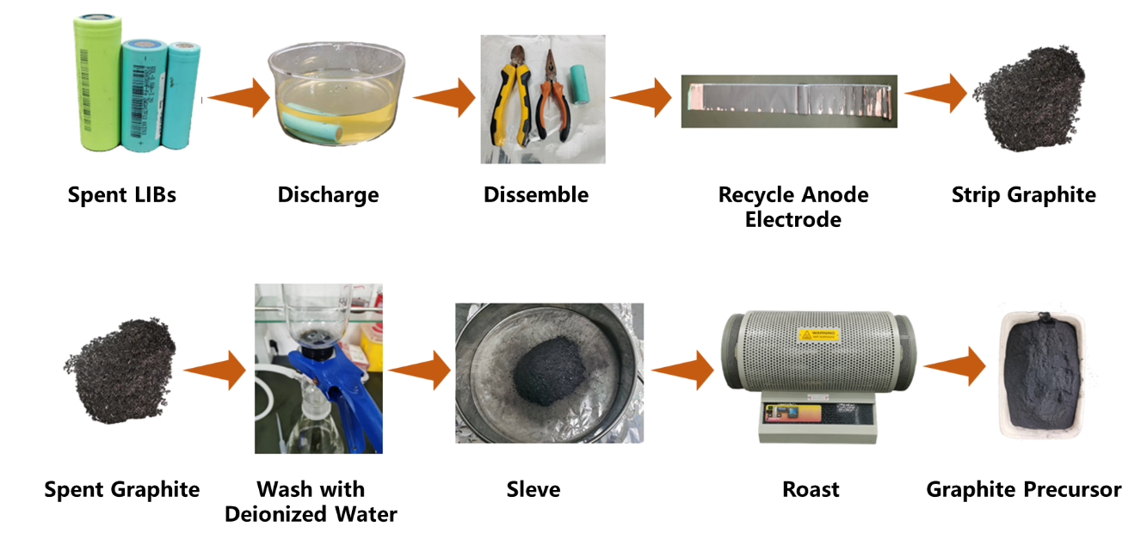
Fig. S1 The pretreatment to obtain graphite precursor from spent lithium-ion batteries

The experimental mechanism of the mechanochemical process
The aforementioned data demonstrates when impacting and shearing graphite during ball milling phase, the former breaks the grains into smaller pieces and reduces their thickness, whereas the latter reduces the grain thickness of graphite (001), converting graphite with more layers into graphite with fewer layers and possibly graphene.

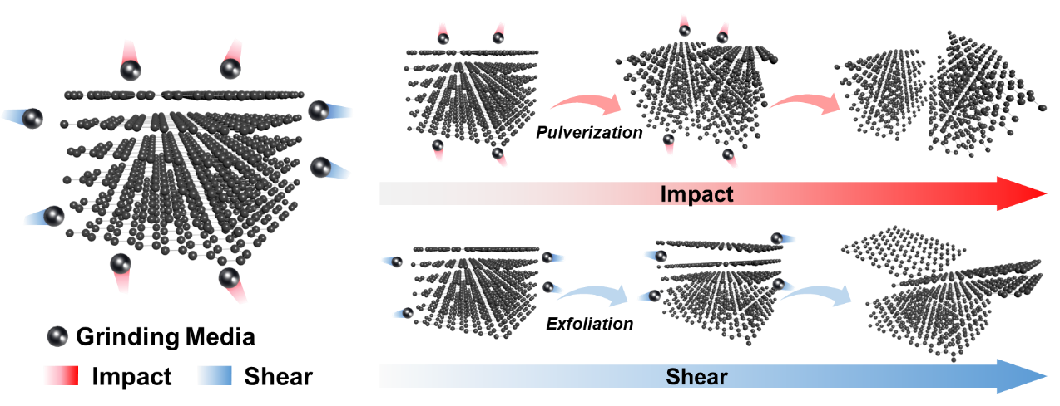
Fig. S2 The illustration of ball milling effects on graphite

The SG is derived from the agglomeration of small grains, while small grains can avoid excessive impact and are mainly peeled off by shear action. The process can be shown in Fig. S3. Graphite particles are like a wall, SG is made up of small bricks. When the hammer is used to smash the two walls separately, there are more gaps (grain boundaries) between the small graphite bricks, which can effectively buffer the impact force, and the whole wall is disassembled into relatively complete small bricks.
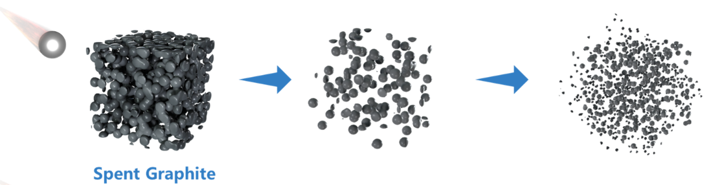
Fig. S3 Analogical grinding model of MG-24 during ball milling

Characterization of MG-24
It can be seen that SG of irregular potato-shaped plates with diameters ranging from 10 to 40 μm was gathered of small plates with sizes ranging from 2 to 10 μm. After 24 hours of ball milling, it can be seen that MG24 has a portion of flaky graphite and numerous tiny plates that range in size from 0.1 to 2 μm.
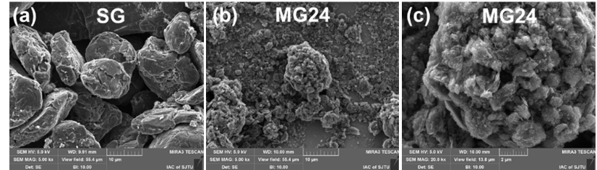
Fig. S4 SEM images of (a) SG; (b-c) MG24

Carbon reaction rate during hydrothermal process
The hydrothermal synthesis process results in the utilization of graphite during the reaction, resulting in a gradual reduction in the intensity of the graphite peak as the concentration increases.
$$4MnO_{4}^{-}+3C+H_{2}O→4MnO_{2}+CO_{3}^{2-}+2HCO_{3}^{-}$$
Within the same time, KMnO₄ solution undergoes decomposition upon heating.
$$2KMnO_{4}→K_{2}MnO_{4}+MnO_{2}+O_{2}↑$$
After hydrothermal experiments, the product was reacted with excess concentrated hydrochloric acid to remove the manganese dioxide produced. Subsequently, the products before and after the reaction were measured by weighing. The experimental results showed that the product changed significantly during the reaction, including the disappearance of manganese dioxide. By comparing the weight data before and after the reaction, we calculated the carbon loss rate and further revealed the effect of the hydrothermal experiment on the material. The results of this experiment are illustrated in the table below. In the initial stage of the experiment, the high concentration of the treatment solution and the carbon material were more fully infiltrated. Over time, however, the formation of MnO2 led to the formation of structures that prevented further reactions from occurring. This structure formation appears to limit the reaction between the carbon material and the treatment solution. This suggests that a higher concentration of KMnO₄ leads to a more significant reaction and conversion of MG24 into GNPs/MnO₂. The formation of thicker layer of MnO2 act as a protective barrier around MG24, that's the reason why MG24 does not react fully with excess potassium permanganate
Table S1 MG24 content before/after hydrothermal treatment
Sample | KMnO₄ concentration  (mmol/L) | MG24 before  (mg) | GNPs/MnO₂  (mg) | MG24 residue  (mg) | Reaction rate  (%)
MG24-5 | 5 | 20.01 | 26.01 | 10.44 | 47.83%
MG24-10 | 10 | 20.03 | 41.09 | 10.32 | 48.48%
MG24-15 | 15 | 19.98 | 57.35 | 10.24 | 48.75%
MG24-20 | 20 | 19.97 | 71.77 | 10.02 | 49.82%
MG24-30 | 30 | 19.94 | 101.16 | 9.77 | 50.99%

