Unlocking the unique catalysts of CoTiO₃/BiVO₄@MIL-Fe(53) for improving Cr(VI) reduction and tetracycline degradation
Xinghui Liu^{a*}, Saraschandra Naraginti^{b*}, Fuchun Zhang^{c*}, Kuppusamy Sathishkumar^{d}, Kuldeep K Saxena^{e}, Xiang Guo^{a*}
ª Science and Technology on Aerospace Chemical Power Laboratory, Hubei Institute of Aerospace Chemotechnology, Xiangyang 441003, China
^{b} School of Chemical and Environmental Engineering, Anhui Polytechnic University, Wuhu 241000, China
^{c} School of Physics and Electronic Information, Yan'an University, Yan'an 716000, China
^{d} Center for Global Health Research, Saveetha Medical College and Hospitals, Saveetha School of Engineering, Saveetha Institute of Medical and Technical Sciences (SIMTS), Thandalam, Chennai 602105, Tamil Nadu, India
^{e} Division of Research and Development, Lovely Professional University, Phagwara, India.

*Corresponding authors Email:
Xinghui Liu: liuxinghui119@gmail.com
Saraschandra Naraginti: nsaraschandra@gmail.com;
Fuchun Zhang: yadxzfc@yau.edu.cn;
Xiang Guo: guoxiang@casc42.cn

Fig. S1 p-XRD spectral pattern of pure COTiO₃, BiVO₄, Fe-MOF and CT/BV@Fe-MOF nanocomposite

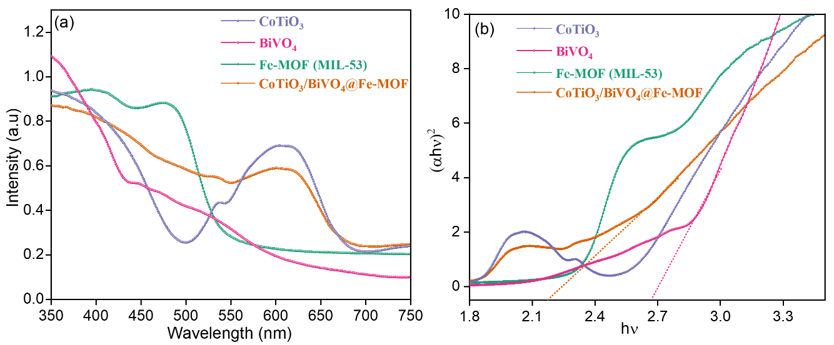
Fig. S2 (a) UV-Vis-DRS plot (b) Tauc plot of CoTiO₃, BiVO₄, Fe-MOF, and CT/BV@Fe-MOF nanocomposite

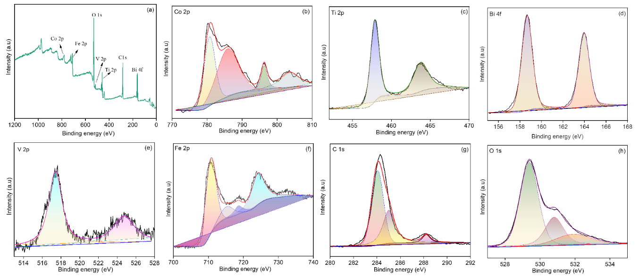
Fig. S3 (a) XPS survey spectra plot (b-h) High resolution deconvoluted XPS spectra for Co2p, Ti2p, Bi4f, V2p, Fe 2p, C1s, and O1s elements of CT/BV@Fe-MOF nanocomposite

Fig. S4 TOC removal during TCL degradation (30 ppm) by CT/BV@Fe-MOF nanocomposite

