Giant dielectric ceramic of Li_{0.3}Ti_{0.02}Ni_{0.68}O with abundant oxygen vacancies enabling high lithium-ion conductivity in composite solid-state electrolyte
Xufei An^{1,3}, Yu Yuan^{1,3}, Ke Yang^{1,3}, Danfeng Zhang^{1*}, Yidan Cao¹, Ming Liu¹, Feiyu Kang^{1,2} and Yan-Bing He^{1*}
1 Shenzhen All-Solid-State Lithium Battery Electrolyte Engineering Research Center, Institute of Materials Research (IMR), Tsinghua Shenzhen International Graduate School, Tsinghua University
Shenzhen 518055, China
2 School of Materials Science and Engineering, Tsinghua University
Beijing 100084, China
3 These authors contributed equally to this work.
E-mail: dfzhang@sz.tsinghua.edu.cn, he.yanbing@sz.tsinghua.edu.cn
Preparation of Li_{0.3}Ti_{0.02}Ni_{0.68}O
Firstly, 0.3 mol lithium nitrate (LiNO₃), 0.68 mol nickel nitrate hexahydrate (Ni(NO₃)₂ 6H₂O) and 1 mol citric acid (C₆H₈O₇) were dissolved in 3 mL deionized water and stirred at room temperature until dissolve to obtain a green transparent solution. Then 0.02 mol tetrabutyl titanate (C₁₆H₃₆O₄Ti) was added and stirred at room temperature for 2 h, and then the temperature was raised to 80 ℃ for 24 h to obtain green gel. The gel solution was dried in an oven at 120 ℃ for 24 h to obtain green powder. Finally, the green powder was placed in a Muffle furnace and calcined at a rate of 3 ℃ min⁻¹ from room temperature to 800 ℃ for 1 h to obtain black ceramic powder Li_{0.3}Ti_{0.02}Ni_{0.68}O (LTNO).
Preparation of composite solid-state electrolytes
PVDF powder (Mw = 600,000, Kynar, 761) and LTNO were dried for 24h in a vacuum oven prior to use. The precursor slurry of PVDF electrolyte was made by mixing 400 mg PVDF, 267 mg LiFSI and 15 mL DMF under magnetic stirring for 6 h and the PVDF slurry was dried at 55 ℃ for 24 h to form PVDF electrolyte. LTNO was then added to the solution, followed by 2 h of sonication and 4 h of string. The homogenized mixture was poured into the culture dish mold. Finally, the composite solid-state electrolytes were obtained by drying for 24 h at 55℃ and reposited in the glovebox for 12 h before use.
Characterizations
The X-ray diffraction (XRD) measurements of the samples were characterized on a Bruker D8 Advance with Cu-Kα radiation. The morphology was analyzed by scanning electron microscope (SEM, HITACH S4800) with energy dispersive spectroscopy. The structure was analyzed by a field emission transmission electron microscope (FE-TEM, FEI Tecnai F30). X-ray photoelectron spectroscopy (XPS) measurement was collected on a PHI 5000 VersaProbe II instrument. The Fourier transform infrared (FTIR) spectra were executed by VERTEX 70 spectrometer in an attenuated total reflection (ATR) mode. The tensile strength was tested by a stress-strain curve and the tensile strength was considered to be the stress value at the maximum of the curve. Thermogravametric analysis (TGA) was performed using a Netzsch STA 449F3 thermal analyzer from room temperature to 600 °C at a heating rate of 10 °C min⁻¹ in N₂ atmosphere.
Assembly of solid–state NCM811/Li cell
LiNi_{0.8}Co_{0.1}Mn_{0.1}O₂ (NCM811), PVDF 5130 and Super P were dried at 60 °C for 24 h in the vacuum oven prior to use. The cathode was prepared by mixing NCM811, Super P, PVDF 5130 binder in a weight ratio of 8:1:1 in N-methyl-2-pyrrolidone (NMP), followed by casting the slurry on an aluminum foil and then was dried at 60 ℃ under vacuum to remove the solvent and bound water. Here, the loading of the NCM811active material is 1.5 mg cm⁻². The CR2032 solid-state cells were assembled in an Ar-filled glove box. The symmetric Li cell used a large Li metal piece with the diameter of 15.6 mm on one side and a small Li metal piece with the diameter of 12.5 mm on the other side.
Electrochemical measurements.
The ionic conductivities of PVDF and P-LTNO electrolyte were measured by electrochemical impedance spectroscopy (EIS) from 7 MHz to 0.1 Hz with a 10 mV AC oscillation on a VMP3 multichannel electrochemical station (Bio Logic Science Instruments, France). The LSV curves were examined from 0 to 7 V versus Li/Li⁺ at a scanning rate of 0.1 mV s⁻¹ using a VMP3 multichannel electrochemical station. The NCM811/Li full cells were assembled for the cyclic voltammetry (CV) measurements in the voltage range of 2.8~4.3 V for 5 cycles at a scanning rate of 0.1 mV s⁻¹ using a VMP3 multichannel electrochemical station. Galvanostatic charge and discharge tests of cells were performed on a battery test system (LAND CT2001A) and Neware battery test system with a voltage range from 2.8 to 4.3 V at 25 °C. The cycled cells were transferred into a glovebox and dissembled for further examination. The NCM811 cathode and lithium metal anode were transferred into a chamber with a sealed Ar-filled vessel for SEM examination.
Calculation of the ionic conductivity
The ionic conductivities of PVDF and P-LTNO electrolyte were measured by electrochemical impedance spectroscopy (EIS) from 7 MHz to 0.1 Hz with a 10 mV AC oscillation on a VMP3 multichannel electrochemical station (Bio Logic Science Instruments, France). The test cells were assembled by a small piece of electrolyte slice sandwiched between two stainless-steel blocking electrodes. The ionic conductivities (σ) were calculated following Eq. (2):
$σ=\frac{L}{RS}$ (2)
where L is the thickness of electrolytes, R is obtained by EIS measurement with electrolytes sandwiched between two stainless plates of steel, and S is the area of stainless steel. The activation energy was calculated from the Arrhenius Eq. (3)
$σ=σ_{0}\exp\left(-\frac{E_{a}}{RT}\right)$ (3)
where σ₀ and Ea is the pre-exponential factor and the activation energy of ions transport, respectively.
Calculation of the lithium transference number
The Li/Li symmetric cells were assembled and polarized by a voltage (ΔV=10 mV) for 3000 s to test the lithium transference number (t_{Li+}). At the same time, EIS measurement as well as initial and steady state of Li/Li symmetric cells was performed from 7 MHz to 0.1 Hz with a 10 mV AC oscillation. t_{Li+} is calculated based on the following Eq. (4)
$t_{{Li}^{+}}=\frac{I_{s}(∆V-I_{0}R_{0})}{I_{0}(∆V-I_{s}R_{s})}$ (4)

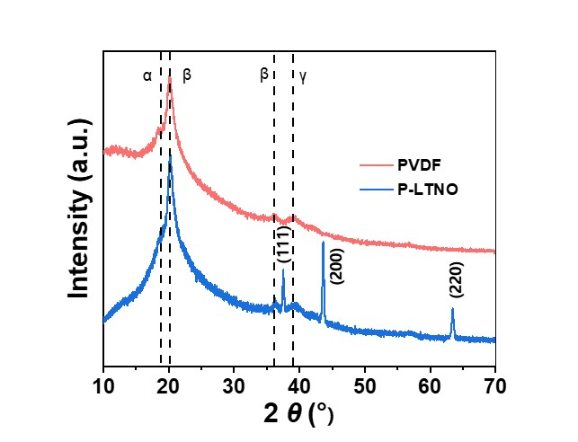
Figure S1 XRD patterns of PVDF and P-LTNO electrolyte.

Figure S2 FTIR spectra of P-LTNO and PVDF electrolyte.

Figure S3 a) Ionic conductivities of P-LTNO based electrolytes with various LTNO content at 25 ℃; Raman spectra of P-LTNO based electrolytes with b) 5wt% LTNO and c) 15wt% LTNO; d) the quantification results of the FSI⁻ anion states in the electrolytes of P-LTNO based electrolytes with various LTNO content.

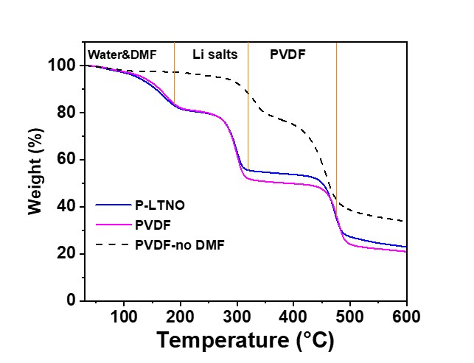
Figure S4 TGA curves of PVDF and P-LTNO electrolyte

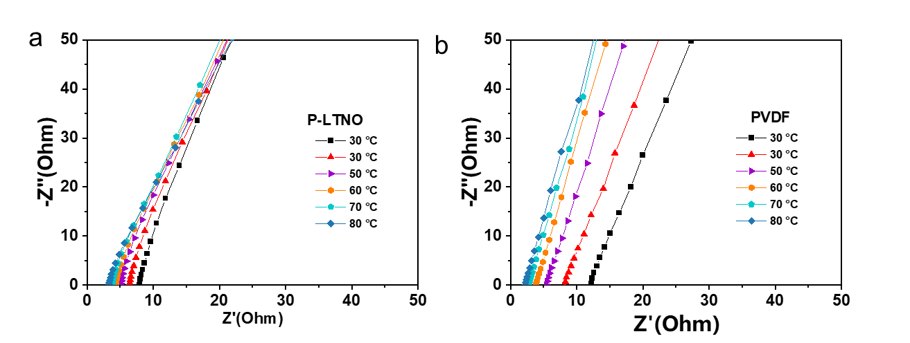
Figure S5 EIS of SS (Stainless steel)-SS cells at different temperatures using a) P-LTNO electrolyte and b) PVDF electrolyte.

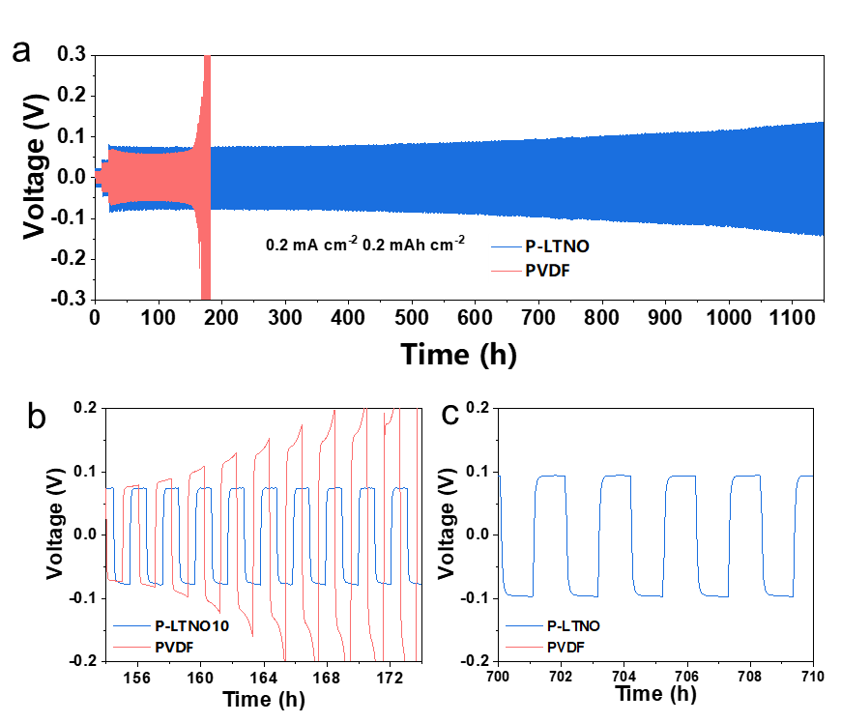
Figure S6 Galvanostatic cycling curves of the symmetrical Li/Li cell with PVDF and P-LTNO electrolyte at 0.2 mA cm⁻², 0.2 mA h cm⁻²

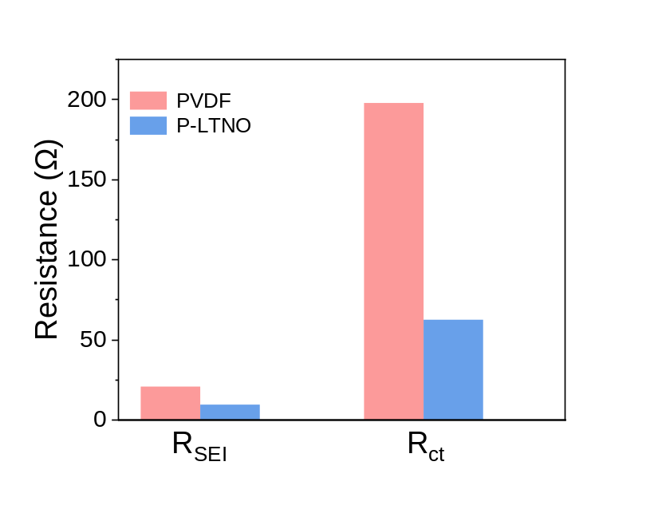
Figure S7 Fitting R_{SEI}/R_{ct} resistance values of the symmetric Li/Li cell cells with PVDF and P-LTNO electrolyte
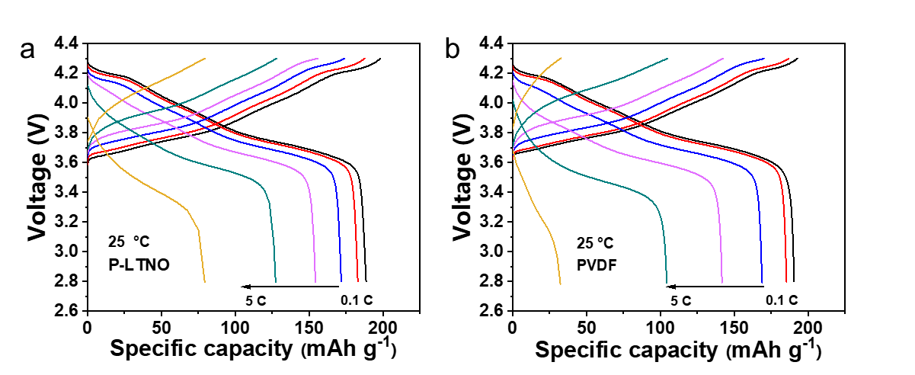
Figure S8 Charge/discharge curves at different rates of a) NCM811/P-LTNO/Li and b) NCM811/PVDF/Li cell.

Figure S9 Long-term cycling performance of NCM811/Li cells at 0.5 C with P-LTNO and PVDF electrolyte

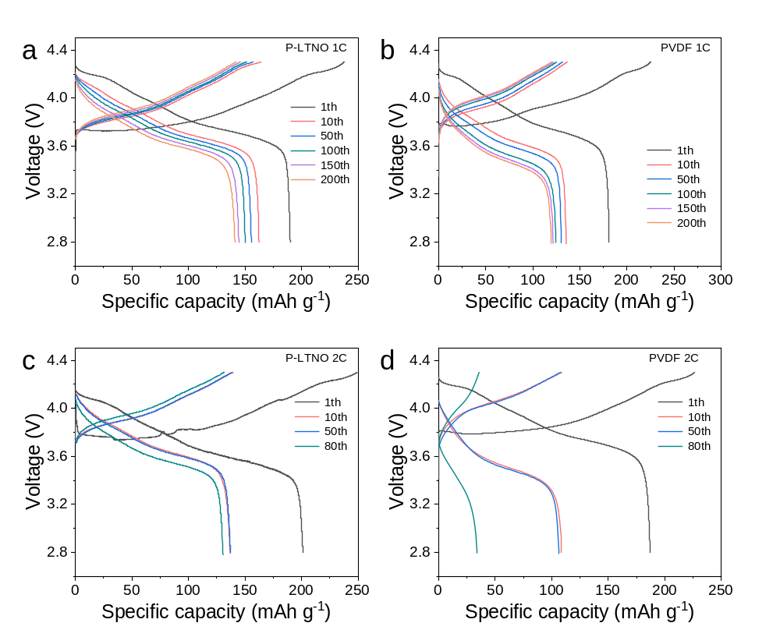
Figure S10 Charge/discharge curves at different rates of a) NCM811/P-LTNO/Li and b) NCM811/PVDF/Li cell at 1C; Charge/discharge curves at different rates of c) NCM811/P-LTNO/Li and d) NCM811/PVDF/Li cell at 2C

Table S1 Comparation of the Li transference number.
Composite solid electrolyte | Li transference number | Reference
PVDF/ CuPcLi | 0.43 | Adv. Energy Mater. 2023, 13, 2204425
PVDF/LATP | 0.58 | Angew. Chem. Int. Ed. 2021, 60, 24668^{[2]}
PVDF/Si₃N₄ | 0.53 | Energy Storage Mater. 2022, 53, 305
PVDF/zeolite | 0.47 | Angew. Chem. Int. Ed. 2024, 63, e202401428
PVDF/ g-C₃N₄ | 0.49 | Nano Energy 2022, 100, 107470^{[5]}
PVDF/B₂O₃ | 0.57 | Adv. Funct. Mater. 2023, 2307677
PVDF/SiO₂ | 0.59 | ACS Appl. Mater. Interfaces 2023, 15, 17978
PVDF/NaNbO₃ | 0.49 | Adv. Mater. 2024, 36, 2311195
PVDF/BTO-LLTO | 0.57 | Nat. Nanotechnol. 2023, 18, 602-610
PVDF/LiTaO₃ | 0.45 | Energy Mater. Devices, 2023, 1, 9370004
PVDF/LTNO | 0.61 | This work

Table S2 Comparation of the dielectric constant.
Composite solid electrolyte | ε_{r} | Reference
PVDF/BTO | 46 at 10 Hz | Energy Environ. Sci., 2024, 17, 3797–3806
P(VDF–TrFE–CTFE) | 44 at 10 Hz | Energy Environ. Sci., 2021, 14, 6021–6029
PVDF/Si₃N₄ | 16.2 at 10⁶ Hz | Energy Storage Mater. 2022, 53, 305
PVDF/MoSe₂ | 21.7 at 10 Hz | Nat. Commun. 2023, 14, 6296
PVDF/ PbZr_{x}Ti_{1–x}O₃ | 15 at 10 Hz | ACS Nano 2023, 17, 14, 14114–14122
PVDF/NaNbO₃ | 20.4 at 20 Hz | Adv. Mater. 2024, 36, 2311195
PVDF/BTO-LLTO | 24 at 10 Hz | Nat. Nanotechnol. 2023, 18, 602-610
PVDF/LTNO | 50 at 10 Hz | This work

