SUPPLEMENTARY MATERIALS

Table S1 Sources, Emission and Capture Cost
Source Notation | Industry Type | CO₂ Rate (MTPA)  (m_{s,t}) | $C_{s}^{capture}$  ($ per ton)
s1 | Coal Fired Power Plant | 0.554 | 82.20
s2 | Coal Fired Power Plant | 0.415 | 93.02
s3 | Gas Fired Power Plant | 0.324 | 107.25
s4 | Gas Fired Power Plant | 0.299 | 78.59
s5 | Gas Fired Power Plant | 0.238 | 110.21
s6 | Gas Fired Power Plant | 0.155 | 91.06
s7 | Combined Cycle Power Plant | 0.475 | 112.46
s8 | Combined Cycle Power Plant | 0.393 | 106.92
s9 | Combined Cycle Power Plant | 0.254 | 108.8
s10 | Combined Cycle Power Plant | 0.063 | 139.76
s11 | Oil Refinery | 0.698 | 122.95
s12 | Cement Plant | 1.054 | 89.68
s13 | Natural Gas Processing | 0.327 | 15.22
s14 | Ammonia Plant | 0.078 | 40.60

Table S2 Reservoir Capacity, Availability, and Storage Cost
Reservoir Sink | Type | CO₂ Storage Capacity (MT)  (Zhang & Lau, 2022) | Estimation of Injection Start Time | $C_{r}^{storage}$ ($ per ton)
r1 | Gas reservoir | 68 | 2039 | 1.84 to 3.47
r2 | Oil Reservoir | 6.8 | 2033 | 7.09
r3 | Oil Reservoir | 4.3 | 2035 | 11.15
r4 | Oil Reservoir | 23.3 | 2035 | 5.81 to 6.02
r5 | Gas reservoir | 234 | 2037 | 2.00
r6 | Gas reservoir | 85 | 2029 | 1.53
r7 | Gas reservoir | 102 | 2027 | 3.40 to 4.47
r8 | Oil Reservoir | 14 | 2027 | 4.04 to 5.40

Table S3 Distance to Hub
Distance to Hub (km)
 |  | h1 | h2
Sink | r1 | 124 | 205
Sink | r2 | 126 | 159
Sink | r3 | 114 | 166
Sink | r4 | 56 | 100
Sink | r5 | 204 | 158
Sink | r6 | 179 | 134
Sink | r7 | 165 | 120
Sink | r8 | 83 | 36
Source | s1 | 187 | 116
Source | s2 | 103 | 203
Source | s3 | 107 | 60
Source | s4 | 86 | 88
Source | s5 | 85 | 82
Source | s6 | 110 | 62
Source | s7 | 108 | 61
Source | s8 | 59 | 106
Source | s9 | 87 | 89
Source | s10 | 81 | 91
Source | s11 | 90 | 80
Source | s12 | 106 | 211
Source | s13 | 90 | 190
Source | s14 | 107 | 62
Junction Nodes | g1 | 98 | -
Junction Nodes | g2 | - | 88

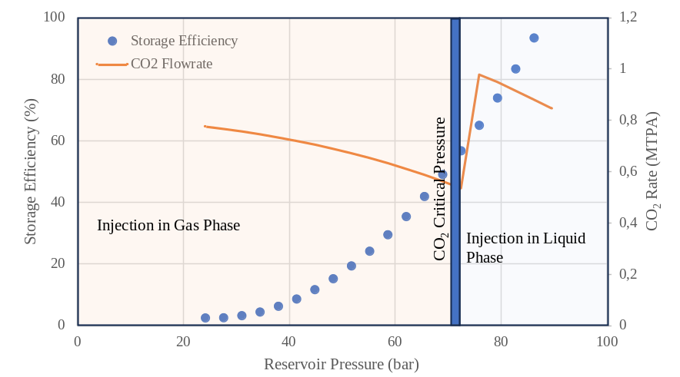
Fig. S1 Storage Efficiency vs Pressure Reservoir – r1
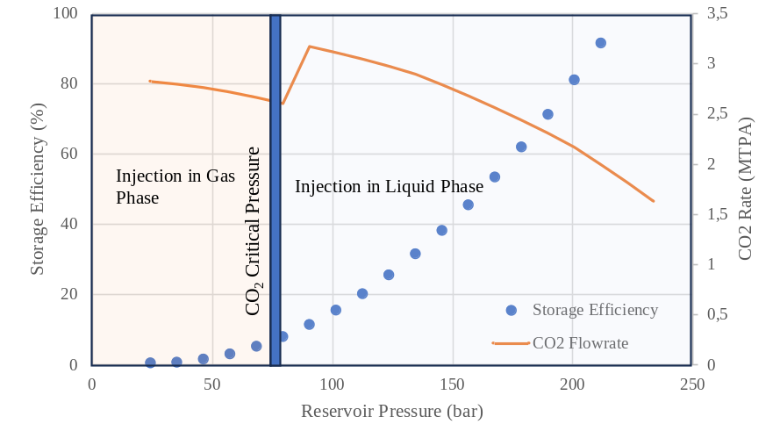
Fig. S2 Storage Efficiency vs Pressure Reservoir – r2
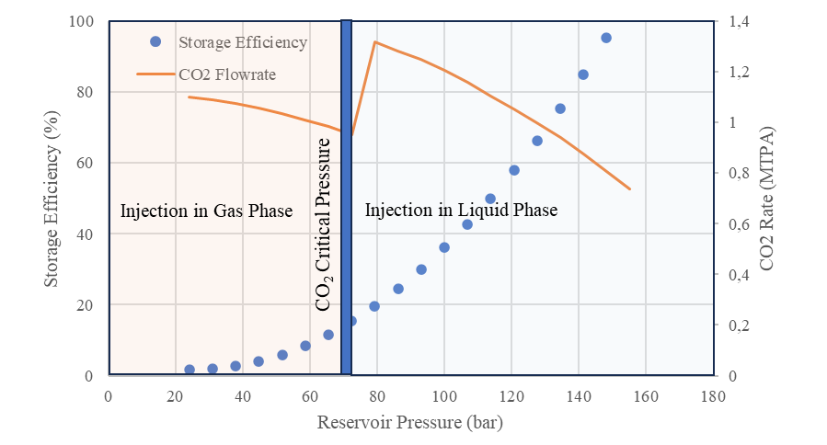
Fig. S3 Storage Efficiency vs Pressure Reservoir – r4

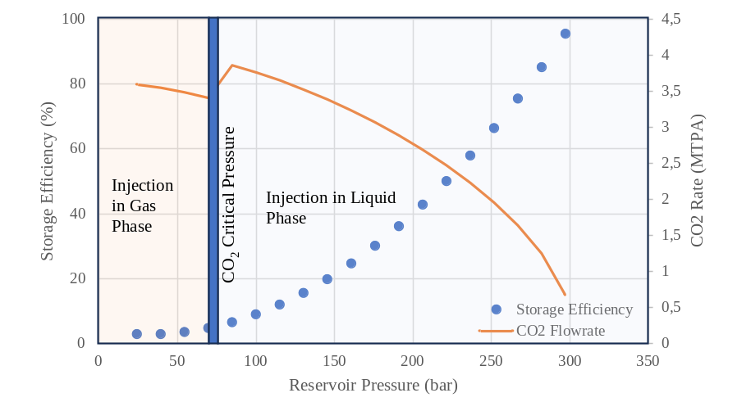
Fig. S4 Storage Efficiency vs Pressure Reservoir – r5

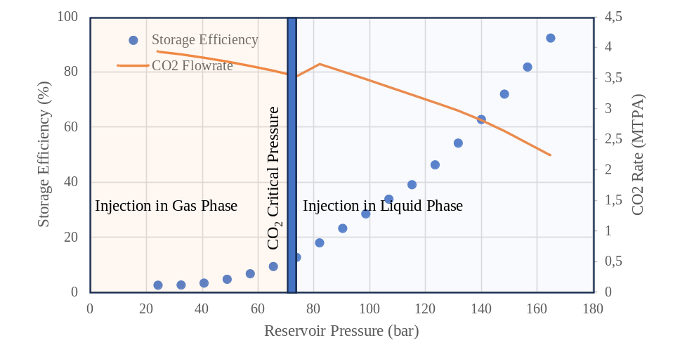
Fig. S5 Storage Efficiency vs Pressure Reservoir – r6

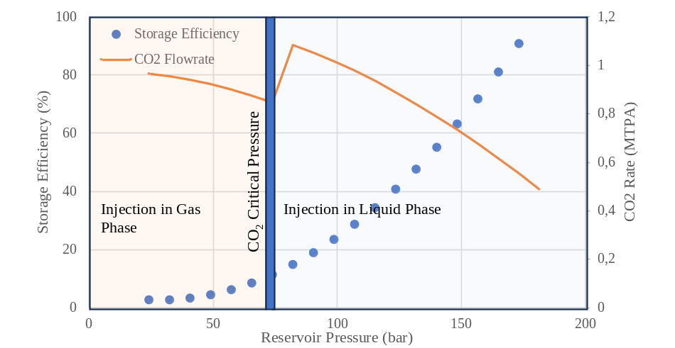
Fig. S6 Storage Efficiency vs Pressure Reservoir – r7
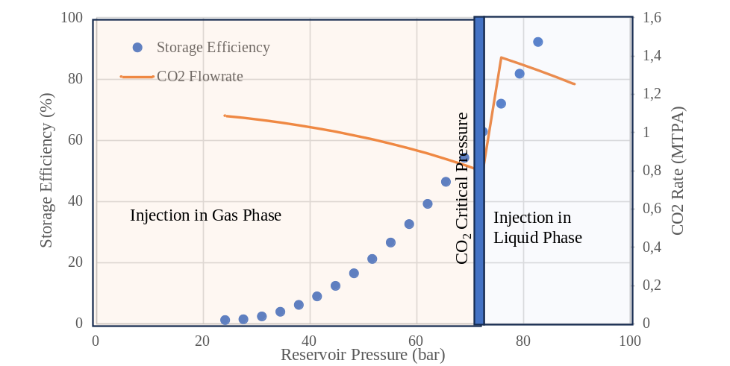
Fig. S7 Storage Efficiency vs Pressure Reservoir – r8

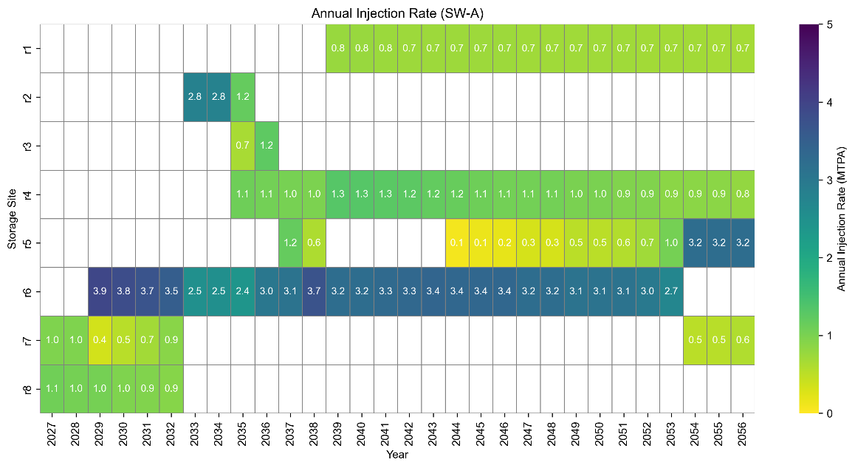
Fig. S8 Annual CO₂ Injection Volume in the SW-A Scenario (MILP result)
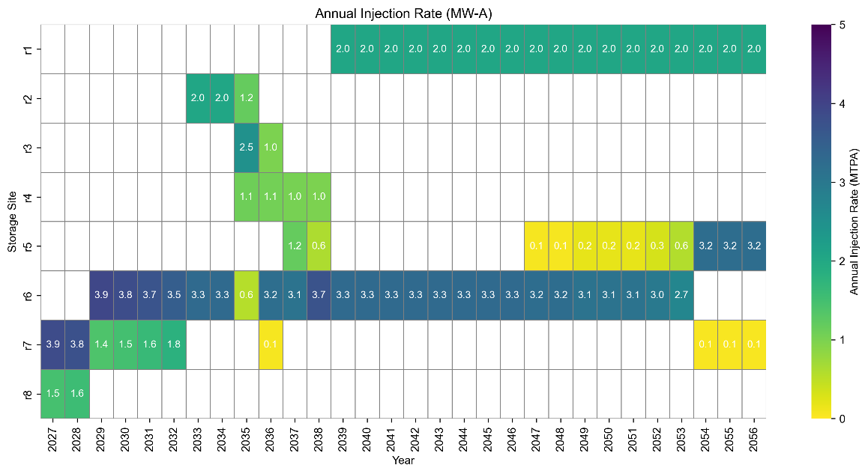
Fig. S9 Annual CO₂ Injection Volume in the MW-A Scenario (MILP result)
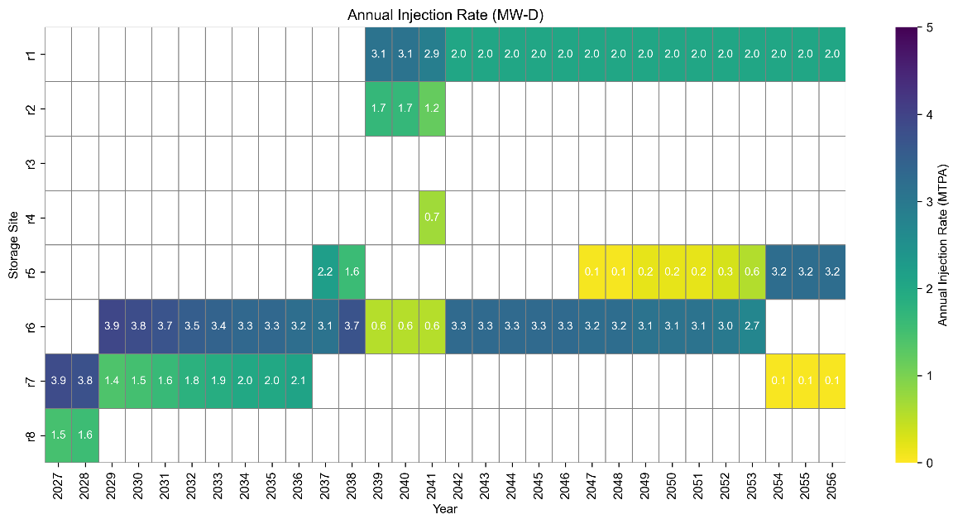
Fig. S10 Annual CO₂ Injection Volume in the MW-D Scenario (MILP result)

