Supplementary Information for
Quantifying Atmospheric Carbon Removal at Pulp and Paper Mills: A Life Cycle Assessment Across System Boundaries

Edgar Carrejo ª, Rhonald Ortega ª, Kai Lan ª, Daniel L. Sanchez ^{c}, Sunkyu Park ^{a,*}, William J. Sagues ^{b,*}

ª Department of Forest Biomaterials, North Carolina State University, 2820 Faucette Dr., Raleigh, NC 27695, USA
^{b} Department of Biological & Agricultural Engineering, North Carolina State University, 3110 Faucette Dr., Raleigh, NC 27695, USA
^{c} Department of Environmental Science, Policy, and Management, University of California-Berkeley, 130 Mulford Hall #3114, Berkeley, CA 94720, USA

*Corresponding authors: sunkyu_park@ncsu.edu (Sunkyu Park), wjsagues@ncsu.edu (William Joe Sagues).

This file includes:
Tables S1 – S13.
Figures S1 – S8.

Table S1. Parameters used in the WinGEMS Model.
 | WinGEMS model parameters |  | Softwood
 | Wood chips to the digester | od mt/day | 2,384
Composition Before Pulping | Carbon | % | 51.6
Composition Before Pulping | Hydrogen | % | 6.4
Composition Before Pulping | Oxygen | % | 41
 | Debarking yield | % | 90
 | Chipping yield | % | 95
 | Kappa Number |  | 100
 | Pulp yield | % | 56
 | Effective Alkali on Wood (%as NaOH) | % | 12.75
 | Effective Alkali concentration (g/L as NaOH) | g/L | 120
 | Sulfidity | % | 30
 | Causticizing Efficiency | % | 85
Composition Dissolved Solids | Carbon | % | 53
Composition Dissolved Solids | Hydrogen | % | 6.5
Composition Dissolved Solids | Oxygen | % | 40.5
 | Weak black liquor solids | % | 16
 | Solids after evaporator 1 | % | 30
 | Solids after evaporator 2 | % | 55
 | Solids after concentrator | % | 72
 | Recovery Boiler Reduction | % | 95
 | Na₂SO₄ make-up | mt/h | 0.5
 | NaOH make-up | mt/h | 0.51
 | CaO make-up | mt/h | 0.55
 | Dregs | od mt/h | 0.22
 | Grits | od mt/h | 0.08
 | Mud loss | od mt/h | 0.81
 | Paper product | od mt/day | 1,242
wood moisture: 50%; paper moisture: 6%; od mt: oven-dry metric ton; g/L: grams per liter

Table S2. Input pulp and paper mill materials normalized to 1 ad mt lineboard production and factor emissions utilized in the LCA.
Stage | Description | Flowrate (mt/ad mt) | Emission Factor (GWP100) (kg CO_{2e}/kg) | Process description - Ecoinvent Cutoff 3.10 database | Reference
Woodyard | Roundwood logs | 1.6488* | 4.10e-2 |  | [1]
Woodyard | Purchased wood chips | 0.4161* | 3.38e-2 | wood chips, wet, measured as dry mass - Softwood forestry, pine, sustainable forest management - Rest-of-World | [2]
Brownstock Washing | Wash Water | 9.1319 | 4.33e-4 | tap water production, conventional treatment - Rest-of-World - tap water | [3]
Condenser | Water | 4.0845 | 4.88e-4 | water production, deionised - Rest-of-World - water, deionised | [4]
Recovery Boiler | Sodium sulfate make-up | 0.0091 | 0.60 | market for sodium sulfate, anhydrite - Rest-of-World - sodium sulfate, anhydrite | [5]
Slaking/Causticizing | Lime make-up | 0.0100 | 1.18 | quicklime production, in pieces, loose - Rest-of-World - quicklime, in pieces, loose | [6]
Slaking/Causticizing | Sodium hydroxide make-up | 0.0093 | 1.47 | market for sodium hydroxide, without water, in 50% solution state - Rest-of-World - sodium hydroxide, without water, in 50% solution state | [7]
Slaking/Causticizing | Lime Filter Wash Water | 1.7786 | 4.33e-4 | tap water production, conventional treatment - Rest-of-World - tap water | [3]
Lime Kiln | Natural Gas Usage | 0.0011 | 65.98** |  | [8]
Lime Kiln | Scrubber water | 0.5236 | 4.33e-4 | tap water production, conventional treatment - Rest-of-World - tap water | [3]
Paper Machine | Stock preparation water | 7.4170 | 4.33e-4 | tap water production, conventional treatment - Rest-of-World - tap water | [3]
Paper Machine | Talc | 0.0063 | 0.01 |  | [9]
Paper Machine | Alum | 0.0076 | 0.69 |  | [9]
Paper Machine | Retention Aid | 0.0001 | 4.35 | retention aid production, for paper production - Rest-of-World - retention aid, for paper production | [10]
Natural Gas Boiler | Natural Gas Usage | 0.0049 | 65.98** |  | [8]
Combined Heat Power | Condensate make-up | 4.3894 | 4.88e-4 | water production, deionised - Rest-of-World - water, deionised | [4]
ad mt: air dry metric ton paper; od mt: oven-dry metric ton
*od mt/ad mt; **kg CO_{2e}/MMBtu
Table S3. Pulp and paper mill output normalized to 1 ad mt lineboard production and factor emissions utilized in the LCA.
Stage | Description | Flowrate (mt/ad mt) | Emission Factor (GWP100) (kg CO_{2e}/kg) | Process description - Ecoinvent Cutoff 3.10 database | Reference
Brownstock Washing | Screen rejects | 0.0193* | 0.478* | treatment of wastewater, average, wastewater treatment - Rest-of-World - wastewater, average | [11]
Evaporators | Condensate | 0.3365 | 0.934 | treatment of sludge from pulp and paper production, sanitary landfill - Rest-of-World - sludge from pulp and paper production | [12]
Recovery Boiler | CO₂ in Flue gas | 1.5308 | 1
Slaking/Causticizing | Dregs | 0.0081 | 0.358 | treatment of green liquor dregs, residual material landfill - Rest-of-World - green liquor dregs | [13]
Lime Kiln | CO₂ in Flue gas | 0.2035 | 1
Paper Machine | Primary screen | 0.0022 | 0.934 | treatment of sludge from pulp and paper production, sanitary landfill - Rest-of-World - sludge from pulp and paper production | [12]
Paper Machine | Secondary screen | 0.0018 | 0.934 | treatment of sludge from pulp and paper production, sanitary landfill - Rest-of-World - sludge from pulp and paper production | [12]
Paper Machine | Excess water to sewer | 12.3651* | 0.478* | treatment of wastewater, average, wastewater treatment - Rest-of-World - wastewater, average | [11]
Biomass Boiler | CO₂ in Flue gas | 0.4918 | 1
Natural Gas Boiler | CO₂ in Flue gas | 0.2767 | 1
*Amount referred in cubic meters

Table S4. Life cycle inventory of the cultivation, harvesting, and handling of southern softwood chips.[1]
Parameter | Unit | Mean
Cultivation, per hectare per year
Inputs
Stand rotation | years | 21
Nitrogen | kg | 9.6
P₂O₅ | kg | 6.1
Glyphosate | kg | 0.1
Diesel for soil preparation | L | 5.6
Diesel for thinning and harvesting | L | 52.7
Outputs
Total Production | m³ | 450.6
Methane | g | 1.6
Carbon dioxide | kg | 156.6
Nitrous Oxide | kg | 0.1
Ammonia | kg | 0.7
Particulate matter | kg | 0.1
Sawmill, per m³ of green lumber
Inputs
Roundwood | m³ | 2.1
Diesel | L | 0.5
Gasoline | L | 0.1
Electricity | kWh | 34.8
Water | L | 80
Outputs
SS chips* | kg, dry basis | 311.2
Bark, hog fuel, sawdust | kg, dry basis | 182.8
Green Lumber | m³ | 1
Wood dust | g | 5.7
Particulate matter | g | 29
Chipping of pulpwood, per m³ of wood chips
Inputs
Pulpwood |  | 1.2
Diesel for debarking | L | 0.7
Diesel for chipping | L | 1.0
Outputs
Bark | m³ | 0.2
Chips* | m³ | 1.0
Carbon monoxide | g | 3.0
* Bulk density: 470 kg/m³

Table S5. Carbon Capture and Storage Plant Input Parameters when recovery boiler flue gas is fed into the CCS plant (Reference).
Parameter | Units | Value | Reference
CCS facility design capacity | mt CO₂/year | 707,748 | UBSK WinGEMS Model
CCS Capture rate | % | 90 | [14]
Run time | hr/day | 24 | [15]
Run time | days/year | 350 | [15]
Plant lifetime | years | 30 | [15]
CC Plant cost | $MM | 152 | [16]
CC Supporting System & Infrastructure Cost | $MM | 76 | [16]
Byproducts disposal | mt/year | 134 | [17]
Truck distance disposal | miles | 50 | Assumption
NaOH for water treatment | mt/year | 37 | [17]
Power usage in RB Electrostatic precipitator | kWh/hr | 349 | Internal vendor quote
CC Plant Grid Subregion | - | SERC South | [18]
CCS Steam Source
Natural Gas Use in Biomass Boiler | % | 2 | Assumption
Bark Use in Biomass Boiler | % | 98 | Assumption
Bark calorific value @50% moisture | BTU/lb | 4500 | [19]
Biomass Boiler efficiency | % | 75 | UBSK WinGEMS Model
Truck distance transportation | miles | 50 | Assumption
Steam ratio | mt steam/mt CO_{2captured} | 1.2 | Own Simulation
Steam required | lb/hr | 223,000
CO₂ Compression, Transport & Storage
Capture System power consumption | MWe | 5.39 | [16]
CO₂ compression/conditioning power consumption | MWe | 6.15 | [16]
Power consumption ratio | kWh/mt CO₂ | 137 | [20]
Equipment costs | $MM | 76.1 | [16]
CO₂ losses during transport and injection | % | 0.01 | [21]
Injection power consumption | kWh/mt CO₂ | 2.77 | [22]

Table S6. Emission Factors used to account for the GWP of CCS plant operation.
Description | Units | Emission Factor (GWP100) | Reference
Emissions factor electricity at capture plant | kgCO_{2e}/MWh | 407.175 | [18]
Emissions factor electricity at injection | kgCO_{2e}/MWh | 407.175 | [18]
Emission factor natural gas (excl. leakage) | kgCO_{2e}/MMBTU | 53.16 | [23]
Natural gas leakage | kgCO_{2e}/MMBTU | 12.82 | [8]
Emission factor natural gas (incl. leakage) | kgCO_{2e}/MMBTU | 65.98 | [8,23]
Emissions factor harvest, collection & processing bark | kgCO_{2e}/MMBTU | 0.33 | [24]
Emissions factor railroad crossties | kgCO_{2e}/MMBTU | 12.64 | [25]
Emissions factor Capture Equipment | kgCO_{2e}/$ | 0.19 | [26]
Emissions Factor Balance of Plant | kgCO_{2e}/$ | 0.21 | [26]
Emissions factor embodied T&S | kgCO_{2e}/$ | 0.36 | [26]
Emissions factor rail transport | kgCO₂/ton-mile | 0.0231 | [27]
Emissions factor truck transport | kgCO₂/ton-mile | 0.23 | [27]
Emissions factor solvent | kgCO₂/ton | 3,926 | [28]
Emissions factor NaOH | kgCO₂/ton | 1,467 | [29]
Bark Emission Factor | kg CO_{2e}/MMBtu | 97.98 | [30]

Table S7. Annual CO_{2e} emissions baseline from an integrated Unbleached Softwood Kraft Mill process (System 1).
UBSK Paper Mill | CO_{2e} Emissions (mt *10³/year)
Biogenic CO₂ captured by wood | (1806.2)
Emissions from RB | 707.7
Emissions from BB | 227.4
Emissions from LK (biogenic) | 57.8
Biogenic CO₂ in Product | 782.0
Biogenic CO₂ in Grits | 0.2
CO₂ in Lime Mud Losses | 2.4
CO₂ losses | 28.6
Emissions from NGB | 127.9
Emissions from LK (anthropogenic) | 36.3
Landfill Emissions | 14.2
Wood Procurement | 39.5
Wood Transportation | 10.6
Make-up Chemicals | 17.1
Water Usage | 5.7
Power Generation Credits | (17.7)
Net CO₂ Emissions | 233.8

Table S8. Annual CO_{2e} emissions and net carbon removal under a CDR perspective of a CCS project fed by paper mill CO₂ point sources (System 2).
CCS Facility | CO_{2e} Emissions (mt *10³/year)
CO₂ Point Source | RB | RB + CCS BB
Biogenic CO₂ gross captured | (636.97) | (868.3)
CO₂ losses | 0.064 | 0.087
Emissions from NG use in CCS BB | 3.67 | 4.995
Emissions from power usage | 41.39 | 55.012
Make-up chemicals | 0.584 | 0.604
Bark transportation | 4.03 | 5.494
CCS Embodied emissions | 1.451 | 1.754
Net CO₂ removal | (585.79) | (799.4)
Net carbon removal efficiency | 91.97% | 92.06%

Table S9. Carbon capture and storage Plant input parameters when several flue gases are targeted to be captured in the CCS plant.
Scenario |  | 1 | 2 | 3 | 4 | 5
Parameter | Units/Sources | RB | RB + CCS BB | RB + CCS BB + BB | RB + CCS BB + BB + LK | RB + CCS BB + BB + LK + NGB
CCS facility design capacity | mt CO₂/year | 707,748 | 964,784 | 1,274,589 | 1,402,856 | 1,577,220
CC Plant cost | $MM | 152 | 184 | 218 | 231 | 248
CC Supporting System & Infrastructure Cost | $MM | 76 | 92 | 109 | 116 | 124
Byproducts disposal | mt/year | 134 | 149 | 171 | 181 | 194
NaOH for water treatment | mt/year | 37 | 51 | 67 | 74 | 83
Steam required | lb/hr | 223,000 | 303,854 | 401,426 | 441,824 | 496,739
CO₂ Compression, Transport & Storage
Capture System power consumption | MWe | 5.39 | 7.35 | 9.71 | 10.69 | 12.02
CO₂ compression/conditioning power consumption | MWe | 6.15 | 8.38 | 11.08 | 12.19 | 13.71
Equipment costs | $MM | 76.1 | 80.32 | 85.02 | 86.89 | 89.36

Table S10. Annual CO_{2e} emissions and net carbon removal under a CDR perspective of a CCS integrated into the UBSK mill (System 3).
P&P Mill + CCS Facility | CO_{2e} Emissions (mt *10³/year)
CO₂ Point Source | RB | RB + CCS BB | RB + CCS BB + BB
Biogenic CO₂ gross captured | (636.97) | (868.3) | (1,147.1)
CO₂ losses | 0.064 | 0.087 | 0.115
Emissions from NG use in CCS BB | 3.67 | 4.995 | 6.599
Emissions from power usage | 22.49 | 37.085 | 54.681
Make-up chemicals | 0.584 | 0.604 | 0.627
Bark transportation | 4.03 | 5.494 | 7.258
CCS Embodied emissions | 1.451 | 1.754 | 2.078
P&P Direct Fossil Emissions | 164.42 | 164.42 | 164.42
P&P Indirect Fossil Emissions | 87.09 | 87.09 | 87.09
Net CO₂ removal | (353.18) | (566.77) | (824.26)
Net carbon removal efficiency | 55.44% | 65.27% | 71.86%

Table S11. Annual CO_{2e} emissions and net carbon removal under a complete static LCA perspective of a CCS integrated into the UBSK mill (System 4).
P&P Mill + CCS Facility | CO_{2e} Emissions (mt *10³/year)
CO₂ Point Source | RB | RB + CCS BB | RB + CCS BB + BB | RB + CCS BB + BB + LK | RB + CCS BB + BB + LK + NGB
CO₂ originating from biomass | (2063.2) | (2156.4) | (2268.9) | (2315.5) | (2378.8)
Biogenic CO₂ emissions | 613.04 | 474.9 | 308.48 | 239.60 | 145.97
Biogenic CO₂ in Pulp | 784.67 | 784.67 | 784.67 | 784.67 | 784.67
Other Biogenic CO₂ losses | 28.63 | 28.63 | 28.63 | 28.63 | 28.63
Direct Fossil Emissions | 168.09 | 169.42 | 171.02 | 171.68 | 172.59
Indirect Fossil Emissions | 115.64 | 132.09 | 151.74 | 159.89 | 171.20
Net CO₂ removal | (353.18) | (566.71) | (824.37) | (931.0) | (1075.72)
Net carbon removal efficiency | 17.12% | 26.28% | 36.33% | 40.21% | 45.22%

Paper Product End-of-Life: Implications for Carbon Capture and Sequestration
Understanding the end-of-life (EoL) context for paper and cardboard products in the United States is crucial when accounting for biogenic CO₂ derived from the carbon content in the paper product from pulp and paper (P&P) operations that integrate carbon capture and storage (CCS). Our primary manuscript comprehensively analyzes the complete conversion of paper's carbon content to CO₂, such as during incineration. Here, we detail the different EoL pathways for the paper product, incorporating recent U.S. data: 60% is recycled, 36% is landfilled, and 4% incinerated [31].
Of the landfilled paper, 32.44% is biodegraded to CO₂ and CH₄ [32]. While landfill gas is flared (without energy recovery), a residual CH₄ emission of 0.054 kg CH₄ per kg paper waste remains [32]. Table S12 summarizes the CO_{2e} emissions associated with the end-of-life of the paper product of our reference paper mill. The carbon content (46.13%) in the paper product degraded in the landfill is entirely transformed to CO₂ after gas is flared. The residual methane from the total landfilled paper is converted to CO_{2e} after multiplying by the CH₄ to CO₂ GWP₁₀₀ factor of 28. For recycled paper, only transportation emissions (within a 50-mile radius to the recycling mill gate) are considered using a cutoff method, as the energy for fiber disintegration and reprocessing is not included here [33]. Previous studies suggest that the global impact of paper recycling on CO₂ emissions is minor if technology remains constant [34].
Overall, the estimated EoL emissions represent 48.3% of the emissions calculated under the hypothetical scenario where all the carbon in the paper product degrades to CO_{2.} Under this scenario, some carbon is kept out of the atmosphere due to the recycling of the fibers and the amount of landfilled paper that does not degrade, which explains the lower emissions obtained.

Table S12. Estimated emissions from the end of life of the paper product.
End of Life (%) | Amount of paper (mt/y) | CO_{2e} emissions (mt/y)
Landfill (36%) | 166,442 | 251,661 | from residual CH₄
Landfill (36%) | 166,442 | 91,327 | from flared CH₄
Incineration (4%) | 18,494 | 31,281 | from combustion
Recycling (60%) | 277,404 | 3,085 | from transportation
Total (100%) | 462,339 | 377,354 | -
To evaluate the impact of fully integrating CCS across multiple point sources within pulp and paper (P&P) operations, we assessed net carbon removal across five sequential capture scenarios. These scenarios are normalized to the total biogenic CO₂ fixed by biomass, representing the theoretical carbon removal potential, with emissions disaggregated using a comprehensive cradle-to-grave system boundary (Fig. S2).
The initial scenario (Fig. S2a), targeting only the recovery boiler flue gas, yields the lowest net carbon removal efficiency at 36%. This modest efficiency is due to upstream and operational emissions from both the P&P and CCS facilities. Nevertheless, this system still achieves net-negative emissions, demonstrating that even partial CCS integration can transform a kraft mill into a carbon sink while continuing to produce economically and socially valuable materials.
Including flue gas from additional point sources significantly increases net carbon removal efficiency:
- Capturing emissions from the CCS biomass boiler increases efficiency to 45% (Fig. S2b).
- Further inclusion of the P&P biomass boiler raises this to 54% (Fig. S2c).
- The most comprehensive scenario, expanding to include the lime kiln and natural gas boiler, elevates net carbon removal efficiency to 62% (Fig. S2e).
This demonstrates that when all primary CO₂ point sources are captured, more than half of the potential carbon drawdown from biomass is durably sequestered by the CCS operation. This also highlights the crucial role of stable carbon within recycled paper and the portion of landfilled paper that does not degrade. By capturing emissions from all primary CO₂ point sources, we can durably sequester over half of the potential carbon drawdown from biomass. Furthermore, the carbon stability inherent in recycled paper and the resistance to degradation of some landfilled paper underscore the importance of robust recycling infrastructure alongside the implementation of CCS technologies in P&P operations. These combined strategies are vital for minimizing the industry's carbon footprint and enhancing its role in carbon sequestration.
Paper Product End-of-Life Sensitivity Analysis: Methane Emissions Impact
Given the significantly higher global warming potential of methane compared to carbon dioxide, we conducted a sensitivity analysis on the net carbon removal efficiency of integrated virgin mills with CCS, focusing on the biogenic carbon degraded to CO₂ and CH₄ in landfilled paper, and residual CH₄ emissions. In the reference case (Fig. S1), 32.44% of landfilled paper biodegrades to CO₂ and CH₄, with landfill gas flared (without energy recovery), resulting in 0.054 kg CH₄ per kg of paper waste [32].
We estimated the effect on net carbon removal efficiency for a range of 30% to 70% landfilled paper degradation and 0 to 0.2 kg of residual CH₄ emission per kg of paper waste (Fig. S3). For System 4, in the CO₂ capture case where only recovery boiler flue gas is targeted and all direct/indirect emissions are accounted for, the sensitivity analysis reveals that if 70% of the biogenic carbon in landfilled paper degrades and 0.194 kg of CH₄ per kg of landfilled paper is emitted, the net carbon removal efficiency becomes zero. Higher values for these combined parameters would negate the carbon removal benefit of CCS integration in P&P operations, assuming all other reference mill and CCS facility parameters remain constant. Below this threshold, carbon removal benefits are still achieved under System 4 assumptions.
When all point sources from the P&P mill are targeted for capture in the CCS facility, the adverse effects of methane generation from landfilled paper are significantly mitigated. Even under the conditions that offset net carbon removal when only the recovery boiler flue gas is captured (70% and 0.2 kg CH₄/kg paper), capturing more CO₂ from other point sources results in a net carbon removal of 29.2%. This demonstrates that extensive CCS integration still converts the P&P mill into a carbon sink.

Table S13. Annual CO_{2e} emissions and net carbon removal under a complete dynamic LCA perspective of a CCS integrated into the UBSK mill (System 5).
P&P Mill + CCS Facility | CO_{2e} Emissions (mt *10³/year)
CO₂ Point Source | RB | RB + CCS BB | RB + CCS BB + BB | RB + CCS BB + BB + LK | RB + CCS BB + BB + LK + NGB
CO₂ originating from biomass | (2063.2) | (2156.4) | (2268.9) | (2315.5) | (2378.8)
Biogenic CO₂ emissions | 613.04 | 474.9 | 308.48 | 239.60 | 145.97
Biogenic CO₂ in Pulp | 784.67 | 784.67 | 784.67 | 784.67 | 784.67
Dynamic biogenic carbon flux | 103.87 | 92.05 | 77.80 | 71.91 | 66.34
Other Biogenic CO₂ losses | 28.63 | 28.63 | 28.63 | 28.63 | 28.63
Direct Fossil Emissions | 168.09 | 169.42 | 171.02 | 171.68 | 172.59
Indirect Fossil Emissions | 115.64 | 132.09 | 151.74 | 159.89 | 171.20
Net CO₂ removal | (249.26) | (474.66) | (746.57) | (859.12) | (1009.37)
Net carbon removal efficiency | 12.08% | 22.01% | 32.90% | 37.10% | 42.43%

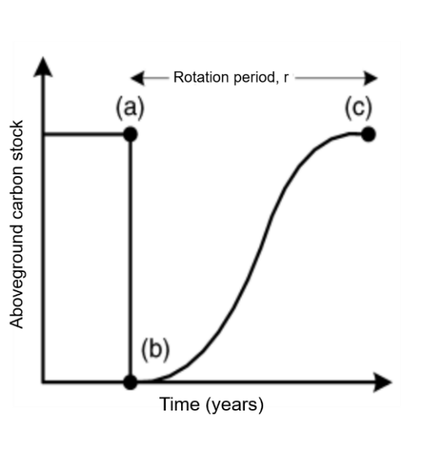
Fig. S1. Dynamics of forest growth: (a) the biomass stand begins in equilibrium; (b) all above-ground carbon is felled and immediately oxidized to CO₂, while the site is replanted so new growth begins absorbing that CO₂; (c) by the rotation's ends the regenerating vegetation has sequestered the same amount of carbon that was released [35].

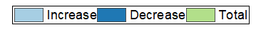
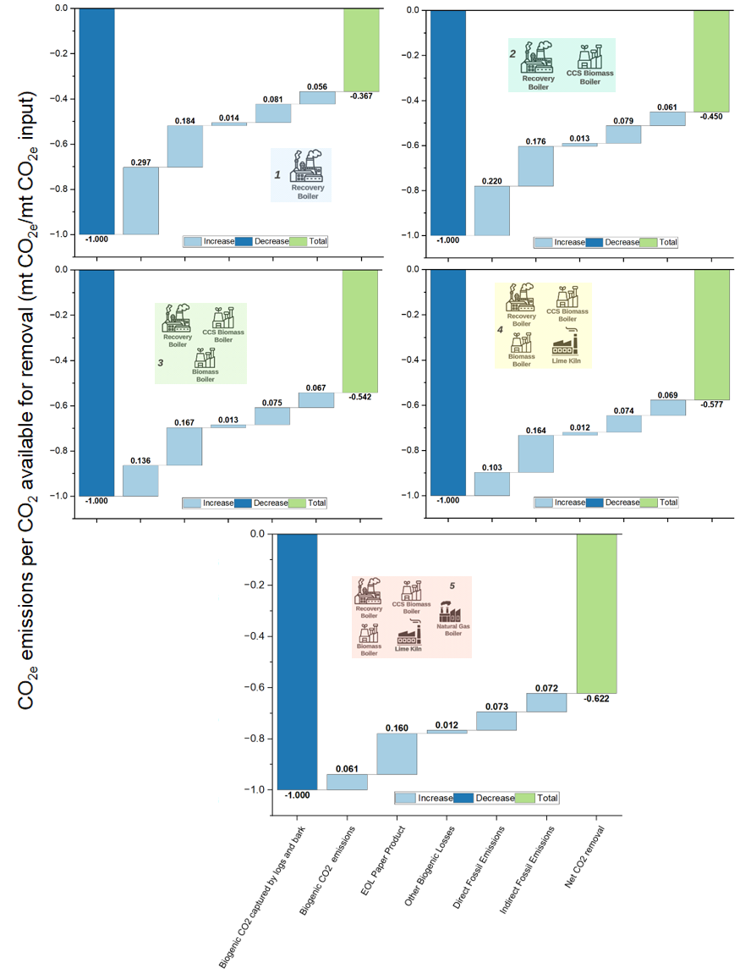
b.
e.
d.
c.
a.
Fig. S2. Life cycle greenhouse gas emissions associated with the integration of a CCS facility into a UBSK pulp and paper mill (System 4), normalized by the total biogenic CO₂ fixed by the biomass—representing the theoretical maximum carbon removal under each scenario. Include the actual end of life of the paper product. Results are shown for five capture configurations: a. recovery boiler only, b. recovery boiler and CCS biomass boiler, c. recovery boiler, CCS biomass boiler, and P&P biomass boiler, d. same as (c) plus lime kiln, and e. same as (d) plus natural gas boiler.

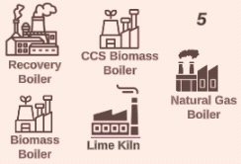
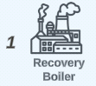
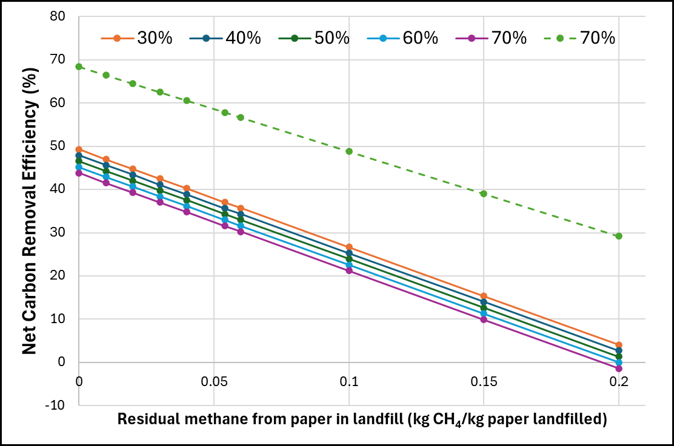
Fig. S3. Impact of residual (leaked) methane from landfills on net carbon removal efficiency for different extents of paper decomposition in System 4.

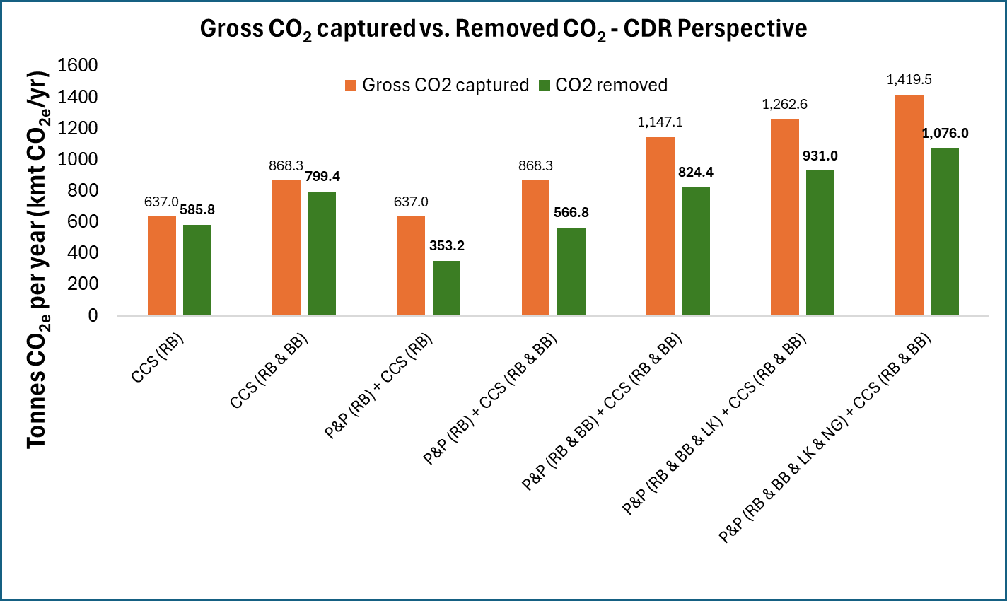
Fig. S4. Gross CO₂ captured versus net CO₂ removed for every analyzed scenario when a CCS is integrated into a pulp and paper mill under a CDR perspective (System 3).

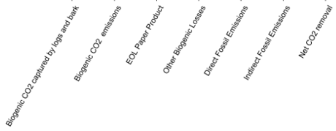
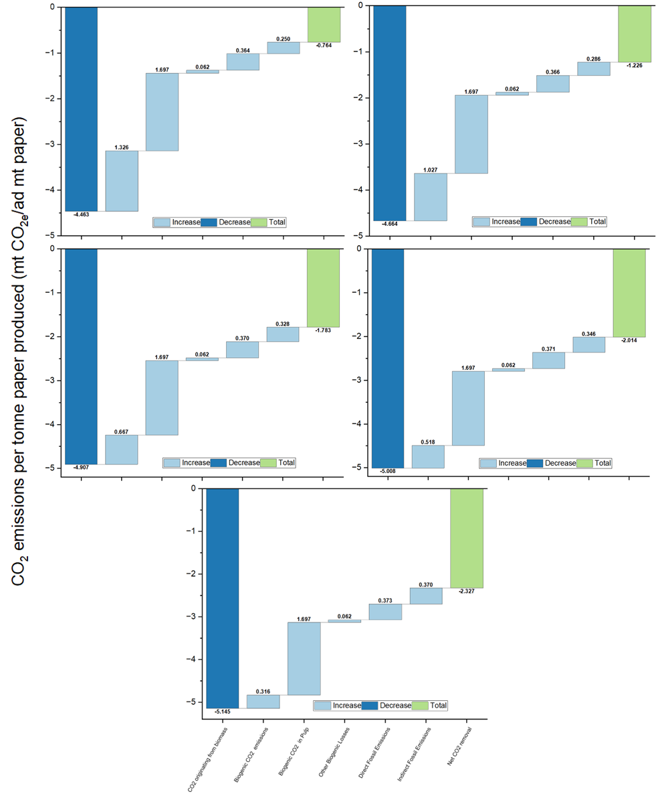
e
d
c
b
a

Fig. S5. Life cycle greenhouse gas emissions associated with the integration of a CCS facility into a UBSK pulp and paper mill (System 4), normalized by the total paper produced. Results are shown for five capture scenarios: a. recovery boiler only, b. recovery boiler and CCS biomass boiler, c. recovery boiler, CCS biomass boiler, and P&P biomass boiler, d. same as (c) plus lime kiln, and e. same as (d) plus natural gas boiler.
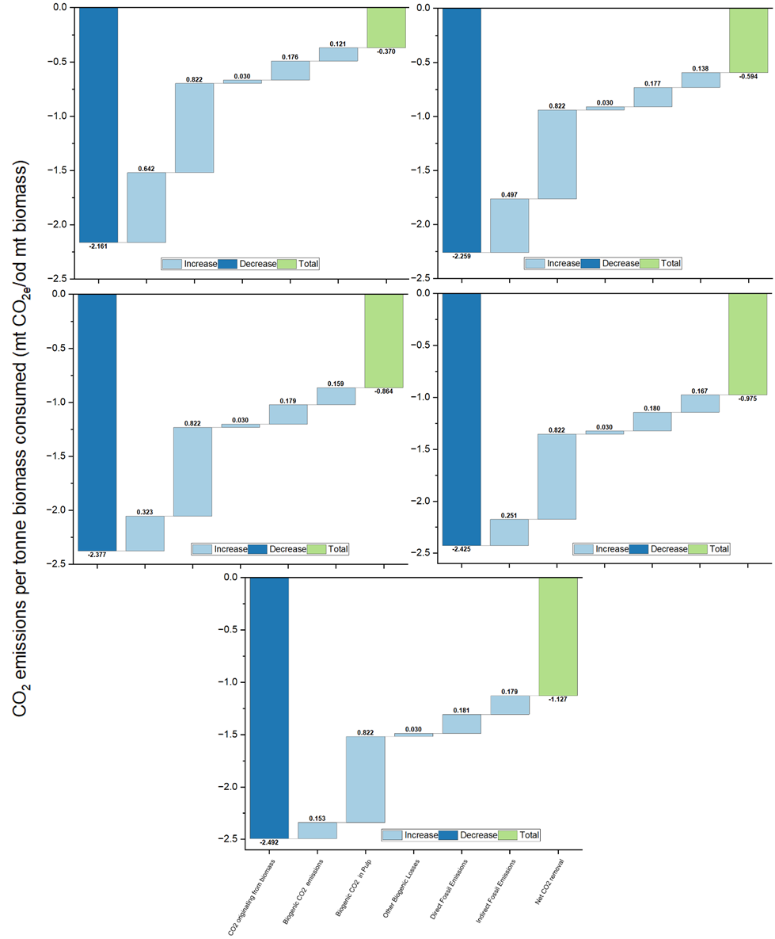
e
d
c
b
a
Fig. S6. Life cycle greenhouse gas emissions associated with the integration of a CCS facility into a UBSK pulp and paper mill (System 4), normalized by the total biomass consumed. Results are shown for five capture scenarios: a. recovery boiler only, b. recovery boiler and CCS biomass boiler, c. recovery boiler, CCS biomass boiler, and P&P biomass boiler, d. same as (c) plus lime kiln, and e. same as (d) plus natural gas boiler.

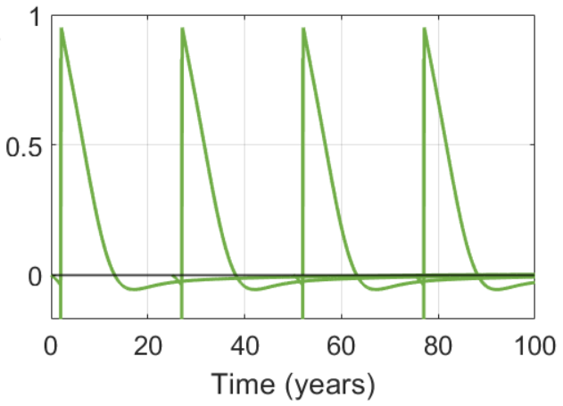
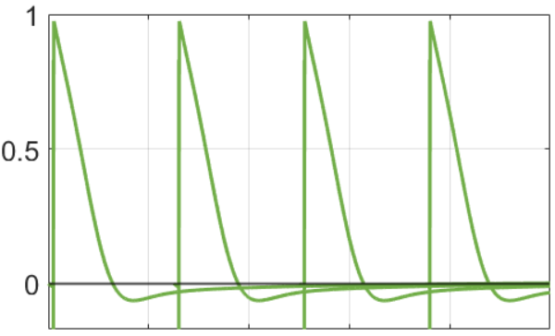
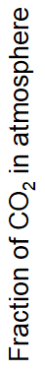
a
b

Fig. S7. Carbon flux profiles for System 5: (a) carbon storage credit from one year of temporary sequestration in the packaging product, (b) carbon storage credit from two years of temporary sequestration in the packaging product.

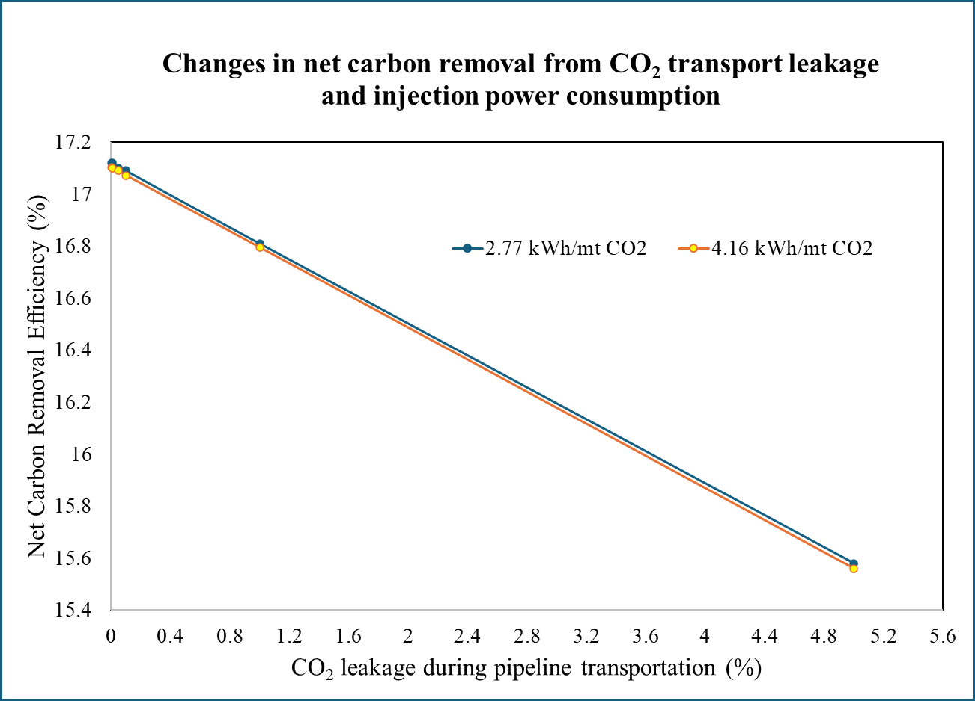
Fig. S8. Changes in net carbon removal efficiency from CO2 transport leakage and injection power consumption in Scenario 1 (System 4).

References
[1] N. Forfora, I. Azuaje, K.A. Vivas, R.E. Vera, A. Brito, R. Venditti, S. Kelley, Q. Tu, A. Woodley, R. Gonzalez, Evaluating biomass sustainability: Why below-ground carbon sequestration matters, J. Clean. Prod. 439 (2024) 140677. https://doi.org/10.1016/j.jclepro.2024.140677.
[2] wood chips production, softwood, at sawmill - Rest-of-World - wood chips, wet, measured as dry mass | ecoQuery, (n.d.). https://ecoquery.ecoinvent.org/3.10/cutoff/dataset/12115/impact_assessment (accessed May 30, 2025).
[3] tap water production, conventional treatment - Rest-of-World - tap water | ecoQuery, (n.d.). https://ecoquery.ecoinvent.org/3.10/cutoff/dataset/10674/documentation (accessed May 30, 2025).
[4] water production, deionised - Rest-of-World - water, deionised | ecoQuery, (n.d.). https://ecoquery.ecoinvent.org/3.10/cutoff/dataset/7996/documentation (accessed May 30, 2025).
[5] market for sodium sulfate, anhydrite - Rest-of-World - sodium sulfate, anhydrite | ecoQuery, (n.d.). https://ecoquery.ecoinvent.org/3.10/cutoff/dataset/256/documentation (accessed May 30, 2025).
[6] quicklime production, in pieces, loose - Rest-of-World - quicklime, in pieces, loose | ecoQuery, (n.d.). https://ecoquery.ecoinvent.org/3.10/cutoff/dataset/2639/documentation (accessed May 30, 2025).
[7] market for sodium hydroxide, without water, in 50% solution state - Rest-of-World - sodium hydroxide, without water, in 50% solution state | ecoQuery, (n.d.). https://ecoquery.ecoinvent.org/3.10/cutoff/dataset/28164/documentation (accessed May 30, 2025).
[8] R.A. Alvarez, D. Zavala-Araiza, D.R. Lyon, D.T. Allen, Z.R. Barkley, A.R. Brandt, K.J. Davis, S.C. Herndon, D.J. Jacob, A. Karion, E.A. Kort, B.K. Lamb, T. Lauvaux, J.D. Maasakkers, A.J. Marchese, M. Omara, S.W. Pacala, J. Peischl, A.L. Robinson, P.B. Shepson, C. Sweeney, A. Townsend-Small, S.C. Wofsy, S.P. Hamburg, Assessment of methane emissions from the U.S. oil and gas supply chain, Science (80-. ). 361 (2018) 186–188. https://doi.org/10.1126/science.aar7204.
[9] K.E. Tomberlin, R. Venditti, Y. Yao, Life cycle carbon footprint analysis of pulp and paper grades in the United States using production-line-based data and integration, BioResources 15 (2020) 3899–3914. https://doi.org/10.15376/biores.15.2.3899-3914.
[10] retention aid production, for paper production - Rest-of-World - retention aid, for paper production | ecoQuery, (n.d.). https://ecoquery.ecoinvent.org/3.10/cutoff/dataset/3667/impact_assessment (accessed May 30, 2025).
[11] treatment of wastewater, average, wastewater treatment - Rest-of-World - wastewater, average | ecoQuery, (n.d.). https://ecoquery.ecoinvent.org/3.10/cutoff/dataset/26546/documentation (accessed May 30, 2025).
[12] treatment of sludge from pulp and paper production, sanitary landfill - Rest-of-World - sludge from pulp and paper production | ecoQuery, (n.d.). https://ecoquery.ecoinvent.org/3.10/cutoff/dataset/1057/documentation (accessed May 30, 2025).
[13] treatment of green liquor dregs, residual material landfill - Rest-of-World - green liquor dregs | ecoQuery, (n.d.). https://ecoquery.ecoinvent.org/3.10/cutoff/dataset/4921/impact_assessment (accessed May 30, 2025).
[14] K. Onarheim, S. Santos, P. Kangas, V. Hankalin, Performance and cost of CCS in the pulp and paper industry part 2: Economic feasibility of amine-based post-combustion CO 2 capture, Int. J. Greenh. Gas Control 66 (2017) 60–75. https://doi.org/10.1016/j.ijggc.2017.09.010.
[15] E. Carrejo, H. Jameel, S. Park, W.J. Sagues, Biogenic carbon capture at pulp mills via sodium spiking and oxy-fuel calcination, Int. J. Greenh. Gas Control 145 (2025) 104409. https://doi.org/10.1016/j.ijggc.2025.104409.
[16] H. Sarah E. Baker, Joshuah K. Stolaroff, George Peridas, Simon H. Pang, J.P.-R. M. Goldstein, Felicia R. Lucci, Wenqin Li, Eric W. Slessarev, R.D.A. Frederick J. Ryerson, Jeff L. Wagoner, Whitney Kirkendall, R. Daniel L. Sanchez, Bodie Cabiyo, Joffre Baker, Sean McCoy, Sam Uden, N.M. Runnebaum, Jennifer Wilcox, Peter C. Psarras, Hélène Pilorgé, C.M. Daniel Maynard, Getting to Neutral: Options for Negative Carbon Emissions in California, 2020. https://doi.org/LLNL-TR-796100.
[17] D.A. Jones, Technoeconomic Evaluation of MEA versus Mixed Amines and a Catalyst System for CO2 Removal at Near-Commercial Scale at Duke Energy Gibson 3 Plant and Duke Energy Buck NGCC Plant, Lawrence Livermore Natl. Lab. (2019) 15–19.
[18] Power Profiler | US EPA, (n.d.). https://www.epa.gov/egrid/power-profiler#/ (accessed May 30, 2025).
[19] R. Dumitraşcu, A. Lunguleasa, C. Spîrchez, Renewable Pellets Obtained from Aspen and Birch Bark, BioResources 13 (2018) 6985–7001.
[20] D.W. Keith, G. Holmes, D. St. Angelo, K. Heidel, A Process for Capturing CO2 from the Atmosphere, Joule 2 (2018) 1573–1594. https://doi.org/10.1016/j.joule.2018.05.006.
[21] R.A. Alvarez, S.W. Pacala, J.J. Winebrake, W.L. Chameides, S.P. Hamburg, Greater focus needed on methane leakage from natural gas infrastructure, Proc. Natl. Acad. Sci. U. S. A. 109 (2012) 6435–6440. https://doi.org/10.1073/pnas.1202407109.
[22] FE/NETL CO2 Saline Storage Cost Model (2017) - Submissions - EDX, (n.d.). https://edx.netl.doe.gov/dataset/fe-netl-co2-saline-storage-cost-model-2017 (accessed May 29, 2025).
[23] GHG Emission Factors Hub | US EPA, (n.d.). https://www.epa.gov/climateleadership/ghg-emission-factors-hub (accessed May 30, 2025).
[24] H. Xu, G. Latta, U. Lee, J. Lewandrowski, M. Wang, Regionalized Life Cycle Greenhouse Gas Emissions of Forest Biomass Use for Electricity Generation in the United States, Environ. Sci. Technol. 55 (2021) 14806–14816. https://doi.org/10.1021/acs.est.1c04301.
[25] C.A. Bolin, S.T. Smith, Life Cycle Assessment of Creosote-Treated Wooden Railroad Crossties in the US with Comparisons to Concrete and Plastic Composite Railroad Crossties, J. Transp. Technol. 03 (2013) 149–161. https://doi.org/10.4236/jtts.2013.32015.
[26] Supply Chain Greenhouse Gas Emission Factors v1.2 by NAICS-6 - Catalog, (n.d.). https://catalog.data.gov/dataset/supply-chain-greenhouse-gas-emission-factors-v1-2-by-naics-6 (accessed May 29, 2025).
[27] U.S. Life Cycle Inventory Database | Energy Analysis | NREL, (n.d.). https://www.nrel.gov/analysis/lci (accessed May 30, 2025).
[28] market for monoethanolamine - Global - monoethanolamine | ecoQuery, (n.d.). https://ecoquery.ecoinvent.org/3.10/cutoff/dataset/9782/impact_assessment (accessed May 30, 2025).
[29] market for sodium hydroxide, without water, in 50% solution state - Rest-of-World - sodium hydroxide, without water, in 50% solution state | ecoQuery, (n.d.). https://ecoquery.ecoinvent.org/3.10/cutoff/dataset/28164/impact_assessment (accessed May 30, 2025).
[30] A. Bhatt, V. Ravi, Y. Zhang, G. Heath, R. Davis, E.C.D. Tan, Emission factors of industrial boilers burning biomass-derived fuels, J. Air Waste Manage. Assoc. 73 (2023) 241–257. https://doi.org/10.1080/10962247.2023.2166158.
[31] A. Milbrandt, J. Zuboy, K. Coney, A. Badgett, Paper and cardboard waste in the United States: Geographic, market, and energy assessment, Waste Manag. Bull. 2 (2024) 21–28. https://doi.org/10.1016/j.wmb.2023.12.002.
[32] Z. Mousania, J.D. Atkinson, A cradle-to-grave life cycle assessment of multilayer plastic film food packaging materials, comparing to a paper-based alternative, Waste Manag. 200 (2025) 114747. https://doi.org/10.1016/j.wasman.2025.114747.
[33] I. Azuaje, N. Forfora, I. Urdaneta, R. Ortega, R. Frazier, R. Vera, K.A. Vivas, D. Luana, R. Venditti, H. Jameel, Q. Tu, K. Lan, R. Marquez, E. Lizundia, S. Kelley, R. Gonzalez, Reducing subjectivity when performing LCA for recycling systems in the paper industry through a comprehensive evaluation of different allocation methods, Resour. Conserv. Recycl. 215 (2025) 108061. https://doi.org/10.1016/j.resconrec.2024.108061.
[34] S. van Ewijk, J.A. Stegemann, P. Ekins, Limited climate benefits of global recycling of pulp and paper, Nat. Sustain. 4 (2021) 180–187.
[35] F. Cherubini, G.P. Peters, T. Berntsen, A.H. Strømman, E. Hertwich, CO2 emissions from biomass combustion for bioenergy: atmospheric decay and contribution to global warming, GCB Bioenergy 3 (2011) 413–426. https://doi.org/10.1111/j.1757-1707.2011.01102.x.

