Supporting information
Assessing the potential environmental benefits of PVC waste recycling in China toward carbon neutrality
Mengqi Han^{a,b}, Xiaofeng Gao^{c}, Zhaoqing Wang^{d}, Shogo Kumagai^{a,e,}*, Yuko Saitoª, Toshiaki Yoshioka^{a,}*, Dungang Gu^{b}, Tingting Hu^{b}, Guanghui Li^{b}, Jiaqi Lu^{b,}*
ª Graduate School of Environmental Studies, Tohoku University, 6-6-07 Aoba, Aramaki-aza, Aoba-ku, Sendai, Miyagi 980-8579, Japan
^{b} Innovation Centre for Environment and Resources, School of Chemistry and Chemical Engineering, Shanghai University of Engineering Science, No.333 Long teng Road, Songjiang District, Shanghai 201620, China
^{c} Key Laboratory of the Three Gorges Reservoir Region’s Eco-Environment, Ministry of Education, College of Environment and Ecology, Chongqing University, 174 Sha zheng Road, Shapingba District, Chongqing 400044, China
^{d} Department of Environment and Social Development, School of Marxism, Chang 'an University, No. 126, the Middle Section of 2nd Ring Road, Xi' an 710064, China
^{e} Graduate School of Engineering, Tohoku University, 6-6-07 Aoba, Aramaki-aza, Aoba-ku, Sendai, Miyagi 980-8579, Japan
* Corresponding author:
Jiaqi Lu: wilsherelu@foxmail.com
Shogo Kumagai: kumagai@tohoku.ac.jp
Toshiaki Yoshioka: yoshioka@tohoku.ac.jp
Contents
1. Data preparation for the calculation of life cycle assessment (Table S1-3 and Figure S1-8)
2. Scenario description in China from 2020 to 2050 (Table S4-6)
3. The environmental impacts of 1 kg PVC waste recycling (Table S7-9 and Figure S9)
4. Scenario analysis for treating 1 kg PVC waste by ER, MR,CR methods (Figure S10)
5. Sensitivity analysis of electricity and PVC waste amount (Table S10-11)
6. Provincial and interprovincial transportation models(Table S12-19 and Figure S11)
Summary Information
Number of pages: 36
Figures：11
Tables: 23
1. Data preparation for the calculation of life cycle assessment
1.1 Data preparation for LCA
Based on the defined goal and scope, the life cycle inventory data should be prepared for the calculation of LCA. The process can be divided into two parts: first is data collection; second is data inventory.
1.1.1 Data collection
Three important data information should be supplied to inventory by previous researches.
- Energy recovery (ER)
The information of PVC waste ER were collected by combining the amount emission and the regenerated electricity based on characteristic of PVC waste. PVC waste is incinerated and converted into energy including the process of using activated carbon to adsorb dioxin like substances.
The amount emission and the regenerated electricity can be calculated by the study: Plasma gasification versus incineration of plastic waste: Energy, economic and environmental analysis (Cudjoe 2022).
Table S1. The content of PVC
Content(%) | C | H | Cl | N | S | ASH
PVC | 38.34 | 4.47 | 56.96 | 0.23 | 0 | 0
Calculation process of regenerated electricity:
①The electricity generation formula:
$$E_{INC}=PVC×\frac{{LHV}_{PVC}}{3.6}×α$$
②The low heat value formula:
$${LHV}_{PVC}={HHV}_{PVC}−(9×\%H+\%H20)×2.44$$
③The high heat value formula:
$${HHV}_{PVC}=0.3491C+1.1783H+0.1005S−0.1034O−0.015N−0.0211A$$
E_{INC}: Energy generated by incineration
PVC: Mass of PVC waste
LHV_{PVC}: Lower heating value of the incinerated PVC waste
α: Electrical efficiency of the steam turbine (taken as 29%)
HHV_{PVC}: Higher heating value of the incinerated PVC waste
%H:Percentage weight of atomic hydrogen
%H₂O:Percentage weight of water
C,H,S,O,N,A:Percentage weight of carbon, hydrogen, sulfur, oxygen, nitrogen, and ash.
According to the study of Sun (2003) and Wang (2024), we calculated the consumed activated carbon for the absorption of dioxin.
Combination with the dioxins emission from PVC waste incineration process, the Cl content of PVC waste will release into bottom ash (0.023kg), fly ash (0.031kg) and absorption by CaO (0.516kg), which refers to the research of Ren-De Sun. According to the emission standard for dioxins in incinerators released by China in 2019 was 0.1ng (TEQ/Nm³) (China 2019),while the dioxin concentration from PVC waste incineration is 13.84 ng/kg, which is equaling to 7.974ng (TEQ/Nm³). In order to achieve the demand of standard, it is necessary to decrease the emission of dioxins by activated carbon. Based on the study of Wang, the correlation between activated carbon dosage and dioxin removal efficiency can be calculated by the below formula:
$$Y=\left[−140.3∗e^{\left(−\frac{x}{0.075}\right)}\right]+102.7$$

Y: the dioxin removal efficiency(%)
x: the activated carbon consumption(g)
By this function, the activated carbon will be consumed 0.268g, when the removal efficiency is 98.75%.
- Mechanical recycling (MR)
Data on the MR treatment process of PVC waste was collected through the previous research on the recycling process of waste plastic, which has been published (Han 2024).
- Chemical recycling (CR)
The foreground data of the CR process of PVC waste were obtained from the literature of Lu (2020) and factory research, which respectively analyzed the chlorine recovery process of PVC waste, in which pre-dechlorination treatment is carried out by using a ball mill at 190 ℃ to remove chlorine from PVC waste in the form of chloride salts through sodium hydroxide and ethylene glycol solutions, obtaining a sodium chloride/ethylene glycol solution. Sodium chloride/ethylene glycol solution is separated by electrodialysis treatment, and the obtained chloride salt solution forms solid sodium chloride through evaporation crystallization. The separated ethylene glycol solution enters the dechlorination process again, reducing the waste of organic solution. The dechlorinated hydrocarbons are converted into petrochemical products through cracking treatment.
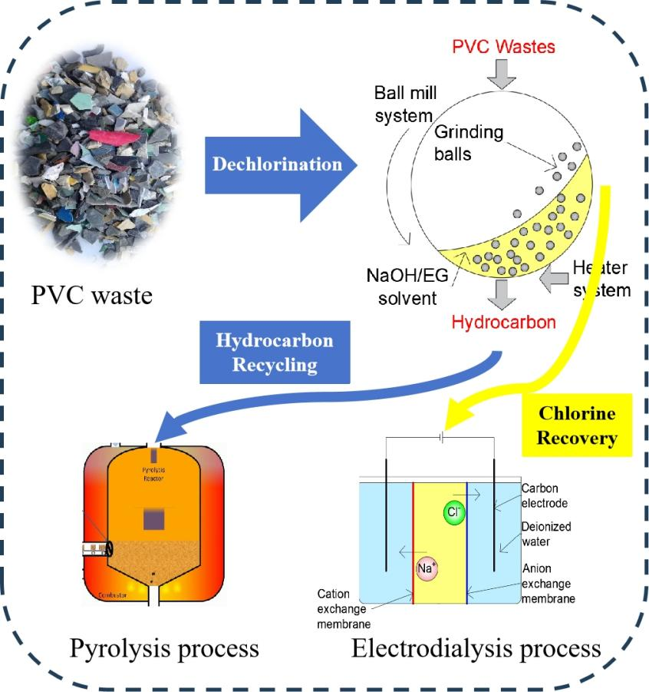
Figure S1. The chemical recycling system of PVC waste

1.1.2 Data inventory
Table S2. The background data sources of various PVC treatment methods
Items | Sources
Activated carbon | Activated carbon production, granular from hard coal|activated carbon granular | Cutoff, U-Row
CaO | quicklime production, in pieces, loose | quicklime, in pieces, loose | Cutoff, U
Hazardous waste | Treatment of hazardous waste, undergound deposit| hazardous waste, for underground deposit| Cutoff, U - RoW
PVC particles | polyvinylchloride production, emulsion polymerisation | polyvinylchloride, emulsion polymerised | Cutoff, U - RoW
NaOH | sodium hydroxide to generic market for neutralising agent | neutralising agent, sodium hydroxide-equivalent | Cutoff, U
Ethylene glycol | ethylene glycol production | ethylene glycol | Cutoff, U
Water | tap water production, conventional treatment | tap water | Cutoff, U
Liquid gas | natural gas liquids production | natural gas liquids | Cutoff, U
Heat | Heat production, natural gas, at boiler atmosphere non-modulating<100kW| heat, central or small size-scale, natural gas | Cutoff, U-Row
Light oil | light fuel oil production, petroleum refinery operation | light fuel oil | Cutoff, U - RoW
Heavy oil | heavy fuel oil production, petroleum refinery operation | heavy fuel oil | Cutoff, U - RoW
paraffin | paraffin production | paraffin | Cutoff, U - RoW
coke | petroleum coke production, petroleum refinery operation | petroleum coke | Cutoff, U - RoW
gas | refinery gas production, petroleum refinery operation | refinery gas | Cutoff, U - RoW
NaCl | sodium chloride production, powder | sodium chloride, powder | Cutoff, U - RoW
Landfill | Treatment of waste plastic, mixture, sanitary landfill | waste plastic, mixture| Cutoff, U - RoW
Electricity | Literature (Tang 2024)

1.2 Data preparation for PVC waste flow in China
In order to get the PVC waste flow in China, lots of data on PVC waste generation had been collected. The data can be shown as two parts: one is the PVC waste generation in various provinces; two is the PVC waste from different sources treatment conditions.
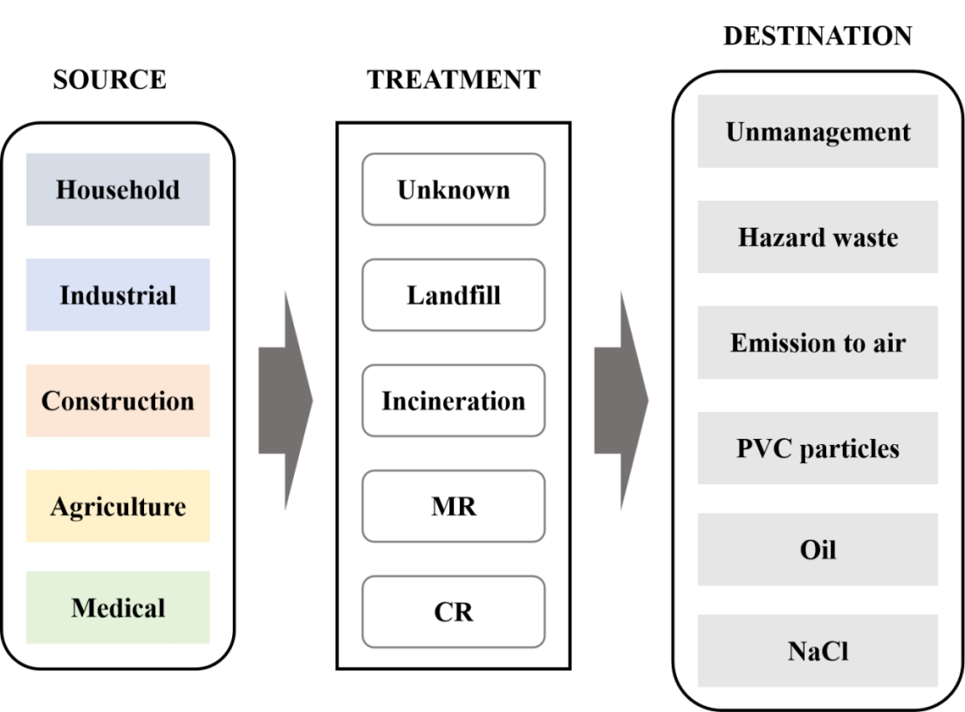
Figure S2. The flow of PVC waste in China

1.2.1 The PVC waste generation in various provinces
The amount of PVC waste and the sources of PVC waste can be obtained by Bi’s study: Dynamic materials flow analysis of polyvinyl chloride and its typical additives in China (Bi 2023). The future generation of PVC waste also is predicted, whose increase ratio is 2.7% annual by the demand and supply of PVC. From 2020 to 2050, the PVC waste generation is displayed in the below table:
Table S3. The PVC waste generation from 2020 to 2050.
PVC waste | Household waste | Construction waste | Industrial solid waste | Agricultural waste | Medical waste
2020 | 297.2362 | 595.0438 | 164.5895 | 75.7540 | 18.2537
2025 | 336.3081 | 673.2628 | 186.2250 | 85.7119 | 20.6531
2030 | 375.3800 | 751.4818 | 207.8604 | 95.6699 | 23.0526
2035 | 414.4520 | 829.7008 | 229.4958 | 105.6278 | 25.4521
2040 | 453.5239 | 907.9198 | 251.1313 | 115.5857 | 27.8515
2045 | 492.5959 | 986.1388 | 272.7667 | 125.5436 | 30.2510
2050 | 531.6678 | 1064.3578 | 294.4021 | 135.5016 | 32.6504

Additionally, we collected the generation condition about construction, industrial, household, agriculture, and medical solid waste in China Statistical Yearbook. The PVC waste generation in different provinces are shown in figure S3.
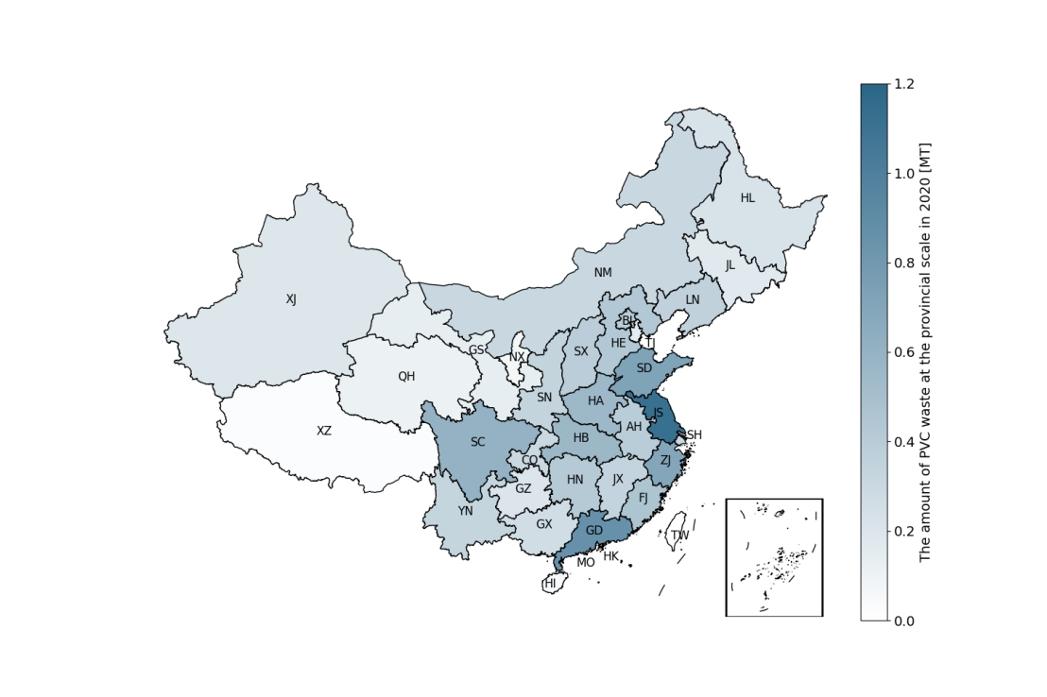
Figure S3. The PVC waste generation in different provinces
1.2.2 The PVC waste from different sources treatment conditions
The different sources of PVC waste have different recycling rate. The treatment rates of five PVC waste sources are shown below.
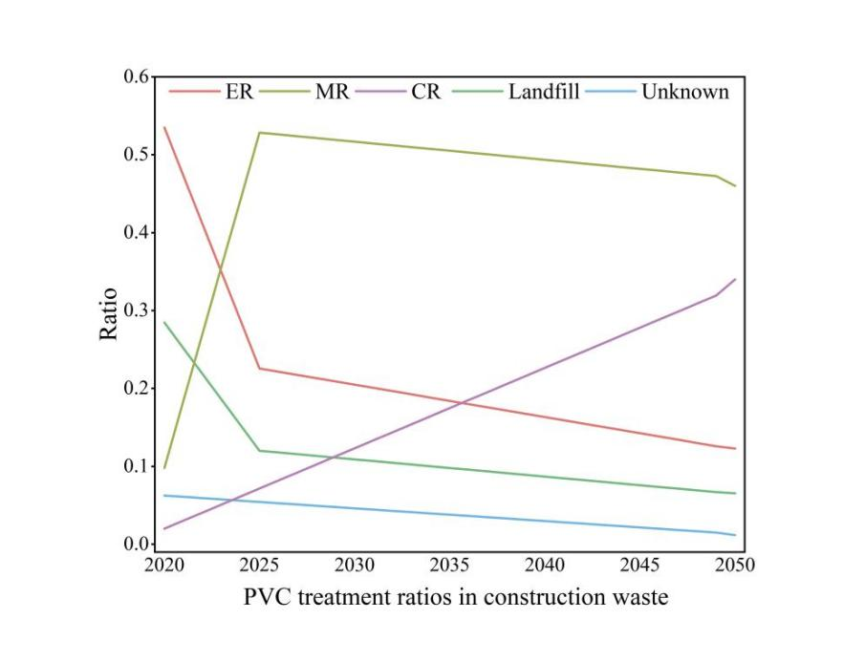
Figure S4. The treatment rate of PVC waste from construction solid waste

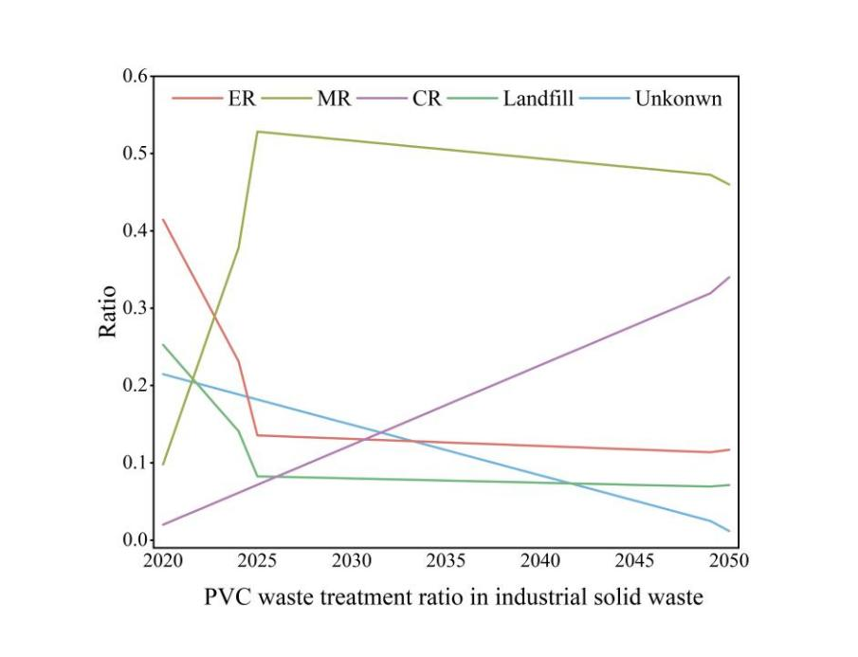
Figure S5.The treatment rate of PVC waste from industrial solid waste

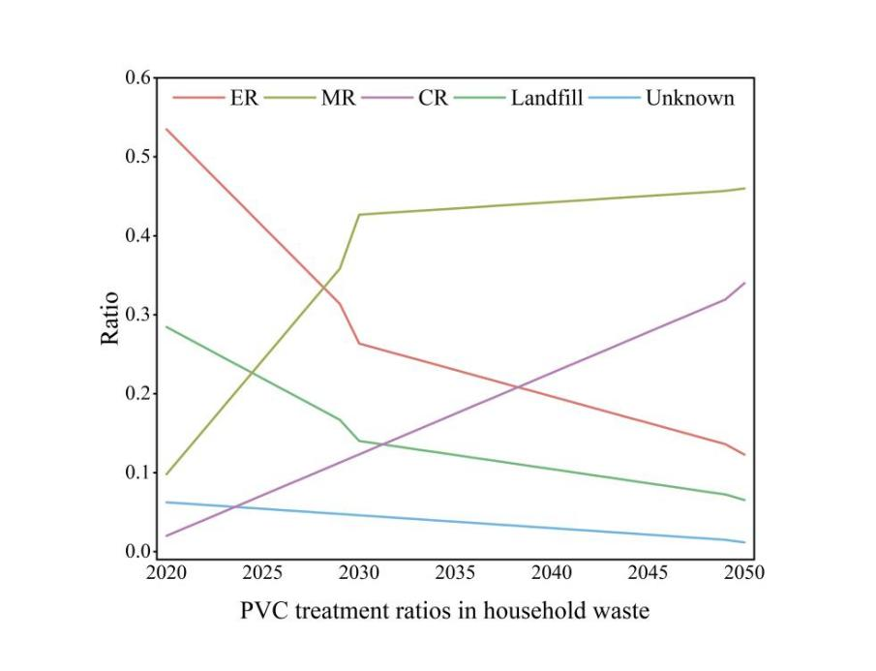
Figure S6. The treatment rate of PVC waste from household solid waste

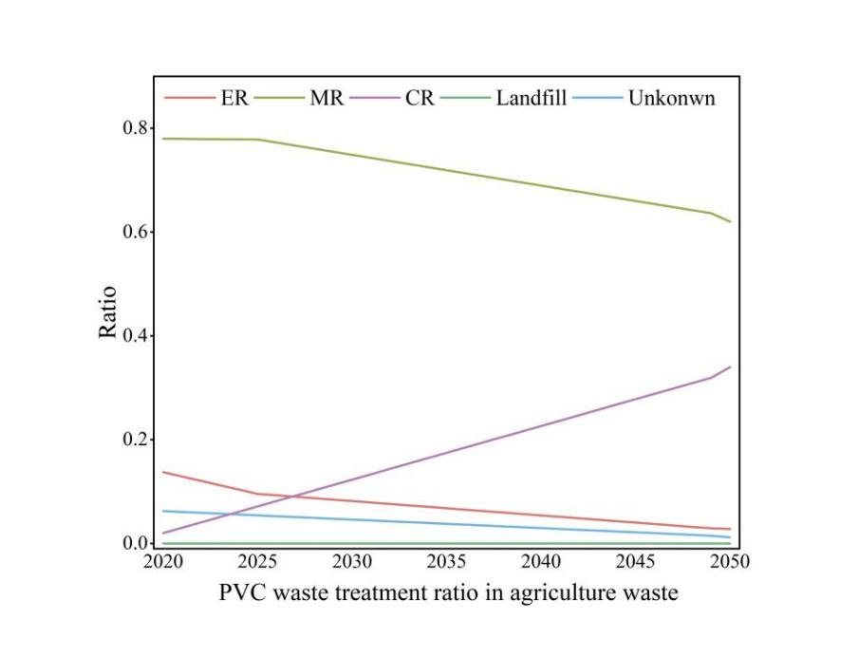
Figure S7. The treatment rate of PVC waste from agriculture solid waste
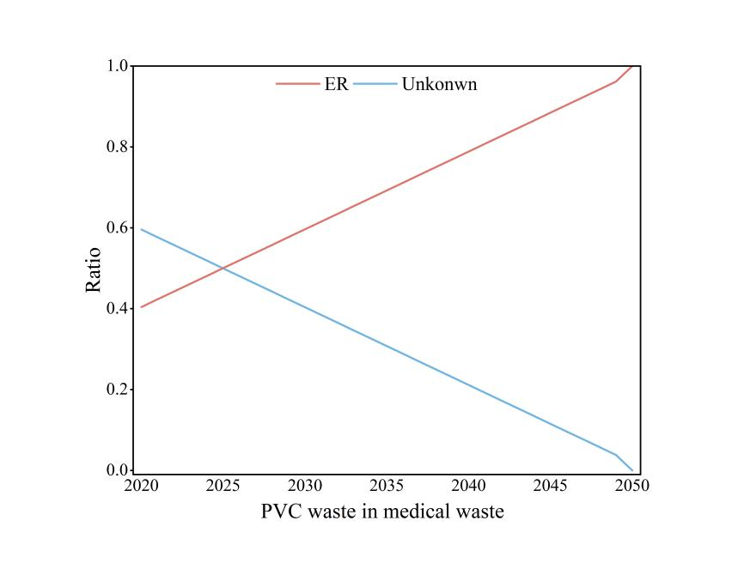
Figure S8. The treatment rate of PVC waste from medical solid waste

- Scenario description in China from 2020 to 2050

The environmental impacts of electricity in future scenario.
Table S4. The environmental impacts under SA1
Electricity_S1 | Carbon footprint (kg CO₂-eq/kg) | Human health  (DALY) | Resource depletion (USD) | Ecosystem quality (species.yr)
2020 | 9.66×10⁻¹ | 2.31×10⁻⁶ | 1.91×10⁻² | 4.11×10⁻⁹
2025 | 1.02×10⁰ | 2.43×10⁻⁶ | 1.96×10⁻⁶ | 4.33×10⁻⁹
2030 | 1.03×10⁰ | 2.46×10⁻⁶ | 1.96×10⁻⁶ | 4.37×10⁻⁹
2035 | 1.03×10⁰ | 2.47×10⁻⁶ | 1.96×10⁻⁶ | 4.40×10⁻⁹
2040 | 1.03×10⁰ | 2.47×10⁻⁶ | 1.95×10⁻⁶ | 4.40×10⁻⁹
2045 | 1.04×10⁰ | 2.48×10⁻⁶ | 1.95×10⁻⁶ | 4.42×10⁻⁹
2050 | 1.04×10⁰ | 2.50×10⁻⁶ | 1.96×10⁻⁶ | 4.46×10⁻⁹

Table S5. The environmental impacts under SA2.
Electricity_S2 | Carbon footprint (kg CO₂-eq/kg) | Human health  (DALY) | Resource depletion (USD) | Ecosystem quality (species.yr)
2020 | 9.65×10⁻¹ | 2.31×10⁻⁶ | 1.91×10⁻² | 4.11×10⁻⁹
2025 | 7.71×10⁻¹ | 1.86×10⁻⁶ | 1.57×10⁻² | 3.30×10⁻⁹
2030 | 4.87×10⁻¹ | 1.20×10⁻⁶ | 1.04×10⁻² | 2.10×10⁻⁹
2035 | 3.94×10⁻¹ | 9.85×10⁻⁷ | 8.82×10⁻³ | 1.71×10⁻⁹
2040 | 3.09×10⁻¹ | 7.89×10⁻⁷ | 7.43×10⁻³ | 1.36×10⁻⁹
2045 | 1.97×10⁻¹ | 5.30×10⁻⁷ | 5.55×10⁻³ | 8.85×10⁻¹⁰
2050 | 1.19×10⁻¹ | 3.49×10⁻⁷ | 4.25×10⁻³ | 5.58×10⁻¹⁰

Table S6. The environmental impacts under SA3.
Electricity_S3 | Carbon footprint (kg CO₂-eq/kg) | Human health  (DALY) | Resource depletion (USD) | Ecosystem quality (species.yr)
2020 | 8.73×10⁻¹ | 2.08×10⁻⁶ | 1.88×10⁻² | 3.71×10⁻⁹
2025 | 6.84×10⁻¹ | 1.66×10⁻⁶ | 1.41×10⁻² | 2.93×10⁻⁹
2030 | 2.30×10⁻¹ | 6.07×10⁻⁷ | 5.89×10⁻³ | 1.04×10⁻⁹
2035 | 6.84×10⁻² | 2.30×10⁻⁷ | 3.00×10⁻³ | 3.50×10⁻¹⁰
2040 | 4.00×10⁻² | 1.67×10⁻⁷ | 2.60×10⁻³ | 2.34×10⁻¹⁰
2045 | 3.61×10⁻² | 1.59×10⁻⁷ | 2.63×10⁻³ | 2.20×10⁻¹⁰
2050 | 3.57×10⁻² | 1.61×10⁻⁷ | 2.69×10⁻³ | 2.21×10⁻¹⁰

3. The environmental impacts of 1 kg PVC waste recycling
The different environmental impacts of different treatment methods in provincial-level are calculated as:
$$I_{m}=\sum_{j=1}^{5}{\sum_{k=1}^{5}{E(i,j,k)×F_{k}^{m}}}$$
I_{m}: the m environmental impact of PVC waste treatment in i province.

The carbon footprint from the transportation of recycled products is calculated by the below formula:
$${{TE}_{a,b}=W}_{a,b}×D_{a,b}×c_{eff}×{EF}_{a,b}$$
Transport weight W_{a,b}: Decision variable representing the weight of cargo transported from province a to province b.
Transport distance D_{a,b}: Constant representing the distance from province a to province b.
Energy efficiency c_{eff}: Constant indicating energy consumption per ton of cargo per kilometer, representing the electricity usage efficiency.
Electricity carbon footprint factor EF_{a,b}: The factor associated with electricity usage for each province or city, indicating the carbon footprint per kWh.
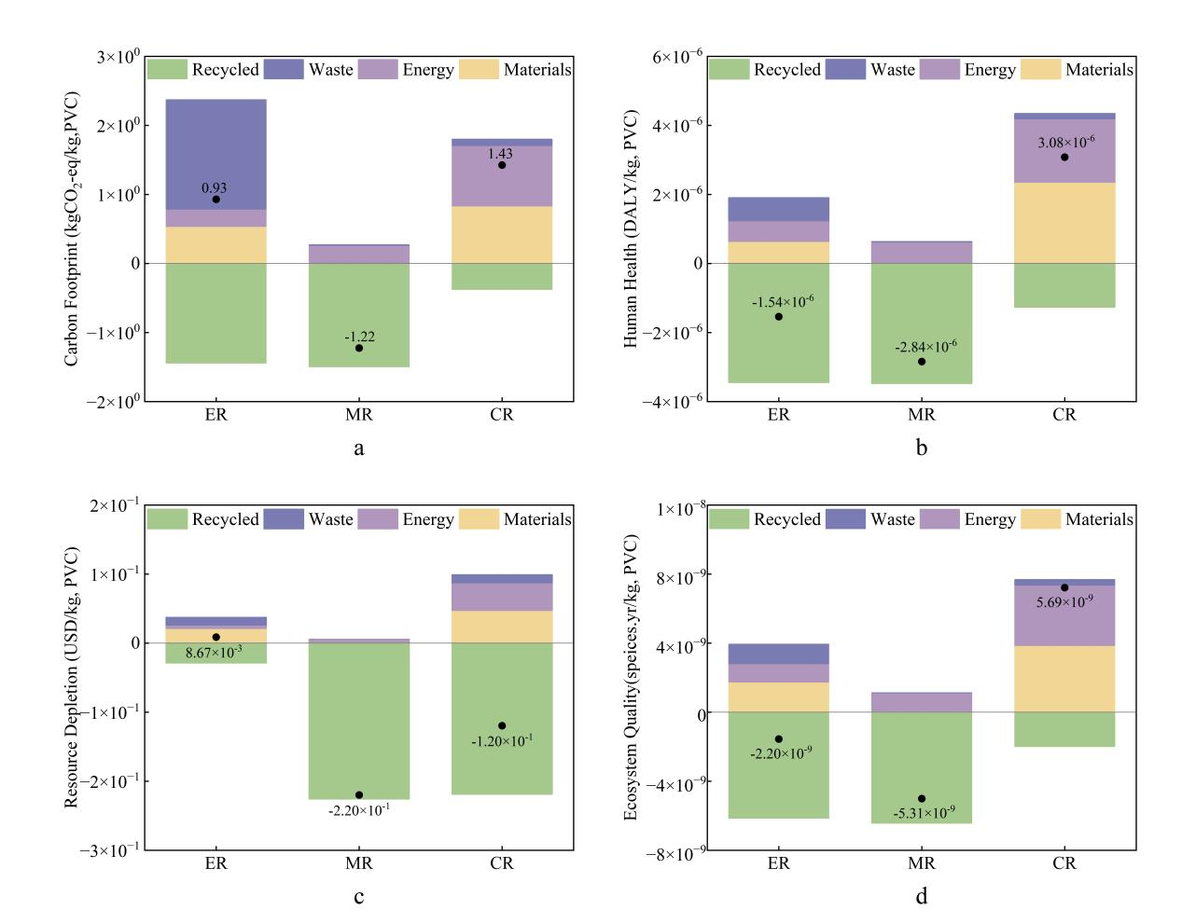
Figure S9. Environmental footprints contribution analysis of unit PVC waste recycling methods.
Figure S9a: the carbon footprint contribution analysis; Figure S9b: the human health contribution analysis; Figure S9c: the resource depletion contribution analysis; Figure S9d: the ecosystem quality contribution analysis. The analysis results were categorized into four part: yellow-input materials (materials), mauve- input energy (Energy), purple-waste emissions (Waste) and cyan-recycled materials (Recycled).

To assess the environmental footprints of PVC waste recycling in China, we calculated the carbon footprint, human health, resource depletion and ecosystem quality of various PVC waste recycling methods.
As the carbon footprint results of ER, MR, and CR shown in figure S9a, the largest carbon footprint emission method is CR, 1.43 (kgCO₂-eq/kg, PVC)，whose main contributor is energy consumption, accounting for 61.46%, then is 58.31% of input materials. This result shown that both energy and materials will contribute most of carbon footprint, the CR of PVC waste has extra step-dechlorination, consuming amount of materials and energy to remove the Cl elements. Then is ER method, even though the direct emission occupying 170.68% is higher than other recycling methods, but the regenerated electricity (1.44 kg CO₂-eq/kg, PVC) will offset most emission like the gray part, accounting for -155.22%. Expect for the two parts, the input materials can’t be ignored, approximately contributing 57.62% to remove the toxic dioxin gas. Those results stated that the control of housewarming gases and toxic gases during incineration are always inevitable task in ER process. As for the MR method, due to the deduction of regenerated PVC particles, the MR method displayed the lowest carbon footprint emission with -1.22 kg CO₂-eq/kg, PVC. Those results indicated that MR is currently the recycling technology with the lowest carbon footprint emissions. However, due to MR’s requirements for plastic quality, most of the PVC waste cannot be downgraded recycling through MR. ER and CR do not have a demand for the quality of PVC waste, but energy and material input factors result in high carbon footprint emissions for ER and CR. In addition, the high emissions from the ER process are an issue that cannot be ignored. Therefore, in the future, how to improve the processing efficiency of the CR process and reduce material and energy consumption during the process is a prerequisite for the development of CR.
Based on the RECIPE method, we evaluated the endpoint impacts of three recycling methods respectively,shown in Figure S9c-d. Furthermore, the midpoint impacts also was calculated, being placed in SI.
For human health in Figure S9b, CR is the top impact method among three recycling methods, 3.08×10⁻⁶ DALY, in which upstream emissions in scope 3 from the input materials is the main origin, accounting 76.62%, then is indirect emissions from energy consumption with 59.75% contribution, the downstream emission from the regenerated materials with 41.03% contribution. The negative values of human health for ER and MR are caused by the offset of regenerated materials, with -223.52% and -122.28%, respectively. During ER process, the contributions from direct, indirect and upstream emissions are all around 40%, for MR the contribution from indirect emission of energy is 21.04%, the direct and upstream impact are less than 1%, the downstream impact make the total impact reduce by -122.28%. These results suggest that the low human health impacts of ER and MR are due to the deduction of recycled materials, while the high human environmental impact of ER comes from upstream emissions from material consumption and indirect emissions from energy consumption.
For resource depletion in Figure S9c, ER has the highest impact with 8.67×10⁻³ USD, then is CR with -1.2×10⁻¹ USD, the last is MR with -2.2×10⁻¹ USD. The upstream impact of ER from materials consumption accounts for 246.57% and the direct impact is lower to 125.53%, while the downstream impact for regenerated electricity only for -38.13%. The downstream impact of recycled PVC on the resource depletion in MR has been over 100% reduction, which is main factor causing the negative value. For the resource depletion, the recycled materials of oil, gas, and coke make the total impact decrease 182.69%, while the upstream impact from input materials and indirect impact from input energy have contributed to the impact of 39.73% and 33.44%. The contribution analysis result of resource depletion is different with the carbon footprint and human health resulting from the focus of assessment varies among the three types of impacts. Resource depletion emphasizes the degree of depletion of non renewable resources such as fossil fuels and minerals, while human health risks and ecological environment quality are more sensitive to specific types of pollutants such as heavy metals, greenhouse gases, particulate matter, etc., resulting in different proportion analysis results of resource depletion compared to others.
For ecosystem quality contribution analysis of three recycling methods, the sequence of total impact resembles with the human health, while there are little difference in proportion. For ER, the proportions of the upstream impact from input materials, the indirect impact from input energy, the direct impact from waste and the downstream impact from regenerated electricity are 78.92%, 48.41%, 51.75% and -18.5%, respectively. For MR, the proportions are 0.92%, 20.09%, 0.21% and -121.23%, while for CR, the contributions are 67.83%, 61.35%, 5.9% and -35.08%. The influencing factors are also similar to human health, so we will not elaborate on them here.
Above all, in the input-output process of ER and CR method, improving the treatment efficiency or matching more renewable energy can reduce the environmental impacts caused by materials and energy consumption during the recycling process. Based on the above results, under the current processing technology, we will conduct a future scenario analysis on the promotion of renewable energy for electricity in the recycling method of PVC waste. According to the environmental impact emissions of future PVC recycling methods, we have designed circular scenario for the generation and treatment of future PVC waste at the provincial level in China, in order to conduct a spatio-temporal analysis of the environmental impact assessment of the PVC waste management process.

Table S7. The midpoint and endpoint impact of 1 kg PVC waste ER method.
Impact | Categories | MI | EI | W | R | Total | Units
Midpoint | Climate change | 5.36E-01 | 2.50E-01 | 1.59E+00 | -1.44E+00 | 9.30E-01 | kg CO₂ eq
Midpoint | Fine particulate matter formation | 1.90E-04 | 4.73E-04 | 3.00E-04 | -2.73E-03 | -1.76E-03 | kg PM2.5 eq
Midpoint | Fossil resource scarcity | 5.16E-02 | 5.06E-02 | 4.52E-02 | -2.92E-01 | -1.44E-01 | kg oil eq
Midpoint | Freshwater ecotoxicity | 1.09E-03 | 2.81E-03 | 1.01E-02 | -1.62E-02 | -2.15E-03 | kg 1,4-DCB
Midpoint | Freshwater eutrophication | 1.61E-05 | 4.76E-05 | 7.86E-05 | -2.75E-04 | -1.32E-04 | kg P eq
Midpoint | Human carcinogenic toxicity | 4.04E-03 | 9.45E-03 | 8.16E-02 | -5.45E-02 | 4.06E-02 | kg 1,4-DCB
Midpoint | Human non-carcinogenic toxicity | 4.53E-02 | 1.19E-01 | 1.30E-01 | -6.88E-01 | -3.93E-01 | kg 1,4-DCB
Midpoint | Ionizing radiation | 3.96E-03 | 8.99E-03 | 3.98E-03 | -5.18E-02 | -3.49E-02 | kBq Co-60 eq
Midpoint | Land use | 6.75E-03 | 5.71E-04 | 4.27E-02 | -3.29E-03 | 4.68E-02 | m²a crop eq
Midpoint | Marine ecotoxicity | 2.07E-03 | 3.85E-03 | 1.43E-02 | -2.22E-02 | -1.98E-03 | kg 1,4-DCB
Midpoint | Marine eutrophication | 4.65E-06 | 3.23E-06 | 7.52E-06 | -1.86E-05 | -3.22E-06 | kg N eq
Midpoint | Mineral resource scarcity | 6.17E-05 | 7.71E-05 | 6.94E-03 | -4.45E-04 | 6.64E-03 | kg Cu eq
Midpoint | Ozone formation, Human health | 3.57E-04 | 7.26E-04 | 4.68E-04 | -4.18E-03 | -2.63E-03 | kg NOx eq
Midpoint | Ozone formation, Terrestrial ecosystems | 3.66E-04 | 7.27E-04 | 5.02E-04 | -4.19E-03 | -2.60E-03 | kg NOx eq
Midpoint | Stratospheric ozone depletion | 6.36E-08 | 3.96E-08 | 4.26E-08 | -2.28E-07 | -8.25E-08 | kg CFC11 eq
Midpoint | Terrestrial acidification | 4.67E-04 | 9.38E-04 | 4.79E-04 | -5.41E-03 | -3.52E-03 | kg SO₂ eq
Midpoint | Terrestrial ecotoxicity | 8.74E-01 | 1.27E-01 | 2.51E-01 | -7.33E-01 | 5.18E-01 | kg 1,4-DCB
Midpoint | Water consumption | 3.26E-04 | 6.68E-04 | 1.01E-03 | -3.85E-03 | -1.85E-03 | m³
Endpoint | Human Health | 6.44E-07 | 5.98E-07 | 6.63E-07 | -3.45E-06 | -1.54E-06 | DALY
Endpoint | Resource Depletion | 2.14E-02 | 4.95E-03 | 1.09E-02 | -2.86E-02 | 8.67E-03 | USD
Endpoint | Ecosystem Qaulity | 1.74E-09 | 1.07E-09 | 1.14E-09 | -6.15E-09 | -2.20E-09 | species.yr

Table S8. The midpoint and endpoint impact of 1 kg PVC waste MR method
Impact | Categories | MI | EI | W | R | Total | Units
Midpoint | Climate change | 1.15E-02 | 2.50E-01 | 1.00E-02 | -1.50E+00 | -1.22E+00 | kg CO₂ eq
Midpoint | Fine particulate matter formation | 1.56E-05 | 4.73E-04 | 2.99E-06 | -2.20E-03 | -1.71E-03 | kg PM2.5 eq
Midpoint | Fossil resource scarcity | 1.94E-03 | 5.06E-02 | 4.51E-04 | -6.65E-01 | -6.12E-01 | kg oil eq
Midpoint | Freshwater ecotoxicity | 1.01E-03 | 2.81E-03 | 1.01E-04 | -6.82E-02 | -6.43E-02 | kg 1,4-DCB
Midpoint | Freshwater eutrophication | 3.81E-06 | 4.76E-05 | 7.85E-07 | -4.22E-04 | -3.70E-04 | kg P eq
Midpoint | Human carcinogenic toxicity | 1.19E-03 | 9.45E-03 | 8.15E-04 | -9.85E-02 | -8.71E-02 | kg 1,4-DCB
Midpoint | Human non-carcinogenic toxicity | 1.63E-02 | 1.19E-01 | 1.30E-03 | -1.27E+00 | -1.14E+00 | kg 1,4-DCB
Midpoint | Ionizing radiation | 4.92E-04 | 8.99E-03 | 3.98E-05 | -5.82E-02 | -4.87E-02 | kBq Co-60 eq
Midpoint | Land use | 2.70E-04 | 5.71E-04 | 4.27E-04 | -1.28E-02 | -1.15E-02 | m²a crop eq
Midpoint | Marine ecotoxicity | 1.30E-03 | 3.85E-03 | 1.43E-04 | -8.81E-02 | -8.28E-02 | kg 1,4-DCB
Midpoint | Marine eutrophication | 1.05E-06 | 3.23E-06 | 7.51E-08 | -4.93E-05 | -4.49E-05 | kg N eq
Midpoint | Mineral resource scarcity | 7.24E-05 | 7.71E-05 | 6.94E-05 | -4.47E-03 | -4.25E-03 | kg Cu eq
Midpoint | Ozone formation, Human health | 1.90E-05 | 7.26E-04 | 4.67E-06 | -3.02E-03 | -2.27E-03 | kg NOx eq
Midpoint | Ozone formation, Terrestrial ecosystems | 1.93E-05 | 7.27E-04 | 5.02E-06 | -3.13E-03 | -2.38E-03 | kg NOx eq
Midpoint | Stratospheric ozone depletion | 2.94E-09 | 3.96E-08 | 4.26E-10 | -9.95E-07 | -9.52E-07 | kg CFC11 eq
Midpoint | Terrestrial acidification | 2.91E-05 | 9.38E-04 | 4.78E-06 | -4.61E-03 | -3.64E-03 | kg SO₂ eq
Midpoint | Terrestrial ecotoxicity | 2.77E-02 | 1.27E-01 | 2.50E-03 | -2.25E+00 | -2.09E+00 | kg 1,4-DCB
Midpoint | Water consumption | 1.07E-04 | 6.68E-04 | 1.01E-05 | -2.12E-02 | -2.04E-02 | m³
Endpoint | Human Health | 2.86E-08 | 5.98E-07 | 6.62E-09 | -3.47E-06 | -2.84E-06 | DALY
Endpoint | Resource Depletion | 5.11E-04 | 4.95E-03 | 1.09E-04 | -2.26E-01 | -2.20E-01 | USD
Endpoint | Ecosystem Quality | 4.89E-11 | 1.07E-09 | 1.14E-11 | -6.43E-09 | -5.31E-09 | species.yr

Due to the recycled PVC particles,all of the eighteen environmental impacts are negative, in which terrestrial acidification has the smallest value, -2.09 kg 1,4-DCB, causing from recycled PVC particles, and the main positive impact from indirect impact of energy consumption; and then is climate change, -1.22 kg CO₂-eq, the indirect impact from energy consumption as the climate change contributor. In addition, the endpoint impact values also beyond zero, among them, human health impact is -2.84×10⁻⁶ DALY, resource depletion impact is -2.2×10⁻¹ USD ,and ecosystem quality is -5.31×10⁻⁹ species.yr. In MR treatment process, the main positive impact from the indirect impact of energy consumption. But the offset value of recycled PVC particles is far greater than from indirect impact, that makes the total impact are negative. However, it is worth noting that not all PVC waste can be mechanically recycled, especially heavily polluted waste plastics. Therefore, improving the recycling capacity of PVC waste MR technology and enhancing the quality of recycled products are key ways to promote the wider application of PVC waste MR technology.

Table S9. The midpoint and endpoint impacts of 1 kg PVC waste CR method
Impact | Categories | MI | EI | W | R | Total | Units
Midpoint | Climate change | 3.44E-01 | 8.76E-01 | 9.48E-02 | -2.66E-01 | 1.05E+00 | kg CO₂ eq
Midpoint | Fine particulate matter formation | 6.87E-04 | 1.31E-03 | 3.93E-05 | -7.29E-04 | 1.31E-03 | kg PM2.5 eq
Midpoint | Fossil resource scarcity | 9.99E-02 | 2.11E-01 | 3.32E-02 | -5.18E-01 | -1.74E-01 | kg oil eq
Midpoint | Freshwater ecotoxicity | 1.65E-02 | 8.53E-03 | 1.15E-03 | -1.49E-02 | 1.13E-02 | kg 1,4-DCB
Midpoint | Freshwater eutrophication | 1.40E-04 | 1.31E-04 | 7.34E-06 | -5.99E-05 | 2.19E-04 | kg P eq
Midpoint | Human carcinogenic toxicity | 2.38E-02 | 2.92E-02 | 7.54E-03 | -2.46E-02 | 3.60E-02 | kg 1,4-DCB
Midpoint | Human non-carcinogenic toxicity | 3.47E-01 | 3.33E-01 | 1.50E-02 | -2.64E-01 | 4.31E-01 | kg 1,4-DCB
Midpoint | Ionizing radiation | 2.40E-02 | 2.47E-02 | 5.36E-04 | -1.84E-02 | 3.08E-02 | kBq Co-60 eq
Midpoint | Land use | 4.51E-03 | 1.67E-03 | 3.18E-03 | -4.43E-03 | 4.94E-03 | m²a crop eq
Midpoint | Marine ecotoxicity | 2.15E-02 | 1.19E-02 | 1.67E-03 | -2.00E-02 | 1.50E-02 | kg 1,4-DCB
Midpoint | Marine eutrophication | 1.53E-05 | 9.00E-06 | 6.90E-07 | -1.44E-05 | 1.06E-05 | kg N eq
Midpoint | Mineral resource scarcity | 9.35E-04 | 2.93E-04 | 5.43E-04 | -1.19E-03 | 5.85E-04 | kg Cu eq
Midpoint | Ozone formation, Human health | 7.66E-04 | 2.07E-03 | 8.41E-05 | -1.03E-03 | 1.89E-03 | kg NOx eq
Midpoint | Ozone formation, Terrestrial ecosystems | 7.76E-04 | 2.08E-03 | 8.93E-05 | -1.09E-03 | 1.86E-03 | kg NOx eq
Midpoint | Stratospheric ozone depletion | 3.17E-07 | 1.66E-07 | 2.69E-08 | -3.93E-07 | 1.17E-07 | kg CFC11 eq
Midpoint | Terrestrial acidification | 1.12E-03 | 2.63E-03 | 8.06E-05 | -1.96E-03 | 1.87E-03 | kg SO₂ eq
Midpoint | Terrestrial ecotoxicity | 5.01E-01 | 3.59E-01 | 2.55E-02 | -7.18E-01 | 1.67E-01 | kg 1,4-DCB
Midpoint | Water consumption | 6.97E-03 | 1.87E-03 | 1.07E-04 | -1.68E-03 | 7.26E-03 | m³
Endpoint | Human Health | 9.32E-07 | 1.84E-06 | 1.43E-07 | -8.57E-07 | 2.06E-06 | DALY
Endpoint | Resource Depletion | 2.41E-02 | 4.00E-02 | 1.14E-02 | -2.29E-01 | -1.53E-01 | USD
Endpoint | Ecosystem Qaulity | 1.57E-09 | 3.49E-09 | 3.36E-10 | -1.44E-09 | 3.96E-09 | species.yr

Different with ER and MR process, the midpoint impact of CR method shown that the maximum value of impact is climate change,1.05 kg CO₂-eq whose direct impact from material consumption and waste emission is slightly lower than indirect impact of energy consumption. Then is Human non-carcinogenic toxicity, 4.31×10⁻¹ kg 1,4-DCB and terrestrial ecotoxicity 1.67×10⁻¹ kg 1,4-DCB, both them causing from the materials and energy consumption. The endpoint values indicated that convert PVC waste into petrochemical production and NaCl have grand potential in mitigating the resource depletion impact, which is -1.53×10⁻¹ USD. Other impacts like human health impact main comes from the indirect impact of energy consumption, 2.06×10⁻⁶ DALY. While for ecosystem quality, the direct impact of material consumption, 1.57×10⁻⁹ species.yr is equal to the indirect impact of energy consumption, 3.49×10⁻⁹ species.yr. For these two impacts, recycled materials can’t afford the credit from process input. Above all, in the input-output process of CR treatment, matching more renewable energy and recycled materials to reduce the environmental impact caused by material and energy consumption during the recycling process. In addition, improving the thermal utilization efficiency and product recovery rate of technology is another way to enhance the efficient utilization of PVC waste.

4. Scenario analysis for treating 1 kg PVC waste by ER, MR,CR methods
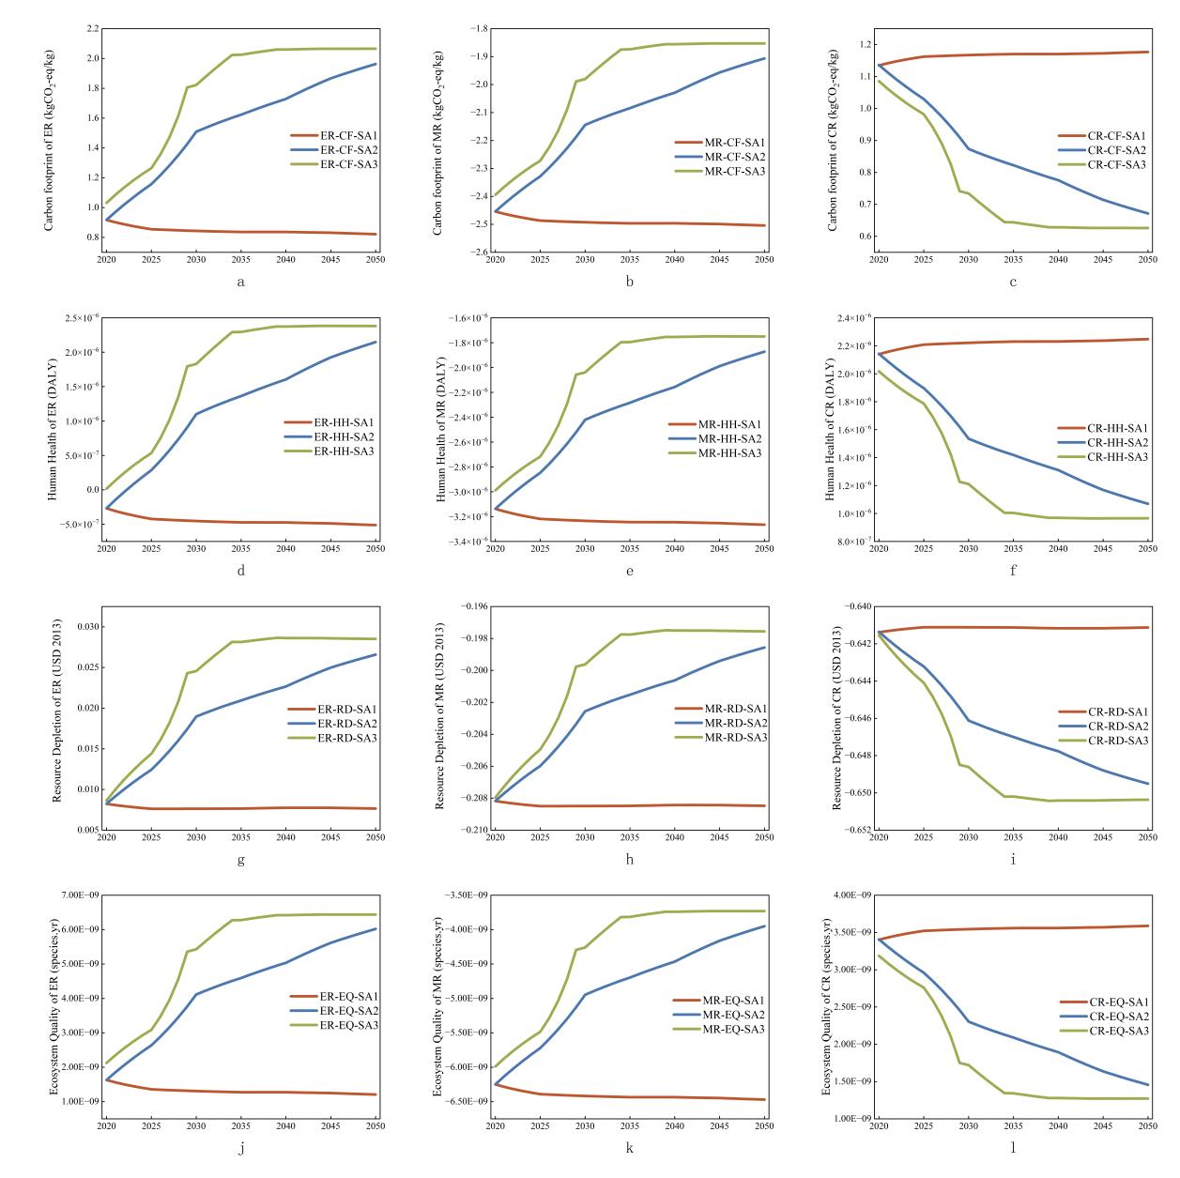
Figure S10. The scenario analysis of ER, MR and CR from 2020 to 2050 under three decarbonization of power grids. From a-c are the carbon footprint variety of ER, MR and CR from 2020 to 2050; From d-f are the human health changes of them from 2020 to 2050; From g-i are the resource depletion changes of them from 2020 to 2050; From j-l are the ecosystem quality changes of them from 2020 to 2050. The red line represents the results under SA1, the blue line represents the results under SA2, the green line represents the results under SA3.

For three types of PVC waste recycling methods, the scenario analysis results of them are shown in Figure S10. We can find that for three types recycling methods, the change tendency of carbon footprint, human health, and ecosystem quality are similar, while the values of them are different, but for the initial value of resource depletion are same nearly under three scenarios, which is caused by the resource depletion impact of electricity are equaled almost under decarbonization of power grid scenarios (0.0191USD, 0.0191USD, 0.0188USD). Based on the environmental impact results of ER, we find that when keep the dominant of thermal generation in structure of power grid as the scenario 1, the carbon footprint, human health, resource depletion and ecosystem quality impacts decreased by 10.39%, 1300.04%, 6.99%, and 25.84%, due to the deduction of regenerated electricity, the initial value of human health is too small that the change ratio from is more big than others. However once the decarbonztion of power grid with the renewable energy development, the situation is starting to veer under SA2 and SA3. Specially, under SA3, which is the deep decarbonization scenario, the carbon footprint, human health, resource depletion and ecosystem quality impacts increased by 100.32%, 15148.10%, 229.39%, 202.79%, the more decarbonization of power grid, the more increasing of environmental impacts, resulting from the deduction of regenerated electricity decrease much by the low environmental impact with year variation.
From the figure b,e,f,k, we find a different condition for environmental impacts of PVC waste MR process that under scenario 1, the four environmental impacts all decrease by 2.03%, 4.05%, 0.14%, 3.53% , by analyzing of the calculation process, it was found that it was due to the simultaneous scenario analysis of the upstream electricity consumption in the production process of PVC particles that can be avoided by recycling products. In SA1, the environmental footprints of electricity increased, and the environmental footprints of the corresponding amount of PVC particles produced also increased . In addition, the electricity consumption in the MR process was very low, and the increase in indirect effects was not as fast as the deduction amount of recycled products. In SA2 and SA3, the environmental impacts increase variation ratio are near 22.31%, 40.32%, 4.61%, 36.79% and 22.62%, 41.44%, 5.00%, 37.70% for the carbon footprint, human health, resource depletion and ecosystem quality impacts respectively, the increasing condition stems from the environmental impacts of electricity, which inducing the indirect impacts from electricity both consumption and offset go down.
The environmental footprint changes of CR process are different from those of ER and MR. The key factor is the electricity consumption accounting main contribution of environmental impacts, which is higher than the electricity consumption from the upstream of recycled materials. Therefore, under SA1, the electricity environmental impacts change from small to big, the CR environmental impacts follow the change to vary by 3.72%, 5.03%, 0.04%, 5.48%. According to the results of the carbon footprint, human health, resource depletion and ecosystem quality impacts under SA2 and SA3, those environmental impacts have changed by -40.89%, -50.10%, -1.27%, -57.24%, and -42.34%, -52.12%, -1.38%, -60.10%, indicating that the deep decarbonization of power grid benefits the development of CR method. Additionally from the contribution analysis, we known that the most contributor of environmental impacts can be divided into two parts: one is the electricity consumption, two is the material consumption, however, in this study,we didn’t consider the decarbonization of upstream electricity consumption from input materials, which will cause the environmental impacts results of CR higher than reality. The input materials of ER and MR are too little to finding the significant change after decarbonizing the upstream electricity of input materials, but for CR, the input material of NaOH accounts for 1/3 environmental impacts almost, and during the production of NaOH, the electricity consumption occupies more than 76% of total environmental impacts.
In high-carbon scenario, the CR has the greatest potential, followed by ER, and ultimately CR. However, regardless of the decarbonization scenarios, the potential for MR is still the greatest, followed by CR, and ultimately ER. The planning of China's future power grid structure will develop more renewable energy, and the high carbon scenario does not conform to the actual situation. Therefore, under the future development trend, the potential of CR cannot be underestimated.

5. Sensitivity analysis of electricity and PVC waste amount
Table S10 The sensitivity of environmental impacts with electricity change
Sensitivity analysis of electricity | CF | HH | RD | EQ
-20% | 633.33 | 0.00056 | -28.83 | 1.73×10⁻⁶
-10% | 569.13 | 0.00041 | -30.32 | 1.46×10⁻⁶
0 | 504.93 | 0.00026 | -31.81 | 1.19×10⁻⁶
10% | 440.72 | 0.00011 | -33.29 | 9.18×10⁻⁷
20% | 376.52 | -4.51×10⁻⁵ | -34.78 | 6.47×10⁻⁷

Table S11 The sensitivity of environmental impacts with PVC waste amount
Sensitivity analysis of PVC waste amount | CF | HH | RD | EQ
-20% | 403.94 | 0.00021 | -25.44 | 9.52×10⁻⁷
-10% | 454.43 | 0.00023 | -28.63 | 1.07×10⁻⁶
0 | 504.93 | 0.00026 | -31.81 | 1.19×10⁻⁶
10% | 555.42 | 0.00028 | -34.99 | 1.31×10⁻⁶
20% | 605.91 | 0.00031 | -38.17 | 1.43×10⁻⁶

5. Provincial and interprovincial transportation models
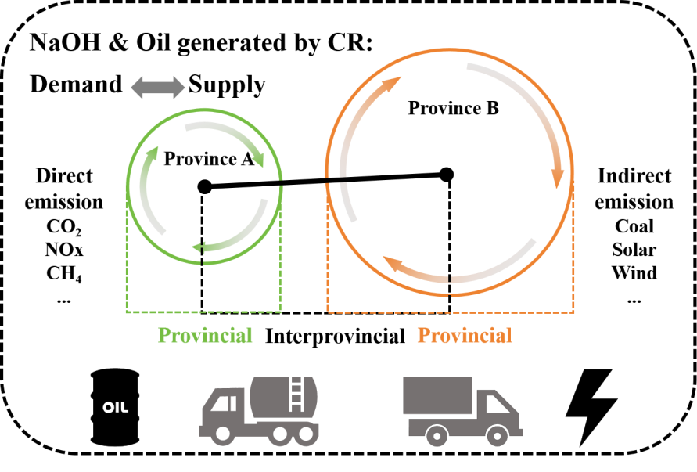
Figure S11. The concept of provincial and interprovincial transportation

When PVC waste is recycled, all the recycled materials should be used to supply the avoided materials, however, there are little research consider the transportation of recycled material in provincial and interprovincial by according the demand and supply in each province. Therefore, we conduct a transportation analysis with and between provinces to calculate the CR regenerated materials reusing and flowing.
Refer to Lu’s study (Lu 2023), we simply the provincial and interprovincial transportation models by only optimizing the CO2 emission from the transportation under balance the supply from CR recycled materials and the demand from different provinces.
The simplified objective function is expressed as:
$$minimize \sum_{i,j}{(W_{i,j}×D_{i,j}×c_{eff}×{EF}_{i,j})}$$
Main variables and parameters:
Transport weight Wi,j: Decision variable representing the weight of cargo transported from province i to province j.
Transport distance Di,j: Constant representing the distance from province i to province j.
Energy efficiency ceff: Constant indicating energy consumption per ton of cargo per kilometer, representing the electricity usage efficiency.
Electricity emission factor EFi,j: The emission factor associated with electricity usage for each province or city, indicating the carbon emissions per kWh.
Adjustable supply ASupi: The adjustable supply amount at each production center, constrained within a specified range.
Charging amount Cdepi,j and Cdesi,j: Charging amounts at the departure and destination points of province i to j, balancing electricity needs across locations.
Model constraints:
Supply-demand balance:
$${ASup}_{i}+\sum_{j=1}^{P}{W_{j,i}}={Dem}_{i}+\sum_{j=1}^{P}{W_{i,j}}$$
Where ASupi is the adjustable supply at province i, and Demi is the demand for province i.
Production adjustment limit:
$${ASup}_{i}≤\left(1+APC\right)×{Sup}_{i}$$
$${ASup}_{i}≥\left(1−APC\right)×{Sup}_{i}$$
Where APC is the allowable percentage adjustment for production allocation.
Energy consumption constraint:
$$E_{i,j}=W_{i,j}×D_{i,j}×c_{eff}$$
This calculates the total energy consumption for transporting goods from province i to province j.
Charging balance and battery capacity constraints:
$${US}_{i,j}+{Cdep}_{i,j}+{Cdes}_{i,j}+S_{i,j}=E_{i,j}$$
$${US}_{i,j}+{Cdep}_{i,j}≥W_{i,j}×B_{i,j}×c_{eff}$$
Where USi,j is the electricity stored from the previous trip, and Si,j is the stored electricity reserved for the next leg.
The optimization results for the regenerated NaCl and oil.
Table S12. The fossil-fueled vehicle transportation carbon footprint optimization results of NaCl
Year | Interprovincial carbon footprint | Provincial carbon footprint | Total carbon footprint
2020 | 6379.75 | 601.79 | 6981.54
2030 | 30413.92 | 2698.75 | 33112.66
2040 | 44127.67 | 4495.76 | 48623.43
2050 | 30674.59 | 7600.76 | 38275.35

Table S13. The electric vehicle transportation carbon footprint optimization results of NaCl under SA1
Year | Interprovincial carbon footprint | Provincial carbon footprint | Total carbon footprint
2020 | 7271.23 | 632.37 | 7903.60
2030 | 57977.71 | 4421.14 | 62398.85
2040 | 138159.22 | 13478.42 | 151637.64
2050 | 263815.94 | 26655.93 | 290471.87

Table S14. The electric vehicle transportation carbon footprint optimization results of NaCl under SA2
Year | Interprovincial carbon footprint | Provincial carbon footprint | Total carbon footprint
2020 | 6239.67 | 547.94 | 6787.60
2030 | 36044.98 | 2917.90 | 38962.88
2040 | 63617.59 | 5926.43 | 69544.02
2050 | 48206.40 | 9479.10 | 57685.50

Table S15. The electric vehicle transportation carbon footprint optimization results of NaCl under SA3
Year | Interprovincial carbon footprint | Provincial carbon footprint | Total carbon footprint
2020 | 6379.75 | 601.79 | 6981.54
2030 | 30413.92 | 2698.75 | 33112.66
2040 | 44127.67 | 4495.76 | 48623.43
2050 | 30674.59 | 7600.76 | 38275.35

Table S16. The fossil-fueled vehicle transportation carbon footprint optimization results of oil
Year | Interprovincial carbon footprint | Provincial carbon footprint | Total carbon footprint
2020 | 9249.73 | 7249.00 | 16498.72
2030 | 71973.10 | 56405.19 | 128378.28
2040 | 159798.60 | 125233.88 | 285032.48
2050 | 281265.60 | 220427.35 | 501692.95

Table S17. The electric vehicle transportation carbon footprint optimization results of oil under SA1
Year | Interprovincial carbon footprint | Provincial carbon footprint | Total carbon footprint
2020 | 6763.74 | 1521.69 | 8285.44
2030 | 53761.25 | 13070.81 | 66832.07
2040 | 124863.43 | 48142.15 | 173005.59
2050 | 241229.92 | 113675.00 | 354904.92

Table S18. The electric vehicle transportation carbon footprint optimization results of oil under SA2
Year | Interprovincial carbon footprint | Provincial carbon footprint | Total carbon footprint
2020 | 5858.73 | 1051.58 | 6910.30
2030 | 33123.41 | 6881.17 | 40004.58
2040 | 57701.08 | 16548.21 | 74249.29
2050 | 41361.84 | 19024.27 | 60386.11

Table S19. The electric vehicle transportation carbon footprint optimization results of oil under SA3
Year | Interprovincial carbon footprint | Provincial carbon footprint | Total carbon footprint
2020 | 5804.14 | 2129.90 | 7934.04
2030 | 27833.34 | 5287.34 | 33120.68
2040 | 40511.33 | 9226.42 | 49737.75
2050 | 29373.49 | 11338.61 | 40712.10
Regard of the optimal condition, we calculated other environmental impacts of NaCl and oil transportation under the best scenario-SA1. The results are shown below:
Table S20. The fossil-fueled vehicle transportation carbon footprint optimization results of NaCl
Year | Ecosystem quality(MT*specie.yr)_ | Human health(MT*DALY) | Resource depletion(MT*USD)
2020 | 0.046 | 19.99 | 1960943.52
2030 | 0.26 | 153.44 | 15239855.63
2040 | 0.59 | 339.26 | 33825879.35
2050 | 1.01 | 597.13 | 59538304.24

Table S21. The electric vehicle transportation carbon footprint optimization results of NaCl under SA1
Year | Ecosystem quality(MT*specie.yr)_ | Human health(MT*DALY) | Resource depletion(MT*USD)
2020 | 0.050 | 30.10 | 289587.03
2030 | 0.12 | 84.08 | 939758.95
2040 | 0.081 | 85.57 | 1340413.31
2050 | 0.14 | 150.23 | 2395448.03

Table S22. The fossil-fueled vehicle transportation carbon footprint optimization results of oil
Year | Ecosystem quality(MT*specie.yr)_ | Human health(MT*DALY) | Resource depletion(MT*USD)
2020 | 0.016 | 6.79 | 665517.97
2030 | 0.088 | 52.08 | 5172202.89
2040 | 0.20 | 115.14 | 11480050.52
2050 | 0.34 | 202.66 | 20206503.68

Table S23. The electric vehicle transportation carbon footprint optimization results of oil under SA1
Year | Ecosystem quality(MT*specie.yr)_ | Human health(MT*DALY) | Resource depletion(MT*USD)
2020 | 0.018 | 11.00 | 105872.81
2030 | 0.044 | 30.74 | 343575.18
2040 | 0.031 | 31.28 | 490054.13
2050 | 0.051 | 54.92 | 875774.06

This model allows flexibility in production allocation, enabling the selection of optimal transportation and charging routes according to the differences in electricity emission factors in each location. The model optimizes logistics by adjusting transport routes, charging distribution, and production allocations across centers to achieve minimum carbon emissions.
1. Cudjoe et al. (2022) Plasma gasification versus incineration of plastic waste: Energy, economic and environmental analysis. Fuel Processing Technology 237 107470.https://doi.org/https://doi.org/10.1016/j.fuproc.2022.107470
2. Sun et al. (2003) Suppressing effect of CaCO3 on the dioxins emission from poly(vinyl chloride) (PVC) incineration. Polymer Degradation and Stability 79 253-256.https://doi.org/https://doi.org/10.1016/S0141-3910(02)00288-4
3. Wang (2024) Doctor Zhejiang University. https://doi.org/10.27461/d.cnki.gzjdx.2024.000024.
4. China (2019).https://www.codeofchina.com/standard/GB18485-2014XG1-2019.html.
5. Han et al. (2024) Carbon feasibility of terminating plastic waste leakage by landfill mining: A case study based on practical projects in China. Science of The Total Environment 906 167461.https://doi.org/https://doi.org/10.1016/j.scitotenv.2023.167461
6. Lu et al. (2020) Combined experiment, simulation, and Ex-ante LCA approach for sustainable Cl recovery from NaCl/ethylene glycol by electrodialysis. Industrial & Engineering Chemistry Research 59 20112-20122.https://doi.org/10.1021/acs.iecr.0c03565
7. Tang et al. China’s Sustainable Energy Transition Path to Low-Carbon Renewable Infrastructure Manufacturing under Green Trade Barriers. Sustainability. 2024 (10.3390/su16083387).
8. Bi (2023) Master Shandong University. https://doi.org/10.27272/d.cnki.gshdu.2022.004196.
9. Lu et al. (2023) Emission reductions from heavy-duty freight electrification aided by smart fleet management. Transportation Research Part D: Transport and Environment 121.https://doi.org/10.1016/j.trd.2023.103846

