Supplementary Information

Balancing High Entropy Complexity and Defects for Efficient Green Hydrogen Production

Dongliang Zhang^{1†}, Fei Wei^{1†}, Yinbo Zhan¹, Haijiao Lu², Guoqiang Shen³, Xufang Qian^{4*} and Xia Long^{1*}
¹China-UK Low Carbon College, Shanghai Jiao Tong University, Shanghai, 201306, Shanghai, China.
²Nanomaterials Centre, School of Chemical Engineering, Australian Institute for Bioengineering and Nanotechnology, The University of Queensland, St Lucia, 4072, Queensland, Australia.
³College of Smart Energy, Shanghai Jiao Tong University, Shanghai, 200240, China
⁴School of Environmental Science and Engineering, Shanghai Jiao Tong University, Shanghai, 200240, Shanghai, China.
* Corresponding author(s). E-mail(s): x.long@sjtu.edu.cn; qianxufang@sjtu.edu.cn
†These authors contributed equally to this work.

METHODS

1.1 Materials
Iron nitrate nonahydrate (Fe(NO₃)₃·9H₂O, 98.5%), cobalt nitrate hexahydrate (Co(NO₃)₂·6H₂O, 99.99%), zinc nitrate hexahydrate (Zn(NO₃)₂·6H₂O, 99%), manganese chloride tetrahydrate (MnCl₂·4H₂O, 99.7%), were purchased from Sinopharm Chemical Reagent. Nickel nitrate hexahydrate (Ni(NO₃)₂·6H₂O, 99%) was bought from Shanghai Titan Scientific Co., Ltd. Aluminum nitrate nonahydrate (Al(NO₃)₃·9H₂O, 99%) was purchased from Shanghai Aladdin Biochemical Technology Co., Ltd.
1.2 Synthesis of FeAlNiCoZn High-Entropy Layered Double Hydroxide (HE-LDH).
FeAlNiCoZn HE-LDH was synthesized via a hydrothermal method. Ferric nitrate nonahydrate (Fe(NO₃)₃·9H₂O, 0.003 mol) and aluminum nitrate nonahydrate (Al(NO₃)₃·9H₂O, 0.003 mol) were used as trivalent cation sources, while cobalt nitrate hexahydrate (Co(NO₃)₂·6H₂O, 0.004 mol), nickel nitrate hexahydrate (Ni(NO₃) ₂·6H₂O, 0.004 mol), and zinc nitrate hexahydrate (Zn(NO₃)₂·6H₂O, 0.004 mol) served as divalent cation precursors. All metal salts were dissolved in 20 mL of deionized water under vigorous stirring to form a homogeneous precursor solution. Separately, sodium carbonate (Na₂CO₃, 1.696 g) and sodium hydroxide (NaOH, 1.536 g) were dissolved in 20 mL of deionized water to prepare an alkaline solution. The two solutions were simultaneously added dropwise into a reaction vessel under continuous stirring to promote coprecipitation. After aging for 30 min, the resulting suspension was transferred into a Teflon-lined stainless-steel autoclave and maintained at 100 ℃ for 24 h. The obtained solid was collected by centrifugation, washed several times with deionized water and ethanol, and dried at 70 ℃ for 12 h to yield FeAlNiCoZn HE-LDH powder.
1.3 Synthesis of Vacancy-Engineered FeAlNiCoZn HE-LDH (HE-D-LDH)
To introduce vacancies, the as-prepared FeAlNiCoZn HE-LDH powder was dispersed in 3 M NaOH solution and stirred at room temperature for 0.5 h. The resulting product was separated by centrifugation, washed repeatedly with deionized water until neutral, and dried at 70 ℃ for 12 h.
1.4 Synthesis of Mn-Doped FeAlNiCoZn HE-LDH with Vacancy (HE-D-Mn-LDH)
The Mn-doped vacancy-engineered FeAlNiCoZn high-entropy layered double hydroxide (HE-D-Mn-LDH) was synthesized based on the as-prepared vacancy-engineered FeAlNiCoZn HE-LDH (HE-D-LDH). The obtained HE-D-LDH powder was dispersed in a 0.05 M MnCl₂ aqueous solution and stirred at room temperature for a designated period to allow Mn species to interact with and occupy the pre-generated cation vacancies. After the adsorption process, the solid product was collected by centrifugation, washed several times with deionized water to remove residual Mn²⁺ ions, and dried at 70 °C for 12 h. The resulting material was denoted as HE-D-Mn-LDH.

1.5 Synthesis of FeAlNiCoZnMn Layered Double Hydroxides
FeAlNiCoZnMn layered double hydroxide was synthesized via a hydrothermal method similar to that used for FeAlNiCoZn HE-LDH, with Mn introduced through direct elemental incorporation. Ferric nitrate nonahydrate (Fe(NO₃)₃·9 H₂O, 0.003 mol) and aluminum nitrate nonahydrate (Al(NO₃)₃·9 H₂O, 0.003 mol) were used as trivalent cation sources. Cobalt nitrate hexahydrate (Co(NO₃)₂·6 H₂O, 0.003 mol), nickel nitrate hexahydrate (Ni(NO₃)₂·6H₂O, 0.003 mol), zinc nitrate hexahydrate (Zn(NO₃)₂·6H₂O, 0.003 mol), and manganese nitrate tetrahydrate (Mn(NO₃)₂·4 H₂O, 0.003 mol) served as divalent metal precursors. All metal salts were dissolved in 20 mL of deionized water under vigorous stirring to form a homogeneous precursor solution. Separately, sodium carbonate (Na₂CO₃, 1.696 g) and sodium hydroxide (NaOH, 1.536 g) were dissolved in 20 mL of deionized water to prepare an alkaline solution. The two solutions were simultaneously added dropwise into a reaction vessel under continuous stirring to promote coprecipitation. After aging for 30 min, the resulting suspension was transferred into a Teflon-lined stainless-steel autoclave and maintained at 100 °C for 24 h. The obtained solid was collected by centrifugation, washed several times with deionized water and ethanol, and dried at 70 °C for 12 h to yield FeAlNiCoZnMn LDH powder.

1.6 Characterization
The crystal structures of the as-prepared high-entropy layered double hydroxides (HE-LDHs) were analyzed by powder X-ray diffraction (XRD, Bruker D8 Advance) using Cu Kα radiation (λ = 1.5406 Å) over a 2θ range of 10–80°. The morphology, microstructure, and elemental distribution were examined using field-emission scanning electron microscopy (FE-SEM, ZEISS Sigma 300) equipped with an energy-dispersive X-ray spectroscopy (EDS) detector and high-resolution transmission electron microscopy (HRTEM, FEI Talos F200X G2). The average lateral size of nanosheets was statistically estimated based on the projected length of each platelet.
The surface chemical composition and oxidation states of the metal elements were investigated by X-ray photoelectron spectroscopy (XPS, Thermo Fisher Scientific ESCALAB 250Xi). All binding energies were calibrated with reference to the C 1s peak at 284.8 eV.
X-ray absorption spectroscopy (XAS) measurements, including X-ray absorption near-edge structure (XANES) and extended X-ray absorption fine structure (EXAFS), were carried out at the Fe, Co, Ni, Mn, and Zn K-edges on the beamline MEX-1 of the Australian Synchrotron. The energy scales were calibrated using the first inflection point in the first derivative of the corresponding metal foil spectra. The obtained EXAFS data were processed and fitted using Athena and Artemis software to analyze the local coordination environment and electronic structure of metal centers.[1]
Electron paramagnetic resonance (EPR) spectra were collected on a Bruker A300 spectrometer to evaluate the evolution of defect structures during etching process.
Faradaic efficiency measurements were conducted using an online gas chromatography system (Agilent 8860) in a sealed electrochemical cell.
Inductively coupled plasma optical emission spectroscopy (ICP-OES, Avio 200, PerkinElmer) was employed to determine the elemental concentrations in the electrolyte after electrochemical testing.
Raman and in situ Raman measurements were performed on a Renishaw Raman microscope equipped with a 532 nm excitation laser to investigate the structural evolution of catalysts under OER operating conditions.

1.7 Identification of Zn²⁺ using Zincon
Zn²⁺ ions in solution were identified by a colorimetric method using Zincon as the zinc-specific indicator.[2] Prior to analysis, the sample solution was acidified to eliminate possible hydroxide precipitates and then adjusted to alkaline conditions using an ammonia-based buffer. Zincon solution was subsequently added, and the mixture was allowed to react at room temperature.

1.8 Identification of Al³⁺ using Aluminon
Al³⁺ ions released into solution were qualitatively identified using Aluminon as a colorimetric indicator.[3] Briefly, the sample solution was first acidified with diluted nitric acid to dissolve any hydroxide species and subsequently adjusted to weakly acidic conditions using an acetate buffer. Aluminon solution was then added, and the mixture was gently shaken and allowed to stand at room temperature.

1.9 Electrochemical measurement
Electrochemical measurements were carried out on a CHI 760E electrochemical workstation using a standard three-electrode configuration. A platinum sheet was used as the counter electrode, and an Ag/AgCl (saturated KCl) electrode served as the reference electrode. The catalyst-coated nickel foam (1 × 1 cm²) was employed as the working electrode.
To prepare the catalyst ink, 1 mg of catalyst powder was first ultrasonically dispersed in 200 μL of ethanol to form a uniform suspension. Subsequently, 200 μL of 6 wt% PTFE dispersion was added, and the mixture was sonicated again until a turbid suspension was obtained. The resulting ink was drop-cast onto pre-cleaned nickel foam and dried at room temperature to prepare the working electrode.
All electrochemical tests were performed in 1.0 M KOH aqueous electrolyte at room temperature. The cyclic voltammetry (CV) measurements were cycled at a scan rate of 10 mV/s for 100 times before other electrochemical tests.
LSV measurements were conducted with scan rate of 5 mV/s and presented with 95% iR compensation.
Tafel slope tests were conducted with scan rate of 1 mV/s and presented without iR compensation.
Electrochemical impedance spectroscopy (EIS) analyses were conducted at 1.53 V vs RHE with the frequency ranging from 100 kHz to 0.01 Hz.
The electrochemical double-layer capacitance (C_{dl}) was determined from cyclic voltammetry (CV) measurements in the non-Faradaic region at scan rates ranging from 20 to 100 mV/s.
Chronopotentiometry (CP) was carried out under a high constant current density of 100 mA/cm² with 1 M KOH as electrolyte and room temperature.
All potentials were calibrated with reversible hydrogen electrode (RHE) by the Nernst equation: E_{RHE} (V) = E + 0.059*pH + 0.197 and the overpotential was calculated as E_{RHE} (V) - 1.23.
1.10 Calculation of Configurational Entropy
The configurational entropy ($S_{config}$) of the multicomponent LDH systems was calculated based on the molar fractions of the constituent metal cations, assuming a random distribution of cations within the metal hydroxide layers. The configurational entropy was evaluated using the classical Boltzmann expression:
$$\begin{aligned}S_{config}=-R\sum_{i=1}^{n}{c_{i}}\ln{c_{i}}\#\left(1\right)\end{aligned}$$
where $R$is the universal gas constant, $c_{i}$is the molar fraction of the $i$-th metal cation, and $n$is the total number of distinct metal species in the LDH lattice. The molar fractions were determined from quantitative compositional analyses (XPS), and the entropy values are reported in units of $R$ for direct comparison among different samples. This approach enables quantitative tracking of entropy evolution induced by defect engineering and dopant incorporation.
1.11 Calculation of Lattice Distortion Parameter (δ)
To quantify lattice distortion arising from atomic size mismatch in the multicomponent LDH system, the lattice distortion parameter ($δ$) was employed. The parameter reflects the degree of local lattice strain caused by differences in ionic radii among constituent cations and was calculated according to the following equation:
$$\begin{aligned}δ=\sqrt{\sum_{i=1}^{n}{c_{i}}{\left(1 − \frac{r_{i}}{r }ˉ \right)}^{2}}×100\%\#\left(2\right)\end{aligned}$$
where $c_{i }$is the molar fraction of the $i$-th metal cation, $r_{i}$is the corresponding ionic radius, and $r ˉ$is the average ionic radius of all constituent cations, defined as:
$$\begin{aligned}r ˉ=\sum_{i=1}^{n}{c_{i}}r_{i}\#\left(3\right)\end{aligned}$$
The ionic radii were selected according to the appropriate coordination environment of metal cations in LDH structures. A larger $δ$value indicates a higher degree of atomic size mismatch and enhanced local lattice strain, whereas a smaller $δ$suggests more homogeneous accommodation of cation sizes and reduced average lattice distortion.
1.12 Determination of K-edge Positions
The Mn, Fe, Co, and Ni K-edge positions of the samples were determined from the normalized XANES spectrum and correlated with their average oxidation states by comparison with reference compounds. The K-edge positions of each transition metal were obtained using the integral method:[4]
An average edge energy $E_{”edge}”$is defined as:
$$\begin{aligned}E_{\text{edge}}=\frac{1}{μ_{1}-μ_{2}}\int_{μ_{1}}^{μ_{2}}{E\left(μ\right) dμ}\#\left(4\right)\end{aligned}$$
where $E\left(μ\right)$is the inverse function of the normalized XANES spectrum $μ\left(E\right)$.
Equivalently, the same $E_{”edge}“$value can be expressed as:
$$\begin{aligned}E_{\text{edge}}=E\left(μ_{1}\right)+\frac{1}{μ_{1}-μ_{2}}\int_{E\left(μ_{1}\right)}^{E\left(μ_{2}\right)}{\left[μ_{2}-μ\left(E\right)\right]} dE\#\left(5\right)\end{aligned}$$
For experimental XANES spectra, the function $μ\left(E\right)$is discrete and generally not strictly monotonic. As a consequence, the integration limits of the inverse function, $E\left(μ_{1}\right)$and $E\left(μ_{2}\right)$, are not uniquely defined. Therefore, numerical integration is performed using a truncated absorption function $\hat{μ}\left(E\right)$, defined as:
$$\begin{aligned}\hat{μ}\left(E\right)=\left\{\begin{matrix}μ_{1}, & μ\left(E\right)<μ_{1} \\ μ_{2}, & μ\left(E\right)>μ_{2} \\ μ\left(E\right), & \text{otherwise}\end{matrix}\right.\#\left(6\right)\end{aligned}$$
Accordingly, for all energy points within a suitably chosen interval $\left[E_{1} , E_{2}\right]$, the edge position is calculated as:
$$\begin{aligned}E_{\text{edge}}=E_{1}+\frac{1}{μ_{1}-μ_{2}}\int_{E_{1}}^{E_{2}}{\left[μ_{2}-\hat{μ}\left(E\right)\right]} dE\#\left(7\right)\end{aligned}$$
The calculated $E_{”edge}”$value is independent of the specific choices of the boundary energies $E_{1}$and $E_{2}$, provided that they satisfy the conditions $μ\left(E_{1}\right)<μ_{1}$and $μ\left(E_{2}\right)>μ_{2}$. In contrast, the value of $E_{”edge}”$ directly depends on the parameters $μ_{1}$and $μ_{2}$.
In this work, the lower integration limit was set to $μ_{1}=0.15$to minimize the influence of pre-edge features, while the upper limit was fixed at $μ_{2}=1.00$to ensure that the determined edge position is not strongly affected by variations in white-line intensity.
1.13 ECSA-normalized activity and TOF calculations
The electrochemically active surface area (ECSA) was estimated from the double-layer capacitance (C_{dl}) according to:
$$\begin{aligned}ECSA=\frac{C_{dl}}{C_{s}} \#\left(8\right)\end{aligned}$$
where (C_{s}) is the specific capacitance of a flat surface and was assumed to be 40 μF cm⁻². The ECSA-normalized current density was subsequently obtained by normalizing the geometric current density to the calculated ECSA.
To further evaluate the intrinsic catalytic activity, the turnover frequency (TOF) values were estimated at an overpotential of 300 mV according to:
$$\begin{aligned}TOF=\frac{j_{ECSA}N_{A}}{4FΓ} \#\left(9\right)\end{aligned}$$
where N_{A} is Avogadro’s constant, F is the Faraday constant, and the factor of 4 corresponds to the four-electron OER process. Γ is the assumed surface active-site density, which was taken as 1.0×10¹⁵ sites cm⁻²_{ECSA} for a conservative atomic-scale surface-site approximation.
1.14 Faradaic efficiency measurements
The Faradaic efficiency (FE) for hydrogen evolution was evaluated using a gas chromatography (GC) method in a sealed three-electrode electrochemical configuration. During the measurement, chronoamperometric electrolysis was conducted at a constant current density (0.1 A/cm²) in 1 M KOH electrolyte, while the generated hydrogen gas was periodically quantified by online gas chromatography.
The FE was subsequently calculated according to:
$$\begin{aligned}FE_{H_{2}}\left(\%\right)=\frac{n_{H_{2},measured}}{n_{theoretical}}×100\%=\frac{2F⋅n_{H_{2},measured}}{I}×100\%\#\left(10\right)\end{aligned}$$
where $n_{H_{2},measured}$ and $n_{theoretical}$ represent the experimentally measured and theoretically calculated amounts of hydrogen, respectively, $F$ is the Faraday constant (96485 C mol⁻¹), $I$ is the applied current.

Supplementary figures and tables
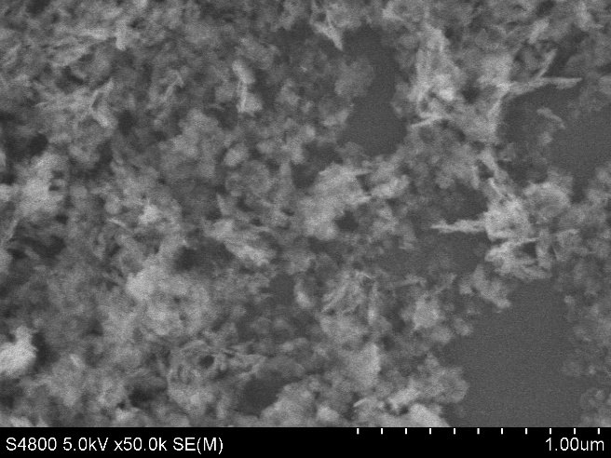
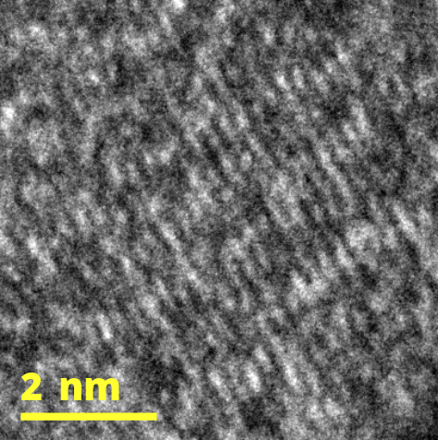
Figure S1.SEM images of the HE-LDH
0.227nm (015)
Figure S2. HRTEM images of the HE-LDH

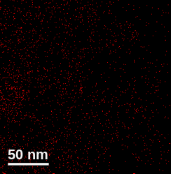
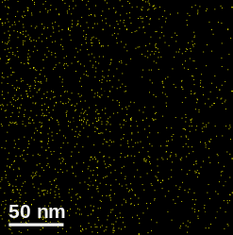
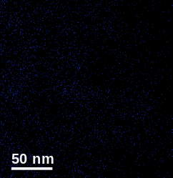
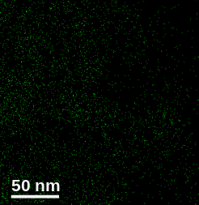
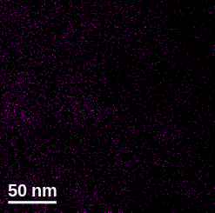
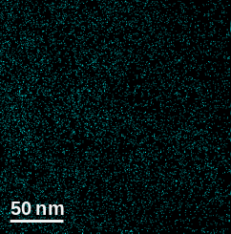
Figure S3. EDS-Mapping of HE-LDH.
Fe
Al
Ni
Co
Zn
O

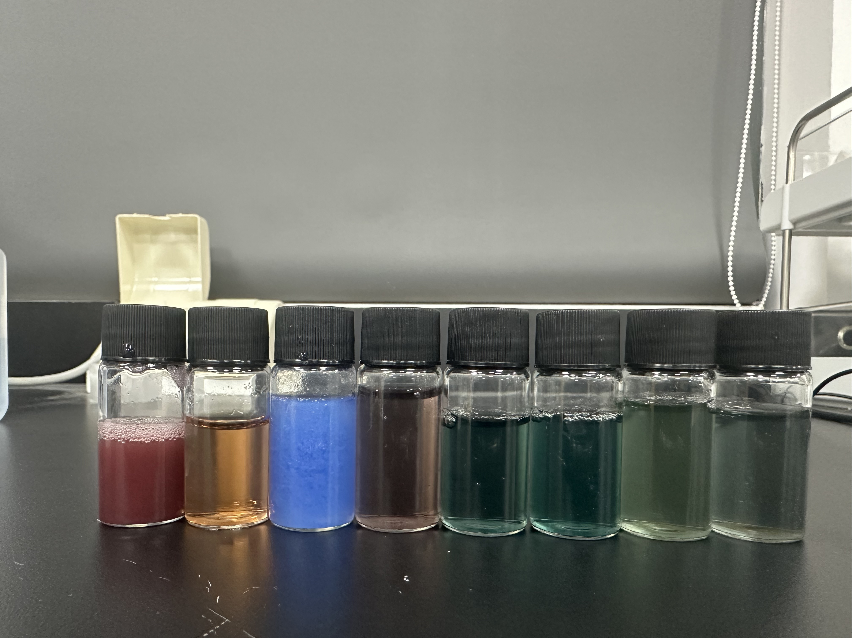
Figure S4. Qualitative colorimetric identification of Zn leaching during alkaline etching of FeAlNiCoZn-LDH.
Zincon
0.1%
DI
ZnSO4
FeNiCo-LDH

FeAlNiCoZn-LDH

0h
2h
0.5h
FeNiCoZn-LDH

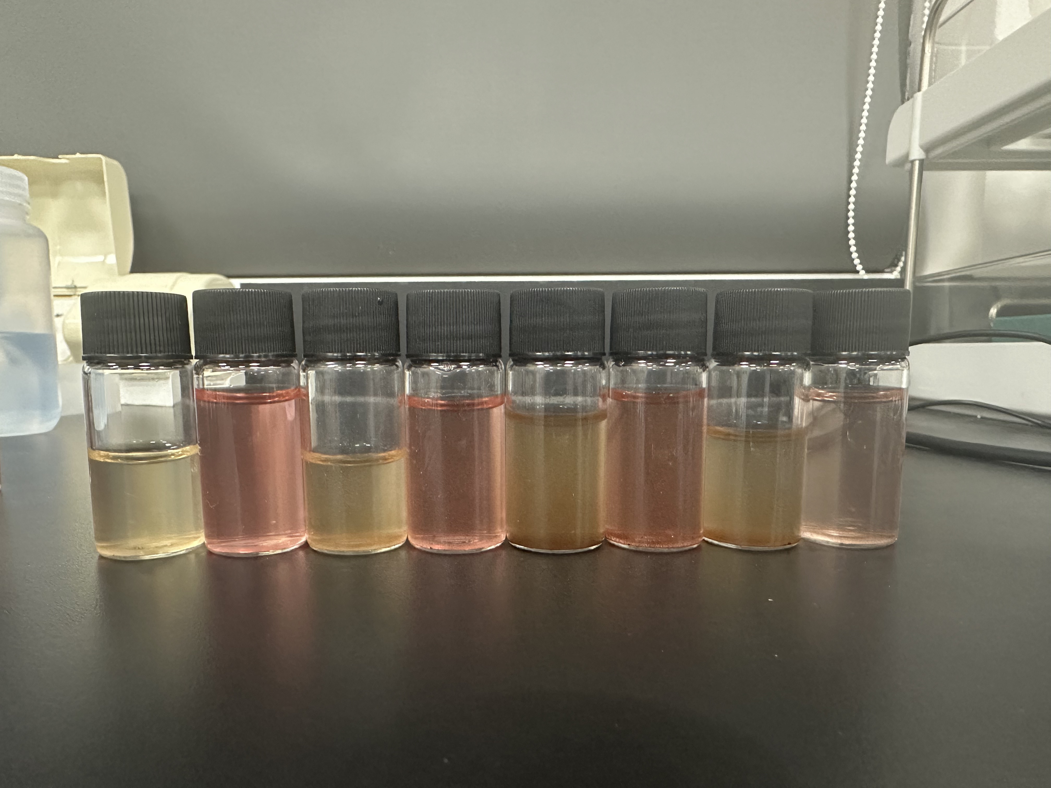
Figure S5. Qualitative colorimetric identification of Al leaching during alkaline etching of FeAlNiCoZn-LDH.
0h→
0.5h→
15h→
2h→

Figure S6. EPR spectra of pristine HE-LDH and etched samples collected after different alkaline etching durations.

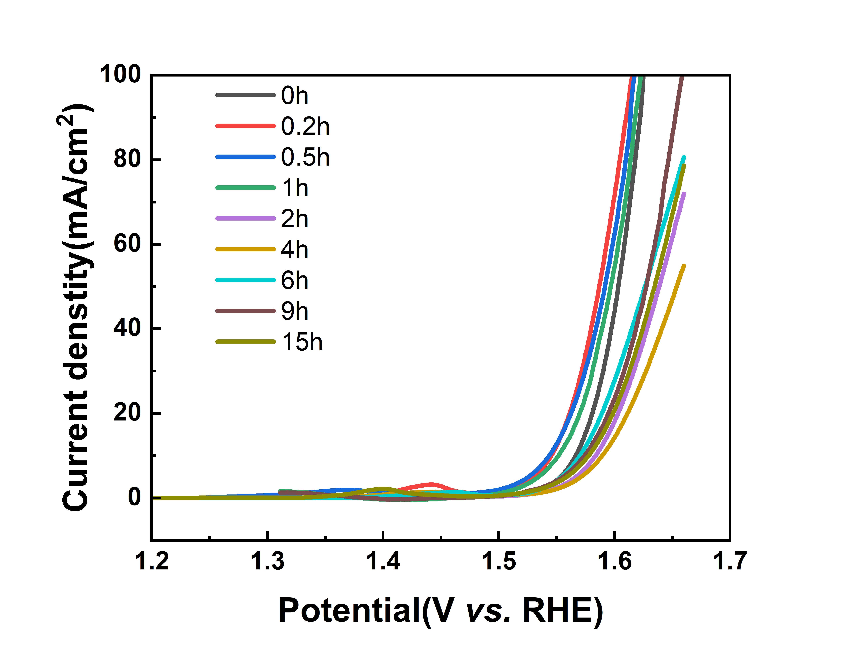
Figure S7. Linear sweep voltammetry (LSV) curves of FeAlNiCoZn LDH catalysts subjected to different alkaline etching times.

Figure S8. Tafel slope of FeAlNiCoZn LDH catalysts subjected to different alkaline etching times.

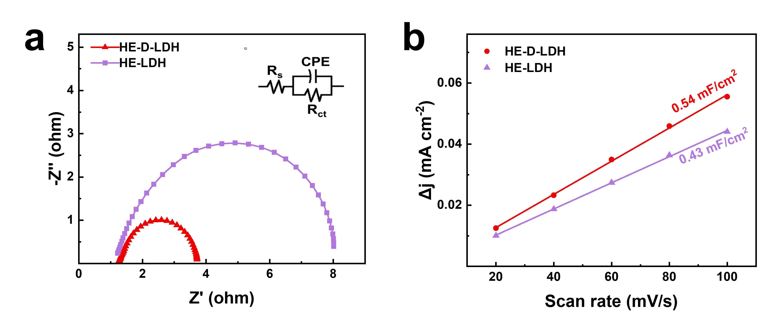
Figure S9. (a) Nyquist plots of the as-prepared LDHs. (b) The double layer capacitance slope values at different scanning rates.

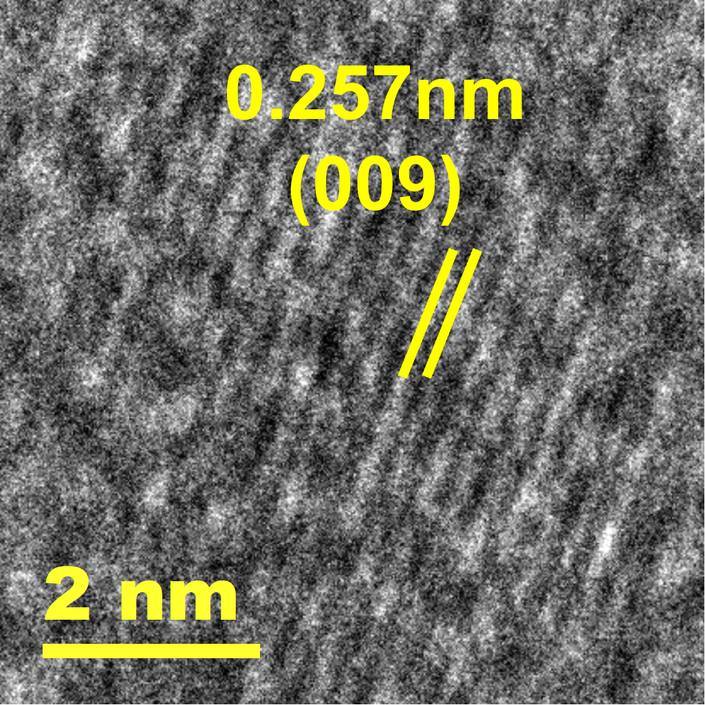
Figure S10. HRTEM images of the HE-D-Mn-LDH

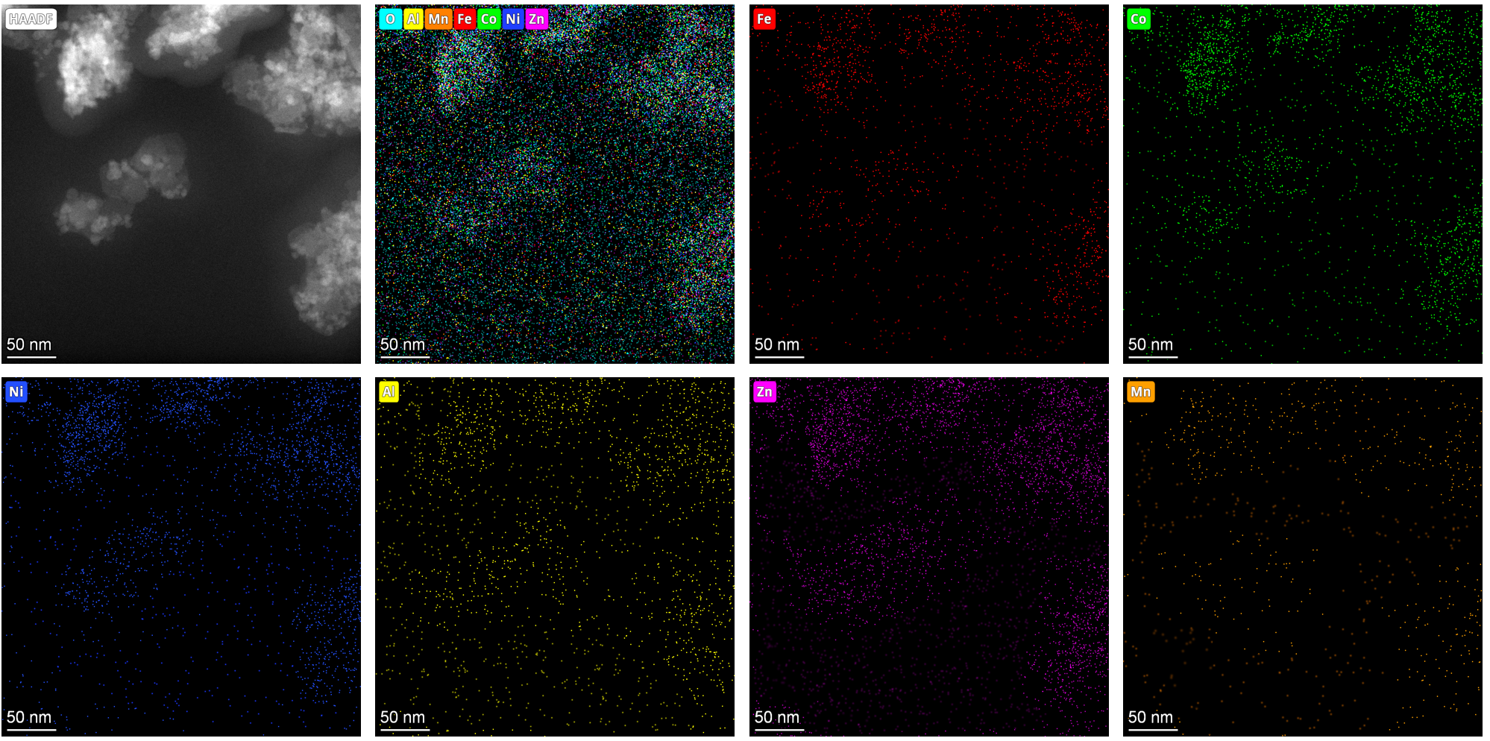
Figure S11. HAADF-STEM image and corresponding STEM-EDS elemental mappings of Fe, Al, Ni, Co, Zn, Mn, and O for HE-D-Mn-LDH.

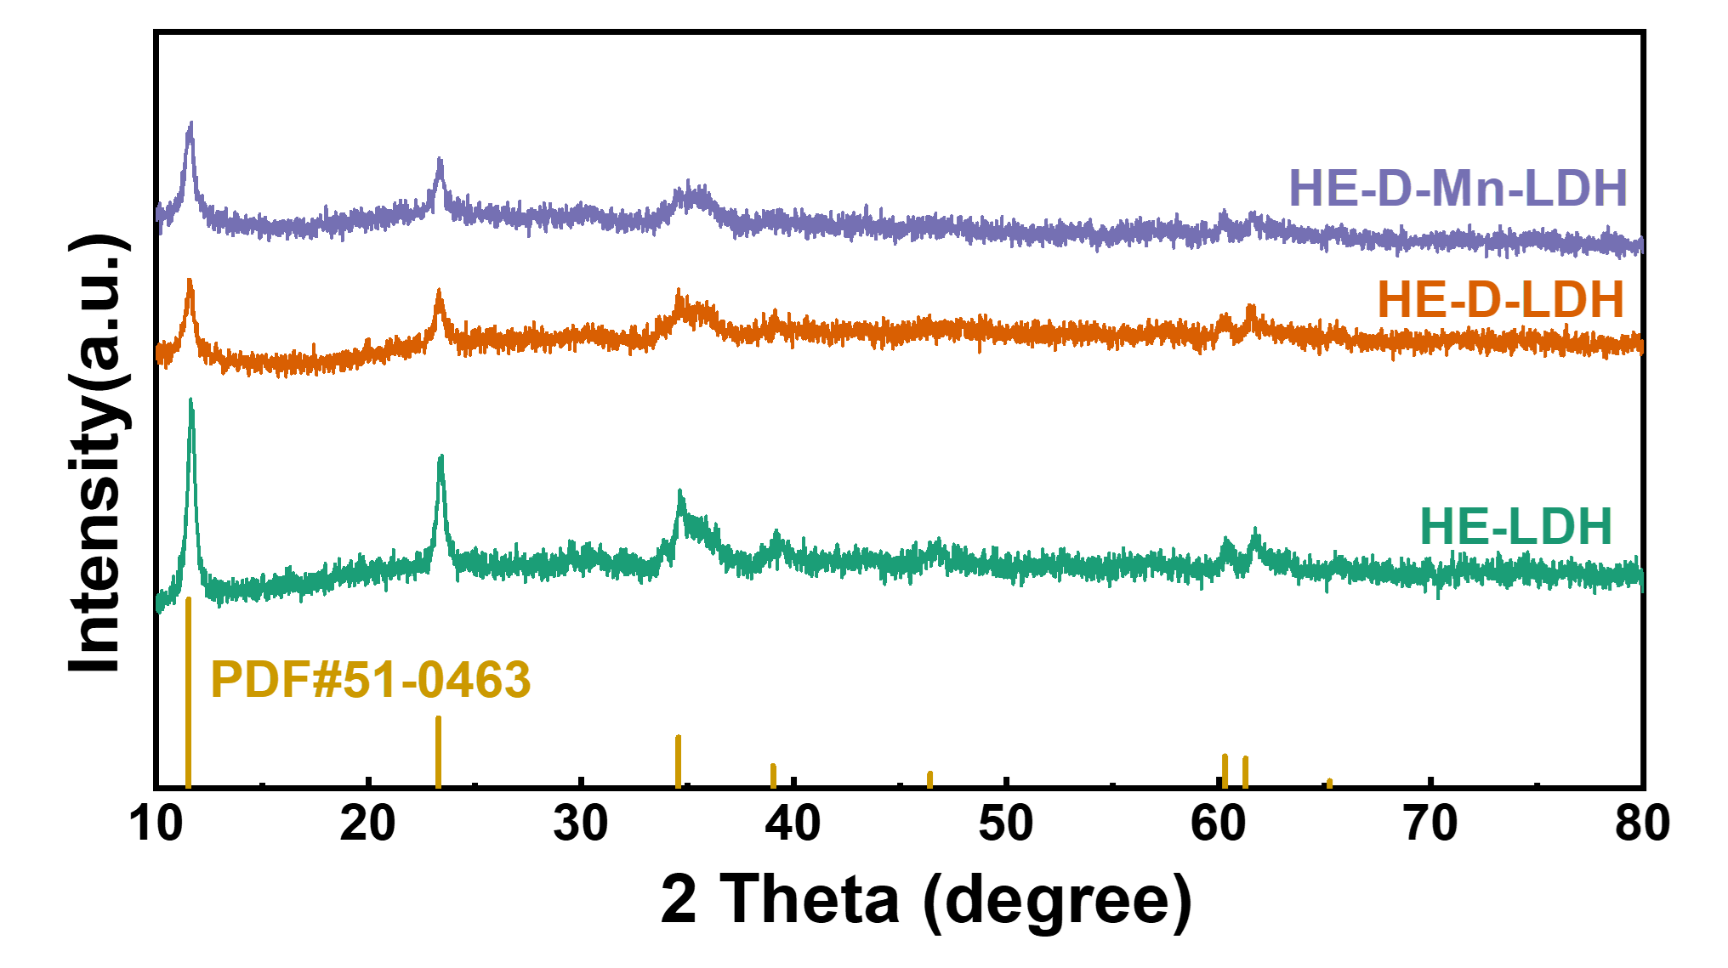
Figure S12. XRD patterns of HE-D-Mn-LDH.

Figure S13. High-resolution XPS spectra of HE-D-Mn-LDH. (a) Ni 2p, (b) Fe 2p and (c) Co 2p. (d) XPS survey spectrum.

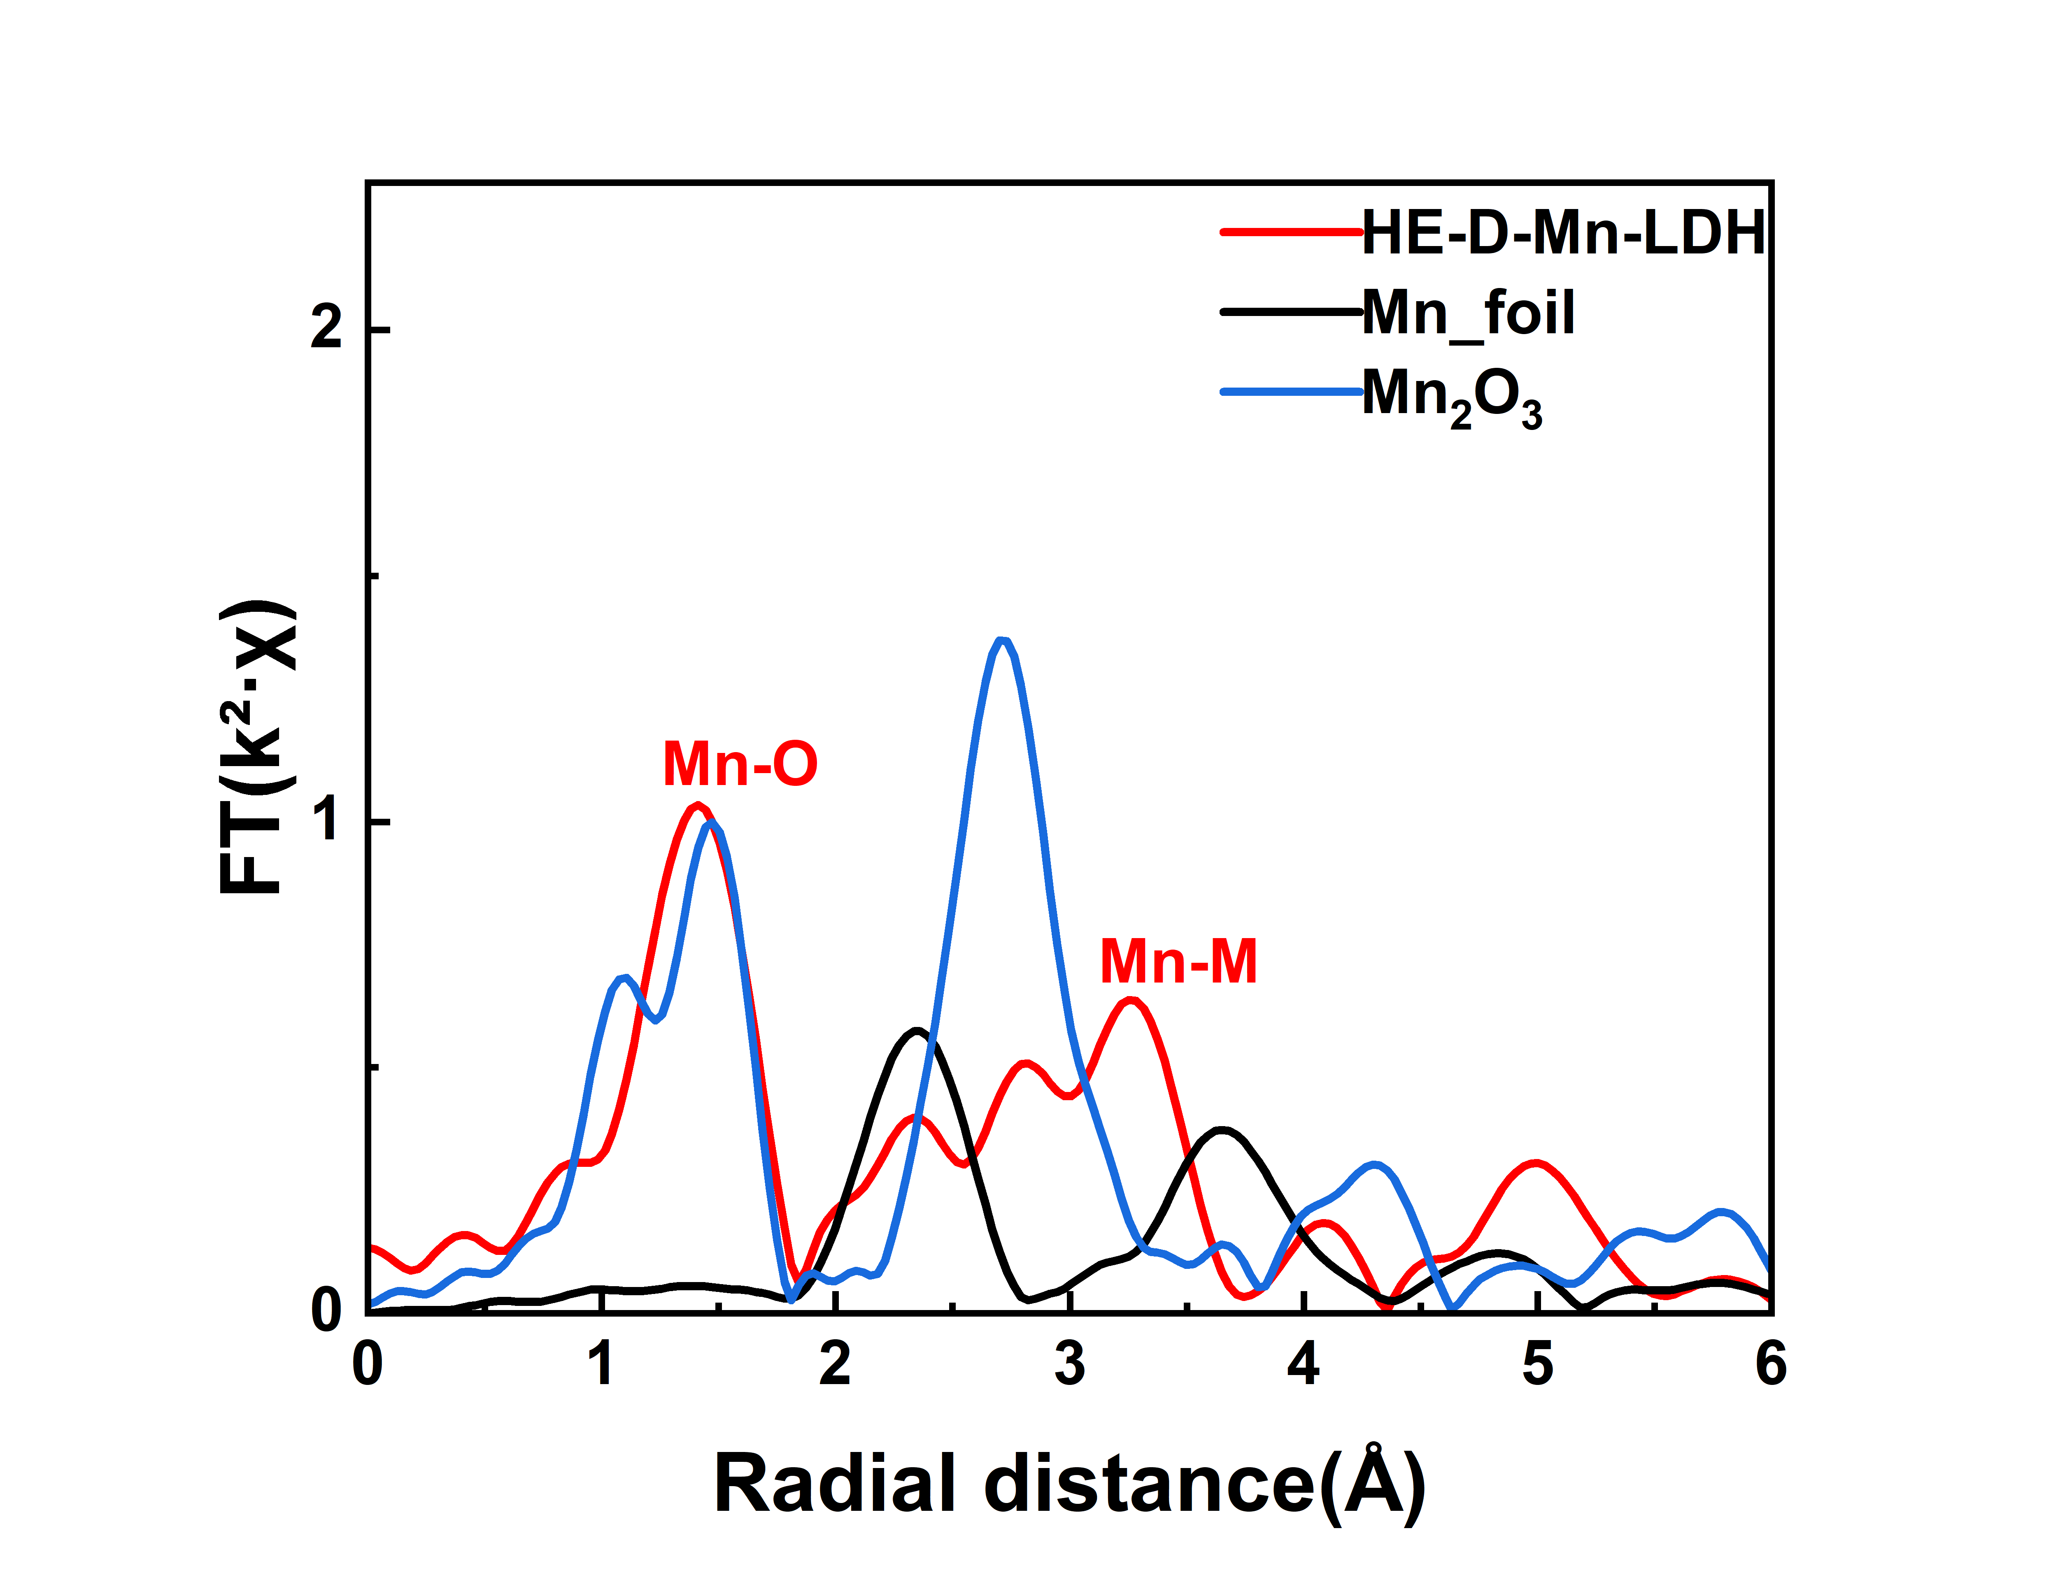
Figure S14. Fourier-transformed EXAFS spectra of HE-D-Mn-LDH and references at the Mn K-edges.

Figure S15. Faradaic efficiency measurement of HE-D-Mn-LDH during water electrolysis.

Figure S16. LSV curves of directly Mn-treated HE-LDH and the corresponding reference samples measured in 1.0 M KOH.

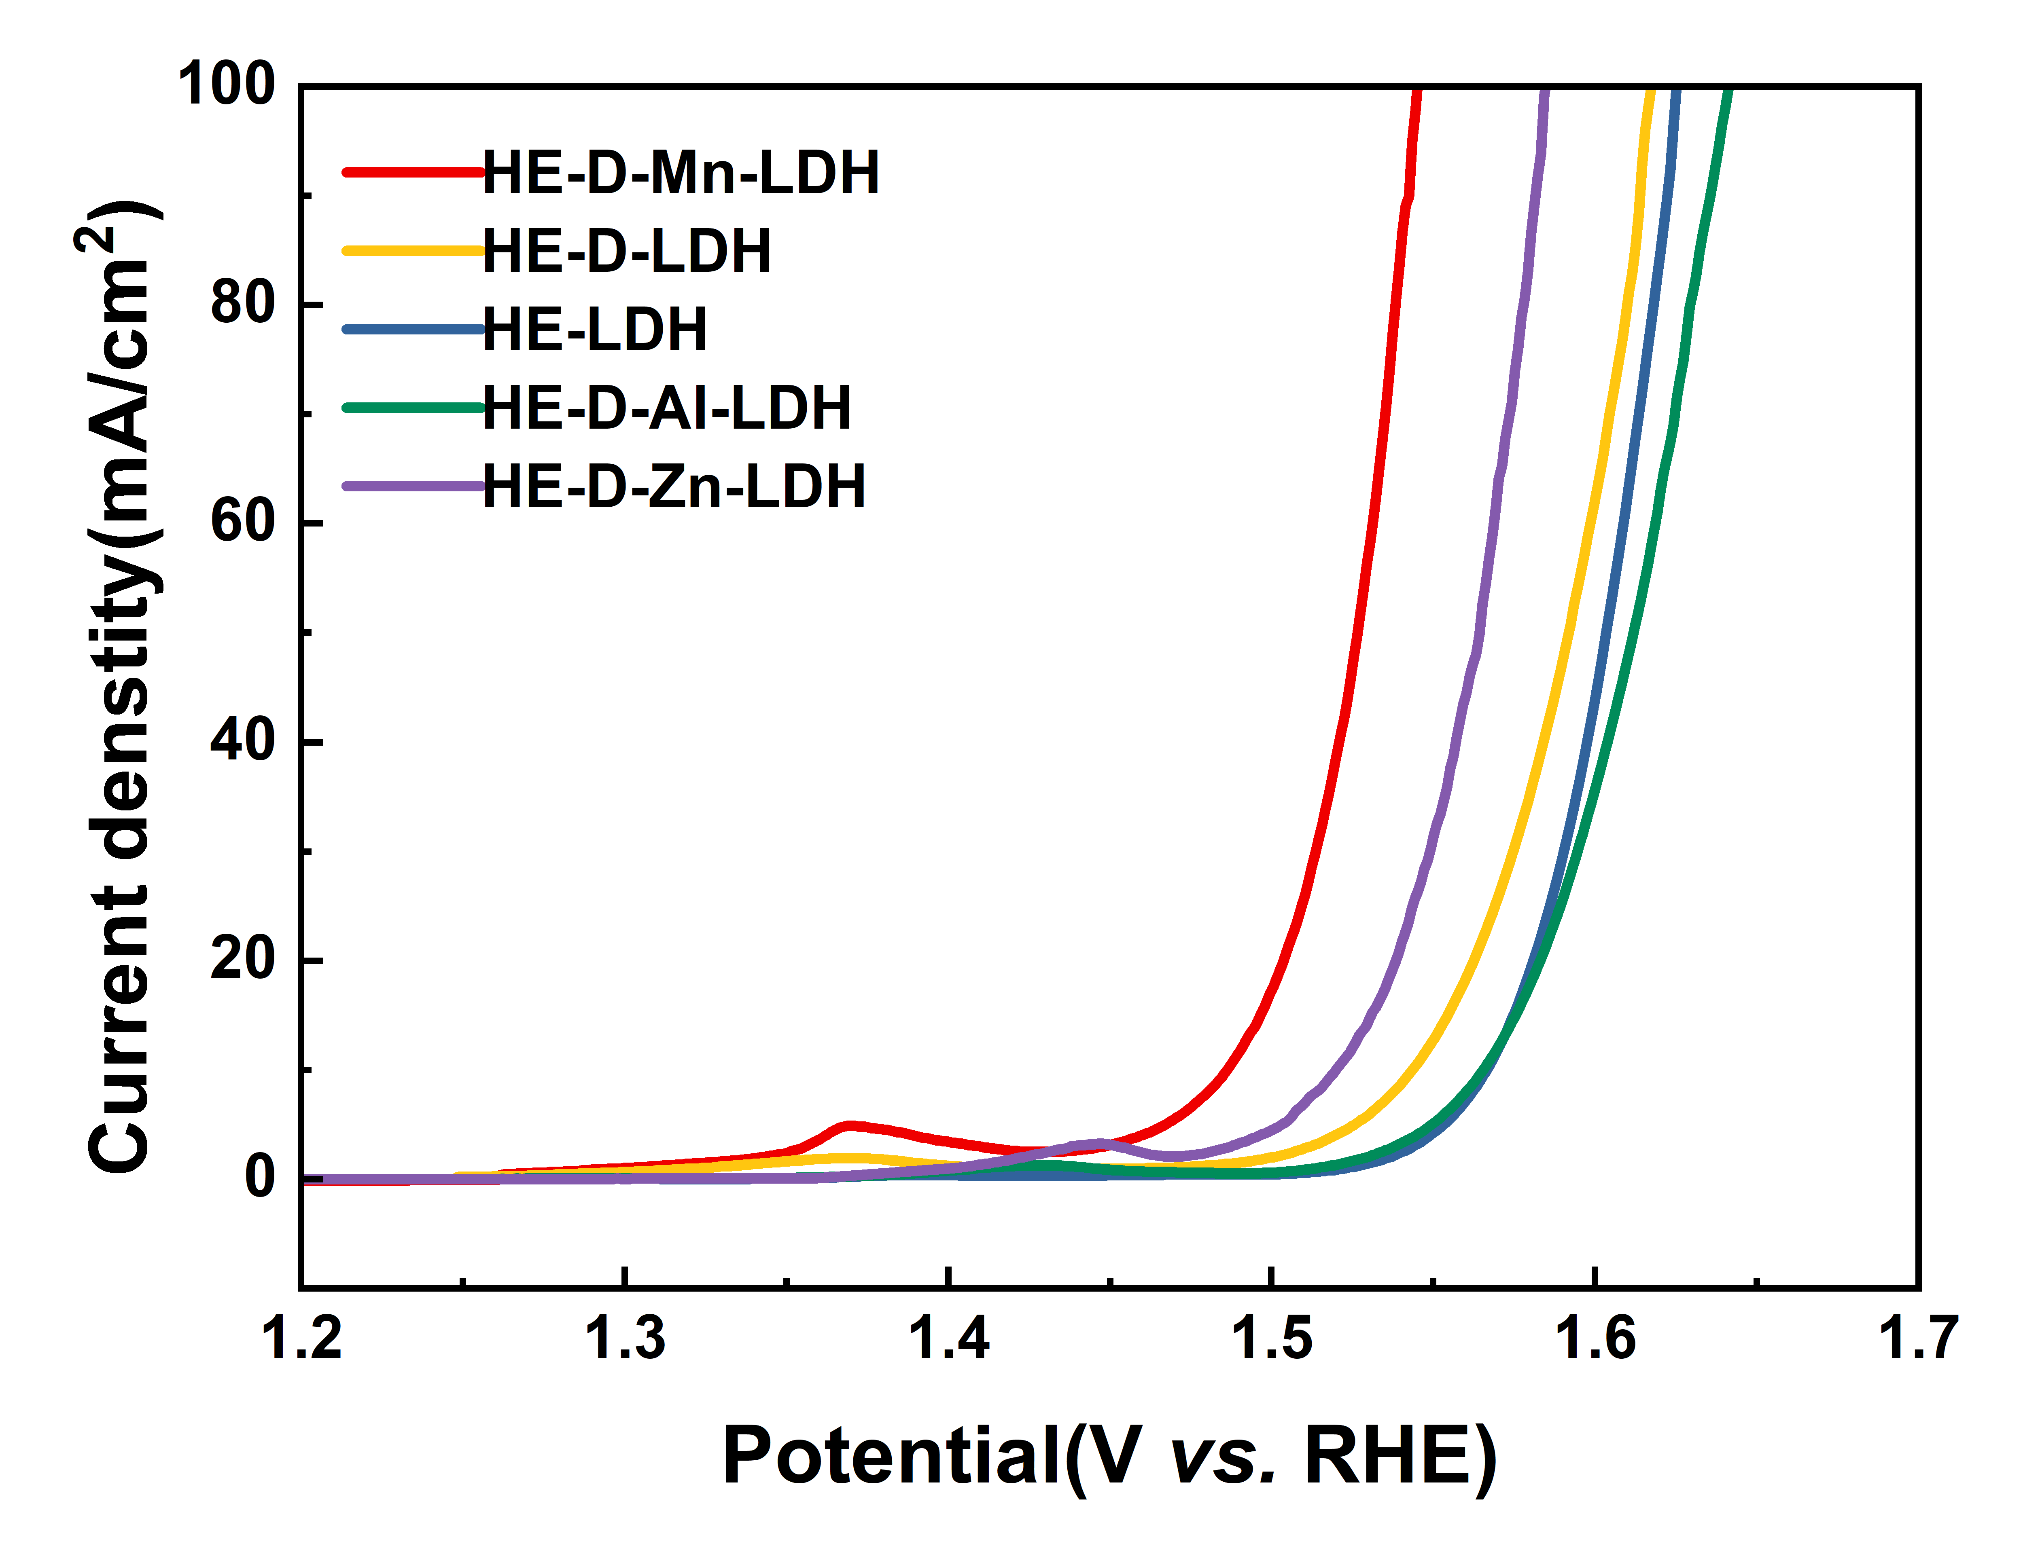
Figure S17. LSV curves of HE-D-LDH with different re-doping elements.
Figure S18. LSV curves of HE-D-LDH samples incorporated with different transition-metal dopants measured in 1.0 M KOH electrolyte.

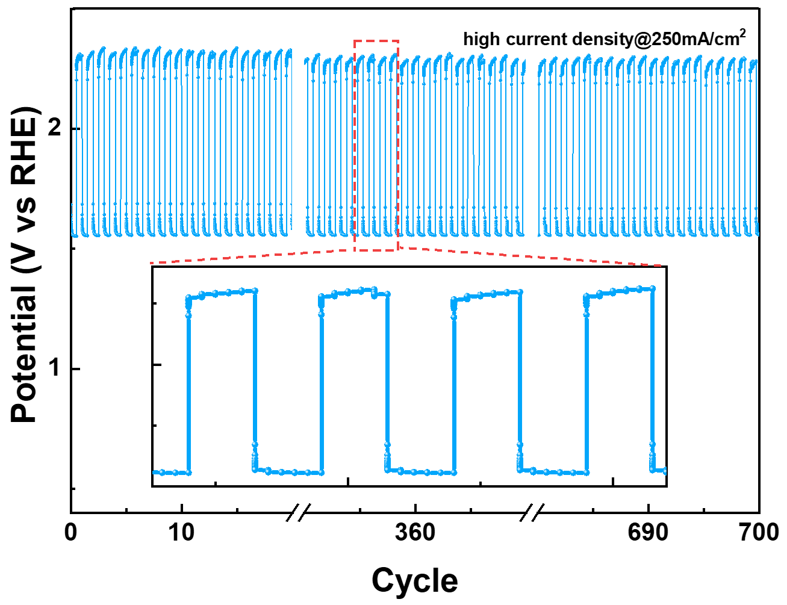
Figure S19. Chrono potentiometric response of HE-D-LDH under repeated current density switching between 1 and 250 mA/cm² with a holding time of 5 s per step.

Figure S20. Chronopotentiometric step test of HE-D-Mn-LDH under varied current densities. The current density was switched between 50, 100, and 150 mA/cm² with a half hour interval for each step.

Figure S21. XRD pattern of HE-D-Mn-LDH collected after the chronopotentiometric OER test.

Figure S22. In situ Raman spectra of (a) HE-LDH, (b) HE-D-Mn-LDH collected from OCP to 1.6 V vs. RHE in the range of 900–1200 cm⁻¹.

Figure S23. High-resolution O 1s XPS spectra of HE-LDH, HE-D-LDH, and HE-D-Mn-LDH.

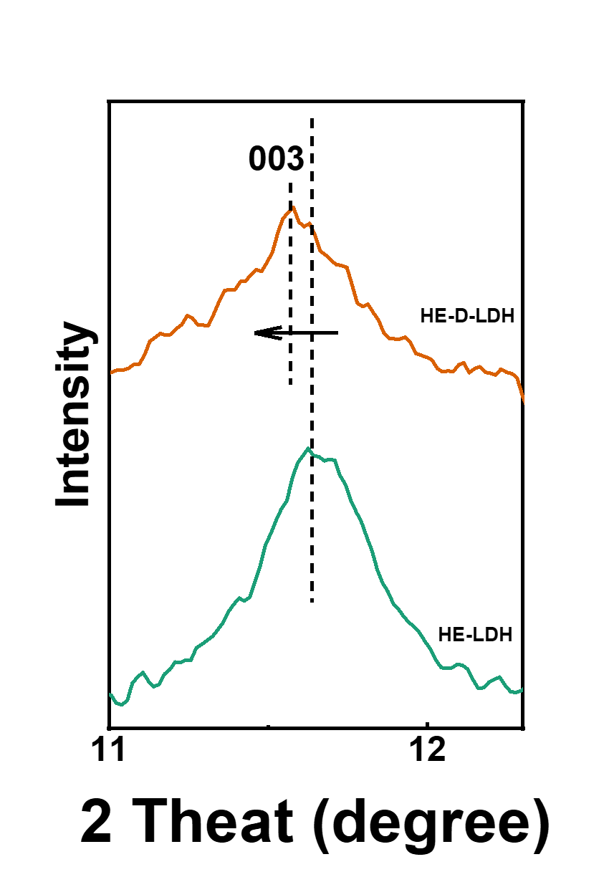
Figure S24. Extended XRD patterns derived from Fig. 1d

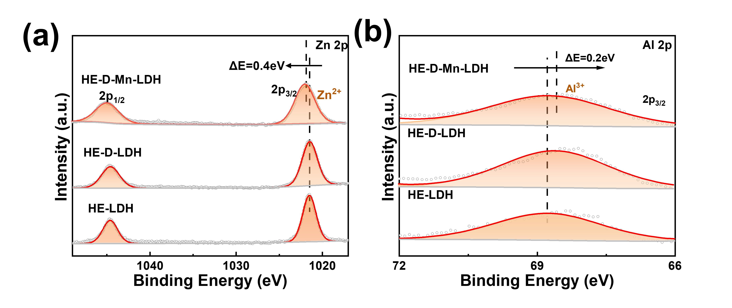
Figure S25. High resolution XPS spectra of LDHs, (a) Zn 2p, (b) Al 2p

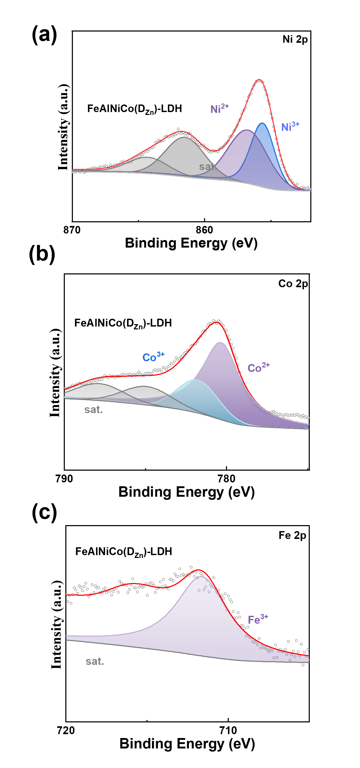
Figure S26. High resolution XPS spectra of HE-LDH etching Zn, (a) Ni 2p, (b) Co 2p, (c) Fe 2p

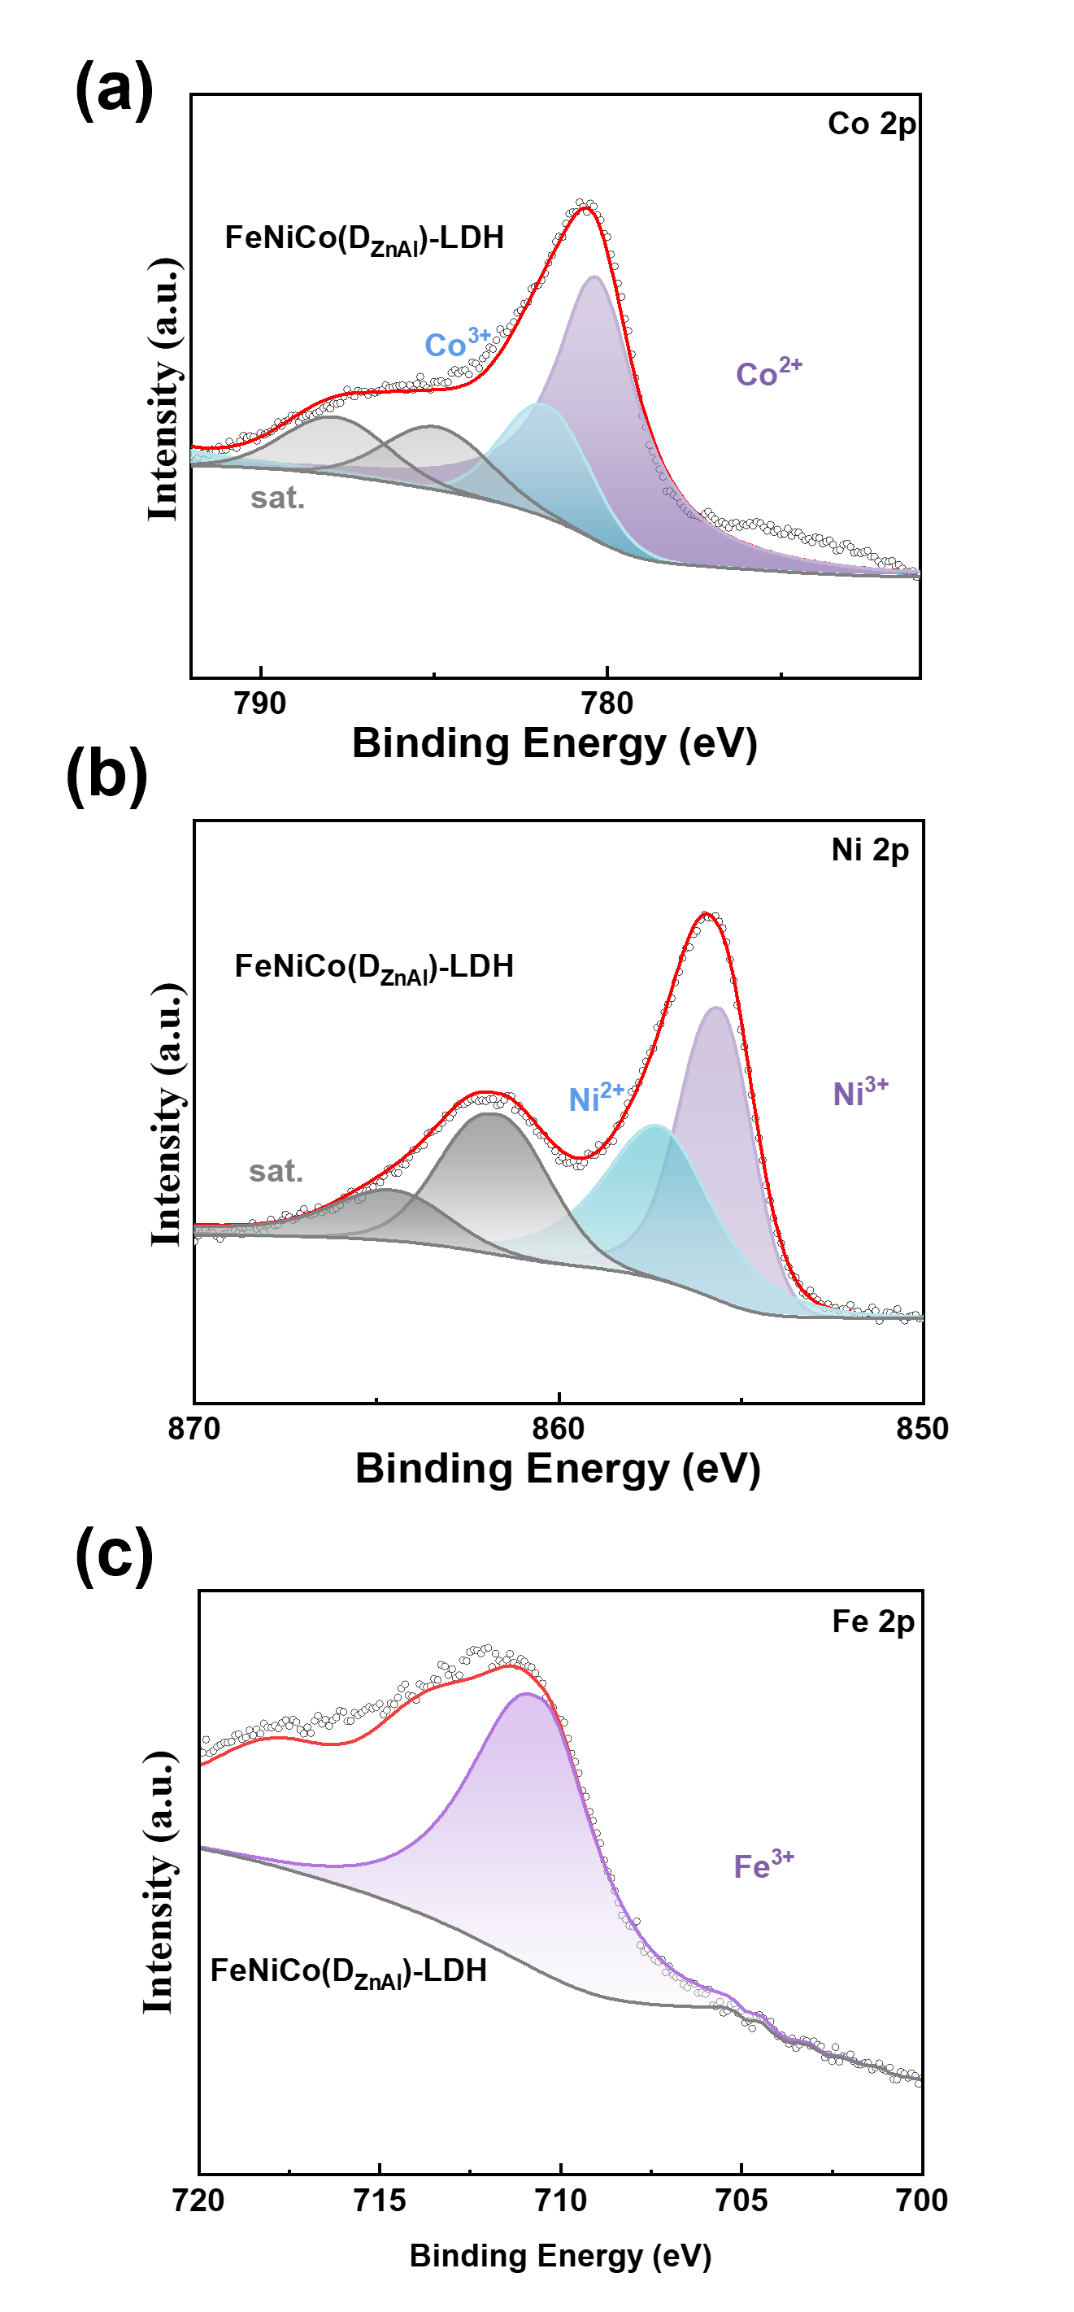
Figure S27. High resolution XPS spectra of HE-LDH etching Zn and Al, (a) Co 2p, (b) Ni 2p, (c) Fe 2p
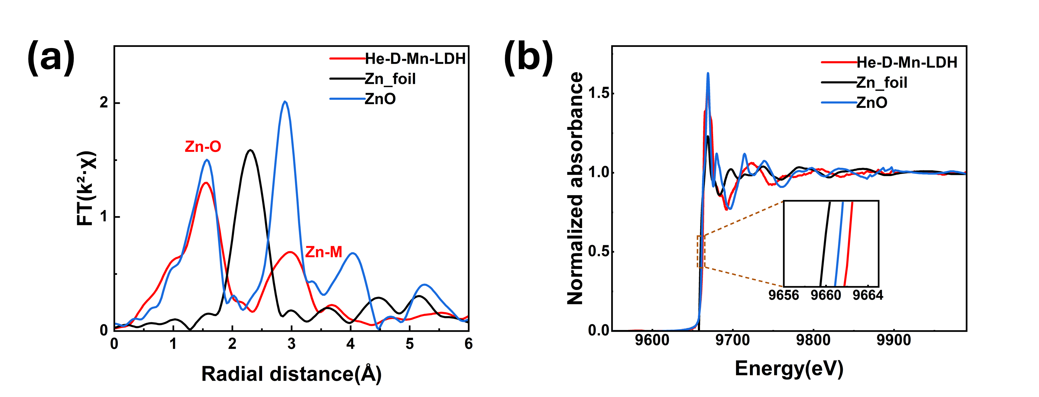
Figure S28. (a) Fourier-transformed EXAFS spectra of HE-D-Mn-LDH and references at the Zn K-edges. (b) Zn K-edge XANES spectra of HE-D-Mn-LDH and corresponding metal foils and oxides.

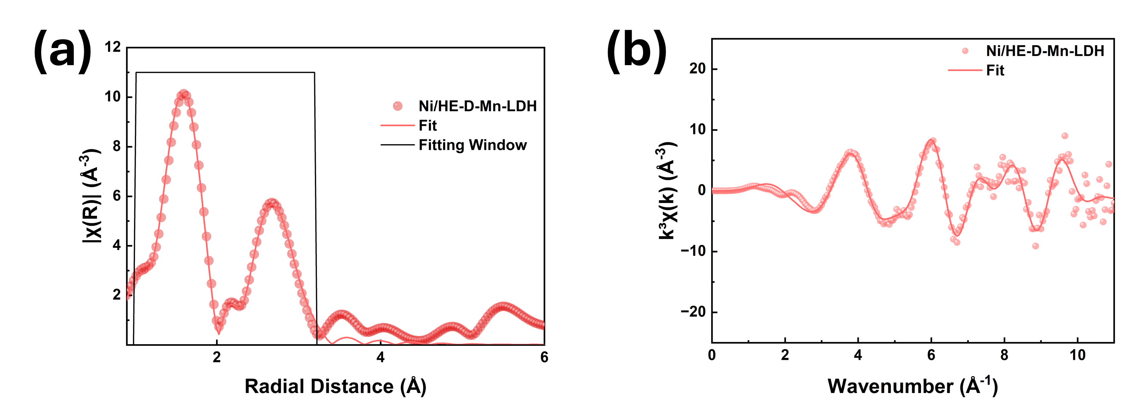
Figure S29. (a) Fourier-transformed Ni K-edge EXAFS spectra of HE-D-Mn-LDH in R space (b) Ni K-edge EXAFS spectra. The regions used for fitting are denoted by black boxes, and the experimental and fitted data are represented by scattered and line plots, respectively.

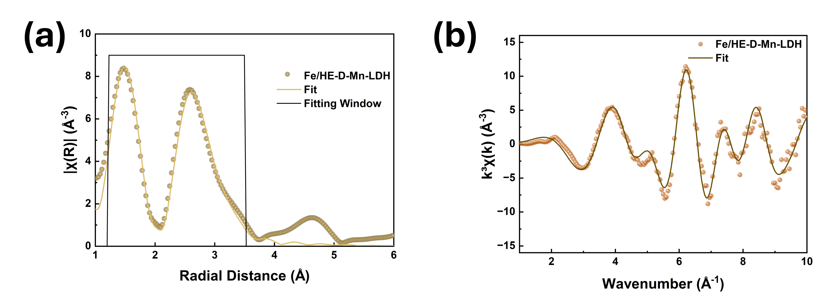
Figure S30. (a) Fourier-transformed Fe K-edge EXAFS spectra of HE-D-Mn-LDH in R space (b) Fe K-edge EXAFS spectra. The regions used for fitting are denoted by black boxes, and the experimental and fitted data are represented by scattered and line plots, respectively.

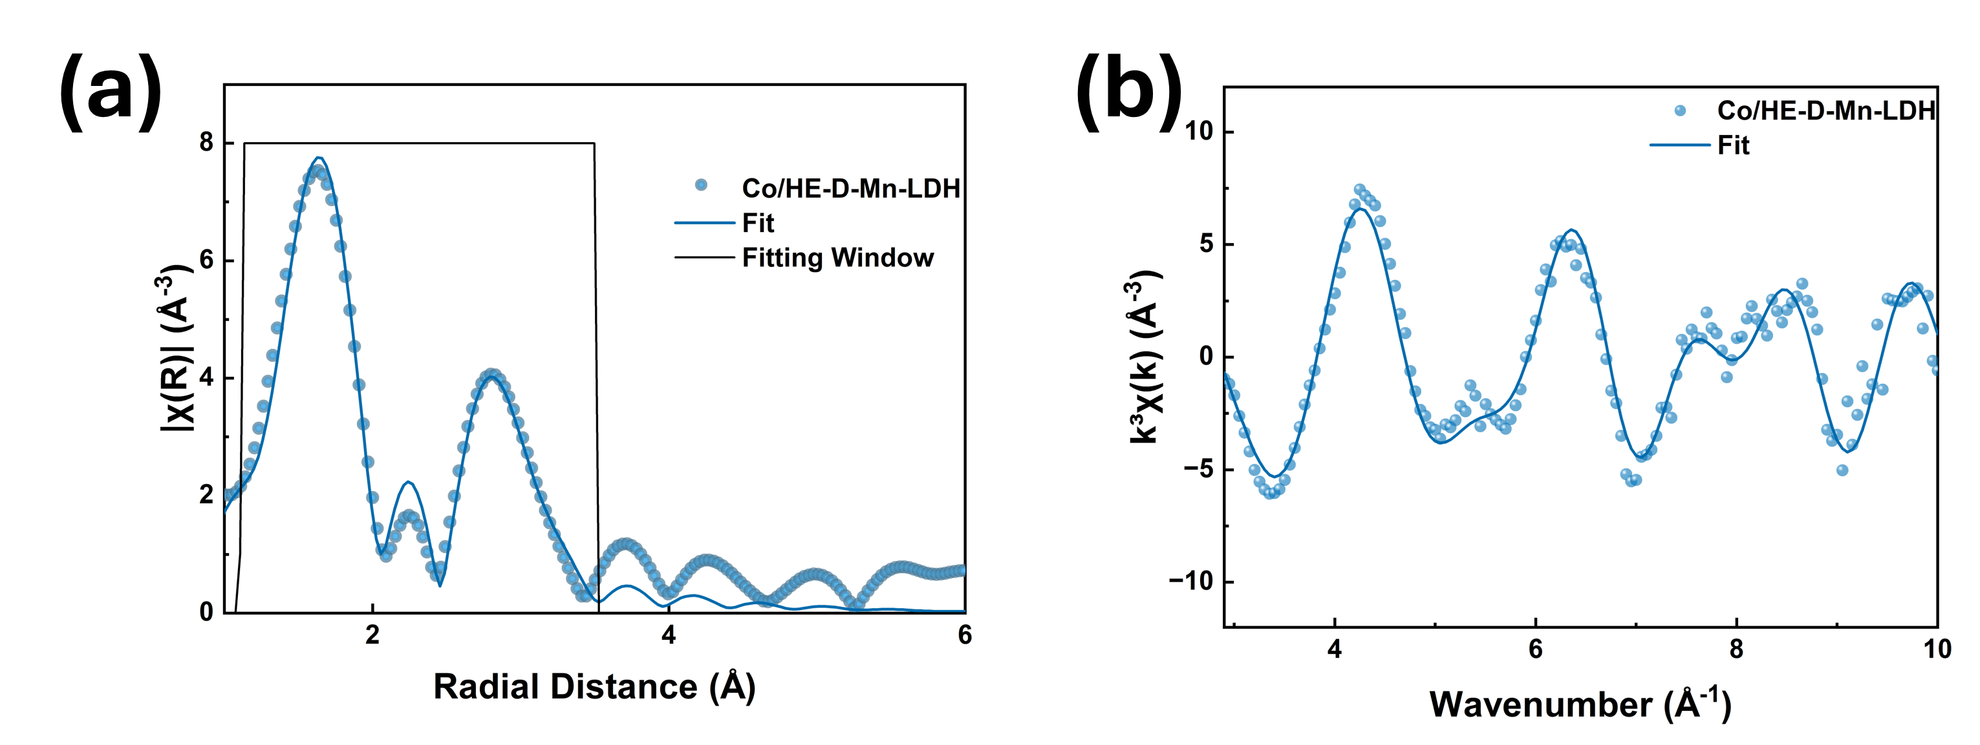
Figure S31. (a) Fourier-transformed Co K-edge EXAFS spectra of HE-D-Mn-LDH in R space (b) Co K-edge EXAFS spectra. The regions used for fitting are denoted by black boxes, and the experimental and fitted data are represented by scattered and line plots, respectively.

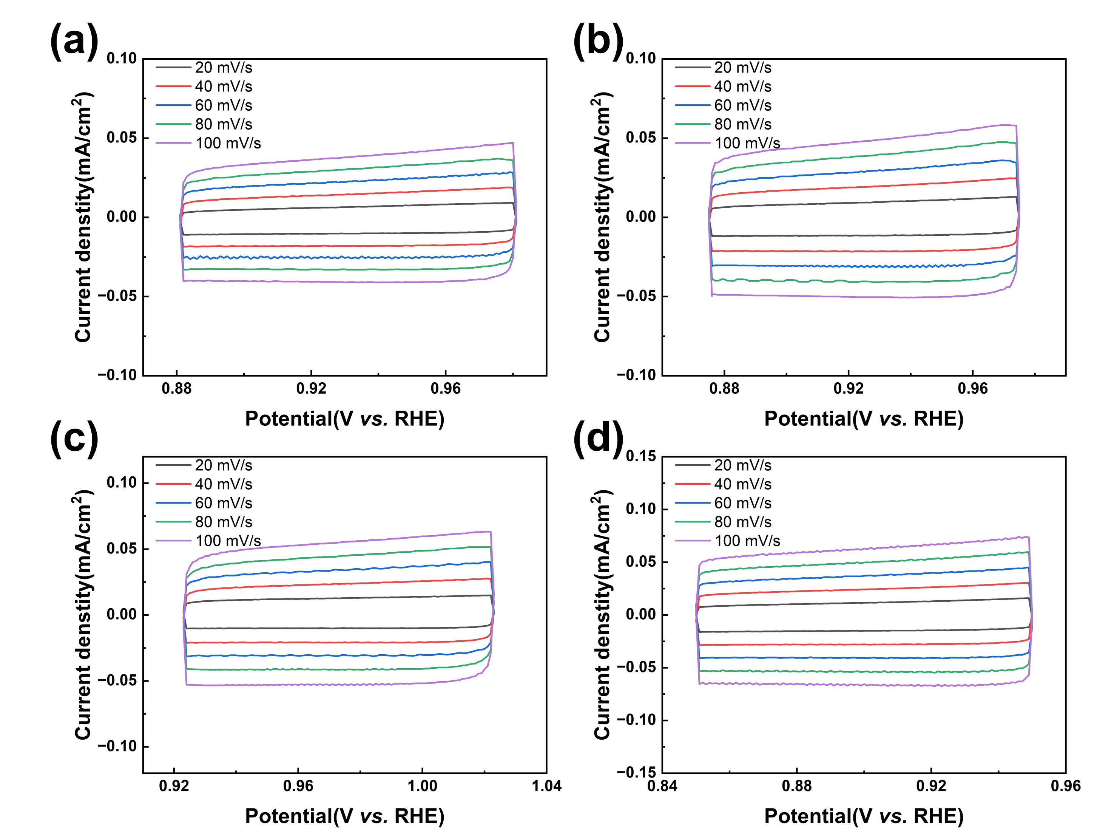
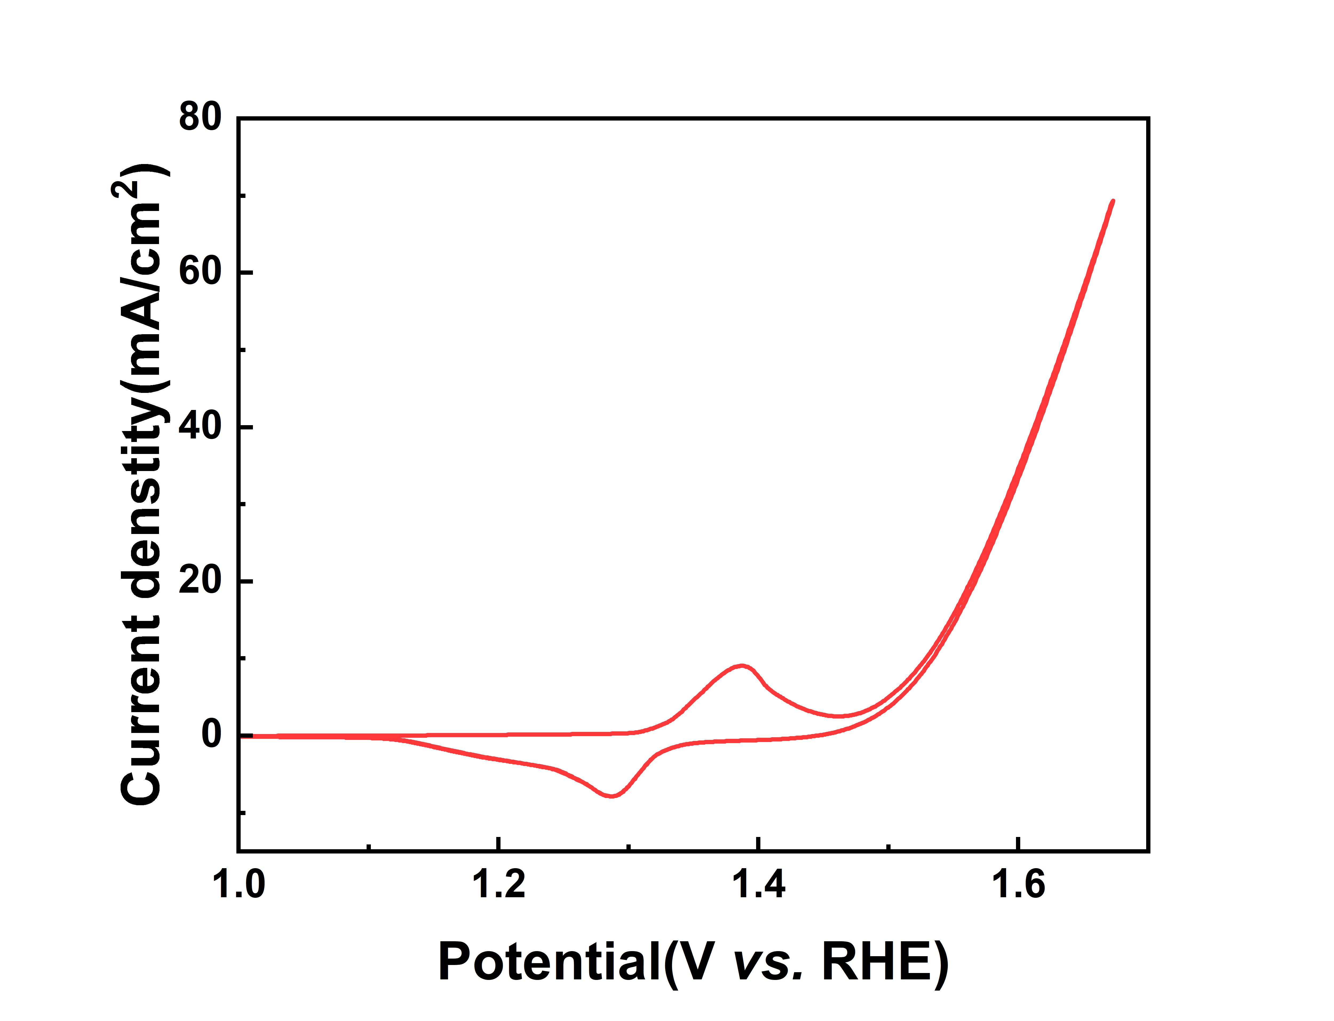
Figure S32. Cyclic voltammetry curves at different scan rates for HE-LDHs (a) HE-LDH (b) HE-D-LDH (c) HE-D-Mn-LDH (d) FeAlNiCoZnMn-LDH

Figure S33. Cyclic voltammetry curves for HE-D-Mn-LDH

Table S1. Elemental compositions (determined by XPS, SEM-EDS, and TEM-EDS), configurational entropy, δ parameters, and estimated upper bounds of cation vacancy concentration for the HE-LDH series and related Mn-incorporated samples.

 | Ni (%) | Co (%) | Zn (%) | Mn (%) | Fe (%) | Al (%) | S_{config} (R) | 𝛿 | Estimated vacancy upper bound (%)
HE-LDH | 18.32 | 16.96 | 14.51 | n/a | 13.25 | 36.96 | 1.525±0.022 | 6.22±0.05 | n/a
HE-LDH |  | 14.67 | 14.92 | n/a | 15.28 | 40.30 | 1.525±0.022 | 6.22±0.05 | n/a
  14.83
HE-LDH | 16.47 | 16.23 | 15.84 | n/a | 16.11 | 35.35 | 1.525±0.022 | 6.22±0.05 | n/a
HE-D-LDH | 19.26 | 16.02 | 7.41 | n/a | 14.78 | 42.51 | 1.445±0.015 | 6.51±0.12 | 7.5±2.3
HE-D-LDH | 15.84 | 13.67 | 9.82 | n/a | 17.21 | 43.46 | 1.445±0.015 | 6.51±0.12 | 7.5±2.3
HE-D-LDH | 22.37 | 18.54 | 5.63 | n/a | 11.92 | 41.54 | 1.445±0.015 | 6.51±0.12 | 7.5±2.3
HE-D2h-LDH | 31.40 | 25.15 | n/a | n/a | 21.32 | 22.13 | 1.370±0.009 | n/a | 30.8±1.3
HE-D2h-LDH | 34.62 | 22.84 | n/a | n/a | 18.57 | 23.97 | 1.370±0.009 | n/a | 30.8±1.3
HE-D2h-LDH | 27.48 | 28.73 | n/a | n/a | 24.36 | 19.43 | 1.370±0.009 | n/a | 30.8±1.3
HE-D15h-LDH | 43.29 | 29.67 | n/a | n/a | 27.04 | n/a | 1.073±0.018 | n/a | 52.6±2.1
HE-D15h-LDH | 47.84 | 25.31 | n/a | n/a | 26.85 | n/a | 1.073±0.018 | n/a | 52.6±2.1
HE-D15h-LDH | 38.56 | 34.02 | n/a | n/a | 27.42 | n/a | 1.073±0.018 | n/a | 52.6±2.1
HE-D-Mn-LDH | 16.07 | 13.03 | 11.46 | 5.85 | 11.86 | 41.73 | 1.607±0.014 | 6.31±0.04 | 4.5 ± 2.0
HE-D-Mn-LDH | 19.10 | 12.35 | 9.64 | 6.81 | 13.27 | 38.83 | 1.607±0.014 | 6.31±0.04 | 4.5 ± 2.0
HE-D-Mn-LDH | 17.24 | 14.88 | 12.16 | 3.42 | 15.03 | 37.27 | 1.607±0.014 | 6.31±0.04 | 4.5 ± 2.0

Table S2. Edge Position of different samples

Sample | Edge Position (E_{edge}) (eV) | Normalized XANES Spectrum
Ni/HE-D-Mn-LDH | 8347.48 | Fig. 3a
Ni/HE-D-LDH | 8347.92 | Fig. 3a
Ni/HE-LDH | 8344.98 | Fig. 3a
Ni/NiO | 8342.22 | Fig. 3a
Fe/HE-D-Mn-LDH | 7133.38 | Fig. 3b
Fe/HE-D-LDH | 7132.36 | Fig. 3b
Fe/HE-LDH | 7131.98 | Fig. 3b
Fe/Fe₂O₃ | 7131.33 | Fig. 3b
Co/HE-D-Mn-LDH | 7727.64 | Fig. 3c
Co/HE-D-LDH | 7727.68 | Fig. 3c
Co/HE-LDH | 7727.70 | Fig. 3c
Co/CoO | 7727.05 | Fig. 3c
Co/Co₃O₄ | 7728.87 | Fig. 3c
Mn/HE-D-Mn-LDH | 6556.82 | Fig. 3g
Mn/Mn₂O₃ | 6553.90 | Fig. 3g
Mn foil | 6548.58 | Fig. 3g

Table S3. EXAFS fitting results.
The Fe, Co, Ni, and Mn K-edge EXAFS data of the HE-D-Mn-LDH sample, together with the corresponding reference compounds, were analyzed by EXAFS fitting based on standard transition-metal oxide structures (Fe₂O₃, CoO, NiO, and Mn₂O₃) retrieved from the Materials Project database.[5] The extracted fitting parameters, including scattering paths, coordination numbers (N), absorber–scatterer distances (R), model-based effective distances (R_{eff}), Debye–Waller factors (σ²), amplitude reduction factors (S₀²), energy shift parameters (ΔE), and R-factors, are listed. For each metal species, the first coordination shell of HE-D-Mn-LDH was fitted using a fixed S₀²value derived from its corresponding reference oxide. On this basis, further fitting involving higher coordination shells was conducted with S₀² constrained, thereby minimizing parameter correlation and maintaining the physical reliability of the fitting results.
Sample | Scattering path | N | R (Å) | R_{eff} (Å) | σ²(Å²) | S₀² | R-factor | Fitting plots
Ni/HE-D-Mn-LDH | Ni-O  Ni-M | 5.73  3.14 | 2.06  3.07 | 2.09  2.96 | 0.005  0.007 | 0.80 | 0.002 | Figure S28
Fe/HE-D-Mn-LDH | Fe-O  Fe-M₁  Fe-M₂ | 4.46  2.36  4.46 | 2.08  3.65  3.14 | 1.99  3.49  3.00 | 0.004  0.004  0.008 | 0.78 | 0.003 | Figure S29
Co/HE-D-Mn-LDH | Co-O  Co-M₁  Co-M₂ | 4.52  3.54  2.57 | 2.05  3.08  2.87 | 1.91  3.16  3.01 | 0.009  0.008  0.013 | 0.77 | 0.009 | Figure S30

Table S4. Comparison of the OER performance of the prepared HE-D-Mn-LDH with the state-of-the-art electrocatalysts.
Catalysts | η₁₀₀ [mV] | Tafel slope [mV/dec] | Stability | TOF  [s⁻¹] | Ref.
Co₃O₄@WO₃ | 315 | 55 | 100 h@100mA cm⁻² | / | [6]
NiFe LDH | 330 | 44 | 24 h@50mA cm⁻² | 0.22 | [7]
MgMnFeCoNi | 330 | 47 | 60 h@100mA cm⁻² | 0.142@1.61 V | [8]
Mo-doped CoFe LDH | 331 | 101 | 24 h@100mA cm⁻² | 3.6@η₃₀₀ | [9]
Co_{14.3}Ni_{85.7}Ox | 338 | 60 | 12 h@20mA cm⁻² | / | [10]
(MgFeCoNiZn)O | 340 | 45 | 5 h@100mA cm⁻² | 0.028@1.61 V | [11]
(FeNiCoCrCu)₃O₄/MOF | 345 | 93 | 36 h@20mA cm⁻² | / | [12]
Ag/Co(OH)₂ | 350 | 80 | 15 h@50mA cm⁻² | 0.49@η₃₀₀ | [13]
Mo-Ni₂P₂O₇ | 357 | 98 | 25 h@100mA cm⁻² | / | [14]
ZIF-67@Co₃O₄ | 390 | 65 | 6 h@10mA cm⁻² | 1.3@1.61 V | [15]
La(CrMnFeCo₂Ni)O₃ | 395 | 51 | 50 h@10mA cm⁻² | 0.0267@η₄₀₀ | [16]
Ni₂P | 422 | 138 | 20 h@20mA cm⁻² | / | [17]
FeCoNiIrRu/CNFs | 490 | 153 | 14 h@10mA cm⁻² | / | [18]
HE-D-Mn-LDH | 310 | 43 | 450 h@100mA cm⁻² | 0.72 | this work

Table S5. ICP-MS analysis of the electrolyte after the stability test of HE-D-Mn-LDH.
Element | Fe | Co | Ni | Mn
Concentration (ppm) | 0.0103 | 0.0117 | 0.1447 | 0.0008

Table S6. Comparison overpotential, Tafel slope, C_{dl} and EIS for different LDHs. All values are retained to one decimal place.
Catalyst | Overpotential (mV) | Tafel slope (mV/dec) | C_{dl} (mF/cm²) | EIS (Ω)
HE-LDH | 331.3±1.5 | 76±2.6 | 0.41±0.02 | 6.9±0.2
HE-D-LDH | 313±8.5 | 57.4±2.1 | 0.54±0.006 | 2.9±0.2
HE-D-Mn-LDH | 257.6±1.5 | 44.4±0.7 | 0.69±0.02 | 2.1±0.1
FeAlNiCoZnMn-LDH | 270±2.7 | 49.5±1.5 | 0.58±0.03 | 2.6±0.1

Table S7. Cdl, ECSA-normalized overpotential, and TOF values of the HE-LDH series after alkaline etching.

Sample | Cdl  (mF/cm²) | η_{ECSA} @1 mA  (mV) | TOF@η₃₀₀  (s⁻¹)
HE-LDH | 0.43 | 330 | 0.53
HE-D-LDH | 0.54 | 321 | 0.72
HE-D2h-LDH | 0.72 | 369 | 0.092
HE-D15h-LDH | 0.83 | 370 | 0.13

Table S8. Comparison of the mass activity of HE-D-Mn-LDH with recently reported LDH-based OER electrocatalysts.
Catalysts | Mass activity  (mA/mg) | Ref. | Notes
FeNi-LDH/MOF | 76 | [19] | Non-precious
FeNi-LDH | 16 | [19] | Non-precious
a/c-CoFe-LDH | 43 | [20] | Non-precious
CoNi-LDH | 91 | [21] | Non-precious
NiMg-LDH | 56 | [22] | Non-precious
Au_{SA}-MnFeCoNiCu LDH | 732 | [23] | Noble-metal-containing
HE-D-Mn-LDH | 118 | This work | Non-precious

References
1. Ravel B, Newville M (2005) ATHENA, ARTEMIS, HEPHAESTUS: data analysis for X-ray absorption spectroscopy using IFEFFIT. J Synchrotron Radiat 12(4):537-541. https://doi.org/doi:10.1107/S0909049505012719
2. Säbel C E, Neureuther J M, Siemann S (2010) A spectrophotometric method for the determination of zinc, copper, and cobalt ions in metalloproteins using Zincon. Anal Biochem 397(2):218-226. https://doi.org/10.1016/j.ab.2009.10.037
3. Clark R A, Krueger G L (1985) Aluminon: its limited application as a reagent for the detection of aluminum species. J Histochem Cytochem 33(7):729-32. https://doi.org/10.1177/33.7.3891J Histochem Cytochem845
4. Dau H, Liebisch P, Haumann M (2003) X-ray absorption spectroscopy to analyze nuclear geometry and electronic structure of biological metal centers—potential and questions examined with special focus on the tetra-nuclear manganese complex of oxygenic photosynthesis. Anal Bioanal Chem 376(5):562-583. https://doi.org/10.1007/s00216-003-1982-2
5. Jain A, Ong S P, Hautier G, Chen W, Richards W D, Dacek S, Cholia S, Gunter D, Skinner D, Ceder G, Persson K A (2013) Commentary: The Materials Project: A materials genome approach to accelerating materials innovation. APL Mater 1(1)https://doi.org/10.1063/1.4812323
6. Yan Z, Wei Z, Tan Z, Guo S, Fang Z, Wang W, Li G, Yuan X, Tang M, Feng Z (2025) A cost-effective Co₃O₄@WO₃ hetero-structure derived from WO₃@Co-CoPBA for oxygen evolution reaction. RSC Adv 15(36):29925-29936. https://doi.org/10.1039/D5RA04599A
7. Zhou D, Jia Y, Duan X, Tang J, Xu J, Liu D, Xiong X, Zhang J, Luo J, Zheng L, Liu B, Kuang Y, Sun X, Duan X (2019) Breaking the symmetry: Gradient in NiFe layered double hydroxide nanoarrays for efficient oxygen evolution. Nano Energy 60:661-666. https://doi.org/10.1016/j.nanoen.2019.04.014
8. Wu H, Lu Q, Li Y, Zhao M, Wang J, Li Y, Zhang J, Zheng X, Han X, Zhao N, Li J, Liu Y, Deng Y, Hu W (2023) Structural Framework-Guided Universal Design of High-Entropy Compounds for Efficient Energy Catalysis. J Am Chem Soc 145(3):1924-1935. https://doi.org/10.1021/jacs.2c12295
9. Zhao G, Wang B, Yan Q, Xia X (2022) Mo-doping-assisted electrochemical transformation to generate CoFe LDH as the highly efficient electrocatalyst for overall water splitting. J Alloys Compd 902:163738. https://doi.org/10.1016/j.jallcom.2022.163738
10. Wu Z, Wang X, Huang J, Gao F (2018) A Co-doped Ni–Fe mixed oxide mesoporous nanosheet array with low overpotential and high stability towards overall water splitting. J Mater Chem A 6(1):167-178. https://doi.org/10.1039/C7TA07956G
11. Wu H, Lu Q, Li Y, Wang J, Li Y, Jiang R, Zhang J, Zheng X, Han X, Zhao N, Li J, Deng Y, Hu W (2022) Rapid Joule-Heating Synthesis for Manufacturing High-Entropy Oxides as Efficient Electrocatalysts. Nano Lett 22(16):6492-6500. https://doi.org/10.1021/acs.nanolett.2c01147
12. Fereja S L, Zhang Z, Fang Z, Guo J, Zhang X, Liu K, Li Z, Chen W (2022) High-Entropy Oxide Derived from Metal–Organic Framework as a Bifunctional Electrocatalyst for Efficient Urea Oxidation and Oxygen Evolution Reactions. ACS Appl Mater Interfaces 14(34):38727-38738. https://doi.org/10.1021/acsami.2c09161
13. Tong R, Xu M, Fan Y, Wang S, Yuan Y, Huang H, Zhang C, Cai D (2023) Spontaneous synthesis of Ag nanoparticles on ultrathin Co(OH)₂ nanosheets@nitrogen-doped carbon nanoflake arrays for high-efficient water oxidation. Int J Hydrogen Energy 48(8):3026-3036. https://doi.org/10.1016/j.ijhydene.2022.10.178
14. Guo W, Yang T, Zhang H, Zhou H, He M, Wei W, Liang W, Zhou Y, Yu T, Zhao H (2023) Fe and Mo Co-Modulated Coral-like Nickel Pyrophosphate in situ Derived from Nickel-Foam for Oxygen Evolution. ChemSusChem 16(17):e202300633. https://doi.org/10.1002/cssc.202300633
15. Li X, You S, Du J, Dai Y, Chen H, Cai Z, Ren N, Zou J (2019) ZIF-67-derived Co₃O₄@carbon protected by oxygen-buffering CeO₂ as an efficient catalyst for boosting oxygen reduction/evolution reactions. J Mater Chem A 7(45):25853-25864. https://doi.org/10.1039/C9TA08926H
16. Nguyen T X, Liao Y-C, Lin C-C, Su Y-H, Ting J-M (2021) Advanced High Entropy Perovskite Oxide Electrocatalyst for Oxygen Evolution Reaction. Adv Funct Mater 31(27):2101632. https://doi.org/10.1002/adfm.202101632
17. Wang J, Ma X, Qu F, Asiri A M, Sun X (2017) Fe-Doped Ni₂P Nanosheet Array for High-Efficiency Electrochemical Water Oxidation. Inorg Chem 56(3):1041-1044. https://doi.org/10.1021/acs.inorgchem.6b02808
18. Zhu H, Zhu Z, Hao J, Sun S, Lu S, Wang C, Ma P, Dong W, Du M (2022) High-entropy alloy stabilized active Ir for highly efficient acidic oxygen evolution. Chem Eng J 431:133251. https://doi.org/10.1016/j.cej.2021.133251
19. Qin H, Cheng J, Zhou P, Ji Z, Peng H, Shen X, Zhou H, Zhu G, Yang J (2024) In situ semi-etching of bimetallic LDH nanosheet arrays into FeNi-LDH/MOF to boost oxygen evolution reaction. Chem Eng J 493:152721. https://doi.org/10.1016/j.cej.2024.152721
20. Gong C, Li W, Du X, He X, Wang D, Chen H, Fang W, Zhao L, Chai Y (2025) Manipulating spin polarization by in-situ reconstructed amorphous/crystalline CoFe-LDH for efficient electrocatalytic water splitting. Nano Research 18(9):94907668. https://doi.org/10.26599/NR.2025.94907668
21. Madhu R, Muthukumar J, Arunachalam P, Gudlur P, Kundu S (2024) Unraveling Activation Energy with Temperature-Dependent Analyses of CoNiSe2 Electrocatalysts Derived from CoNi-LDH for Water Splitting Reaction. The Journal of Physical Chemistry C 128(31):12891-12902. https://doi.org/10.1021/acs.jpcc.4c04052
22. Chen L, Zhang Y, Li D, Wang Y, Duan C (2018) Magnesium-regulated oxygen vacancies of nickel layered double hydroxides for electrocatalytic water oxidation. J Mater Chem A 6(38):18378-18383. https://doi.org/10.1039/C8TA04615H
23. Wang F, Zou P, Zhang Y, Pan W, Li Y, Liang L, Chen C, Liu H, Zheng S (2023) Activating lattice oxygen in high-entropy LDH for robust and durable water oxidation. Nature Communications 14(1):6019. 10.1038/s41467-023-41706-8

