Table 1 Soil information as described by National Bureau of Soil Survey and Land Use Planning [29]
Soil zones | Soil characteristics | Area (km²)
35 | Very shallow, somewhat excessively drained, loamy soils on moderately steeply sloping undulating western foothill slopes and narrow valleys with severe erosion and strong stoniness; associated with shallow, somewhat excessively drained ,loamy soils with severe erosion and strong stoniness. | 30.67
38 | Moderately deep, well drained, loamy soils on moderately moderately sloping spurs with severe erosion and moderate stoniness; associated with moderately deep, well drained, clayey soils on moderately steeply sloping spurs with severe erosion and moderate stoniness | 110.80
58 | Very shallow, well drained, loamy soils on steeply sloping elongated ridges of Sahyadri with severe erosion and moderate stoniness, associated with moderately deep, well drained loamy soils with severe erosion and slight stoniness. | 8.76
121 | Very shallow well drained, loamy soils on gently sloping undulating lands, with moderate erosion and moderate stoniness associated with very shallow, well drained, clayey soils with very shallow well drained, clayey soils with severe erosion and moderate erosion. | 0.37
141 | Shallow, well drained, loamy soils on moderately sloping lands with very severe erosion and slightly stoniness, moderately deep, well drained, clayey soils with moderate erosion and slight stoniness. | 60.05
142 | Shallow, well drained, clayey soils on gently sloping lands with moderate erosion and slight stoniness; associated with slightly deep, well drained, fine soils with moderate erosion, and slight stoniness | 21.25
152 | Moderately deep, well drained, clayey calcareous soil on very gently sloping plain with moderate erosion; associated with very deep, well drained, clayey, calcareous soil with moderate erosion | 22.21
158 | Very deep, well drained, fine, calcareous soils on very gently sloping plain with moderate erosion; associated with moderately shallow, well drained, fine calcareous soils with moderate erosion and moderate salinity. | 146.05
172 | Extremely shallow, somewhat excessively drained, clayey soils on moderately sloping undulating lands with mesas and buttes with severe erosion and moderate stoniness; associated with extremely shallow somewhat excessively drained, loamy soils with moderate erosion. | 12.25
Total |  | 412.44

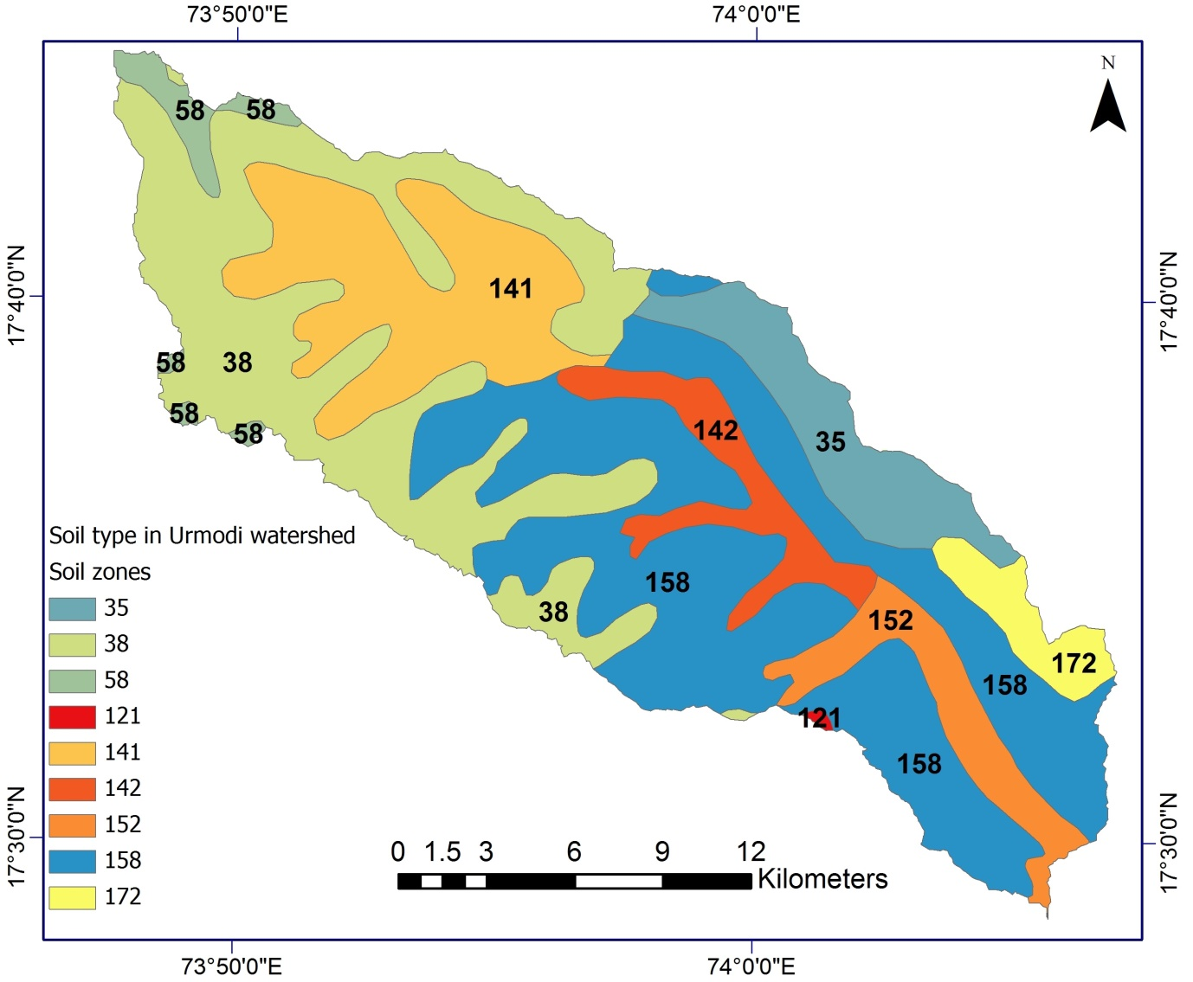
Fig. 1 Soil type in the Urmodi river watershed by National Bureau of Soil Survey and Land Use Planning (NBSS & LUP) Nagpur

Table 2 Soil characteristics and respective descriptive statistics of SOC, SOCD and SOC stock in the Urmodi river watershed (raster value based)
Soil zones | Area (km2) | SOC (g/kg⁻¹) |  |  |  | SOCD (kg/m⁻²) |  |  |  | SOCS (ton/ha⁻¹)
Soil zones | Area (km2) | Minimum | Maximum | Mean | SD | Minimum | Maximum | Mean | SD | Minimum | Maximum | Mean | SD
35 | 30.67 | 0.51 | 0.51 | 0.24 | 1.79 | 12.10 | 144.88 | 59.59 | 24.00 | 1.29 | 4.42 | 3.28 | 0.59
38 | 110.80 | 0.59 | 0.59 | 0.08 | 1.97 | 0.00 | 133.26 | 53.05 | 14.31 | 1.46 | 4.54 | 3.42 | 0.52
58 | 8.76 | 1.25 | 1.25 | 0.06 | 1.82 | 36.84 | 91.22 | 58.24 | 7.71 | 2.74 | 4.09 | 3.76 | 0.18
121 | 0.37 | 1.23 | 1.23 | 0.24 | 1.45 | 52.43 | 60.54 | 56.22 | 2.02 | 3.26 | 3.92 | 3.55 | 0.17
141 | 60.05 | 0.59 | 0.59 | 0.09 | 2.00 | 10.51 | 84.22 | 46.04 | 9.15 | 1.48 | 4.68 | 3.08 | 0.51
142 | 21.25 | 1.06 | 1.06 | 0.28 | 1.57 | 33.55 | 94.48 | 66.08 | 12.97 | 2.68 | 4.09 | 3.43 | 0.22
152 | 22.21 | 0.56 | 0.56 | 0.23 | 1.68 | 22.59 | 82.56 | 55.46 | 14.77 | 1.47 | 4.34 | 3.34 | 0.72
158 | 146.05 | 0.51 | 0.51 | 0.29 | 1.98 | 7.19 | 142.42 | 63.03 | 17.02 | 1.39 | 5.29 | 3.64 | 0.60
172 | 12.25 | 0.79 | 0.79 | 0.79 | 1.96 | 23.72 | 101.75 | 66.43 | 19.85 | 2.02 | 5.07 | 4.00 | 0.77

