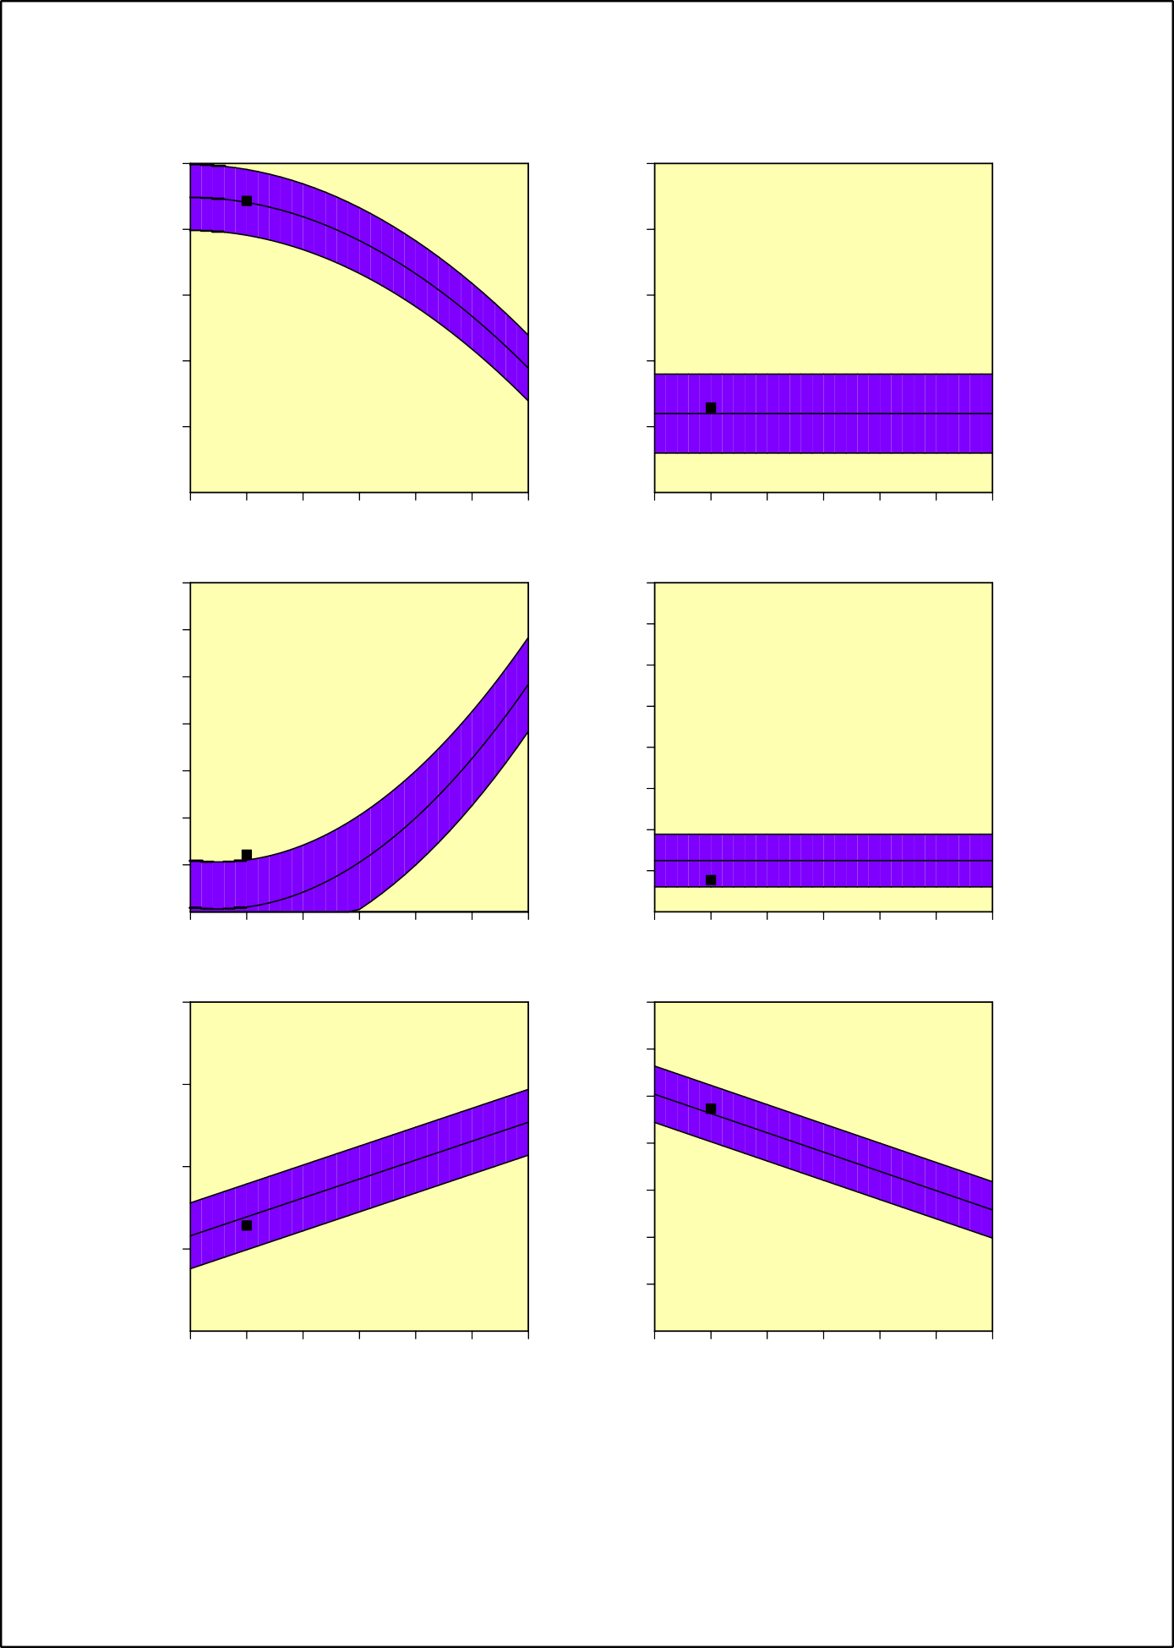
%-tage of residues in most favoured regions

- Ramachandran plot quality assessment 100
- Peptide bond planarity - omega angle sd 25

80 20
Standard deviation (degrees)

60 15

40 10

20 5

1.0 1.5 2.0 2.5 3.0 3.5 4.0
Resolution (Angstroms)
- Measure of bad non-bonded interactions 70

60
Bad contacts per 100 residues
50
40
30
20
10
1.0 1.5 2.0 2.5 3.0 3.5 4.0
Resolution (Angstroms)
- Alpha carbon tetrahedral distortion
20.0
Zeta angle standard dev. (degrees)
17.5
15.0
12.5
10.0
7.5
5.0
2.5

1.0 1.5 2.0 2.5 3.0 3.5 4.0
Resolution (Angstroms)
- Hydrogen bond energies
2.0
Standard deviation (kcal/mol)

1.5

1.0

0.5
1.0 1.5 2.0 2.5 3.0 3.5 4.0
Resolution (Angstroms)
- Overall G-factor
1.0
0.5
0.0
-0.5
G-factor
-1.0
-1.5
-2.0

1.0 1.5 2.0 2.5 3.0 3.5 4.0
Resolution (Angstroms)
1.0 1.5 2.0 2.5 3.0 3.5 4.0
Supplementary Figure 1: Mainchain parameters of 5WSL
Resolution (Angstroms)

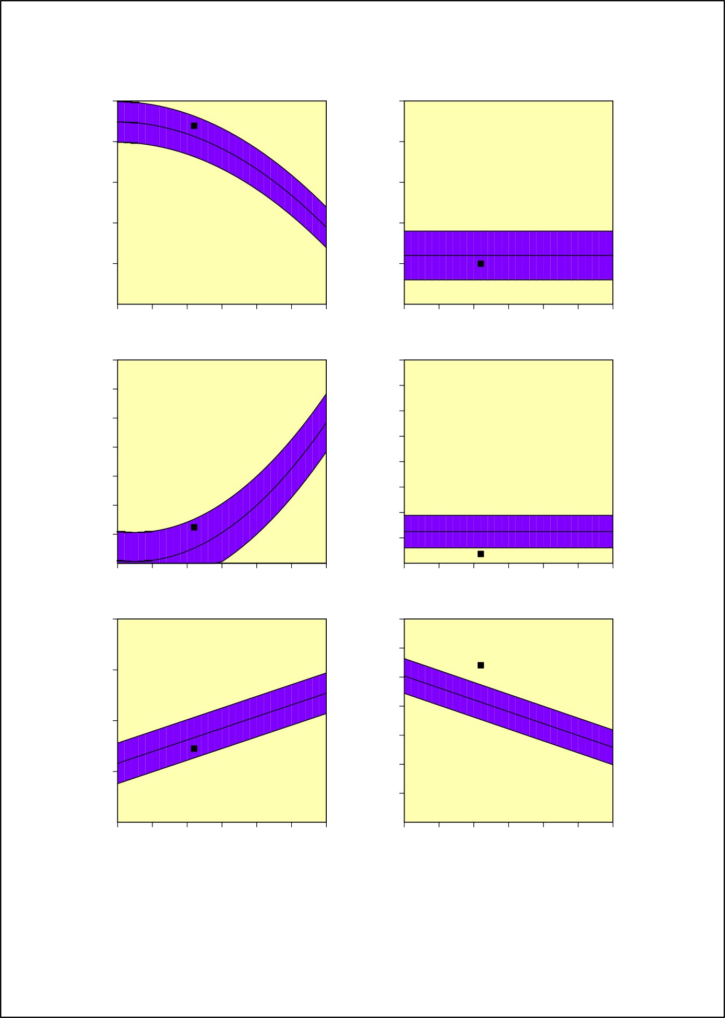
%-tage of residues in most favoured regions

- Ramachandran plot quality assessment 100
- Peptide bond planarity - omega angle sd 25

80 20
Standard deviation (degrees)

60 15

40 10

20 5

1.0 1.5 2.0 2.5 3.0 3.5 4.0
Resolution (Angstroms)
- Measure of bad non-bonded interactions 70

60
Bad contacts per 100 residues
50
40
30
20
10
1.0 1.5 2.0 2.5 3.0 3.5 4.0
Resolution (Angstroms)
- Alpha carbon tetrahedral distortion
20.0
Zeta angle standard dev. (degrees)
17.5
15.0
12.5
10.0
7.5
5.0
2.5

1.0 1.5 2.0 2.5 3.0 3.5 4.0
Resolution (Angstroms)
- Hydrogen bond energies
2.0
Standard deviation (kcal/mol)

1.5

1.0

0.5
1.0 1.5 2.0 2.5 3.0 3.5 4.0
Resolution (Angstroms)
- Overall G-factor
1.0
0.5
0.0
-0.5
G-factor
-1.0
-1.5
-2.0

1.0 1.5 2.0 2.5 3.0 3.5 4.0
Resolution (Angstroms)
1.0 1.5 2.0 2.5 3.0 3.5 4.0
Resolution (Angstroms)

Supplementary Figure 2: Mainchain parameters of 6FZX

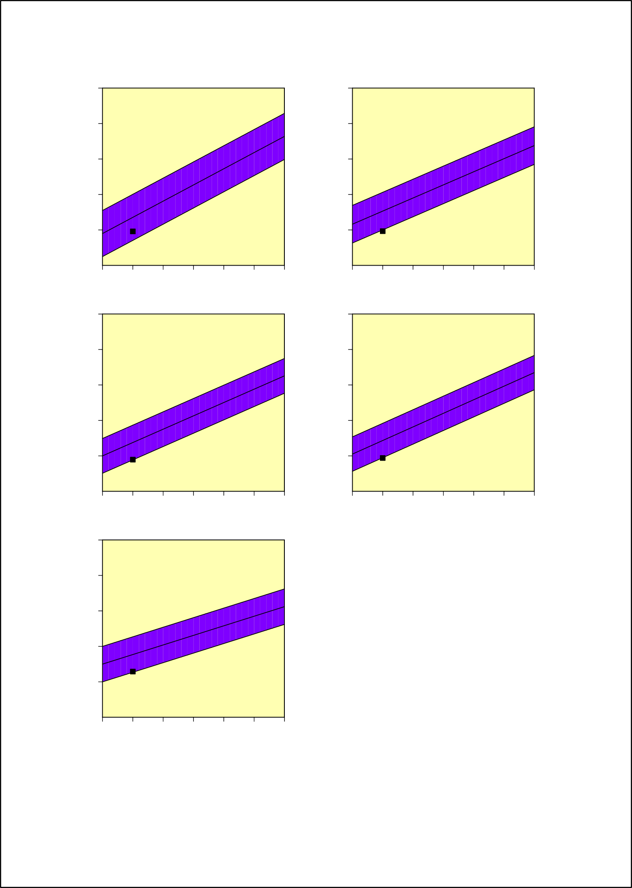

  - Chi-1 gauche minus
50
  - Chi-1 trans
50

40 40
Standard deviation (degrees)
Standard deviation (degrees)

30 30

20 20

10 10

1.0 1.5 2.0 2.5 3.0 3.5 4.0
Resolution (Angstroms)
  - Chi-1 gauche plus
50
1.0 1.5 2.0 2.5 3.0 3.5 4.0
Resolution (Angstroms)
  - Chi-1 pooled standard deviation
50

40 40
Standard deviation (degrees)
Standard deviation (degrees)

30 30

20 20

10 10

1.0 1.5 2.0 2.5 3.0 3.5 4.0
Resolution (Angstroms)
  - Standard deviation of Chi-2 trans angle 50
1.0 1.5 2.0 2.5 3.0 3.5 4.0
Resolution (Angstroms)

40
Standard deviation (degrees)

30

20

10

1.0 1.5 2.0 2.5 3.0 3.5 4.0
Resolution (Angstroms)
Supplementary Figure 3: Side chain parameters of 5WSL

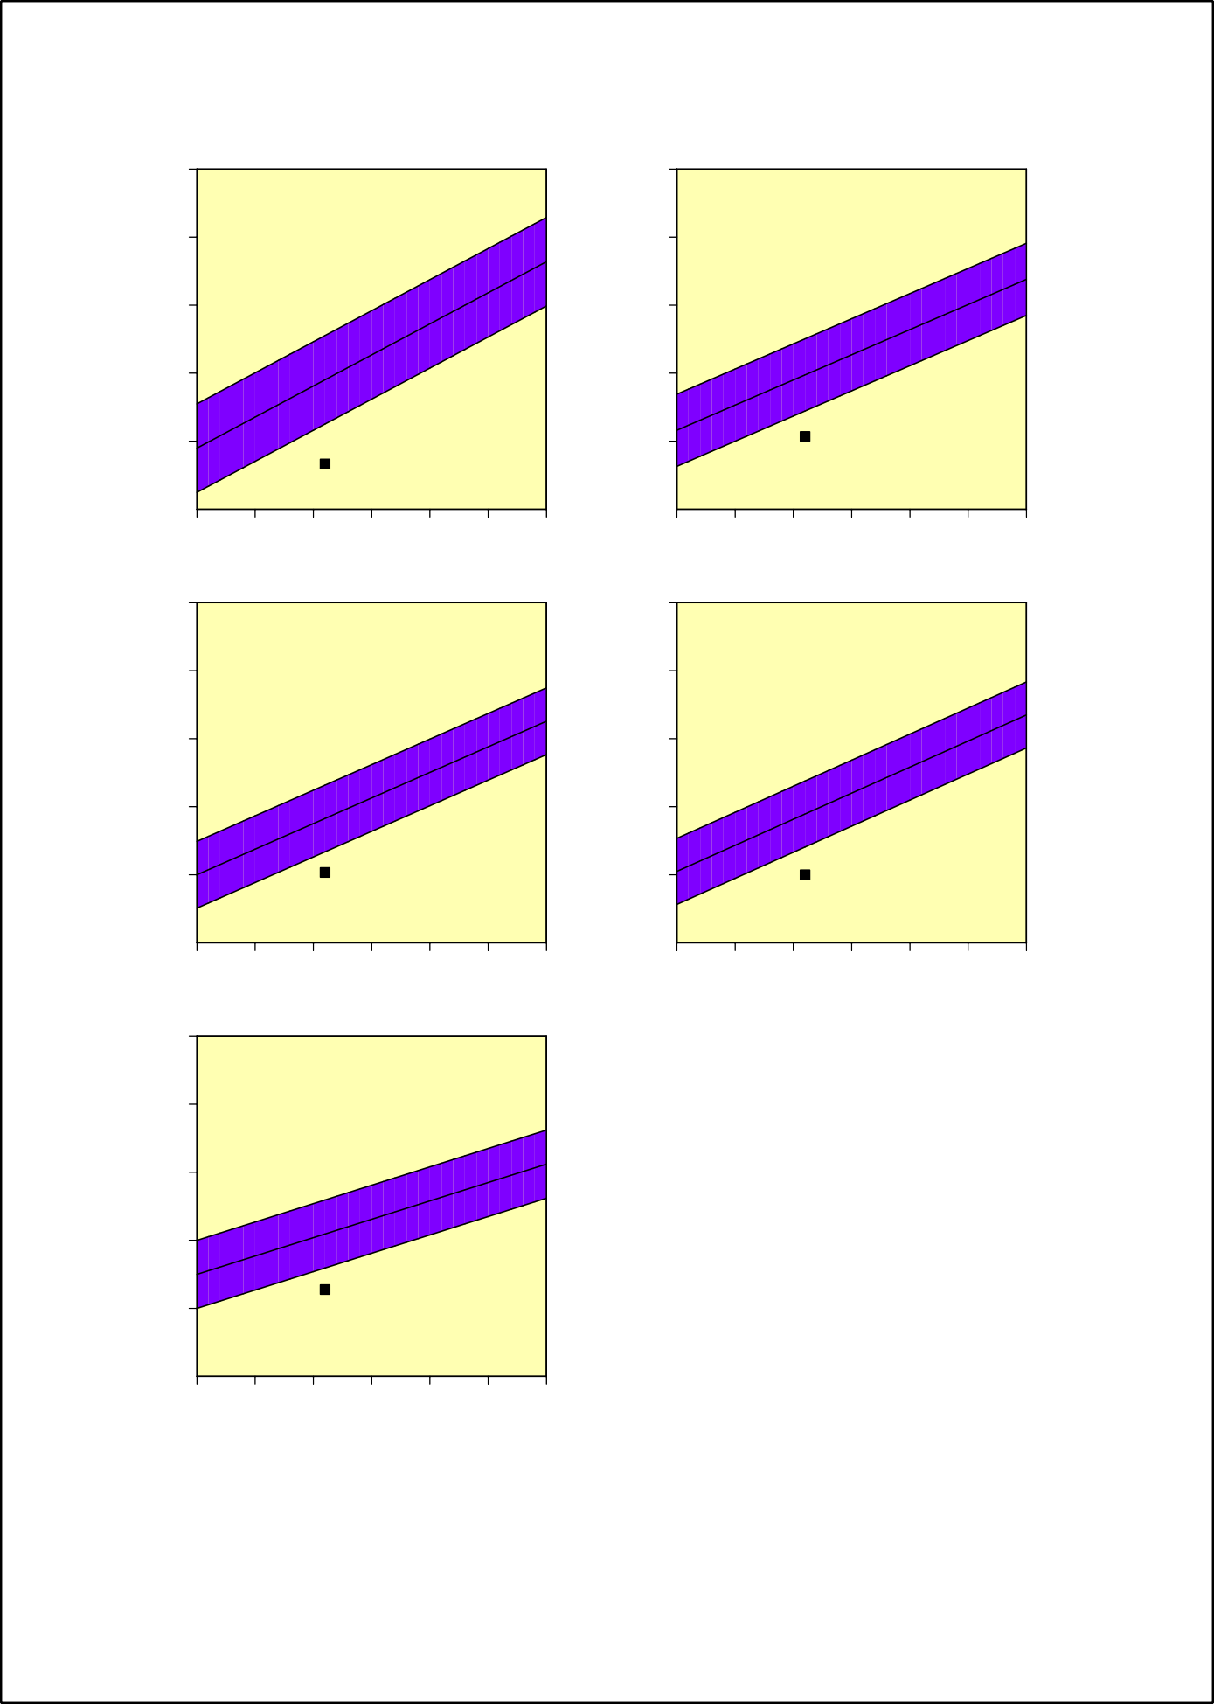

    - Chi-1 gauche minus
50
    - Chi-1 trans
50

40 40
Standard deviation (degrees)
Standard deviation (degrees)

30 30

20 20

10 10

1.0 1.5 2.0 2.5 3.0 3.5 4.0
Resolution (Angstroms)
    - Chi-1 gauche plus
50
1.0 1.5 2.0 2.5 3.0 3.5 4.0
Resolution (Angstroms)
    - Chi-1 pooled standard deviation
50

40 40
Standard deviation (degrees)
Standard deviation (degrees)

30 30

20 20

10 10

1.0 1.5 2.0 2.5 3.0 3.5 4.0
Resolution (Angstroms)
    - Standard deviation of Chi-2 trans angle 50
1.0 1.5 2.0 2.5 3.0 3.5 4.0
Resolution (Angstroms)

40
Standard deviation (degrees)

30

20

10

1.0 1.5 2.0 2.5 3.0 3.5 4.0
Resolution (Angstroms)

Supplementary Figure 4: Side chain parameters of 6FZX

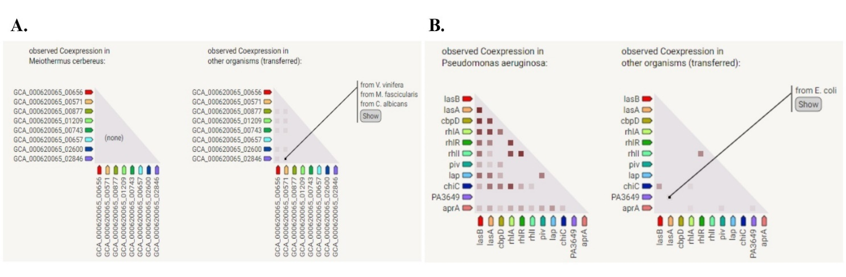
Supplementary Figure 5: A. Gene Coexpression of 5WSL and B. Gene Coexpression of 6FZX.

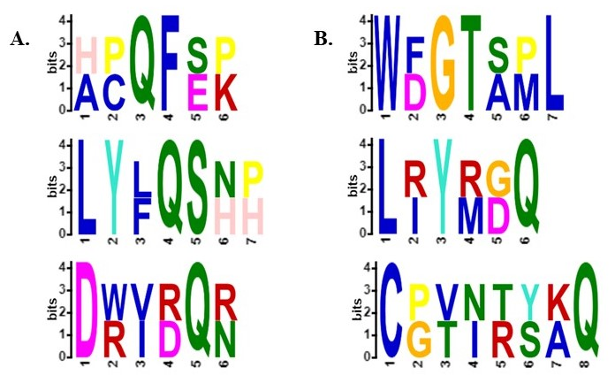
Supplementary Figure 6: Distribution of conserved motifs and their multiple sequence alignments present in protein sequences of A. 5WSL B. 6FZX

Supplementary Table 1: Plot statistics of mainchain parameters of 5WSL
Stereochemical parameter | No of data pts | Parameter value | Comparison typical value | Values band width | No of band width from mean | Remarks
a. %-tage residues in A, B, L | 711 | 88.6 | 88.2 | 10 | 0 | Inside
b. Omega angle st dev | 834 | 6.5 | 6 | 3 | 0.2 | Inside
c. Bad contacts / 100 residues | 103 | 12.2 | 1 | 10 | 1.1 | WORSE
d. Zeta angle st dev | 741 | 1.9 | 3.1 | 1.6 | -0.7 | Inside
e. H-bond energy st dev | 509 | 0.6 | 0.7 | 0.2 | -0.3 | Inside
f. Overall G-factor | 846 | -0.1 | -0.2 | 0.3 | 0.2 | Inside

Supplementary Table 2: Plot statistics of mainchain parameters of 6FZX

Stereochemical parameter | No of data pts | Parameter value | Comparison typical value | Values band width | No of band width from mean | Remarks
a. %-tage residues in A, B, L | 254 | 87.8 | 82.6 | 10 | 0.5 | inside
b. Omega angle st dev | 295 | 5 | 6 | 3 | -0.3 | inside
c. Bad contacts / 100 residues | 37 | 12.4 | 5.2 | 10 | 0.7 | inside
d. Zeta angle st dev | 265 | 0.9 | 3.1 | 1.6 | -1.4 | BETTER
e. H-bond energy st dev | 190 | 0.7 | 0.8 | 0.2 | -0.5 | inside
f. Overall G-factor | 298 | 0.2 | -0.4 | 0.3 | 2.1 | BETTER

Supplementary Table 3: Plot statistics of sidechain parameters of 5WSL

Stereochemical parameter | No of data pts | Parameter value | Comparison typical value | Values band width | No of band width from mean | Remarks
a. Chi-1 gauche minus st dev | 139 | 9.6 | 13.6 | 6.5 | -0.6 | inside
b. Chi-1 trans st dev | 180 | 9.7 | 15.3 | 5.3 | -1.1 | BETTER
c. Chi-1 gauche plus st dev | 284 | 8.9 | 13.8 | 4.9 | -1 | inside
d. Chi-1 pooled st dev | 603 | 9.4 | 14.3 | 4.8 | -1 | BETTER
e. Chi-2 trans st dev | 112 | 12.9 | 17.7 | 5 | -1 | inside

Supplementary Table 4: Plot statistics of sidechain parameters of 6FZX

Stereochemical parameter | No of data pts | Parameter value | Comparison typical value | Values band width | No of band width from mean | Remarks
a. Chi-1 gauche minus st dev | 42 | 6.7 | 19 | 6.5 | -1.9 | BETTER
b. Chi-1 trans st dev | 69 | 10.7 | 19.7 | 5.3 | -1.7 | BETTER
c. Chi-1 gauche plus st dev | 118 | 10.3 | 18.3 | 4.9 | -1.6 | BETTER
d. Chi-1 pooled st dev | 229 | 10 | 18.9 | 4.8 | -1.8 | BETTER
e. Chi-2 trans st dev | 53 | 12.8 | 20.9 | 5 | -1.6 | BETTER

