Supplementary Information (SI)
Application of Benesi-Hildebrand and Tauc Approaches of New Synthesized Schiff Bases Interacted with Two Types of Electron Acceptors Modules

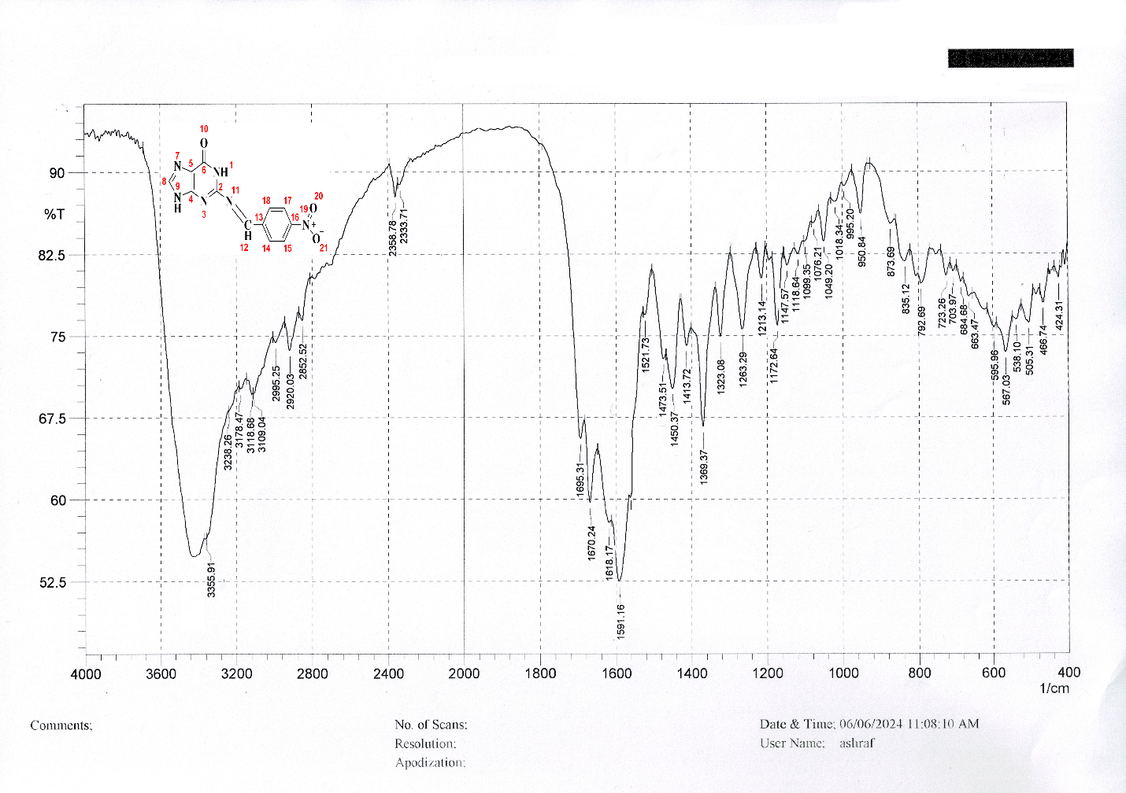
Fig. S1 FTIR-spectrum of (S₁) Schiff base

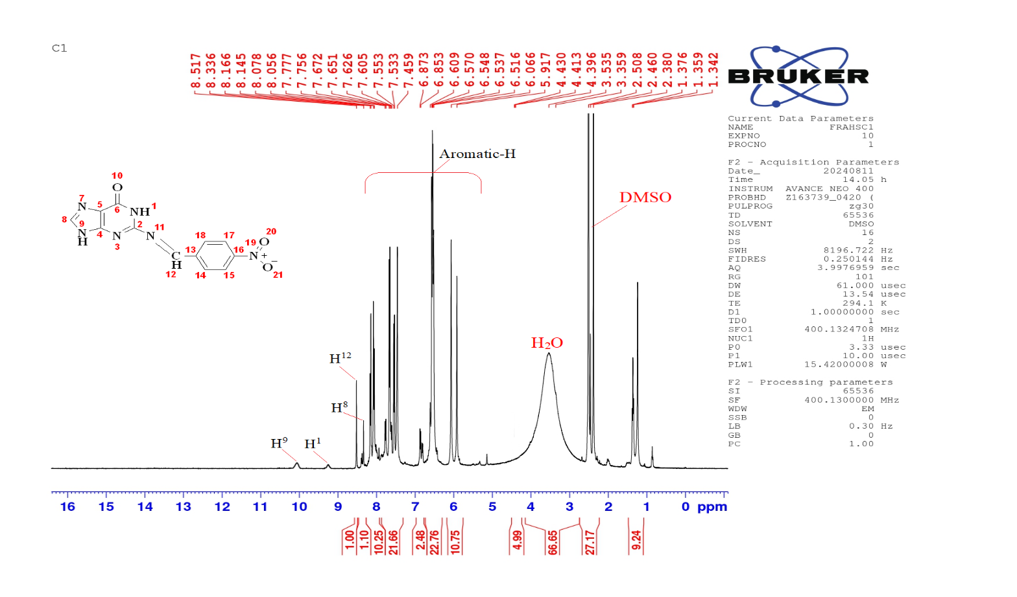
a
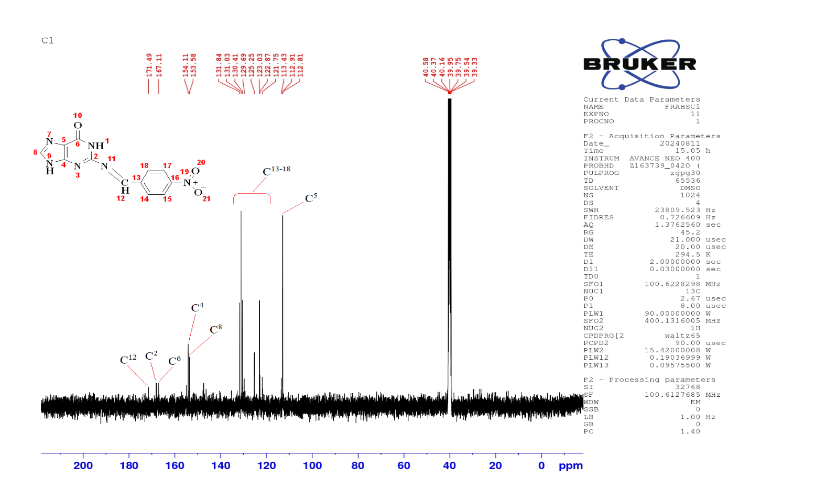
b
Fig. S2 The spectra of ¹HNMR (a) and ¹³CNMR (b) of (S₁) Schiff base
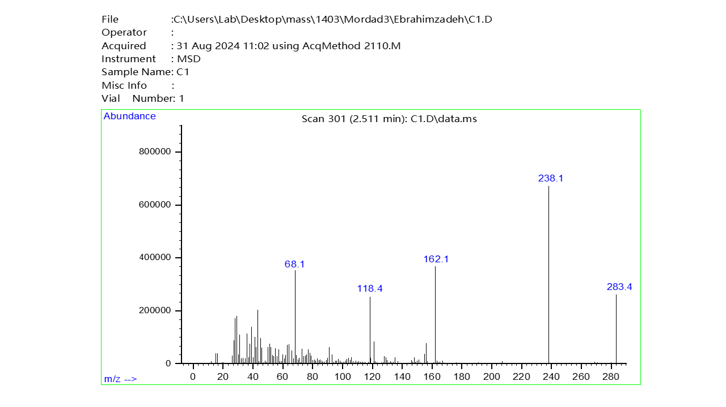
Fig. S3 The mass spectrum of (S₁) Schiff base

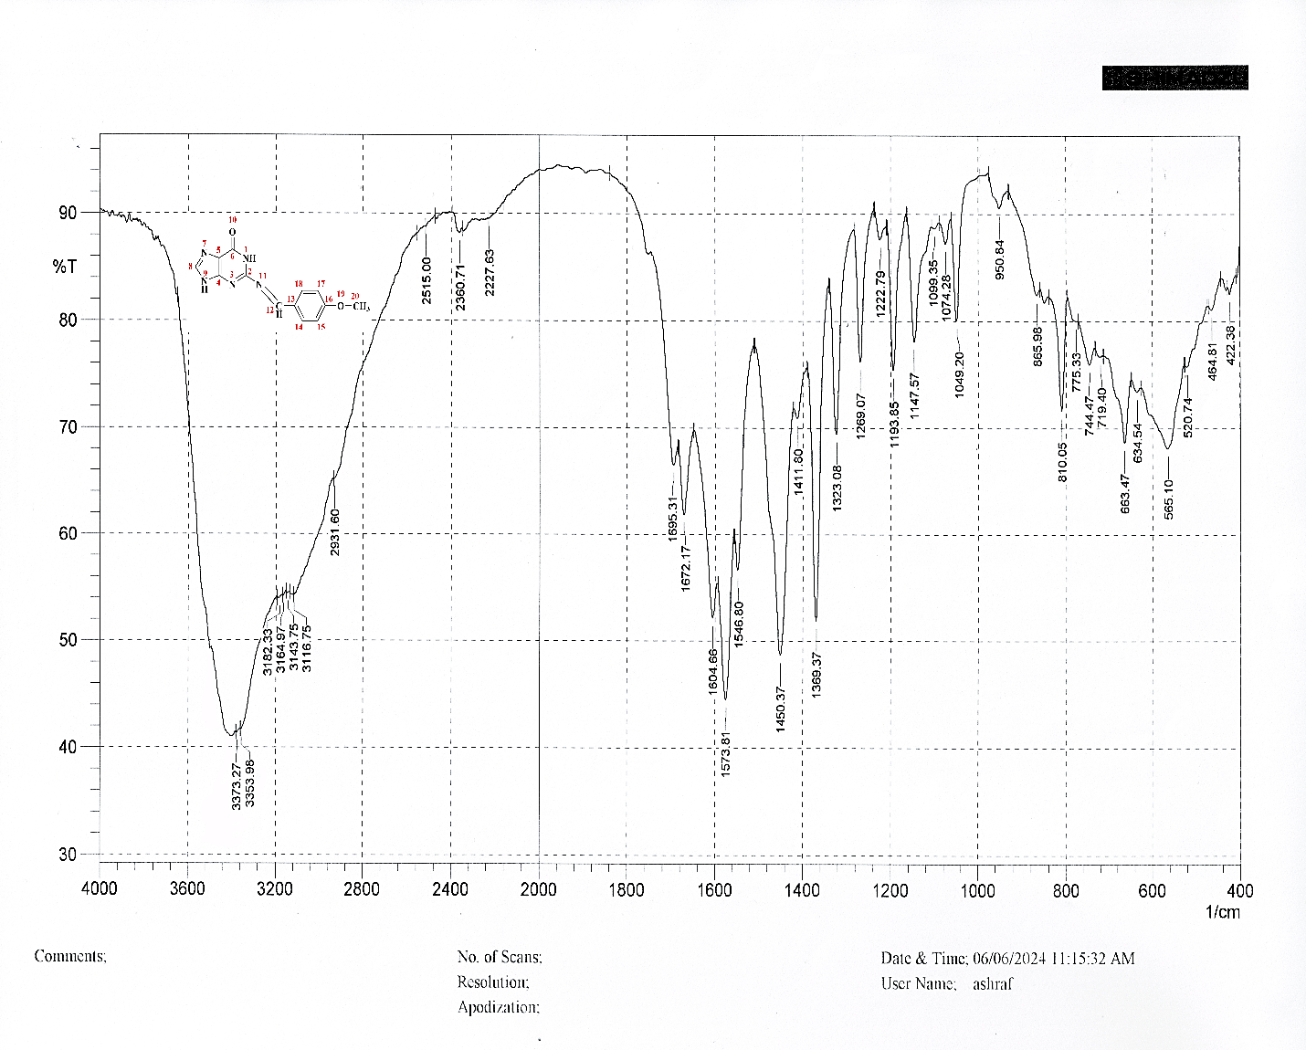
Fig. S4 FTIR-spectrum of (S₂) Schiff base

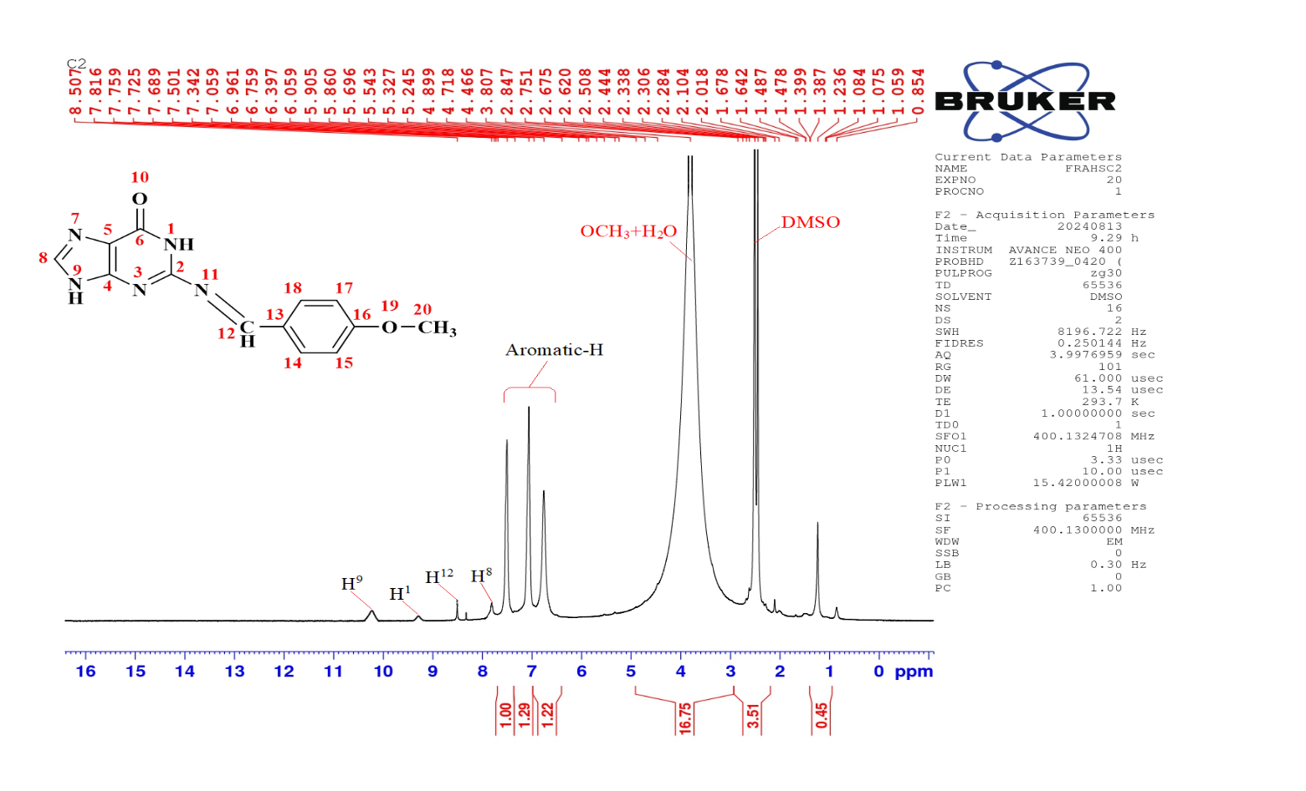
a
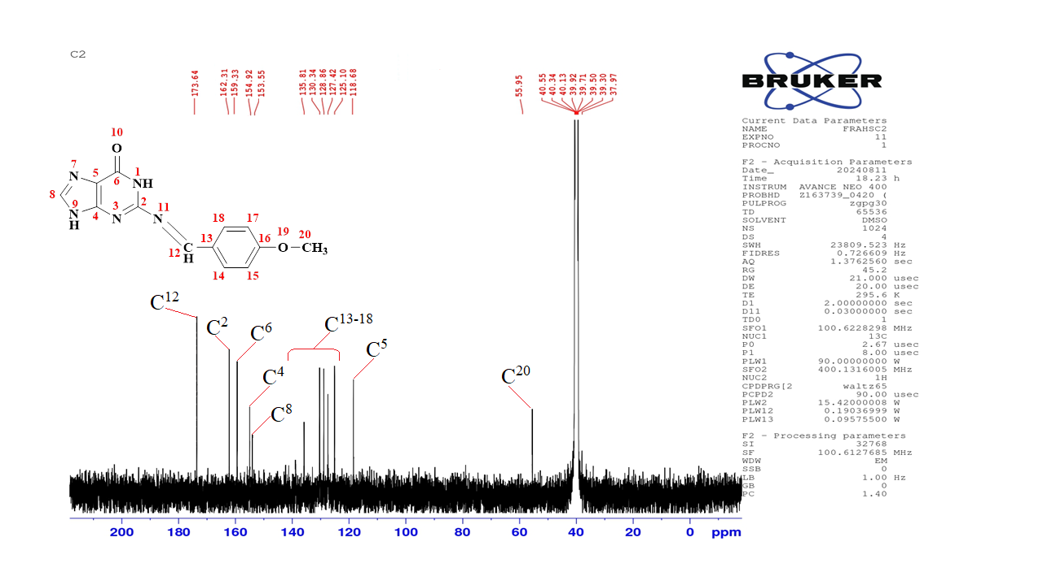
b
Fig. S5 The spectra of ¹HNMR (a) and ¹³CNMR (b) of (S₂) Schiff base
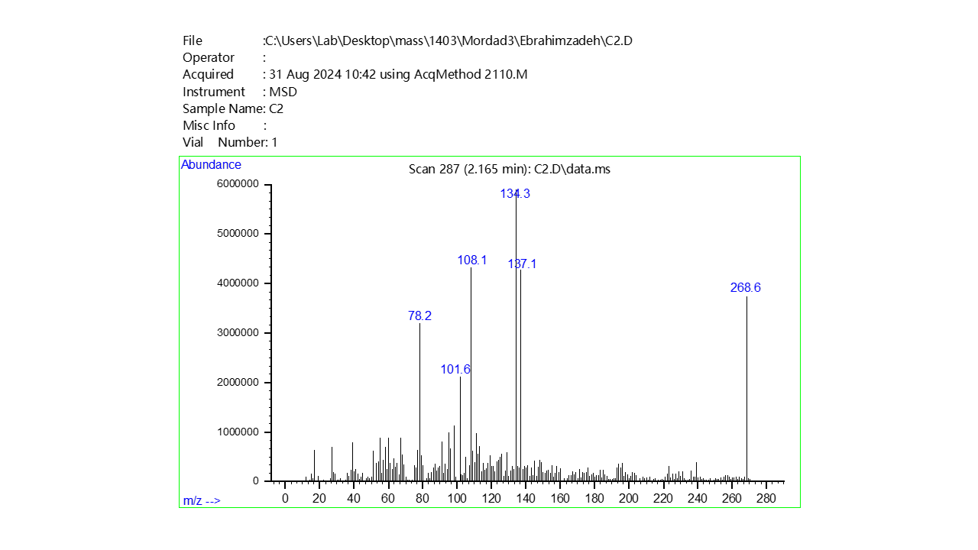
Fig. S6 The mass spectrum of (S₂) Schiff base

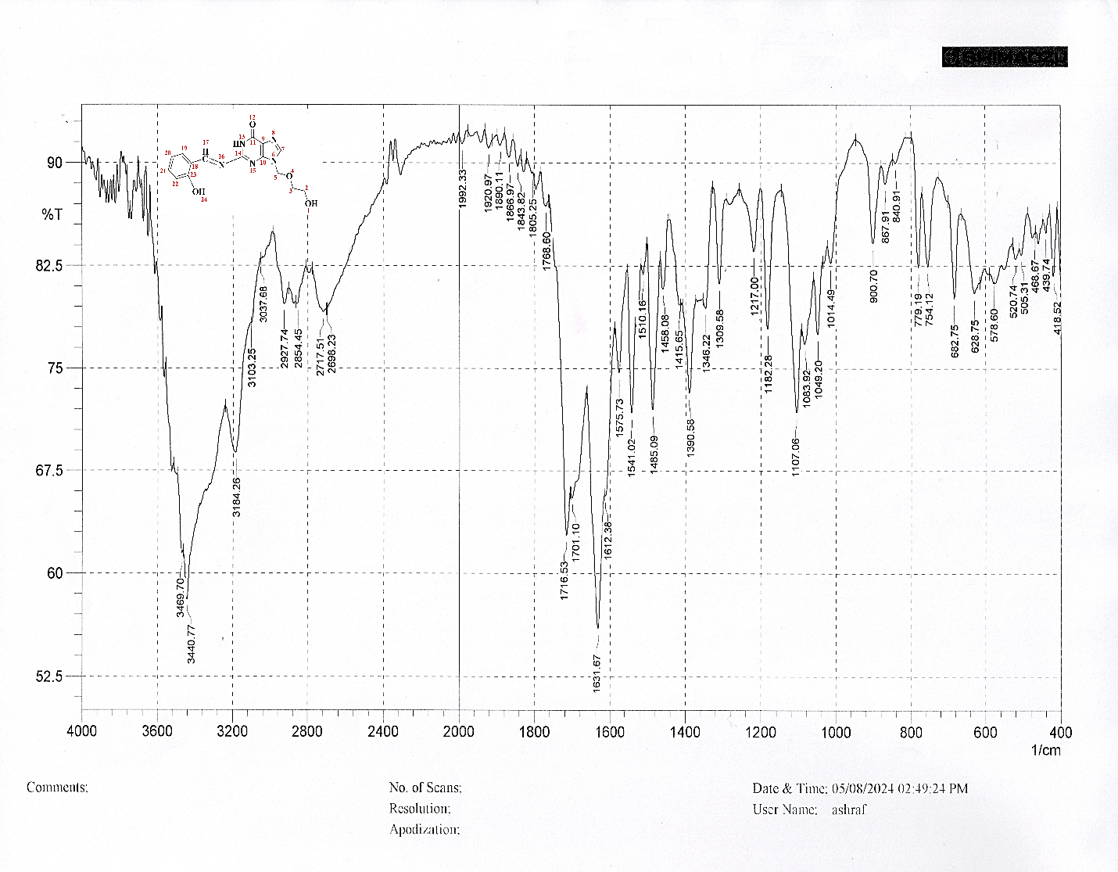
Fig. S7 FTIR-spectrum of (S₃) Schiff base

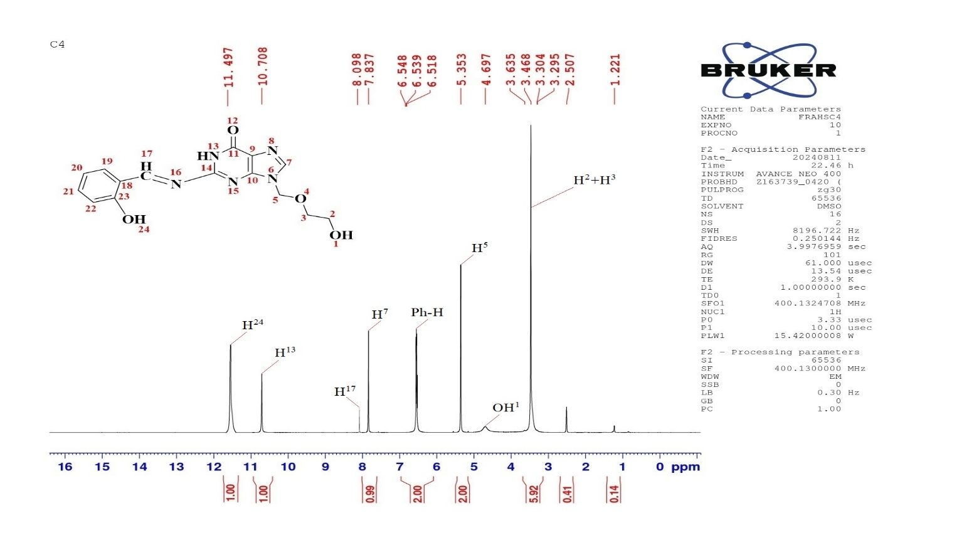
a
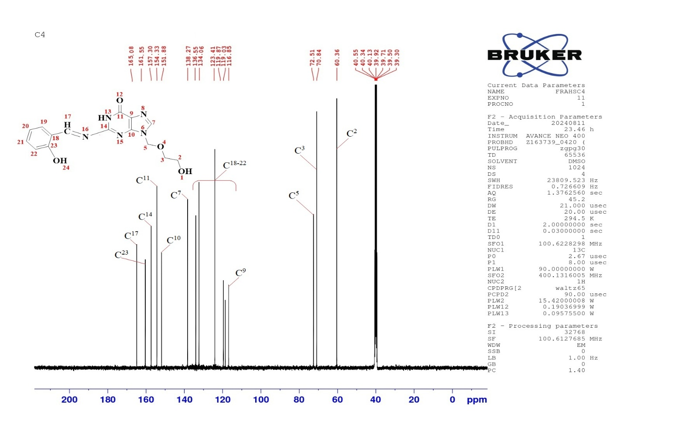
b
Fig. S8 The spectra of ¹HNMR (a) and ¹³CNMR (b) of (S₃) Schiff base
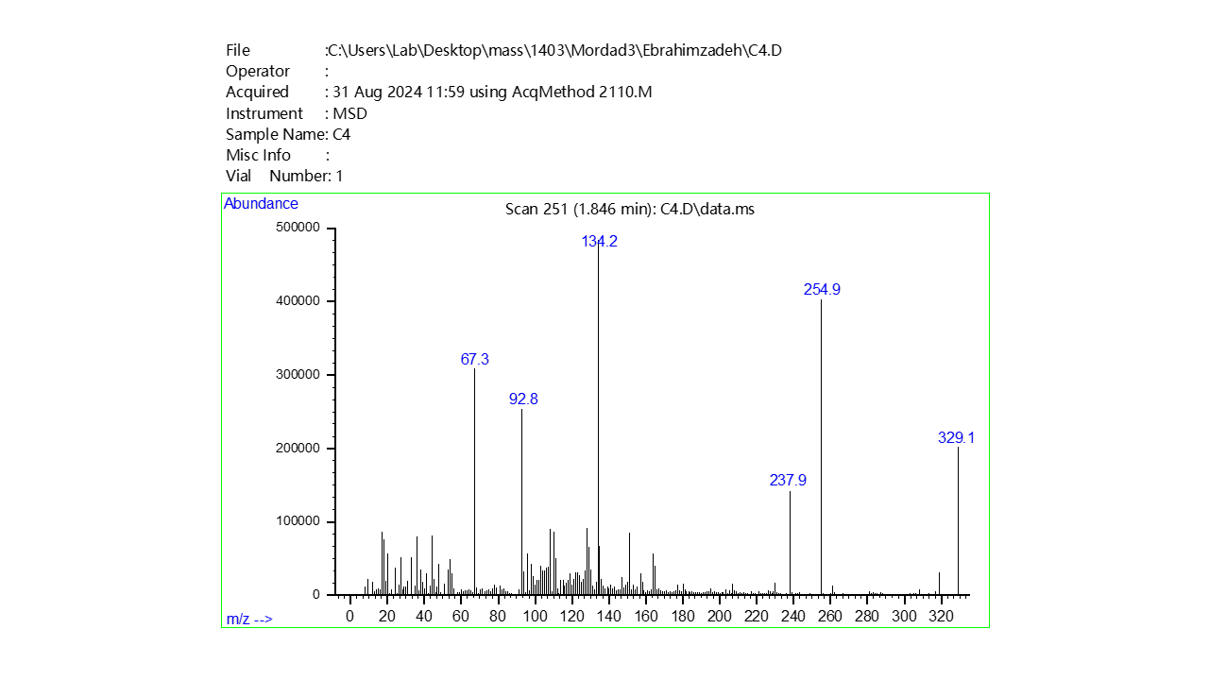
Fig. S9 The mass spectrum of (S₃) Schiff base

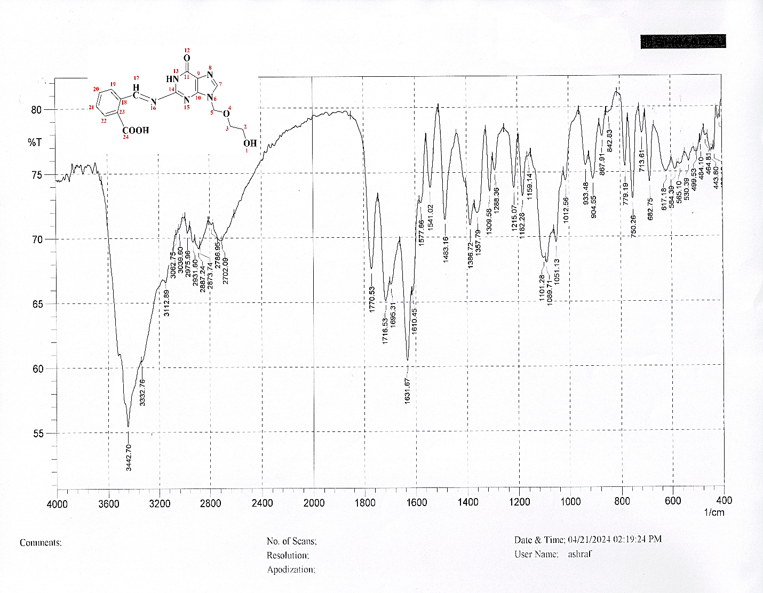
Fig. S10 FTIR-spectrum of (S₄) Schiff base
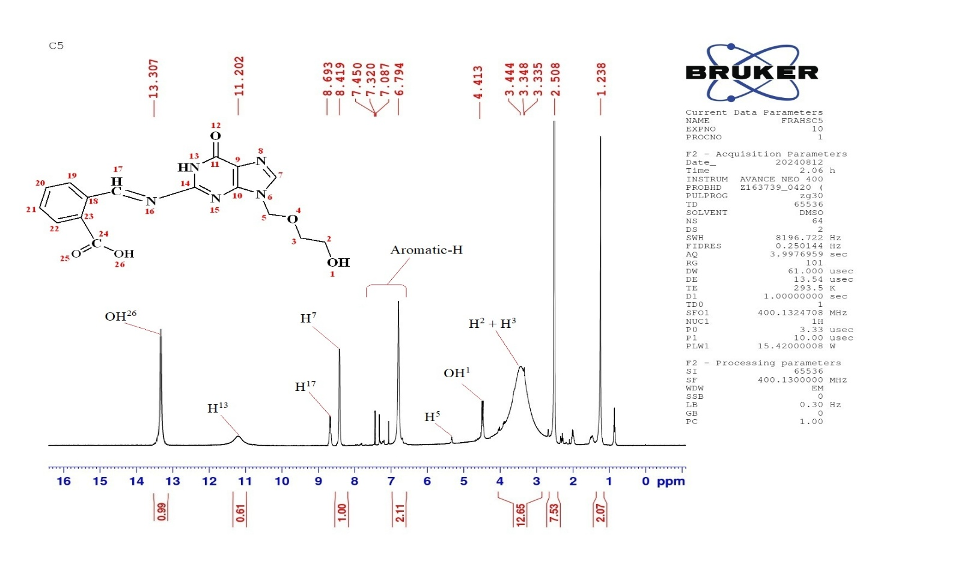
a
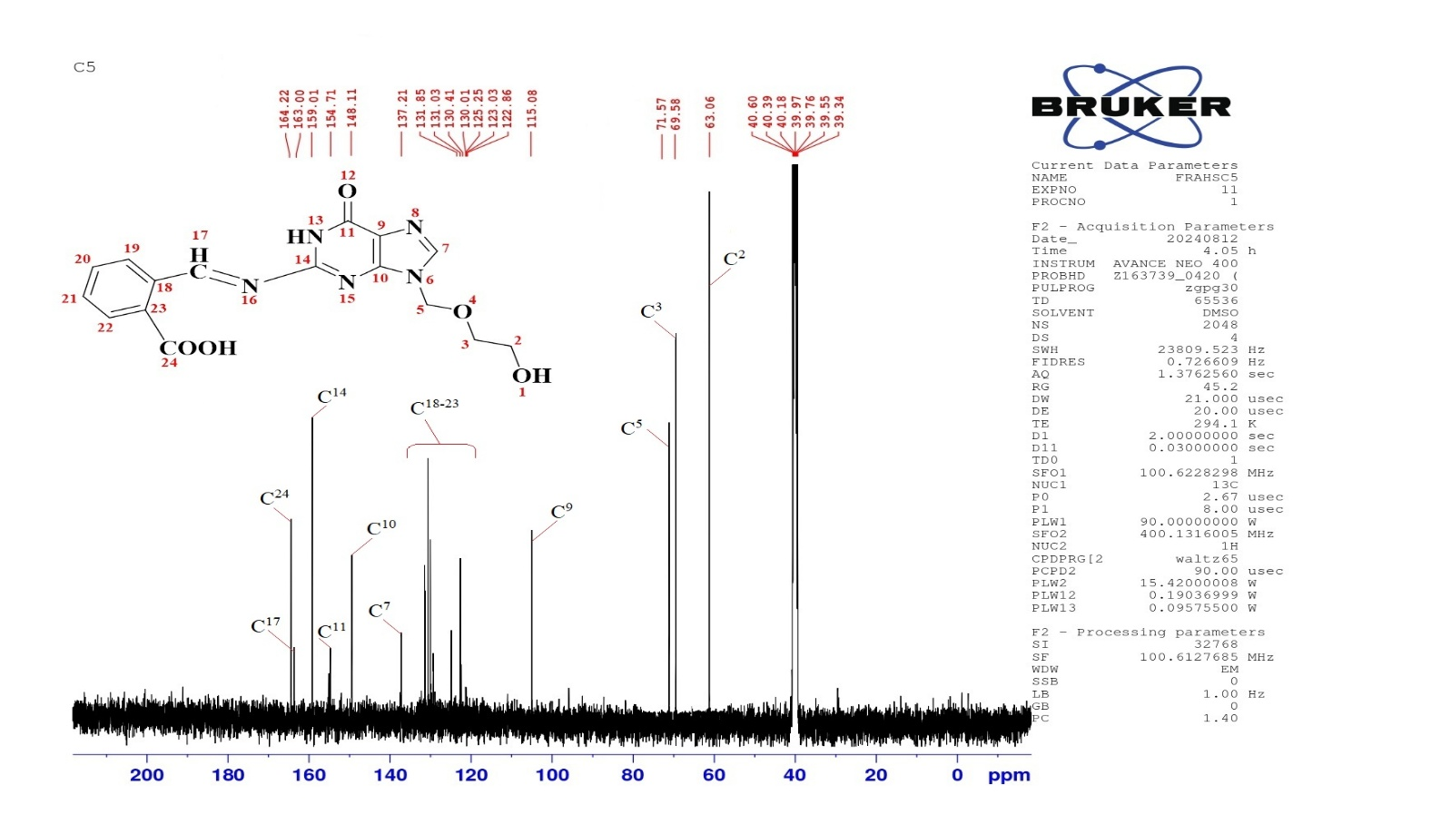
b
Fig. S11 The spectra of ¹HNMR (a) and ¹³CNMR (b) of (S₄) Schiff base
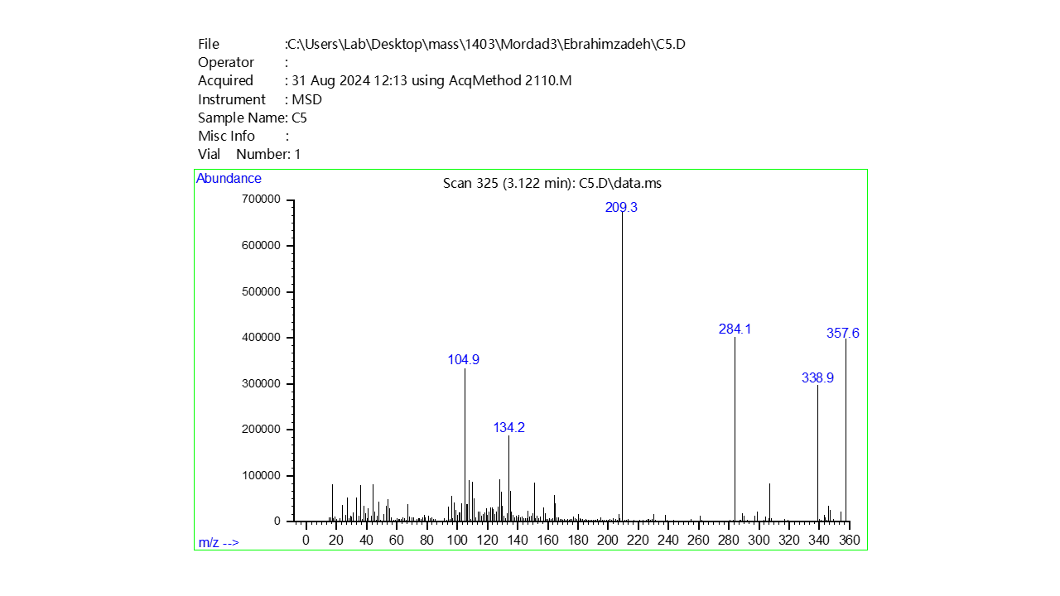
Fig. S12 The mass spectrum of (S₄) Schiff base

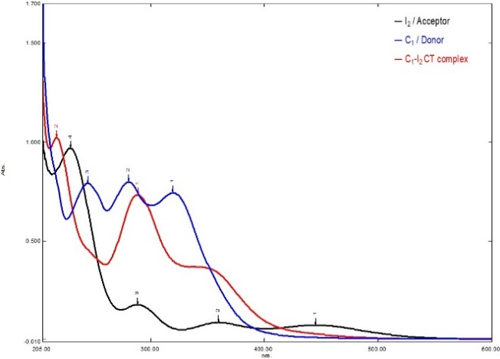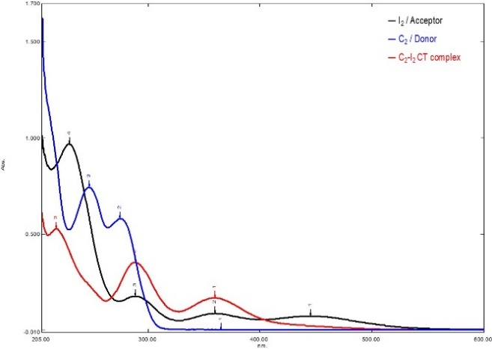
S₂
S₁
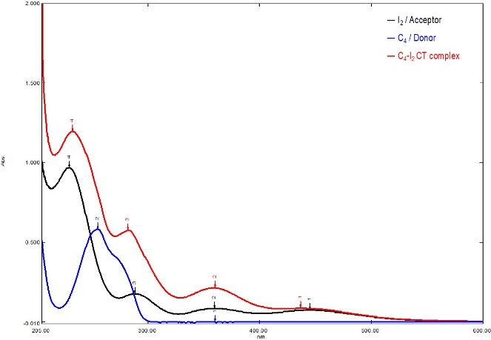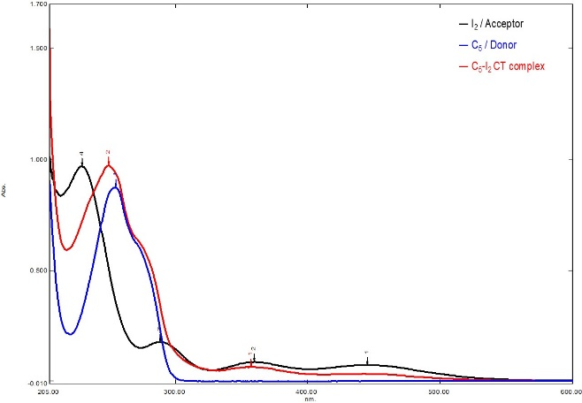
S₄
S₃

Fig. S13 Uv-vis spectrum of I₂, Shiff bases (S₁,S₂,S₃,S₄), and CT–Iodine complexes in ethanol at 301K.
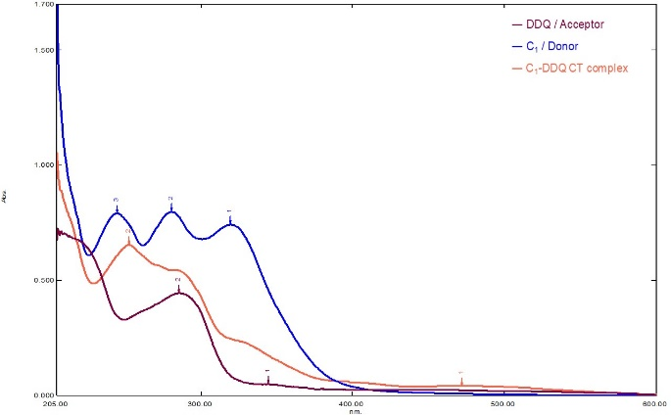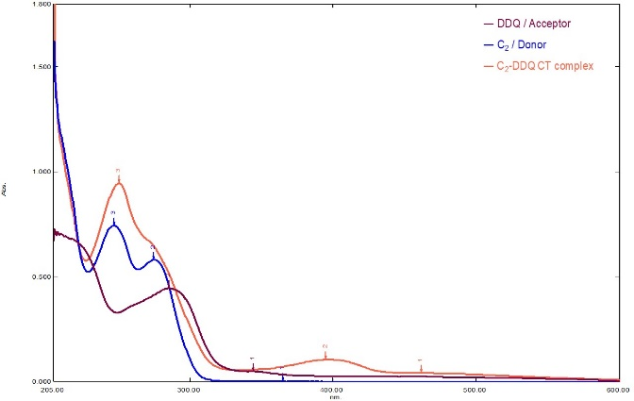
S₂
S₁
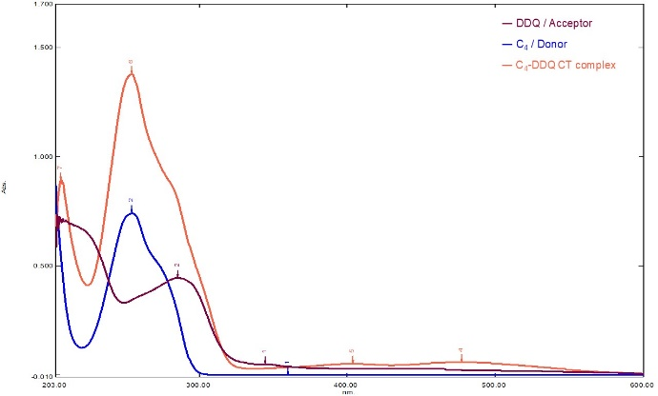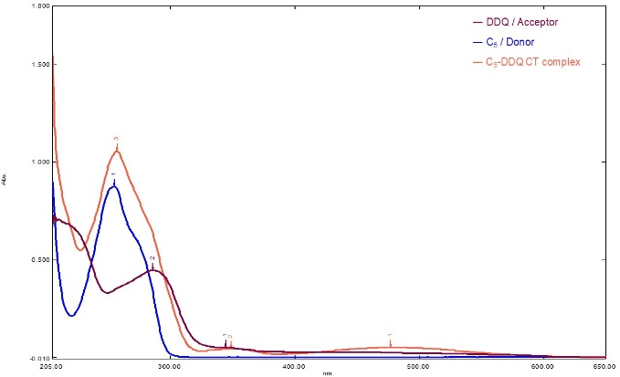
S₄
S₃

Fig. S14 Uv-vis spectrum of DDQ, Shiff bases (S₁,S₂,S₃,S₄), and CT–DDQ complexes in ethanol at 301K.

