Appendix (Survey)
A Study on the Impact of Biophilic Design on Women in Workplaces in Egypt
Dear Participant,
Thank you for taking a few minutes to help with this research. This survey is part of a study exploring how natural elements in indoor workplaces—like plants, sunlight, natural colors, or fresh air—might support women’s well-being, health, and productivity.
Your participation is entirely voluntary. You can skip any question or stop at any time. The survey is entirely anonymous—we don’t ask for your name or any personal details that could identify you. Your answers will only be used for academic purposes, and there are no risks or negative consequences from participating. However, we kindly ask that you only submit the survey if you complete it, as partial responses may affect the accuracy of the results. By completing the survey, you agree to take part in the study. Your input will help make workplaces better for women in Egypt.

Section 1: Demographic Information (About You).
This section aims to gather your personal and professional background to ensure more accurate data analysis.
- .................................... | Name "Optional": | 1
- .................................... | Workplace Location:  City/Region: | 2
- .................................... | Job Title: | 3
○ Under 25 years  ○ 25–34 years  ○ 35–44 years  ○ 45–54 years  ○ 55 years or older | Age: | 4
○ High school or less  ○ Diploma  ○ Bachelor’s degree  ○ Postgraduate studies | Educational Level: | 5
○ Office-based  ○ Field-based  ○ Mixed | Nature of Work: | 6
○ Less than 5 hours  ○ 5–7 hours  ○ 8–10 hours  ○ More than 10 hours | Daily Working Hours: | 7
○ Less than 5 years  ○ 5–10 years  ○ 10–20 years  ○ More than 20 years | Years of Experience: | 8
○ Less than 3 hours  ○ 3–5 hours  ○ 6–8 hours  ○ More than 8 hours | Daily Sitting Time at the Desk: | 9
○ Government  ○ Private  ○ Non-profit sector  ○ Other (please specify): | Workplace Type: | 10
○ Rarely  ○ 1–3 days  ○ 4–7 days  ○ More than 7 days | Monthly Absence Rate from Work: | 11
Section 2: Your Current Workplace Environment.
This section aims to evaluate the design of your current workplace environment and its impact on your comfort and health.
Please rate the following statements using the scale below:
(1) Strongly Disagree | (2) Disagree | (3) Neutral | (4) Agree | (5) Strongly Agree
Your workplace includes plants and green spaces. | 1
Your workplace includes water features (e.g., fountains or aquariums). | 2
Your workplace relies on natural lighting and provides sufficient brightness. | 3
Transparent windows in your workplace allow you to see external views. | 4
You can control the temperature and humidity in your workplace. | 5
Lighting can be adjusted in your workplace to suit your needs. | 6
The colors used in your workplace are inspired by nature. | 7
Natural materials (e.g., wood or stone) are used in your workplace. | 8
The design of your workplace helps reduce stress and tension. | 9
The design of your workplace positively impacts your focus and productivity. | 10
The design of your workplace enhances your comfort and sense of well-being. | 11
Does the design of your workplace improve your overall work experience? | 12
Section 3: Perceptions of Biophilic Design (Your Thoughts About Nature at Work).
This section aims to understand your perceptions of the impact of biophilic design on your health and well-being.
Please rate the following statements using the scale below:
(1) No impact | (2) Weak impact | (3) Moderate impact | (4) Strong impact | (5) Very strong impact
How important do you consider the presence of natural elements in your workplace? | 1
Do you believe natural elements in the workplace help improve your focus and creativity? | 2
Do natural elements contribute to improving your physical and mental health? | 3
Section 4: The Impact of Biophilic Design Elements on Women's Health, Well-Being, and Productivity.
This section aims to evaluate the effect of each element on your health, Well-Being, and productivity.
Please rate the following statements using the scale below:
(1) No impact | (2) Weak impact | (3) Moderate impact | (4) Strong impact | (5) Very strong impact
Do you believe that the following elements impact your health by reducing stress and psychological pressure, enhancing positive emotions, making you feel comfortable and relaxed, boosting creativity at work, improving focus, and increasing productivity in your workplace?
Plants and green spaces. | 1
Natural lighting. | 2
Ability to control light intensity. | 3
Natural ventilation. | 4
Ability to control temperature and humidity. | 5
Water features such as fountains and aquariums. | 6
Nature-inspired colors (e.g., blue, green, brown). | 7
Furniture made from natural materials like wood and stone. | 8
Nature-inspired artwork. | 9
Organic patterns and flowing lines. | 10
Sitting near windows with views of natural landscapes. | 11
Natural scents (e.g., plants and flowers) or other pleasant aromas. | 12
Natural sounds like water or birdsong. | 13
Moving screens displaying nature imagery and videos. | 14
Availability of private spaces for solitude. | 15
The impact of working in an environment similar to the one depicted in the following image. | 16
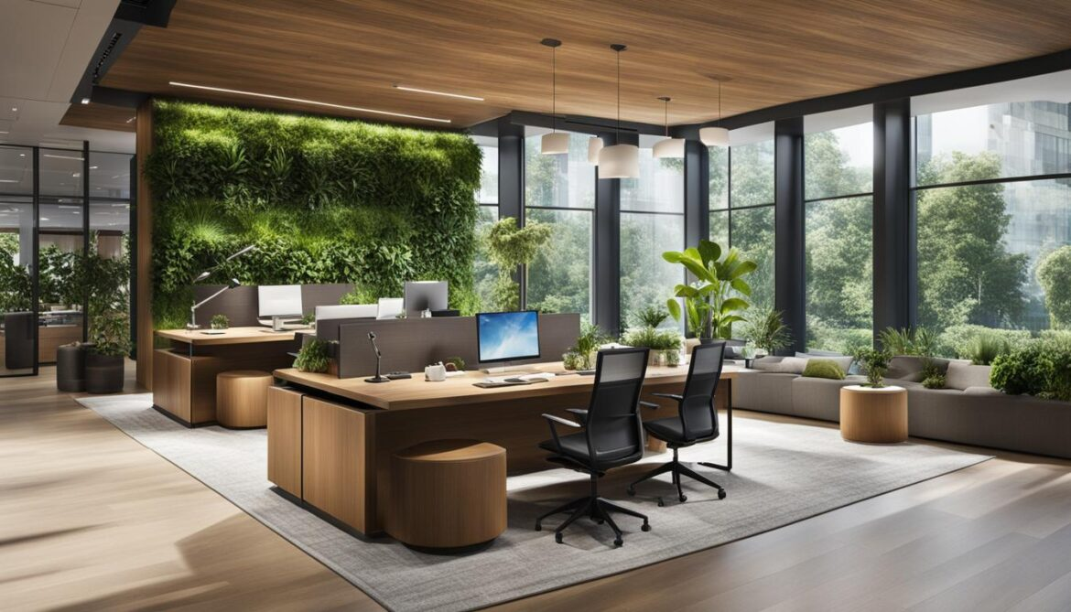
"The following image illustrates an example of a biophilic design for a workplace. Please answer the question based on your expectations of this environment."

If you could redesign your workplace using natural elements, what would you add? (Choose as many as you like):
(Plants – Natural lighting – Natural ventilation – Water features – Use of natural materials in furniture – Nature-inspired artwork – Nature-inspired colors – Natural scents – Natural sounds – Moving screens – Private spaces – Other: ..............)
Section Five: Open-Ended Questions
- What improvements would you like to see in your workplace design?
...........................................................................................................................................
- Which natural elements impact your comfort and health in the workplace?
...........................................................................................................................................
- What challenges do you anticipate in implementing biophilic design or adding natural elements to your workplace?
...........................................................................................................................................
- Do you have any additional suggestions for improving women’s workplace environments in Egypt?
...........................................................................................................................................
End of the Questionnaire:
Thank you for your time and valuable participation. Your responses will enhance the design of women’s workplaces better to support their Health, Well-Being, and Productivity.

