Additional file: Supplementary Fig. 1 Data preprocessing for transcriptome analysis and WGCNA. A, The cluster analysis was conducted using 12 sample datasets. B, Calculation of the soft threshold for the model. C, Gene enrichment trend chart. D, Calculation of the correlation coefficient and cluster analysis. E, Analysis of gene-module correlations. F, Analysis of gene-phenotype correlations. Supplementary Fig. 2 Heatmap of MEmagenta module core gene expression. Supplementary Fig. 3 Ten genes from the MEmagenta module that exhibit differential expression at random were selected and analysed.
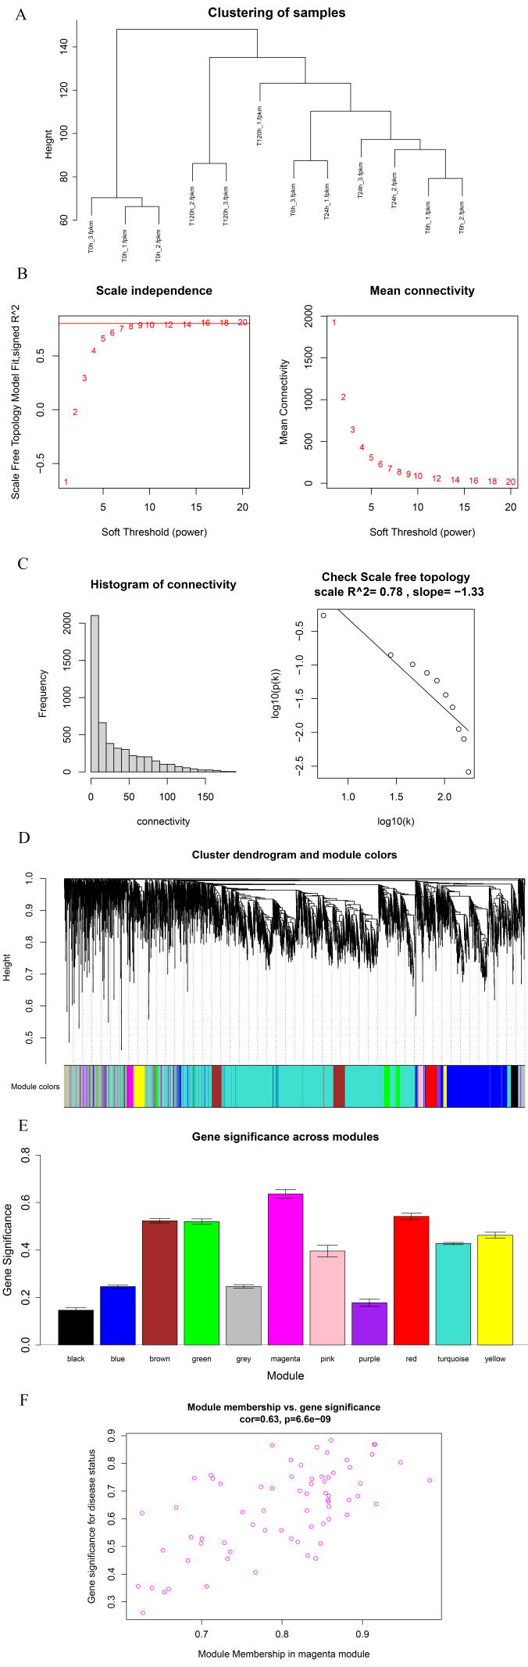
Supplementary Fig. 1 Data preprocessing for transcriptome analysis and WGCNA. A, The cluster analysis was conducted on 12 sample datasets. B, Calculation of the soft threshold for the model. C, Gene enrichment trend chart. D, Calculation of the correlation coefficient and cluster analysis. E, Analysis of gene-module correlations. F, Analysis of gene-phenotype correlations.

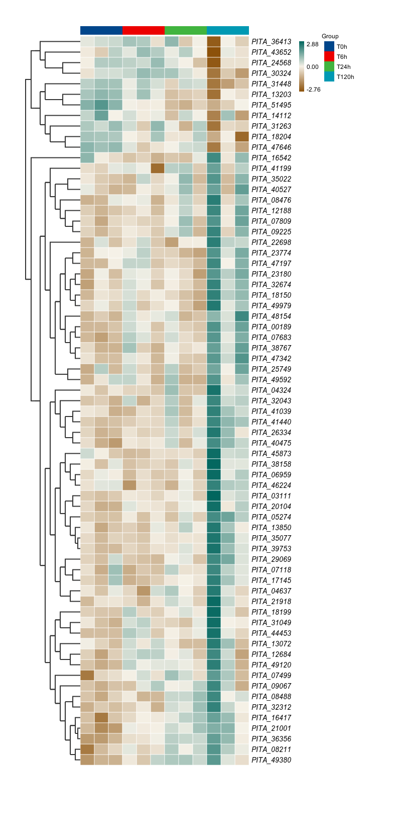
Supplementary Fig. 2 Heatmap of MEmagenta module core gene expression

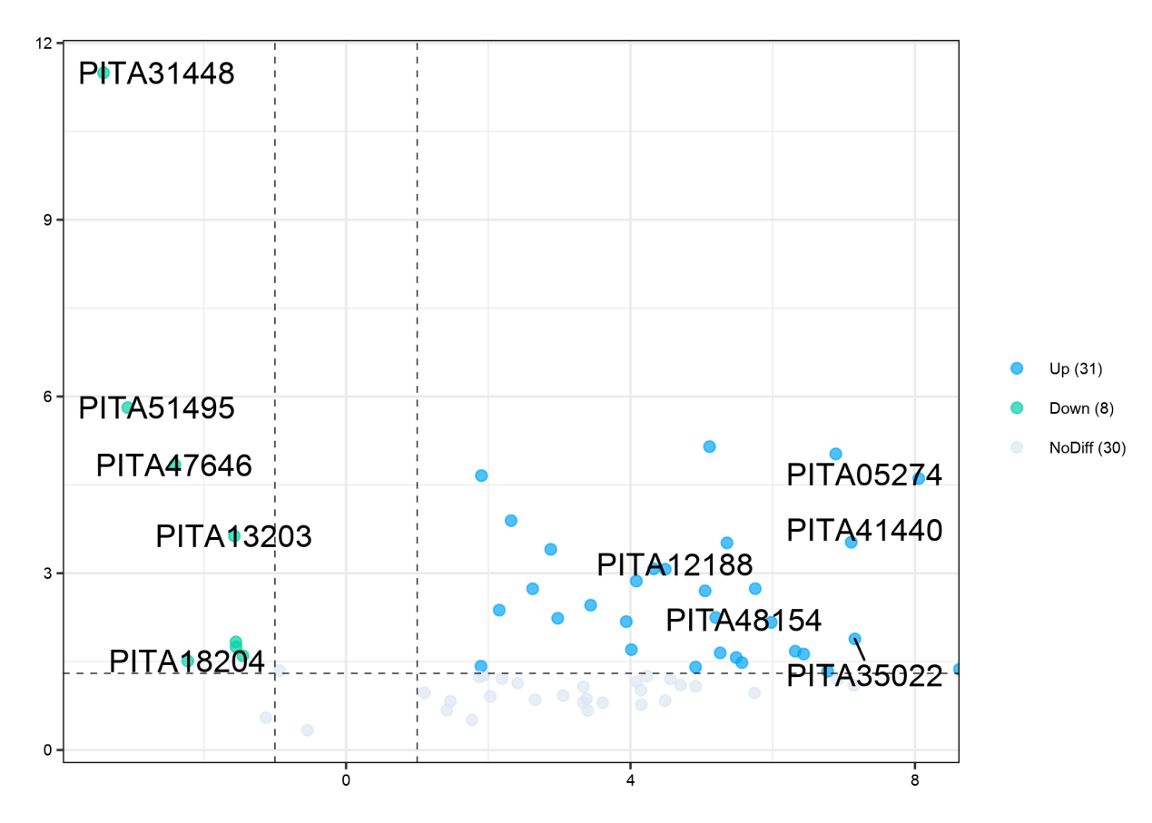
Supplementary Fig. 3 Selection and analysis of ten genes from the MEmagenta module that exhibit differential expression at random

