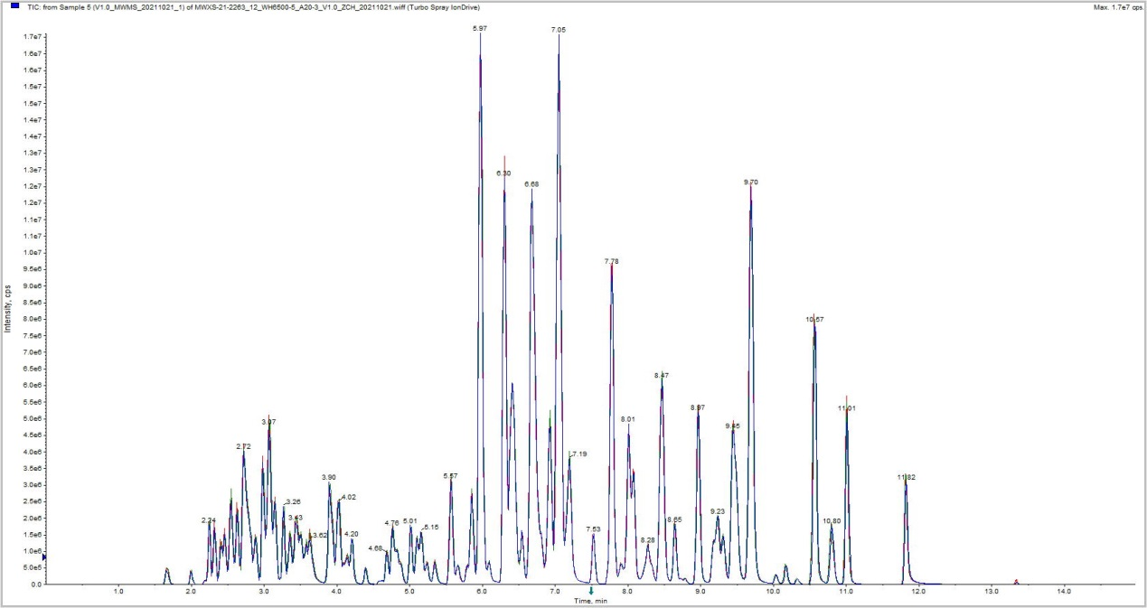
Figure S1. Total ion flow chromatogram. The x-axis represents the retention time and the y-axis the ion intensity (cps).
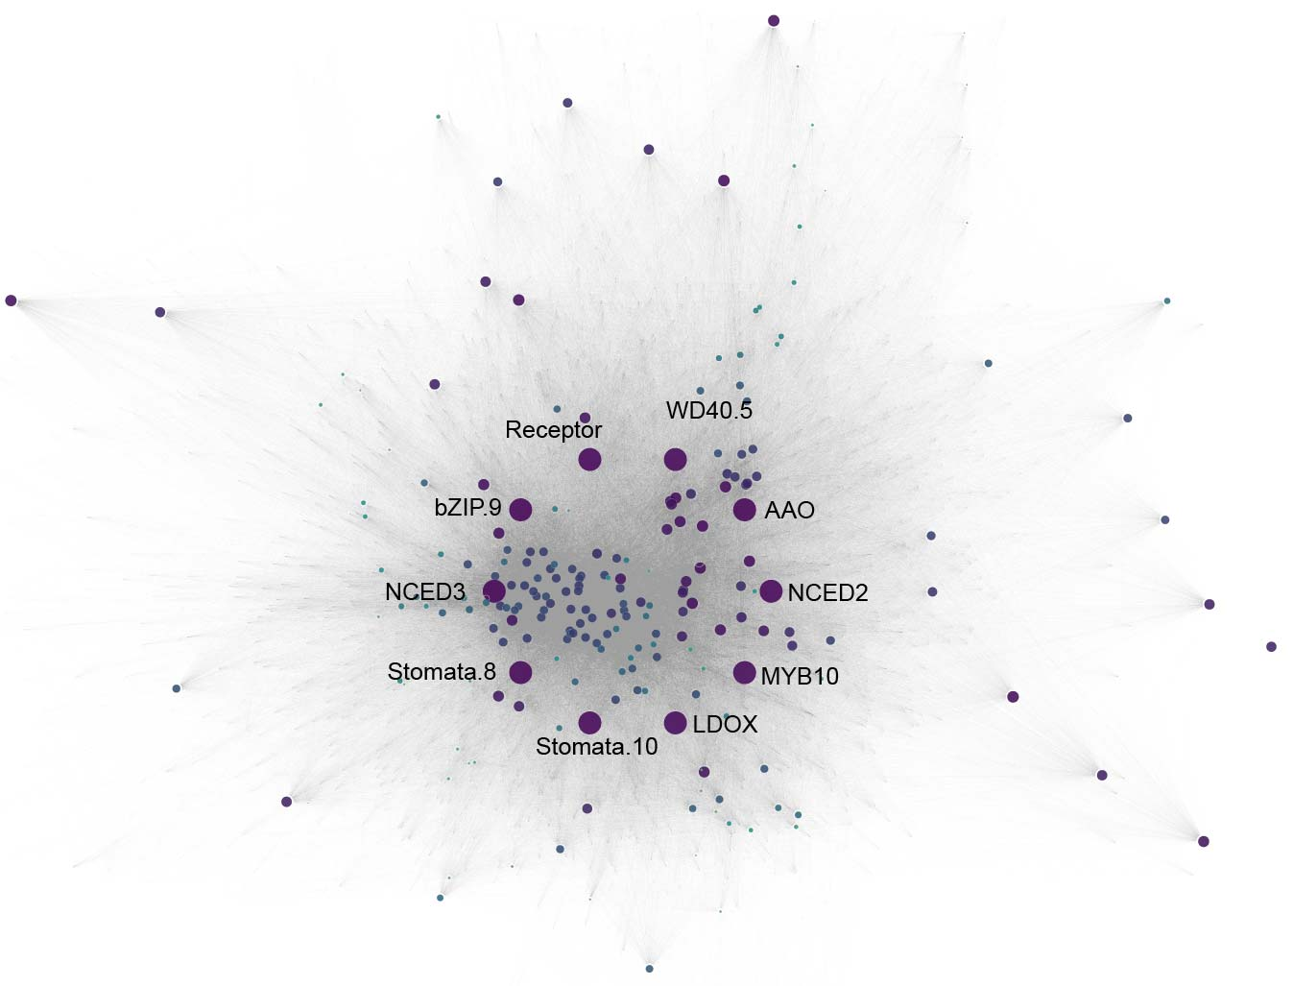
Figure S2. Top 10 hub-genes of the co-expression network constructed from all differentially expressed genes (DEGs).

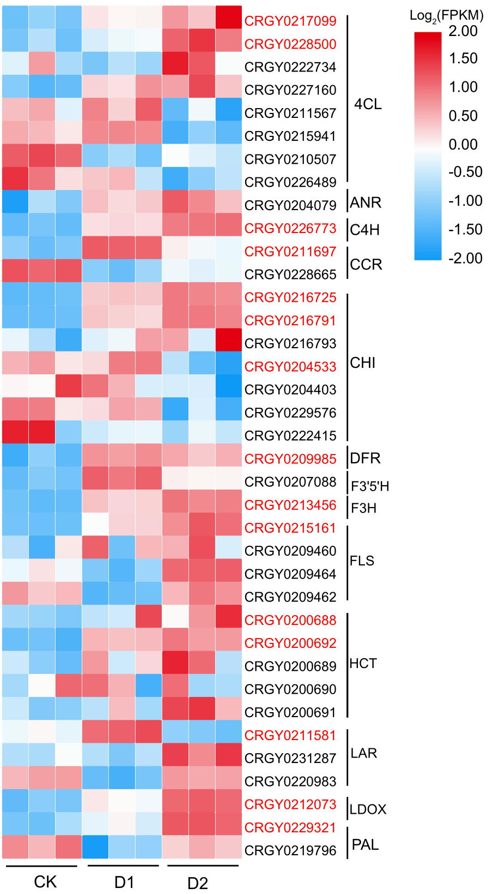
Figure S3. The expression of genes in the flavonoid biosynthesis pathway. The red letters represent differentially expressed genes.

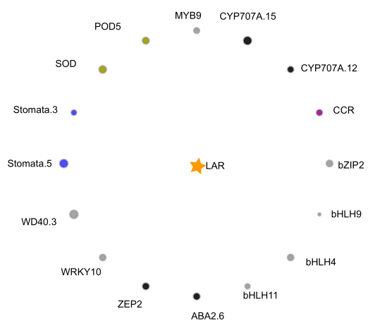
Figure S4. DEGs directly interacted with LAR (CRGY0211581). The orange, grey, black, green, blue, brown, and pink circles represent DEGs in flavonoids biosynthesis, transcription factors, ABA biosynthesis and signaling pathway, photosynthesis, stomatal movement, antioxidant enzymes and protein kinases, respectively. The size of circles represents the connectivity of the genes.

