Distinct Cadmium detoxicity response between rice cultivars carrying functional or loss-of-function OsHMA3 allele

Fuqing Sui¹, Jing Tian¹, Ziyuan Yang¹, Yanzheng Yang¹, Chang Li¹, Hongen Liu, Jiali Yan^{2*}, and Peng Zhao^{1*}

1. Key Laboratory of Soil Pollution Control and Remediation of Henan Province, College of Resources and Environment, Henan Agricultural University, Zhengzhou, China

2. College of Civil and Architecture Engineering, Chuzhou University, Chuzhou, 239000, China

* Correspondence: zhaopeng@henau.edu.cn or jialiyan092@163.com. No. 218, Pingan Rd., Jinshui Dist., Zhengzhou, China. 450002.

Supplementary materials

Table S1 Effects of Cd treatment on chlorophyll content of different rice cultivars
Treatment | Chlorophyll contents  (mg g-1 FW) |  |  | Carotenoid contents  (mg g-1 FW)
Treatment | a | b | a+b | Carotenoid contents  (mg g-1 FW)
W4-CK | 34.62±0.38a | 15.65±1.39a | 50.26±1.01a | 8.23±0.35a
9311-CK | 34.67±0.36a | 9.14±0.3b | 43.84±2.23b | 8.88±0.29a
W4-Cd10 | 23.88±0.33b | 8.98±0.35b | 32.86±0.66c | 4.53±0.16b
9311-Cd10 | 31.69±3.68a | 9.97±1.07b | 41.66±2.61b | 8.40±0.80a
The rice seedlings were hydroponically treated with or without 10 μM Cd for 14 d. Data were shown as means ± S.D., n = 3. FW, Fresh weight. Different lower cases indicate significant differences at P < 0.05 by Tukey’s test.

Table S2 Effect of Cd treatment on root morphological parameters
Treatment | Root length (cm) | Root surface area (cm²) | Root diameter (mm) | Root volume (cm³) | Root tip number
W4-CK | 354.90±28.49a | 46.34±5.56b | 0.40±0.02bc | 354.90±28.49b | 1912±104.89a
9311-CK | 362.50±12.70a | 56.85±4.60a | 0.47±0.02a | 469.93±65.49a | 2001.24±125.80a
W4-Cd10 | 238.54±30.87b | 26.26±3.96c | 0.35±0.03c | 238.54±30.87c | 1374.78±126.20b
9311-Cd10 | 361.24±6.28a | 49.76±3.93ab | 0.44±0.03ab | 361.24±6.28b | 2031.70±100.75a
The rice seedlings were hydroponically treated with or without 10 μM Cd for 14 d. Data were shown as means ± S.D., n = 3. Different lower cases indicate significant differences at P < 0.05 by Tukey’s test.

Table S3 Effects of Cd treatment on photosynthetic characteristics of different rice cultivars
Treatment | P_{n}/(μmol·m⁻²·s⁻¹) | G_{s}/(mol·m⁻²·s⁻¹) | C_{i}/(μmol·mol⁻¹) | T_{r}/(mmol·m⁻²·s⁻¹)
W4-CK | 25.34±1.45b | 0.09±0.01a | 449.73±16.41a | 1.68±0.2a
9311-CK | 35.00±2.69a | 0.12±0.02a | 470.08±1.78a | 1.97±0.24a
W4-Cd10 | 23.55±0.49b | 0.03±0.002b | 343.11±66.76b | 0.47±0.08c
9311-Cd10 | 32.48±3.50a | 0.05±0.003ab | 467.54±32.93a | 0.91±0.05b
The rice seedlings were hydroponically treated with or without 10 μM Cd for 14 d. Data were shown as means ± S.D., n = 3. Different lower cases indicate significant differences at P < 0.05 by Tukey’s test.

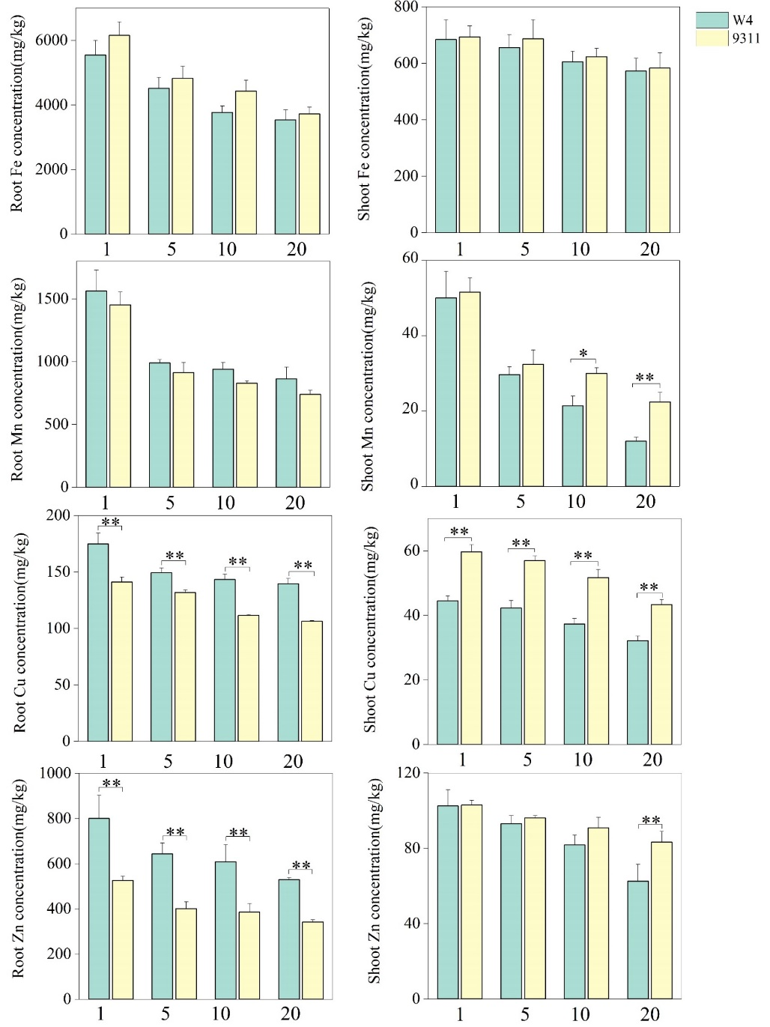
Fig. S1 Fe, Mn, Cu, and Zn contents in rice seedling roots and shoots of W4 and 9311 in the presence of 10 μM Cd for 14 d. Data were shown as means ± S.D., n = 3. * and ** indicate significant differences at P < 0.05 or P < 0.01 by Tukey’s test, respectively.

