Table S1 Primers used for construction of TrMMV-VIGS vectors and RT-qPCR
Primer names | Primer sequences（5'-3'）
CP-TCG-F | GCGGGCACCAAAGCCCAATTACAGCAAATGTCGTTCCAC
CP-TCG-R | GCTGTAATTGGGCTTTGGTGCCCGCCACAGAG
TrMMV-VIGS-insert1F | GTTCATTTCATTTGGAGAGGATGGGGATAAAAGTATTTAAGCACA
TrMMV-VIGS-insert1R | CATCAACCCTTCGTCGACCCAAAGGGTCT
TrMMV-VIGS-insert2F | GGGTCGACGAAGGGTTGATGGTTCATAC
TrMMV-VIGS-insert2R | CCGGCGCGCCATCGATAGTACTATTATAAAGATCTAAATAAGGGAAAAAGG
TrMMV-VIGS-insert3F | TACTATCGATGGCGCGCCGGATCCTCTTATGTTTCTAAGTCTGGTTTGAACC
TrMMV-VIGS-insert3R | TGGAGATGCCATGCCGACCCTGGGGTCCTTACCCAGGACA
QP-TrMMV-F | AGTCGCTCGTTGGCTTGTTA
QP-TrMMV-R | GACAGCATTCAGCGCTTCAC
NbSu215-insertF | GATCTTTATAATAGTCAGGGCAGAGTCAAGGGAG
NbSu215-insertR | AAACATAAGAGGATCATTCAGCAAAAGACATAACTTCATC
CuPDS90-insertF | GATCTTTATAATAGTATGCTTACTTGGCCAGAGA
CuPDS90-insertR | AAACATAAGAGGATCATTATCTTGAGCCTCAACATAGGA
CuPDS150-insertF | GATCTTTATAATAGTGATATGGGCTATTTTAAGGAACAAC
CuPDS150-insertR | AAACATAAGAGGATCCCCCGACTTCTCATCCACTC
CuPDS213-insertF | GATCTTTATAATAGTATGCTTACTTGGCCAGAGAAAA
CuPDS213-insertR | AAACATAAGAGGATCAATGCATTGCATAGAAAGTTCATCG
CuPDS400-insertF | GATCTTTATAATAGTTTTGGGGCTTATCCCAATGTGC
CuPDS400-insertR | AAACATAAGAGGATCAAATGCATTGCATAGAAAGTTCATC
QP-NbActin-F | AAAGACCAGCTCATCCGTGGAGAA
QP-NbActin-R | TGTGGTTTCATGAATGCCAGCAGC
QP-NbSu-F | TCTCGCTCCTCTAAATCTTCCA
QP-NbSu-R | CTTGAGCAGGGCTGACTTCC
QP-CuActin-F | ATGGTCAAGGCTGGATTTGC
QP-CuActin-R | TGAGCTTCATCACCAACATAGGC
QP-CuPDS-F | TGTGTGGATTACCCTAGACC
QP-CuPDS-R | CCAAGCTGCTACCTTTCCAC

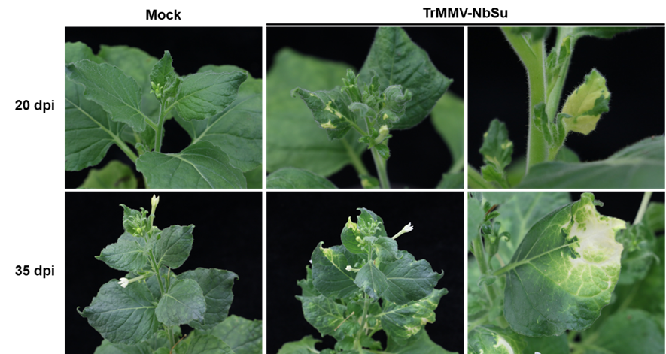

Fig. S1 Gene silencing phenotype of N. benthamiana triggered by TrMMV-NbSu. N. benthamiana plants were agroinoculated with Agrobacterium tumefaciens cells harboring TrMMV-NbSu. Plants agroinoculated with TrMMV-MCS were used as mock controls.

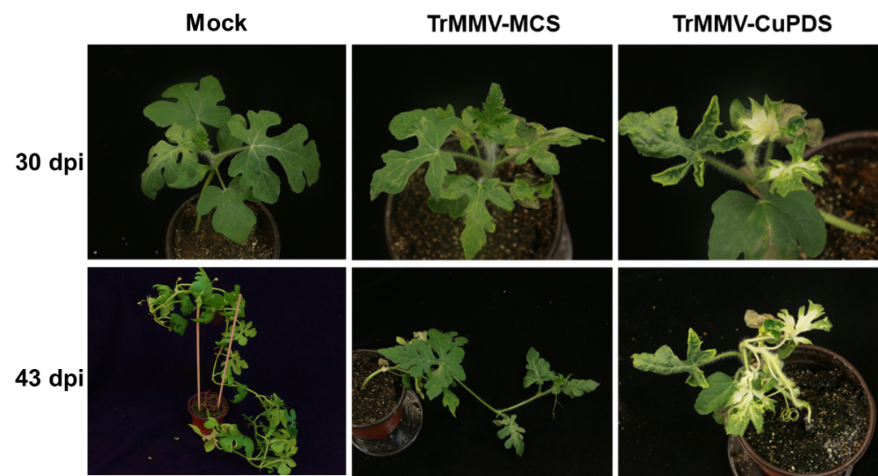
Fig. S2 Silencing phenotype of CuPDS observed in Citrullus lanatus.

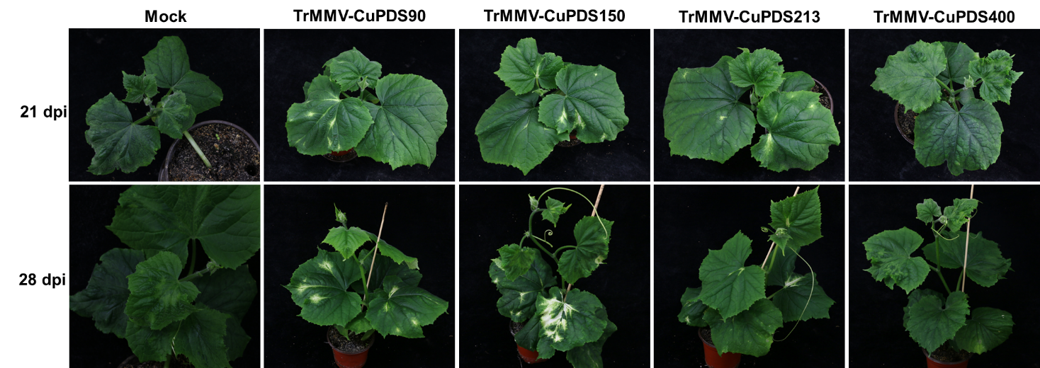
Fig. S3 Silencing phenotype of C. sativus inoculated with TrMMV-CuPDS vectors carrying PDS fragments of different lengths.

