Supporting Information

Article title: Hypoxia-induced oxidative stress and mitochondrial damage initiate ferroptosis in Cryptocaryon irritans, a protozoan parasite of marine fish
Author: Baotun Wang, Zhi Luo, Jingyu Zhuang, Zhicheng Li, Xueli Lai, Huicheng Wu, Qing Han, Jizhen Cao, Hebing Wang, Chuanfu Dong, Anxing Li

Table Legends
Supplemental Table S1 Primers in this study
prime | Sequences (5’-3’)
EF-1β-F | GGAGATGATGATGATAATGATGA
EF-1β-R | CCAAACTAAACCTTCCAACT
ADP_GK-F | TCAGTGATGCTAGGAGGACC
ADP_GK-R | TGATGGTGCTGTTATTGATCCCA
pgk-F | TGGAGTGGATTGGACTGTGG
pgk-R | ACTAGCTCCTCCTCCGGTAC
acss-F | CCAACCAGTTTCAGTTTGCCA
acss-R | CAAGGACCCAGATGCAGGAA
GAPDH-F | GTTATCATCTCAGCCCCACCT
GAPDH-R | AGTCCCTCAACAAGTCCGAA
eno-F | AGCAGCTACATCCATACCCA
eno-R | TCGGTGCTGAGGTTTACCAC
camk-F | TTGGTCATGTGGCGTGGTTA
camk-R | TGGTTGAGACATTCTTAGGCGT
mtor-F | GCTTTCGGTTCCTGGGCTAT
mtor-R | ACTCGTTCATCTTGGCGGAG
glna-F | ATGCTGAAGTTGCTCCTGGG
glna-R | CCTTCACTTCTGGTTTTGGTGG
GPI1-F | TTCAGGTTTCAACGCCAGAG
GPI1-R | TGGCCATTAGTACCAGGTTCA
gpx-F | GCTCTTCCGAATTCCTTTTCAGA
gpx-R | GCCTCTGATAATCCCTTGTCGA
gpx4-F | AAAAGACTACGAGGATTTGGGTG
gpx4-R | TGGCTCTTAACCAATGAAAAATTGA
GS-F | AGCCAGTGCCAAGATTAGGA
GS-R | AGCCACTCCTCCTTCATTAG
p53-F | ACTCCTTCCAAGCCATCACG
p53-R | CCACCCCAACATCCTGTCTC
nd75-F | AGGAGCTTCGAACCTTGGATT
nd75-R | GCCATCATAGGAGAATTTGCCG
cyc1-F | TGGGCTGGATTGATTGAGAACA
cyc1-R | TGAGGTCGGAACAGAACATGG
sdhb-F | CATGTCCTAGTTATTGGTGGCA
sdhb-R | TCCTCTGCAACTTTGTTCTCTCT
img5-F | TCAGCCCGTTTTTATCTTTCAC
img5-R | GTTCTTATGGAGCAATGGAACCTTT
mcar-F | CCCTTAGTCAGTAGCCTTTGTGA
mcar-R | AGGGAGGAGGGTCTTAAAGGA
pdi-F | TGGCCATACAATTCTGACAGT
pdi-R | TCGGAGAAAACAAAGCTTGCC

Figure Legends
Supplemental Figrue S1 OPLS-DA analysis of C. irritans tomonts under hypoxia

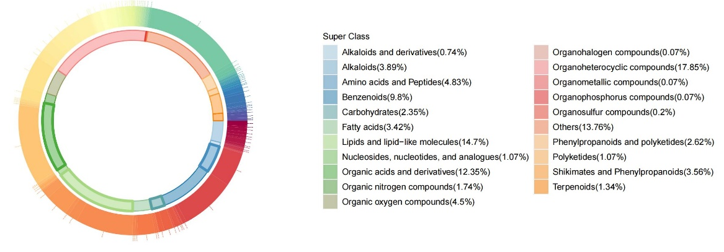
Supplemental Figrue S2 Ring diagram shows differential metabolites in Cryptocaryon irritans tomonts under hypoxia

Supplemental Figrue S3 Malic acid and pyruvate content in Cryptocaryon irritans tomonts under hypoxia. Statistical analysis in was performed using a two-tailed Student’s t-test (n=6), Data are shown as mean ± SD. ‘n’ indicates biological replicates.

Supplemental Figrue S4 Lactic acid content in Cryptocaryon irritans tomonts under hypoxia. Statistical analysis was performed using one-way ANOVA with Dunnett's multiple comparisons test (n=3). Data are shown as mean ± SD. ‘n’ indicates biological replicates. **p<0.01.

Supplemental Figrue S5. mRNA expression of ferroptosis-related genes in Cryptocaryon irritans tomonts under hypoxia. (a) 6 h, (b) 24 h, and (c) 48 h post-treatment (n=3). Statistical analysis was performed using one-way ANOVA with Dunnett's multiple comparisons test. Data are shown as mean ± SD. ‘n’ indicates biological replicates. *p<0.05 and **p<0.01.

Supplemental Figrue S6. mRNA expression of ferroptosis-related genes in Cryptocaryon irritans tomonts treated with erastin under normoxia and hypoxia. (a) 6, (b) 24, and (c) 48 h post-treatment (n=3). Statistical analysis was performed using one-way ANOVA with Dunnett's multiple comparisons test. Data are shown as mean ± SD. ‘n’ indicates biological replicates. *p<0.05 and **p<0.01.

