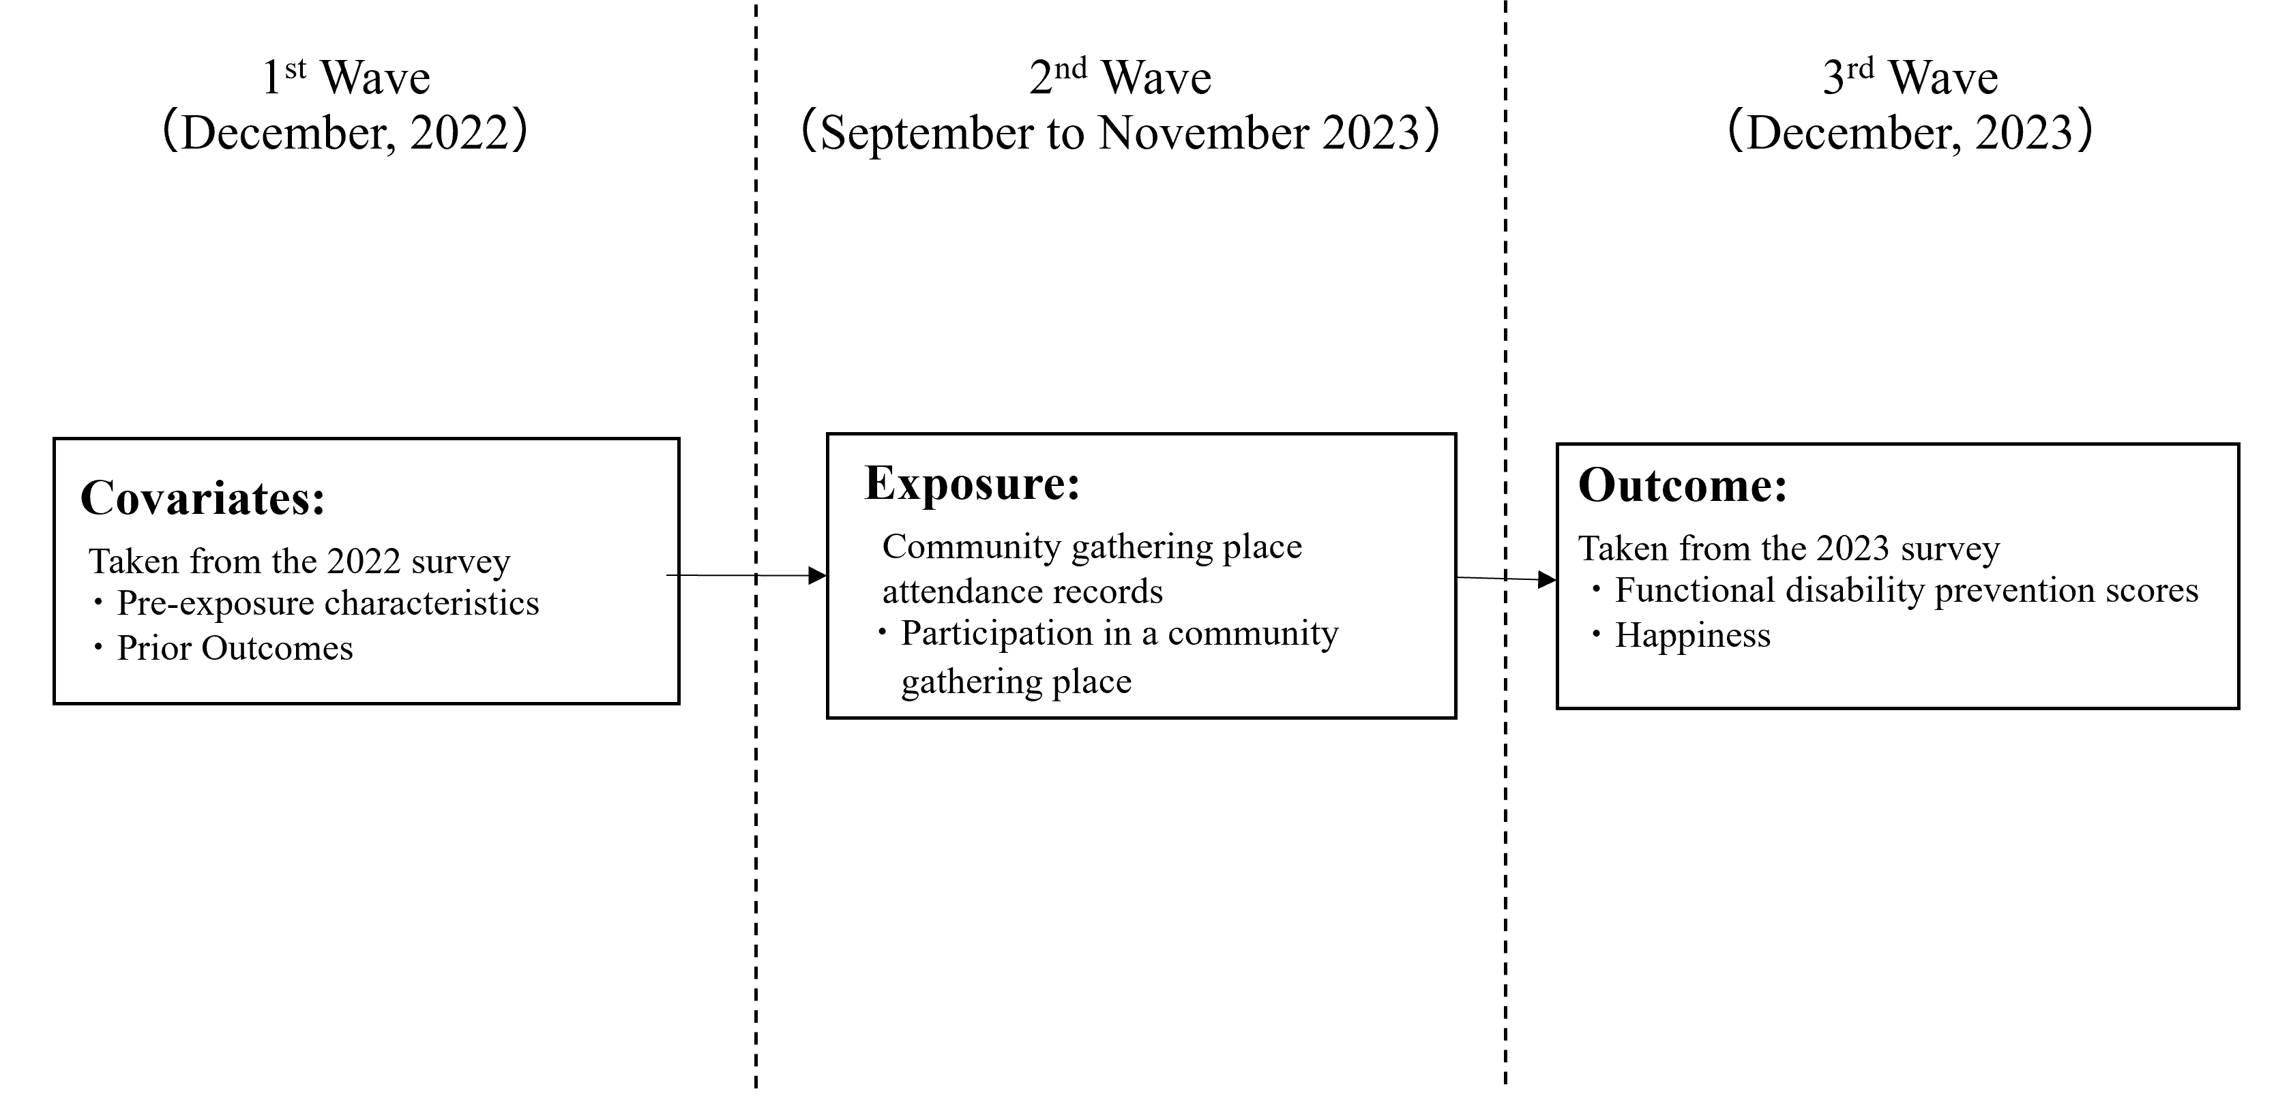
Figure S1 Diagram illustrating the temporal order of data linkage and variables included in the analysis

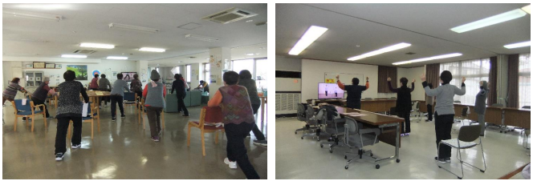
Figure S1 Scenes from CGP activities held in Nishiwaki City

Table S1 The functional disability prediction score
Item |  |  |  | Response | Score
Can you go out by bus or train by yourself? |  |  |  | No | 2
Can you go shopping to buy daily necessities by yourself? |  |  |  | No | 3
Can you manage your own deposits and savings at the bank? |  |  |  | No | 2
Do you normally climb stairs without using a handrail or wall for  support? |  |  |  | No | 3
Do you normally stand up from a chair without any aids? |  |  |  | No | 2
Do you normally walk continuously for 15 min? |  |  |  | No | 1
Have you experienced a fall in the past year? |  |  |  | Yes | 2
Are you very worried about falls? |  |  |  | Yes | 2
Body mass index <18.5 kg/m² |  |  |  | Yes | 3
Do you go out less frequently compared to last year? |  |  |  | Yes | 3
Gender |  |  |  | Man | 1
Age
Years | Score | Years | Score
65,66 | 0 | 78 | 14
67,68 | 1 | 79 | 15
69 | 3 | 80 | 17
70 | 4 | 81 | 18
71 | 6 | 82,83 | 19
72 | 7 | 84,85 | 21
73 | 9 | 86,87 | 22
74 | 10 | 88,89 | 23
75,76 | 12 | 90+ | 24
77 | 13

Table S2 Detailed Explanation of CGP Site Types in Nishiwaki City
Format | Site Type | Explanation
Weekly-scheduled | Weekly-scheduled Orihime Taiso ª Only | Sites that hold weekly sessions exclusively offer the Orihime Taiso, a local exercise program developed to promote muscle strength and oral health.
Weekly-scheduled | Weekly-scheduled Orihime + Other Taiso | Sites that hold weekly sessions combining Orihime Taiso with other locally arranged exercise routines, such as Radio-Taiso.
Weekly-scheduled | Weekly-scheduled Orihime Taiso + Tea Gathering | Sites that hold weekly Orihime Taiso sessions followed by informal tea gatherings for social interaction.
Monthly-scheduled | Monthly Frailty Prevention & Events | Sites that hold monthly, focusing mainly on frailty prevention through educational sessions and community-based events.
- Orihime Taiso is a series of exercise programs developed in Nishiwaki City, Japan, in collaboration with physicians, dentists, and other health professionals. These programs aim to improve lower-limb strength and maintain oral health among older adults. The program consists of three levels:
- Orihime Taiso 1: A approximately 20-minute exercise routine designed to strengthen muscles that tend to decline with age—especially in the legs and lower back—while also promoting oral health. Developed jointly by medical professionals and Nishiwaki City.
- Orihime Taiso 2: A rhythmic exercise performed to the Nishiwaki City song. This shorter (approximately 2 minutes 40 seconds) routine encourages fun and easy full-body movement across all age groups, differing from Orihime Taiso 1 in its pace and accessibility.
- Orihime Taiso 3: A more approximately 12-minute advanced program incorporating additional resistance (e.g., weights) and slower movements to engage muscles more intentionally, aiming to enhance strength, endurance, and balance through motions like single leg stands, reaching, and stepping.

Table S3 Number (Percentage) of missing values
Variables |  | N (%)
 | Age | 0 (0)
 | Gender | 0 (0)
 | Education | 31 (2.8)
 | Household equivalized income | 166 (14.9)
 | Employment | 117 (10.5)
 | Marital status | 12 (1.0)
 | Living alone | 22 (1.9)
 | Participation in community gathering places | 33 (2.9)
 | Participation in community organizations | 112 (10.1)
 | Activities of daily living (dependent) | 20 (1.8)
 | Self-reported disease | 35 (3.1)
 | Functional disability prediction scores 2022 | 91 (8.2)
 | Functional disability prediction scores 2023 | 62 (5.6)
 | Happiness 2022 | 33 (2.9)
 | Happiness 2023 | 12 (1.0)

Table S4-1 Characteristics stratified by living arrangement from 2022 survey (n = 1,108)
Characteristics |  | Household equivalized income
 |  | Living together | Living alone
 |  | n=942 | n=166
 | Age (years), mean (SD) | 74.6 (6.5) | 77.0 (6.4)
 | Gender (Women), n (%) | 569 (60.4) | 140 (80.0)
 | Education, n (%) <10 years | 206 (21.8) | 45 (25.7)
 | Household equivalized income (million yen), mean | 2.307 (1.434) | 177.5 (1.466)
 | Employment (Retired/ Never), n (%) | 493 (54.1) | 86 (49.1)
 | Marital status (Married), n (%) | 754 (82.7) | 8 (4.5)
 | Participation in community gathering places, n (%) | 254 (27.8) | 68 (38.8)
 | Participation in community organizations, n (%) | 545 (59.8) | 108 (61.7)
 | Activities of daily living (dependent), n (%) | 39 (4.2) | 5 (2.8)
 | Self-reported disease, n (%) | 616 (67.6) | 124 (70.8)
 | Functional disability prediction score, mean (SD) | 14.2 (8.7) | 17.3 (8.6)
 | Happiness, mean (SD) | 7.4 (1.8) | 6.9 (1.8)
Abbreviations: CGPs, community gathering places; SD, standard deviation.

Table S4-2 Characteristics stratified by household equivalized income missing from 2022 survey (n = 1,108)
Characteristics |  | Household equivalized income
 |  | No missing | Missing
 |  | n=942 | n=166
 | Age (years), mean (SD) | 74.6 (6.5) | 77.5 (6.7)
 | Gender (Women), n (%) | 544 (59.7) | 129 (77.7)
 | Education, n (%) <10 years | 204 (22.3) | 50 (30.1)
 | Employment (Retired/ Never), n (%) | 518 (54.9) | 73 (43.9)
 | Marital status (Married), n (%) | 671 (71.2) | 102 (61.4)
 | Living alone, n (%) | 157 (16.6) | 18 (10.8)
 | Participation in community gathering places, n (%) | 267 (28.3) | 59 (35.5)
 | Participation in community organizations, n (%) | 556 (59.0) | 110 (66.2)
 | Activities of daily living (dependent), n (%) | 34 (3.6) | 12 (7.2)
 | Self-reported disease, n (%) | 645 (68.4) | 106 (63.8)
 | Functional disability prediction score, mean (SD) | 14.3 (8.7) | 17.8 (8.5)
 | Happiness, mean (SD) | 7.4 (1.8) | 7.5 (1.8)
Abbreviations: CGPs, community gathering places; SD, standard deviation.

Table S5 Characteristics from 2022 survey by CGPs content (n = 1,108)
Characteristics |  | Not participation | Participation in CGPs^{a,b}
 |  | Not participation | Type 1 | Type 2 | Type 3 | Type 4
 |  | n=761 | n=136 | n=61 | n=32 | n=137
Number of CGPs Participations, mean (SD) |  | - | 8.9 (2.7) | 12.4 (7.8) | 6.7 (4.1) | 3.2 (2.4)
 | Age (years), mean (SD) | 73.6 (6.4) | 78.5 (5.1) | 78.6 (5.2) | 74.9 (6.4) | 79.4 (5.6)
 | Gender (Women), n (%) | 411 (54.0) | 124 (91.1) | 58 (95.0) | 29 (90.6) | 93 (67.8)
 | Education, n (%) <10 years | 151 (19.8) | 40 (29.4) | 26 (42.6) | 5 (15.6) | 39 (28.4)
 | Household equivalized income (million yen), mean (SD) | 2.288 (1.477) | 1.776 (1.002) | 1.986 (1.222) | 2.221 (0.956) | 2.195 (1.724)
 | Employment (Retired/ Never), n (%) | 372 (48.8) | 88 (64.7) | 39 (63.9) | 16 (50.0) | 90 (65.6)
 | Marital status (Married), n (%) | 576 (75.6) | 61 (44.8) | 26 (42.6) | 18 (56.2) | 88 (64.2)
 | Living alone, n (%) | 94 (12.3) | 36 (26.4) | 22 (36.0) | 4 (12.5) | 25 (18.2)
 | Participation in community gathering places, n (%) | 80 (10.5) | 119 (87.5) | 52 (85.2) | 19 (59.3) | 74 (54.0)
 | Participation in community organizations, n (%) | 369 (48.4) | 116 (85.2) | 53 (86.8) | 26 (81.2) | 117 (85.4)
 | Activities of daily living (dependent), n (%) | 28 (3.6) | 7 (5.1) | 1 (1.6) | 3 (9.3) | 7 (5.1)
 | Self-reported disease, n (%) | 506 (66.4) | 102 (75.0) | 47 (77.0) | 15 (46.8) | 97 (70.8)
 | Functional disability prediction score, mean (SD) | 13.9 (9.0) | 19.1 (7.1) | 19.4 (7.3) | 14.4 (8.0) | 19.3 (7.0)
 | Happiness, mean (SD) | 7.3 (1.8) | 7.7 (1.5) | 7.5 (1.7) | 8.3 (1.4) | 7.5 (1.6)
Abbreviations: CGPs, community gathering places; SD, standard deviation.
ª We defined participation in community gathering places based on attendance records, categorized by content types as follows:
Type 1 (Weekly-scheduled Orihime Taiso Only), Type 2 (Weekly-scheduled Orihime + Other Taiso), Type 3 (Weekly-scheduled Orihime Taiso + Tea Gathering), Type 4 (Monthly-scheduled Frailty Prevention & Events)
^{b} Among CGP participants (n = 347), 17 individuals participated in two types of CGPs, and one person participated in three types.

Table S6-1 Characteristics of CGPs participants and non-participants after propensity score matching in a model with functional disability prediction score as the outcome
Variables |  | After propensity score matching
 |  | CGPsª  Non-Participants | CGPsª  Participants | ASD
 |  | n=163 | n=163 | ASD
 | Age (years), mean (SD) | 76.8 | 77.4 | 0.099
 | Gender (Women), n (%) | 80.4 | 79.8 | 0.014
 | Education, n (%) <10 years | 27.0 | 27.6 | 0.014
 | Household equivalized income (million yen), mean (SD) | 2.068 | 2.070 | 0.002
 | Employment (Retired/ Never), n (%) | 22.1 | 23.3 | 0.028
 | Marital status (Married), n (%) | 66.3 | 63.8 | 0.053
 | Living alone, n (%) | 19.6 | 19.0 | 0.016
 | Participation in community gathering places, n (%) | 66.3 | 66.3 | 0.000
 | Participation in community organizations, n (%) | 82.8 | 89.6 | 0.161
 | Activities of daily living (dependent), n (%) | 3.7 | 3.7 | 0.000
 | Self-reported disease, n (%) | 68.7 | 68.7 | 0.000
 | Functional disability prediction score, mean (SD) | 17.5 | 18.0 | 0.061
Abbreviations: SD, standard deviation. ASD, absolute standardized difference
ª We defined CGPs participation as participation at least once per every month, based on the attendance records.

Table S6-2 Characteristics of CGPs participants and non-participants after propensity score matching in a model with happiness as the outcome
Variables |  | After propensity score matching
 |  | CGPsª  Non-  Participants | CGPsª  Participants | ASD
 |  | n=165 | n=165 | ASD
 | Age (years), mean (SD) | 76.9 | 77.0 | 0.029
 | Gender (Women) (%) | 79.4 | 80.6 | 0.028
 | Education (%) <10 years | 27.3 | 27.9 | 0.014
 | Household equivalized income (million yen), mean | 2.110 | 1.983 | 0.091
 | Employment (Retired/ Never), (%) | 20.6 | 21.2 | 0.014
 | Marital status (Married), (%) | 67.9 | 67.9 | 0.000
 | Living alone, (%) | 18.2 | 18.2 | 0.000
 | Participation in community gathering places, (%) | 66.7 | 78.5 | 0.058
 | Participation in community organizations, (%) | 83.6 | 86.1 | 0.048
 | Activities of daily living (dependent), (%) | 4.8 | 4.8 | 0.000
 | Self-reported disease, (%) | 67.3 | 68.5 | 0.027
 | Happiness, mean | 7.61 | 7.66 | 0.027
Abbreviations: SD, standard deviation. ASD, absolute standardized difference
ª We defined CGPs participation as participation at least once per every month, based on the attendance records.

Table S7 Multiplicative Effect Modification of the Associations Between Monthly Community Gathering Place Participation and Later Functional Disability and Happiness
 | Functional disability prediction score |  |  |  |  | Happiness
Moderator level | B (95%CI) | Multiplicative |  |  |  | B (95%CI) | Multiplicative
Moderator level | B (95%CI) | B (95%CI) | p^{c} |  |  | B (95%CI) | B (95%CI) | p^{c}
Gender
Men | -0.94 (-1.76- -0.13) | Ref. |  |  |  | 0.66 (0.24- 1.08) | Ref.
Women | -0.89 (-1.57- -0.20) | -0.38 (-1.34- 0.58) | 0.381 |  |  | 0.43 (-0.002- 0.86) | -0.33 (-0.90- 0.24) | 0.213
Age
<75 years | -0.62 (-2.05- 0.80) | Ref. |  |  |  | 0.38 (-0.06- 0.82) | Ref.
≥75 years | -1.00 (-1.61- -0.40) | -0.28 (-1.75- 1.17) | 0.656 |  |  | 0.57 (0.18- 0.95) | 0.16 (-0.32- 0.65) | 0.454
Education
≥13 years | -0.88 (-1.62- -0.13) | Ref. |  |  |  | 0.46 (-0.22- 1.14) | Ref.
10- 13 years | -1.14 (-2.38- 0.09) | -0.53. (-1.54- 0.48) | 0.256 |  |  | 0.51 (0.11- 0.91) | 0.01 (-0.50- 0.52) | 0.953
<10 years | -0.36 (-1.66- 0.92) | -0.02 (-0.94- 0.88) | 0.942 |  |  | 0.35 (-0.18- 0.89) | 0.31 (-0.21- 0.85) | 0.206
Household equivalized income
Tertile 1 (2.59.8- 9.50) | -0.72 (-1.65- 0.21) | Ref. |  |  |  | 0.35 (-0.09- 0.80) | Ref.
Tertile 2 (1.428- 2.474) | -0.02 (-1.23- 1.18) | -0.28 (-1.66- 1.10) | 0.647 |  |  | 0.14 (-0.30- 0.59) | -0.06 (-0.47- 0.34) | 0.728
Tertile 3 (0.102- 1.375) | -1.81 (-2.86- -0.76) | -1.20 (-2.07- -0.33) | 0.013 | * |  | 0.97 (0.33- 1.61) | 0.61 (0.02- 1.21) | 0.042 | *
Abbreviations: B: unstandardized regression coefficient; CI: confidence interval; Ref: Reference. *p<0.05, **p<0.0125
ª We defined monthly participation in community gathering places as attending at least once every month, based on attendance records.
^{b} We used linear regression models to estimate multiplicative interaction terms, examining effect modification by gender, age, education, and household equivalized income.
^{c} We applied the Bonferroni correction and set statistical significance at p < 0.0125 (0.05/4).
Table S8 Robustness to unmeasured confounding (E-values) of associations between monthly community gathering places participation and later functional disability prediction scores and happiness scores.
Outcomes | E-values
Outcomes | Point Estimate | CI limit
Functional disability prediction score | 3.65 | 1.95
Happiness scores | 2.48 | 1.64
Abbreviations: CI, confidence interval.

Table S9 Antecedents of participation in a community gathering place.
 | Monthly community gathering places participation
 | Functional disability prediction scores |  |  |  |  | Happiness scores
 | RR | 95%CI |  | p |  | RR | 95%CI |  | p
Age | 1.03 | 0.98 | 1.07 | 0.171 |  | 1.02 | 0.99 | 1.05 | 0.127
Women (Ref. Men) | 1.35 | 1.04 | 1.74 | 0.021 |  | 1.34 | 1.02 | 1.76 | 0.030
Low education (Ref. >9 years years) | 1.05 | 0.89 | 1.24 | 0.507 |  | 1.05 | 0.89 | 1.24 | 0.527
Household equivalized income (million yen) | 0.99 | 0.99 | 1.00 | 0.497 |  | 0.99 | 0.99 | 1.00 | 0.499
Unemployment (Ref. Current) | 1.31 | 1.08 | 1.59 | 0.005 |  | 1.31 | 1.08 | 1.58 | 0.005
Not married (Ref. Married) | 1.25 | 0.91 | 1.71 | 0.155 |  | 1.25 | 0.91 | 1.71 | 0.152
Living alone (Ref. Living together) | 1.01 | 0.75 | 1.35 | 0.945 |  | 1.01 | 0.75 | 1.34 | 0.944
Participation in community gathering places  (Ref. Not participating) | 5.30 | 3.92 | 7.15 | <0.001 |  | 5.28 | 3.92 | 7.11 | <0.001
Participation in community organizations  (Ref. Not participating) | 1.84 | 1.34 | 2.54 | <0.001 |  | 1.85 | 1.33 | 2.56 | <0.001
Activities of daily living (Ref. Not independent) | 0.99 | 0.68 | 1.44 | 0.965 |  | 1.00 | 0.66 | 1.52 | 0.990
Self-reported disease (Ref. No disease) | 1.26 | 1.07 | 1.47 | 0.004 |  | 1.26 | 1.07 | 1.48 | 0.005
Functional disability prediction scores | 0.99 | 0.96 | 1.02 | 0.695 |  | - | - | - | -
Happiness scores | - | - | - | - |  | 1.01 | 0.95 | 1.06 | 0.721
Abbreviations: CI, confidence interval; RR, Risk ratio
ª We used a modified Poisson regression with robust standard errors to estimate risk ratios for the association between each of the predictors in 2022 and monthly community gathering places participation, controlling for all other pre-baseline covariates.
^{b} Since we performed separate analyses for each model—functional disability prediction score and happiness; we did not apply Bonferroni correction.

