Supplementary Materials
Diverse retinal-kidney phenotypes associated with NPHP1 homozygous whole gene deletions in patients with kidney failure
Gavin Esson¹, Ian Logan¹, Katrina Wood² Andrew C. Browning³ and John A. Sayer^{1,4,5}

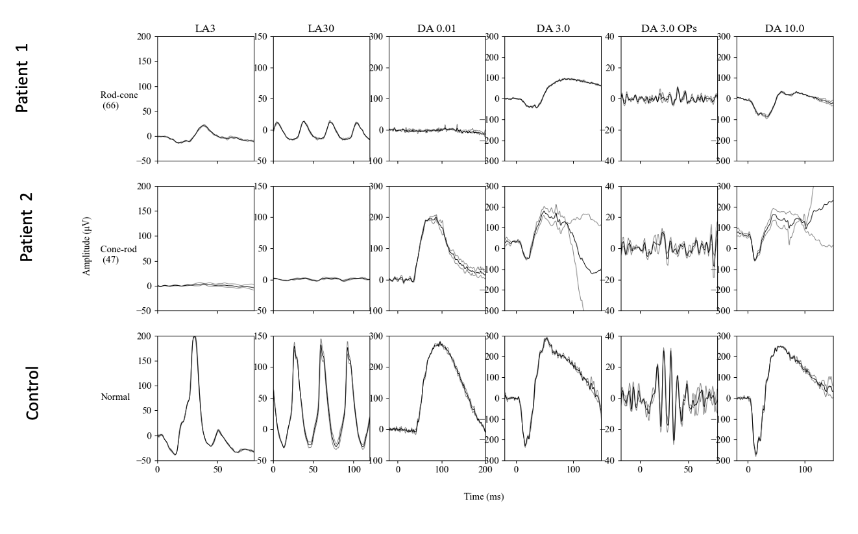

Supplemental Figure S1. Electroretinograms of patients and control
International Society for Clinical Electrophysiology of Vision (ISCEV) standard full filed electroretinogram (ERG) of patient 1 (upper traces) and patient 2 (middle traces). The lower traces are from a normal age matched control. The patient 1 traces demonstrate barely detectable rod photoreceptor function (DA 0.01) and attenuated cone function (LA 3.0 and LA 30 Hz) consistent with a rod/cone dystrophy. The patient 2 traces demonstrate barely detectable cone function (LA 3.0 and LA 30 Hz) while rod photoreceptor function (DA 0.01) is well preserved, consistent with a cone dystrophy.

Supplementary Table 1. 15 gene tubulointerstitial kidney disease panel (R202, PanelApp version 1.3)
ANKS6
CEP164
CEP83
GATM
HNF1B
INVS
MAPKBP1
NPHP1
NPHP3
NPHP4
REN
TMEM67
TTC21B
UMOD
WDR19

Supplementary Table 2. Retinal disorders panel (R32), PanelApp version 3.0)
ABCA4 | C21orf2 | CROCC | GNPTG | LRAT | OPN1LW | PRTFDC1 | SPTLC1 | WDR19
ABCC6 | C2orf71 | CRX | GP1BA | LRIT3 | OPN1MW | RAB28 | SPTLC2 | WFS1
ABHD12 | C3 | CSPP1 | GPR143 | LRMDA | OPN1SW | RAX2 | SRD5A3 | WHRN
ACBD5 | C5orf42 | CTC1 | GPR179 | LRP1 | OR2M7 | RB1 | SSBP1 | WT1
ACO2 | C8orf37 | CTNNA1 | GRIP1 | LRP2 | OTX2 | RBP3 | STRA6 | ZFYVE26
ADAM9 | CA4 | CTNNB1 | GRK1 | LRP5 | P3H2 | RBP4 | TCTN1 | ZNF408
ADAMTS18 | CABP4 | CTSD | GRM6 | LZTFL1 | PAK2 | RCBTB1 | TCTN2 | ZNF423
ADGRA3 | CACNA1F | CTSF | GRN | MAK | PANK2 | RD3 | TCTN3 | ZNF513
ADGRV1 | CACNA2D4 | CUBN | GUCA1A | MAPKAPK3 | PAX2 | RDH11 | TEAD1 | ZPR1
ADIPOR1 | CAPN5 | CWC27 | GUCA1B | MED12 | PAX6 | RDH12 | TEX28
AFG3L2 | CC2D2A | CYP1B1 | GUCY2D | MERTK | PCDH15 | RDH5 | TIMM8A
AGBL5 | CCT2 | CYP27A1 | HARS | MFN2 | PCYT1A | REEP6 | TIMP3
AHI1 | CCZ1B | CYP2R1 | HCCS | MFRP | PDAP1 | RGR | TINF2
AHR | CDH23 | CYP4V2 | HGSNAT | MFSD8 | PDE6A | RGS9 | TMEM126A
AIPL1 | CDH3 | DHDDS | HK1 | MIR204 | PDE6B | RGS9BP | TMEM216
AIRE | CDHR1 | DHX38 | HKDC1 | MKKS | PDE6C | RHO | TMEM218
ALDH3A2 | CEP164 | DMD | HMCN1 | MKS1 | PDE6G | RIMS1 | TMEM231
ALMS1 | CEP19 | DRAM2 | HMX1 | MMACHC | PDE6H | RIMS2 | TMEM237
ALPK1 | CEP250 | DTHD1 | HTRA1 | MSTO1 | PDSS1 | RLBP1 | TMEM67
AMACR | CEP290 | DYNC2H1 | IDH3A | MT-ATP6 | PDZD7 | RNU4ATAC | TOPORS
AMN | CEP41 | EFEMP1 | IDH3B | MT-ND1 | PEX1 | ROM1 | TPP1
AP3B2 | CEP78 | ELOVL1 | IFT140 | MT-ND4 | PEX2 | RP1 | TRAF3IP1
ARHGEF18 | CERKL | ELOVL4 | IFT172 | MT-ND6 | PEX6 | RP1L1 | TREX1
ARL13B | CFB | EMC1 | IFT27 | MT-TH | PEX7 | RP2 | TRIM32
ARL2BP | CFH | ERCC6 | IFT74 | MT-TL1 | PGK1 | RP9 | TRNT1
ARL3 | CHM | ERCC8 | IFT81 | MTTP | PHYH | RPE65 | TRPM1
ARL6 | CIB2 | ESPN | IKBKG | MT-TP | PITPNM3 | RPGR | TSPAN12
ARMS2 | CLCC1 | EVR3 | IMPDH1 | MT-TS2 | PITX2 | RPGRIP1 | TTC21B
ARSG | CLN3 | EXOSC2 | IMPG1 | MVK | PITX3 | RPGRIP1L | TTC8
ASRGL1 | CLN5 | EYS | IMPG2 | MYO7A | PLA2G5 | RS1 | TTLL5
ATF6 | CLN6 | FAM161A | INPP5E | MYOC | PLD4 | RTN4IP1 | TTPA
ATOH7 | CLN8 | FAM57B | INVS | NAALADL1 | PLK4 | SAG | TUB
ATP13A2 | CLRN1 | FAM71A | IQCB1 | NBAS | PNPLA6 | SAMD11 | TUBB4B
ATXN7 | CLUAP1 | FBLN5 | IRX5 | NDP | POC1B | SCAPER | TUBGCP4
B3GLCT | CNGA1 | FLVCR1 | IRX6 | NEK2 | POC5 | SDCCAG8 | TUBGCP6
BBIP1 | CNGA3 | FOXC1 | ITIH2 | NEUROD1 | PODNL1 | SEMA4A | TULP1
BBS1 | CNGB1 | FOXE3 | ITM2B | NMNAT1 | POMGNT1 | SLC24A1 | TYR
BBS10 | CNGB3 | FOXI2 | JAG1 | NPHP1 | POMT1 | SLC24A5 | TYRP1
BBS12 | CNNM4 | FRAS1 | KCNJ13 | NPHP3 | POMZP3 | SLC25A46 | UBAP1L
BBS2 | COL11A1 | FREM1 | KCNV2 | NPHP4 | PPT1 | SLC37A3 | UNC119
BBS4 | COL11A2 | FREM2 | KCTD7 | NR2E3 | PRCD | SLC38A8 | USH1C
BBS5 | COL18A1 | FRMD7 | KIAA1549 | NR2F1 | PRDM13 | SLC45A2 | USH1G
BBS7 | COL2A1 | FSCN2 | KIF11 | NRL | PROM1 | SLC6A6 | USH2A
BBS9 | COL4A1 | FUT5 | KIF3B | NUMB | PRPF3 | SLC7A14 | USP45
BCOR | COL9A1 | FZD4 | KIF7 | NYX | PRPF31 | SMOC1 | VAX1
BEST1 | COL9A2 | GDF6 | KIZ | OAT | PRPF4 | SNRNP200 | VCAN
BMP4 | COQ2 | GNAT1 | KLHL7 | OCA2 | PRPF6 | SOX2 | VPS13B
C12orf65 | COQ4 | GNAT2 | LAMA1 | OFD1 | PRPF8 | SPATA7 | VSX2
C1QTNF5 | COQ5 | GNB3 | LCA5 | OPA1 | PRPH2 | SPG7 | WASF3
C2 | CRB1 | GNPTAB | LIG3 | OPA3 | PRPS1 | SPP2 | WDPCP

Supplementary Table 3. Additional alleles identified in patient 1 and patient 2

Patient 1
Gene | Zygosity | HGVS description | Location | Classification | Allele Frequency (gnomAD v.4.0.0)
NPHP1 | Homozygous | NM_000272.4: (NPHP1) whole gene deletion | Chr2 (GRCh38) g.(?_110962545)_(110881368_?)x0 | Pathogenic  (PM2_Moderate; PM3_Very Strong; PVS1_Very Strong) | 0.002198
ABCC6 | Heterozygous | NM_001171.5 (ABCC6); c.3421C>T; p.(Arg1141Ter) | Chr16 (GRCh38):g.(1613078)G>A | Pathogenic  (PM2_Moderate; PVS1_Very Strong; PM3_Very Strong) | 0.001613

Patient 2

Gene | Zygosity | HGVS description | Location | Variant Classification* | Allele Frequency (gnomAD v.4.0.0)
NPHP1 | Homozygous | NM_000272.4: (NPHP1) whole gene deletion | Chr2 (GRCh38): g.(110095625-110226966del) | Pathogenic  (PM2_Moderate; PM3_Very Strong; PVS1_Very Strong) | 0.002198
USH1C | Heterozygous | NM_153676.4 (USH1C);  c.586C>T; p.(Arg196Ter) | Chr11 (GRCh38): g.(17547982G>A) | Pathogenic | 0.000008895

*Variant classification using ACMG guidelines is given.

