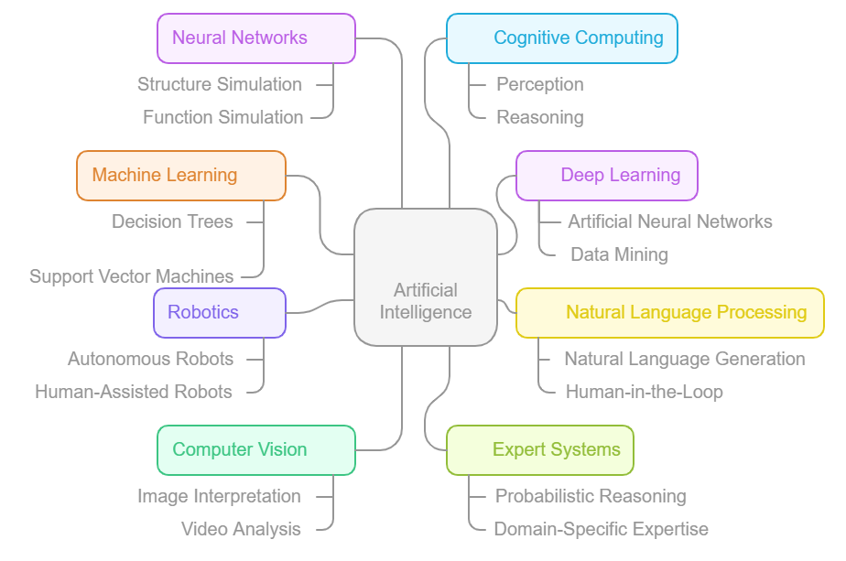
Figure S1. Artificial Intelligence: Key concepts used in tool for drug discovery and pharmaceutical product development.

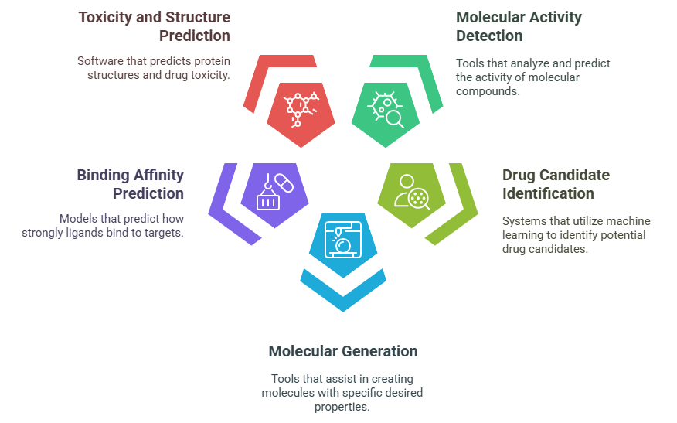
Figure S2. AI tool’s role in drug design.
Table S1. List of AI based tools for drug discovery.
S.NO. | Details | Tools | References
1. | A deep learning approach that uses cancer cell lines to predict medication sensitivity | PathDSP | ⁵⁰
2. | MLP model that utilize a python-root. AI system to identify a good candidate for pharmaceutical research. | Deepchem | ⁵¹
3. | A framework for creating novel compounds based on auto-encoders | Chemical VAE | ⁵²
4. | Forecast a compound's biological activity by predicting nonlinear correlations between its physicochemical properties. | ANN | ⁵²
5. | The Software pose the ability to forecasts the toxicity of total of 12000 drugs | DeepTox | ⁵²
6. | Deep learning-based web server for virtual compound screening | Deep-screening | ⁵³
7. | A computational instrument for examining protein-DNA/RNA binding | DeepBind | ⁵⁴
8. | A Python-based system powered by computational instruments to facilitate the identification of a compound's chemical activity | Deep Neural Net QSAR | ⁵⁵
9. | A computational technique that combines reinforcement learning and graph neural networks to create molecules with the required features | Deep GraphMol | ⁵⁶
10. | A tool for molecular production that aids in creating molecules with desired characteristics | Organic | ⁵⁷
11. | Forecast the binding affinity of ligands using NNs. | PotentialNet | ⁵⁷
12. | ML technique to forecast molecules that might respond to biosynthetic assays | HitDexter | ⁵⁷
13. | A scoring function for rescoring drug-ligand binding affinity | DeltaVina | ⁵⁷
14. | Helps to forecast properties of novel molecules | Neural Graph Finger-print | ⁵⁷
15. | Forecasts 3D Designs of protein | AlphaFold | ⁵⁷
16. | Helps to report a robust system for synthetic synthesis in standardized format | Chemputer | ⁵⁷
17. | A versatile framework for drug discovery models built on Pytorch | TorchDrug | ⁵⁷

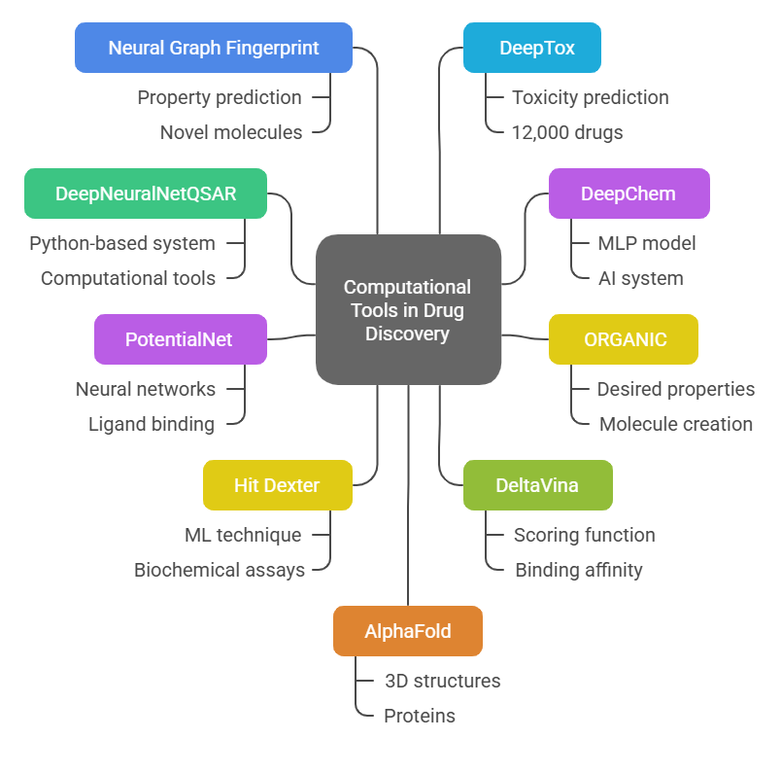
Figure S3. AI tools in drug discovery and ADME-toxicity prediction of pharmaceutical product.

