Supplementary
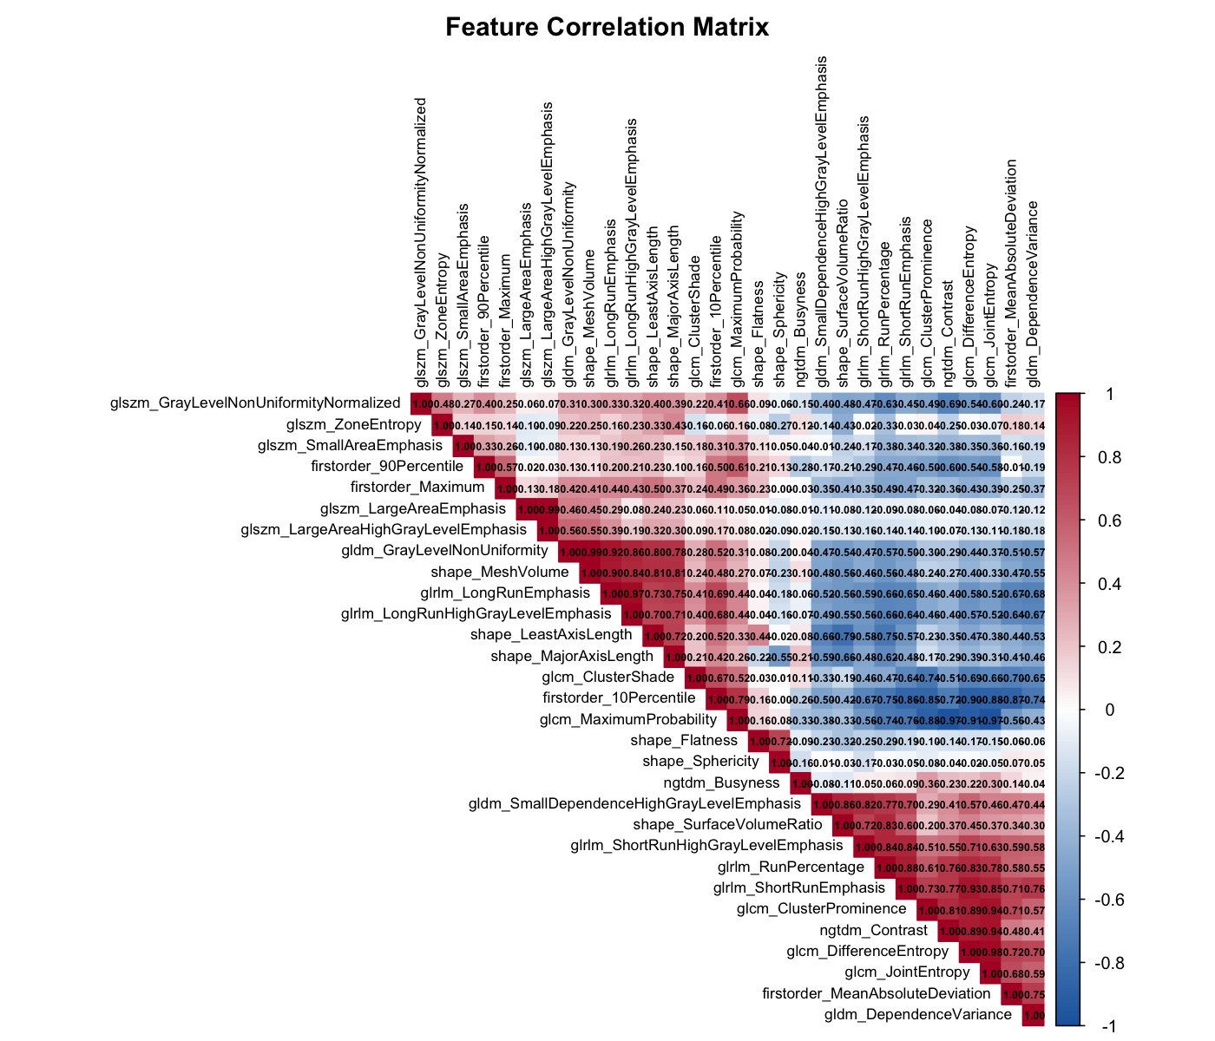
Supplementary Figure 1: Pearson Correlation plot of the 30 radiomics identified after applying stepwise AIC feature selection from the full set of 107 available radiomics, several of which exhibited multicollinearity deemed unsuitable for a reliable Cox model or SHAP analysis.

