Supplementary file

Artificial Intelligence Enabled Food Quality Assessment Through Digital Sensing and Explainable Analytics
Authors: Suraja Parida¹, Sanjukta Dasgupta^{1✉}
¹ Department of Biotechnology and Biosciences, Centre for Multidisciplinary Research and Innovations, Brainware University, Kolkata, India

✉Corresponding author: Sanjukta Dasgupta
Brainware University, 398, Ramkrishnapur Rd, near Jagadighata Market, Barasat, Kolkata, West Bengal 700125, India
Email id: sd.bt@brainwareuniversity.ac.in
Orcid ID: 0000-0002-9085-2658

Supplementary Table 1. Major drivers of food loss and waste and the role of AI-driven solutions

Food waste driver | AI-enabled solution | Reported benefits | Current limitations
Improper freshness assessment | Computer vision, hyperspectral imaging, CNN-based freshness prediction | Early spoilage detection and dynamic shelf-life estimation | Performance decreases under heterogeneous storage conditions and limited external validation
Temperature abuse during storage and transport | IoT sensors with predictive analytics and edge-AI | Real-time monitoring and early warning systems | Sensor calibration instability and high implementation costs
Manual sorting and grading errors | Automated vision-based inspection and defect detection systems | Improved grading accuracy and reduced post-harvest losses | Requires large annotated datasets and high-quality imaging infrastructure
Delayed contamination detection | Biosensors integrated with ML algorithms | Rapid identification of microbial contamination and safety risks | Limited scalability and regulatory standardization
Supply-chain inefficiencies and inventory mismanagement | AI-driven demand forecasting and predictive analytics | Improved inventory control and reduced unnecessary disposal | Data integration challenges and poor interoperability across supply-chain platforms

Supplementary Table 2. Examples of sensor drift and proposed calibration strategies in AI-driven food quality monitoring
Sensor platform | Source of drift | Effect on model performance | Proposed calibration protocol
Electronic nose (MOS sensors) | Humidity, sensor aging, VOC accumulation | Accuracy reduction from ~95–98% to <80–85% over prolonged operation | Daily baseline correction and periodic recalibration
Hyperspectral imaging | Illumination variation, detector aging | Reduced spectral reproducibility and lower external prediction accuracy | White-reference calibration and transfer learning updates
Biosensors | Fouling and biochemical degradation | Increased false-positive and false-negative rates | Reference-standard calibration and sensor replacement schedules
IoT environmental sensors | Temperature fluctuations and hardware variability | Reduced shelf-life prediction reliability | Adaptive recalibration and continuous quality control monitoring

Supplementary Table 3. Recommended preprocessing strategies for different sensor modalities and food matrices
Sensor type | Food matrix/application | Major source of variability | Recommended preprocessing methods | Rationale
Hyperspectral imaging (VIS/NIR) | Fruits, vegetables, grains | Light scattering, particle size, uneven illumination | SNV, MSC, Savitzky–Golay derivatives, wavelength selection | Corrects scattering effects and enhances subtle spectral differences
FTIR spectroscopy | Dairy products, meat, oils | Baseline drift and overlapping absorption bands | MSC, first derivative, normalization, autoscaling | Improves peak resolution and spectral comparability
Raman spectroscopy | Honey, oils, adulteration studies | Fluorescence background and spectral noise | Baseline correction, smoothing, normalization | Removes fluorescence interference and improves signal quality
Electronic nose | Meat freshness, fermentation monitoring | Sensor drift, humidity and temperature effects | Baseline correction, normalization, drift compensation | Reduces long-term sensor instability and environmental variability
Electronic tongue | Beverage quality and flavor profiling | Sensor variability and signal fluctuations | Normalization, PCA-based outlier detection | Improves reproducibility and sample discrimination
Smart packaging/IoT sensors | Shelf-life prediction and cold-chain monitoring | Time-series noise and missing data | Smoothing, moving averages, temporal feature extraction | Enhances robustness of dynamic measurements
Biosensors | Pathogen and toxin detection | Baseline fluctuations and batch effects | Baseline correction, normalization, outlier detection | Improves analytical consistency and reduces false predictions

Supplementary Table 4. Computational characteristics and deployment suitability of commonly used AI models in food quality assessment
AI Model | Predictive Performance | Inference Time | Memory Requirement | Computational Complexity | Edge-Device Compatibility | Typical Applications
SVM | High | Fast | Low | Low–Moderate | High | Spectral classification, food authentication
Random Forest | High | Fast | Moderate | Moderate | High | Quality grading, contamination detection
k-NN | Moderate–High | Moderate–Slow | Low | Low training, high prediction cost | Moderate | Similarity-based classification
ANN | High | Moderate | Moderate | Moderate | Moderate | Nonlinear prediction and regression
CNN | Very High | Moderate–Slow | High | High | Moderate–Low | Image-based defect and freshness detection
Deep CNN (ResNet, VGG, Inception) | Very High | Slow | Very High | Very High | Low | Complex image classification tasks
CNN-LSTM | Very High | Slow | Very High | Very High | Low | Time-series and multimodal data analysis
MobileNet | High | Fast | Low | Low | High | Real-time mobile and embedded applications
EfficientNet-B0 | High | Moderate | Moderate | Moderate | Moderate–High | Edge-AI image classification
Transformer-based models | Very High | Slow | Very High | Extremely High | Low | Multimodal learning and large-scale datasets

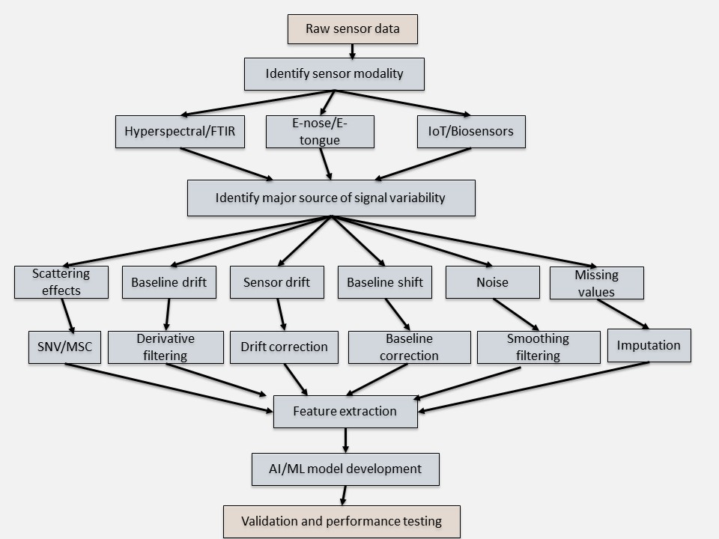
Supplementary figure 1: Decision framework illustrating the selection of preprocessing techniques according to sensor modality and dominant sources of signal variability in AI-driven food quality assessment systems.

