Supplementary Figures:

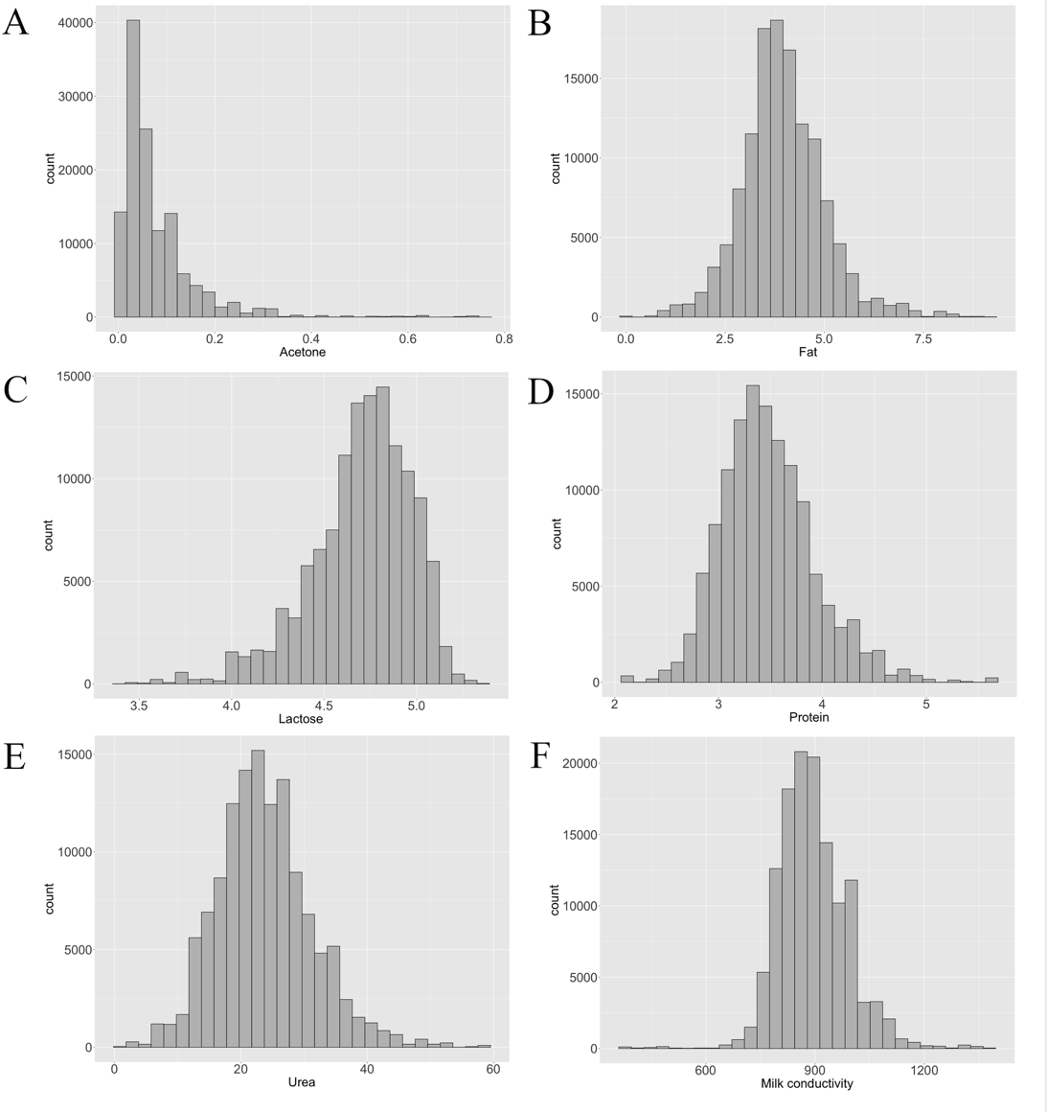
Supplementary Figure 1: Distribution of the features used in the random forest model for the prediction of individual welfare indicators. A) Acetone, B) Fat, C) Lactose, D) Protein, E) Urea, and F) Milk conductivity.

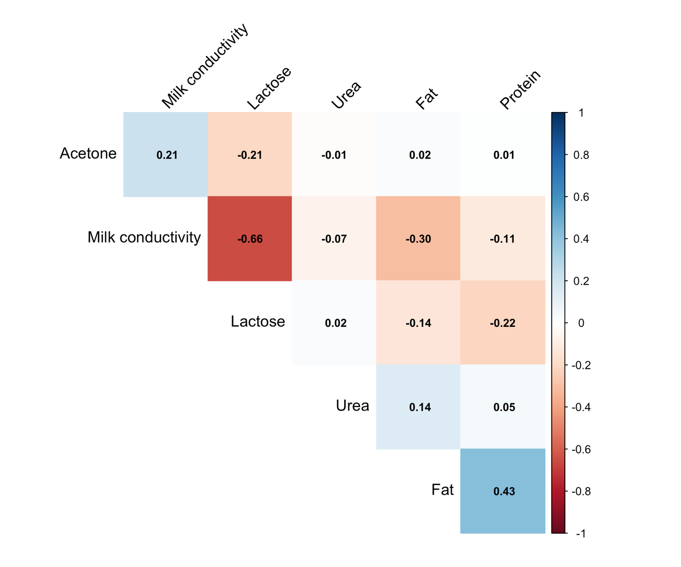
Supplementary Figure 2: Correlations among the features used in the random forest model for the prediction of individual welfare indicators.

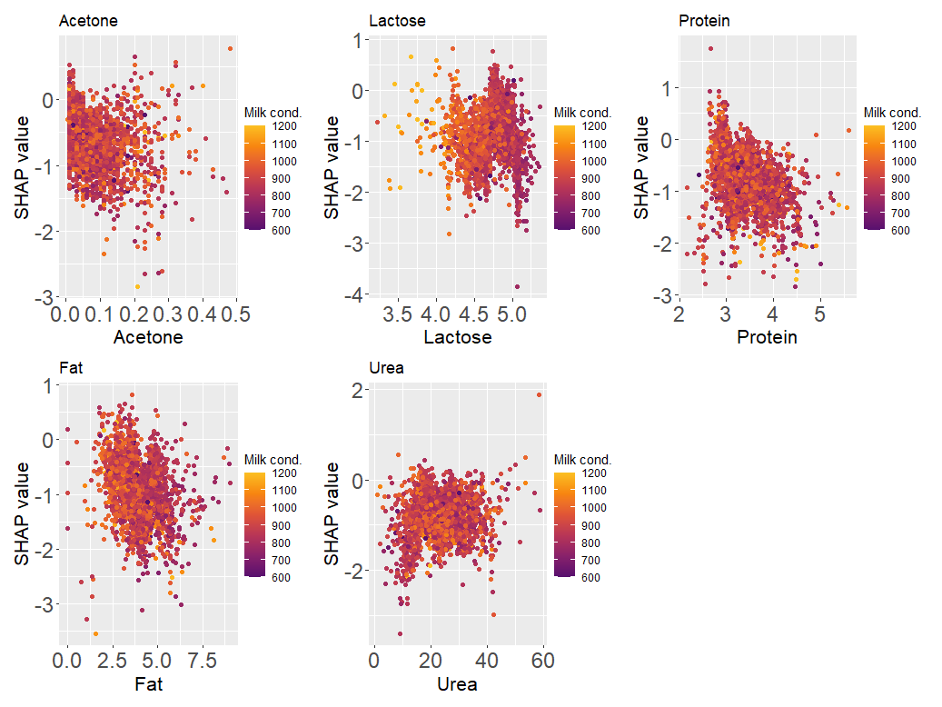
Supplementary Figure 3: Beeswarm plot showing the relationship between SHAP values and feature distribution for the mastitis welfare indicator for class G.

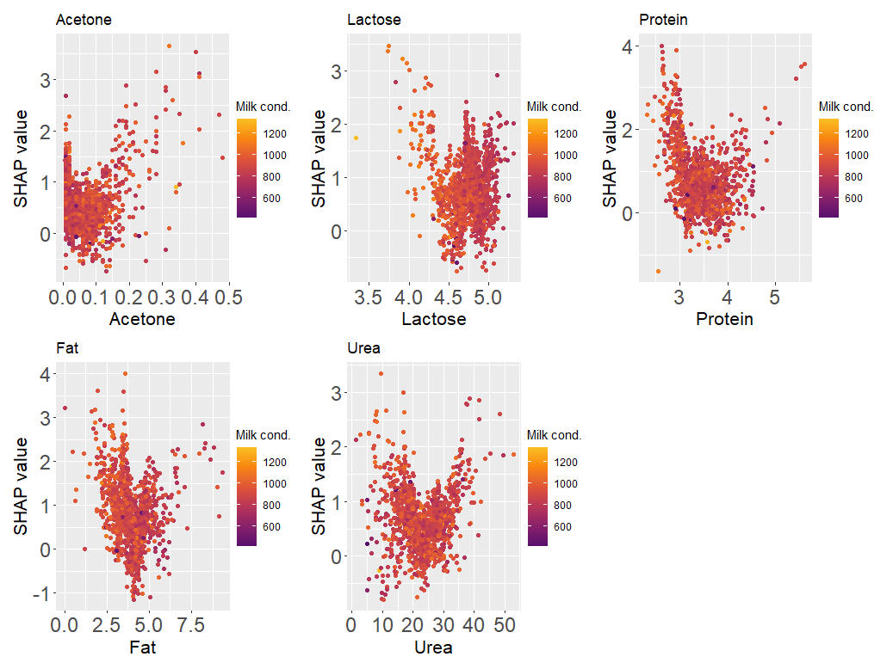
Supplementary Figure 4: Beeswarm plot showing the relationship between SHAP values and the feature distribution for the mastitis welfare indicator for class I.

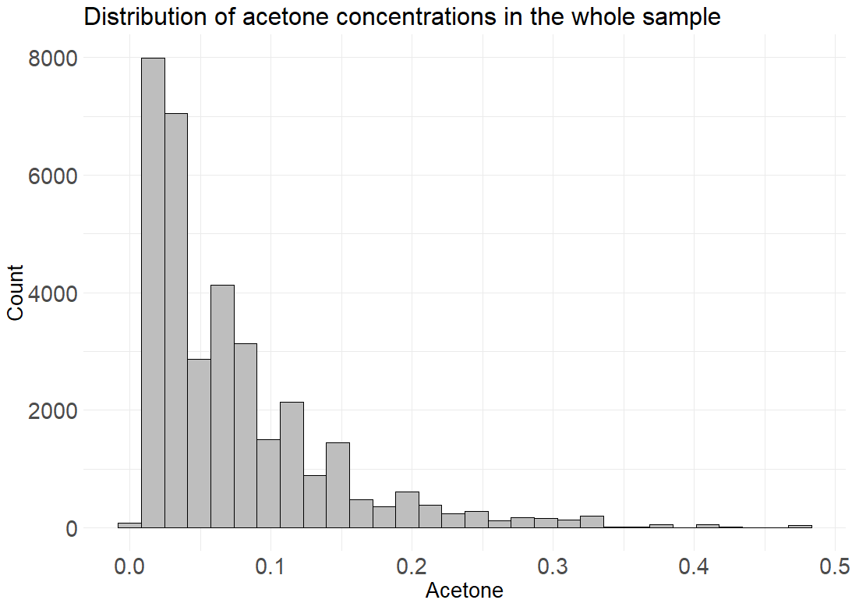
Supplementary Figure 5: Distribution of acetone values in the test set.

