Supplemental Information
Characterisation of TT1 and NCI-H441 monocultures
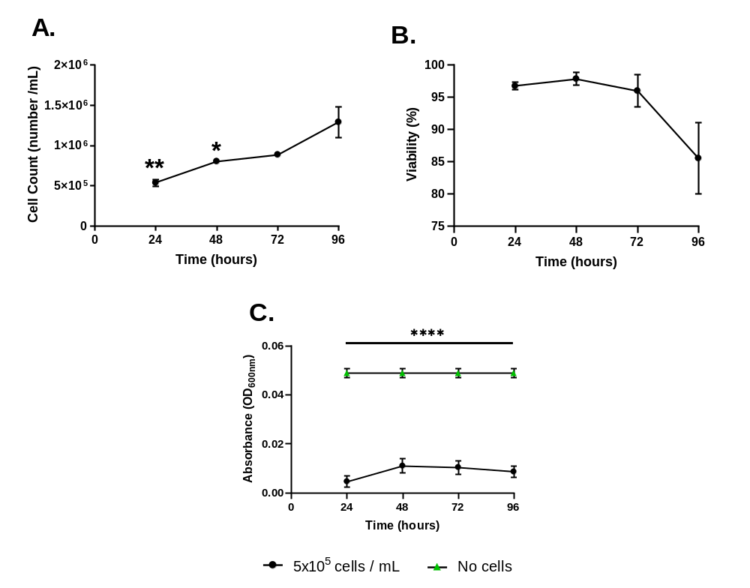
Figure S1 - TT1 monoculture characteristics at the ALI. These data represent the baseline characteristics on TT1 cells when seeded at the optimised 5 x 10⁵ cells / mL. Cell doubling (A) continued through 96 hrs of culture, viability (B) remained above 85% throughout, and barrier integrity (C) remained significantly(p<0.05) increased up to 96 hrs when compared to negative controls.
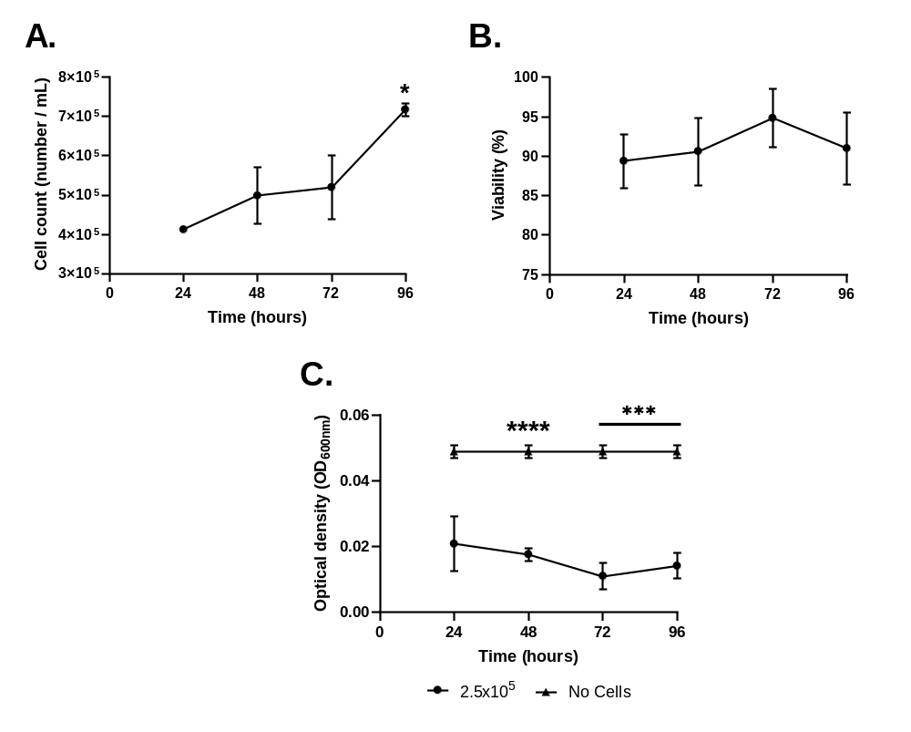
Figure S2 - NCI-H441 monoculture characterisation at the ALI. These data represent the baseline characteristics on NCI-H441 cells when seeded at the optimised 2.5 x 10⁵ cells / mL. Cell doubling (A) continued through 96 hrs of culture, peaking at 96 hrs, viability (B) remained above 90% and barrier integrity (C) remained significantly (p<0.05) increased than negative controls up to 96 hrs.

Establishing suitable culture conditions for the co-culture
Table S1 - Different cell number ratios and media concentrations used and tested during optimisation. Number of cells is specified as a ratio, 50:50 for example, and media is specified as a percentage of total media volume.
TT1 cells (number) | NCI-H441 cells (number) | DCCM-1 (%) | RPMI (%)
50 | 50 | 100 | 0
50 | 50 | 50 | 50
50 | 50 | 0 | 100
11 | 1 | 100 | 0
11 | 1 | 50 | 50
11 | 1 | 0 | 100
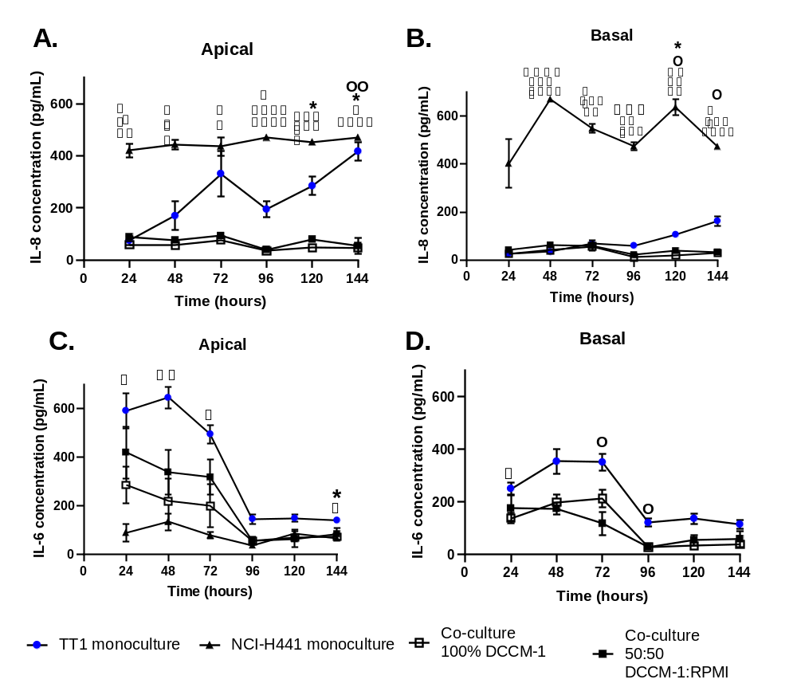
Figure S3 - Concentrations of interleukin-8 (IL-8) (A, B) and interleukin-6 (IL-6) (C, D) in supernatants from co-cultures submerged in 100% TT1 growth media (DCCM-1) and in 50:50 ratio of TT1 media and NCI-H441 media (DCCM-1 + RPMI). TT1 and NCI-H441 monocultures in optimal conditions cell cultures in submerged conditions are also compared. Supernatants were taken every 24 hrs for a total of 144 hrs from both apical (A, C) and basal (B, D) regions of the cell culture and concentrations measured using an ELISA kit. Cells were seeded at 11:1 TT1: NCI-H441, respectively. Since media is replaced every 72 hrs, concentrations measured between 24 – 72 and 96 -144 hrs are cumulative. Data shown are n=3, ± SEM. Significance is noted using * when comparing TT1 monoculture with co-culture in 100% DCCM, Ο for TT1 monoculture vs co-culture in 50:50 media, □ when comparing TT1 monocultures with NCI-H441 monocultures, ●when comparing NCI-H441 monocultures and co-cultures in 50:50 media, ■ when comparing NCI-H441 monocultures and co-cultures in 100% DCCM-1 media. The number of significance symbols defines the level of significance; *=p<0.05, **=p<0.01, ***=p<0.001, ****=p<0.0001.
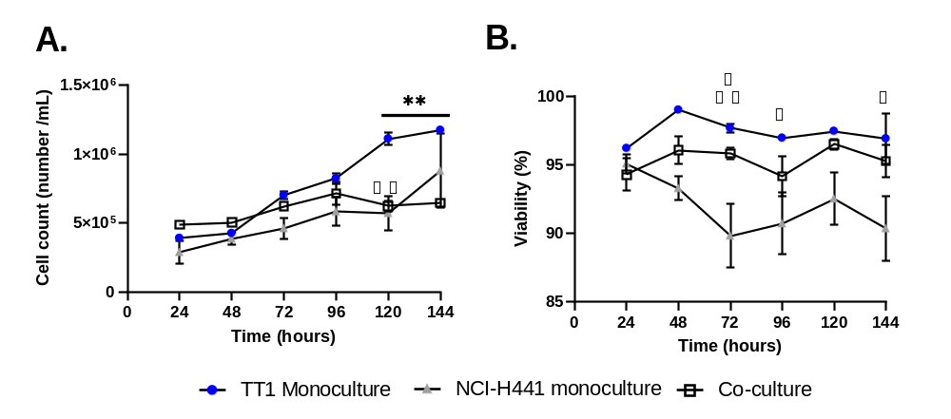
Figure S4 - Cell number (A) and viability (B) of TT1 and NCI-H441 co-cultures compared to TT1 and NCI-H441 monocultures, both in submerged conditions. Data calculated using trypan blue exclusion assay every 24 hrs after seeding. Co-culture was seeded at an 11:1 ratio, TT1: NCI-H441 respectively, and TT1 cells seeded at 5x10⁵ cells/ mL. Data shown are n=3, ±SEM. Statistical significance is noted using * when comparing TT1 monoculture with co-culture in 100% DCCM, □ when comparing TT1 monocultures with NCI-H441 monocultures, ■ when comparing NCI-H441 monocultures and co-cultures. The number of significance symbols defines the level of significance; *=p<0.05, **=p<0.01.

