A critical review of bioaccumulation and biotransformation of organic chemicals in birds

Supplementary Information
S1 Data Structure of the Main B/BT Database 2
S1.1 Data structure 2
S1.2 Types of bioaccumulation metrics 2
S1.3 Explanations of select data columns 4
S2 Data Structure of Bird Taxonomy and Diet Database 8
S2.1 Data structure 8
S2.2 Explanations on select data columns 8
S3 Chemicals (substrates) and Test Frequency with Generic Microsomal Fractions 12
S4 Overview of Bird Taxonomy and Diet Database 13
S4.1 Species distribution of various taxonomic and ecological classifications 13
S4.2 Various distribution of species of bird taxonomy and diet database 17
S4.3 Quantitative description of diet intake and foraging strategy 20
S5 Avian metabolic microsomal studies 25
S6 Fructivorous and Nectarivorous Birds in the Field Database 27
S7 Overview of Major Field Sampling Sites 28
S8 No-predictions and Out-of-domain Predictions in RAx Models 30
Abbreviations 31
References 33

S1 Data Structure of the Main B/BT Database
S1.1 Data structure
The main B/BT database had the following data sections: (i) chemical identification, properties, and classifications; (ii) reference and site description; (iii) bird identity, taxonomy/breed, and biometrics (e.g., age, sex, weight, lipid and protein contents); (iv) tissue/biological matrix chemical concentration; (v) exposure medium and properties (e.g., medium description, organic carbon content); (vi) laboratory versus field measurement, temperature, and chemical analysis; (vii) exposure duration and dosage; (viii) pharmacokinetic parameters such as disposition (e.g., V_{d}, F, CL, AUC, etc.) and kinetics (e.g., k_{abs}, k_{elim}, half-lives); (ix) main bioaccumulation metrics; (x) biomagnification (BMF)-related parameters (e.g., bird chemical concentration, diet chemical concentration, diet description and status); (xi) toxicokinetic parameters (e.g., uptake and depuration rate constants); (xii) general biotransformation (e.g., BT half-life, in vivo versus in vitro classification, reporting of BT measurements and metabolites), in vitro biotransformation assay conditions and parameters (e.g., NADPH concentration, microsomal concentration, pH, temperature, etc.); (xiii) data referencing and dates; and (xiv) chemical formulation and study type. These data sections were distributed over 174 columns. Notes and clarifications related to specific data columns are provided below.
S1.2 Types of bioaccumulation metrics
In response to the variety of experiments documented in the literature and the lack of standard BAF, BSAF, or BMF measurements, a number of bioaccumulation-related metrics were adapted in this review. These included the (i) biota-feed accumulation factor (BFAF), defined as biota (or tissue) concentration divided by feed concentration; (ii) biota-water factor (BWF), defined as biota (or tissue) concentration divided by drinking water concentration; (iii) transfer factor (TF), defined as biota concentration divided by daily dose applied; (iv) maximum transfer factor (maxTF), defined as the maximum biota concentration observed during the chemical uptake/depuration divided by dose applied; (v) steady-state tissue-plasma ratio (TPRss) (Daley et al. 2013), defined as the tissue-specific concentration internally referenced to plasma level; (vi) ovo-diet concentration factor (ODF), defined as the egg concentration divided by diet concentration applied to adults; (vii) ovo-maternal concentration factor (OMF), defined as the concentration in egg divided by the concentration in maternal tissues; and (viii) maternal transfer burden fraction, defined as the mass fraction of chemical intake that is passed onto the egg/hatchlings.
Several clarifications are needed on these new metrics. First, BWF appears similar to bioconcentration factor (BCF) in its mathematical formulation; however, the experimental basis of BWF differs from that of BCF substantially. In standard BCF experiments, the organism is continuously exposed in aqueous medium, through both respiratory and dietary pathways. In BWF experiments, the test chemical is administered via drinking water to organisms—uptake of chemical only occurs when the individuals drink the aqueous solution. Furthermore, drinking water exposure is typically conducted for short durations (e.g., ≤ 7 days) within which steady state or pseudo-steady state is often not established. The mechanistic and chemical meanings of BCF and BWF are thus different. Similarly, BFAF appears identical to BMF (diet-based) in its definition, although it generally refers to short- to medium-term exposure to contaminated feed where steady state or pseudo-state state is not yet achieved by the end of the exposure period.
TF and maxTF are needed for studies in which the exposure concentration is undefined and only the daily dosage or applied dosage is known (i.e., pharmacokinetic studies). Namely, the total mass of chemicals applied (i.e., dose × body weight of individual bird) is known, rather than the applied feed/aqueous concentrations. MaxTF refers to instances in which the maximum biological matrix or body concentration of chemical is observed (e.g., peak in the plasma concentration profile following chemical administration), whereas TF is more generic and less specific in the definition of biological matrix or body concentration (i.e., single-point measurements that may or may not be at steady state or maximum).
The three maternal transfer–related metrics, ODF, OMF, and maternal transfer burden ratio, attempt to associate chemical levels in the egg to the exposure condition of the parent (hen) through diet concentration of the parent (i.e., ODF), biological matrix concentration of the parent (i.e., OMF), and chemical intake by the parent (i.e., burden ratio).
S1.3 Explanations of select data columns
Chemical formulation. Quality of the test chemicals used in the primary studies was characterized by both their origin and purity. Chemicals acquired from recognized analytical chemical vendors with purity >95% were considered as analytical grade. Entries associated low purity formulation (e.g., 5%–10% formulation) or those with only a partial chemical quality description were denoted as commercial formulation. Chemicals reported as technical grade were labeled accordingly. Test compounds with natural origins and applied in their native form were labeled as natural compound. A number of studies employed chemicals synthesized in laboratory and were categorized as synthesized regardless of their purity. Chemicals used in game farm-type studies (i.e., birds housed in pens and fed a prepared diet containing the test compound) or field media were labeled as farmexposure and fieldcontaminants, respectively. Data reported from studies without clear indication of the origin or purity of test chemicals were denoted as unspecified.
Biomagnification parameters. Bird tissue/matrix and diet/prey chemical concentrations were documented separately for clarity. Data fields included biota tissue or biological matrix concentration (C_{biota}), diet/prey concentration (C_{diet}), diet description (DietDescription), and concentration status (DietStatus).
Biotransformation parameters. General information and quantities pertaining to reported biotransformation or metabolism were documented in this section. These included any derived/estimated biotransformation half-life (t_{1/2_biotransform}), whether it was an in vivo or in vitro biotransformation (InVivo-InVitro), brief classification or description on the type of details reported for metabolism (MeasurementReported), and the metabolite(s) identified (MetaboliteAnalyzed and MetaboliteAbbrev). Qualifiers used to characterize reported biotransformation information are summarized in Table S1.1.
Table S1.1 Qualifiers used for biotransformation parameters in the main database
Data field and labels | Explanation
MeasurementReported
AmountReported | Mole of metabolite/parent compound was documented and available in the study
ConcentrationReported | Concentration of metabolite was documented
FractionReported | Relative fraction of the metabolite, either as fraction of total metabolites or as fraction of parent compound + analyzed metabolites, was documented
metabolite | Particular entry or row of data belongs to a metabolite
NoDegradationReported | Quantifiable biotransformation of the parent compound was not observed
notdetected | Metabolite was expected although not detected in the study
notreported | Neither the metabolism of the parent compound nor the emergence of possible metabolites was tracked
PC&MBcombined | Metabolite and parent compound were summed
PercentConversionReported | Percent conversion of the parent compound was reported
RatioReported | Molar ratio of metabolite/parent compound reported
MetaboliteAnalyzed or MetaboliteAbbrev
multiple | More than one metabolite identified/quantified

In vitro assay parameters. Several data fields provide detailed documentation of in vitro metabolism assays. These data columns included nature of the in vitro assay (e.g., assay involving hepatic microsomes or other cellular fractions), pH (pH_{invitro}), temperature (T_{invitro}), incubation duration (t_{assay}) and description of the buffer employed in the assay (BufferSolution), and the concentrations of target parent compound (C_{PCinitial}), microsome (C_{MicrosomeOrAssay}), NADPH (C_{NADPH}) of the assay solution. As metabolism kinetics were often described in the in vitro biotransformation studies, these parameters were compiled under the following data fields: (i) metabolism rate (MetabolismRate), which depicts the reaction rate or the disappearance of parent analyte in unit of pmol_{PC}/mg_{prot}⋅min; (ii) metabolite formation rate (MetaboliteFormationRate), which quantifies the formation rate of a specific metabolite in unit of pmol_{MB}/mg_{prot}⋅min; and (iii) metabolite to total-metabolite molar fraction (f_{MB}/_{totMB}), which quantifies the molar fraction of a given metabolite to the total mole of metabolites analyzed. Uncertainty fields were allotted for experimental errors associated with MetabolismRate, MetaboliteFormationRate, and f_{MB}/_{totMB}.
Study type. The following exposure types were devised for experiments with different durations of chemical exposure. Pharmacokinetic denoted conventional single chemical administration. This included administration schemes such as intravenous (IV), intramuscular (IM), subcutaneous (SC), and intraperitoneal (IP) injection and single-oral exposure. Brief exposure denoted repeated chemical administration with the total exposure period <7 days (i.e., t < 7 days). Weekly exposure denoted repeated chemical administration with the total exposure duration between 7 and up to 14 days (i.e., 7 days ≤ t ≤ 14 days). Sustained exposure denoted repeated chemical administration with the total exposure period >14 days (i.e., t > 14 days).
Nonlaboratory exposure experiments were categorized under field exposure (fieldbioaccumulation) and farm exposure (farmbioaccumulation) scenarios. In certain cases, depletion kinetics were characterized with birds under field or farm chemical exposure.
Maternal transfer (maternaltransfer) denoted data entries associated with measurements that characterize the transfer of chemical from maternal tissues to eggs (from hen during vitellogenesis in ovary , and following ovulation albumen deposition in oviduct), nestlings, or chicks. Limited measurements were reported for chemical depuration via eggs/nestlings/chicks after maternal transfer, and these were categorized as birth-depletion (birth corresponds to hatch).
Disposition studies associated with air-cell or albumen injection were also differentiated from standard pharmacokinetic administration or daily exposure via feed or water. These were labeled accordingly (i.e., aircell-uptake and albumen-uptake, respectively).
Biotransformation measurements associated with in vitro assays were denoted as invitrobiotransformation. Additional secondary qualifiers (i.e., uptake, depletion, full) were provided for further characterization of various measurements.

S2 Data Structure of Bird Taxonomy and Diet Database
S2.1 Data structure
The bird taxonomy and diet database had the following data sections: (i) species/breed identification and grouping, (ii) taxonomy and conservation status, (iii) dietary fraction, and (iv) foraging strategy. These were distributed over 34 columns. Notes and clarifications on specific data column are provided below.
S2.2 Explanations on select data columns
SpeciesName and CommonName. SpeciesName was the official identifier (ITIS Integrated Taxonomic Information System, https://www.itis.gov/) for a particular avian species or a domestic breed. It was typically the scientific name for wild birds [e.g., Parus major] or the specific breed for the domestic birds [e.g., chicken (Leghorn)]. CommonName was the common name assigned to the particular birds in a given study. Several species have multiple common names for a given scientific name (e.g., Circus cyaneus, Corvus macrorhynchos). For reference purposes, these common names have been retained as separate species entries with the same scientific name.
CommonGroup. This was a mid-level grouping of birds according to their reference in common terms such as egrets, buzzards, sandpipers, terns, guillemots, cormorants, owls, petrels, and so forth. A total of 85 unique common groups were adopted in the current review effort.
HabitatGroup. This was a high-level grouping of birds loosely according to their habitats, foraging strategies, or prey types using common descriptors such as raptor, seabird, and shorebird. Classifications under this grouping are summarized in Table S2.1.

Table S2.1 Descriptors and explanations of different habitat groups
Habitat group | Equivalent  descriptors | Explanations and examples
Aquatic | Water bird, waterfowl | Birds with habitats in lakes, wetlands, swamps, ponds, and so on, mostly foraging in freshwater landscapes; category includes bitterns, cormorants, darters, egrets, geese, grebes, herons, kingfishers, loons, pelicans, rails, storks, teals, and various wild and domestic ducks.
Raptor | Bird of prey | Birds that prey on vertebrates of comparable body size; category includes buzzard, eagle, falcon, harrier, hawk, kite, osprey, owl, and vulture.
Seabird |  | Birds that forage in coastal or pelagic environments; category includes albatrosses, auks, boobies, egrets, gannets, guillemots/murres, gulls, kingfishers, noddies, petrels, shearwaters, skimmers, skuas, storks, and terns.
Seabird (flightless) |  | Flightless birds in coastal or pelagic environments; category includes only penguins.
Shorebird | Wader | Birds that forage at shorelines, mudflats, or sands; category includes avocets, bitterns, curlews, dunlins, egrets, flamingos, herons, ibises, plovers, sanderlings, and sandpipers, etc.
Terrestrial | Land bird | Birds that forage in various terrestrial environments; category includes bulbuls, crows, doves and pigeons, partridges, pheasants, quails, starlings, and various songbirds and passerines.
Terrestrial (flightless) | Flightless land bird | Terrestrial flightless birds; category includes ostriches and various breeds of chicken.
Other |  | Birds or mixed birds with ambiguous grouping.

IUCN status. Conservation status for a given species is shown as classified in the International Union for Conservation of Nature (IUCN) Red List. The current review covered 19 species in the threatened categories (i.e., critically endangered [CR], endangered [EN], vulnerable [VU]) and 33 birds in the near threatened [NT] category. Conservation status was not assigned to 12 bird entries as these entries contained mixed species of birds; no status information was found for Falco pelegrinoides and Phalacrocorax verrucosus. A summary of compiled bird species/entries (e.g., terns [mixed], owls [mixed]) is provided in Table S2.2.
Table S2.2 IUCN conservation status and species counts of birds examined in this review
IUCN status | Explanation | Species entries in a given category (n)
CR | Critically endangered | 1
EN | Endangered | 5
VU | Vulnerable | 13
NT | Near threatened | 33
LC | Least concern | 416
NA | Status not available | 12

Taxonomy and scientific name. The order, family, and scientific name of avian species in this review were compiled. The taxonomical information was obtained by matching the reported scientific name of a species to matching entries in two extant avian taxonomy databases (BirdLife International 2018; Wilman et al. 2014). The taxonomical information and scientific name of most species were generally consistent between the two databases; however, there was a slight difference in family characterization for <5% of the examined species. As discussed earlier, some scientific names of species have changed over time, so the two databases had different scientific names for a number of avian species. Consequently, taxonomy information from both sources were retained for reference (i.e., data fields labeled Order1, Family1, SciName1, Order2, Family2, and SciName2).
Dietary fraction information and foraging strategy. Both dietary composition and foraging strategy for a given avian species were taken directly from the dietary database compiled by Wilman et al. (2014) without further verification. Specific dietary information compiled included the following avian species ID (SpecID); diet fractions for 10 different diets, feed, or prey (e.g., f_{inv}, f_{mb}, f_{fish}, etc.); a qualitative diet category distilled from the diet fractions (diet.category); and data quality indicator (diet.data.quality). Wilman et al. also provided foraging strategy through eight different fractional foraging categories (e.g., FSbelowsurf, FSground, FSaerial, etc.). This approach allowed mixed foraging to be quantitatively characterized. In addition, nocturnal foraging (Nocturnal.Foraging) and a mean reference body mass (Reference.Body.Mass) were also provided.
In a preliminary version of the bird database, characterizations on feeding/dietary strategy (e.g., insectivorous, piscivorous, avivorous, etc.), diet sources (e.g., insect, fish, crustaceans, etc.), and habitat characterizations (e.g., terrestrial, aquatic, mixed) were compiled based on the information provided by the individual studies. As these classifications/characterizations were not reported on a consistent basis in different B/BT studies, they were eventually abandoned.
Breeding or community pattern (e.g., colonial, solitary, etc.) and migratory behavior (e.g., migratory, resident, dispersive, etc.) were also noted in the earlier database. However, sources providing systematic and consistent characterization of avian traits were not identified within the scope of this study. Consequently, these descriptions were also abandoned in the current version of bird database. Preliminary search suggested that these characterizations may be available in the European Environment Agency (2019) European Nature Information System (EUNIS) or data archives published by the Cornell Laboratory of Ornithology (2018).

S3 Chemicals (substrates) and Test Frequency with Generic Microsomal Fractions
Table S3.1 Chemicals and test frequency with generic microsomal fractions
Generic fraction | Chemical | Frequency
Microsomal + cytosol fraction | 4-Androstene-3,17-dione | 4
 | 17β-estradiol | 4
 | Testosterone | 4
Microsomal | Aldrin | 52
 | HCEª | 52
S9 microsomal fraction | 17β-estradiol | 5
 | Progesterone | 4
 | Testosterone | 4
Total hepatic activity | Naphthalene | 18
aHCE = 1,2,3,4,9,9-hexachloro-1,4,4,a,5,6,7,8,8a-octahydro-exo-7,8-epoxy-1,4-methanonaphthalene.

S4 Overview of Bird Taxonomy and Diet Database
S4.1 Species distribution of various taxonomic and ecological classifications
Tables S4.1–S4.4 provide an overview of the bird taxonomy and diet database by habitat group, order, family, and common avian group, respectively.
Table S4.1 Overview of the bird taxonomy and diet database, by habitat group
Habitat group | Species/breeds (n) | Percentage
Raptor | 97 | 20.0
Seabird | 97 | 20.0
Terrestrial | 95 | 19.5
Aquatic | 86 | 17.7
Shorebird | 52 | 10.7
Terrestrial (flightless) | 49 | 10.1
Seabird (flightless) | 8 | 1.6
Otherª | 2 | 0.4
aA catch-all label for remaining bird descriptions without clear indication of species or habitat.
Table S4.2 Overview of the bird taxonomy and diet database, by order
Order | Species/breeds (n) | Percentage
Charadriiformes | 109 | 22.4
Galliformes | 75 | 15.4
Accipitriformes | 53 | 10.9
Passeriformes | 48 | 9.9
Anseriformes | 38 | 7.8
Pelecaniformes | 27 | 5.6
Strigiformes | 24 | 4.9
Procellariiformes | 19 | 3.9
Suliformes | 18 | 3.7
Falconiformes | 17 | 3.5
Columbiformes | 16 | 3.3
Coraciiformes | 9 | 1.9
Sphenisciformes | 8 | 1.6
Gruiformes | 7 | 1.4
Podicipediformes | 4 | 0.8
Ciconiiformes | 3 | 0.6
Cathartiformes | 2 | 0.4
Gaviiformes | 1 | 0.2
Otidiformes | 1 | 0.2
Phoenicopteriformes | 1 | 0.2
Struthioniformes | 1 | 0.2
Table S4.3 Overview of bird taxonomy and diet database, by family
Family | Species (n) | Percentage
Phasianidae | 71 | 14.6
Accipitridae | 52 | 10.7
Laridae | 49 | 10.1
Anatidae | 38 | 7.8
Scolopacidae | 25 | 5.1
Strigidae | 21 | 4.3
Ardeidae | 19 | 3.9
Falconidae | 17 | 3.5
Alcidae | 16 | 3.3
Columbidae | 16 | 3.3
Corvidae | 13 | 2.7
Phalacrocoracidae | 13 | 2.7
Procellariidae | 11 | 2.3
Charadriidae | 10 | 2.1
Alcedinidae | 9 | 1.9
Spheniscidae | 8 | 1.6
Diomedeidae | 7 | 1.4
Rallidae | 7 | 1.4
Turdidae | 6 | 1.2
Odontophoridae | 4 | 0.8
Pelecanidae | 4 | 0.8
Podicipedidae | 4 | 0.8
Stercorariidae | 4 | 0.8
Sturnidae | 4 | 0.8
Sulidae | 4 | 0.8
Ciconiidae | 3 | 0.6
Icteridae | 3 | 0.6
Paridae | 3 | 0.6
Pycnonotidae | 3 | 0.6
Threskiornithidae | 3 | 0.6
Tytonidae | 3 | 0.6
Cathartidae | 2 | 0.4
Estrildidae | 2 | 0.4
Passerellidae | 2 | 0.4
Passeridae | 2 | 0.4
Recurvirostridae | 2 | 0.4
Acrocephalidae | 1 | 0.2
Anhingidae | 1 | 0.2
Chionidae | 1 | 0.2
Dicruridae | 1 | 0.2
Gaviidae | 1 | 0.2
Haematopodidae | 1 | 0.2
Hirundinidae | 1 | 0.2
Hydrobatidae | 1 | 0.2
Laniidae | 1 | 0.2
Mimidae | 1 | 0.2
Muscicapidae | 1 | 0.2
Nectariniidae | 1 | 0.2
Otididae | 1 | 0.2
Pandionidae | 1 | 0.2
Phoenicopteridae | 1 | 0.2
Rostratulidae | 1 | 0.2
Scopidae | 1 | 0.2
Struthionidae | 1 | 0.2
Sylviidae | 1 | 0.2
Troglodytidae | 1 | 0.2
Zosteropidae | 1 | 0.2

Table S4.4 Overview of the bird taxonomy and diet database, by common avian group
Common avian group | Species (n) | Percentage
Chicken | 48 | 9.9
Duck | 31 | 6.4
Gull | 28 | 5.8
Owl | 25 | 5.1
Tern | 19 | 3.9
Falcon | 17 | 3.5
Auk | 14 | 2.9
Cormorant | 13 | 2.7
Hawk | 13 | 2.7
Sandpiper | 12 | 2.5
Turkey | 12 | 2.5
Eagle | 11 | 2.3
Heron | 10 | 2.1
Pigeon | 10 | 2.1
Harrier | 9 | 1.9
Kingfisher | 9 | 1.9
Plover | 9 | 1.9
Penguin | 8 | 1.6
Vulture | 8 | 1.6
Albatross | 7 | 1.4
Buzzard | 7 | 1.4
Crow | 7 | 1.4
Quail | 7 | 1.4
Rail | 7 | 1.4
Dove | 6 | 1.2
Kite | 6 | 1.2
Magpie | 6 | 1.2
Petrel | 6 | 1.2
Shearwater | 6 | 1.2
Thrush | 6 | 1.2
Bittern | 5 | 1
Egret | 4 | 0.8
Goose | 4 | 0.8
Grebe | 4 | 0.8
Other | 4 | 0.8
Pelican | 4 | 0.8
Skua | 4 | 0.8
Sparrow | 4 | 0.8
Bulbul | 3 | 0.6
Gannet | 3 | 0.6
Grouse | 3 | 0.6
Ibis | 3 | 0.6
Pheasant | 3 | 0.6
Snipe | 3 | 0.6
Starling | 3 | 0.6
Stork | 3 | 0.6
Tit | 3 | 0.6
Curlew | 2 | 0.4
Finch | 2 | 0.4
Guillemot | 2 | 0.4
Icterid | 2 | 0.4
Knot | 2 | 0.4
Limosa | 2 | 0.4
Partridge | 2 | 0.4
Sanderling | 2 | 0.4
Shelduck | 2 | 0.4
Avocet | 1 | 0.2
Blackbird | 1 | 0.2
Booby | 1 | 0.2
Bustard | 1 | 0.2
Catbird | 1 | 0.2
Darter | 1 | 0.2
Drongo | 1 | 0.2
Dunlin | 1 | 0.2
Flamingo | 1 | 0.2
Lapwing | 1 | 0.2
Loon | 1 | 0.2
Myna | 1 | 0.2
Noddy | 1 | 0.2
Osprey | 1 | 0.2
Ostrich | 1 | 0.2
Oystercatcher | 1 | 0.2
Parrotbill | 1 | 0.2
Robin | 1 | 0.2
Scopus | 1 | 0.2
Sheathbill | 1 | 0.2
Shrike | 1 | 0.2
Skimmer | 1 | 0.2
Stilt | 1 | 0.2
Stint | 1 | 0.2
Sunbird | 1 | 0.2
Swallow | 1 | 0.2
Teal | 1 | 0.2
Turnstone | 1 | 0.2
Warbler | 1 | 0.2
White-eye | 1 | 0.2
Wren | 1 | 0.2

S4.2 Various distribution of species of bird taxonomy and diet database
Figures S4.1–S4.6 demonstrate the distribution of the major avian orders, avian families, avian common groups, and avian groups by habitat, diet category, and conservation status in this review, respectively.
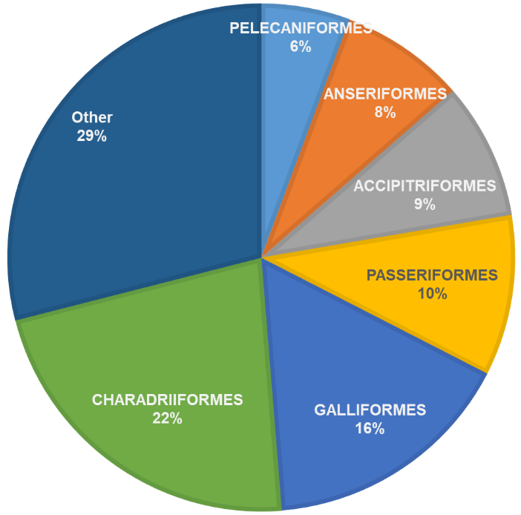
Fig. S4.1 Major avian orders in this review (n = 390)
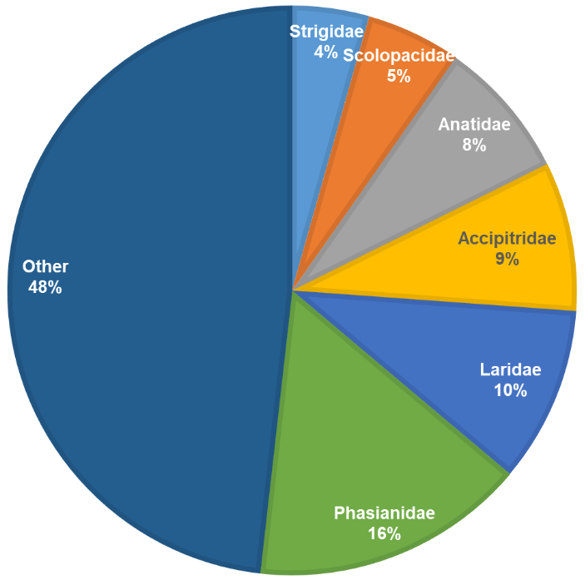
Fig. S4.2 Major avian families in this review (n = 390)

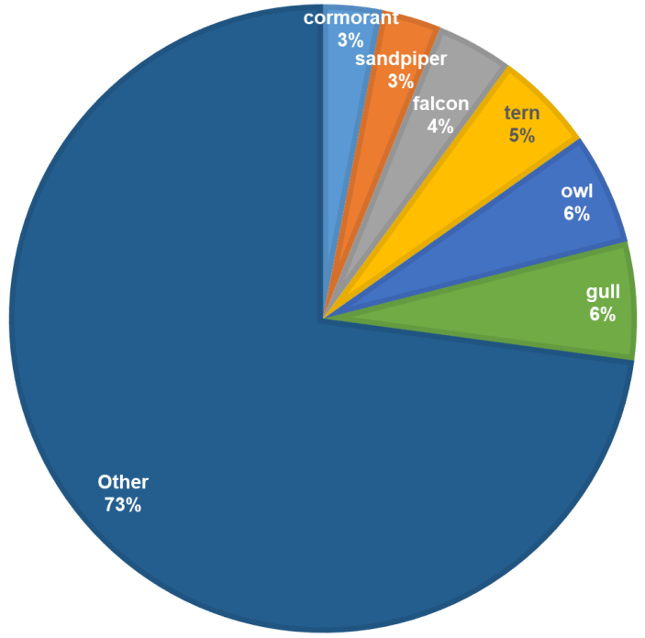
Fig. S4.3 Major avian common groups compiled in this review (n = 310, excluding domestic breeds)

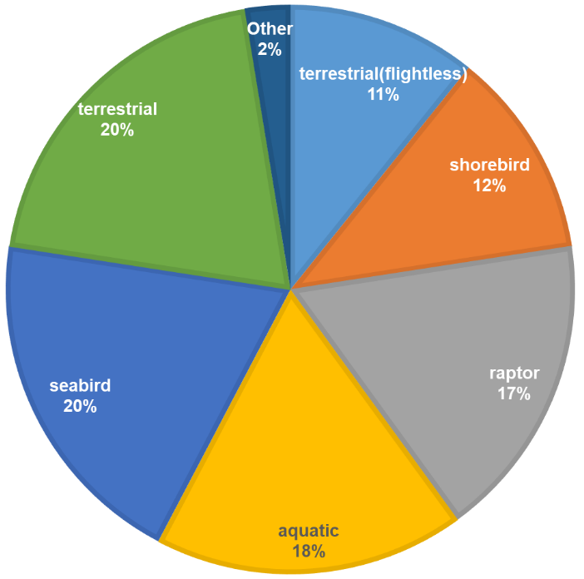
Fig. S4.4 Major avian groups by habitat compiled in this review (n = 390)

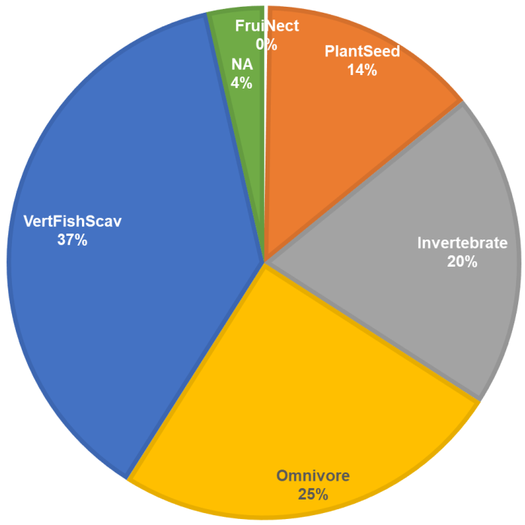
Fig. S4.5 Major avian groups by diet category (assigned according to Wilman et al. 2014) compiled in this review (n = 390)

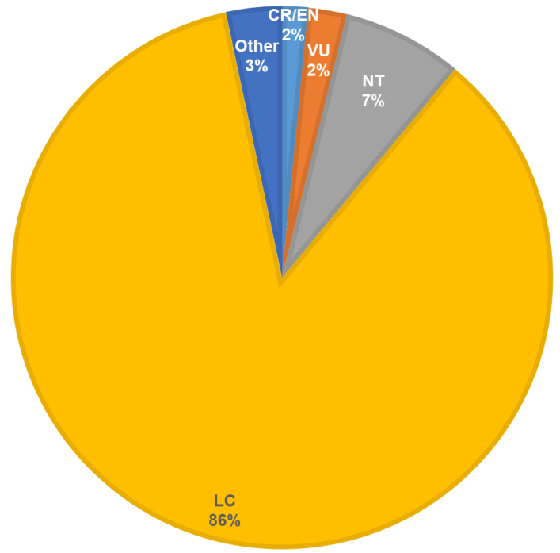
Fig. S4.6 Major avian groups by their conservation status (n = 390) assigned by the International Union for Conservation of Nature (2019)
CR/EN = critical or endangered, VU = vulnerable, NT = near threatened, LC = least concern

S4.3 Quantitative description of diet intake and foraging strategy
Mean diet intake and foraging strategy data are available upon earlier compilation effort (Wilman et al. 2014). These are presented in the bird taxonomy and diet database in detail for individual species. The averages of mean diet composition and mean foraging strategy are presented for all birds using the same habitats in Figures S3.7 and S3.8, respectively.
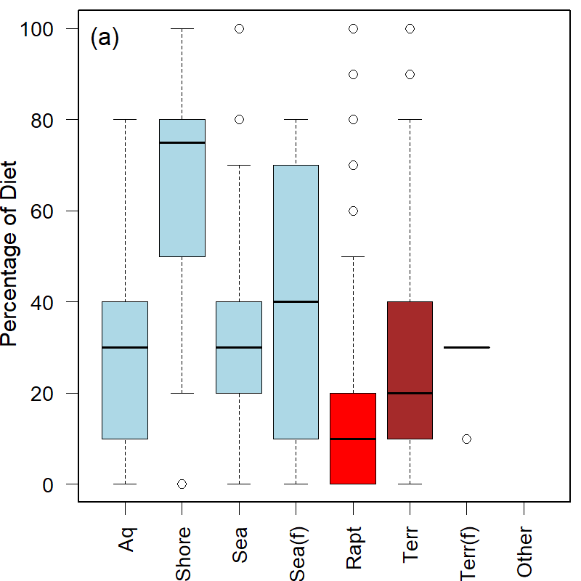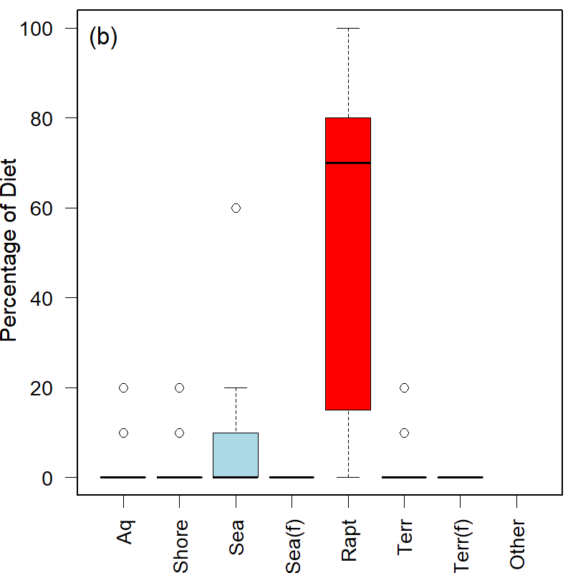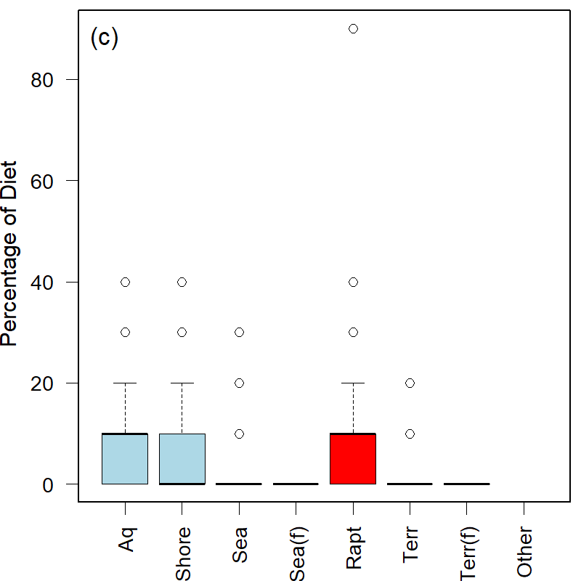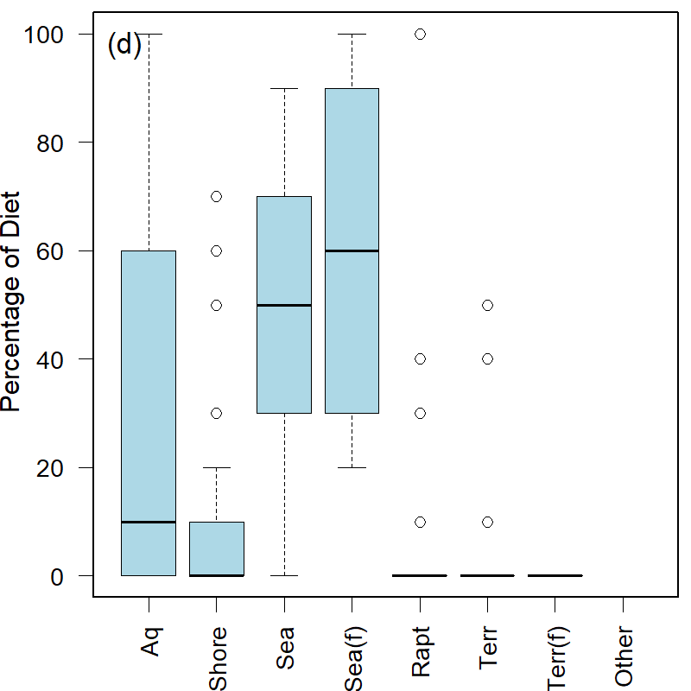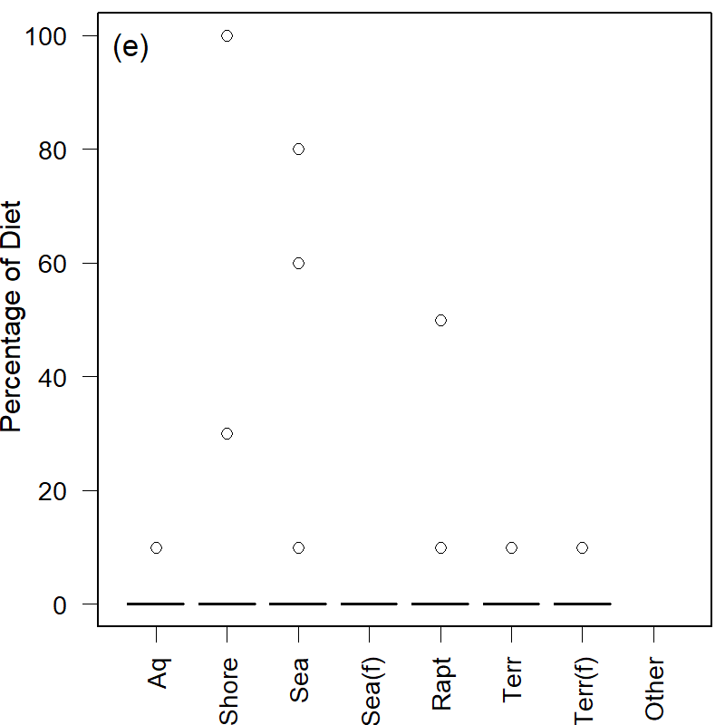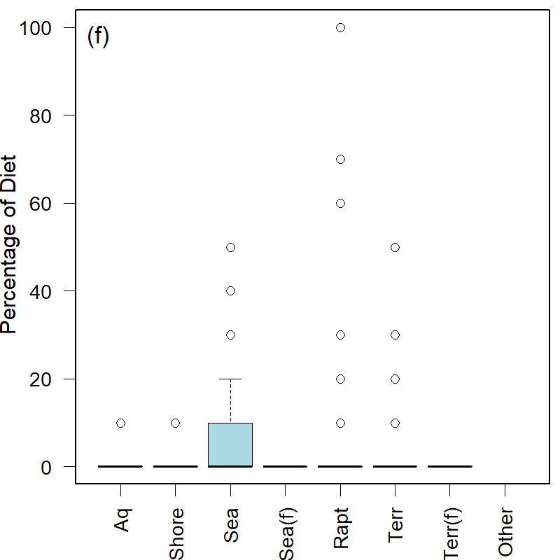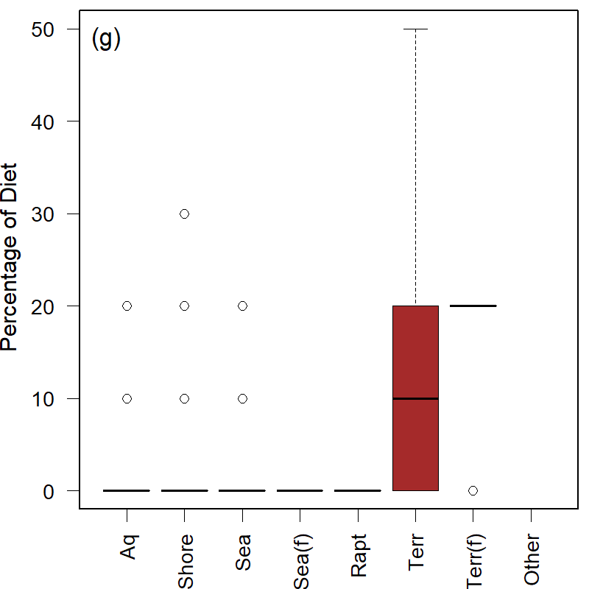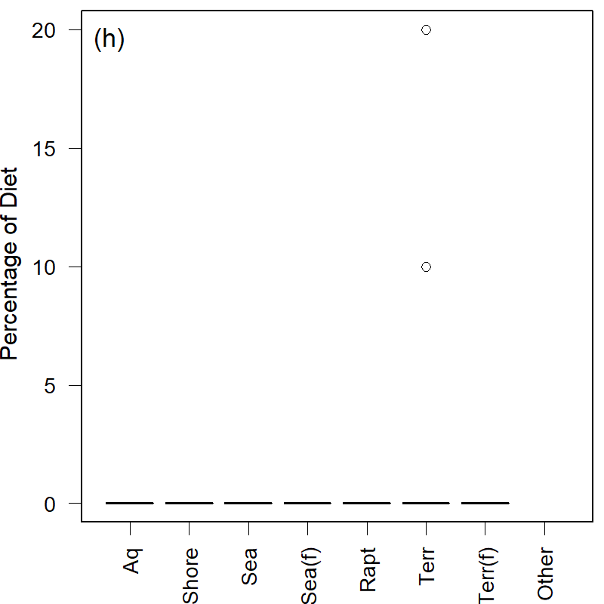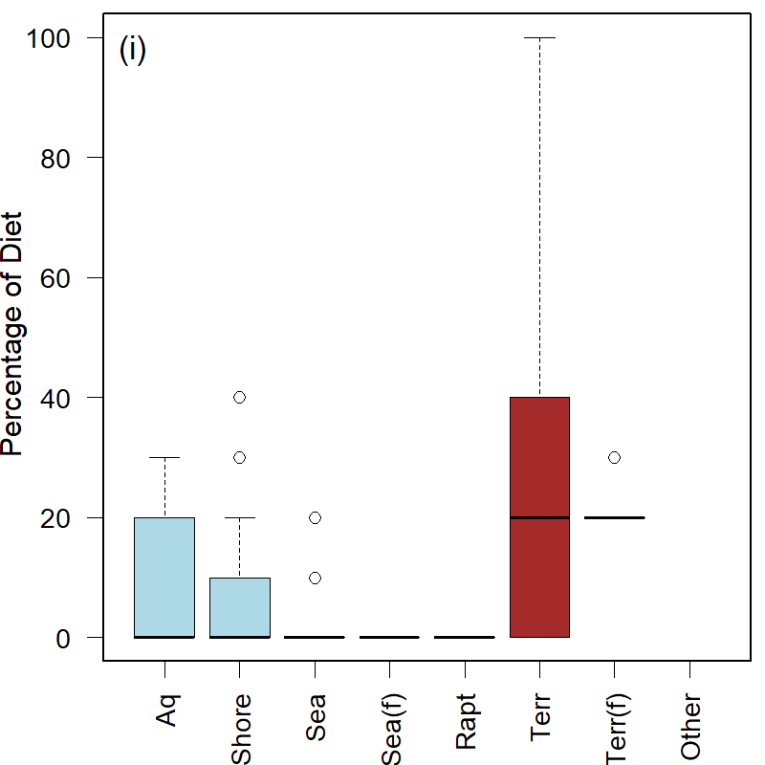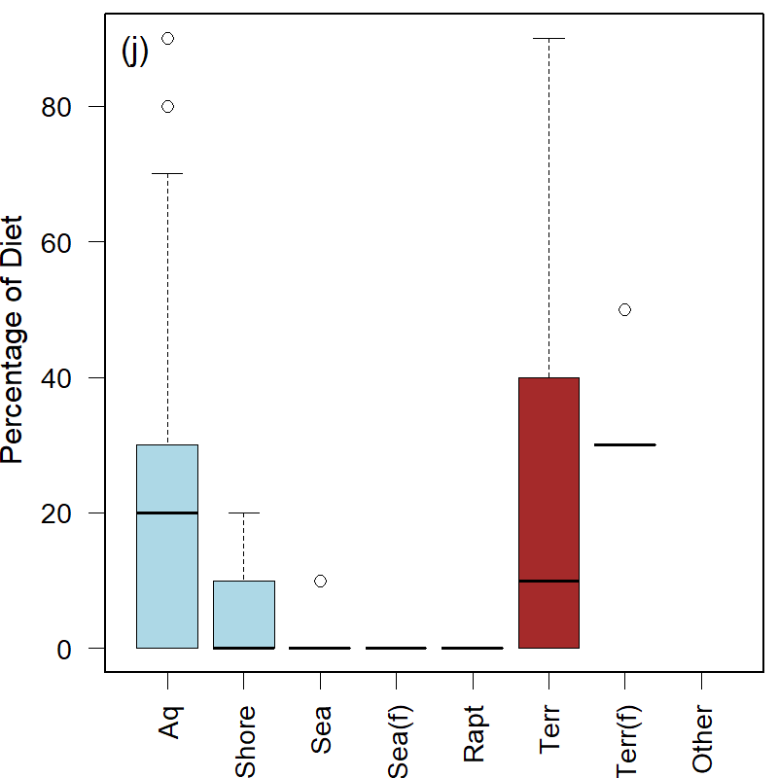
Fig. S4.7 Percentage intake of 10 different diets in birds of different habitat group (box and whisker plot): (a) invertebrates, (b) mammals and birds, (c) reptiles, amphibians, and snakes, (d) fish, (e) unknown vertebrates, (f) scavenge and carrion, (g) fruit, (h) nectar, (i) seed, and (j) plant matter, with raw intake fraction data taken from Wilman et al. (2014)
Aq = aquatic bird, Shore = shorebird, Sea = seabird, Sea(f) = seabird (flightless), Rapt = raptor, Terr = terrestrial bird, Terr(f) = terrestrial bird (flightless).

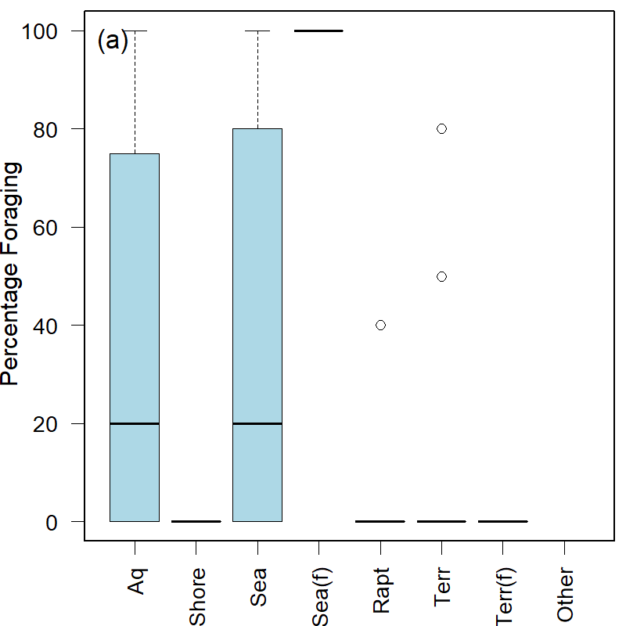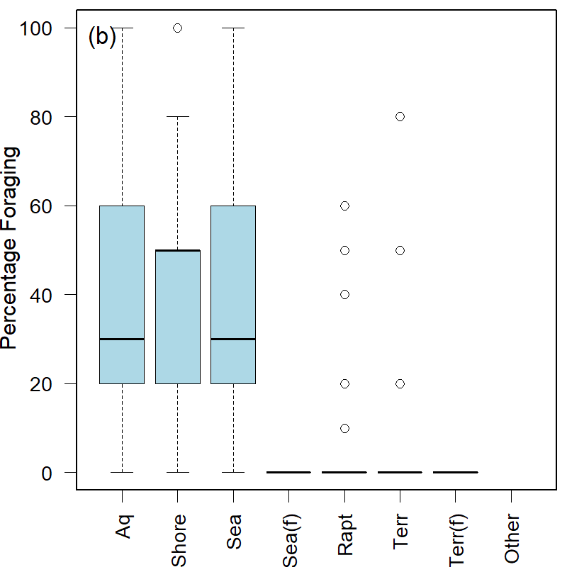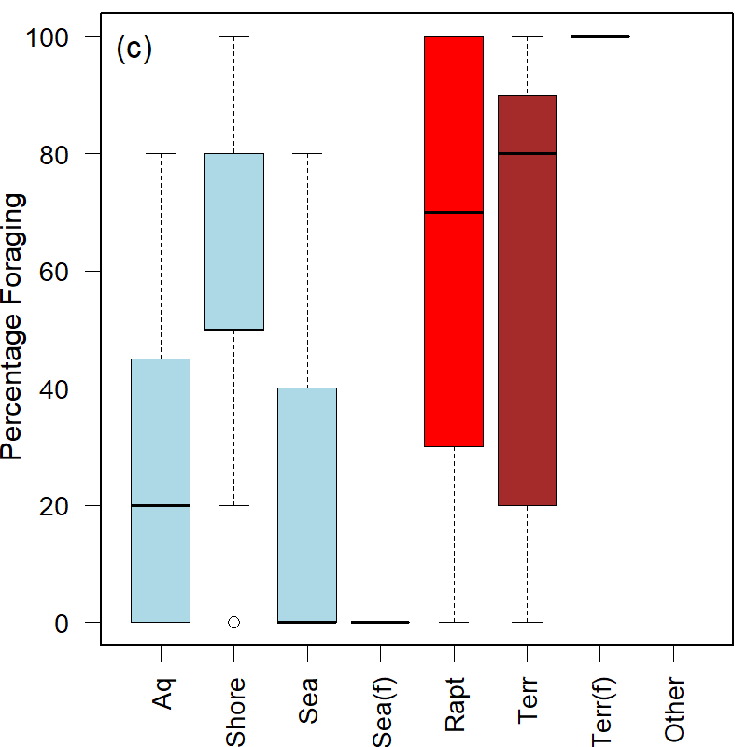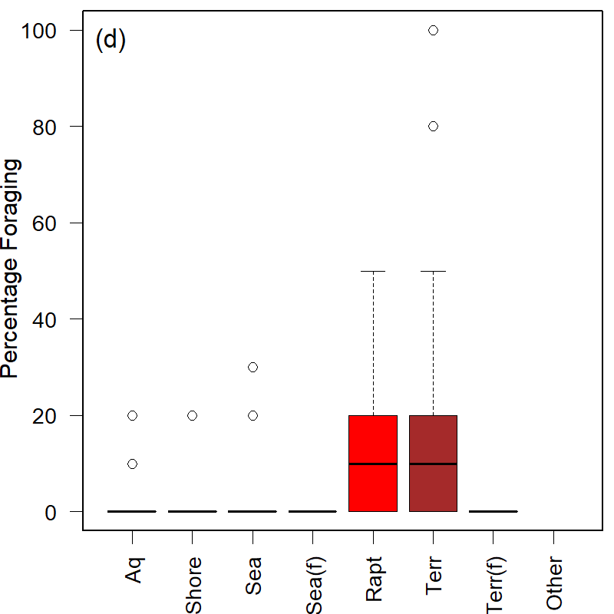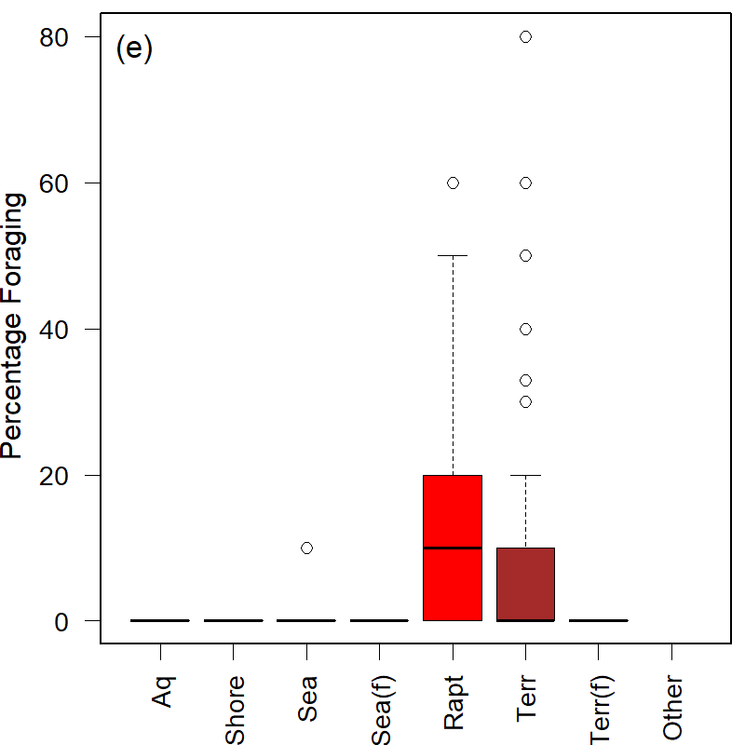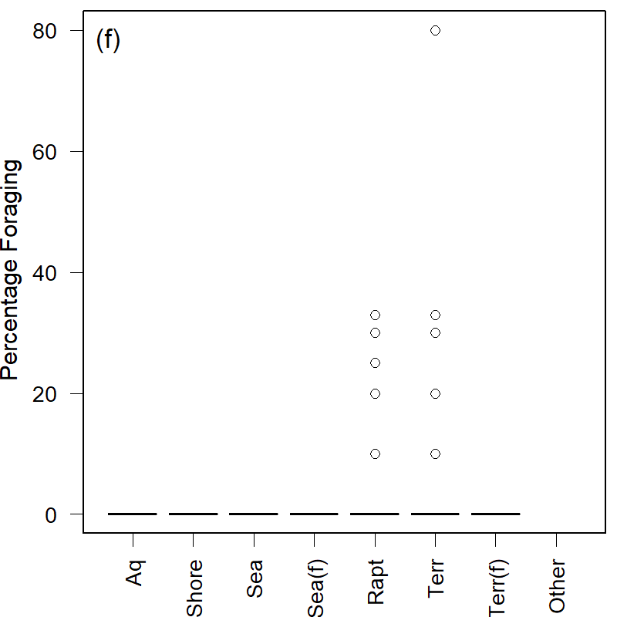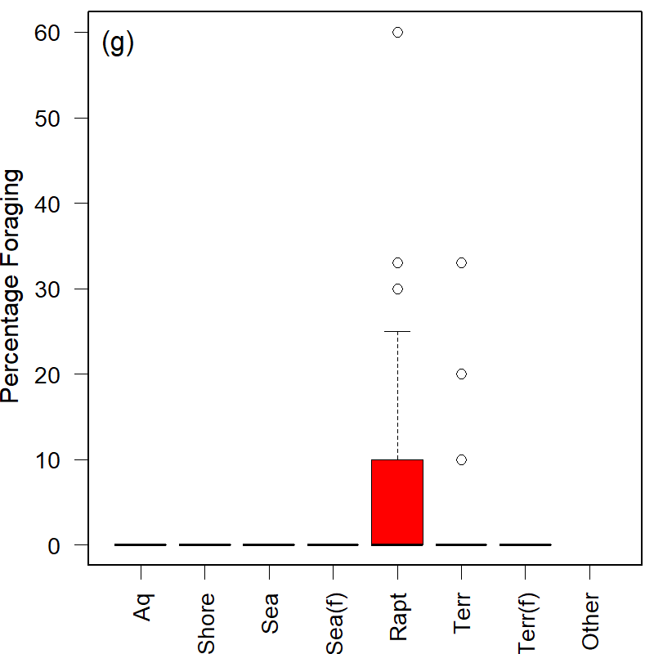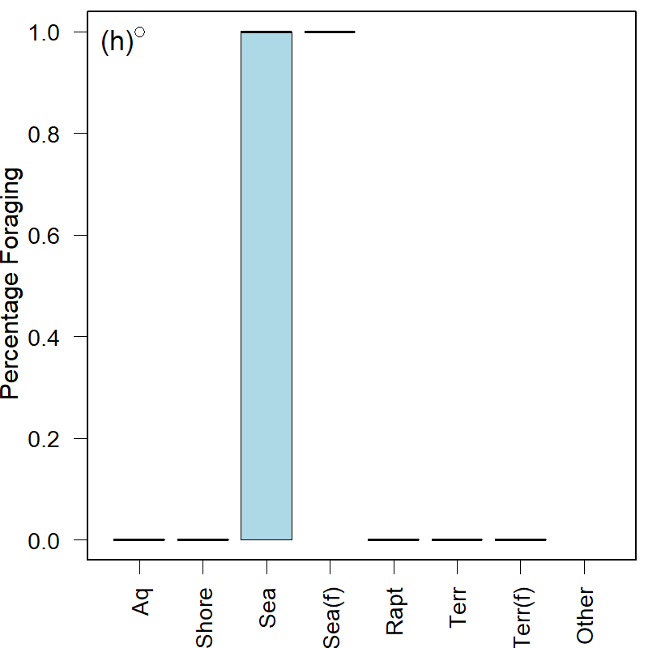
Fig. S4.8 Percentage in eight foraging strategies by different birds habitat groups (box and whisker plot): (a) below water surface, (b) around water surface, (c) ground, (d) vegetation/forest-understory, (e) vegetation/forest-mid-height, (f) vegetation/forest-canopy, (g) aerial, and (h) pelagic, with raw foraging fraction data taken from Wilman et al. (2014)
Aq = aquatic bird, Shore = shorebird, Sea = seabird, Sea(f) = seabird (flightless), Rapt = raptor, Terr = terrestrial bird, Terr(f) = terrestrial bird (flightless).

S5 Avian metabolic microsomal studies
Table S5.1 Dose-activity relationship reported in selected avian metabolic microsomal studies
Chemical | Species | Tissue | Enzymeª | Response type | Reference
Benzo(a)anthracene | Bobwhite quail (Colinus virginianus) | Liver | EROD, PROD | Plateau, peaking | Brausch et al. (2010)
 |  | Renal | PROD | Plateau
Imazalil | Bobwhite quail  (Colinus virginianus) | Liver | HYDROX | Increasing | Lavrijsen et al. (1990)
 |  |  | EROD | Peaking
 |  |  | ECOD | Plateau
 |  |  | NADPH-CRed | Declining
Mixed contaminants | Guillemot  (Uria aalge) | Liver | EROD | Increasing | De Roode et al. (2002)
PBDE-71 | Mallard duck  (Anas platyrhynchos) | Liver | EROD | Plateau | McKernan et al. (2009)
 | American kestrel (Falco sparverius) |  | EROD | Plateau
 | Chicken  (Gallus gallus) |  | EROD | Increasing
PCBs | Gray partridge (Perdix perdix) | Liver | EROD, PROD, BROD | Increasing, peaking | Abiola et al. (1989)
 |  | Liver | COH | Declining
 |  | Liver | ECOD | Plateau
 | American kestrel (Falco sparverius) | Kidney | N-DMTHL | Increasing | Elliott et al. (1997)
 |  | Liver | EROD | Plateau
 |  |  | N-DMTHL | Plateau
 | Japanese quail  (Coturnix japonica) | Liver | EROD | Plateau
 |  |  | N-DMTHL | Plateau, peaking
 | Japanese quail  (Coturnix japonica) | Liver | ECOD, EROD | Declining | Miranda et al. (1987)
 |  | Intestinal | ECOD, EROD | Increasing
PCB-126 | Double-crested cormorant (Phalacrocorax auritus) | Liver | EROD | Increasing | Powell et al. (1998)
aBROD = alkylresorufin O-dealkylase, COH = coumarin 7-hydroxylase, ECOD = 7-ethoxycoumarin-O-deethylase, EROD = 7-ethoxyresorufin-O-deethylase, HYDROX = (aniline) hydroxylase, NADPH-CRed = NADPH-cytochrome c reductase, N-DMTHL = (aminopyrine) N-demethylase, PBDE = polybrominated diphenyl ether, PCB = polychlorinated biphenyl, PROD = pentoxyresorufin O-deethylase.

S6 Fructivorous and Nectarivorous Birds in the Field Database
Diet intake fraction f | Species with  fructivorous diet (n) | Species with  nectarivorous diet (n)
f ≥ 50% | 3 | 0
20% < f < 50% | 11 | 0
0% < f ≤ 20% | 29 | 8

Classification method: species considered fructivorous or nectarivorous when their respective dietary intake ≥50% (i.e., f ≥ 50%), then the number of fructivorous birds is three species (i.e., Pycnonotus sinensis, Pycnonotus capensis, and Turdus migratorius) and the number of nectarivorous birds is 0.

S7 Overview of Major Field Sampling Sites
A large number of field studies were focused on the Great Lakes region (Boersma et al. 1986; de Solla et al. 2016; Donaldson et al. 1999; Elliott and Shutt 1993; Fernie and Letcher 2010; Hughes et al. 2016; Letcher et al. 2015; Lu et al. 2019; McGoldrick et al. 2018; Mora et al. 1993; Norstrom et al. 2002; Struger et al. 1985; Wang et al. 2017), the Arctic region (Borgå et al. 2005; Braune et al. 2014; Braune and Simon 2003; Buckman et al. 2004; Solheim et al. 2016; Verreault et al. 2005; Verreault et al. 2006), and Antarctica (Colabuono et al. 2016; Corsolini et al. 2007, 2011; Mello et al. 2016; Montone et al. 2016; Roscales et al. 2016; Rudolph et al. 2016; Taniguchi et al. 2009). Some of these sites/regions are special in that they have unique species (e.g., penguins in Antarctica). Working repeatedly at select sites can support assessment of temporal trends on contamination (Braune et al. 2015; Braune and Mallory 2017; de Solla et al. 2016; Hughes et al. 2016; McGoldrick et al. 2018) and facilitate operational activities and logistics. However, this will lead to geographic and ecological biases in capturing the regional/global status of contamination. Many of these frequently investigated sites areaquatic/marine ecosystems. Consequently, field studies exhibit a bias toward bioaccumulation/biomagnification in waterbirds compared to terrestrial birds—the number of entries for waterbirds (i.e., seabird, aquatic birds, and shorebirds) is five times that for terrestrial birds. This is also evident as Passeriformes (e.g., sparrow, starling, weavers, etc.) make up merely 10% of the reviewed avian species and the low counts of species feeding upon fruit, nectar, seed, or plant matter. If continued, this study tendency will lead to a weaker basis for understanding bioaccumulation/biomagnification of organic contaminants in nonpredatory land birds.
Field study geography extended beyond commonly reported sites and regions. Some of these sites include Greenland (Cleemann et al. 2000; Vorkamp et al. 2018), northern Japan (Choi et al. 2001a, b), southern Africa (Bouwman et al. 2008; Polder et al. 2008, 2016), Greece (Antoniadou et al. 2007; Hela et al. 2006; Konstantinou et al. 2000), Iran (Rajaei et al. 2010), Turkey (Olanca et al. 2014), South America (Baldassin et al. 2016; Cifuentes et al. 2003), northern Pacific (Jones et al. 1996; Kawano et al. 1988; Kubota et al. 2010), Vietnam (Minh et al. 2002), Mexico (Mora et al. 2011; Vallarino and Rendon von Osten 2017), Ethiopia (Yohannes et al. 2017), and Central and Eastern Europe (Falkowska et al. 2016; Fossi et al. 1986).
Fewer studies focus on spatial trends of contamination than on temporal trends. Here, several field bird studies with extensive spatial scope are highlighted as examples. Jarman et al. (1993) examined organochlorines in falcon and clapper-rail eggs from 24 locations in 7 different states across the United States. Lu et al. (2017) examined the presence of volatile methylsiloxanes and organophosphate esters in starling and gull eggs at roughly 15 sites across Canada. These sites chosen include both urbanized/industrialized areas as well as relatively less polluted sites. The study conducted by Kunisue et al. (2003) is particularly impressive in its scale and geographical reach. They analyzed a suite of legacy organochlorines in tissues (mostly whole body samples) of >30 species of birds collected from Russia, India, Vietnam, the Philippines, and Japan. Spatial field bioaccumulation surveys of such scale will likely require strong collaboration, advanced planning, and generous resources. Coordinating and integrating field results from different monitoring programs may be a feasible alternative. For instance, there are >180 chemical biomonitoring programs on raptors across 33 European countries (Espín et al. 2016). Similar programs may also exist in other continents/regions under different jurisdictions.
S8 No-predictions and Out-of-domain Predictions in RAx Models
RAx models appear less versatile for novel chemical functionalities and they tend to produce more no-predictions (NPs) or out-of-domain predictions (ODPs) than standard QSARs. Quantitative chemical RAx models have applicability domains – the interpolation spaces within which reliable predictions can be made. When applied to out-of-domain chemicals, RAx prediction reliability declines, and no-prediction may result with fully dissimilar chemicals. Helma et al. (2018) attributed a 24% NPs for 155 chemicals to the lack of similar reference chemicals. RAx modules in the QSAR Toolbox and VEGA also produced more NPs (19% for both modules) and ODPs (19% and 50%, respectively) than QSAR-based predictions (19% NPs and ODPs for both Ecological Structure Activity Relationships Predictive Model and QSAR Toolbox QSAR module) when evaluating Daphnia magna LC₅₀ for 16 priority chemicals (Zhou et al. 2021). In this respect, well-trained QSARs may be better suited for gap-filling in the chemical space of bird B/BT/TK data.

Abbreviations
AUC area under the curve
B bioaccumulation
BAF bioaccumulation factor
BCF bioconcentration factor
BFAF biota-feed accumulation factor
BMF biomagnification factor
BSAF biota-sediment/soil accumulation factor
BT biotransformation
BWF biota-water factor
CL clearance
CR critically endangered
EN endangered
EUNIS European Nature Information System
F pharmacokinetic bioavailability
f_{MB/ΣMB} fraction or yield of metabolite
IM intramuscular
IP intraperitoneal
IUCN International Union for Conservation of Nature
IV intravenous
k_{abs} absorption rate constant
k_{elim} blood/plasma elimination rate constant
LC least concern
maxTF maximum transfer factor
MB metabolite
NP non-prediction
NT near threatened
ODF ovo-diet concentration factor
ODP out-of-domain prediction
OMF ovo-maternal concentration factor
PC parent compound
RAx read-across
SC subcutaneous
TF transfer factor
TPRss steady-state tissue-plasma ratio
V_{d} volume of distribution
VU vulnerable

References
Antoniadou V, Konstantinou IK, Goutner V, Sakellarides TM, Albanis TA, Bintoudi E (2007) PCB levels and accumulation patterns in waterbird eggs and in their prey at Lake Kerkini, a North-Eastern Mediterranean wetland of international importance. Arch Environ Contam Toxicol 53:249–260. https://doi.org/10.1007/s00244-006-0176-2
Baldassin P, Taniguchi S, Gallo H, Maranho A, Kolesnikovas C, Amorim DB, Mansilla M, Navarro RM, Tabeira LC, Bicego MC, Montone RC (2016) Persistent organic pollutants in juvenile Magellanic penguins (Spheniscus magellanicus) in South America. Chemosphere 149:391–399. https://doi.org/10.1016/j.chemosphere.2016.01.016
BirdLife International (2018) BirdLife Data Zone: HBW and BirdLife taxonomic checklist version 3. http://datazone.birdlife.org/species/taxonomy. Accessed 13 March 2021.
Boersma DC, Ellenton JA, Yagminas A (1986) Investigation of the hepatic mixed-function oxidase system in herring gull embryos in relation to environmental contaminants. Environ Sci Technol 5:309–318. https://doi.org/10.1002/etc.5620050311
Borgå K, Wolkers H, Skaare JU, Hop H, Muir DCG, Gabrielsen GW (2005) Bioaccumulation of PCBs in Arctic seabirds: influence of dietary exposure and congener biotransformation. Environ Pollut 134:397–409. https://doi.org/10.1016/j.envpol.2004.09.016
Bouwman H, Polder A, Venter B, Skaare JU (2008) Organochlorine contaminants in cormorant, darter, egret, and ibis eggs from South Africa. Chemosphere 71:227–241. https://doi.org/10.1016/j.chemosphere.2007.09.057
Braune BM, Gaston AJ, Letcher RJ, Grant Gilchrist H, Mallory ML, Provencher JF (2014) A geographical comparison of chlorinated, brominated and fluorinated compounds in seabirds breeding in the eastern Canadian Arctic. Environ Res 134:46–56. https://doi.org/10.1016/j.envres.2014.06.019
Braune BM, Letcher RJ, Gaston AJ, Mallory ML (2015) Trends of polybrominated diphenyl ethers and hexabromocyclododecane in eggs of Canadian Arctic seabirds reflect changing use patterns. Environ Res 142:651–661. https://doi.org/10.1016/j.envres.2015.08.010
Braune BM, Mallory ML (2017) Declining trends of polychlorinated dibenzo-p-dioxins, dibenzofurans and non-ortho PCBs in Canadian Arctic seabirds. Environ Pollut 220:557–566. https://doi.org/10.1016/j.envpol.2016.10.003
Braune BM, Simon M (2003) Dioxins, furans, and non-ortho PCBs in Canadian Arctic seabirds. Environ Sci Technol 37:3071–3077. https://doi.org/10.1021/es021082p
Buckman AH, Norstrom RJ, Hobson KA, Karnovsky NJ, Duffe J, Fisk AT (2004) Organochlorine contaminants in seven species of Arctic seabirds from northern Baffin Bay. Environ Pollut 128:327–338. https://doi.org/10.1016/j.envpol.2003.09.017
Choi JW, Matsuda M, Kawano M, Iseki N, Masunaga S, Wakimoto T (2001a) Accumulation of polychlorinated dibenzo-p-dioxins, dibenzofurans, and dioxin-like PCBs in black-tailed gulls and eggs. Bull Environ Contam Toxicol 67:733–740. https://doi.org/10.1007/s001280184
Choi JW, Matsuda M, Kawano M, Wakimoto T, Iseki N, Masunaga S, Hayama S, Watanuki Y (2001b) Chlorinated persistent organic pollutants in black-tailed gulls (Larus crassirostris) from Hokkaido, Japan. Chemosphere 44:1375–1382. https://doi.org/10.1016/s0045-6535(00)00358-1
Cifuentes JM, Becker PH, Sommer U, Pacheco P, Schlatter R (2003) Seabird eggs as bioindicators of chemical contamination in Chile. Environ Pollut 126:123–137. https://doi.org/10.1016/s0269-7491(02)00400-1
Cleemann M, Riget F, Paulsen GB, Dietz R (2000) Organochlorines in Greenland glaucous gulls (Larus hyperboreus) and Icelandic gulls (Larus glaucoides). Sci Total Environ 245:117–130. https://doi.org/10.1016/s0048-9697(99)00437-4
Colabuono FI, Vander Pol SS, Huncik KM, Taniguchi S, Petry MV, Kucklick JR, Montone RC (2016) Persistent organic pollutants in blood samples of Southern Giant Petrels (Macronectes giganteus) from the South Shetland Islands, Antarctica. Environ Pollut 216:38–45. https://doi.org/10.1016/j.envpol.2016.05.041
Cornell Laboratory of Ornithology (2018) eBird. https://www.birds.cornell.edu/home/. Accessed 13 March 2021.
Corsolini S, Borghesi N, Ademollo N, Focardi S (2011) Chlorinated biphenyls and pesticides in migrating and resident seabirds from East and West Antarctica. Environ Int 37:1329–1335. https://doi.org/10.1016/j.envint.2011.05.017
Corsolini S, Borghesi N, Schiamone A, Focardi S (2007) Polybrominated diphenyl ethers, polychlorinated dibenzo-dioxins, -furans, and -biphenyls in three species of Antarctic penguins. Environ Sci Pollut Res Int 14:421–429. https://doi.org/10.1065/espr2006.01.017
Daley JM, Norstrom RJ, Drouillard KG (2013) Tissue distribution kinetics of 2,2',4,4',5,5'-hexachlorobiphenyl in ringdoves after oral dosing. Bull Environ Contam Toxicol 91:367–371. https://doi.org/10.1007/s00128-013-1069-5
de Solla SR, Weseloh DVC, Hughes KD, Moore DJ (2016) Forty-year decline of organic contaminants in eggs of herring gulls (Larus argentatus) from the Great Lakes, 1974 to 2013. Waterbirds 39:166–179.
Donaldson GM, Shutt JL, Hunter P (1999) Organochlorine contamination in bald eagle eggs and nestlings from the Canadian Great Lakes. Arch Environ Contam Toxicol 36:70–80. https://doi.org/10.1007/s002449900444
Elliott JE, Shutt L (1993) Monitoring organochlorines in blood of sharp-shinned hawks (Accipiter striatus) migrating through the Great Lakes. Environ Sci Technol 12:241–250. https://doi.org/10.1002/etc.5620120207
Espín S, García-Fernández AJ, Herzke D, Shore RF, van Hattum B, Martínez-López E, Coeurdassier M, Eulaers I, Fritsch C, Gómez-Ramírez P, Jaspers VLB, Krone O, Duke G, Helander B, Mateo R, Movalli P, Sonne C, van den Brink NW (2016) Tracking pan-continental trends in environmental contamination using sentinel raptors—what types of samples should we use? Ecotoxicology 25:777–801. https://doi.org/10.1007/s10646-016-1636-8
European Environment Agency (2019) European Nature Information System (EUNIS). https://eunis.eea.europa.eu/. Accessed 13 March 2021.
Falkowska L, Reindl AR, Grajewska A, Lewandowska AU (2016) Organochlorine contaminants in the muscle, liver and brain of seabirds (Larus) from the coastal area of the Southern Baltic. Ecotoxicol Environ Saf 133:63–72. https://doi.org/10.1016/j.ecoenv.2016.06.042
Fernie KJ, Letcher RJ (2010) Historical contaminants, flame retardants, and halogenated phenolic compounds in peregrine falcon (Falco peregrinus) nestlings in the Canadian Great Lakes Basin. Environ Sci Technol 44:3520–3526. https://doi.org/10.1021/es100400n
Fossi C, Leonzio C, Focardi S (1986) Increase of organochlorines and MFO activity in water birds wintering in an Italian lagoon. Bull Environ Contam Toxicol 37:538–543. https://doi.org/10.1007/bf01607801
Hela DG, Konstantinou IK, Sakellarides TM, Lambropoulou DA, Akriotis T, Albanis TA (2006) Persistent organochlorine contaminants in liver and fat of birds of prey from Greece. Arch Environ Contam Toxicol 50:603–613. https://doi.org/10.1007/s00244-005-0101-0
Hughes KD, de Solla SR, Weseloh DVC, Martin PA (2016) Long-term trends in legacy contaminants in aquatic wildlife in the Hamilton Harbour Area of Concern. Aquat Ecosyst Health Manage 19:171–180. https://doi.org/10.1080/14634988.2016.1150113
International Union for Conservation of Nature (2019) International Union for Conservation of Nature website. https://www.iucn.org/ Accessed 18 August 2019.
Jarman WM, Norstrom RJ, Simon M, Burns SA, Bacon CA, Simoneit BRT (1993) Organochlorines, including chlordane compounds and their metabolites, in peregrine-falcon, prairie-falcon, and clapper-rail eggs from the USA. Environ Pollut 81:127–136. https://doi.org/10.1016/0269-7491(93)90077-2
Jones PD, Hannah DJ, Buckland SJ, Day PJ, Leathem SV, Porter LJ, Auman HJ, Sanderson JT, Giesy JP, Summer C, Ludwig JP, Colborn TL (1996) Persistent synthetic chlorinated hydrocarbons in albatross tissue samples from midway atoll. Environ Toxicol Chem 15:1793–1800. https://doi.org/10.1002/etc.5620151021
Kawano M, Inoue T, Wada T, Hidaka H, Tatsukawa R (1988) Bioconcentration and residue patterns of chlordane compounds in marine animals: invertebrates, fish, mammals, and seabirds. Environ Sci Technol 22:792–797. https://doi.org/10.1021/es00172a008
Konstantinou IK, Goutner V, Albanis TA (2000) The incidence of polychlorinated biphenyl and organochlorine pesticide residues in the eggs of the cormorant (Phalacrocorax carbo sinensis): an evaluation of the situation in four Greek wetlands of international importance. Sci Total Environ 257:61–79. https://doi.org/10.1016/s0048-9697(00)00500-3
Kubota A, Watanabe M, Kunisue T, Kim EY, Tanabe S, Iwata H (2010) Hepatic CYP1A induction by chlorinated dioxins and related compounds in the endangered black-footed albatross from the North Pacific. Environ Sci Technol 44:3559–3565. https://doi.org/10.1021/es1000177
Kunisue T, Watanabe M, Subramanian A, Sethuraman A, Titenko AM, Qui V, Prudente M, Tanabe S (2003) Accumulation features of persistent organochlorines in resident and migratory birds from Asia. Environ Pollut 125:157–172. https://doi.org/10.1016/S0269-7491(03)00074-5
Letcher RJ, Su G, Moore JN, Williams LL, Martin PA, de Solla SR, Bowerman WW (2015) Perfluorinated sulfonate and carboxylate compounds and precursors in herring gull eggs from across the Laurentian Great Lakes of North America: temporal and recent spatial comparisons and exposure implications. Sci Total Environ 538:468–477. https://doi.org/10.1016/j.scitotenv.2015.08.083
Lu Z, De Silva AO, Zhou W, Tetreault GR, de Solla SR, Fair PA, Houde M, Bossart G, Muir DCG (2019) Substituted diphenylamine antioxidants and benzotriazole UV stabilizers in blood plasma of fish, turtles, birds and dolphins from North America. Sci Total Environ 647:182–190. https://doi.org/10.1016/j.scitotenv.2018.07.405
Lu Z, Martin PA, Burgess NM, Champoux L, Elliott JE, Baressi E, De Silva AO, de Solla SR, Letcher RJ (2017) Volatile methylsiloxanes and organophosphate esters in the eggs of European starlings (Sturnus vulgaris) and congeneric gull species from locations across Canada. Environ Sci Technol 51:9836–9845. https://doi.org/10.1021/acs.est.7b03192
McGoldrick DJ, Pelletier M, de Solla SR, Marvin CH, Martin PA (2018) Legacy of legacies: chlorinated naphthalenes in Lake Trout, Walleye, herring gull eggs and sediments from the Laurentian Great Lakes indicate possible resuspension during contaminated sediment remediation. Sci Total Environ 634:1424–1434. https://doi.org/10.1016/j.scitotenv.2018.04.077
Mello FV, Roscales JL, Guida YS, Menezes JFS, Vicente A, Costa ES, Jiménez B, Torres JPM (2016) Relationship between legacy and emerging organic pollutants in Antarctic seabirds and their foraging ecology as shown by δ(13)C and δ(15)N. Sci Total Environ 573:1380–1389. https://doi.org/10.1016/j.scitotenv.2016.07.080
Minh TB, Kunisue T, Yen NTH, Watanabe M, Tanabe S, Hue ND, Qui V (2002) Persistent organochlorine residues and their bioaccumulation profiles in resident and migratory birds from North Vietnam. Environ Toxicol Chem 21:2108–2118. https://doi.org/10.1002/etc.5620211014
Montone RC, Taniguchi S, Colabuono FI, Martins CC, Cipro CV, Barroso HS, da Silva J, Bícego MC, Weber RR (2016) Persistent organic pollutants and polycyclic aromatic hydrocarbons in penguins of the genus Pygoscelis in Admiralty Bay - an Antarctic specially managed area. Mar Pollut Bull 106:377–382. https://doi.org/10.1016/j.marpolbul.2016.02.047
Mora MA, Auman HJ, Ludwig JP, Giesy JP, Verbrugge DA, Ludwig ME (1993) Polychlorinated biphenyls and chlorinated insecticides in plasma of Caspian terns: relationships with age, productivity, and colony site tenacity in the great lakes. Arch Environ Contam Toxicol 24:320–331. https://doi.org/10.1007/BF01128730
Mora MA, Baxter C, Sericano JL, Montoya AB, Gallardo JC, Rodríguez-Salazar JR (2011) PBDEs, PCBs, and DDE in eggs and their impacts on aplomado falcons (Falco femoralis) from Chihuahua and Veracruz, Mexico. Environ Pollut 159:3433–3438. https://doi.org/10.1016/j.envpol.2011.08.025
Norstrom RJ, Simon M, Moisey J, Wakeford B, Weseloh DV (2002) Geographical distribution (2000) and temporal trends (1981-2000) of brominated diphenyl ethers in Great Lakes hewing gull eggs. Environ Sci Technol 36:4783–4789. https://doi.org/10.1021/es025831e
Olanca B, Cakirogullari GC, Ucar Y, Kirisik D, Kilic D (2014) Polychlorinated dioxins, furans (PCDD/Fs), dioxin-like polychlorinated biphenyls (dl-PCBs) and indicator PCBs (ind-PCBs) in egg and egg products in Turkey. Chemosphere 94:13–19. https://doi.org/10.1016/j.chemosphere.2013.08.056
Polder A, Müller MB, Brynildsrud OB, de Boer J, Hamers T, Kamstra JH, Lie E, Mdegela RH, Moberg H, Nonga HE, Sandvik M, Skaare JU, Lyche JL (2016) Dioxins, PCBs, chlorinated pesticides and brominated flame retardants in free-range chicken eggs from peri-urban areas in Arusha, Tanzania: levels and implications for human health. Sci Total Environ 551–552:656–667. https://doi.org/10.1016/j.scitotenv.2016.02.021
Polder A, Venter B, Skaare JU, Bouwman H (2008) Polybrominated diphenyl ethers and HBCD in bird eggs of South Africa. Chemosphere 73:148–154. https://doi.org/10.1016/j.chemosphere.2008.03.021
Rajaei F, Bahramifar N, Esmaili Sari A, Ghasempouri SM, Savabieasfahani M (2010) PCBs and organochlorine pesticides in ducks of Fereydoon-kenar wildlife refuge in Iran. Bull Environ Contam Toxicol 84:577–581. https://doi.org/10.1007/s00128-010-9988-x
Roscales JL, González-Solís J, Zango L, Ryan PG, Jiménez B (2016) Latitudinal exposure to DDTs, HCB, PCBs, PBDEs and DP in giant petrels (Macronectes spp.) across the Southern Ocean. Environ Res 148:285–294. https://doi.org/10.1016/j.envres.2016.04.005
Rudolph I, Chiang G, Galbán-Malagón C, Mendoza R, Martinez M, Gonzalez C, Becerra J, Servos MR, Munkittrick KR, Barra R (2016) Persistent organic pollutants and porphyrins biomarkers in penguin faeces from Kopaitic Island and Antarctic Peninsula. Sci Total Environ 573:1390–1396. https://doi.org/10.1016/j.scitotenv.2016.07.091
Solheim SA, Sagerup K, Huber S, Byrkjedal I, Gabrielsen GW (2016) The black-legged kittiwake preen gland - an overlooked organ for depuration of fat-soluble contaminants? Polar Res 35:29651. https://doi.org/10.3402/polar.v35.29651
Struger J, Weseloh DV, Hallett DJ, Mineau P (1985) Organochlorine contaminants in herring gull eggs from the Detroit and Niagara Rivers and Saginaw Bay (1978–1982): contaminant discriminants. J Great Lakes Res 11:223–230. https://doi.org/10.1016/S0380-1330(85)71766-2
Taniguchi S, Montone RC, Bícego MC, Colabuono FI, Weber RR, Sericano JL (2009) Chlorinated pesticides, polychlorinated biphenyls and polycyclic aromatic hydrocarbons in the fat tissue of seabirds from King George Island, Antarctica. Mar Pollut Bull 58:129–133. https://doi.org/10.1016/j.marpolbul.2008.09.026
Vallarino A, Rendon von Osten J (2017) Comparison of organochlorine and PAHs residues in terns eggs from two natural protected areas in the Gulf of Mexico. Mar Pollut Bull 116:48–55. https://doi.org/10.1016/j.marpolbul.2016.12.044
Verreault J, Houde M, Gabrielsen GW, Berger U, Haukås M, Letcher RJ, Muir DCG (2005) Perfluorinated alkyl substances in plasma, liver, brain, and eggs of glaucous gulls (Larus hyperboreus) from the Norwegian Arctic. Environ Sci Technol 39:7439–7445. https://doi.org/10.1021/es051097y
Verreault J, Villa RA, Gabrielsen GW, Skaare JU, Letcher RJ (2006) Maternal transfer of organohalogen contaminants and metabolites to eggs of Arctic-breeding glaucous gulls. Environ Pollut 144:1053–1060. https://doi.org/10.1016/j.envpol.2005.10.055
Vorkamp K, Falk K, Møller S, Rigét FF, Sørensen PB (2018) Regulated and unregulated halogenated flame retardants in peregrine falcon eggs from Greenland. Environ Sci Technol 52:474–483. https://doi.org/10.1021/acs.est.7b04866
Wang DG, de Solla SR, Lebeuf M, Bisbicos T, Barrett GC, Alaee M (2017) Determination of linear and cyclic volatile methylsiloxanes in blood of turtles, cormorants, and seals from Canada. Sci Total Environ 574:1254–1260. https://doi.org/10.1016/j.scitotenv.2016.07.133
Wilman H, Belmaker J, Simpson J, de la Rosa C, Rivadeneira MM, Jetz W (2014) EltonTraits 1.0: species-level foraging attributes of the world's birds and mammals. Ecology 95:2027. https://doi.org/10.1890/13-1917.1
Yohannes YB, Ikenaka Y, Nakayama SMM, Mizukawa H, Ishizuka M (2017) DDTs and other organochlorine pesticides in tissues of four bird species from the Rift Valley region, Ethiopia. Sci Total Environ 574:1389–1395. https://doi.org/10.1016/j.scitotenv.2016.08.056

