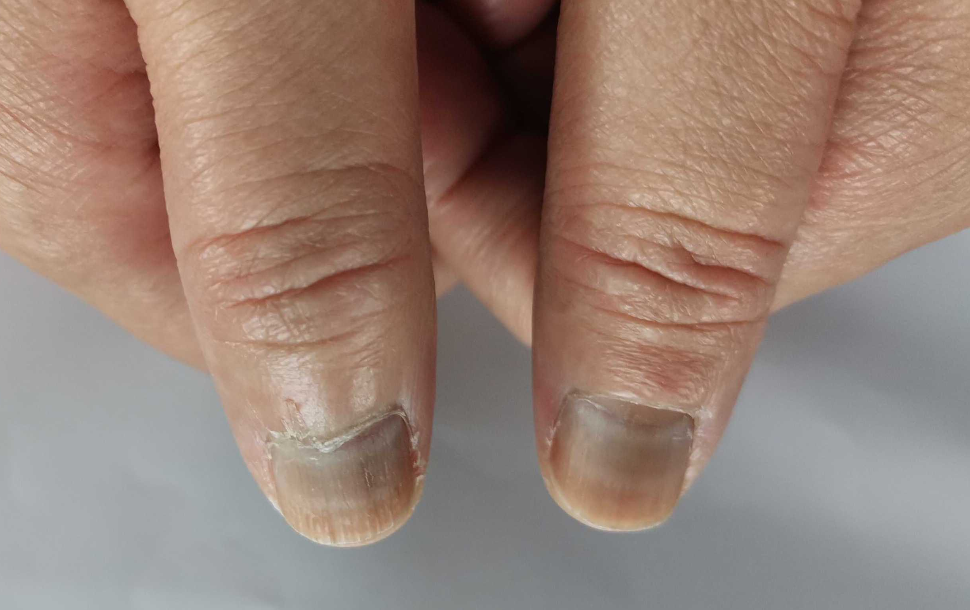

S6. Muehrcke’s lines observed in a patient who received 4 cycles of epirubicin + cyclophosphamide (EC) without hypoalbuminemia.

