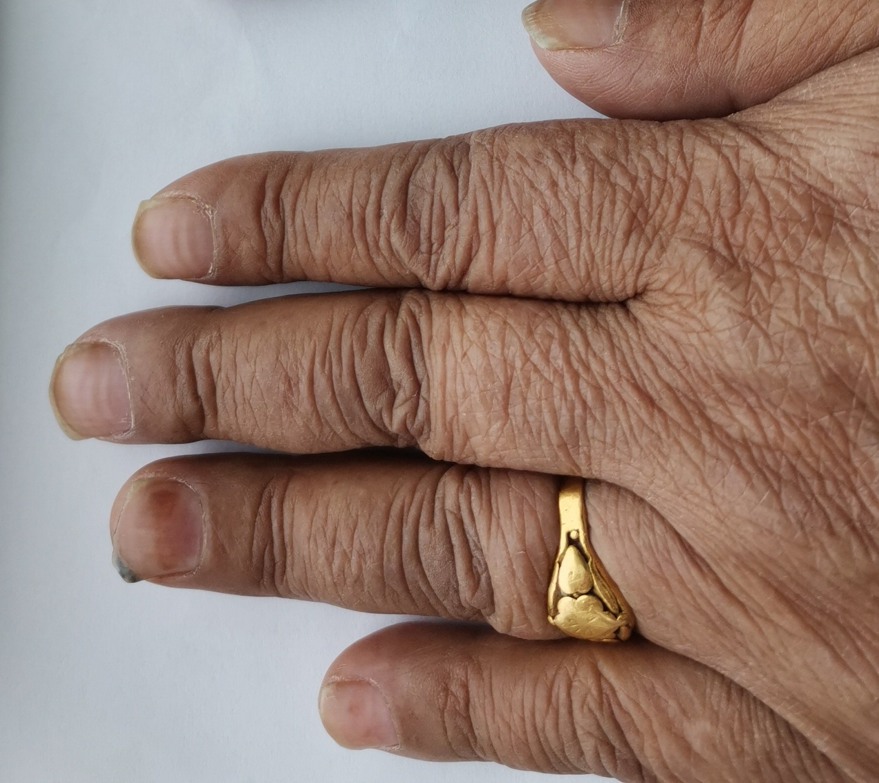

S7. Subungual hemorrhage after 4 cycles of epirubicin + cyclophosphamide (EC) followed by 4 cycles of docetaxel.

