Supplementary tables

Center | MR scanner | Sequence | TR(ms) | TE(ms) | FOV(mm) | ST(mm) | Matrix | FA°
Center 1 | GE SIGNA EXCITE  1.5 T | T1WI | 660 | 11.68 | 280–320 | 6 | 320×224 | 90
 | GE SIGNA EXCITE  1.5 T | T2WI | 4640 | 81.7 | 280–320 | 6 | 320×256 | 90
 | GE SIGNA EXCITE  1.5 T | axi lava 3d + C | 3.8 | 1.8 | 320–380 | 3 | 288×288 | 12
 | GE SIGNA HDx  1.5 T | T1WI | 583 | 12.47 | 260–350 | 5 | 320×224 | 90
 | GE SIGNA HDx  1.5 T | T2WI | 6000 | 39.2 | 260–350 | 5 | 320×192 | 90
 | GE SIGNA HDx  1.5 T | axi Vibrant + C | 5.43 | 2.67 | 260–340 | 1.8 | 384×224 | 15
 | GE DISCOVERY  MR750 (750W) 3.0 T | T1WI | 603 | 7 | 320 | 5 | 384×256 | 111
 | GE DISCOVERY  MR750 (750W) 3.0 T | T2WI | 5266 | 81.28 | 320 | 5 | 320×256 | 111
 | GE DISCOVERY  MR750 (750W) 3.0 T | axi WATER Vibrant + C | 3.9 | 1.72 | 360 | 1.4 | 320×320 | 5
 | GE SIGNA Pioneer  3.0 T | T1WI | 420 | 5.71 | 340 | 5 | 320×256 | 111
 | GE SIGNA Pioneer  3.0 T | T2WI | 3382 | 107.8 | 340 | 5 | 416×256 | 111
 | GE SIGNA Pioneer  3.0 T | axi WATER Disco + C | 4.11 | 1.69 | 320 | 2 | 288×320 | 12
 | SIMENS TrioTim  3.0 T | T1WI | 6.04 | 2.45 | 280–360 | 1.3 | 448×336 | 18.6
 | SIMENS TrioTim  3.0 T | T2WI | 5690 | 83 | 280–360 | 4 | 512×384 | 140
 | SIMENS TrioTim  3.0 T | fl3d_tra T1+ C | 4.4 | 1.75 | 280–350 | 0.7 | 384×416 | 10
 | SIMENS TrioTim  1.5 T | T1WI | 8.6 | 4.7 | 300 | 1.5 | 384×326 | 20
 | SIMENS TrioTim  1.5 T | T2WI | 5000 | 65 | 300 | 5 | 320×288 | 142
 | SIMENS TrioTim  1.5 T | fl3d_tra T1+ C | 4.2 | 1.53 | 370 | 1 | 384×307 | 10
 | Phillips Achieva  3.0 T | T1WI | 627 | 10 | 341 | 4 | 425×424 | 90
 | Phillips Achieva  3.0 T | T2WI | 3640 | 60 | 341 | 4 | 424×421 | 90
 | Phillips Achieva  3.0 T | axi eTHRIVE + C | 4.8 | 2.4 | 340 | 2 | 444×443 | 10
 | United Imaging  3.0 T | T1WI | 680 | 10.5 | 340 | 5 | 448×448 | 120
 | United Imaging  3.0 T | T2WI | 3700 | 74.62 | 340 | 5 | 448×358 | 120
 | United Imaging  3.0 T | axi T1WI + C | 4.32 | 1.99 | 340 | 0.67 | 336×335 | 10
Center 2 | GE DISCOVERY  MR750 (750W) 3.0T | T1WI | 500 | 6.5 | 320 | 4 | 320×256 | 111
 | GE DISCOVERY  MR750 (750W) 3.0T | T2WI | 5349 | 85.97 | 320 | 5 | 320×256 | 111
 | GE DISCOVERY  MR750 (750W) 3.0T | axi WATER Vibrant + C | 6.66 | 1.71 | 360 | 0.8 | 320×320 | 15
 | Phillips Achieva  3.0T | T1WI | 542 | 8 | 350 | 4 | 341×285 | 90
 | Phillips Achieva  3.0T | T2WI | 5000 | 65 | 341 | 4 | 341×324 | 90
 | Phillips Achieva  3.0T | axi eTHRIVE + C | 4.5 | 2.3 | 340 | 1.5 | 405×400 | 12
Table S1. MRI acquisition parameters in two centers
Abbreviations: T1WI, T1-weighted imaging; T2WI, T2-weighted imaging; TR, repetition time; TE, echo time; FOV, field of view; ST, slice thickness; FA, flip angle.

Table S2. The definition of key radiomic features of combined model
Key features | Feature type | Image processing methods | Definition of features
RF1 | First order | lbp-3D-k | Minimum
RF2 | First order | lbp-3D-m1 | Median
RF3 | First order | square | Range
RF4 | First order | wavelet_HLH | Mean
RF5 | First order | wavelet_LHL | Robust Mean Absolute Deviation
RF6 | First order | wavelet_LLL | Skewness
RF7 | First order | wavelet-HLH | Mean
RF8 | First order | wavelet-LHL | Skewness
RF9 | First order | wavelet-LLH | Skewness
RF10 | Shape | original | Elongation_y
RF11 | GLCM | lbp-3D-k | Correlation
RF12 | GLCM | lbp-3D-k | MCC
RF13 | GLCM | logarithm | Cluster Shade
RF14 | GLCM | log-sigma-3-0-mm-3D | Inverse Variance
RF15 | GLCM | wavelet_LHL | Idn
RF16 | GLCM | wavelet_LLL | Imc2
RF17 | GLDM | lbp-3D-k | Small Dependence High Gray Level Emphasis
RF18 | GLRLM | lbp-3D-m1 | Gray Level Variance
RF19 | GLRLM | wavelet_LHH | Gray Level Variance
RF20 | GLRLM | wavelet_LHH | Run Variance
RF21 | GLSZM | lbp-3D-k | Small Area Low Gray Level Emphasis
RF22 | GLSZM | lbp-3D-m2 | Zone Entropy
RF23 | GLSZM | wavelet-HHH | Small Area Low Gray Level Emphasis
RF24 | NGTDM | exponential | Strength
RF25 | NGTDM | wavelet_LLL | Busyness
Note: RF, radiomic feature; GLCM, gray-level co-occurrence matrix; GLDM, gray-level dependence matrix; GLRLM, gray-level run-length matrix; GLSZM, gray-level size zone matrix; NGTDM, neighborhood gray-tone difference matrix; LOG, Laplacian of Gaussian; Wavelet, wavelet transform; LBP, local binary pattern.

Supplementary figures

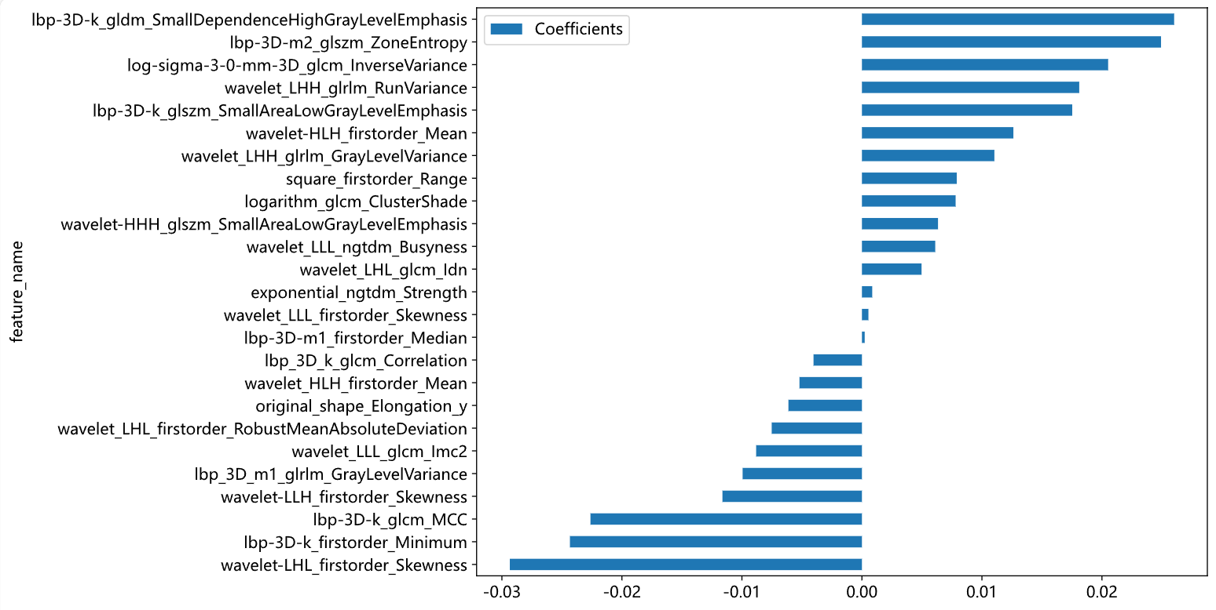
Figure S1. Key radiomic features weights of the combined model

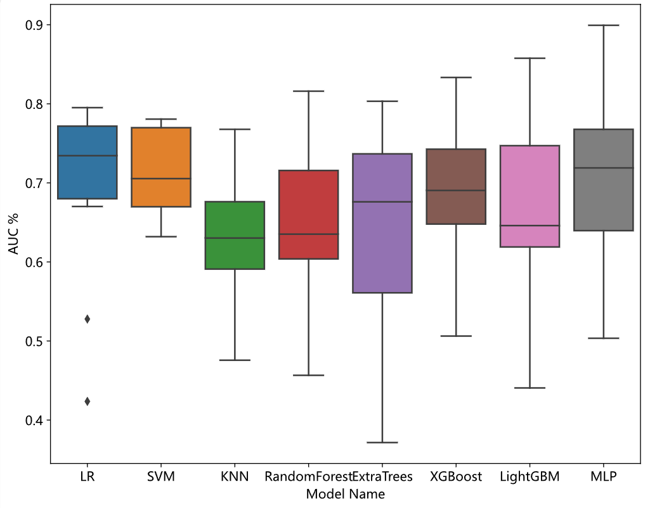
Figure S2. Ten-fold cross-validation results of each machine learning model
To evaluate the robustness of models, ten-fold cross-validation was conducted on the training set. As depicted in the figure, the average performance across the different machine learning models was comparable, however, the models built with LR, SVM, KNN, and XGBoost demonstrated the highest stability.

