Annex 1 Questionnaire and check lists

- Abattoirs

- Observational Assessment of abattoir sites and facilities

Date__________________
Name of abattoir________________

Table 1 Observational Assessment of abattoir sites and facilities
S.no | Assessment criteria | Abattoirs
S.no | Assessment criteria | Mojo Municipal abattoirs (Yes/No) | Adama Municipal abattoir  (Yes/No) | Bishoftu Municipal Abattoirs  (Yes/No)
 | Abattoir location/ Site
 | Far from the residential area
 | Far from Industry
 | Far from crop farms
 | Free from Dust
 | Free access to the road connecting to it
 | Lairage
 | Abattoirs has drained lairage
 | Abattoirs have fencing that leads the animal to the slaughterhouse.
 | Abattoirs has slightly separated within a few distances from the slaughter area
 | Isolation pens for sick animals are available at abattoirs.
 | Rooms in slaughterhouses
 | Abattoir have the necessary equipment to handle hides and skins.
 | Separate facilities exist in abattoir for cleaning and treating intestines and offal.
 | Inedible and condemned animals, carcasses, and meat are stored, disposed of, and treated separately in abattoir.
 | Surfaces of walls, and floor
 | Surfaces of walls and floor are impervious to water
 | can be easily cleaned
 | Surfaces are resistant to wear and corrosion.
 | Other facilities
 | Before the meat is dispatched to the market, the abattoir contains cooling facilities that can decrease the temperature of the meat.
 | Well drainage system
 | During slaughtering and inspection, the abattoir has adequate lighting.
 | The abattoir has a fence that can be used to keep anyone from entering the compound.
 | Is there any footbath
 | Is there Veterinary laboratory
 | Is there Veterinary office
 | Is there a vehicle available to transport carcasses to the market or butcher shops?

- Hygienic handling practices at the abattoirs

Table 2 Questions for interview hygienic handling practices at the abattoirs
No. | Questions | Answers | Skip to
 | Socio-demographic characteristics of individuals
 | Age | Year completed----------
 | Sex | Male [ ] Female [ ]
 | Level of Education: | Illiterate [ ] Informal Education [ ] Primary Education [ ] Secondary Education [ ] Other (Specify)………………
 | Your main role at the abattoir? | Stunning and bleeding [ ] De-hiding [ ]  Evisceration [ ]  Meat inspector [ ]
 | Duration of working at the abattoir (in years)
 | Have you ever received training on meat handling? | Yes [ ] No [ ]
 | Checklist for observations in the slaughter process
 | Stunning before slaughter | Yes [ ] No [ ] | 8
 | If yes, the method of stunning | -----------------------------------
 | Waiting time to start flaying after stunning? | Min---------------------------
 | Method of carcass dressing: | Vertical (hanging) Horizontal (on the floor):
 | Is carcass washed after evisceration? | Yes [ ] No [ ]
 | Presence of sink for washing hands in the slaughterhouse: | Yes [ ] No [ ]
Use of the following protective materials while working in the abattoir? (observe)
Protective materials | Response
Protective materials | yes | No
Apron
white coat
Headcover
Gloves
Boots

 | Questions for face-to-face interviews
 | Do you wash your hands before handling meat? | Yes [] No [ ]
 | Do you wash your hands after handling meat? | Yes [] No [ ]
 | Do you wash your hands after handling waste/garbage? | Yes [] No [ ]
 | Do you wash your hands after using the toilet? | Yes [] No []
 | Do you wash your hands with soap? | Yes [] No []
 | Source of water for use in the abattoir? | City/Municipal council [] borehole [ ] rain collected water [ ] River [ ] others (specify) [ ]
 | Do you smoke inside meat production areas? | Yes [] No []
 | Do you remove your rings, and watch while producing meat? | Yes [] No []
 | Do you handle/process meat while you are ill? | Yes [] No []
 | Do you handle meat when you have cuts, wounds, or injuries on your hands? | Yes [] No []
 | Do you eat or drink at your workplace? | Yes [] No []
 | Do you replace knives or sterilize them after meat processing? | Yes [] No []
 | Have you gone for medical checkups in the last 6 months? | Yes [ ] No [ ]
 | How frequently do you go for medical checkups? | Once per year [ ] Every three months [ ] Every six months [ ] others(specify)--------------

- Butcher shops

Study area_______________
- Basic information
  - Date____________________
  - Questionnaire Code_________

Table 3 Questions for a face-to-face interview and a checklist for direct observation at butcher shops to assess hygienic meat handling practices

- No | Questions |  | Response | Skip to
- General characteristics of individuals
 | Age |  | Years completed--------
 | Sex |  | Male [] Female [ ]
 | Level of Education: |  | Illiterate [ ] Informal Education [ ] Primary Education [ ] Secondary Education [ ] Other (Specify)…
 | Duration of selling meat in retail (butcher) outlet? |  | Years completed---
 | Have you ever received any training on the hygienic handling of meat |  | Yes [ ] No [ ]
 | Checklist for Observations of butcher shops
 | Is there any cover on the display case? |  | Yes [ ] No [ ]
 | The Butcher shop floor is made of? |  | Tile [] wood earthen material [ ] concrete[]  others(specify)
 | Wall painted with white color |  | Yes [ ] No [ ]
 | If yes, is there a sign of dirt on the wall? |  | Yes [ ] No [ ]
 | What is the ventilation status of the display case and butchery |  | Good [] Fair [] Poor []
Good ventilation allows airflow into the butchery but sieves off dust and other particles [ ]
Fair ventilation allows airflow but does not sieve dust or other particles or allows very little airflow [ ] Poor ventilation does not allow airflow at all [ ]
 | Is there use of bulbs in the display case |  | yes [] No []
 | Presence of a meat cooling facility at the display cabinet |  | Yes [] No []
 | Do you use the following protective materials while selling or handling meat?
Protective material | response
 | Yes | no
Apron/white coat
Headcover
Gloves

 | There is a sink for washing hands |  | Yes [ ] No [ ]
 | Type/kind of cutting board used |  | Wood [] plastic [ ]  Metal [] concrete [ ] Marble [ ]
 | Presence of hot water baths for dipping knives? |  | Yes [] No [ ]
 | Material to wrap meat for sale. |  | New paper [] Plastic [ ] Used paper[ ] Others[ ]
 | Questions for face-to-face interviews
1 | What are the means of transporting meat from the abattoir to the retail shop? |  | Open vehicle [ ] Closed vehicle[ ] Animal transport (Cart horse) [ ]
 | How frequently do you wash the protective (white coat and Apron)? | Once per day [ ] Twice per day [ ] once after every two days [ ] once per week [ ] others [ ]
 | Do you wash your hands before handling meat? | Yes [] No [ ]
 | Do you wash your hands after handling meat? | Yes [] No [ ]
 | Do you wash your hands after handling waste/garbage? | Yes [] No [ ]
 | Do you wash your hands after using the toilet? | Yes [] No [ ]
 | Do you smoke inside meat processing areas? | Yes [ ] No [ ]
 | Do you remove your rings, and watch while processing meat? | Yes [ ] No [ ]
 | Do you handle/process meat while you are ill? | Yes [ ] No [ ]
 | Do you handle the meat when you have cuts, wounds, or injuries on your hands? | Yes [ ] No [ ]
 | Do you eat or drink at your workplace? | Yes [ ] No [ ]
 | Do you wash your hand with soap | Yes [ ] No [ ]
 | What is your source of water for use in the butchery? | City/Municipal council [ ] borehole [ ] rain collected water [ ] River [ ] others (specify) [ ]
 | How often do you wash the following butchery surfaces and equipment?
 | Knife | Cutting boards | Saw/Axes | Display cabinet | Hooks | Floors
Once per day
Twice per day
More than twice
Once every two days
Others (specify)
 | Ways of cleaning butchery equipment | Cold water only [], cold water with soap [] hot water only [] hot water with soap [ ] wiping with pieces of fabrics [ ] others (specify)………………
 | Do you have routine control of flies in your butcher? | Yes [ ] No [ ] | 17
 | If “Yes” what are the methods used to control flies? | Horsetail flys wetter []  Roach killer []  Fumigation []  Fumigation and roach killer [ ] Horsetail fly swatter and fumigation [ ] No control
 | Where do you dispose of waste material? | Open space nearby []  Municipal sewer []  Soak pit []
 | How long does the meat stay in your butchery before it is over? | Less than 12 hours [] one day [] Two days []
 | Do you use a refrigerator for storage of the meat that remains from a daily sale? | Yes [] No []
 | Do you collect money while handling or selling meat? | Yes [] No [ ]
 | Have you ever received any training on the hygienic handling of meat? | Yes [ ] No [ ]
 | Have you gone for medical checkups in the last 6 months? | Yes [ ] No [ ]
 | Do you go for a medical check-up? | Yes [ ] No [ ]
 | How frequently do you go for a medical checkup? | Once per year [ ] every three months [ ] every six months [ ]
 | Do you have different storage and display cabinets for offal and meat? | Yes [ ] No [ ]
 | Do you use the same equipment while handling meat and the offal? | Yes [ ] No [ ]

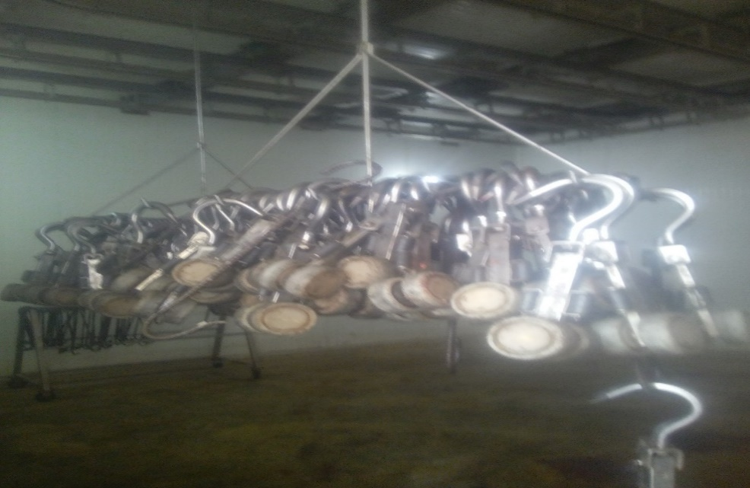

Figure 1: Nonfunctional cooling room in Adama municipal abattoir

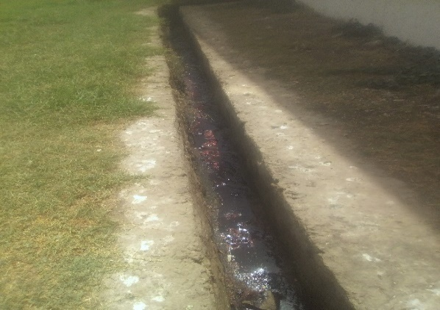
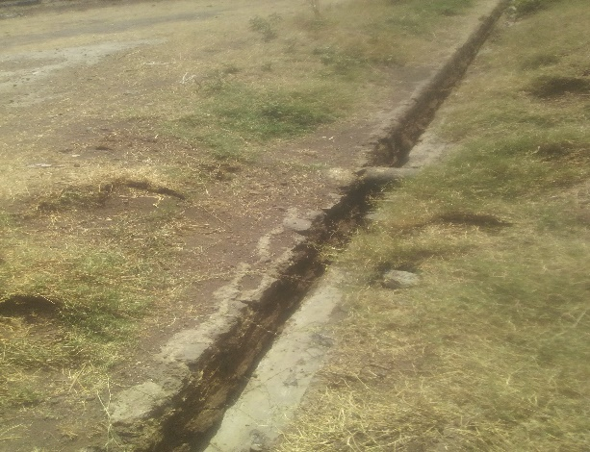

- (B)
Figure 2: Open and grated drainage trench (A) Bishoftu municipal abattoir drainage trench, (B) Adama municipal abattoir drainage trench

