Supplementary Material
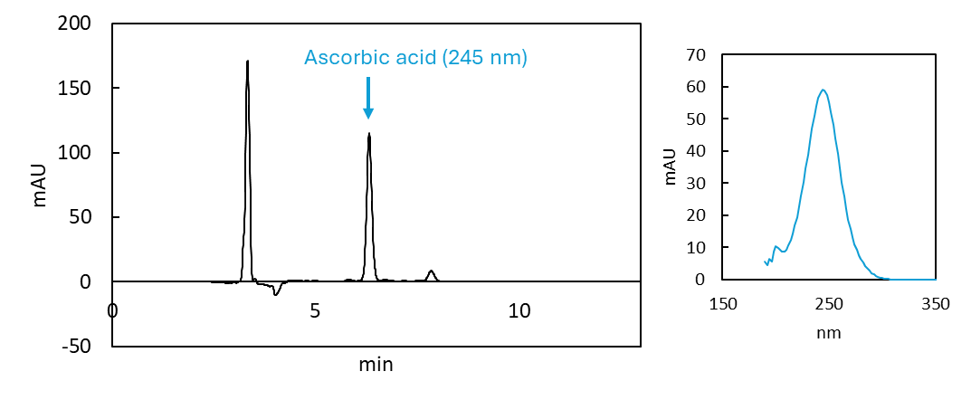
Supplementary Figure A. Representative samples’ chromatogram at 245 nm and spectrum of the corresponding ascorbic acid peak (indicated with blue arrow). Peak retention time and spectrum matched the ascorbic acid standard.
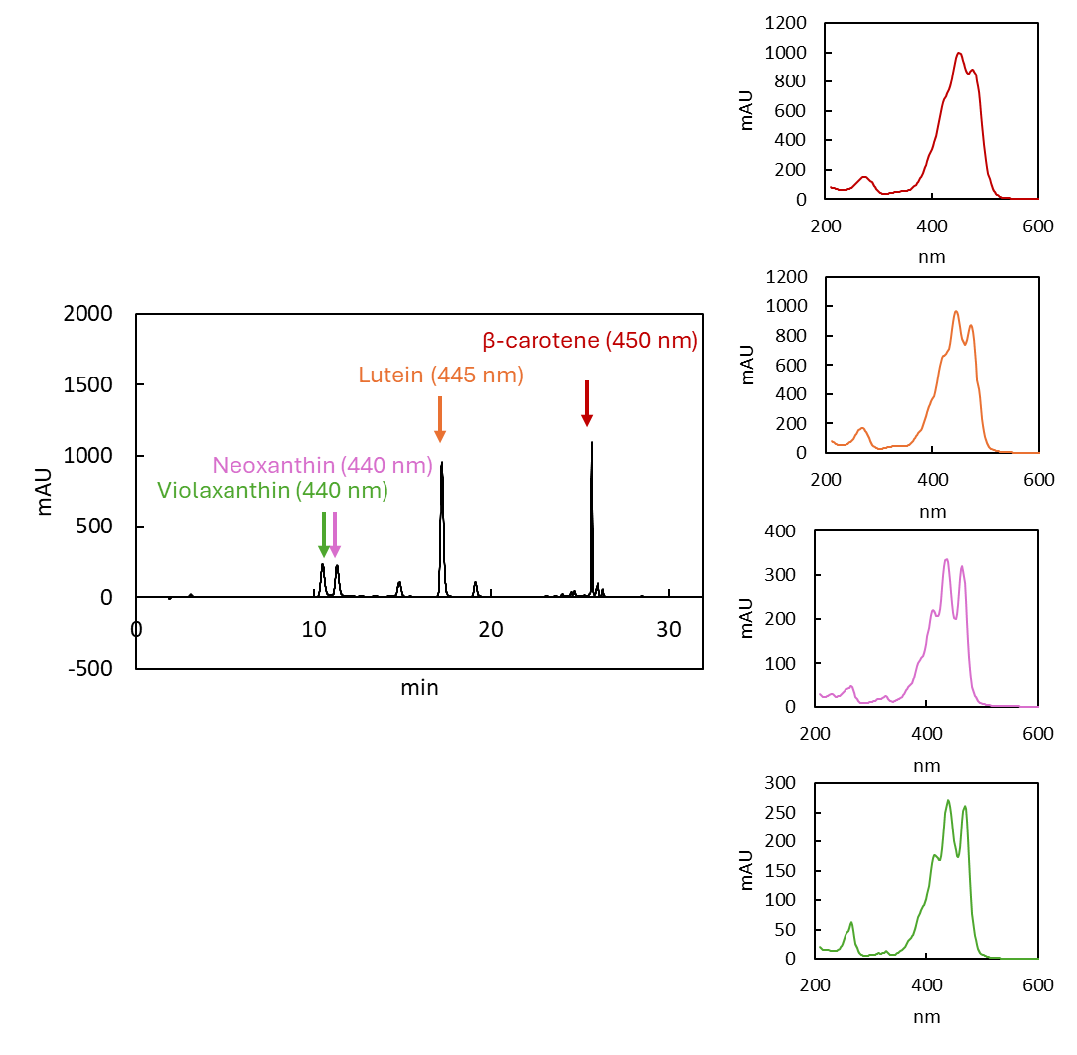
Supplementary Figure B. Representative samples’ chromatogram at 450 nm and spectrum of the corresponding carotenoid peaks (indicated with matching colored arrow and the wavelength at which the peak area was calculated). Peak retention times and spectra matched the carotenoid standards.
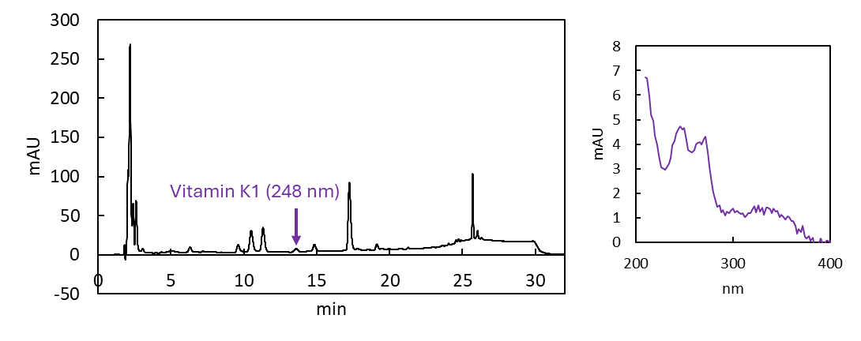
Supplementary Figure C. Representative samples’ chromatogram at 248 nm and spectrum of the corresponding vitamin K1 peak (indicated with a purple arrow). Peak retention time and spectrum matched the vitamin K1 standard.
Glucoerucin
Gluconapin
Gluconasturtiin
Glucoraphanin
Progoitrin
Sinigrin
4-methoxyglucobrassic
Glucobrassicin
Glucotropaeolin
Glucoiberin
Neoglucobrassicin

Supplementary Figure D. Representative samples’ TOF-MS chromatograms for each glucosinolate’s first, second and third ion. Peak retention times matched the glucosinolate standards.

