Supplementary Materials
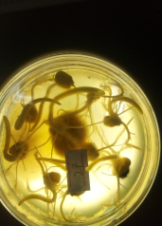
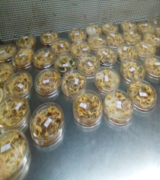
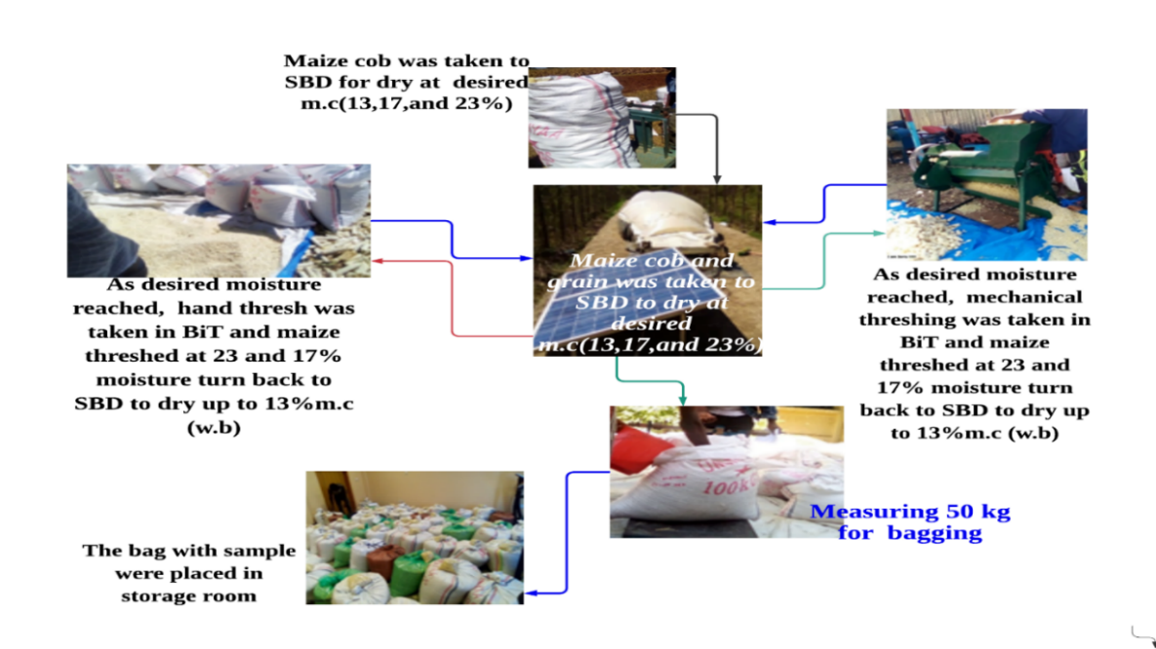
Color determination
Proximate measurment
Mold growth test

Figure S1. Experimental setup from maize harvesting to sample analysis

