Electronic Supporting Information
Antifungal and phytotoxicity of wood vinegar from biomass waste against Fusarium oxysporum f. sp. cubense TR4 infecting banana plants
Dilla Anggrayni^{1,2}, Indra Purnama^{1,3}*, Noor Baity Saidi²*, Fawzia Novianti^{1,3,4}, Nadiya Akmal Baharum², Anisa Mutamima⁵, Nur Amirah Syazwani Binti Razali², Rabah Boukherroub⁶
¹Graduate School of Agricultural Sciences, School of Graduate Studies, Universitas Lancang Kuning, Pekanbaru 28261, Indonesia
²Department of Cell and Molecular Biology, Faculty of Biotechnology and Biomolecular Sciences, Universiti Putra Malaysia, Serdang 43400, Malaysia
³Center for Sustainable Tropical Agricultural Research, Universitas Lancang Kuning, Pekanbaru 28261, Indonesia
⁴Graduate School of Agriculture, Tokyo University of Agriculture and Technology (TUAT), Fuchu 183-8509, Japan
⁵Department of Chemical Engineering, Faculty of Engineering, Universitas Riau, Pekanbaru 28293, Indonesia
⁶Univ. Lille, CNRS, Univ. Polytechnique Hauts-de-France, UMR 8520 - IEMN, F-59000 Lille, France

Corresponding author: indra.purnama@unilak.ac.id, norbaity@upm.edu.my

Table S1. Trend analysis result of type of wood vinegar on plant height change over time
Material | Application Method | Concentration | Slope | Intercept | R^2
Coconut shells | Foliar spraying | 0 | 0.431 | -6.057 | 0.986
Coconut shells | Foliar spraying | 1 | 0.570 | -7.012 | 0.983
Coconut shells | Foliar spraying | 2 | 0.672 | -6.210 | 0.965
Coconut shells | Foliar spraying | 4 | 0.676 | -14.849 | 0.885
Coconut shells | Foliar spraying | 6 | 0.373 | -7.680 | 0.846
Coconut shells | Foliar spraying | 8 | 0.061 | 0.766 | 0.131
Coconut shells | Foliar spraying | 10 | 0.738 | -16.796 | 0.972
Coconut shells | Soil drenching | 0 | 0.445 | -7.436 | 0.975
Coconut shells | Soil drenching | 1 | 0.265 | 2.370 | 0.967
Coconut shells | Soil drenching | 2 | 0.840 | -15.494 | 0.956
Coconut shells | Soil drenching | 4 | 0.133 | -1.672 | 0.999
Coconut shells | Soil drenching | 6 | 0.371 | -7.467 | 0.905
Coconut shells | Soil drenching | 8 | 0.709 | -17.536 | 0.910
Coconut shells | Soil drenching | 10 | -0.071 | 5.725 | 0.284
Acacia wood | Foliar spraying | 0 | 0.431 | -6.057 | 0.986
Acacia wood | Foliar spraying | 1 | 0.712 | -18.462 | 0.849
Acacia wood | Foliar spraying | 2 | 0.981 | -25.231 | 0.878
Acacia wood | Foliar spraying | 4 | 0.746 | -18.361 | 0.846
Acacia wood | Foliar spraying | 6 | 0.747 | -17.574 | 0.815
Acacia wood | Foliar spraying | 8 | 0.879 | -21.533 | 0.888
Acacia wood | Foliar spraying | 10 | 0.268 | -5.556 | 0.989
Acacia wood | Soil drenching | 0 | 0.445 | -7.436 | 0.975
Acacia wood | Soil drenching | 1 | 0.741 | -18.222 | 0.931
Acacia wood | Soil drenching | 2 | 0.575 | -12.864 | 0.864
Acacia wood | Soil drenching | 4 | 0.879 | -21.533 | 0.888
Acacia wood | Soil drenching | 6 | 0.741 | -18.222 | 0.931
Acacia wood | Soil drenching | 8 | 0.272 | -5.195 | 0.783
Acacia wood | Soil drenching | 10 | 0.950 | -24.257 | 0.833

Table S2. Trend analysis result of type of wood vinegar on stem diameter change over time
Material | Application Method | Concentration | Slope | Intercept | R^2
Coconut shells | Foliar spraying | 0 | 0.033 | -0.653 | 0.906
Coconut shells | Foliar spraying | 1 | 0.027 | -0.420 | 0.783
Coconut shells | Foliar spraying | 2 | 0.041 | -0.637 | 0.896
Coconut shells | Foliar spraying | 4 | 0.037 | -0.775 | 0.953
Coconut shells | Foliar spraying | 6 | 0.034 | -0.799 | 0.783
Coconut shells | Foliar spraying | 8 | 0.030 | -0.617 | 0.928
Coconut shells | Foliar spraying | 10 | 0.030 | -0.638 | 0.860
Coconut shells | Soil drenching | 0 | 0.033 | -0.669 | 0.918
Coconut shells | Soil drenching | 1 | 0.047 | -0.845 | 0.924
Coconut shells | Soil drenching | 2 | 0.024 | -0.308 | 0.881
Coconut shells | Soil drenching | 4 | 0.034 | -0.678 | 0.852
Coconut shells | Soil drenching | 6 | 0.027 | -0.648 | 0.869
Coconut shells | Soil drenching | 8 | 0.037 | -0.747 | 0.905
Acacia wood | Foliar spraying | 0 | 0.033 | -0.653 | 0.906
Acacia wood | Foliar spraying | 1 | 0.037 | -0.804 | 0.986
Acacia wood | Foliar spraying | 2 | 0.034 | -0.707 | 0.915
Acacia wood | Foliar spraying | 4 | 0.037 | -0.704 | 0.986
Acacia wood | Foliar spraying | 6 | 0.037 | -0.797 | 0.905
Acacia wood | Foliar spraying | 8 | 0.041 | -0.858 | 0.841
Acacia wood | Foliar spraying | 10 | 0.044 | -1.005 | 0.932
Acacia wood | Soil drenching | 0 | 0.033 | -0.669 | 0.918
Acacia wood | Soil drenching | 1 | 0.051 | -1.207 | 0.875
Acacia wood | Soil drenching | 2 | 0.051 | -1.085 | 0.915
Acacia wood | Soil drenching | 6 | 0.041 | -0.958 | 0.841
Acacia wood | Soil drenching | 8 | 0.013 | -0.238 | 0.942
Acacia wood | Soil drenching | 10 | 0.024 | -0.465 | 0.433

Table S3. Trend analysis result of type of wood vinegar on number of leaves change over time
Material | Application Method | Concentration | Slope | Intercept | R^2
Coconut shells | Foliar spraying | 0 | 0.067 | -1.442 | 0.942
Coconut shells | Foliar spraying | 1 | 0.067 | -1.086 | 0.999
Coconut shells | Foliar spraying | 2 | 0.003 | 1.074 | 0.001
Coconut shells | Foliar spraying | 4 | 0.101 | -2.485 | 0.977
Coconut shells | Foliar spraying | 6 | 0.034 | -0.899 | 0.783
Coconut shells | Foliar spraying | 8 | 0.000 | 0.000 | 1.000
Coconut shells | Foliar spraying | 10 | 0.000 | 0.000 | 1.000
Coconut shells | Soil drenching | 0 | 0.067 | -1.692 | 0.942
Coconut shells | Soil drenching | 1 | 0.037 | 0.175 | 0.132
Coconut shells | Soil drenching | 2 | 0.135 | -1.885 | 0.942
Coconut shells | Soil drenching | 4 | 0.036 | -0.612 | 0.284
Coconut shells | Soil drenching | 6 | 0.068 | -1.799 | 0.783
Coconut shells | Soil drenching | 8 | 0.065 | -0.873 | 0.716
Coconut shells | Soil drenching | 10 | 0.000 | 0.000 | 1.000
Acacia wood | Foliar spraying | 0 | 0.067 | -1.442 | 0.942
Acacia wood | Foliar spraying | 1 | 0.167 | -4.071 | 0.994
Acacia wood | Foliar spraying | 2 | 0.067 | -1.086 | 0.999
Acacia wood | Foliar spraying | 4 | 0.101 | -1.985 | 0.977
Acacia wood | Foliar spraying | 6 | 0.034 | 0.101 | 0.783
Acacia wood | Foliar spraying | 8 | 0.000 | 0.000 | 1.000
Acacia wood | Foliar spraying | 10 | 0.033 | -0.686 | 0.716
Acacia wood | Soil drenching | 0 | 0.067 | -1.692 | 0.942
Acacia wood | Soil drenching | 1 | 0.133 | -3.172 | 0.999
Acacia wood | Soil drenching | 2 | 0.065 | -1.373 | 0.716
Acacia wood | Soil drenching | 4 | 0.000 | 0.000 | 1.000
Acacia wood | Soil drenching | 6 | 0.101 | -2.485 | 0.977
Acacia wood | Soil drenching | 8 | -0.033 | 1.186 | 0.716
Acacia wood | Soil drenching | 10 | 0.065 | -1.373 | 0.716

Figure S1. Plant height change at 24, 31, and 39 DAT with linear trends
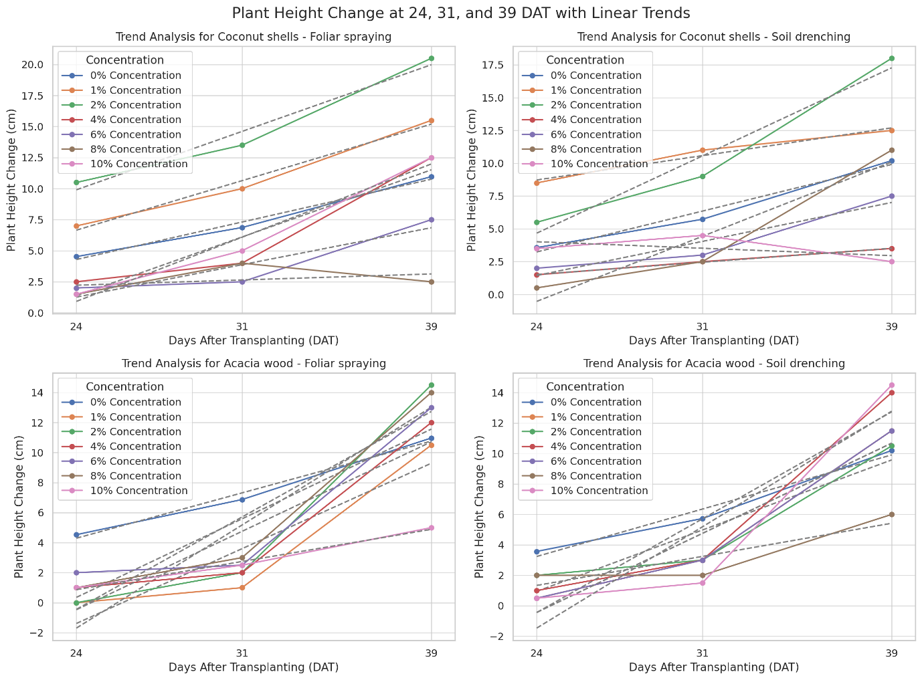

Figure S2. Stem diameter change at 24, 31, and 39 DAT with linear trends
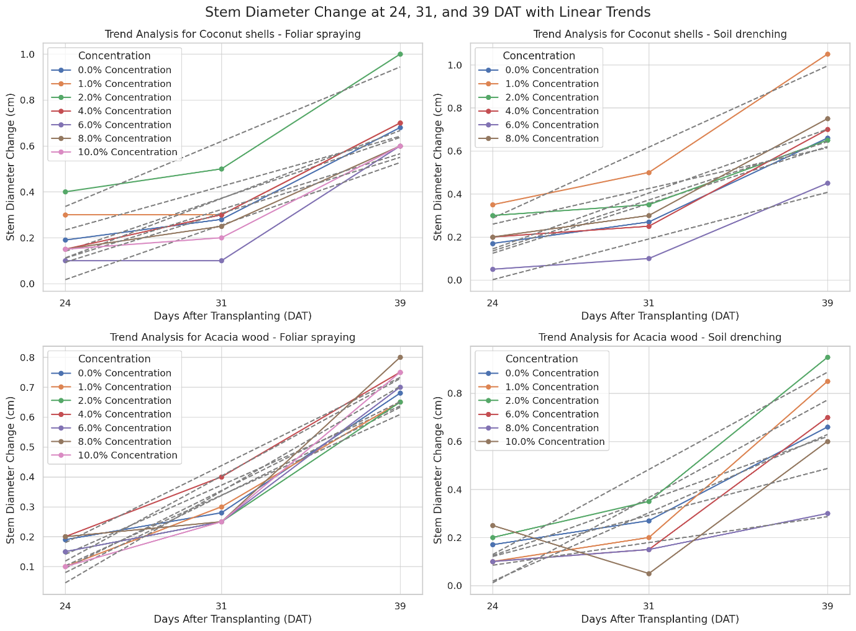

Figure S3. Leaf number change at 24, 31, and 39 DAT with linear trends
