Table 1S: Microbiological quality of CEsP (CFU/g) following boiling:
Test | Values
TBC (Total bacterial count) | ND
Coliform | ND
Salmonella | ND
Staphylococcus | ND
* ND = Not detected

Table 2S: The amount of fortified crackers (8% replacement ratio of WF by CEsP) needed to provide the recommended dietary allowances of calcium:
Age | Recommended Calcium intake  (mg/day) | 8% eggshells fortified crackers amount (g)
4-8 years | 1000 | 135.0
9-18 years | 1300 | 175.5
19-50 years | 1000 | 135.0
50-70 years | 1200 | 162.0
˃ 70 years | 1200 | 162.0

Add pictures of crackers for better understanding in physical changes

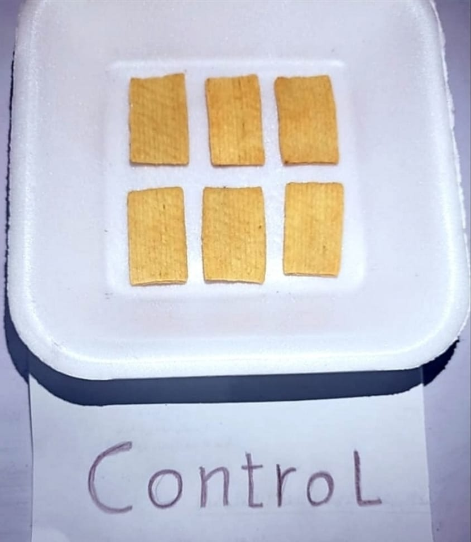 | 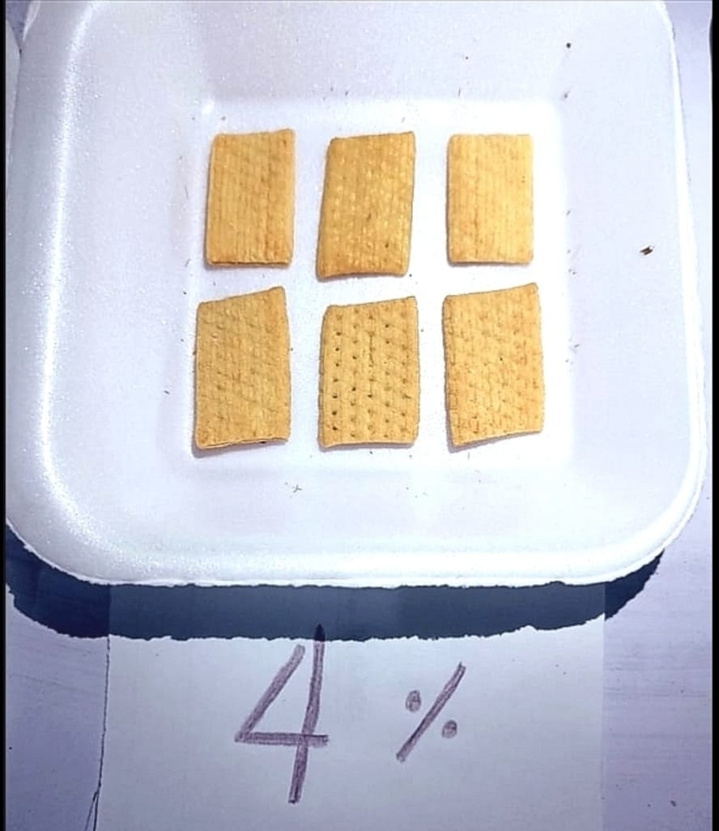 | 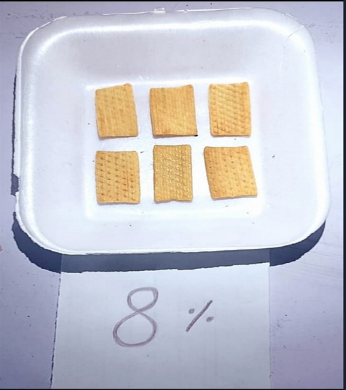 | 