Figure captions:
Fig. S1 Principal component analysis (PCA) loading plot of the 63 volatile profiles of guava genotypes. The sample codes are listed in Table 3.
Fig. S2 Principal component analysis (PCA) biplot of the 63 volatile profiles of guava genotypes. The names for coded numbers of volatiles and genotypes are shown in Tables 1 and 3.
Fig. S3 Metabolome analysis of flavour compounds in guava genotypes. The heat map shows the VOCs in various guava genotypes (reddish pink, pink and white). Each rows represents a guava genotype and columns represent volatile flavour compound. The color key indicates the relative flavour volatile value which underwent normalization by log transformation and auto scaling. In the generated visualizations, a yellow-green color denotes a high abundance of the volatile, while dark blue indicates a relatively low abundance. The names for coded numbers of volatiles and genotypes are shown in Tables 1 and 3.

Fig. S1
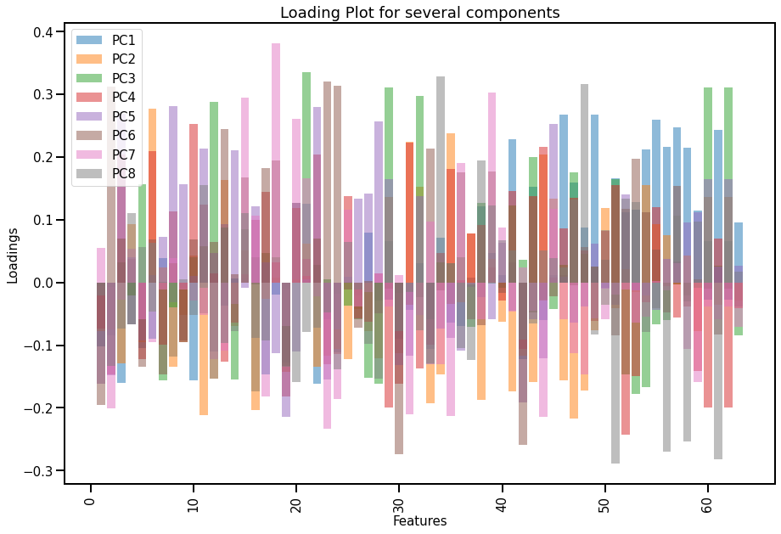

Fig. S2
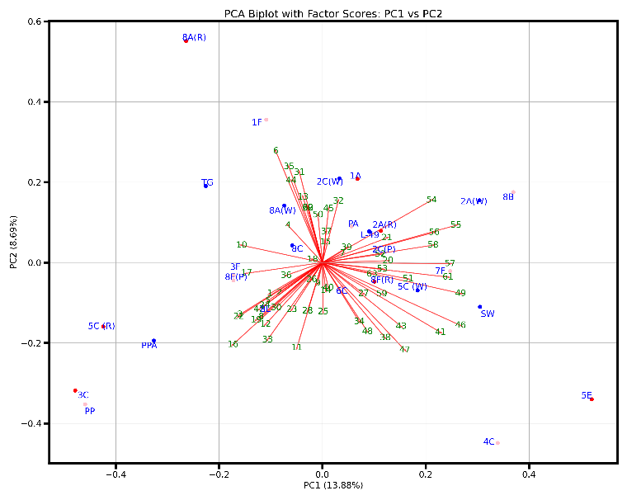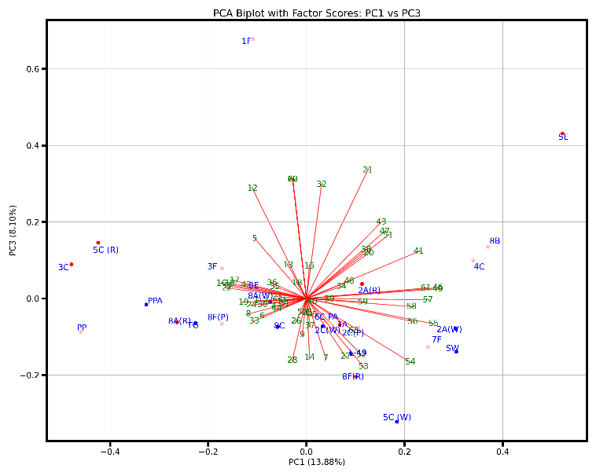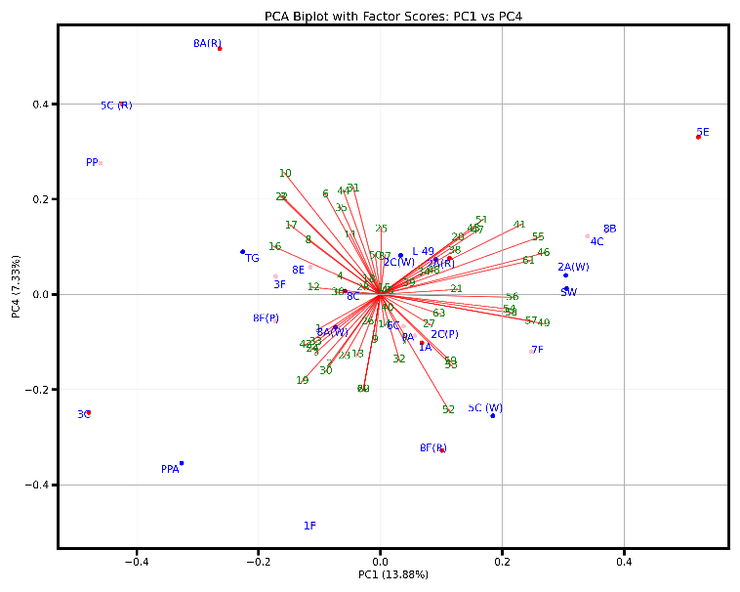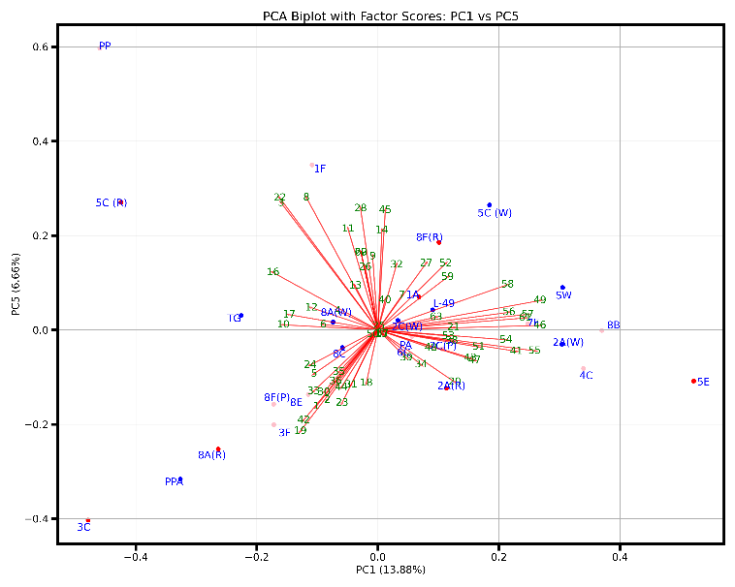
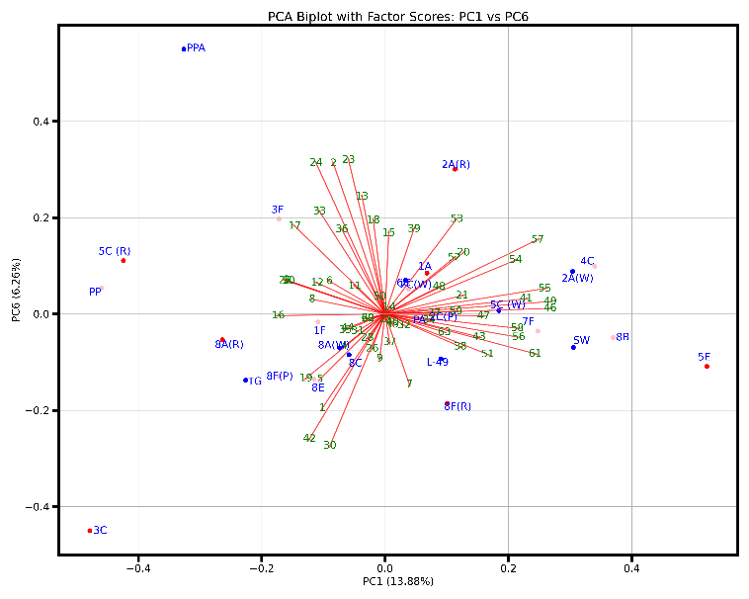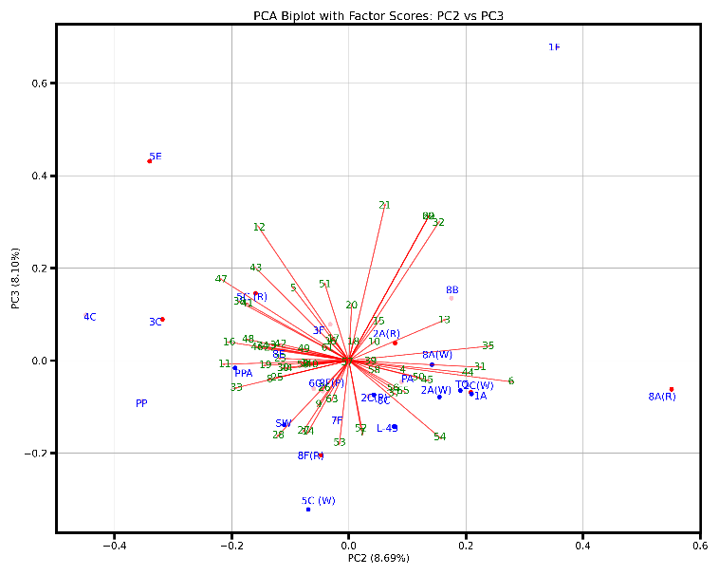

Fig. S2 Cont…
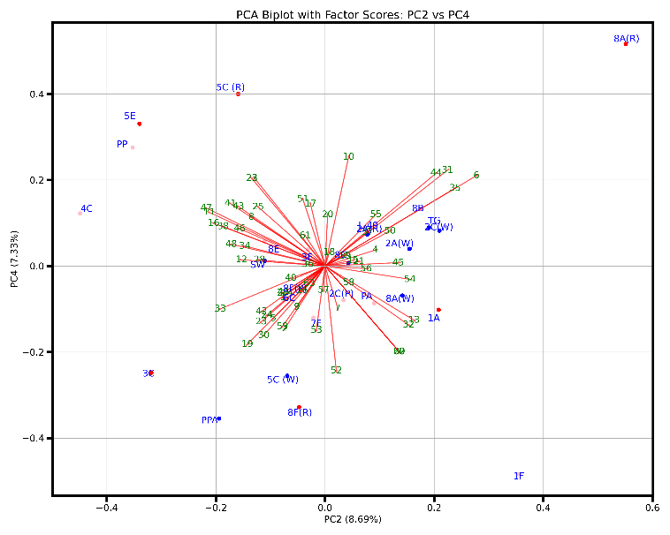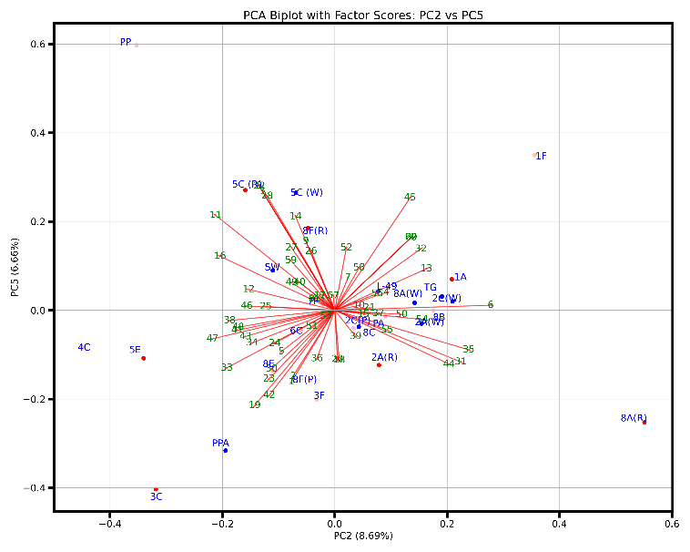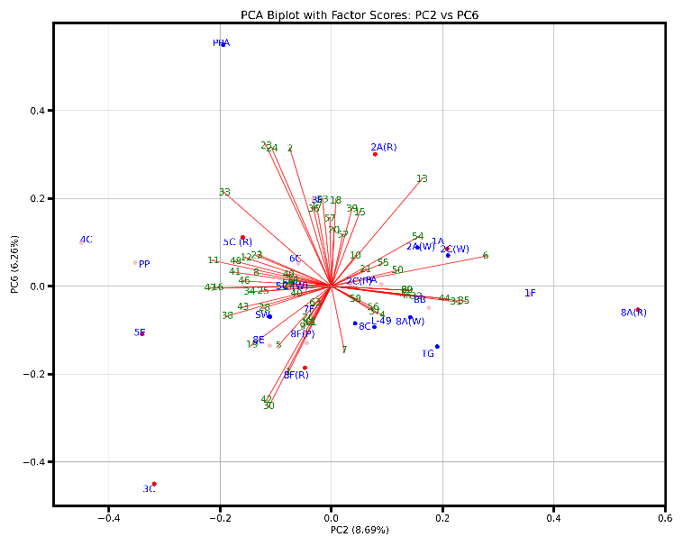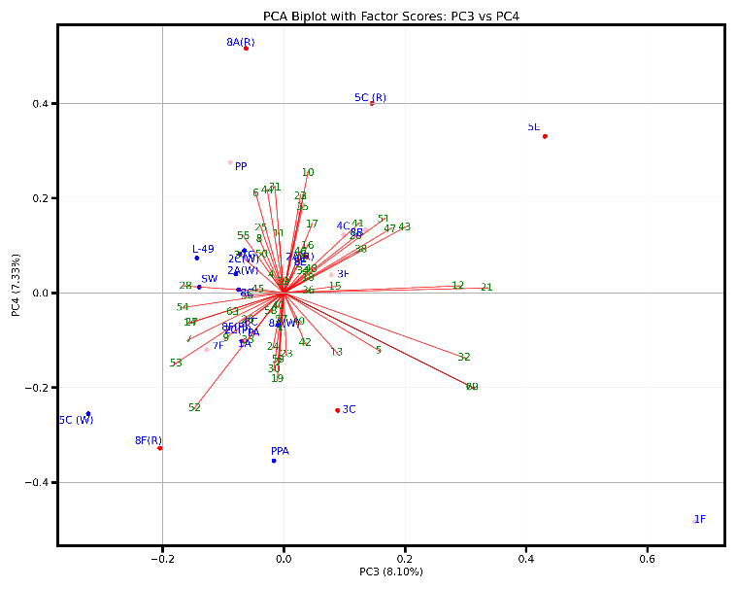
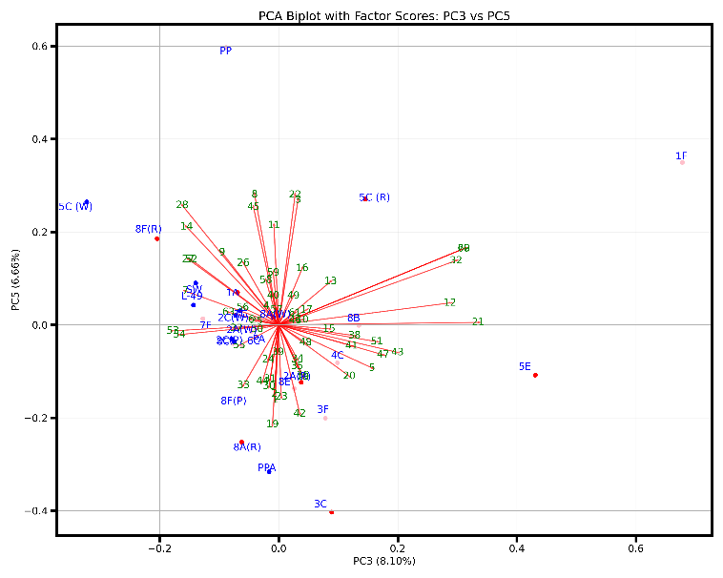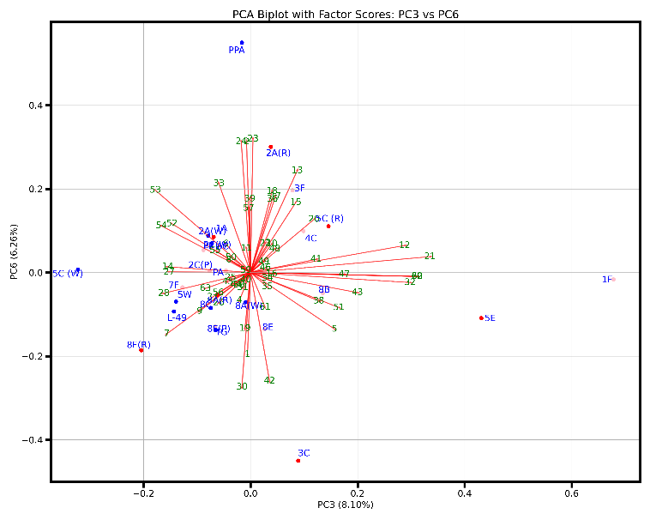

Fig. S2 Cont…
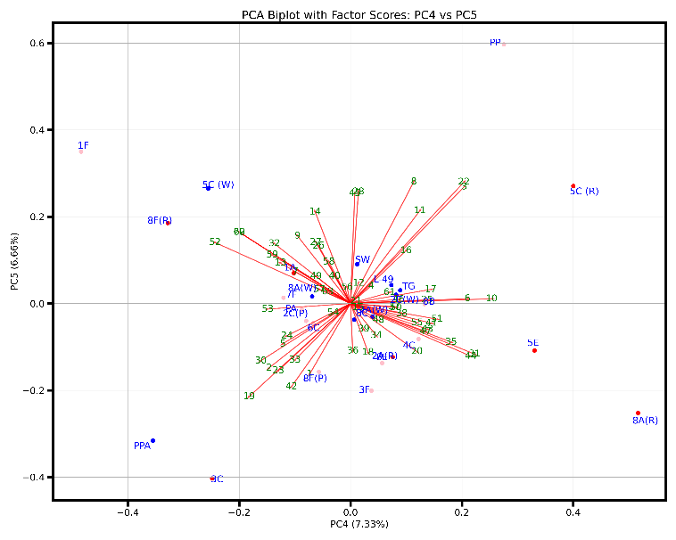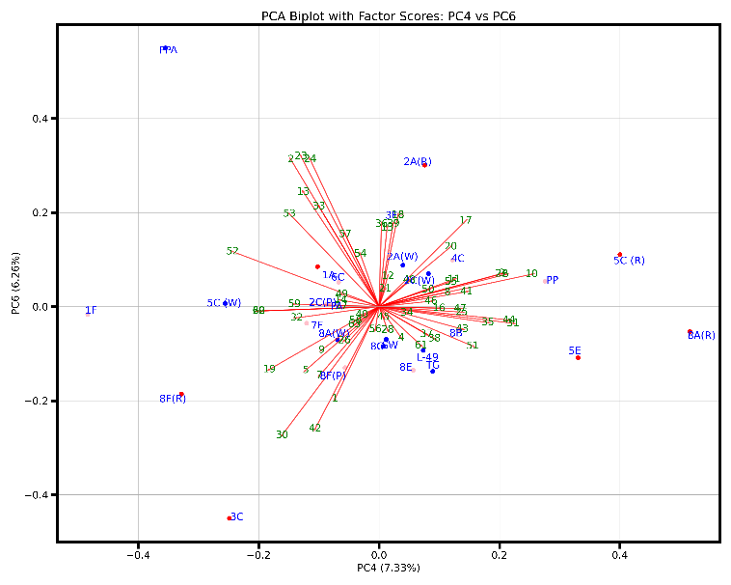
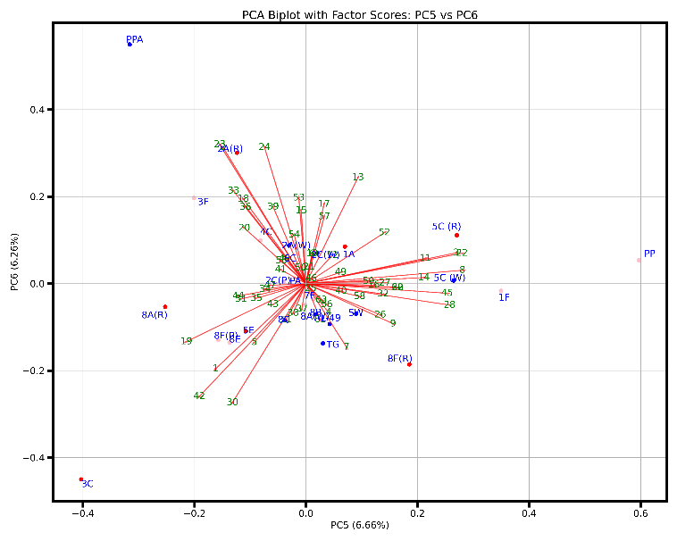

Fig. S3
