Formulation (%) | RF  (g) | BPP  (g) | Baking powder  (g) | Milk powder (g) | Sugar  (g) | Egg  (g) | Edible oil(mL) | Butter  (g) | Salt  (g) | Vanilla  Essence  (mL)
BPP-0 | 100 | 0 | 1 | 7 | 15 | 20 | 5 | 15 | 0.1 | 0.5
BPP-2 | 98 | 2 | 1 | 7 | 15 | 20 | 5 | 15 | 0.1 | 0.5
BPP-4 | 96 | 4 | 1 | 7 | 15 | 20 | 5 | 15 | 0.1 | 0.5
BPP-6 | 94 | 6 | 1 | 7 | 15 | 20 | 5 | 15 | 0.1 | 0.5
BPP-8 | 92 | 8 | 1 | 7 | 15 | 20 | 5 | 15 | 0.1 | 0.5
Supplementary Table 1
Premix composition for the muffins.
RF -Refined flour, BPP-Banana peel powder
Banana peel powder (BPP) was incorporated at varying substitution in the muffins (0, 2, 4, 6 and 8)

Crust | DAY 0 |  |  | DAY 3 |  |  | DAY 6 |  |  | DAY 9
 | L* | a* | b* | L* | a* | b* | L* | a* | b* | L* | a* | b*
BPP-0 | 61.07 ± 10.66 | 6.41 ± 3.74 | 29.93 ± 5.44 | 56.25 ± 3.89 | 8.19 ± 0.51 | 28.11 ± 1.55 | 57.77 ± 6.73 | 8.9 ± 2.63 | 28.34 ± 3.39 | 58.44 ± 1.67 | 9.6 ± 2.3 | 29.15 ± 1.41
BPP-2 | 57.59 ± 5.79 | 2.87 ± 4.47 | 26.75 ± 1.79 | 56.11 ± 2.5 | 2.69 ± 2.93 | 26.11 ± 0.41 | 56.41 ± 3.8 | 4.21 ± 3.53 | 25.87 ± 0.22 | 52.95 ± 2.43 | 5.71 ± 2.18 | 24.82 ± 0.33
BPP-4 | 49.78 ± 1.64 | 6.62 ± 1.23 | 25.09 ± 2.92 | 49 ± 0.96 | 4.63 ± 4.35 | 23.77 ± 0.61 | 49.85 ± 1.65 | 7.16 ± 0.56 | 23.45 ± 1.05 | 49.9 ± 1.17 | 5.92 ± 1 | 23.87 ± 0.2
BPP-6 | 47.03 ± 4.48 | 6.81 ± 0.44 | 21.5 ± 2.15 | 53.11 ± 1.01 | 7.15 ± 0.51 | 24 ± 0.38 | 55.4 ± 2.45 | 5.38 ± 2.02 | 25.56 ± 1.25 | 43.12 ± 2.64 | 8.44 ± 0.8 | 21.21 ± 1.41
BPP-8 | 52.98 ± 2.04 | 5.44 ± 2.11 | 24.82 ± 0.84 | 50.48 ± 4.27 | 7.21 ± 1.17 | 24.82 ± 0.79 | 55.24 ± 4.09 | 5.04 ± 4.02 | 24.84 ± 1.27 | 44.31 ± 1.58 | 9.01 ± 0.94 | 19.95 ± 1.01
Supplementary table 2
Colour values of muffins over storage period

Crumb | DAY 0 |  |  | DAY 3 |  |  | DAY 6 |  |  | DAY 9
 | L* | a* | b* | L* | a* | b* | L* | a* | b* | L* | a* | b*
BPP-0 | 88.27 ± 1.37 | -10.38 ± 0.33 | 28.75 ± 0.48 | 88.96 ± 1.34 | -10.05 ± 0.14 | 28.34 ± 0.28 | 90.8 ± 1.33 | -9.29 ± 0.22 | 28.87 ± 0.14 | 86.14 ± 2.58 | -8.42 ± 0.43 | 27.4 ± 1.16
BPP-2 | 73.67 ± 1.08 | -7.06 ± 0.02 | 23.18 ± 0.16 | 77.07 ± 0.59 | -7.22 ± 0.17 | 23.38 ± 0.28 | 73.98 ± 2.76 | -6.07 ± 0.33 | 22.83 ± 0.6 | 71.08 ± 3.28 | -5.43 ± 0.3 | 22.02 ± 1.04
BPP-4 | 61.78 ± 2.22 | -7.18 ± 2.22 | 21.01 ± 1.23 | 71.16 ± 0.66 | -6.79 ± 0.11 | 21.93 ± 0.21 | 72.27 ± 3.5 | -5.63 ± 1.18 | 22.06 ± 1.03 | 71.14 ± 4.24 | -5.58 ± 0.34 | 21.72 ± 0.96
BPP-6 | 74.88 ± 0.48 | -6.89 ± 0.62 | 21.46 ± 0.36 | 73.08 ± 2.8 | -6.65 ± 0.31 | 21.2 ± 0.86 | 73.11 ± 1 | -6.18 ± 0.2 | 21.57 ± 0.52 | 71.68 ± 3.79 | -5.58 ± 0.11 | 20.96 ± 0.76
BPP-8 | 74.01 ± 5.81 | -7.1 ± 0.12 | 20.48 ± 0.18 | 72.7 ± 2.43 | -6.33 ± 0.11 | 20.02 ± 0.96 | 75.84 ± 1.1 | -6.08 ± 0.15 | 20.91 ± 0.52 | 72.03 ± 2.51 | -5.63 ± 0.17 | 19.83 ± 0.37

Supplementary Table 3
Sensory score card with description
 | Attributes | Description
1 | Appearance (20%) | Appealing/Dry/Moist
2 | Shape (8%) | Good/Irregular/Flat
3 | Taste (10%) | Sweet/ Bitter aftertaste/Off flavour/
4 | Aroma (9%) | Strong peel powder flavour/Off Odor
5 | Texture – crust (7%) | Dry/ crumble/Moist
6 | Texture – crumb (7%) | Soft/firm/Hard
7 | Color (15%) | Appealing/dull/non-appetizing
8 | Springiness (4%) | Good/minimal/excellent/poor
9 | Hardness (5%) | Spongy/Hard
11 | Mouthfeel (15%) | Smooth/grainy/gumminess
12 | Overall acceptability | Recommended/Not recommended

Supplementary Table 4
 |  | Average Panelist Score |  |  |  |  | Weightage score x Average Panelist Score |  |  |  |  | SD
Attributes | Weightage  score | BPP-0 | BPP-2 | BPP-4 | BPP-6 | BPP-8 | BPP-0 | BPP-2 | BPP-4 | BPP-6 | BPP-8
Appearance | 20% | 9.2ª | 9^{ab} | 8.7^{b} | 7.4^{c} | 6.4^{d} | 1.84 | 1.8 | 1.74 | 1.48 | 1.28 | 1.16
Shape | 8% | 8.8^{b} | 9ª | 9ª | 7.2^{c} | 6.9^{d} | 0.70 | 0.72 | 0.72 | 0.57 | 0.55 | 1.12
After Taste | 10% | 9.3ª | 8.8^{b} | 8.8^{b} | 6^{c} | 4.6^{d} | 0.93 | 0.88 | 0.88 | 0.6 | 0.46 | 1.32
Aroma | 9% | 9^{ab} | 9.2ª | 9.2ª | 7.6^{c} | 5^{d} | 0.81 | 0.82 | 0.82 | 0.68 | 0.45 | 1.33
Texture (Crumb) | 7% | 9.2ª | 9^{b} | 9^{b} | 7.4^{c} | 3.3^{d} | 0.64 | 0.63 | 0.63 | 0.52 | 0.23 | 1.05
Texture (Crust) | 7% | 9.2ª | 9^{b} | 9.2ª | 6.5^{c} | 2.3^{d} | 0.64 | 0.63 | 0.644 | 0.45 | 0.16 | 1.21
Color | 15% | 9.3ª | 9^{b} | 8.4^{c} | 6.4^{d} | 6e | 1.39 | 1.35 | 1.26 | 0.96 | 0.92 | 1.33
Springiness | 4% | 8.7ª | 8.4^{b} | 8.4^{b} | 5.5^{c} | 4^{d} | 0.34 | 0.33 | 0.33 | 0.22 | 0.16 | 1.11
Hardness | 5% | 9.5ª | 9.2^{b} | 8.2^{c} | 5.7^{d} | 5.4e | 0.47 | 0.46 | 0.41 | 0.28 | 0.27 | 1.22
Mouthfeel | 15% | 9.5ª | 9.2^{b} | 8.8^{c} | 6.6^{d} | 3.5e | 1.42 | 1.38 | 1.32 | 0.99 | 0.52 | 1.32
Overall acceptability |  |  |  |  |  |  | 9.21 | 9.01 | 8.77 | 6.77 | 4.99
Weighed quantitative mean score analysis of muffins incorporated with different levels of banana peel powder.

.

Banana peel powder (BPP) was incorporated at varying substitution in the muffins (0, 2, 4, 6 and 8)
Data presented are mean value ±standard deviation (n=5). Different superscripts in the same column are significantly different (p < 0.05) by DMRT
(Duncan’s Multiple Range Test)

Supplementary Table 5
Sensory Evaluation- Quantitative Descriptive analysis for Muffin

Name: Product:
Age: Date:
Instruction: Please evaluate the coded samples using the scale below to describe how much you like or dislike the product with notes in accordance to the corresponding
option
Sample code | Appearance | Shape | Taste | Aroma | Texture (Crumb) | Texture (Crust) | Springiness | Hardness | Mouth feel | Overall acceptability
301
302
303
304
305

Suggestions (if any):
Rating Scale
1 | Very Bad
2 | Bad
3 | Slightly bad
4 | Somewhat bad
5 | Neutral
6 | Somewhat good
7 | Good
8 | Very good
9 | Extremely good
10 | Euphoric

Signature

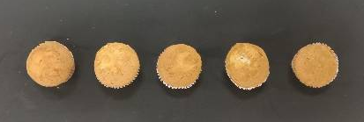
Day 3

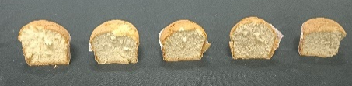
BPP-0 BPP-2 BPP-4 BPP-6 BPP-8
S. Fig. 1a. Nil visual appearance of the mould growth on the crust of the muffin samples on day three of storage. BPP-0:
Banana peel powder (BPP) was incorporated at varying substitution in the muffins (0, 2, 4, 6 and 8)

Day 9
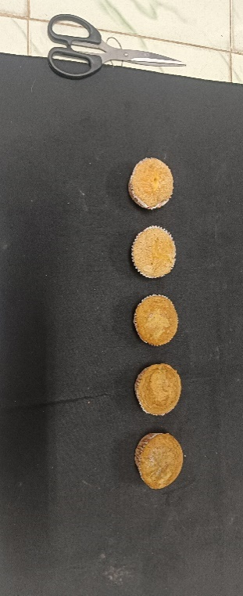

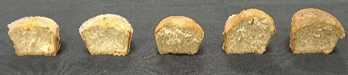
BPP-0 BPP-2 BPP-4 BPP-6 BPP-8
S. Fig. 1b. Visual appearance of the mould growth on the crust of the muffin samples on day nine of storage
(Indicated with arrow marks).
Banana peel powder (BPP) was incorporated at varying substitution in the muffins (0, 2, 4, 6 and 8)

