The results of Pearson correlation analysis between parameters of BSG, dough, and cookies are provided below. The correlation coefficients and P values are provided in the tables and graphs illustrating their relationships are provided accordingly.

- Pearson Correlation
  - % substitution and antioxidants, phenolic content

Table S1.1 Pearson correlation analysis between % substitution and antioxidant capacities using medium BSG
 |  | Total phenolic | FRAP | ABTS | DPPH
Correlation Coefficient | % substitution | 0.959 | 0.984 | 0.978 | 0.987
P Value |  | 0.0406 | 0.016 | 0.022 | 0.0134
Correlation Coefficient | Total phenolic |  | 0.928 | 0.888 | 0.902
P Value |  |  | 0.0723 | 0.112 | 0.0982
Correlation Coefficient | FRAP |  |  | 0.991 | 0.973
P Value |  |  |  | 0.00875 | 0.0267
Correlation Coefficient | ABTS |  |  |  | 0.989
P Value |  |  |  |  | 0.0115

a | b | c
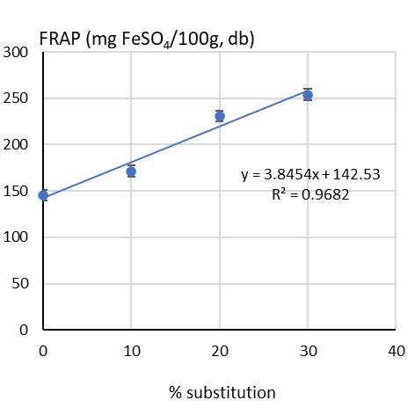 | 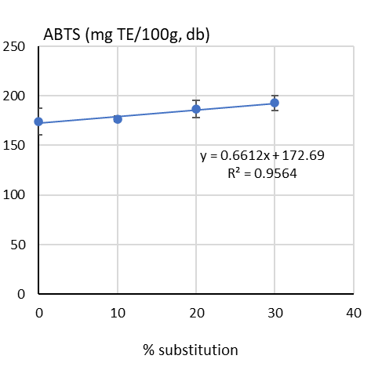 | 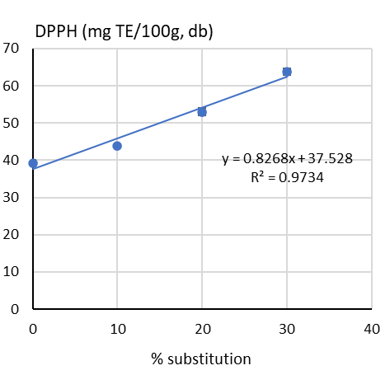
d | e | f
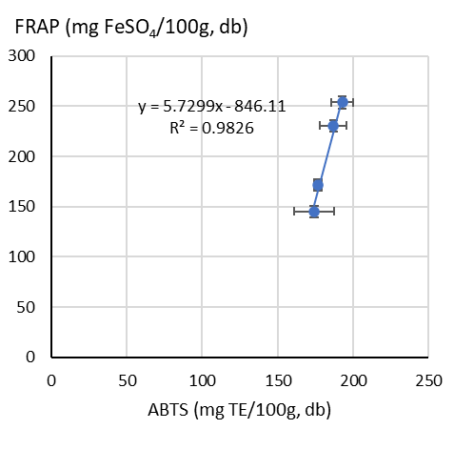 | 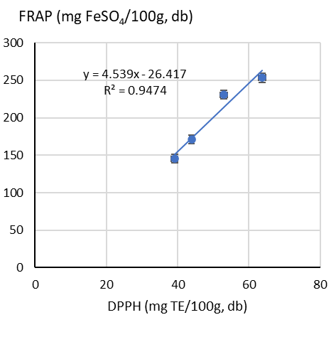 | 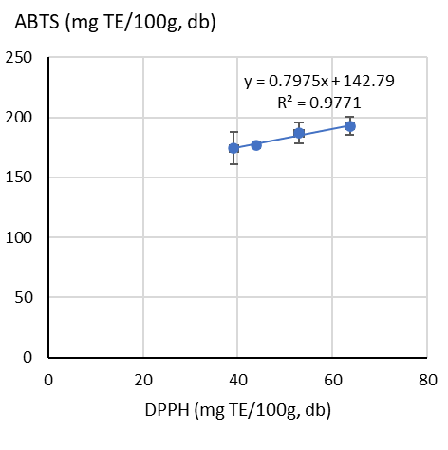
g
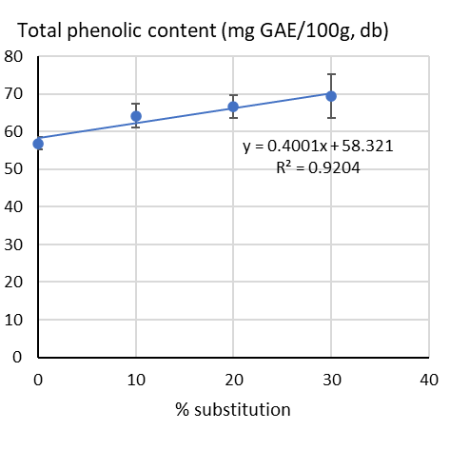

Figure S1.1 Pearson correlation analysis between % substitution and antioxidant capacities using medium BSG

  - % substitution of BSG and texture
    - Coarse BSG

Table S2.1 Pearson correlation analysis between texture attributes of dough and cookies at different substitution level of coarse BSG
 |  | Dough hardness | Dough adhesiveness | Cookies hardness
Correlation Coefficient | % coarse BSG | 0.952 | -0.976 | -0.875
P Value |  | 0.048 | 0.0241 | 0.125
Correlation Coefficient | Dough adhesiveness |  | -0.991 | -0.685
P Value |  |  | 0.00866 | 0.315
Correlation Coefficient | Cookies hardness |  |  | 0.753
P Value |  |  |  | 0.247

a | b | c
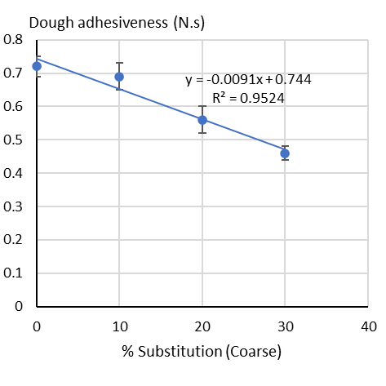 | 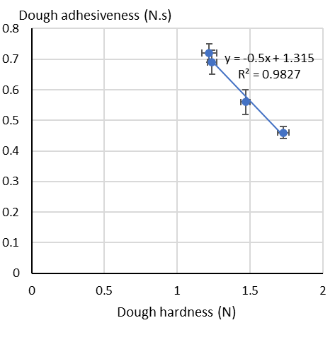 | 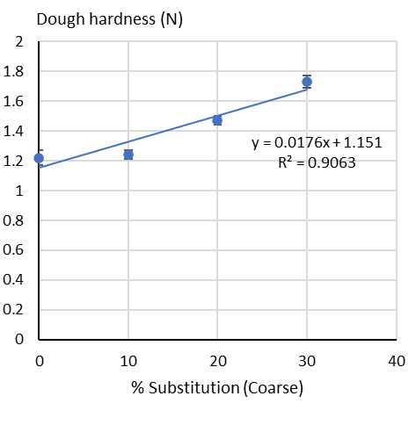
Figure S2.1 Correlation between texture attributes of dough and cookies at different substitution level of coarse BSG

    - Medium BSG

Table S2.2 Pearson correlation analysis between texture attributes of dough and cookies at different substitution level of medium BSG
 |  | Dough hardness | Dough adhesiveness | Cookies hardness
Correlation Coefficient | % Medium-BSG | 0.995 | -0.998 | -0.924
P Value |  | 0.00476 | 0.00212 | 0.0757
Correlation Coefficient | Dough hardness |  | -0.998 | -0.931
P Value |  |  | 0.00229 | 0.0685
Correlation Coefficient | Dough adhesiveness |  |  | 0.912
P Value |  |  |  | 0.0884

a | b | c
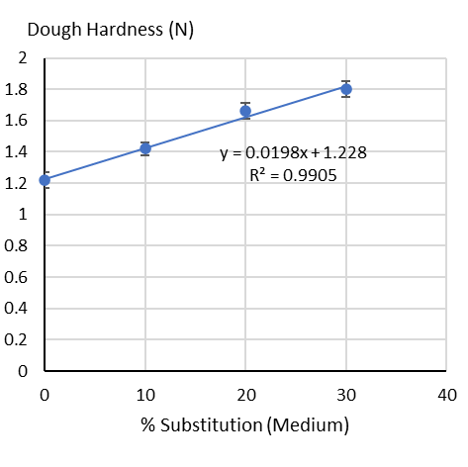 | 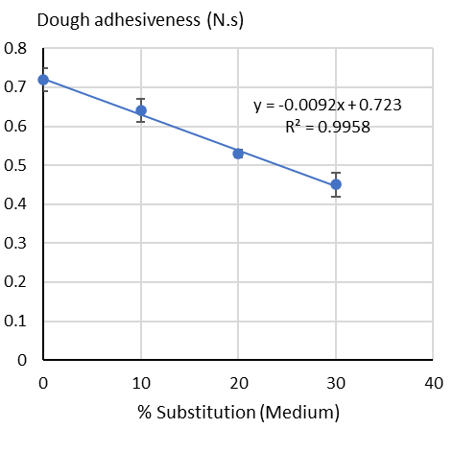 | 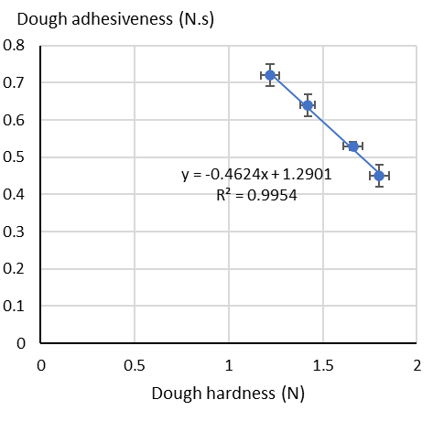
Figure S2.2 Correlation between texture attributes of dough and cookies at different substitution level of medium BSG

    - Fine BSG
Table S2.3 Pearson correlation analysis between texture attributes of dough and cookies at different substitution level of fine BSG
 |  | Dough hardness | Dough adhesiveness | Cookies hardness
Correlation Coefficient | % Fine-BSG | 0.985 | -0.979 | -0.999
P Value |  | 0.0146 | 0.0206 | 0.00125
Correlation Coefficient | Dough hardness |  | -0.974 | -0.977
P Value |  |  | 0.0263 | 0.023
Correlation Coefficient | Dough adhesiveness |  |  | 0.971
P Value |  |  |  | 0.0293

a | b | c
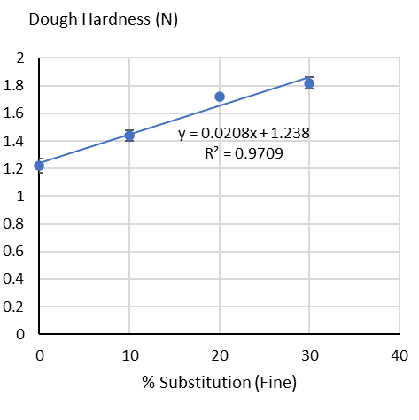 | 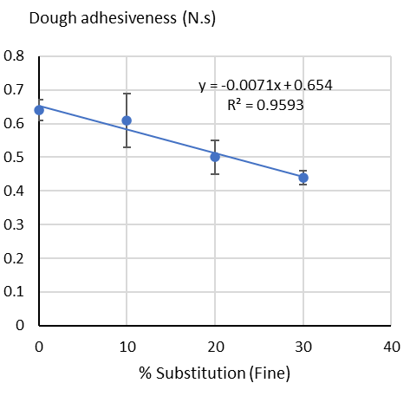 | 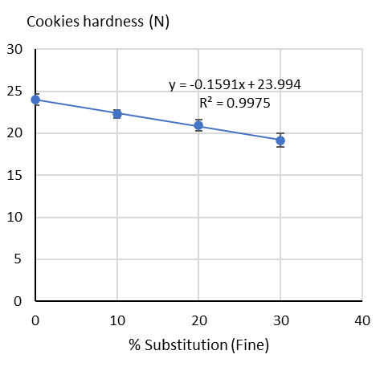
d | e | f
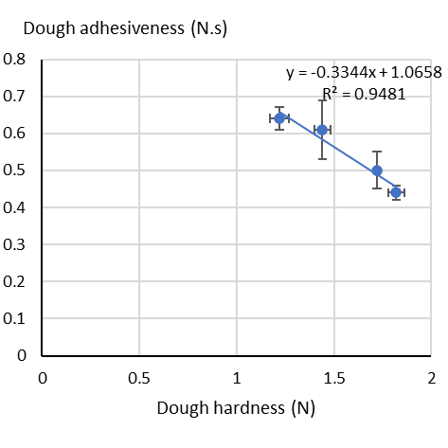 | 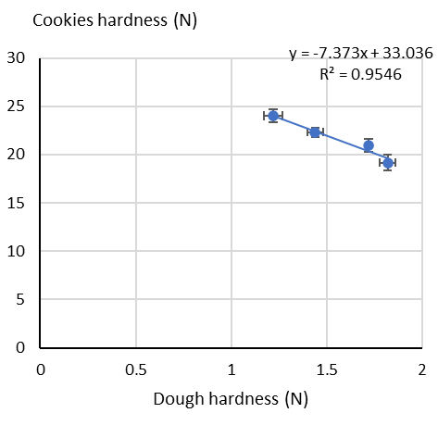 | 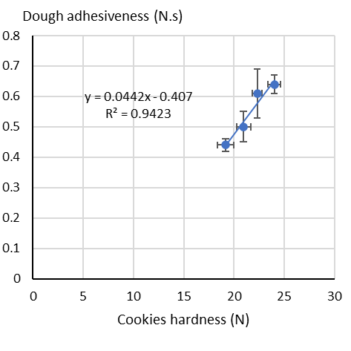
Figure S2.3 Correlation between texture attributes of dough and cookies at different substitution level of fine BSG

    - Cookies hardness using coarse, medium, and fine BSF at different substitution levels

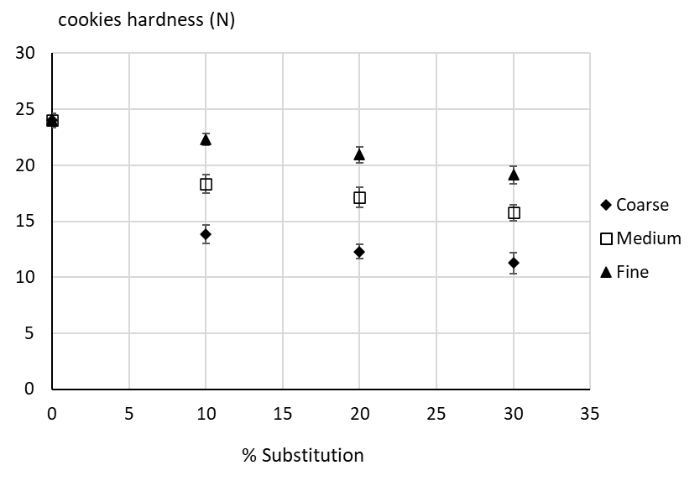
Figure S2.4 Texture attributes of cookies at different substitution level of all BSG particle sizes

Table S2.5 Pearson correlation analysis excluding 0% BSG
 |  | Moisture | protein | Total dietary fibre | Carbohydrate | Dough hardness | Dough adhesiveness | Cookies hardness
Correlation Coefficient | % substitution | 0.81 | 0.987 | 0.992 | -0.997 | 0.989 | -0.996 | -0.999
P Value |  | 0.399 | 0.102 | 0.0812 | 0.0519 | 0.096 | 0.0579 | 0.023
Correlation Coefficient | Moisture |  | 0.893 | 0.878 | -0.855 | 0.713 | -0.754 | -0.831
P Value |  |  | 0.297 | 0.317 | 0.347 | 0.495 | 0.456 | 0.376
Correlation Coefficient | protein |  |  | 0.999 | -0.997 | 0.952 | -0.969 | -0.992
P Value |  |  |  | 0.0205 | 0.0498 | 0.198 | 0.159 | 0.0787
Correlation Coefficient | Total dietary fibre |  |  |  | -0.999 | 0.962 | -0.976 | -0.996
P Value |  |  |  |  | 0.0293 | 0.177 | 0.139 | 0.0582
Correlation Coefficient | Carbohydrate |  |  |  |  | -0.973 | 0.985 | 0.999
P Value |  |  |  |  |  | 0.148 | 0.11 | 0.0289
Correlation Coefficient | Dough hardness |  |  |  |  |  | -0.998 | -0.983
P Value |  |  |  |  |  |  | 0.0381 | 0.119
Correlation Coefficient | Dough adhesiveness |  |  |  |  |  |  | 0.992
P Value |  |  |  |  |  |  |  | 0.0808
P value of different pair is provided.
Selected data pairs were plotted as illustrated in Figure S2.5.

a | b | c
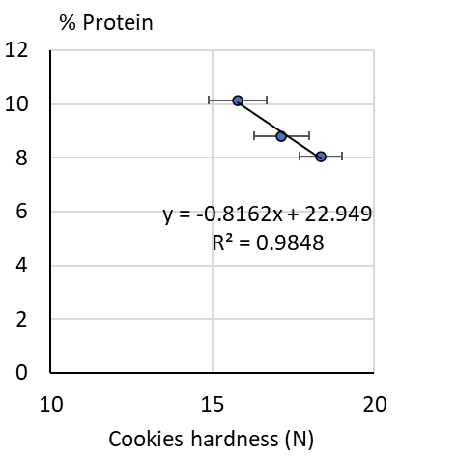 | 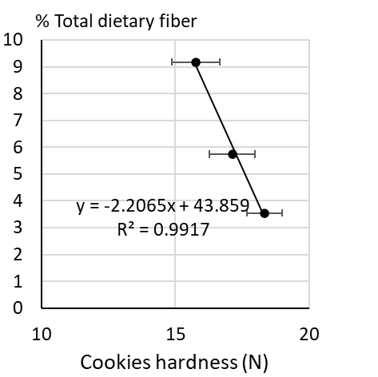 | 