Role of Phytochemicals present in Azadirachta indica Leaves Extracts in Controlling Toxigenic Fungi and Inhibition of Aflatoxins Biosynthesis
Javid Ali¹, Muhammad Ikram², Muhammad Zahoor^{3*} and Amal Alotaibi⁴
- Pakistan Council of Scientific and Industrial Research (PCSIR) Laboratories Complex, Peshawar, Jamrud Road, Peshawar 25120, Pakistan; javedali_14@yahoo.com (J.A)
- Department of Chemistry, Abdul Wali Khan University Mardan, Mardan 23200, Khyber Pakhtunkhwa Pakistan: ikrambiochem2014@gmail.com (M.I)
- Department of Biochemistry, University of Malakand, Dir Lower 18800, Pakistan;
mohammadzahoorus@yahoo.com (M.Z)
- Department of Basic Science, College of Medicine, Princess Nourah bint Abdulrahman University, Riyadh, 11671, Saudi Arabia;amaalotaibi@pnu.edu.sa (A.A)
*Correspondence:mohammadzahoorus@yahoo.com

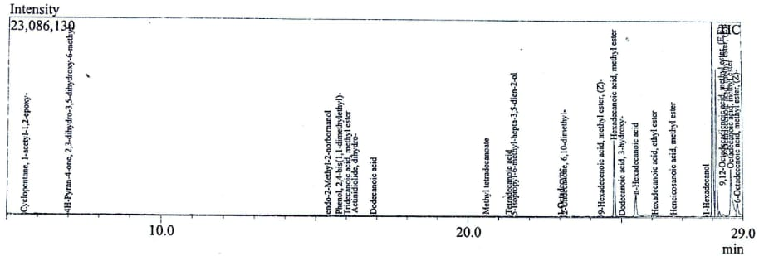
Figure S1: GC-MS chromatogram of NLE (methanol).
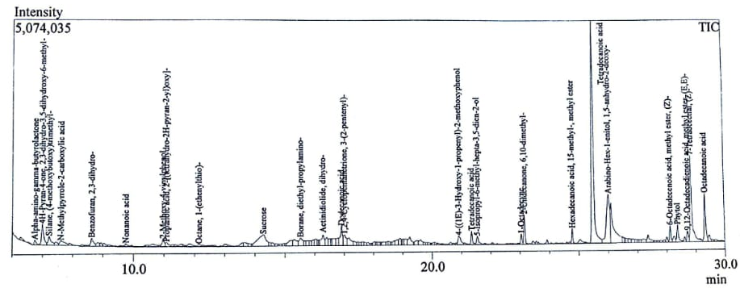
Figure S2: GC-MS chromatogram of NLE (ethanol).

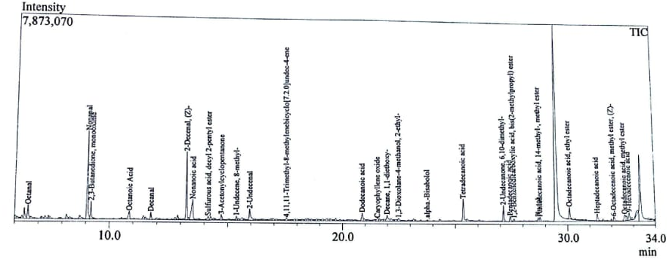
Figure S3: GC-MS chromatogram of NLE (chloroform).

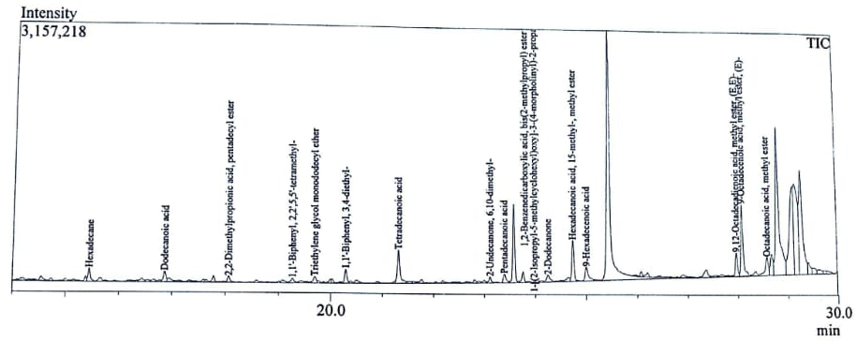
Figure S4: GC-MS chromatogram of NLE (ethyl acetate).

