Supplementary
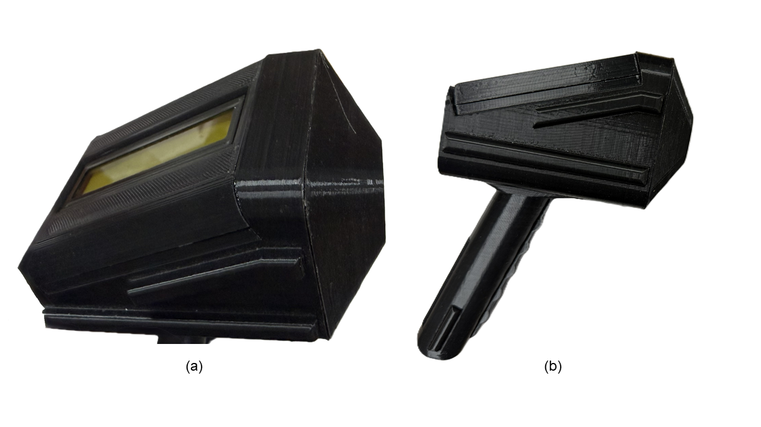
Figure A.1: (a) and (b) The real photograph of the spectrophotometer final product

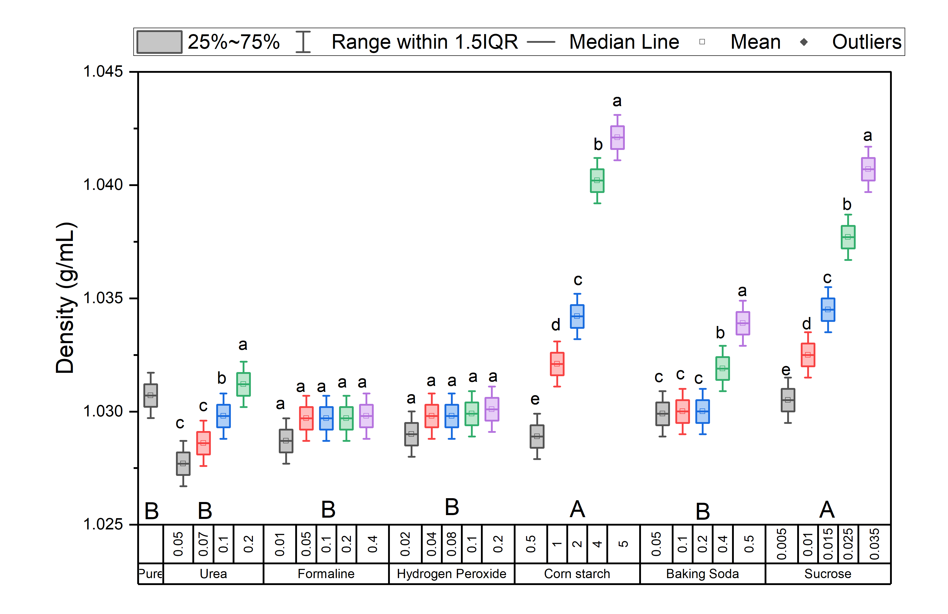
Figure A.2: Box plot of density across different adulterant types

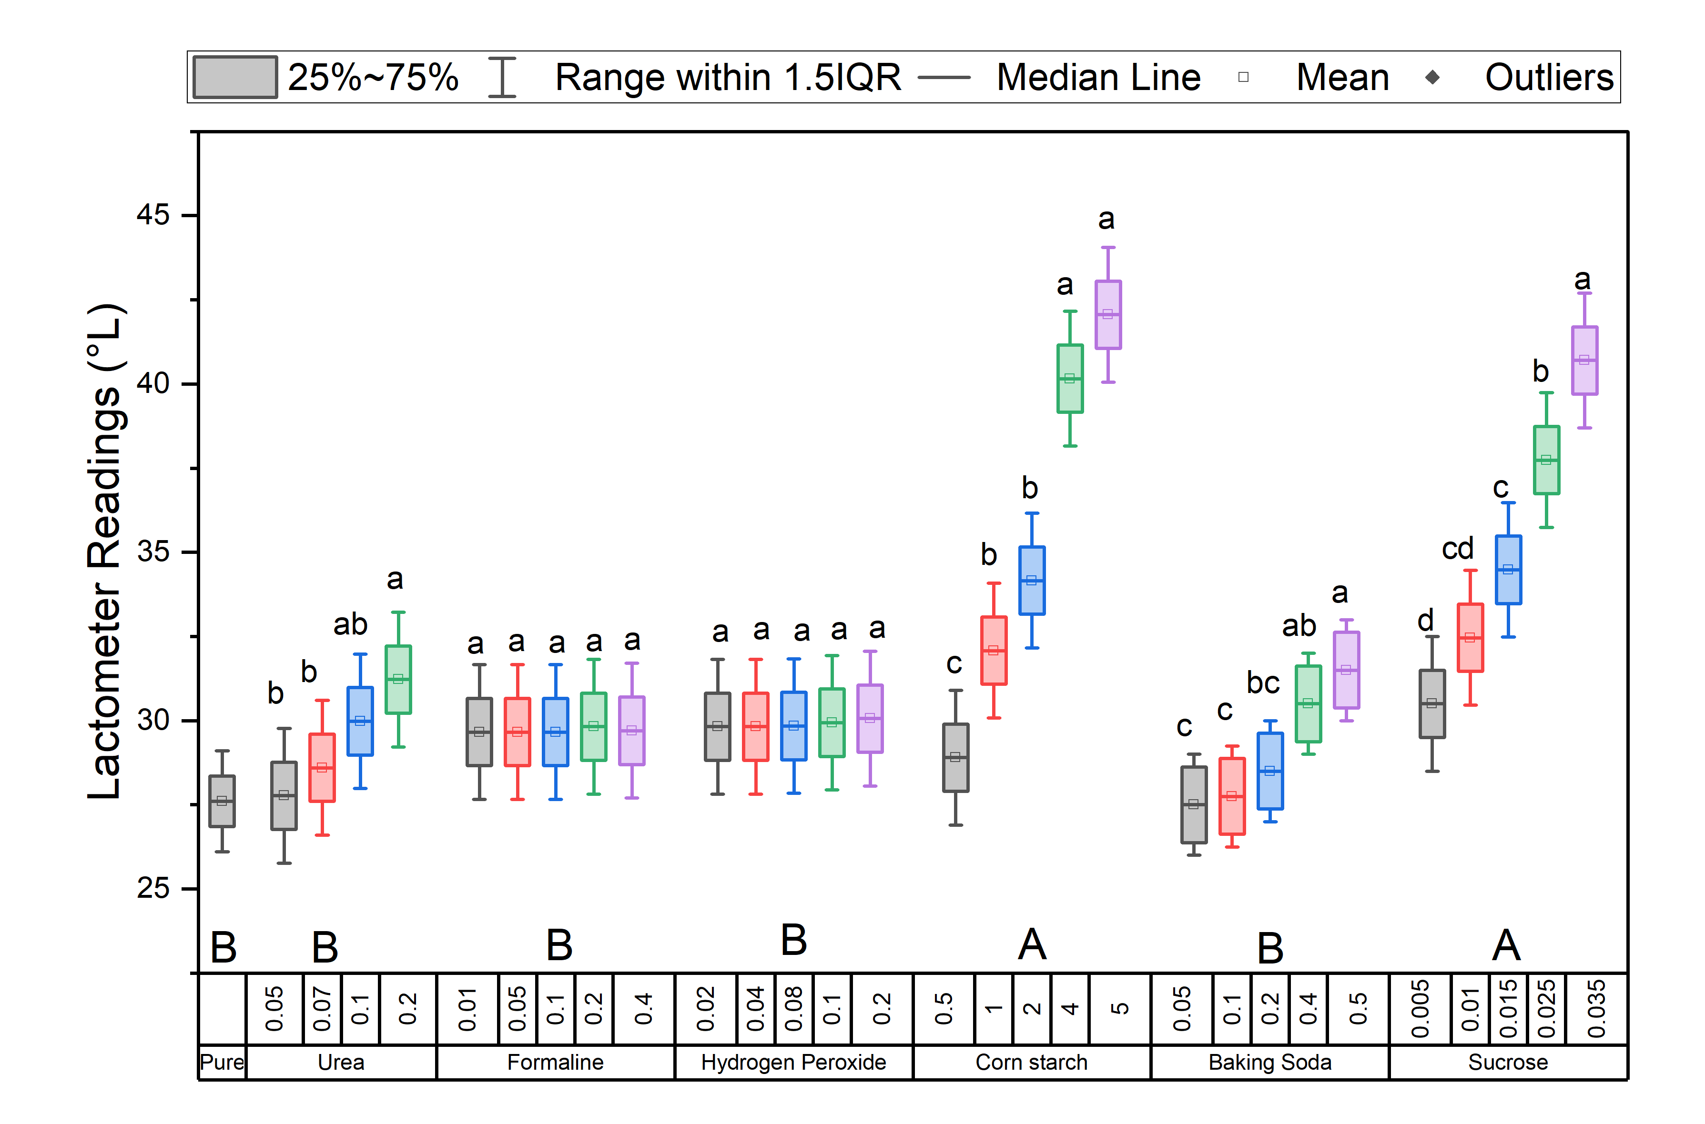
Figure A.3: Box plot of lactometer readings across different adulterant types
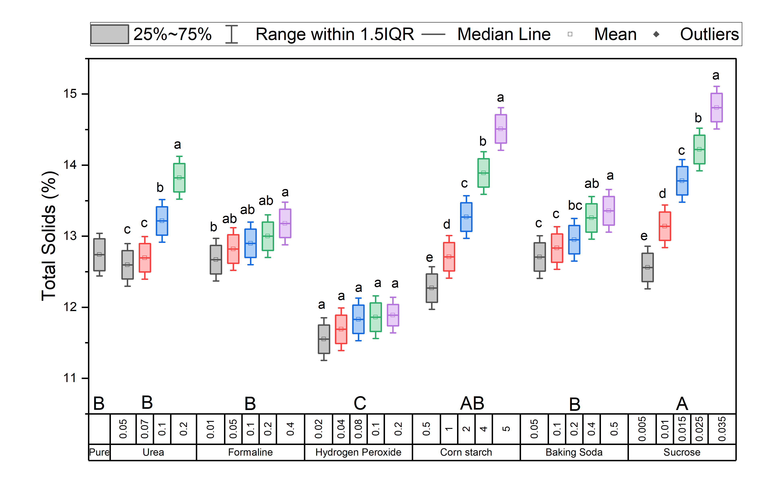
Figure A.4: Box plot of Total Solids across different adulterant types

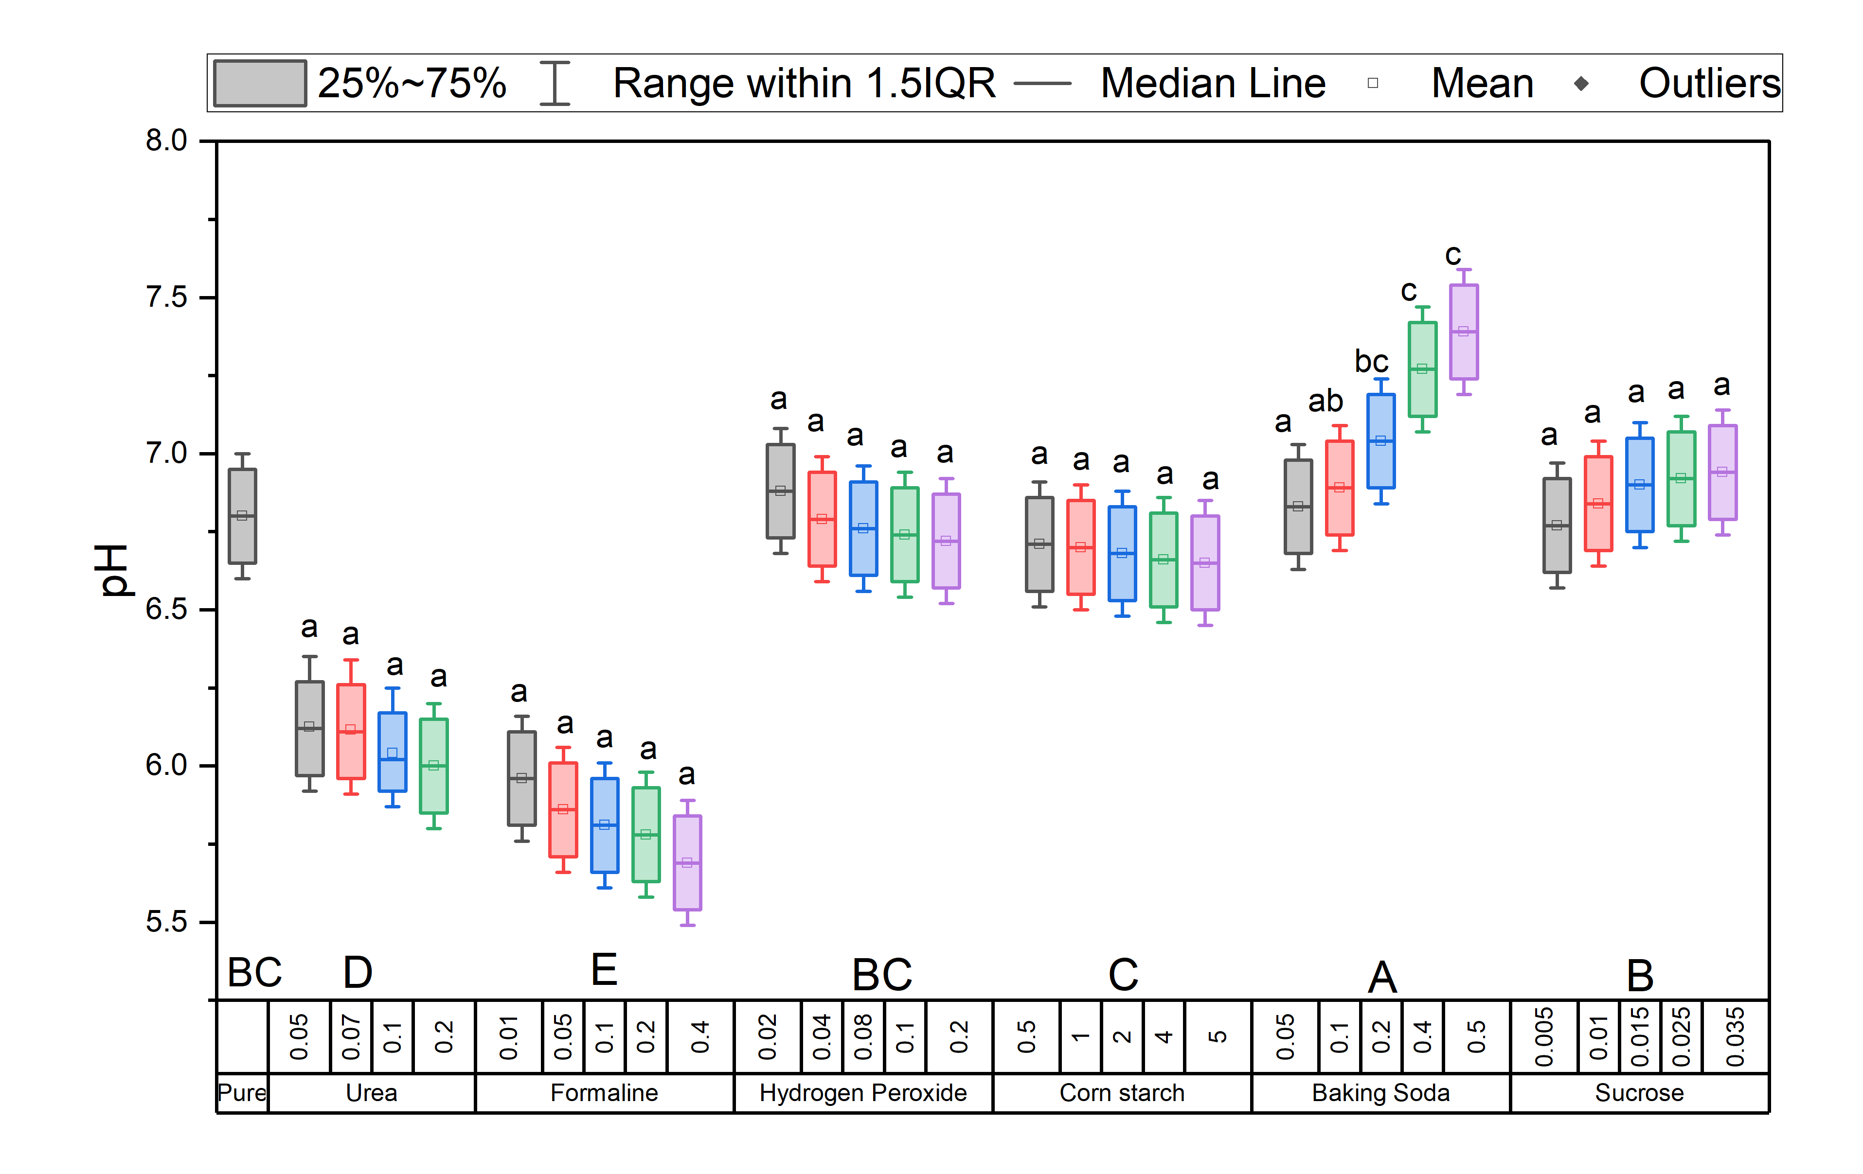
Figure A.5: Box plot of pH across different adulterant types
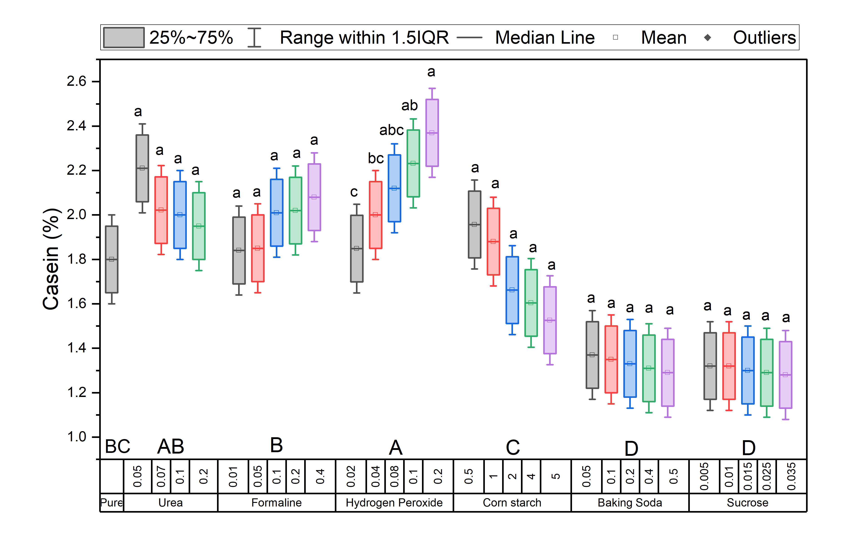
Figure A.6: Box plot of casein across different adulterant types

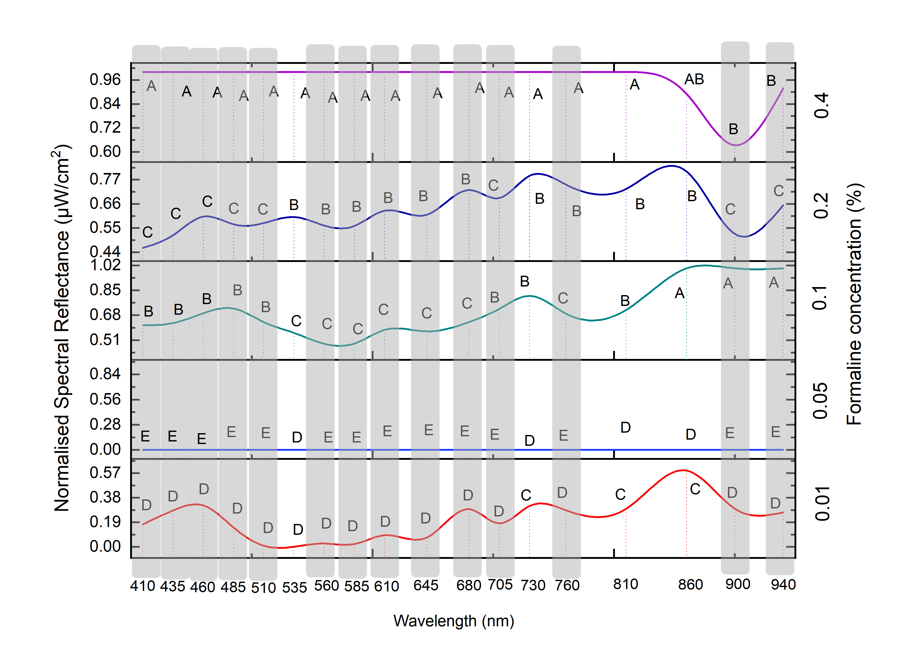
Figure A.7: Tukey Post-hoc Test Results for Analysis of Variance in Formalin-Adulterated Milk Samples

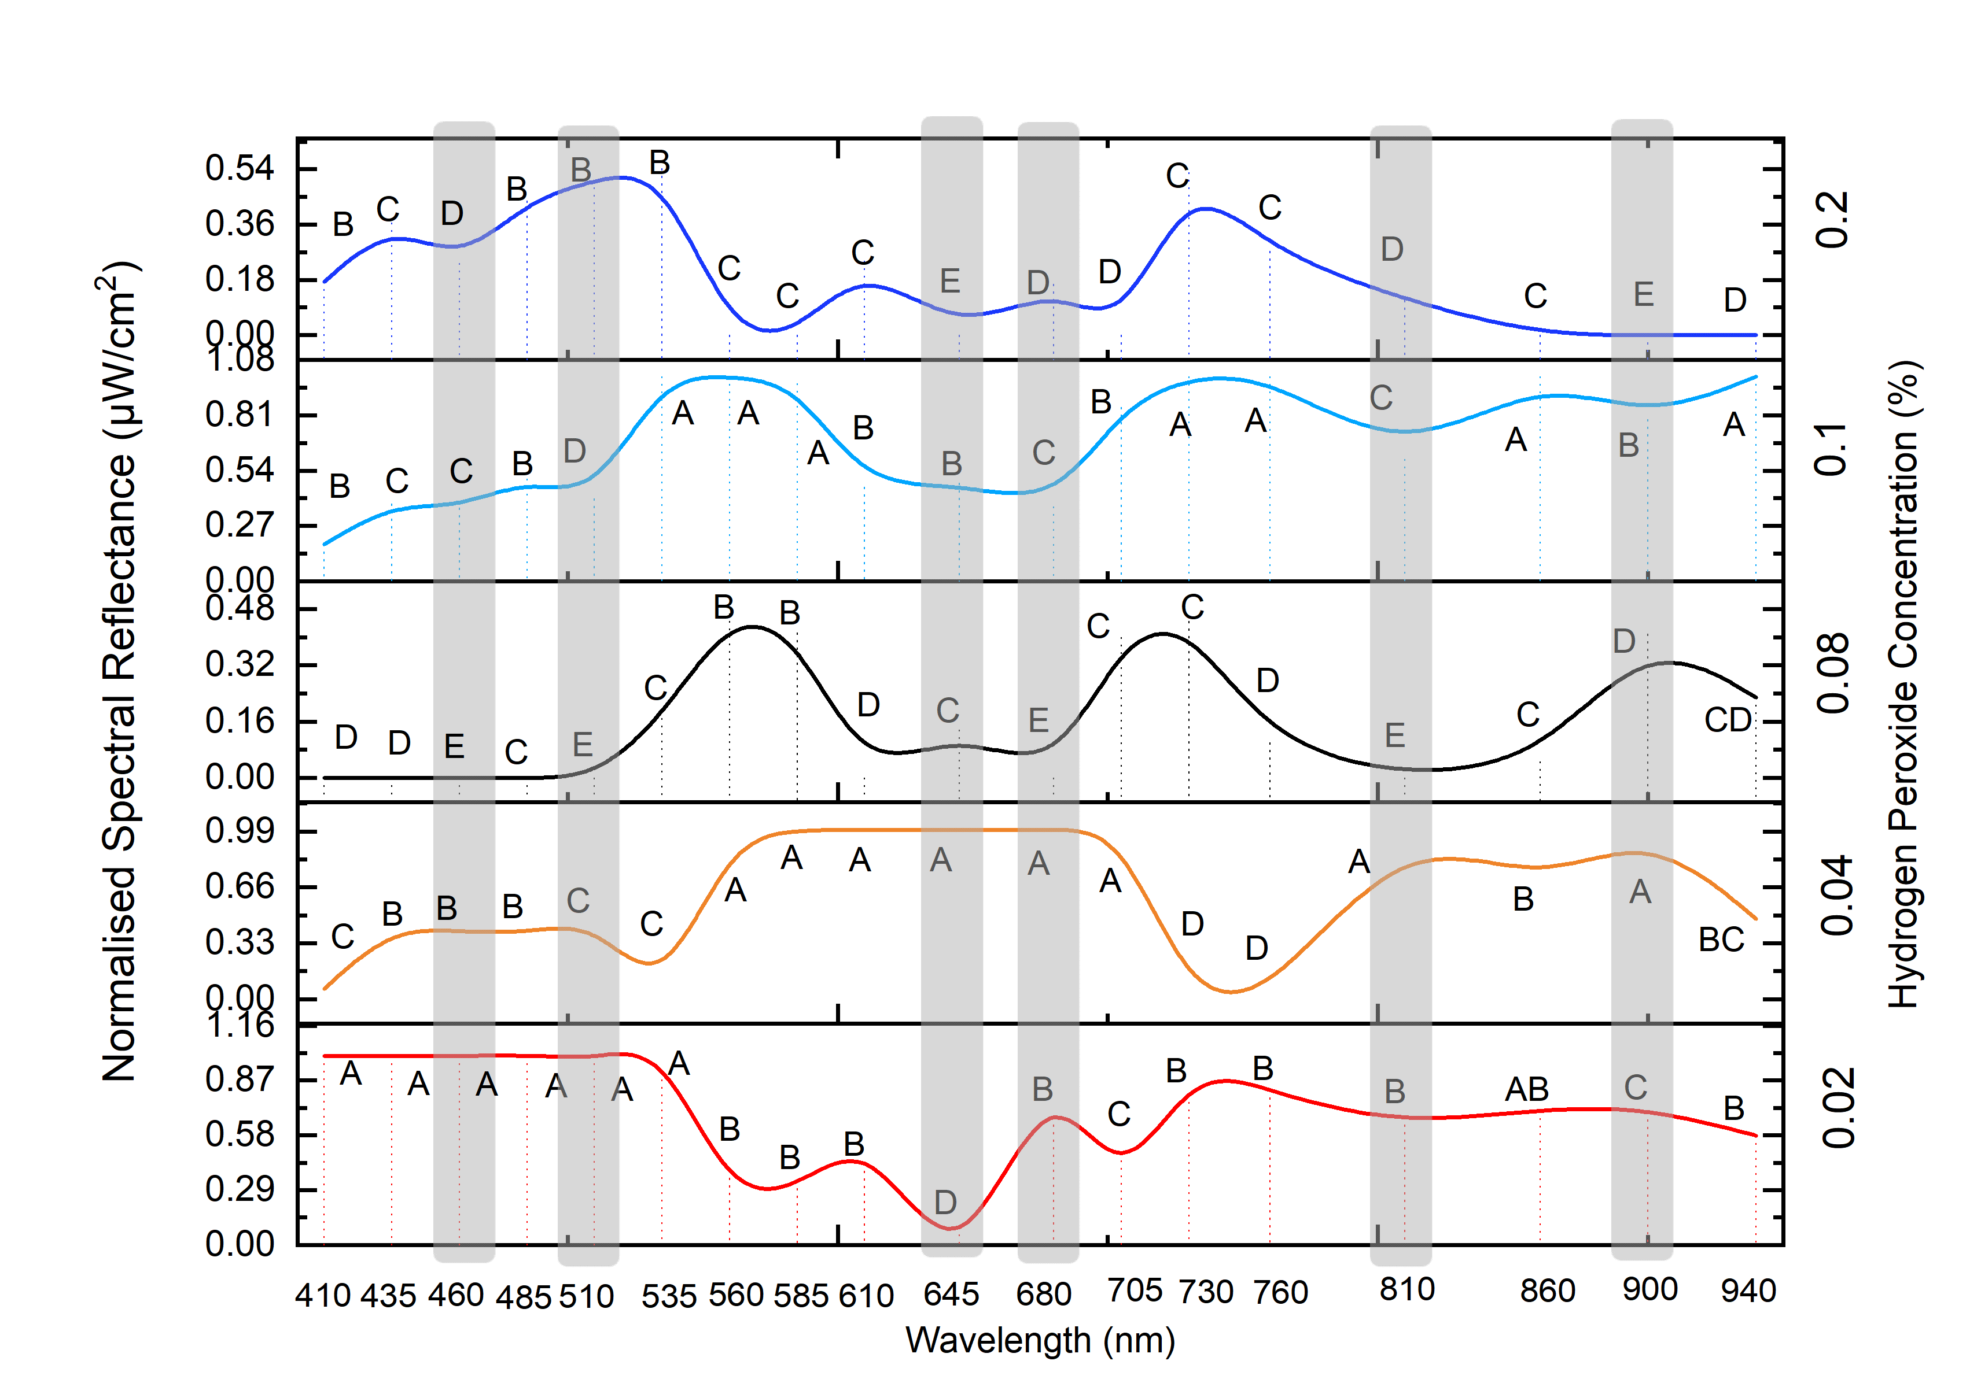
Figure A.8: Tukey Post-hoc Test Results for Analysis of Variance in Hydrogen Peroxide-Adulterated Milk Samples

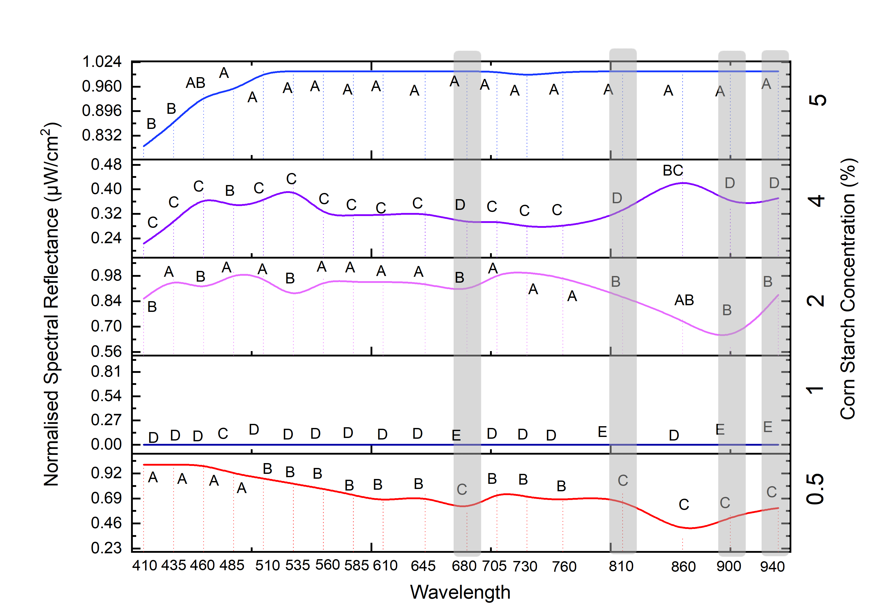
Figure A.9: Tukey Post-hoc Test Results for Analysis of Variance in Cornstarch-Adulterated Milk Samples

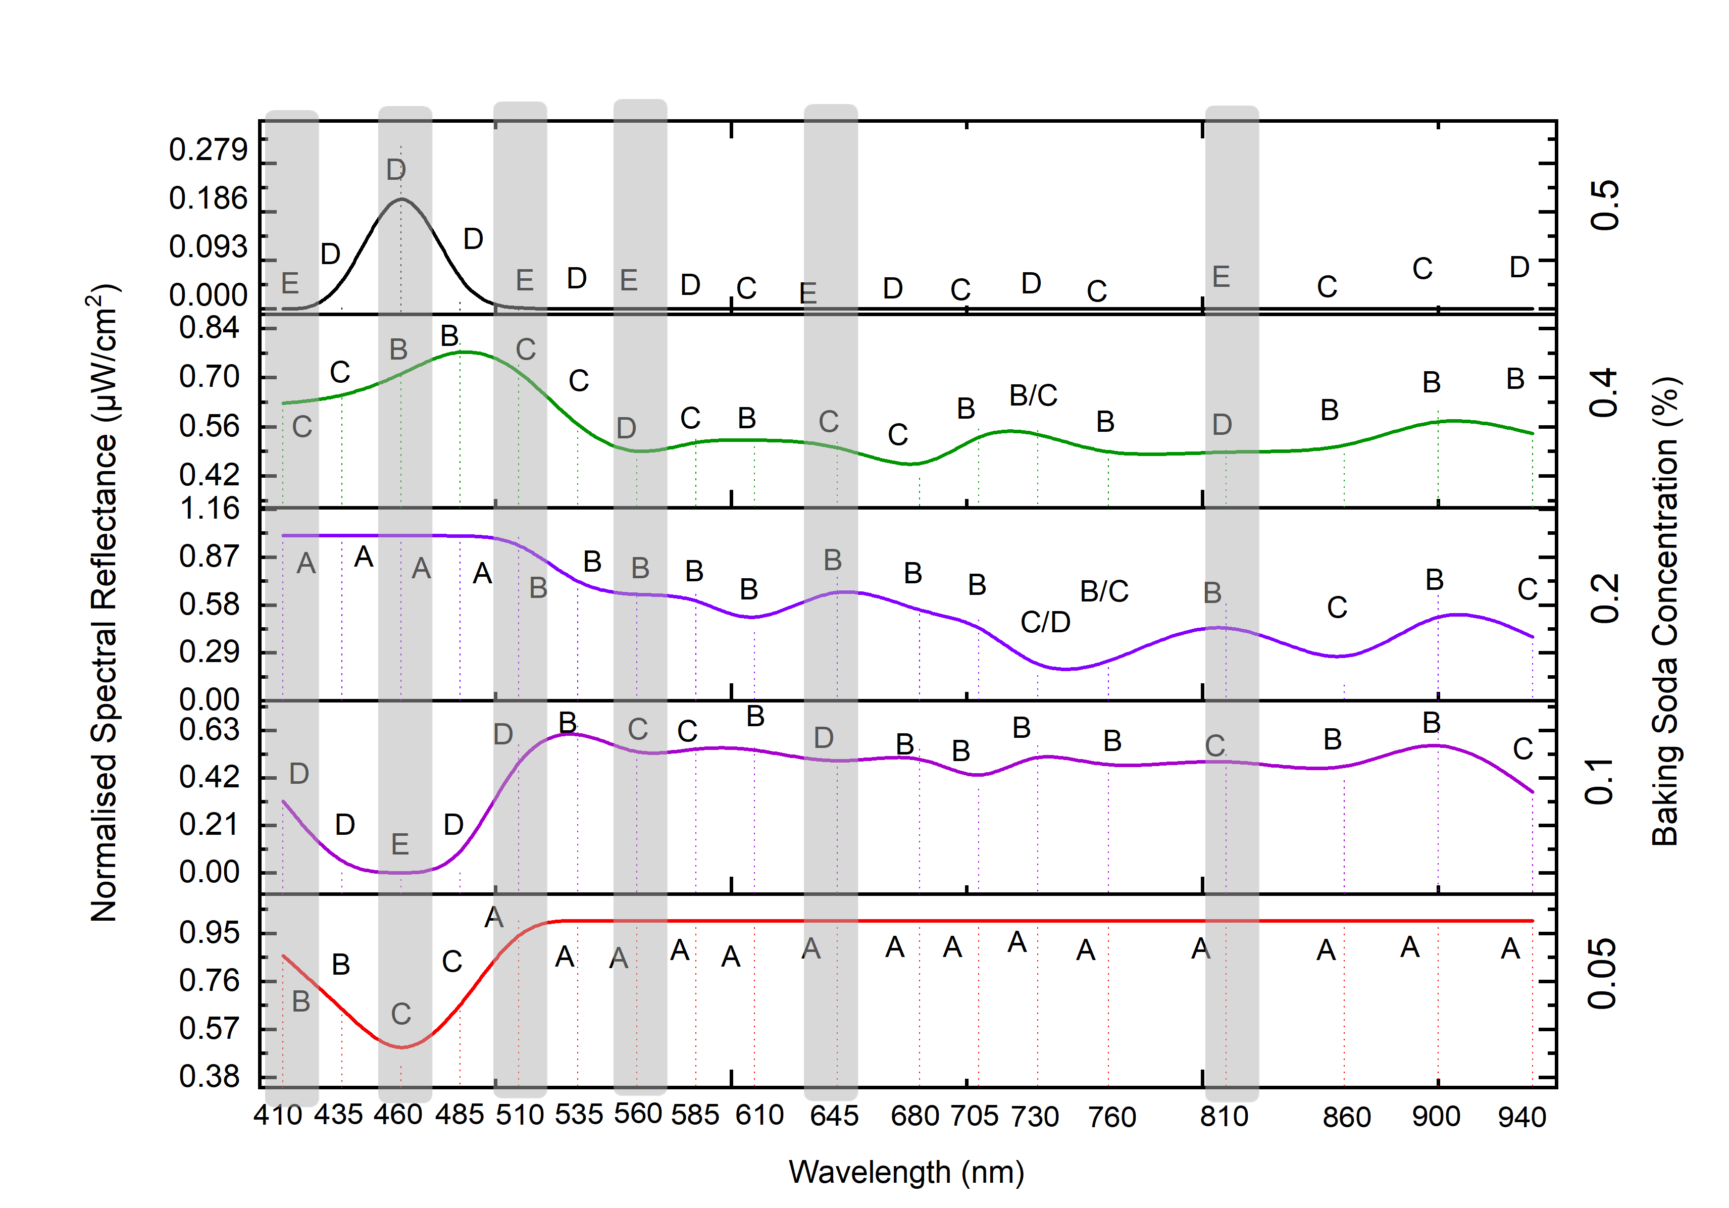
Figure A.10: Tukey Post-hoc Test Results for Analysis of Variance in Baking Soda-Adulterated Milk Samples

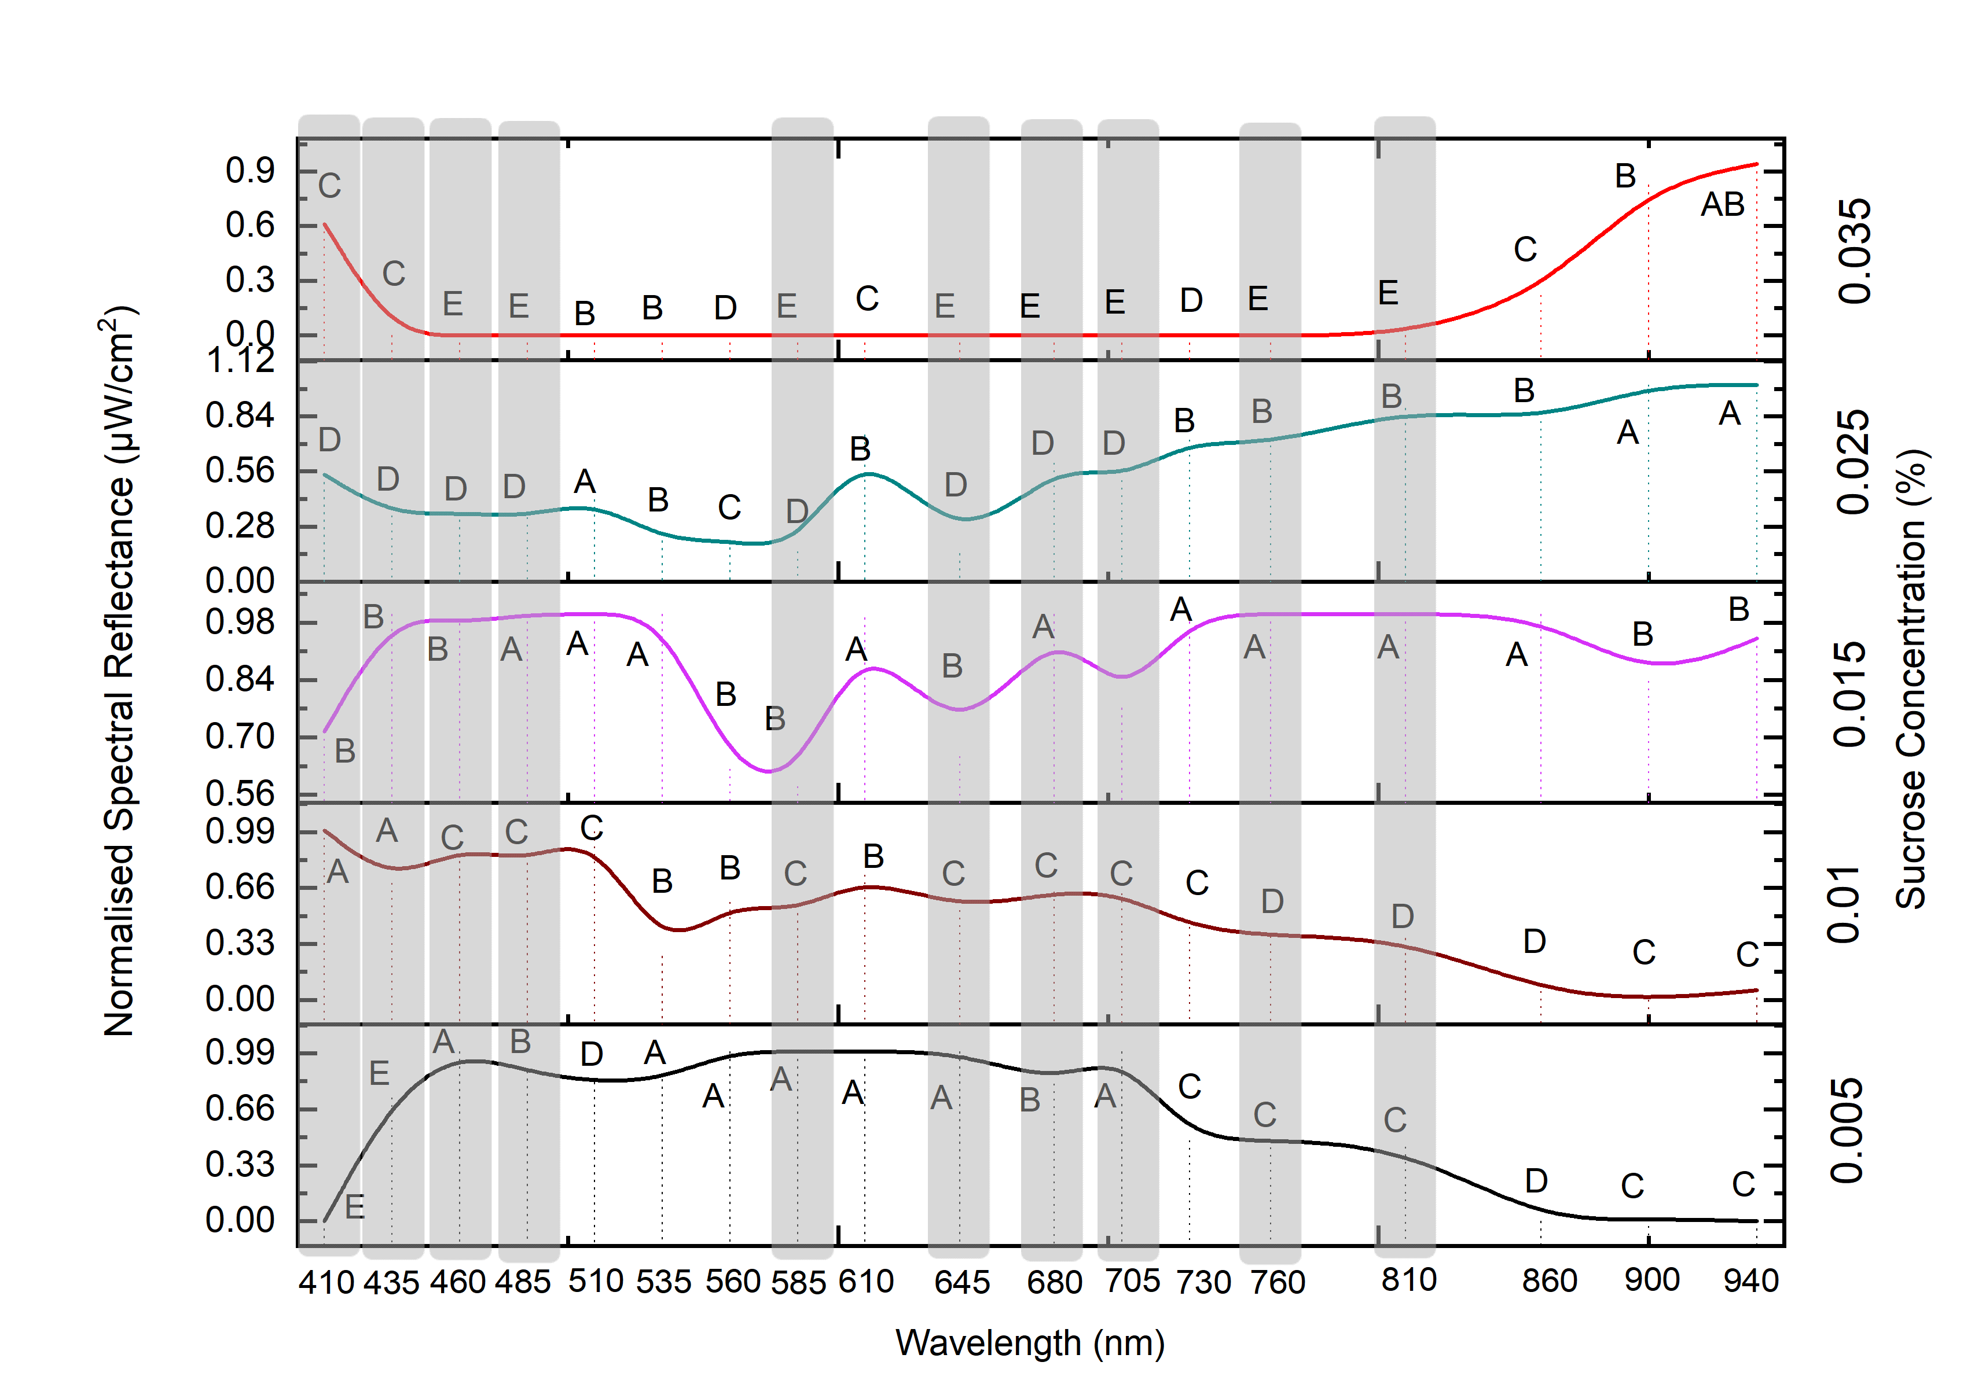
Figure A.11: Tukey Post-hoc Test Results for Analysis of Variance in Sucrose-Adulterated Milk Samples

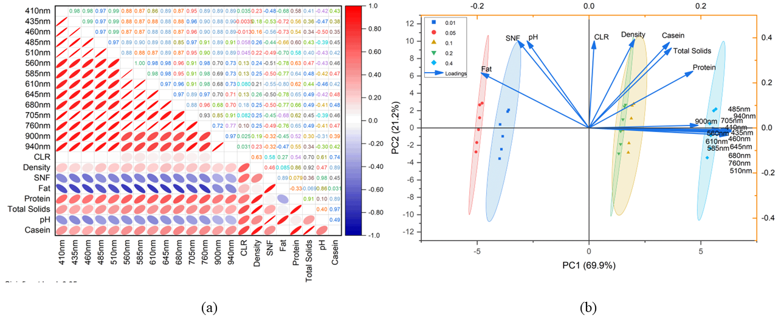
Figure A.12: (a) Spearman correlation plots and (b) PCA biplots for spectral reflectance and physicochemical attributes of formalin adulterated milk across selected wavelengths

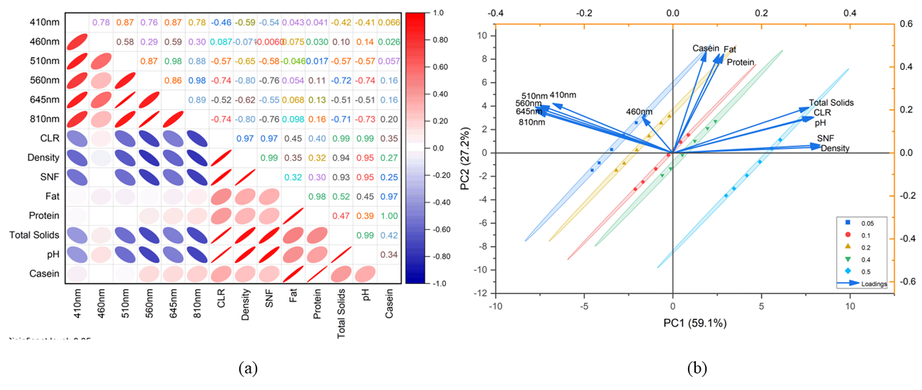
Figure A.13: (a) Spearman correlation plots and (b) PCA biplots for spectral reflectance and physicochemical attributes of baking soda adulterated milk across selected wavelengths

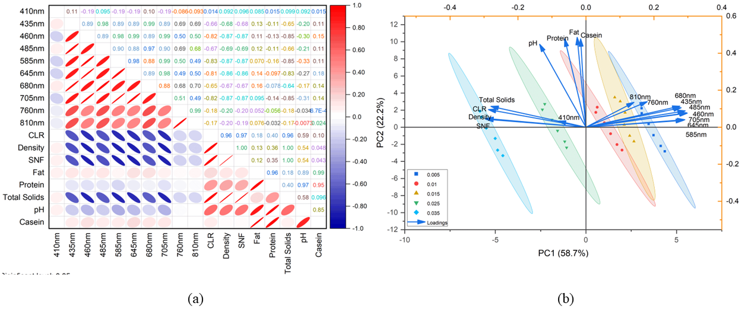
Figure A.14: (a) Spearman correlation plots and (b) PCA biplots for spectral reflectance and physicochemical attributes of sucrose adulterated milk across selected wavelengths

Table A. 1: Concentrations of Various Adulterants in Milk Samples

Adulterant Name | Concentration (%)
Urea | 0.05, 0.07, 0.1, & 0.2
Formalin | 0.01, 0.05, 0.10, 0.20, and 0.40
Hydrogen Peroxide | 0.02, 0.04, 0.08, 0.10, and 0.20
Cornstarch | 0.5, 1, 2, 4, and 5
Baking Soda | 0.05, 0.1, 0.2, 0.4, and 0.5
Sucrose | 0.005, 0.01, 0.015, 0.025, and 0.035

Table A.2: Equipment and Materials Used for Milk Adulteration Analysis
Item | Company Name | Description | Purpose
Cow Milk | Mother Dairy | 4% fat, half-litre packets | Base material for samples
Analytical-Grade Adulterants | - | Urea, formalin, hydrogen peroxide, cornstarch, baking soda, sucrose | Simulate adulteration
Laminar Flow Hood | Modern Lab Interio | Sterile environment | Prevent contamination
Swirlex Vortex Shaker | Abdos | 500 rpm | Uniform adulterant distribution
Calibrated Micropipettes | - | 10–1000 μL | Add liquid adulterants
Digital Balance | Aczel | ±0.001 g accuracy | Weigh solid adulterants
Glass Bottles | - | 100 mL, sterile | Sample storage
Refrigerator | - | 4°C ±1°C | Store samples pre-analysis
Water Bath | Sanco | 95°C ±1°C | Maintains precise temperature
Kjeldahl Steam Distillation | Kelplus Classic – DX Vats | Quantifies Nitrogen by distilling ammonia from digested samples | Determines Protein content
UV Spectroscopy | Elico | 208 - 220 nm | Analyse molecular absorption
High Speed Centrifuge | ALFA Model R-30 | 10,000 rpm for 20 mins | Separates sample components
Defreezer | Vestfrost | -20°C | Thaws frozen sample
Hot Air Oven | Macro Scientific Works | 100 - 102°C | Sterilizes & dries

