SUPPLEMENTARY MATERIAL
Supplemental Figures and Tables
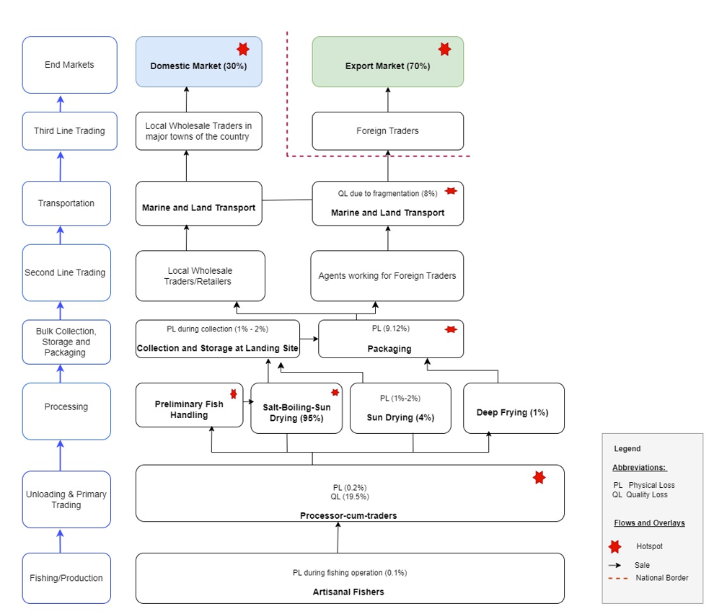
Supplemental Figure 1: Value chain map and estimated marine Dagaa losses of Mafia Island fishery
Supplemental Table 1: Causes of Dagaa losses based on Likert scale
Value chain stage | Loss type | Variables | Weighted Mean (n=64)
Fishing and Landing | Quality | Poor handling practice | 4.39*
Fishing and Landing | Quality | Delays to landing and bargaining process. Distance range from the fishing ground is 7-35 km. | 4.70*
Fishing and Landing | Quality | Mixture with other species | 1.94
Fishing and Landing | Quality | Different size of Dagaa | 1.66
Fishing and Landing | Quality | Inadequate infrastructure and facilities | 3.29*
Fishing and Landing | Physical | Animal predation | 1.38
Processing - Boiling | Physical | Over-boiling | 4.30*
Processing - Boiling | Quality | Prolonged exposure to ambient environment due to low - capacity of boiling tank | 4.55*
Processing -Drying | Physical | Animal predation such as birds and cats | 3.61*
Processing -Drying |  | Sticking to the drying platform (net) | 2.72
Processing -Drying | Quality | Unfavourable weather conditions for effective drying | 4.38*
Storage | Quality | Limited space | 2.48
Storage |  | Mixing products from different production cycles | 4.00*
Storage |  | Longer storage time, poor ventilation and sanitary conditions | 4.05*
Storage |  | Insect infestation | 3.53*
Storage |  | Moisture ingress in the rainy season | 4.08*
Storage | Physical | Animal and insect predation | 2.48
Packaging | Physical | Fragmentation through over stuffing the sacks because of stamping practices and marketing malpractices | 4.45*
Packaging | Quality | Stepping on product for compaction | 4.00*
Packaging |  | Animal predation | 1.59
Transportation to mainland | Physical | Drowning due to poor weather condition | 4.23*
Transportation to mainland | Quality | Soaking or moisture ingress during sea transportation | 3.80*
Transportation to Tunduma | Quality | Delays caused by disorganized supplying system and limited working capital | 3.92*
Transportation to Tunduma | Physical | Fragmentation caused by loading and unloading system at Tunduma | 3.42*
Transportation to Tunduma | Physical | Over stacking of the heavy bags in truck | 4.00*
Transportation to Kasumbalesa | Quality | Delays during transportation | 3.92*
Transportation to Kasumbalesa | Quality | Exposure to high temperatures (poor | 4.38*
Transportation to Lubumbashi | Physical | Over handling of product by loading and unloading practise at Kasumbalesa and Lubumbashi | 3.42*
Marketing at Kasumbalesa Zambia | Quality | Poor storage conditions and over-loaded warehouses | 3.66*
Marketing at Kasumbalesa Zambia | Physical | Fragmentation due to over stacking of sacks | 4.11*
Marketing in Lubumbashi DRC | Quality | Poor storage conditions | 4.27*
Marketing in Lubumbashi DRC | Quality | Marketing malpractices - mixing high quality with low quality Dagaa, improper sieving and flimsy packaging bags. | 1.23
Marketing in Lubumbashi DRC | Physical | Fragmentation due to improper handing | 1.81
Consumption | Physical | Left-over cooked Dagaa thrown away | 4.00*
*Relevant causes of Dagaa loss

Supplemental Methods
Study area - Mafia Island Description
Tumbuju landing site in Mafia Island is characterised by a significant Dagaa fishing industry, supporting 2,051 fishers and yielding an annual catch of 6,000 metric tons. Fishing operations utilise 95 mother boats (7-20m planked canoes), with an average of 70 vessels deployed daily across 160 effective fishing days per annum and ring nets being the primary fishing gear. Postharvest processing infrastructure includes 700 raised drying racks, each with a capacity of approximately 100 kg, and 190 boiling aluminium pans. Drying racks occupy an estimated 40 m² each. The site accommodates about 177 boat owners, 170 porters, 249 traders, and 20 export agents, indicating a substantial logistical network for Dagaa distribution (Mafia District Council Statistics, 2024).

Supplemental Results
  - Stakeholder perceptions of marine Dagaa losses in Mafia Island small-scale fisheries

The dominant processing method for Dagaa is salting, boiling and sun-drying, utilised by 95% of practitioners (Supplemental Figure 1). In contrast, only 4% opt for direct sun drying of fresh Dagaa (no boiling and salting) and deep frying is rare, at 1% (Supplemental Figure 1). Regarding market distribution, 70% of processed Mafia Island marine Dagaa is sold regionally, primarily in Lubumbashi, DRC, with the remaining 30% absorbed by the domestic market (Supplemental Figure 1). Women play a dominant role in processing and marketing operations.

DATA COLLECTION TOOLS

Full load tracking process- questionnaire template
LT Protocol-Fish losses at fishing stage
Objective to quantify physical/quantity and quality losses occurring during actual production or hauling/fishing operation

- Coding of the fishing vessels (optional), ………………………………..
- How many wooden boats are present at this landing site …….. and fiber boats ……
- How much fish get entangled on gears per each haul:
  - What is the mean weight of the caught individual species (gm)………. total number of individuals that remained entangled in the net also floating dead- (count)…………
- How many hauls do you normally do (Numbers):
  - At the beginning of the lunar cycle…..
  - Mid of lunar cycle………….
  - End of Lunar cycle
- At what time of the night do you normally perform hauls in the following lunar cycle (24hrs):
  - At the beginning of the lunar cycle…..
  - Mid of lunar cycle………….
  - End of Lunar cycle………..
- Is there any landing done in the middle of the fishing process: (Yes/No) before going back to fishing on the same day
- If so at what time of lunar cycle do you normally do this
  - At the beginning of the lunar cycle…..
  - Mid of lunar cycle………….
  - End of Lunar cycle………..
- How do you store your catch
  - Boxes
  - Buckets
  - Hull
  - On top of the boat
- Losses due to storage in a holding/storage on vessels, this also corresponds to the number of hauls per night (Could probably influence Quality of the landed catches)
- Are the fishing grounds known? (Yes/No)
- On a scale of 1 to 5 (1=Never, 2=Rarely, 3=very rarely, 4=always, 5= very often) please mention how often do you fish from the following fishing grounds in one spring tide?
  - Mwambakale
  - Nyororo
  - Mbakalemawe
  - Mbakalefungu
  - Shungimbili
  - Fungusefu
  - Maseweni
  - Mwambabikini
  - Mfuruni
  - Rasimzungu
  - Other (specify)________________
What is the distance for each of the following fishing grounds from Tumbuju?
- Mwambakale
- Nyororo
- Mbakalemawe
- Mbakalefungu
- Shungimbili
- Fungusefu
- Maseweni
- Mwambabikini
  - Mfuruni
  - Rasimzungu
  - Other (specify)________________
- Are the Dagaa boats using any preservation methods on board to preserve their fresh catch? (Yes/No)
- If no why……………….
- What is the total time taken between start shooting and hauling and closure of fishing operation? (1 hour to 11 hours)
  - 1-2 hours
  - 3-4 hours
  - 5-6 hours
  - 7-8 hours
  - 9-10 hours
  - 11 hours
- How many times do you land early catches only in a day?
  - once
  - twice
  - daily
  - weekly
  - often
- How many times do you land first catches only in one spring tide?
- once
- twice
- daily
- weekly
- often
- What is the time interval between the first catch and second catch? (45 min to 2 hours)
- 45 min
- 1 hour
- 1.5 hours
- 2 hours
- What is the time interval between the second catch and 3rd catch? (45 min to 2 hours)
- 45 min
- 1 hour
- 1.5 hours
- 2 hours
- What is the time taken between 3rd catch and 4th catch? (45 min to 2 hours)
- 45 min
- 1 hour
- 1.5 hours
- 2 hours
- What is the time taken between 4th catch and last catch? (45 min to 2 hours)
- 45 min
- 1 hour
- 1.5 hours
- 2 hours
- Collect samples of water and fresh fish for micro plastic analysis.

Section 1: Basic information on catch and samples
- Total catch weight in a vessel
  - Dagaa (Buckets)_______________
  - Other species (Buckets)____________
Sample | Total weight of sampled fish  (10 buckets of fish) | Weight of good quality (buckets) | Weight of low quality (saleable)-(buckets) | Weight of low quality (unsaleable)- (buckets)
A
B
C
Total

Section 2: Unloading after fishing
- Boat name/registration number
- Species/local name (select one) (i.e. Lumbunga, Dagaa nyama, Dagaa sola (uono))
- Average size of species (cm)
- Catch method (select one) (i.e. Ring net, others)
Ring net
Other (please specify): ________________
- Departure date: ………………….
- Departure time at the landing site: Hrs…………Min……………
- Arrival time at fishing ground: …………………………
- Time at which lights were switched on ………………….
- Time of first catch (sample A) …………………………………
- Time at which lights were switched on ………………….
- Time of first catch (sample B) …………………………………
- Time at which lights were switched on ………………….
- Time of first catch (sample C) …………………………………
- Name of fishing ground
- Coordinates of the fishing ground:
Latitudes
Longitudes
- Quantity of ice taken to sea (kg)
- How much ice was used (kg)
- Type of insulation used in fish hold (select one)
Styrofoam
Insulated boxes
Other (please specify): ________________
None__________________

- Storage method of fish onboard (select one)
Boxes
Fish hold
Leave it on top of the boat
Other (please specify): ________________
- Total quantity of fish landed (kg)
- How long does it take to agree on price (Negotiation time)? 30 min; 60 min; more than 60 min

- Where is the price agreed upon?
- Were there any delays in price negotiations? (select one)
Yes
No
If yes, please estimate delay time: ________________
- How are the fish transported to the processing site? (select one)
Truck and porters
Boat and porters
Porters only
Other (please specify): ________________
- Are all landed fish in your vessels processed in the same locality (select one)?
Yes
No

Section 3: Processing site
- Name of processor (Optional)……………..
- Gender ………………(M/F)
30. What is the distance from the landing site to the processing site?
a) <0.5 km
b) 0.5-1 km
c) 1-2 km
d) > 2 km
32. What is the average quantity of fish being processed at your facility?
a) Less than 50 kg/day
b) 51-100 kg/day
c) 101-200 kg/day
d) More than 200 kg/day
33. Source of fish for processing (select one)
One vessel
Two vessels
> Two vessels

- Average quantity of fish processed daily (kg)
- Number of processing days per one lunar cycle?...........
- Time used for transporting the purchased catch from the fishing vessel during unloading to the processing locality/point (Hrs)?.........
- Waiting time before the purchased catch is boiled (Hrs)………
- Where do you temporarily keep your purchased catch pending the boiling process
  - On obsolete nets
  - On plastic sheath
  - On reeds mats
  - Others (specify)

Section 4: Boiling information
- Basic Information regarding Boiling per Sample:
Sample | Total weight of fresh fish | Weight of good quality | Weight of low quality (saleable) | Weight of low quality (unsaleable) | Boiling time (mins) | Salinity | Boiling Temp | Weight of boiled fish (kg) | Weight of good quality boiled fish (Kg) | Weight of low quality (saleable) boiled fish (Kg) | Weight of low quality (unsaleable) boiled fish (Kg)
A
B
C
Total

- Collect a sample of water that has been prepared for boiling fish and fish samples before and after boiling the fish. Label them accordingly.
- How do you boil the the graded fish samples?.....Mixing, separately, No grading
- What is the quantity of salt added in boiling water per sample
  - ……Kg in …..Litres of water
  - In ……(Dry/ Wet) Season
- Do you change water when the quality dagaaa change?

- Boiling equipment used (select one)
Traditional pot
Industrial boiler
Aluminium pans
- Firewood type being used ……………
- Quantity of firewood:
Toyo
Kirikuu
Others……….(specify)

- Price of the used firewood
Section 5: Drying information
- Basic Information regarding Drying per Sample
Sample | Total weight of boiled fish | Weight of good quality | Weight of low quality (saleable) | Weight of low quality (unsaleable) | Drying time (mins) | Av humidity during drying | Av. Temp during drying | Av air speed | Weight of dried fish (kg) | Weight of good quality | Weight of low quality (saleable) | Weight of low quality (unsaleable)
A
B
C
Total

- Drying time (mins)
- Average humidity during drying (%)
- Average temperature during drying (°c)
- Average air speed (m/s)
- Weight of dried fish (kg)
- Weight of good quality after drying (kg)
- Weight of low quality after drying (kg)
- Weight of low quality (unsaleable) after drying (kg
- Drying method used (select one)
Ground
Nets
Rack
Other (please specify): ________________

Section 6: Storage information
62. Records on Storage per Sample
Sample | Total weight of dried fish | Weight of good quality | Weight of low quality (saleable) | Weight of low quality (fragments) | Storage time (days) | Av humidity during drying | Av. Temp during drying | Weight of dried fish after storage (kg) | Weight of good quality in store | Weight of low quality (saleable) after | Weight of low quality (fragments)
Day1
Day2
Day3
Day4
Day5
Day6
Total

63. Average humidity during storage (%)
64. Average temperature during storage (°c)
65. Storage facilities (select one)
On the floor
Sack
On the polythlene sheet
Raised platform
Storage hut
Other (please specify): ________________

XXXXXXXXXXXXXXXXXXXXXXXXXXXXXXXXXXXXXXXXXXXXXXXXXXXXXXXXXXXXXXXXXX

Section 7: Packing information
- Packaging records per Sample:
Sample | Total weight of dried fish before packing | Weight of good quality | Weight of low quality (saleable) | Weight of low quality (unsaleable) | Packing time (mins) | Weight of dried fish after (kg) | Weight of good quality after | Weight of low quality (saleable) after | Weight of low quality/broken (unsaleable) after
A
B
C
Total

- Packing time (minutes)
- Weight of dried fish after packing (kg)
- Weight of good quality after packing (kg)
- Weight of low quality after packing (kg)
- Weight of low quality (unsaleable) after packing (kg)
- Packing method and materials used (select one)
Plastic bags
Cardboard boxes
Wooden crates
Other (please specify): ________________

Section 8: Transport to market
Sample | Total weight of dried fish before packing | Weight of good quality | Weight of low quality (saleable) | Weight of low quality (unsaleable) | Packing time (mins) | Distance transported | Transport time | Weight of dried fish after (kg) | Weight of good quality after | Weight of low quality (saleable) after | Weight of low quality/broken (unsaleable) after
A
B
C
Total
- Transport method (select one)
Truck
Boat
Bicycle
Hand-carried
Other (please specify): ________________
- Facilities during transport (select all that apply)
Refrigerated
Ambient temperature
Exposed to sunlight
Covered/insulated
Other (please specify): ________________
Section 9 Marketing
- Price of dried dagga?
- Storage facilities used?
- Any price discount for poor quality product?
Measure the consignment transported and take samples for nutritional and microbiological testing

Storage

Objective:

Measure physical and quality losses after before and after storage.

Quantify the spoilt/damaged fish before and after storage.

Comparative studies:

Storage without packaging vs storage in packaging

Unit of measurement = bucket of dried fish

Sampling & replication –
30% of fish after drying

An alternative is to select every 3rd bucket after drying to be sampled.

Response – for each bucket to be sampled:

after drying and before storage and then after storage:
Weight of good quality fish
Weight of poor-quality fish (saleable)
Weight of poor-quality fish (unsaleable)

Process:

Seek prior agreement of the processor who owns the fish. This should involve an explanation of why the activity is being done to convince the people that it is worthwhile cooperating:
- training purposes
- baseline data
- identify opportunities to improve quality and generate higher prices and more income for fishermen and trader
- improve quality of fish for consumer
- increase post-landing storage life of fish to allow more control over selling process and price.

Organize the time and place to do the measurements. Ideally the place should be quiet and shaded with plenty of space and near the storage place.

Identify the processors/traders who will do the grading/sorting of the samples. Discuss with them their task which is to sort the fish into piles according to quality using their perception of quality. Bearing in mind that colour may also be an important quality attribute for dried fish.

Assemble the equipment and materials ready for measuring and recording.

Spread the plastic sheet on the ground ready for sorting/grading samples.

Weigh the sample of dried fish to get the total weight. Weigh an empty bucket and then weigh a bucket full of fish. Record both weights.

Arrange the sample (Sample A above) to be sorted/graded onto the plastic sheet.

Processors/traders grade the fish by quality.

After the fish has been graded, quickly:

- Weigh the good quality fish and record weight
- Weigh the low quality saleable/processable fish and record weight
- Weigh the low quality unsaleable/unprocessable fish and record weight.

Allow the processor to store the sample in a demarcated area so that the same sample can be identified and assessed after storage.

Record the time that the fish are put in the store.

Record the ambient conditions during storage e.g. temperature, humidity.

After storage, note down the time and calculate the duration of storage.

Weigh the sample of stored dried fish.

Ask the processors/trader to sort/grade the same sample of dried fish by quality (several processors doing this may help speed up the process).

After the fish has been graded, quickly:

- Weigh the good quality fish and record weight
- Weigh the low quality saleable/processable fish and record weight
- Weigh the low quality unsaleable/unprocessable/broken fish and record weight

Take samples for lab analysis (proximate, micronutrient, omega 3 fatty acids and microbial analysis)

Either allow fish to be returned to the value chain or track the different samples of fish to the next stage e.g. transport.

Repeat for next sample (Sample B)
Repeat for final sample (Sample C)

Recording form template:

Sample | Total weight of dried fish | Weight of good quality | Weight of low quality (saleable) | Weight of low quality (unsaleable) | Storage time (mins) | Av humidity during drying | Av. Temp during drying | Weight of dried fish after (kg) | Weight of good quality after | Weight of low quality (saleable) after | Weight of low quality (unsaleable) after
A
B
C
Total

Other information:

Species
Size
History of fish before storage
Prices
Storage conditions (ground, sack, building)

Analysis

- Data tabulated

- Calculate the proportion of low-quality fish as % of overall weight before and after drying

- Calculate loss in value using quantity and price data

Equipment/materials:

- Weighing scale max 20 kg spring balance or table balance
- net for weighing buckets/fish and fish for weighing
- container for weighing sampled fish
- large plastic sheet for fish grading
- recording form & pen or tablet
- thermometer
- humidity meter
- stopwatch/timer

Packing & Transport to Market
Objective:

Measure physical and quality losses after before packing and after transport.

Quantify the spoilt/damaged fish before and after packing and transport.

Comparative studies:

Different transport means, distances and end markets

Unit of measurement = whole sack of dried fish

Sampling & replication –
30% of fish packed and transported

Response – for each sack to be sampled:

after drying and before packing and then after packing and transport:
Weight of good quality fish
Weight of poor-quality fish (saleable)
Weight of poor-quality fish (unsaleable)/broken fish

Process:

Seek prior agreement of the processor/trader who owns the fish. This should involve an explanation of why the activity is being done to convince the people that it is worthwhile cooperating:
- training purposes
- baseline data
- identify opportunities to improve quality and generate higher prices and more income for fishermen and trader
- improve quality of fish for consumer
- increase post-landing storage life of fish to allow more control over selling process and price.

Organize the time and place to do the measurements. Ideally the place should be quiet and shaded with plenty of space and nearby the place near the storage place or where dried fish is normally packed or unloaded after transport.

Identify the processors/traders who will do the grading/sorting of the samples. Discuss with them their task which is to sort the fish into piles according to quality using their perception of quality. Bearing in mind that colour may also be an important quality attribute for dried fish.

Assemble the equipment and materials ready for measuring and recording.

Spread the plastic sheet on the ground ready for sorting/grading samples.

Weigh the sample of dried fish to get the total weight. This should be the total amount of fish that will be packed into the sack normally used.

Arrange the sample (Sample A above) to be sorted/graded onto the plastic sheet.

Processors/traders grade the fish by quality.

After the fish has been graded, quickly:

- Weigh the good quality fish and record weight
- Weigh the low quality saleable/processable fish and record weight
- Weigh the low quality unsaleable/unprocessable/broken fish and record weight.

The dried fish are now packed as per normal practice into the sack. The sack is made ready for transport.

Record the time it takes to pack the fish into the sack.

Repeat grading and packing for 30% of sacks that will be transported.

Sample sacks of dried fish are loaded and transport occurs.

Record the distance transported and time taken.

At the destination, remove the fish from the sack and place back on the plastic sheet.

Ask the processors/trader to sort/grade the same sample of dried fish by quality (several processors doing this may help speed up the process).

After the fish has been graded, quickly:

- Weigh the good quality fish and record weight
- Weigh the low quality saleable/processable fish and record weight
- Weigh the low quality unsaleable/unprocessable/broken fish and record weight

Recording form template:

Sample | Total weight of dried fish before packing | Weight of good quality | Weight of low quality (saleable) | Weight of low quality (unsaleable) | Packing time (mins) | Distance transported | Transport time | Weight of dried fish after (kg) | Weight of good quality after | Weight of low quality (saleable) after | Weight of low quality/broken (unsaleable) after
A
B
C
Total

Other information:

Species
Size
History of fish before packing and transport
Prices
Packing method and materials
Transport method
Conditions during transport

Analysis

- Data tabulated

- Calculate the proportion of low-quality fish, broken fish as % of overall weight before and after transport

- Calculate loss in value using quantity and price data

Equipment/materials:

- weighing scale max 20 kg spring balance or table balance
- net for weighing buckets/fish and fish for weighing
- container for weighing sampled fish
- large plastic sheet for fish grading
- recording form & pen or tablet
- stopwatch/timer

