Supplementary Material

Phytochemical and Nutritional Analysis of Plukenetia corniculata Sm. Leaves for Functional Food Development with Biological Activity

Md. Omar Faruq¹*, Tofael Ahmed¹, Md. Zakir Hossain¹, Md Ragib Siddique Rafi¹, Shuvo Kumar Dey¹, Md. Abdullah Al Mamun¹, Md. Latifuzzaman¹, Fatematuz Zohra Brinte¹, Sraboni Rani Biswas¹, Farzana Mita¹, Farzana Ashrafi Neela¹, Gour Pada Ghosh¹
¹ Department of Botany, University of Rajshahi, Rajshahi-6205, Bangladesh.

* Corresponding Author: omrfrq39@gmail.com / omrfrqbot23@ru.ac.bd

List of Figures

Fig. S1 Phytochemical compounds of Plukenetia corniculata leaf methanolic extract. (a-e). Alkaloids- (Dragendorff’s, Wagner’s, Mayer’s, Hager’s, Tannic acid test) f. Flavonoids g. Terpenoids h. Carbohydrate i. Glycosides j. Cardiac glycosides k. Protein l. Phenol m. Saponins n. Tannin o. Steroids p. Amino acid and q. Coumarins.
Fig. S2 Phytochemical compounds of Plukenetia corniculata leaf ethanolic extract. (a-e). Alkaloids- (Dragendorff’s, Wagner’s, Mayer’s, Hager’s, Tannic acid test) f. Flavonoids g. Terpenoids h. Carbohydrate i. Glycosides j. Cardiac glycosides k. Protein l. Phenol m. Saponins n. Tannin o. Steroids p. Amino acid and q. Coumarins.
Fig. S3 Phytochemical compounds of Plukenetia corniculata leaf aqueous extract. (a-e). Alkaloids- (Dragendorff’s, Wagner’s, Mayer’s, Hager’s, Tannic acid test) f. Flavonoids g. Terpenoids h. Carbohydrate i. Glycosides j. Cardiac glycosides k. Protein l. Phenol m. Saponins n. Tannin o. Steroids p. Amino acid and q. Coumarins.
Fig. S4 Calibration curve of Gallic acid, Quercetin, Tannic acid, and Diosgenin (Standard).
Fig. S5 Overview of the ash and fiber analysis of P. corniculata Leaves.
Fig. S6 Quantitative analysis and standard calibration curves of heavy metals in P. corniculata leaves.
Fig. S7 Calibration curve of Ascorbic acid, Glucose, and Bovine serum albumin (Standard).
Fig. S8 Calibration curve of Acarbose (Standard).
Fig. S9 Amino acid profiling of P. corniculata leaves by HPLC.

Qualitative phytochemical screening
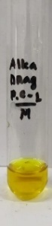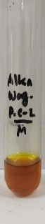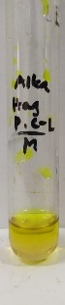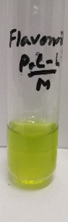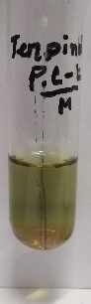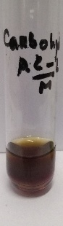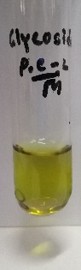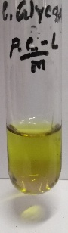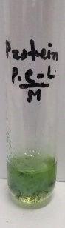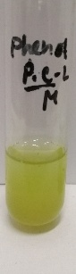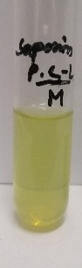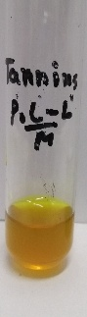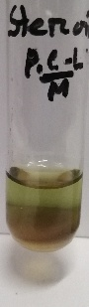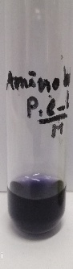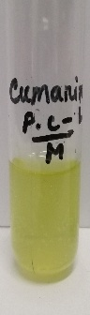
Fig. S1 Phytochemical compounds of Plukenetia corniculata leaf methanolic extract. (a-e). Alkaloids- (Dragendorff’s, Wagner’s, Mayer’s, Hager’s, Tannic acid test) f. Flavonoids g. Terpenoids h. Carbohydrate i. Glycosides j. Cardiac glycosides k. Protein l. Phenol m. Saponins n. Tannin o. Steroids p. Amino acid and q. Coumarins.

a
b
c
d
e
f
g
h
i
j
k
l
q
p
o
n
m

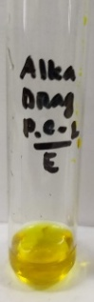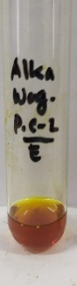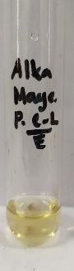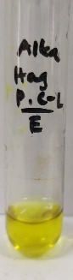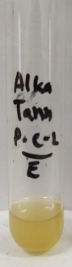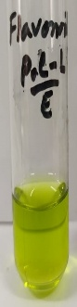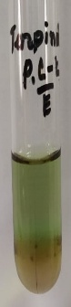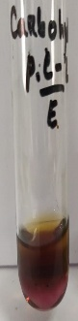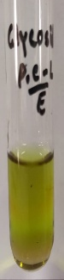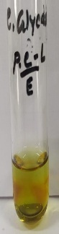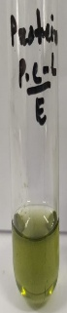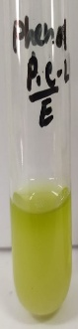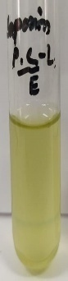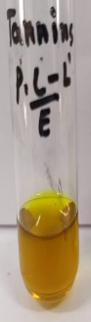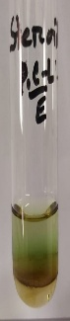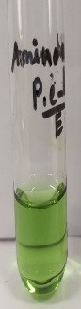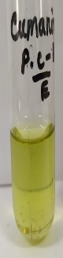
Fig. S2 Phytochemical compounds of Plukenetia corniculata leaf ethanolic extract. (a-e). Alkaloids- (Dragendorff’s, Wagner’s, Mayer’s, Hager’s, Tannic acid test) f. Flavonoids g. Terpenoids h. Carbohydrate i. Glycosides j. Cardiac glycosides k. Protein l. Phenol m. Saponins n. Tannin o. Steroids p. Amino acid and q. Coumarins.

a
b
c
d
e
f
g
h
i
j
k
l
q
p
o
n
m

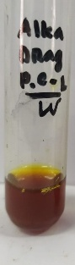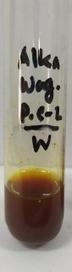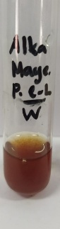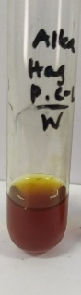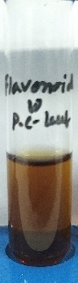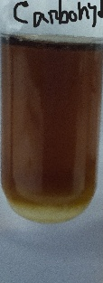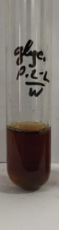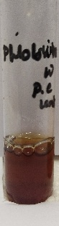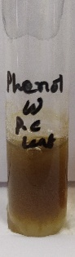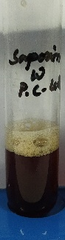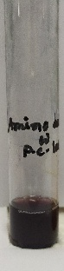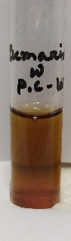
a
b
c
d
e
f
g
h
i
j
k
l
q
p
o
n
m
Fig. S3 Phytochemical compounds of Plukenetia corniculata leaf aqueous extract. (a-e). Alkaloids- (Dragendorff’s, Wagner’s, Mayer’s, Hager’s, Tannic acid test) f. Flavonoids g. Terpenoids h. Carbohydrate i. Glycosides j. Cardiac glycosides k. Protein l. Phenol m. Saponins n. Tannin o. Steroids p. Amino acid and q. Coumarins.

Quantitative phytochemical screening

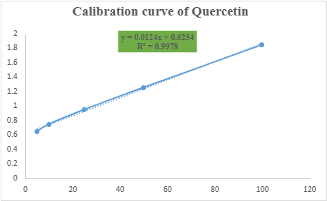
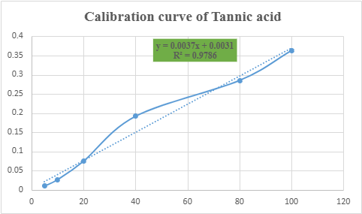
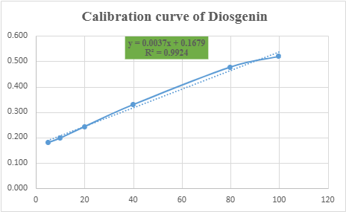
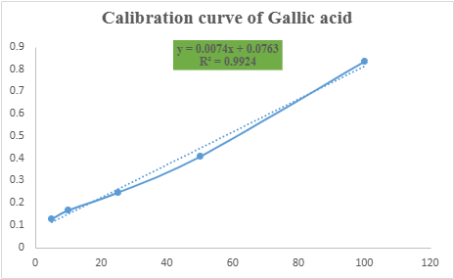

Fig. S4 Calibration curve of Gallic acid, Quercetin, Tannic acid, and Diosgenin (Standard).

Determination of ash and fiber
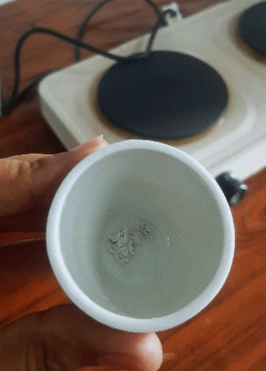
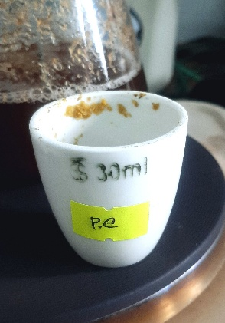
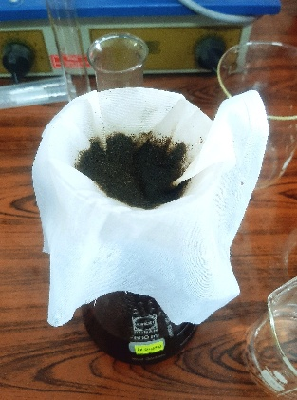
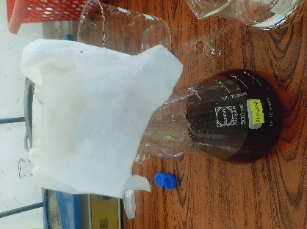
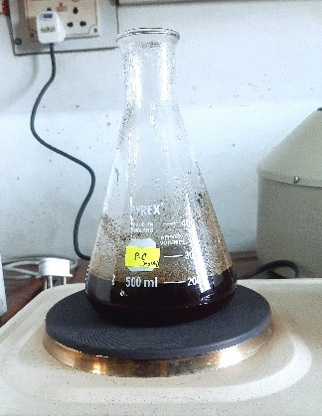
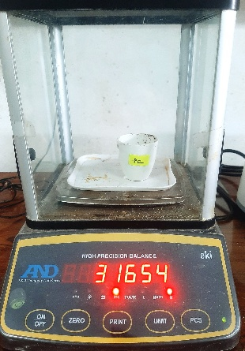
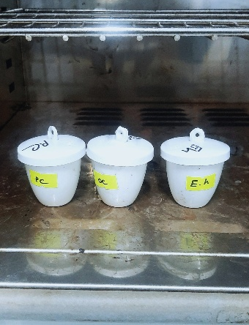
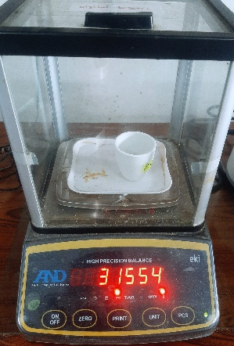

Fig. S5 Overview of the ash and fiber analysis of P. corniculata Leaves.

Determination of heavy metals
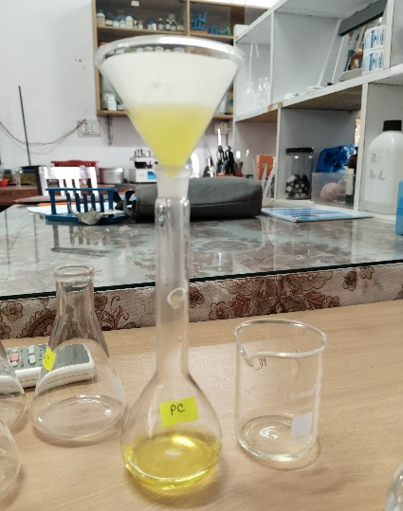
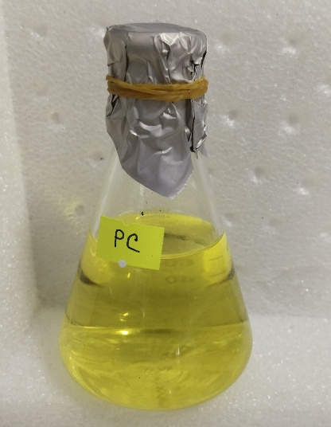
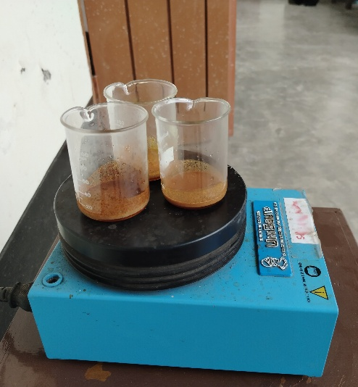

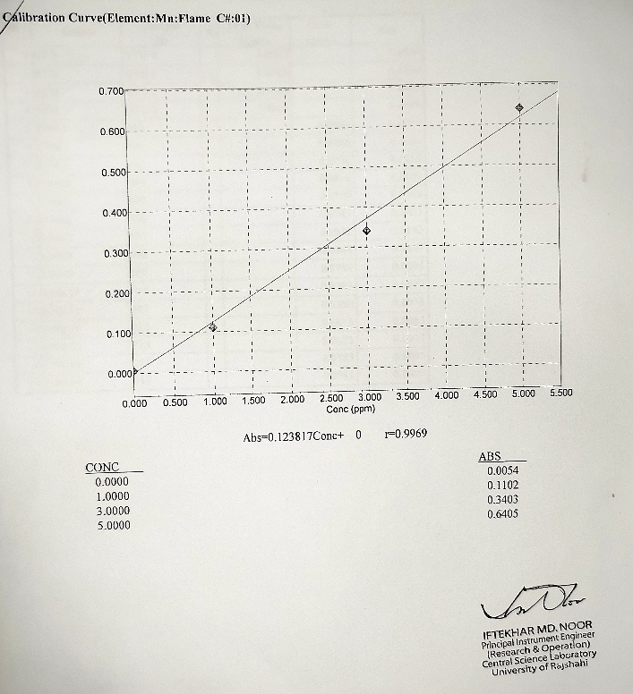
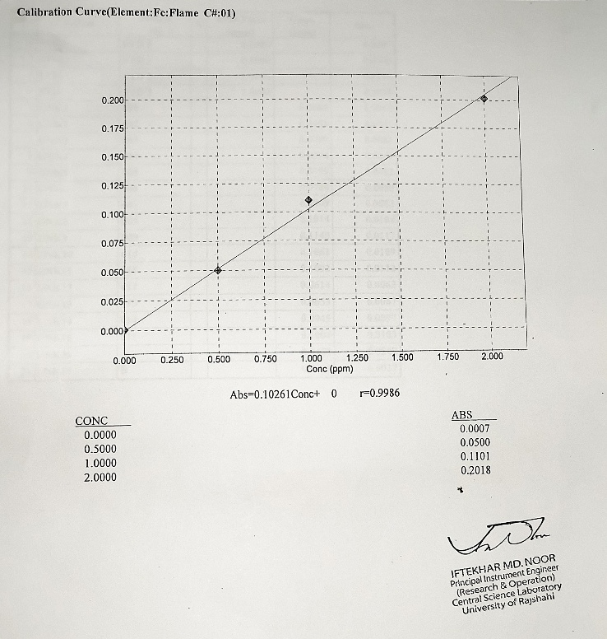
Calibration curve of Mn
Calibration curve of Fe

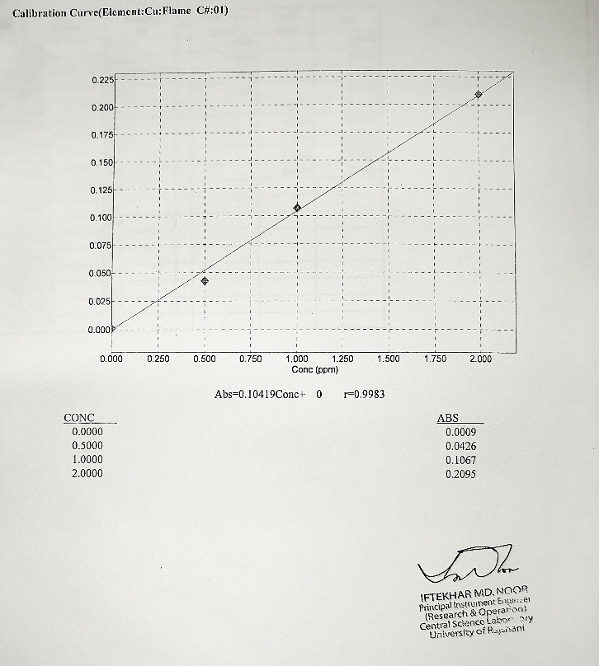
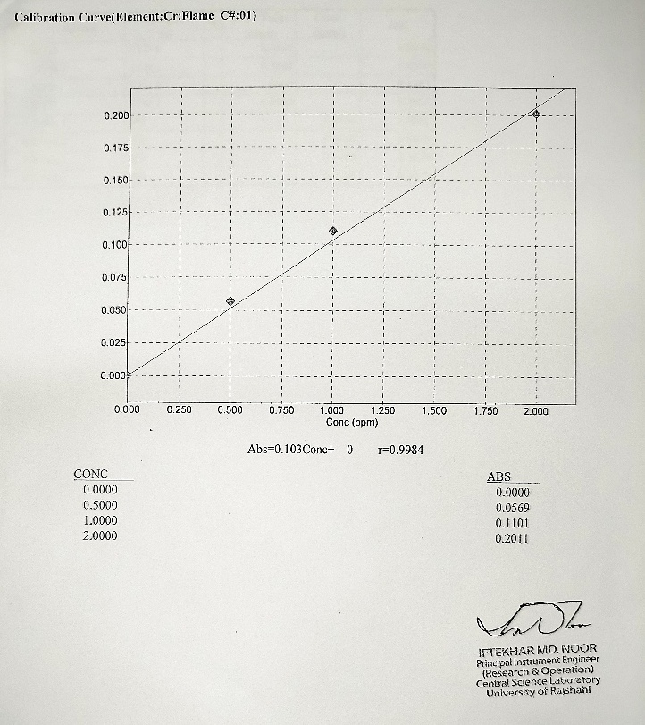
Calibration curve of Cu
Calibration curve of Cr

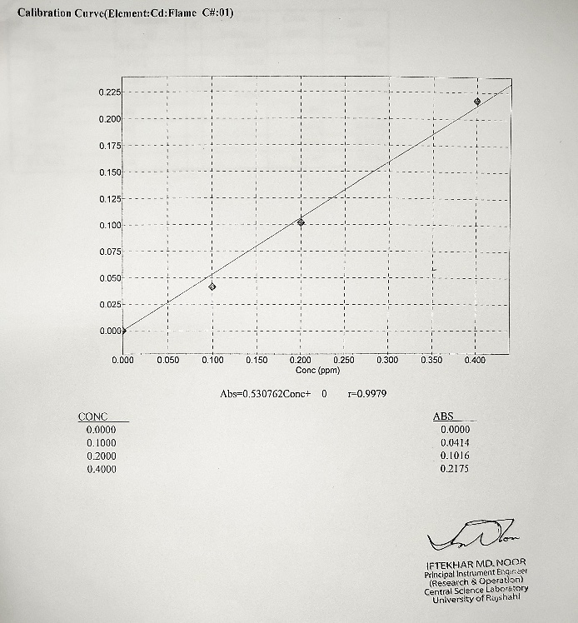
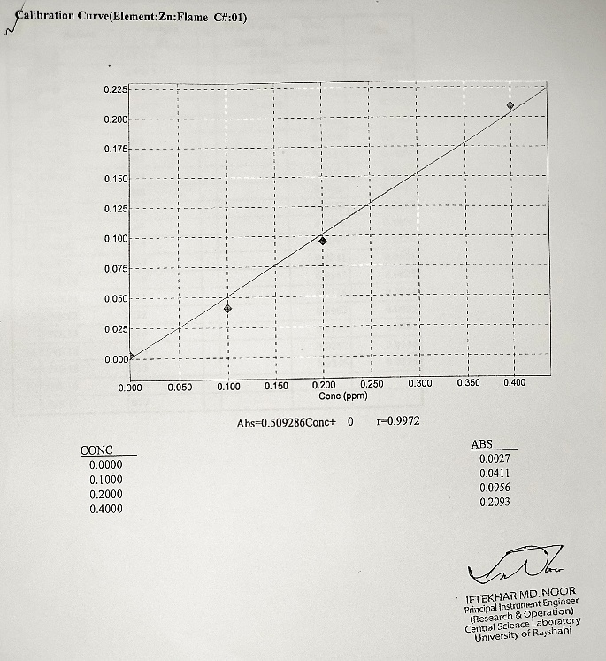
Calibration curve of Cd
Calibration curve of Zn

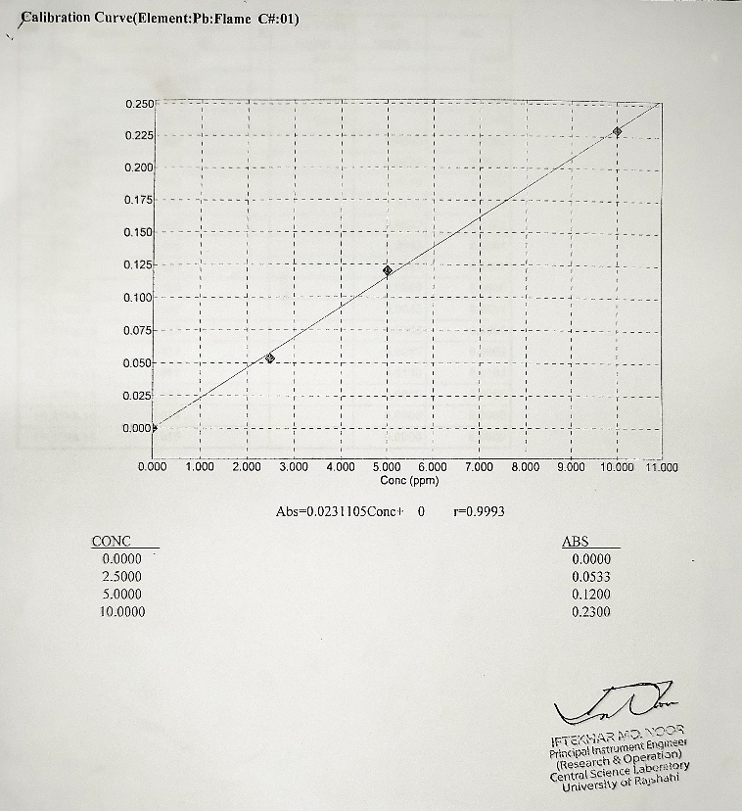
Calibration curve of Pb

Fig. S6 Quantitative analysis and standard calibration curves of heavy metals in P. corniculata leaves.
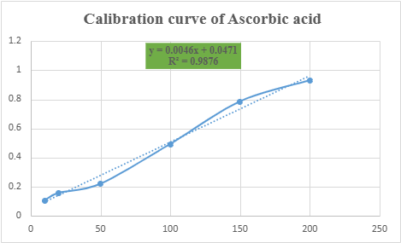

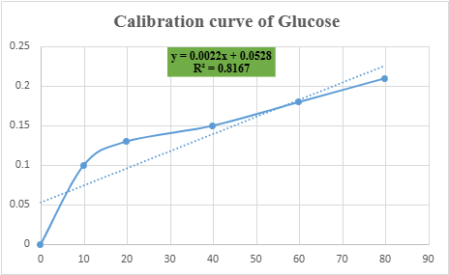

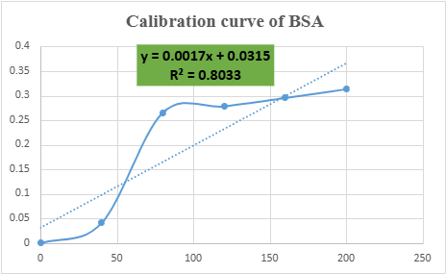

Fig. S7 Calibration curve of Ascorbic acid, Glucose, and Bovine serum albumin (Standard).

Anti-diabetic activity determination
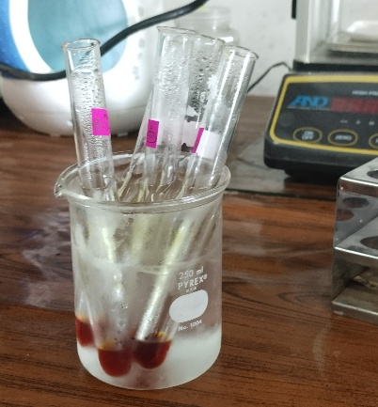
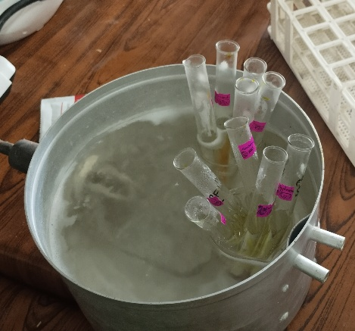
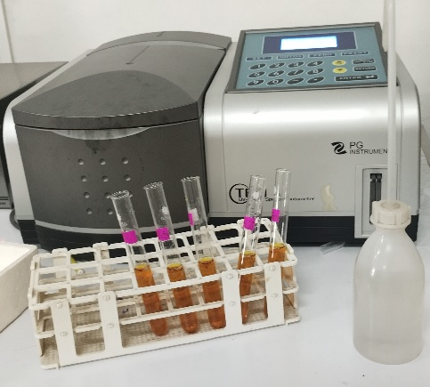

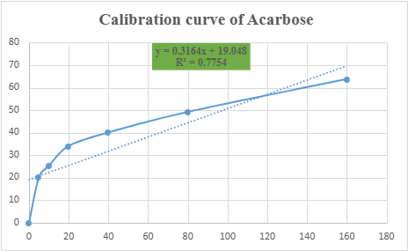

Fig. S8 Calibration curve of Acarbose (Standard).

Amino acid profiling

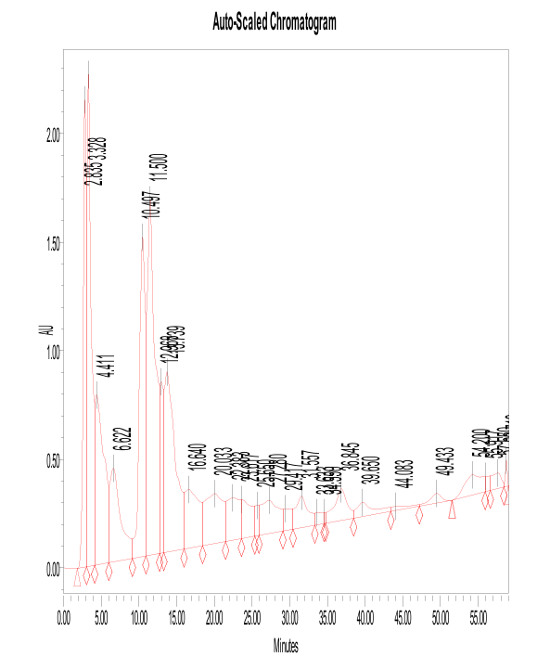

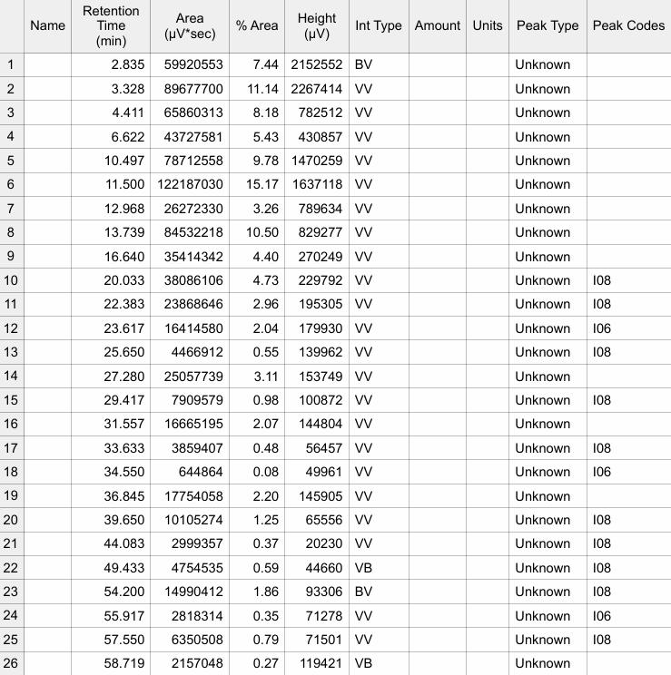

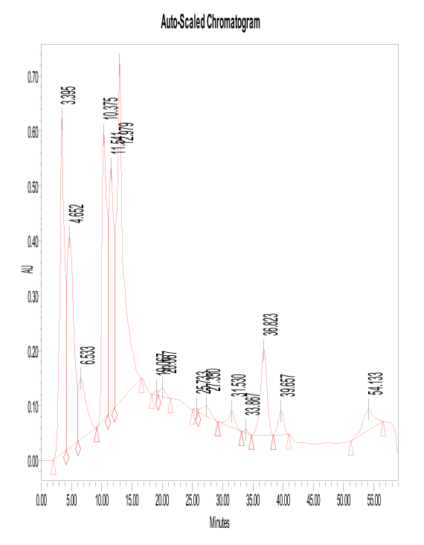

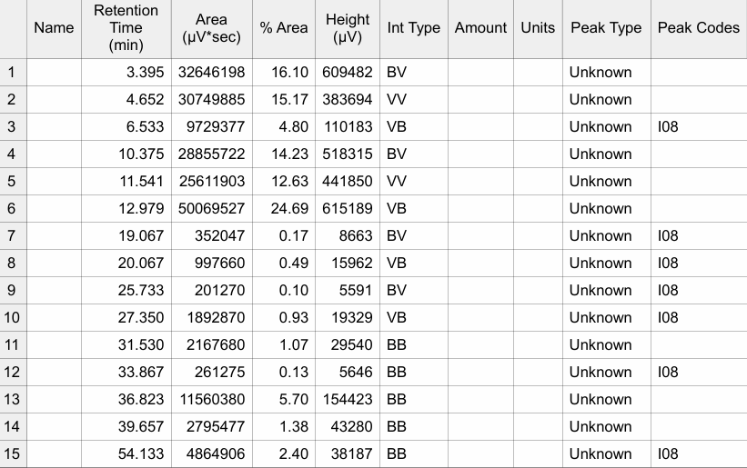

Fig. S9 Amino acid profiling of P. corniculata leaves by HPLC.

