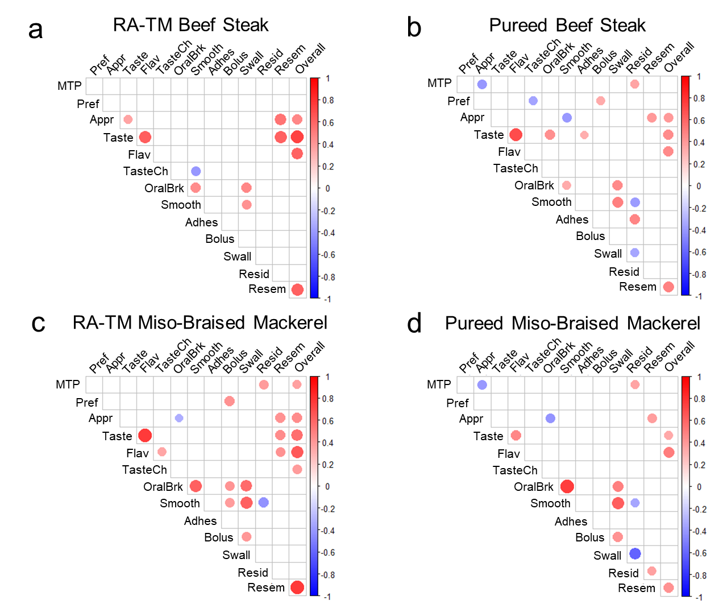
Supplementary Figure 1. Correlation heatmaps without correction for multiple comparisons.
Heatmaps show Spearman’s rank correlation coefficients among maximum tongue pressure and sensory attributes for each food: (a) RA-TM beef steak, (b) pureed beef steak, (c) RA-TM miso-braised mackerel, and (d) pureed miso-braised mackerel. Red indicates positive correlations and blue indicates negative correlations. Only correlations with p < 0.05 (uncorrected) are displayed. The size of each dot is proportional to the absolute value of Spearman’s rank correlation coefficient. These results are presented for exploratory purposes. Abbreviations are the same as in Figure 4.
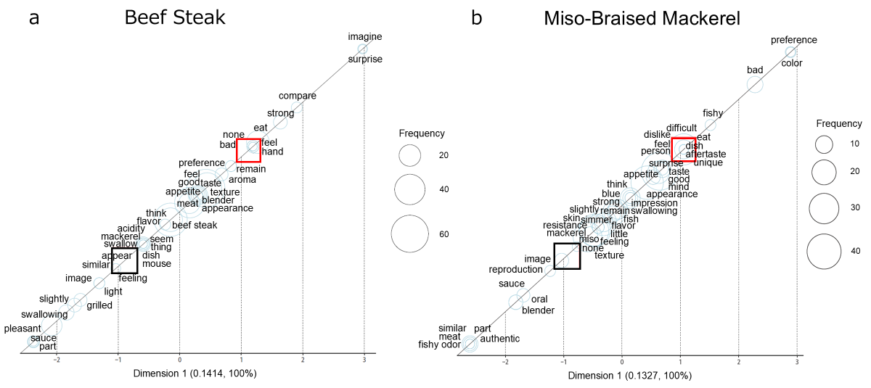Supplementary Fig. 2. Correspondence analysis of free-text comments for RA-TM and pureed texture-modified foods.
Panels (a) and (b) show the results for beef steak and miso-braised mackerel, respectively. Words positioned closer to each food sample indicate terms more strongly associated with that sample. The size of each circle is proportional to the frequency of the corresponding word. The RA-TM samples are indicated by black squares and the pureed samples by red squares.

Supplementary Table 1 Ingredients and nutritional composition of the texture-modified foods used in the study
 | Beef steak | Miso-braised mackerel
Ingredients | Beef, Onion, Shariapin Sauce (Onion, Soy Sauce, Sugar, Other Ingredients), Beef Fat, Dextrin, Salt, Agar / Alcohol, Thickening Agents (Modified Starch, Polysaccharide Thickeners), Colorings (Yellow No. 4, Red No. 102, Red No. 106, Blue No. 1), Flavoring, Enzyme | Mackerel, Onion, Sauce (Miso, Sugar, Soy Sauce, Reduced Starch Syrup, Salt, Tuna Extract, Brewed Vinegar, Spices, Kelp), Dextrin, Salt, Agar / Thickening Agents (Modified Starch, Polysaccharide Thickeners), Colorings (Red No. 102, Yellow No. 4, Blue No. 1, Red No. 106), Alcohol, Enzyme
Nutrition Facts (per 100 g)
Energy (kcal) | 75 | 129
Protein (g) | 7.7 | 7.7
Fat (g) | 3.1 | 7.8
Carbohydrate (g) | 4.1 | 7.1
Salt equivalent (g) | 1.0 | 1.4

Supplementary Table 2 Extracted words and their frequencies in the text mining analysis
Beef steak |  |  |  | RA-TM Beef steak |  |  |  | Pureed Beef steak
 | Extracted words | Frequency |  |  | Extracted words | Frequency |  |  | Extracted words | Frequency
 | taste | 63 |  |  | taste | 30 |  |  | taste | 33
 | beef steak | 48 |  |  | beef steak | 28 |  |  | beef steak | 20
 | appearance | 40 |  |  | appearance | 21 |  |  | feel | 19
 | feel | 36 |  |  | sauce | 17 |  |  | appearance | 19
 | think | 24 |  |  | feel | 17 |  |  | eat | 15
 | eat | 22 |  |  | think | 14 |  |  | think | 10
 | meat | 19 |  |  | meat | 10 |  |  | meat | 9
 | sauce | 18 |  |  | swallowing | 9 |  |  | good | 8
 | good | 16 |  |  | good | 8 |  |  | blender | 6
 | blender | 12 |  |  | slightly | 7 |  |  | strong | 6
Miso-Braised Mackerel |  |  |  | RA-TM Miso-Braised Mackerel |  |  |  | Pureed Miso-Braised Mackerel
 | Extracted words | Frequency |  |  | Extracted words | Frequency |  |  | Extracted words | Frequency
 | taste | 49 |  |  | mackerel | 22 |  |  | taste | 29
 | appearance | 38 |  |  | taste | 20 |  |  | eat | 22
 | mackerel | 36 |  |  | feel | 19 |  |  | appearance | 21
 | eat | 33 |  |  | miso | 19 |  |  | mackerel | 14
 | feel | 31 |  |  | appearance | 17 |  |  | feel | 12
 | miso | 30 |  |  | simmer | 14 |  |  | miso | 11
 | simmer | 24 |  |  | fish | 11 |  |  | good | 10
 | fish | 20 |  |  | eat | 11 |  |  | simmer | 10
 | good | 17 |  |  | similar | 9 |  |  | fish | 9
 | think | 14 |  |  | think | 7 |  |  | bad | 8

