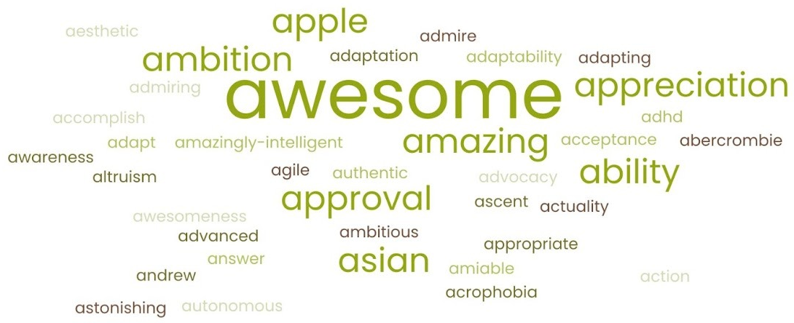
Supplemental Figure 1: Word cloud of participant responses to “A is for ___”. This visualization displays illustrative words generated during a community-based workshop at the Chinatown Service Center in Los Angeles. Participants were asked to fill in the blank of “A is for ___” with a word beginning with “A” that symbolizes your AANHPI experience or lived story. Larger words represent more frequently chosen responses, reflecting themes such as “awesome,” “ability,” “appreciation,” and “ambition.” The diversity of terms illustrates how participants engaged with the narrative medicine device to articulate values, aspirations, and aspects of individual identity within the Asian American, Native Hawaiian, and Pacific Islander (AANHPI) experience.

