Supplementary Materials

A. Supplementary Figures

Supplementary Figure 1. Violin plots illustrating the distributions of behavioral measures and hypothalamic subunit volumes across participants (n = 23). Upper panels show the distributions of Autism-Spectrum Quotient (AQ) scores (left) and ADHD symptom scores (right). Lower panels show the distributions of left supraoptic nucleus–associated (SON) and left paraventricular nucleus–associated (PVN) subunit volumes derived from automated hypothalamic segmentation. Violin plots depict kernel density distributions, with embedded boxplots indicating the median and interquartile range; individual participant values are overlaid as points. Mean and standard deviation are reported in the upper right of each panel. Shapiro–Wilk (SW) statistics are shown to assess normality of each variable.
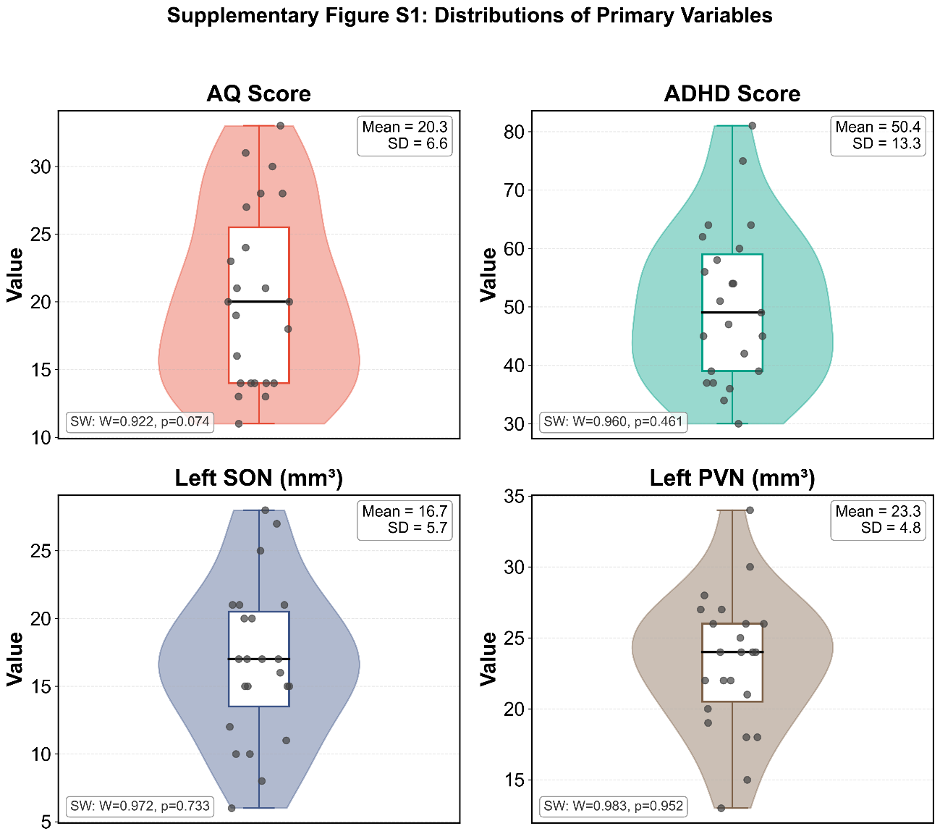

Supplementary Figure 2. Automated hypothalamic subunit segmentation of all subjects. T1-weighted images from multiple participants demonstrate robust and anatomically consistent parcellation of supraoptic nucleus– and paraventricular nucleus–associated subunits across individuals.

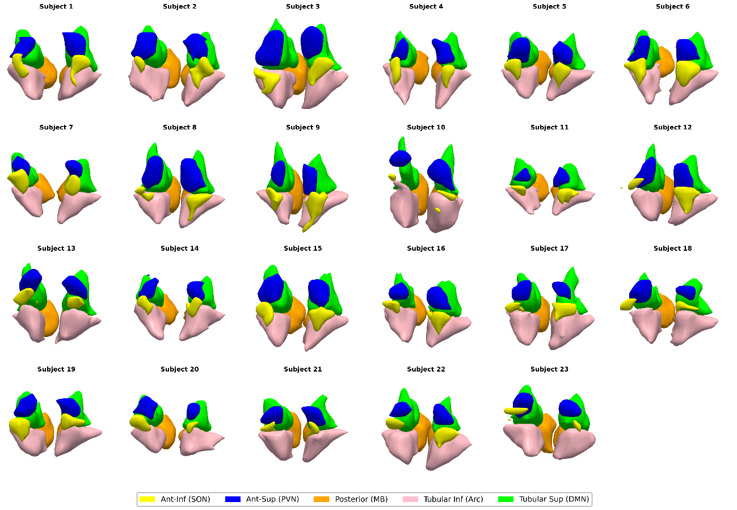
Supplementary Figure 3. Posterior hypothalamic volumes and neurodevelopmental traits. (a) Partial correlation between mammillary body–dominant posterior hypothalamic subunit volume and Autism-Spectrum Quotient scores. (b) Partial correlation between mammillary body–dominant posterior hypothalamic subunit volume and ADHD symptom scores. Both correlations show no significant associations, supporting the anatomical specificity of anterior magnocellular subunit findings. ns, not significant.
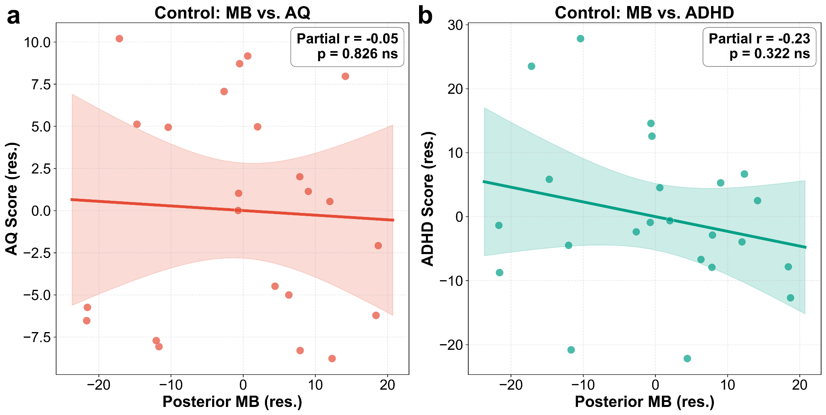

B. Supplementary Tables

Supplementary Table S1. Benjamini-Hochberg FDR results for the full family of 20 exploratory comparisons
Partial correlations were computed for AQ and ADHD across 10 hypothalamic subunits (N = 23), adjusting for Sex_Code, Age, and tiv_cm3. Results are ordered by uncorrected p-value. No comparison survived BH-FDR correction at alpha = 0.05.
Rank | Subunit | Trait | Partial r | Uncorrected p | BH critical value | Survives BH-FDR
1 | Left SON | ADHD | -0.589 | 0.0063 | 0.0025 | No
2 | Left SON | AQ | -0.451 | 0.0462 | 0.0050 | No
3 | Right Arc | AQ | -0.361 | 0.1182 | 0.0075 | No
4 | Left DMN | AQ | -0.302 | 0.1962 | 0.0100 | No
5 | Left PVN | AQ | -0.300 | 0.1992 | 0.0125 | No
6 | Right SON | AQ | -0.267 | 0.2553 | 0.0150 | No
7 | Right PVN | AQ | -0.249 | 0.2895 | 0.0175 | No
8 | Left MB | ADHD | -0.233 | 0.3225 | 0.0200 | No
9 | Left PVN | ADHD | -0.223 | 0.3456 | 0.0225 | No
10 | Right MB | ADHD | 0.206 | 0.3831 | 0.0250 | No
11 | Right SON | ADHD | -0.163 | 0.4934 | 0.0275 | No
12 | Right Arc | ADHD | 0.132 | 0.5791 | 0.0300 | No
13 | Left Arc | ADHD | -0.117 | 0.6232 | 0.0325 | No
14 | Right DMN | AQ | -0.116 | 0.6275 | 0.0350 | No
15 | Right DMN | ADHD | -0.072 | 0.7633 | 0.0375 | No
16 | Left Arc | AQ | -0.062 | 0.7949 | 0.0400 | No
17 | Left DMN | ADHD | -0.057 | 0.8102 | 0.0425 | No
18 | Left MB | AQ | -0.052 | 0.8261 | 0.0450 | No
19 | Right MB | AQ | -0.015 | 0.9491 | 0.0475 | No
20 | Right PVN | ADHD | -0.014 | 0.9522 | 0.0500 | No
Covariates: Sex_Code,Age,tiv_cm3. Abbreviations: AQ, Autism-Spectrum Quotient; ADHD, adult ADHD symptom score; BH-FDR, Benjamini-Hochberg false discovery rate.

Supplementary Table S2. WAIS sensitivity analysis and WAIS-adjusted primary results
WAIS composite was defined as the mean of Processing Speed Index, Verbal Comprehension Index, and Perceptual Organization Index. Section A summarizes WAIS score distributions. Section B reports Pearson correlations between WAIS measures and key study variables. Section C reports partial correlations for the primary analyses before and after inclusion of WAIS composite as an additional covariate.
A. WAIS descriptive statistics
Measure | N | Mean | SD | Min | Max
Processing Speed Index | 23 | 115.1 | 8.8 | 97.0 | 127.0
Verbal Comprehension Index | 23 | 113.1 | 9.1 | 92.0 | 126.0
Perceptual Organization Index | 23 | 111.1 | 11.2 | 91.0 | 130.0
WAIS composite | 23 | 113.1 | 5.9 | 103.0 | 125.0
B. Correlations between WAIS measures and key variables
WAIS measure | Outcome | r | p | N
Processing Speed Index | AQ | -0.151 | 0.491 | 23
Processing Speed Index | ADHD | 0.093 | 0.672 | 23
Processing Speed Index | Left SON volume | 0.008 | 0.971 | 23
Verbal Comprehension Index | AQ | 0.209 | 0.338 | 23
Verbal Comprehension Index | ADHD | -0.034 | 0.878 | 23
Verbal Comprehension Index | Left SON volume | 0.047 | 0.832 | 23
Perceptual Organization Index | AQ | -0.187 | 0.392 | 23
Perceptual Organization Index | ADHD | -0.261 | 0.228 | 23
Perceptual Organization Index | Left SON volume | 0.155 | 0.481 | 23
WAIS composite | AQ | -0.086 | 0.697 | 23
WAIS composite | ADHD | -0.135 | 0.539 | 23
WAIS composite | Left SON volume | 0.125 | 0.57 | 23
C. Primary analyses before and after adjustment for WAIS composite
Analysis | r (Sex+Age+TIV) | p (Sex+Age+TIV) | r (+WAIS composite) | p (+WAIS composite) | Delta r | N
PVN-SON coherence | 0.508 | 0.022 | 0.511 | 0.025 | 0.003 | 23
SON vs AQ | -0.451 | 0.046 | -0.45 | 0.053 | 0.0 | 23
SON vs ADHD | -0.589 | 0.006 | -0.588 | 0.008 | 0.001 | 23
Abbreviations: WAIS, Wechsler Adult Intelligence Scale; AQ, Autism-Spectrum Quotient; ADHD, adult ADHD symptom score; TIV, total intracranial volume. Partial correlations in Section C adjust for Sex, Age, and TIV, with or without WAIS composite as specified.

