Additional file 1

Soil moisture gravity effect at the SG station

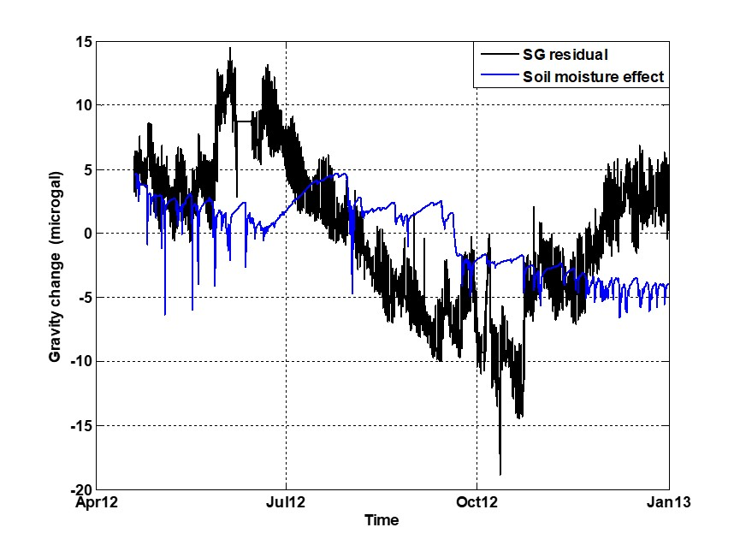

Fig. S1. The observed SG gravity residuals (black) and the modeled soil moisture gravity effects (blue) at Station YMSG. The spikes in the soil moisture effects are caused by anomalous values in the raw moisture measurements. The moisture gravity effects are within $±$5 μGal in 2012 over the TVG area. Here, the SG gravity residuals have been adjusted by the AG data to account for jumps and drifts.

The TVG rainfall data in 2012
Precipitation over the TVG is measured at 14 rain gauge stations installed by the Central Weather Bureau of Taiwan (https://www.cwb.gov.tw/V8/E/P/Rainfall/Rainfall_ QZJ.html). In 2012, most of the rainfall occurred in spring (from April to June) and winter (driven by monsoons and typhoons). Typhoon Saola passed near northern Taiwan from July 31 to August 3 and brought significant precipitation (https://www.jma.go.jp/jma/jma-eng/jma-center/rsmc-hp-pub-e.g./besttrack.html).

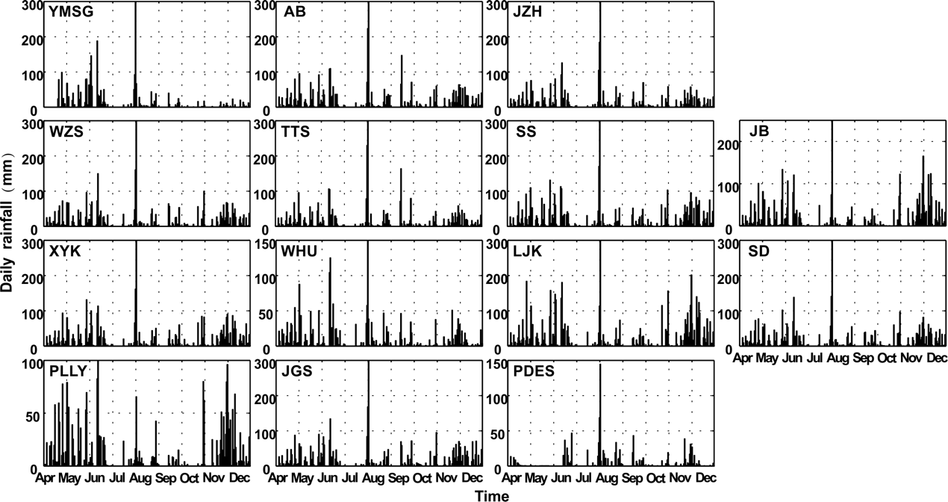
Fig. S2. Rainfall records at 14 stations in the TVG. The station name is indicated in the upper left in each of the plots. The distribution of rain gauge stations can be found in Fig. 1 and Fig. S3.

Hydrogeological parameters used in Model B
In Model B, the hydraulic conductivity parameters (Kx, Ky, Kz), specific yield (Sy), and porosity (%) are related to lithology, which were provided by the databank of the Central Geological Survey. In practice, we adjusted the hydrogeological parameters by comparing the modeled and observed groundwater levels at each well. The tuning process begins with the initial hydraulic conductivities (Kx, Ky, Kz) and is iterated until the modeled groundwater levels have the best possible fit with the observations. We also checked different infiltration coefficients (IC) to obtain groundwater recharge rates that produced the optimal groundwater levels with the observations (Table S1). In practice, specific yield (Sy) and porosity were the last two parameters to be adjusted. The optimal hydraulic parameters used in Model B are presented in Table S1.
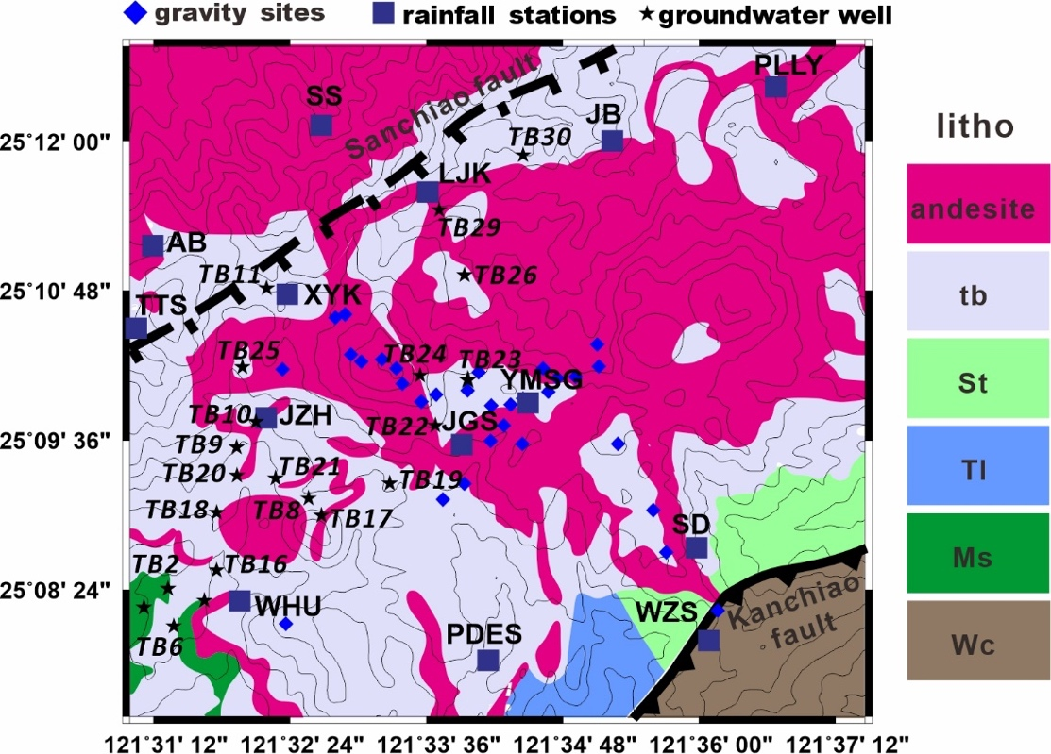
Fig. S3. Geological map of the TVG and the rain gauge stations. The abbreviations of the geological formations are as follows: tb, Tuff breccia; St, Shihti formation; Tl, Taliao formation; Ms, Mushan formation; Wc, Wuchihshan formation. The lava flows from the latest eruption are composed of andesite at the top of the TVG. The initial values of the hydraulic parameters for Model B are given in Table S1.
A brief description of the geological formations (from the Central Geological Survey https://www. moeacgs.gov.tw/eng) is as follows:
Shihti formation (St)
The main rock layers are light gray to white sandstone, gray sandstone, and have gray-black shale interbedded within. Additionally, this layer contains coal.
Taliao Formation (Tl)
This formation comprises a lower mudstone, a middle sandstone, and an upper thin sandstone and contains an interbedded mudstone unit.
Mushan Formation (Ms)
This formation mainly contains white medium-grained to fine-grained ortho-quartz sandstone, mostly in thick layers or blocks. Gray‒black shale is often interbedded with sandstone. This formation contains coal seams and coal mines are located in the Nangang and Dakeng areas.
Wuchihshan Formation (Wc)
This layer is exposed along the Wuzhi ridge, and the rock is mainly white sandstone with shale. The sandstone is composed of medium-grained to coarse-grained quartz sand, and the lower part of this layer occasionally contains very round quartz grains that form well-cemented coarse sandstone.

Table S1: The optimal values of the hydraulic parameters for Model B.
zone | Kx (m/day) | Ky (m/day) | Kz (m/day) | IC | Sy | Porosity (%)
andesite | 0.007 | 0.007 | 0.007 | 0.33 | 0.012 | 15
tb | 0.0058 | 0.0058 | 0.007 | 0.3 | 0.01 | 15
St | 0.01 | 0.01 | 0.02 | 0.45 | 0.03 | 25
Tl | 0.006 | 0.006 | 0.008 | 0.36 | 0.014 | 20
Ms | 0.008 | 0.008 | 0.015 | 0.42 | 0.02 | 25
Wc | 0.04 | 0.04 | 0.07 | 0.5 | 0.3 | 35
Bottom | 0.0005 | 0.0005 | 0.0005 | 0 | 0.001 | 1.2

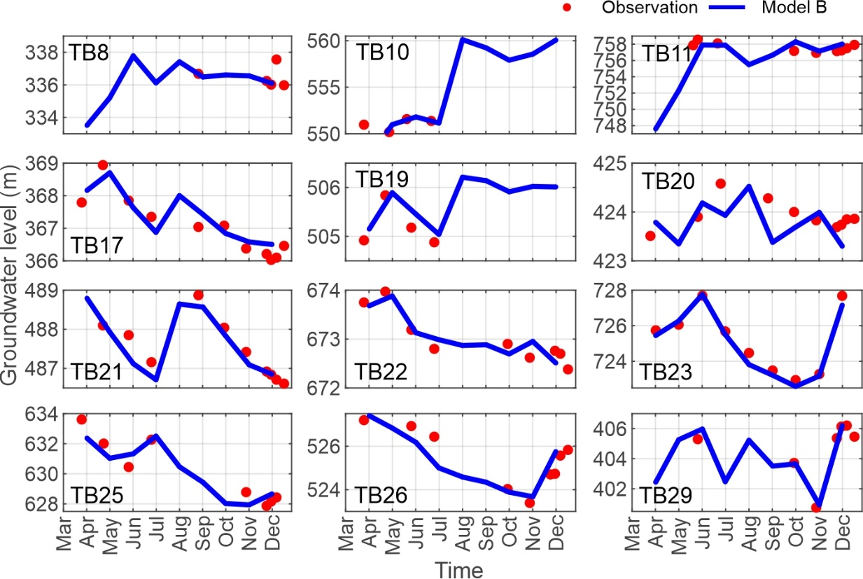
Fig. S4. The groundwater levels for 12 groundwater wells (red dots) and the simulated values from Model B (blue lines). The locations of the groundwater wells and their station codes are presented in Fig. S3. The actual groundwater level variation of the 32 observation wells is 2-6 meters, most of which are within ±2.0 m. Taking a criterion of groundwater level misfit within ±0.5m, concluding from most of the simulated groundwater tables in April from Models A and B, the gravity uncertainties are within ±4.5 μGal. This is already lower than the reading error of our gravity survey (Table 1).

Gravity changes from model predictions and observations
The time series of the observed and modeled gravity changes in 2012 at the gravity sites are shown in Fig. S5. At most of the gravity sites, the maximum gravity changes occurred in June and July, and the minimum changes occurred in September and October.
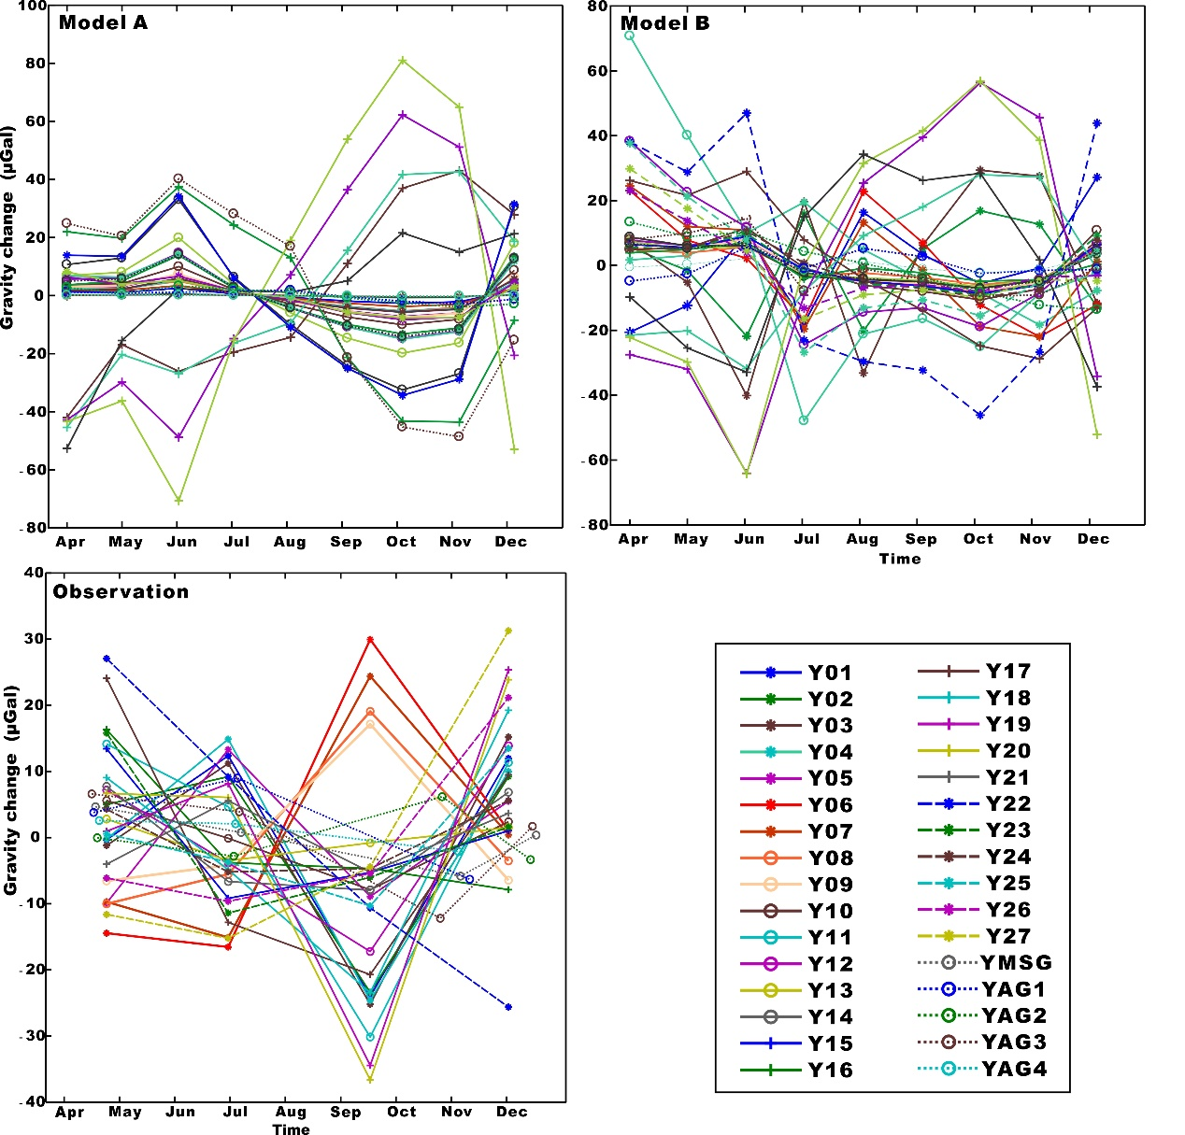
Fig. S5. Time series of gravity changes at the 32 sites from Models A and B and the observations

The second and third EOF modes of the gravity changes

Figure S6 is a supplement to Section 5.2 and Fig. 10 to show the second and third EOF modes from the observed and modeled gravity changes.
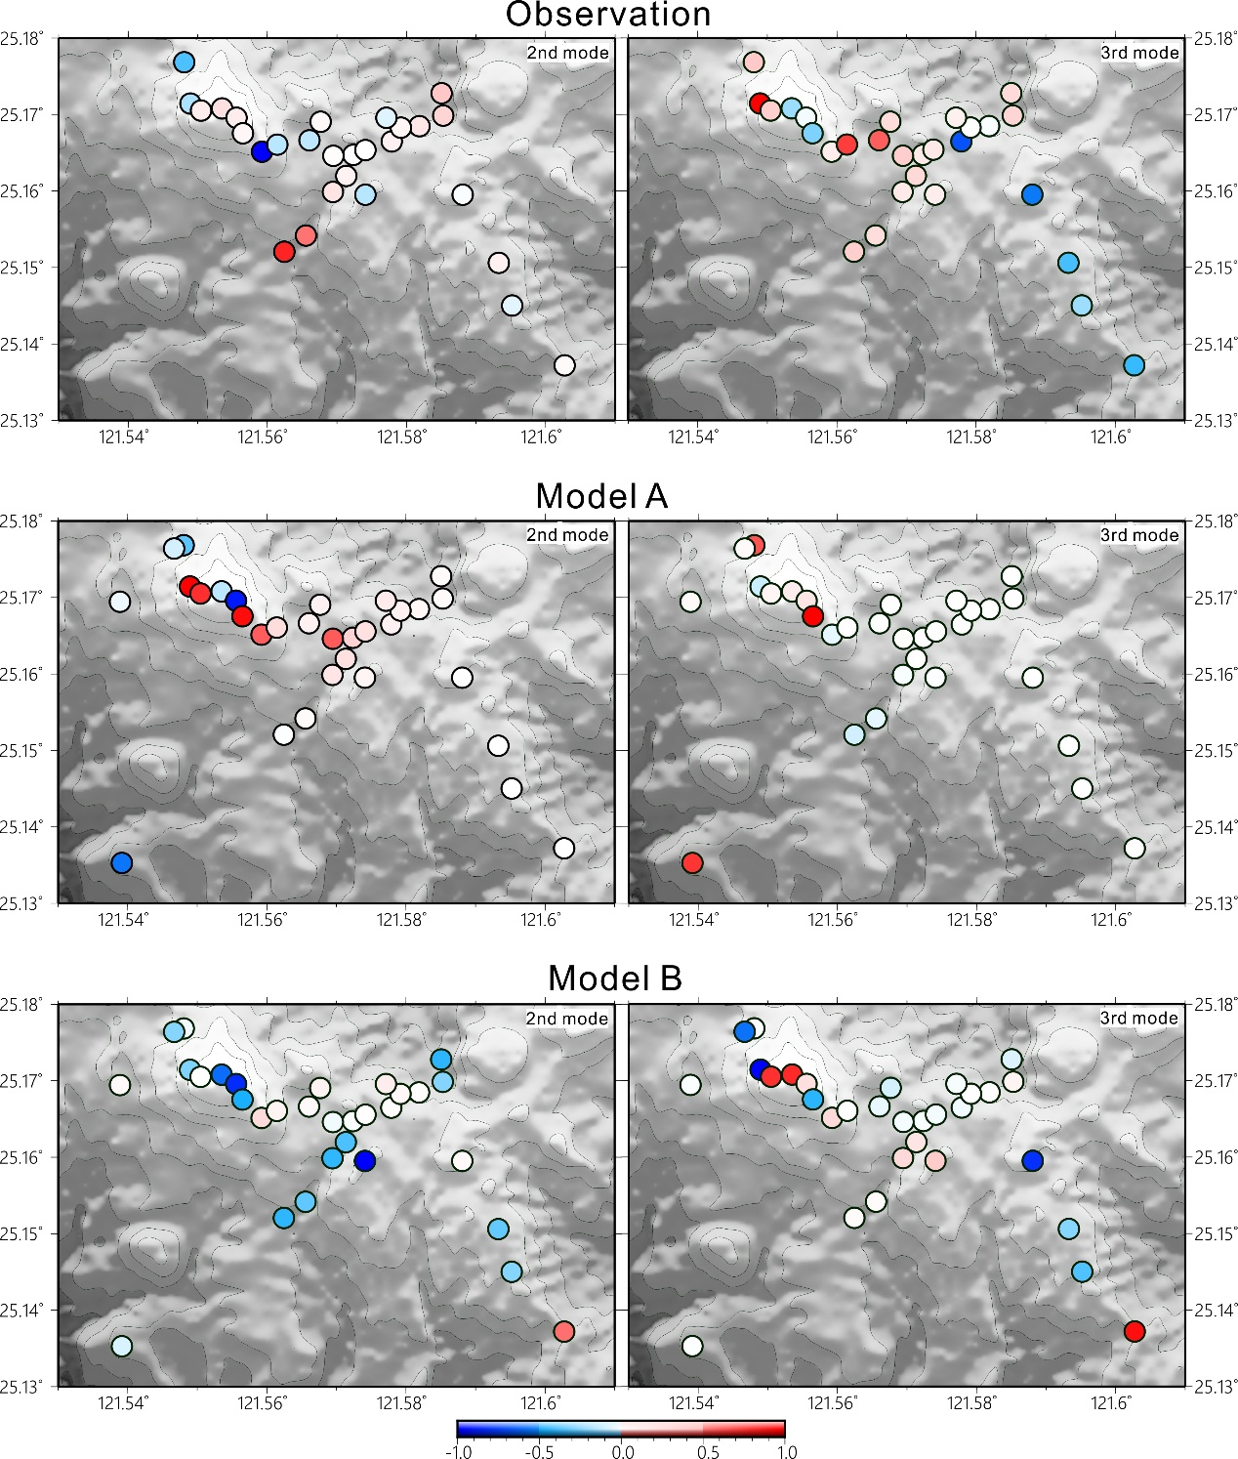
Fig. S6. The second and third EOF modes from the gravity observations and Models A and B.

