1. Principles

1.1. Fourier transform
In a strictly mathematical context, the Fourier transform serves as the transition of an image function into a succession of periodic functions for processing. Regarding its physical implications, the Fourier transform signifies the transition of an image from the spatial domain to the frequency domain, and its inverse transform corresponds to the conversion of an image from the frequency domain back to the spatial domain. Essentially, the physical significance of the Fourier transform is to convert the grayscale distribution function of the image into its frequency distribution function. The Fourier inverse transform reciprocates by converting the frequency distribution function back into the grayscale distribution function. In reality, the two-dimensional Fourier transform of an image to generate a spectrum equates to the distribution of the image gradient, or the Fourier spectrum perceived on contrasting dark and light highlights, or a point on the image and its adjacent points in terms of intensity difference, or the magnitude of the gradient, namely the frequency of the point.
The Fourier transform can be used to transform the signal $x(t)$ from the time domain to the frequency domain by the following equation.
$X\left(w\right)=\int_{-∞}^{+∞}{x(t)e^{-jwt}dt}$ (1)
In the Euler's formula, the imaginary number i and the natural base e are combined in a perfect way in Euler's formula.
$e^{ix}=\cos\left(x\right)+isin(x)$ (2)
In the complex space, $m=a+bi$ can represent a vector in the complex plane with size and direction as follow:
$\left|m\right|=\sqrt{a^{2}+b^{2}}$ (3)
$θ=arctan⁡(\frac{b}{a})$ (4)
In fact, it is similar to the representation of the right-angle coordinate system clock, except that the y-coordinate system is replaced with imaginary numbers.
From Euler's formula, we know that at any position x=k:
$e^{ik}=\cos\left(k\right)+isin(k)$ (5)
So, ${|e}^{ix}|=\sqrt{{\cos^{2}{(k)}+sin}^{2}{(k)}}$ (6)
So $e^{ix}$ represents a complex plane. If x is a function of time t with $x=wt$, then Euler's formula can be written as follow.
$e^{iwx}=\cos\left(wx\right)+isin(wx)$ (7)
This is dynamically equivalent to a small ball moving in a circular motion around the unit circle in the complex plane, and statically equivalent to decomposing the position of the ball in the coordinate system.
The essence of the Fourier transform can then be expressed as multiplying the original signal by a set of trigonometric functions. After this, it is integrated over the entire time domain. The Fourier transform can be written as follows.
$X\left(w\right)=\int_{-∞}^{+∞}{x\left(t\right)\cos\left(wt\right)-jx(t)sin⁡(wt)dt}$ (8)
In this study, we employ the Fourier transform as a means to safeguard the confidentiality of images, rendering them unidentifiable to the unaided eye, while preserving their usability for model training and recognition tasks. Conventionally, privacy safeguards have revolved around data encryption and decryption techniques, though these prove to be less efficacious for applications involving neural networks. To address this, we've incorporated a privacy-conservation strategy anchored in Fourier high-channel filtering. To ensure the protection of the innate characteristics of the entities being analyzed, we've conceptualized a dedicated image feature processing module, visually represented in Figure 3.
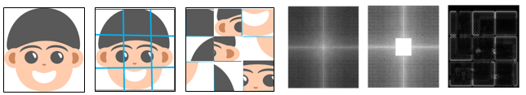
Figure 3. Diagram of privacy protection.
In the preliminary stage, the image is partitioned into a myriad of minute segments and reconfigured. This process amplifies the difficulty in visual recognition for humans, however, it does not inhibit the capacity of AI models to discern these images. Artificial Intelligence models analyze these images via convolution procedures, in which the image is segregated into an assortment of discrete feature images. Hence, this approach predominantly impacts human cognition, while leaving computational analysis unaffected.
In the ensuing stage, we utilize the Fourier transform methodology to expunge the image's low-frequency constituents. Within the realm of image analysis, low-frequency constituents generally signify the image's texture and color, while high-frequency constituents denote edges and pixel-intense regions. Object recognition is contingent on the high-frequency constituents, and thus these are preserved while the low-frequency constituents are eliminated.
The final images, bereft of their low-frequency data, are depicted on the extreme right of Figure 3. These images present themselves as a matrix of small black squares. Notwithstanding the alterations, AI models can still exploit these images for the detection of the inherent information.

1.2. CNN
The genesis of Convolutional Neural Networks (CNNs) can be tracked back to the 1980s, propelled by the necessity to decipher intricate image recognition tasks. Early milestones in the journey of CNNs were reached in the 1990s when luminaries such as Yann LeCun pioneered the LeNet-5 architecture dedicated to handwritten digit identification [1]. However, the ubiquitous acceptance and triumph of CNNs emerged in the 2010s, bolstered by the proliferation of large-scale datasets and strides in computational prowess. The 2012 ImageNet competition saw CNNs distinguishing themselves by virtue of their superior accuracy [2]. CNNs have garnered considerable attention, primarily due to their transformative impact on the domain of computer vision. They are the bedrock enabling deep learning to accomplish groundbreaking outcomes in the field of computer vision in recent times
The key principles behind CNNs are inspired by the visual processing mechanism of the human brain. CNNs are designed to automatically learn and extract meaningful features from input images or other grid-like data, such as spectrograms or time series. These networks consist of interconnected layers that perform operations such as convolution, pooling, and non-linear activation to progressively learn more complex representations.
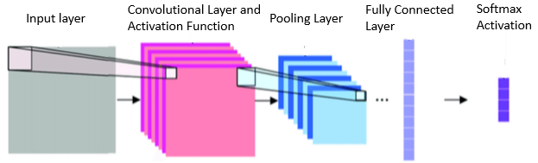
Figure 4. Schematic diagram of the CNN structure.
The main components and principles of CNNs are as shown in Figure 4.
Convolutional Layer. The convolutional layer applies a set of learnable filters (kernels) to the input image. Each filter performs convolution, which involves sliding across the input, multiplying the filter's weights with the overlapping input pixels, and producing a feature map that represents the activation of that filter. This operation captures local spatial patterns in the input. We often use matrix convolution to calculate the features of images.
Activation Function. Following the convolution procedure, an activation function such as the Rectified Linear Unit (ReLU) is deployed element-wise to instill non-linearity and amplify the network's aptitude to discern intricate correlations within the data.
Pooling Layer. The pooling layer diminishes the spatial dimensions of the feature map from the preceding layer, retaining crucial information. Typical methods include max pooling or average pooling operations, which downsample the input by extracting the maximal or average value over minor regions of the feature map, aiding in computational reduction and spatial invariance achievement.
Fully Connected Layer. The fully connected layer ingests the high-level features discerned by previous layers and executes a sequence of matrix multiplications to determine class probabilities or regression values. Every neuron in the preceding layer is connected to every neuron in the existing layer, enabling the network to perceive global dependencies.
Softmax Activation. In tasks related to classification, the softmax activation function is usually employed in the final layer to regularize the output into a probability distribution over potential classes.
The fundamental principles of CNNs facilitate them to autonomously learn and represent vital visual features hierarchically at disparate levels of abstraction. Lower layers encapsulate rudimentary features like edges and textures, while the more profound layers capture intricate features and semantic information.
To instruct CNNs, a substantial labeled dataset is needed. The network learns by modifying the weights of the filters and fully connected layers via backpropagation and gradient descent optimization techniques. The loss function quantifies the variance between the predicted output and the actual labels, and gradients are propagated backward to update the weights, iteratively augmenting the network's performance.
Through the years, CNNs have exhibited remarkable performance across numerous computer vision tasks, encompassing image classification, object detection, segmentation, and even complex tasks like image captioning and visual question answering. Their ability to learn hierarchical representations autonomously from raw data has rendered them a pivotal element of contemporary deep learning and has revolutionized the field of computer vision.

1.3. Attention Mechanism
Attention mechanism [3] is a method in machine learning that is inspired by the human visual attention mechanism. It suggests that we do not treat all information in front of us equally, but focus our attention on certain key parts. Within neural networks, it allows models to 'focus' on specific parts of input data, while ignoring others.
The core idea of the attention mechanism is to calculate a value called attention weight (or score), which determines which parts of the data the model should focus on while processing. This process is often accomplished through a mathematical operation known as 'dot product'. By this means, the attention mechanism can help the model to focus more on important information, and ignore irrelevant or secondary information. The attention mechanism is a powerful and flexible tool that can enhance the performance of many machine learning models.

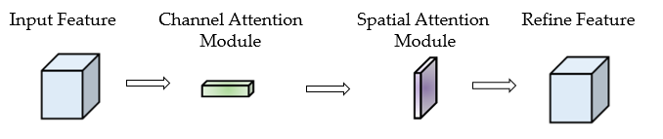
Figure 5. CBAM schematic diagram
CBAM (Convolutional Block Attention Module) [4] is a highly effective attention mechanism used in deep learning. Attention mechanisms, in general, improve model performance by allowing the model to focus on the most important parts of the input for the task at hand. CBAM does this specifically for CNN, which are used primarily for image-related tasks.
CBAM is comprised of two sub-modules: a channel attention module and a spatial attention module, as seen in Figure 5.
Channel Attention Module: This module computes the importance of each feature channel. It does this by using global average pooling and global max pooling to create two different descriptions of the input. These descriptions are then fed through shared network layers to produce a channel attention map. The channel attention map is used to rescale the feature channels of the original input.
Spatial Attention Module: This module computes the importance of each spatial location, emphasizing where important features are located. It uses the output of the channel attention module, applies a convolution operation to it, and generates a spatial attention map. The input features are then rescaled according to this spatial attention map.
In other words, the Channel Attention Module focuses on 'what' is meaningful from a feature perspective, and the Spatial Attention Module focuses on 'where' it is meaningful in the spatial dimension. The two modules can be applied sequentially or in parallel, offering flexibility in model design. The result is an effective and computationally efficient way to adaptively recalibrate feature maps, helping models focus on the most relevant features and spatial locations for the task at hand.
CBAM has been shown to significantly improve the performance of convolutional neural networks on a variety of image-related tasks and it is a lightweight, general-purpose module. CBAM can be seamlessly integrated into any CNN architecture with negligible additional overhead. In this study, the CBAM model is cascaded to the model to improve the model detection accuracy with almost no increase in model size.

1.4. K-means
The technique of cluster analysis forms a vital cornerstone in the domain of data mining, with its primary objective being the extraction of meaningful and hidden insights from within data entities. Predicated on the tenet of similarity, cluster analysis amalgamates data entities exhibiting substantial likeness into identical clusters, while concurrently segregating entities of marked unlikeness into disparate clusters. This ensures an increased congruity among data points within a singular cluster, relative to those residing in alternate clusters.
The K-means algorithm is a typical partition-based clustering algorithm and an unsupervised learning algorithm. For a given dataset, the K-Means algorithm utilizes the Euclidean distance as a measure of similarity between data objects. Similarity is inversely proportional to the distance between data objects, with higher similarity corresponding to smaller distances.
The core idea of the K-means algorithm is as follows:
First, randomly select k initial cluster centers $C_{i}（1≤i≤K）$from the dataset. Then, calculate the Euclidean distance between the remaining data objects and the cluster center $C_{i}$. Assign each data object to the cluster center $C_{i}$ that is closest to it. Next, calculate the average value of data objects within each cluster as the new cluster center and proceed to the next iteration. Repeat this process until the cluster centers no longer change or the maximum number of iterations is reached, at which point the algorithm stops.
The Euclidean distance between the data object and the cluster center in space is calculated as:
$d\left(X,C_{i}\right)=\sqrt{\sum_{j=1}^{m}{{(X_{j}-C_{ij})}^{2}}}$ (9)
Where X is the data object; $C_{i}$ is the ith clustering center; m is the dimension of the data object; $X_{j}$, $C_{ij}$ is the jth attribute value of X and $C_{i}$.
The sum of squared errors of the data set SSE is calculated as:
$SSE=\sum_{i-1}^{k}{{\sum_{X∈C_{i}}{\left|d(X,C_{i})\right|}}^{2}}$ (10)
Among them, k represents the number of clusters; the size of SSE indicates the quality of the clustering results, and a smaller SSE value after multiple iterations indicates a better clustering result.
The value of k needs to be predetermined and is considered prior knowledge. In many cases, estimating the value of k can be very challenging. For the engineering design laboratory teaching scenario studied in this paper, as the courses vary, we are uncertain about the normal values of mouse and keyboard operation frequencies. However, the K-Means algorithm is well-suited for scenarios where the value of k is not expected to be excessively large.

2. Description of main function modules
There are three function modules in the solution, privacy protection, emotional recognition model, and cluster model.

2.1. Privacy protection
The privacy protection module processes the image in a form that cannot be recognized by the naked eye, but it does not affect the image being trained and recognized by AI models.
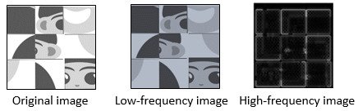
Figure 7. Image privacy protection processing.
As illustrated in Figure 7, low-frequency images appear more akin to the original images compared to high-frequency ones. This can be attributed to human sensitivity towards low-frequency images being markedly higher. Consequently, high-frequency images bolster model training, while simultaneously enhancing the challenge of unaided human recognition. Through this methodology, we can proficiently safeguard the privacy of the images without compromising the quality of image recognition.

2.2 Emotional recognition model
This study proposes a high-performance vision model that can respond quickly, and has high accuracy. We named the model as ERAM (Emotional Recognition with Attention Mechanism). The structure of the ERAM model is shown in Figure 8.
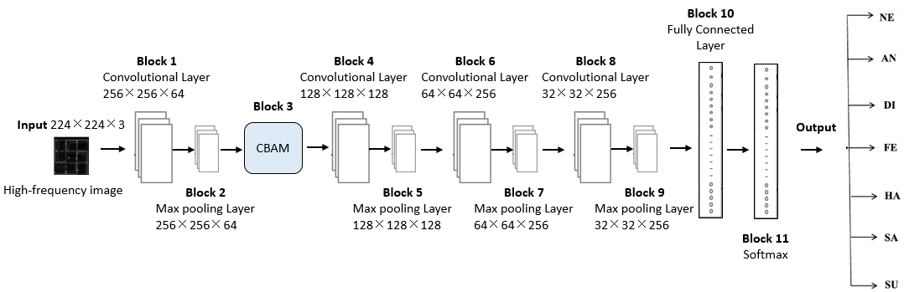
Figure 8. Structure of ERAM model.
- Input
Within the privacy protection module, harvested images are segmented into dimensions of 224×224×3 based on facial criteria. Numerous public sentiment recognition datasets conform to this size. We adapt our input to the 224×224×3 dimensions, thereby facilitating the incorporation of a public dataset in the training process.
- Block 1
Convolution forms the most prevalent operation in the realm of neural networks. Block 1 constitutes a convolutional layer that is designed to extract distinctive features from the input data.
- Block 2
Block 2 is a pooling layer, designed to condense the spatial dimensions of the feature map from the prior layer whilst preserving crucial information. We employ max-pooling, which captures the maximum value from the feature points in the vicinity. Max-pooling proficiently retains texture features, reduces data dimensionality, amplifies computational efficiency, augments model robustness, and mitigates overfitting.
- Block 3
The CBAM is a versatile, low-footprint module that can be seamlessly embedded into any neural network architecture with minimal additional computational load. Typically, CBAM parameters number around 0.1 million, allowing it to elevate the precision of lightweight models without increasing the model's size. CBAM retains input dimensions and can be smoothly integrated into the network model. Within the ERAM, CBAM is appended following the convolutional layer to enhance the model's accuracy.
- Block 4 – Block 9
Blocks 4 through 9 constitute three pairings of convolutional layers and max-pooling layers, mirroring the effects of Block 1 and Block 2, albeit with variant filter sizes.
- Block 10
Block 10 is a fully connected layer that efficiently translates the two-dimensional feature map produced by the convolutional output into a one-dimensional vector. The output generated by this fully connected layer comprises a collection of finely curated features that are subsequently channelled into the final classification or regression process.
- Block 11 (Output layer)
The output layer utilizes the softmax function. In scenarios featuring multi-classification tasks, the softmax function acts as the activation function for the neural network output layer, empowering the model to generate probability values that correspond to potential category affiliations of the sample.

2.3 Cluster model
The clustering model used here is the K-Means algorithm. In computer laboratory teaching, due to variations in courses and differences in the difficulty of practical assignments, we are uncertain about the normal range of keyboard and mouse operation frequencies. Therefore, in this application scenario, using a threshold-based method for determining anomalies is not feasible. The K-Means algorithm is a typical partition-based clustering algorithm and an unsupervised learning algorithm. Unsupervised clustering algorithms can be effectively applied to this scenario. For example, a class typically consists of 40-60 students. We can set the value of k as 6 for clustering calculations, which means dividing the computer operation frequencies of all students into 6 clusters. Among these clusters, the one with the fewest members is considered the anomalous class and the students within it require attention.

References
- Lecun Y , Bengio Y . Convolutional Networks for Images, Speech, and Time-Series [J]. Handbook of Brain Theory & Neural Networks, 1995.
- Krizhevsky A , Sutskever I , Hinton G . ImageNet Classification with Deep Convolutional Neural Networks [J]. Advances in neural information processing systems, 2012, 25(2).
- Mnih V, Heess N, Graves A. Recurrent models of visual attention [J]. Advances in neural information processing systems, 2014, 27.
- Woo S, Park J, Lee J Y, et al. Cbam: Convolutional block attention module[C]//Proceedings of the European conference on computer vision (ECCV). 2018: 3-19.

