Supplementary
- Fig S1: Distribution of CCI in all COVID-19 patients
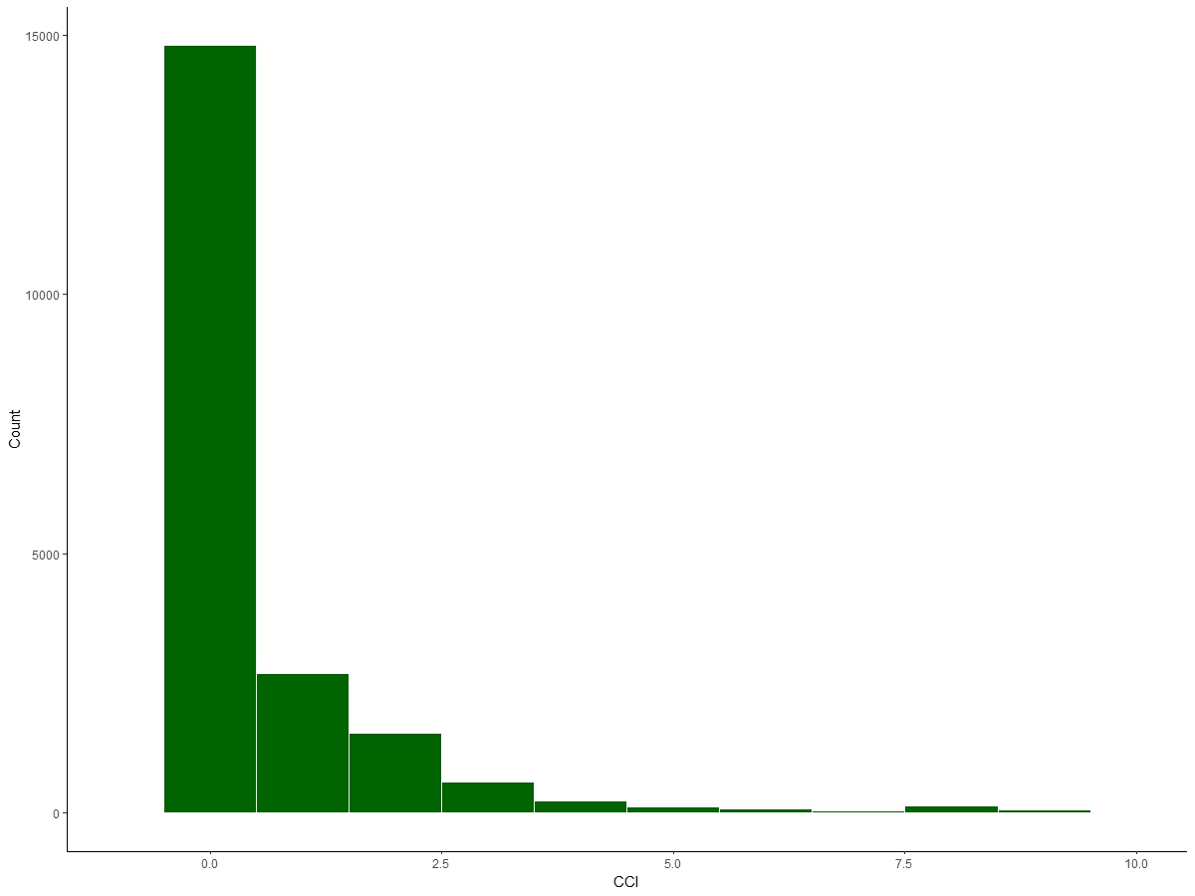
- Fig S2: Colocalization of eQTL and GWAS pairs
A: SLC6A20 region in Breast Mammary Tissue; B: SLC6A20 region in Esophagus Muscularis tissue; C: SLC6A20 region in Muscle Skeleta tissue; D: SLC6A20 region in Nerve Tibial tissue; E: LZTFL1 region in Testis tissue
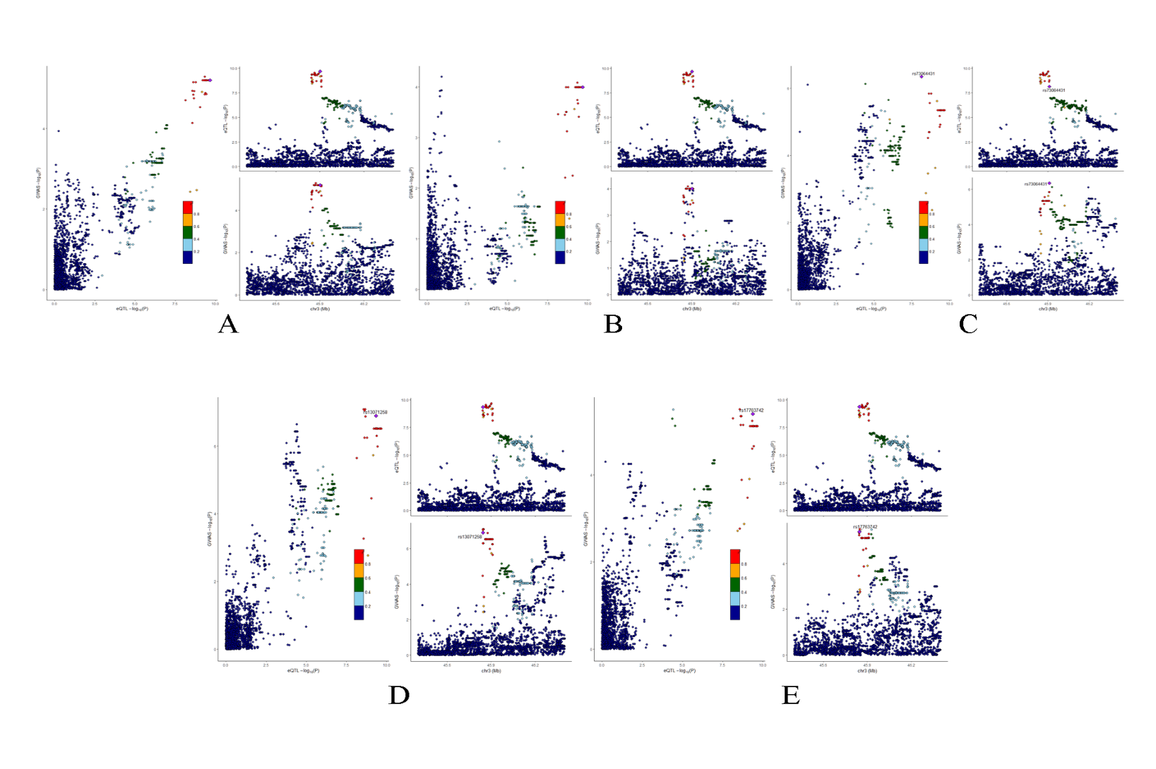
- Fig S3: Distribution and classification of PRS in COVID-19 cases
