Supplementary Figure 1: Clinical signs at admission, diagnosis at discharge based on clinical status at admission and/or at follow-up and on results of diagnostic tests locally available, and positive pathogens detected by real-time PCR in the blood among 286 included patients
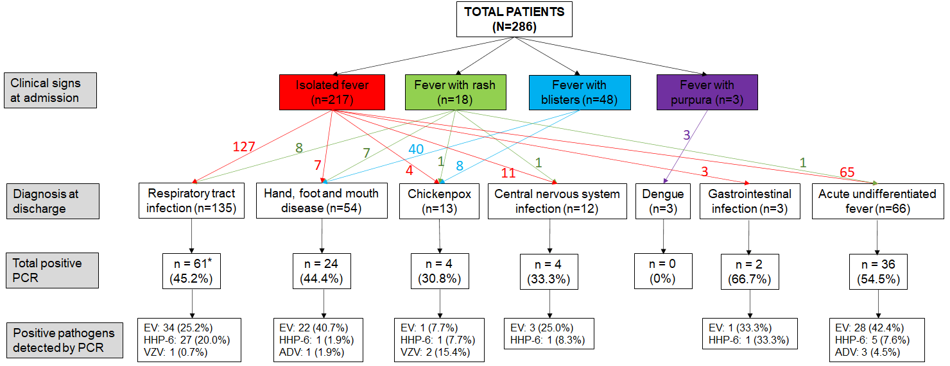
* One patient was co-infected with enterovirus and human herpesvirus 6; HHP-6: human herpesvirus 6; EV: enterovirus; VZV: varicella zoster virus

