Supplementary Data
- DNA extraction from isolates collected in Ukraine
  - Isolates collected between November 2009 and May 2014
To extract and purify high-quality genomic DNA for next-generation sequencing, commercially available (para)magnetic- (Maxwell 16 Cell DNA Purification kit, Promega, Madison, WI, USA; NucliSENS easyMag, Biomerieux, Marcy l'Etoile, France), and column-based (QIAamp DNA Mini Kit, Qiagen, Hilden, Germany) systems, or CTAB (N-cetyl-N,N,N-trimethyl ammonium bromide)/NaCl protocol were used according to manufacturer’s instructions and published procedures.
  - Isolates from prison inmates obtained from V.N. Karazin Kharkiv National University, Kharkiv, Ukraine
These were sequenced using the following protocol: genomic DNA was extracted using 1 mL of MGIT culture, a lysis buffer (NaCl, Triton, EDTA, TRIS), and protease K. The heat inactivation step was performed at 95°C/30 minutes. Total DNA was purified using the Promega Maxwell 16-cell DNA purification kit (AS1020), and the final concentration was quantified by a Qubithigh sensitivity DNA assay (Life Technologies) spectro-photometer with a fluorescent detection system (Qubit 3.0 Fluorometer). A library preparation was performed by the Nextera XT DNA Library prep kit (Illumina, San Diego). All isolates were sequenced on the Illumina NextSeq500 System (Illumina) according to the manufacturer’s instructions.
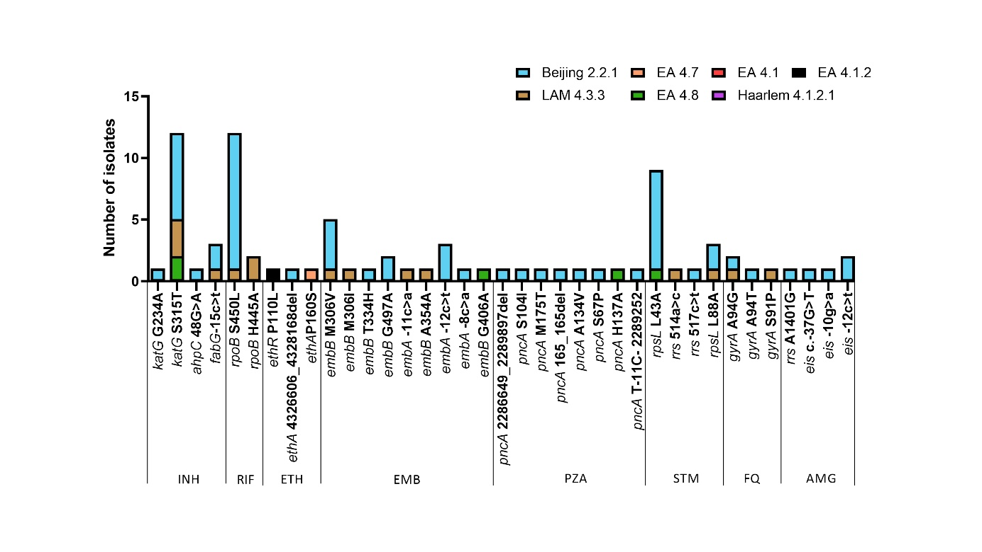
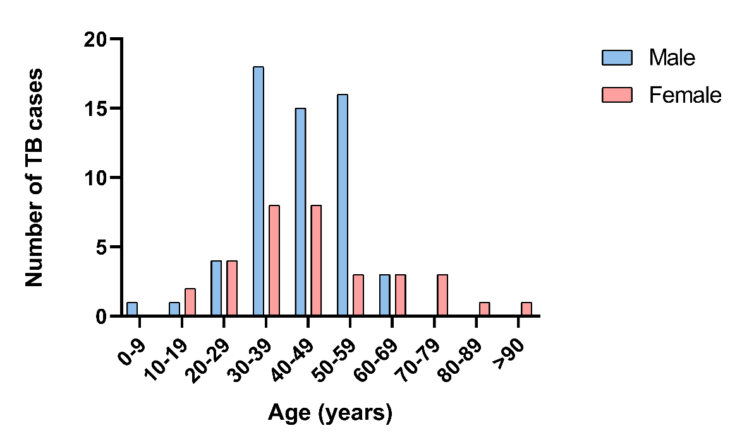
Supplementary Figure 1. Number of reported TB cases in Ukrainian refugees and migrants, by age group and sex, in the Czech Republic and Slovakia.
Supplementary Figure 2. Correlation of genotypic drug resistance and phylogenic lineages of Mtb isolates among Ukrainian refugees and migrants. INH, isoniazid; RIF, rifampicin; EMB, ethambutol; ETH, ethionamide; PZA, pyrazinamide; STM, streptomycin; FQ, fluoroquinolones; AMG, aminoglycosides; PAS, para-aminosalicylic acid; EA, Euro-American; LAM, Latin American Mediterranean
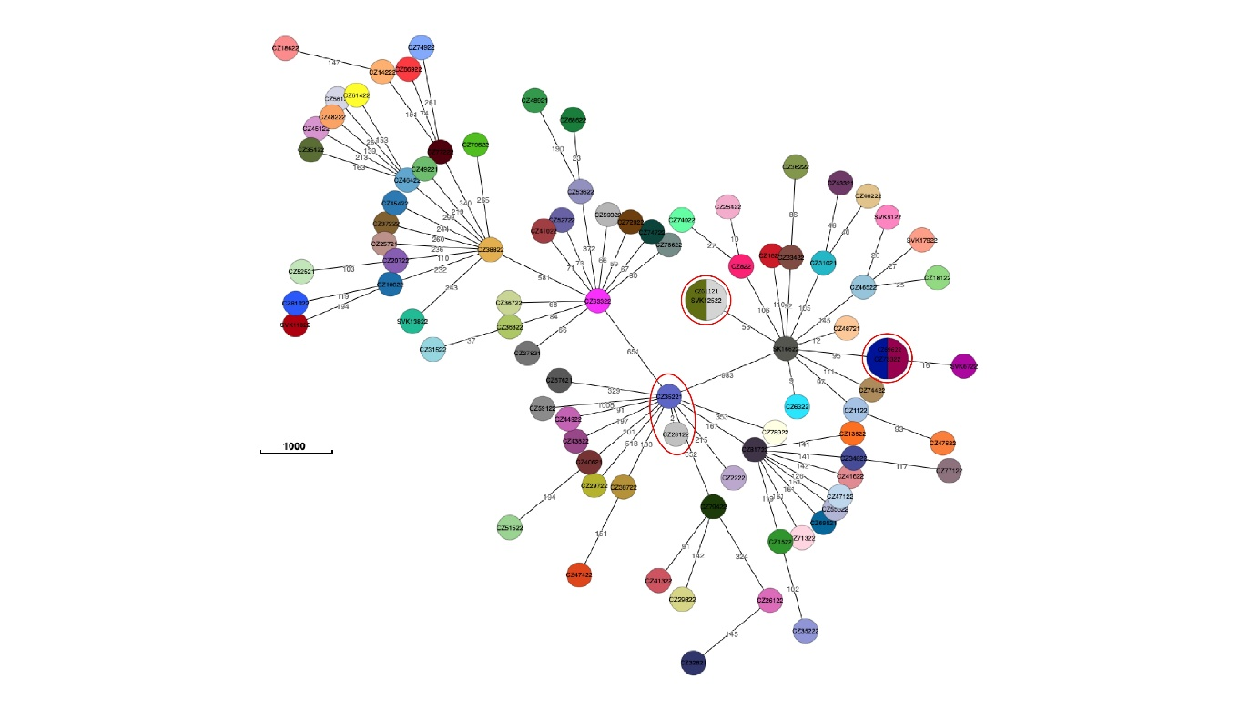
Supplementary Figure 3. Minimum spanning tree based on a maximum of 5 SNPs difference between the 91 strains isolated from Ukrainian war refugees and migrants during the study period

