Title: Age-specific multimorbidity patterns and burden on all-cause mortality and public direct medical expenditure: a retrospective cohort study

Short title: Age-specific multimorbidity patterns and outcomes
Authors: Sabrina Nan Hong¹†, Francisco Tsz Tsun Lai, PhD^{2,3}†, Boyuan Wang, MPH¹, Edmond Pui Hang Choi, PhD⁴, Ian Chi Kei Wong, PhD^{2,3}, Cindy Lo Kuen Lam, MD^{1,5}, Eric Yuk Fai Wan, PhD^{1,2*}

Affiliations:
- Department of Family Medicine and Primary Care, School of Clinical Medicine, Li Ka Shing Faculty of Medicine, The University of Hong Kong, Hong Kong SAR, China
- Centre for Safe Medication Practice and Research, Department of Pharmacology and Pharmacy, Li Ka Shing Faculty of Medicine, The University of Hong Kong, Hong Kong SAR, China
- Laboratory of Data Discovery for Health (D24H), Hong Kong Science Park, Hong Kong Science and Technology Park, Hong Kong SAR, China
- School of Nursing, Li Ka Shing Faculty of Medicine, The University of Hong Kong, Hong Kong SAR, China
- Department of Family Medicine, the University of Hong Kong Shenzhen Hospital, The University of Hong Kong, Hong Kong SAR, China
†Co-first author
*Corresponding author:
Dr Eric Yuk Fai Wan
Department of Family Medicine and Primary Care,
Li Ka Shing Faculty of Medicine,
The University of Hong Kong,
Hong Kong
Email: yfwan@hku.hk

Journal name: Journal of epidemiology and global health

Supplementary Table 1. ICPC-2 and ICD10 codes for the chronic conditions
Chronic conditions | ICD9CM | ICPC-2 | ICD10
Alcohol misuse | 265.2 291.1/291.3 291.5/291.9 303.0 303.9 305.0 357.5 425.5 535.3 571.0/571.3 980 V11.3 | P15 | E52, F10.96, F10.27, F10.951, F10.950, F10.99, G62.1, I42.6, K70.0, K70.30, K70.9, Z65.8
Asthma | 493 | R96 | J45
Atrial fibrillation | 427.3 | K78 | I48
Cancer
Cancer lymphoma | 200/202 203.0 238.6 | B72 | C81-C96
Cancer metastatic | 196/199 | B74 D74 D76 D77 L71 N74 S77 T71 U75 U76 U77 W72 X77 Y78 | C76-C80
Cancer non/metastatic (breast cervical colorectal lung prostate) | 153/154 162/163 174 180 185 230.3/230.6 231.2 233.0/233.1 233.4 | D75 R84 X75 X76 Y77 | C50, C53, C18, C34, C61
Chronic heart failure | 398.91 402.01 402.11 402.91 404.01 404.03 404.11 404.13 404.91 404.93 425.4/425.9 428 | K77 | I50
Chronic kidney disease | 583 584 585 586 592 593.9 | U14 | N18
Chronic pain | 307.80 307.89 338.0 338.2 338.4 719.41 719.45/719.47 719.49 720.0 720.2 720.9 721.0/721.4 721.6 721.8 721.9 722 723.0 723.1 723.3/723.9 724.0/724.6 724.70 724.79 724.8 724.9 729.0/729.2 729.4 729.5 | A01 | G89.21, G89.28, G89.29, G89.4, B02.22, B02.29, G03.9, G90.511, G90.512, G90.513, G90.521, G90.522, G90.523, G90.529, G90.59, G89.0, G96.12, G54.0, G54.1, G54.6, G54.8, G54.4, G56.40, G56.41, G56.42, G56.80, G56.90, G56.91, G56.92, G57.70, G57.71, G57.72
Chronic pulmonary disease | 416.8 416.9 490/492 494/505 506.4 508.1 508.8 | R95 | J40-J47
Cirrhosis | 571.2 571.5 571.6 456.0 456.1 456.20 456.21 567.0 567.2 567.21 567.29 567.8 567.9 572.2 572.4 789.5 (Exclude 567.81 567.82 789.51) | / | K74
Dementia | 290 294.1 331.2 | P70 | F01, F02, F03
Depression | 296.2 296.3 296.5 300.4 309 311 | P76 | F32
Diabetes | 250 | T89/T90 | E08-E13
Hypertension | 401/405 | K86 K87 | I10-I16
Hypothyroidism | 240.9 243 244 246.1 246.8 | T86 | E02, E03
Myocardial infarction | 410 | K75 | I21, I22, I23
Peptic ulcer disease | 531.7 531.9 532.7 532.9 533.7 533.9 534.7 534.9 | D86 | K25-K28
Peripheral vascular disease | 440.2 | K92 | I70.2
Rheumatoid arthritis | 446.5 710.0/710.4 714.0/714.2 714.8 725 | L88 | M05, M06
Schizophrenia | 295 | P72 | F20
Severe constipation | 560.1 560.30 560.39 560.9 564.0 569.83 569.89 (Exclude 152/154 158 179/189 197.5/197.6 235.2 239.0 555/556 568.0 614.6 (560.9 if 789.01 789.02 789.06)) | D12 | K56.0, K56.7, K56.49, K56.600, K56.601, K56.609, K59.00, K63.1, K63.4, K63.89
Stroke or transient ischemic attack | 362.3 430 431 433.01 433.11 433.21 433.31 433.81 433.91 434.01 434.11 434.91 435 436 | K90 | I60, I61, I62, I63.22, I63.139, I63.239, I63.019, I63.119, I63.219, I63.59, I63.20, I63.30, I63.40, I63.50, G45.0, G45.8, G45.1, G45.9, I67.848, I67.59

Supplementary Table 2. Public health services charges
 | HKD ($) | USD ($)
General ward | 4680 | 608.4
Accident & Emergency Department | 990 | 128.7
Specialist clinic | 1110 | 144.3
General clinic | 385 | 50.1
Allied health | 550 | 71.5
Conversion of HKD to USD is based on the exchange rate of 1:0.13.

Supplementary Table 3. Trend of morbidity count from 2009 to 2018
Year 2009 | Prevalence |  |  | Year 2014 | Prevalence
No. of conditions | 0-1 | ≥2 |  | No. of conditions | 0-1 | ≥2
Overall | 1970087 (85.98%) | 321196 (14.02%) |  | Overall | 2043953 (80.31%) | 501281 (19.69%)
Age <50 | 934581 (98.09%) | 18225 (1.91%) |  | Age <50 | 856085 (96.98%) | 26674 (3.02%)
Age 50-64 | 591447 (87.09%) | 87650 (12.91%) |  | Age 50-64 | 706618 (82.97%) | 145066 (17.03%)
Age 65-79 | 325187 (70.21%) | 137999 (29.79%) |  | Age 65-79 | 350187 (63.89%) | 197931 (36.11%)
Age ≥80 | 118872 (60.59%) | 77322 (39.41%) |  | Age ≥80 | 131063 (49.90%) | 131610 (50.10%)
Year 2010 | Prevalence |  |  | Year 2015 | Prevalence
No. of conditions | 0-1 | ≥2 |  | No. of conditions | 0-1 | ≥2
Overall | 1972897 (84.45%) | 363176 (15.55%) |  | Overall | 2055778 (79.55%) | 528581 (20.45%)
Age <50 | 909440 (97.81%) | 20400 (2.19%) |  | Age <50 | 840665 (96.84%) | 27461 (3.16%)
Age 50-64 | 622172 (85.97%) | 101535 (14.03%) |  | Age 50-64 | 717524 (82.48%) | 152393 (17.52%)
Age 65-79 | 319291 (68.02%) | 150116 (31.98%) |  | Age 65-79 | 365287 (63.58%) | 209202 (36.42%)
Age ≥80 | 121994 (57.24%) | 91125 (42.76%) |  | Age ≥80 | 132302 (48.67%) | 139525 (51.33%)
Year 2011 | Prevalence |  |  | Year 2016 | Prevalence
No. of conditions | 0-1 | ≥2 |  | No. of conditions | 0-1 | ≥2
Overall | 1982314 (83.24%) | 399192 (16.76%) |  | Overall | 2057833 (78.76%) | 554866 (21.24%)
Age <50 | 895580 (97.55%) | 22481 (2.45%) |  | Age <50 | 819555 (96.69%) | 28070 (3.31%)
Age 50-64 | 643427 (85.01%) | 113484 (14.99%) |  | Age 50-64 | 722407 (81.96%) | 159056 (18.04%)
Age 65-79 | 319495 (66.43%) | 161463 (33.57%) |  | Age 65-79 | 381480 (63.33%) | 220862 (36.67%)
Age ≥80 | 123812 (54.89%) | 101764 (45.11%) |  | Age ≥80 | 134391 (47.78%) | 146878 (52.22%)
Year 2012 | Prevalence |  |  | Year 2017 | Prevalence
No. of conditions | 0-1 | ≥2 |  | No. of conditions | 0-1 | ≥2
Overall | 2025249 (82.29%) | 435812 (17.71%) |  | Overall | 2049849 (77.92%) | 580730 (22.08%)
Age <50 | 896389 (97.35%) | 24368 (2.65%) |  | Age <50 | 791668 (96.48%) | 28882 (3.52%)
Age 50-64 | 673824 (84.34%) | 125079 (15.66%) |  | Age 50-64 | 722457 (81.45%) | 164558 (18.55%)
Age 65-79 | 327995 (65.33%) | 174093 (34.67%) |  | Age 65-79 | 399336 (63.16%) | 232936 (36.84%)
Age ≥80 | 127041 (53.09%) | 112272 (46.91%) |  | Age ≥80 | 136388 (46.91%) | 154354 (53.09%)
Year 2013 | Prevalence |  |  | Year 2018 | Prevalence
No. of conditions | 0-1 | ≥2 |  | No. of conditions | 0-1 | ≥2
Overall | 2024722 (81.14%) | 470508 (18.86%) |  | Overall | 1899162 (75.88%) | 603643 (24.12%)
Age <50 | 866315 (97.12%) | 25694 (2.88%) |  | Age <50 | 672349 (95.87%) | 28991 (4.13%)
Age 50-64 | 693428 (83.53%) | 136751 (16.47%) |  | Age 50-64 | 688502 (80.32%) | 168723 (19.68%)
Age 65-79 | 335590 (64.43%) | 185287 (35.57%) |  | Age 65-79 | 402870 (62.22%) | 244617 (37.78%)
Age ≥80 | 129389 (51.31%) | 122776 (48.69%) |  | Age ≥80 | 135441 (45.64%) | 161312 (54.36%)
All parameters are expressed in frequency (percentage).

Supplementary Table 4. Prevalence of comorbidity combinations overall and in different age groups
Overall | Percentage |  | Age <50 | Percentage |  | Age 50-64 |  | Percentage
1. HT + DM | 51.4 |  | 1. HT + DM | 50.1 |  | 1. HT + DM |  | 60.4
2. HT + TIA | 20.9 |  | 2. HT + TIA | 11.8 |  | 2. HT + TIA |  | 14.8
3. HT + Pulmonary | 6.8 |  | 3. HT + Depression | 4.8 |  | 3. HT + Depression |  | 4.1
4. HT + Constipation | 5.5 |  | 4. HT + Asthma | 3.2 |  | 4. HT + Hypothyroidism |  | 3.6
5. TIA + DM | 5.2 |  | 5. HT + Hypothyroidism | 3.1 |  | 5. DM + TIA |  | 3.5
6. HT + Cancer | 4.9 |  | 6. HT + CKD | 2.5 |  | 6. HT + Cancer |  | 3.4
7. HT + Depression | 3.4 |  | 7. HT + CHF | 2.0 |  | 7. HT + Asthma |  | 2.7
8. HT + CHF | 3.2 |  | 8. Depression + DM | 1.8 |  | 8. HT + Constipation |  | 2.3
9. HT + Hypothyroidism | 2.9 |  | 9. HT + Cancer | 1.7 |  | 9. HT + Pulmonary |  | 1.8
10. HT + Asthma | 2.6 |  | 10. Alcohol + Cirrhosis | 1.6 |  | 10. HT + Alcohol |  | 1.6
Age 65-79 | Percentage |  | Age ≥80 | Percentage
1. HT + DM | 54.5 |  | 1. HT + DM | 35.9
2. HT + TIA | 21.7 |  | 2. HT + TIA | 29.1
3. HT + Pulmonary | 7.3 |  | 3. HT + Pulmonary | 13.7
4. DM + TIA | 6.3 |  | 4. HT + Constipation | 10.2
5. HT + Cancer | 5.7 |  | 5. HT + CHF | 7.2
6. HT + Constipation | 5.5 |  | 6. DM + TIA | 6.5
7. HT + Depression | 2.8 |  | 7. HT + Cancer | 6.1
8. HT + Hypothyroidism | 2.7 |  | 8. HT + AF | 4.8
9. HT + Asthma | 2.7 |  | 9. HT + Dementia | 4.3
10. HT + AF | 2.5 |  | 10. HT + Depression | 3.3
Percentage of patients with the corresponding morbidity combinations based on patients with multimorbidity.

Supplementary Table 5. Prevalence of comorbidity combinations overall and in different age groups
Overall | Percentage |  | Age <50 | Percentage |  | Age 50-64 | Percentage
1. DM + TIA | 5.2 |  | 1. DM + Depression | 1.8 |  | 1. DM + TIA | 3.5
2. DM + Constipation | 1.8 |  | 2. Alcohol + Cirrhosis | 1.6 |  | 2. DM + Depression | 1.5
3. DM + Cancer | 1.5 |  | 3. DM + TIA | 1.5 |  | 3. DM + Cancer | 1.2
4. DM + Pulmonary | 1.4 |  | 4. Constipation + Depression | 1.4 |  | 4. DM + Constipation | 1.1
5. Pulmonary + TIA | 1.4 |  | 5. Asthma + Depression | 1.4 |  | 5. DM + Hypothyroidism | 1.1
6. DM + Depression | 1.1 |  | 6. DM + Asthma | 1.2 |  | 6. Alcohol + Cirrhosis | 1.1
7. Constipation + TIA | 1.1 |  | 7. DM + Schizophrenia | 1.1 |  | 7. DM + Asthma | 0.9
8. DM + Hypothyroidism | 0.9 |  | 8. DM + Hypothyroidism | 1.1 |  | 8. Depression + TIA | 0.6
9. DM + Asthma | 0.8 |  | 9. Depression + Hypothyroidism | 1.0 |  | 9. DM + Alcohol | 0.6
10. Depression + TIA | 0.8 |  | 10. DM + Constipation | 1.0 |  | 10. Asthma + Pulmonary | 0.5
Age 65-79 | Percentage |  | Age ≥80 | Percentage
1. DM + Constipation | 6.3 |  | 1. DM + TIA | 6.5
2. DM + TIA | 1.9 |  | 2. Pulmonary + TIA | 3.0
3. DM + Cancer | 1.8 |  | 3. DM + Constipation | 2.5
4. DM + Pulmonary | 1.7 |  | 4. DM + Pulmonary | 2.3
5. Pulmonary + TIA | 1.3 |  | 5. Constipation + TIA | 2.2
6. Constipation + TIA | 1.1 |  | 6. Dementia + TIA | 1.7
7. DM + Depression | 0.9 |  | 7. DM + CHF | 1.6
8. DM + Hypothyroidism | 0.9 |  | 8. AF + TIA | 1.5
9. DM + Asthma | 0.9 |  | 9. Constipation + Pulmonary | 1.5
10. DM + AF | 0.9 |  | 10. CHF + Pulmonary | 1.5
Percentage of patients with the corresponding morbidity combinations based on patients with multimorbidity.

Supplementary Figure 1. Chord diagrams of the relative frequencies of morbidity combinations of the five most prevalent diseases in each age group.
- Age < 50
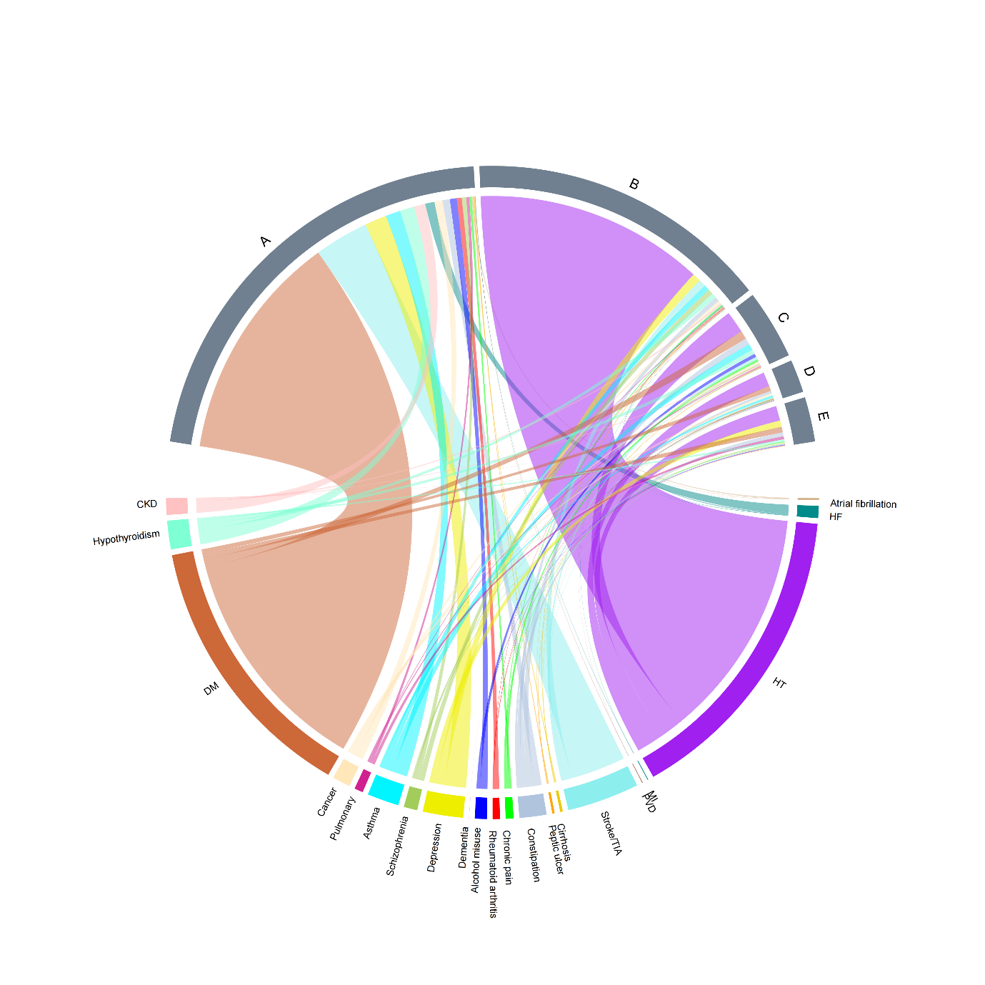
A: HT
B: DM
C: Depression
D: Hypothyroidism
E: Asthma

- Age 50-64
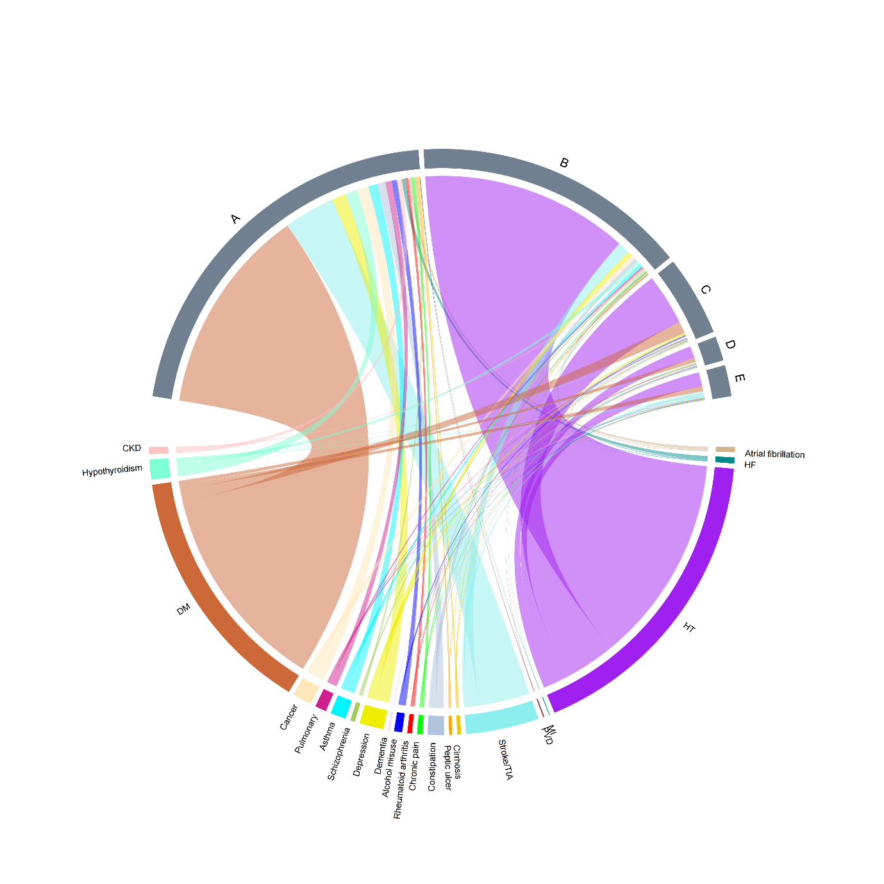
A: HT
B: DM
C: Stroke/TIA
D: Cancer
E: Depression
A: HT
B: DM
C: Stroke/TIA
D: Pulmonary
E: Cancer

- Age 65-79
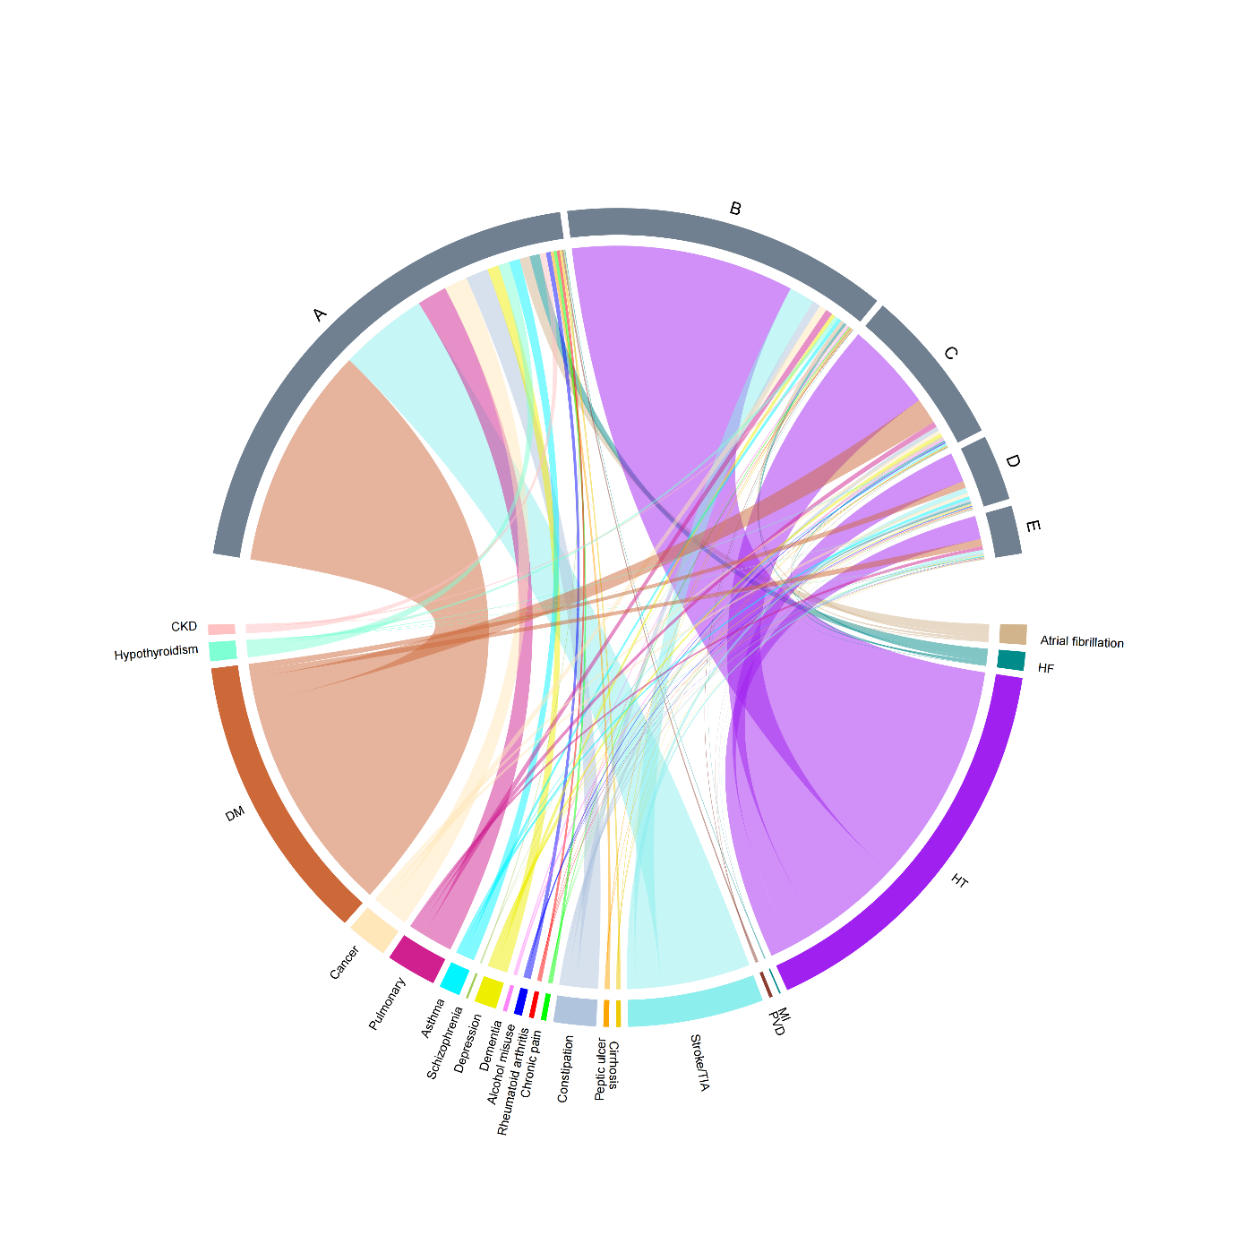
A: HT
B: DM
C: Stroke/TIA
D: Pulmonary
E: Cancer
(D) Age ≥ 80
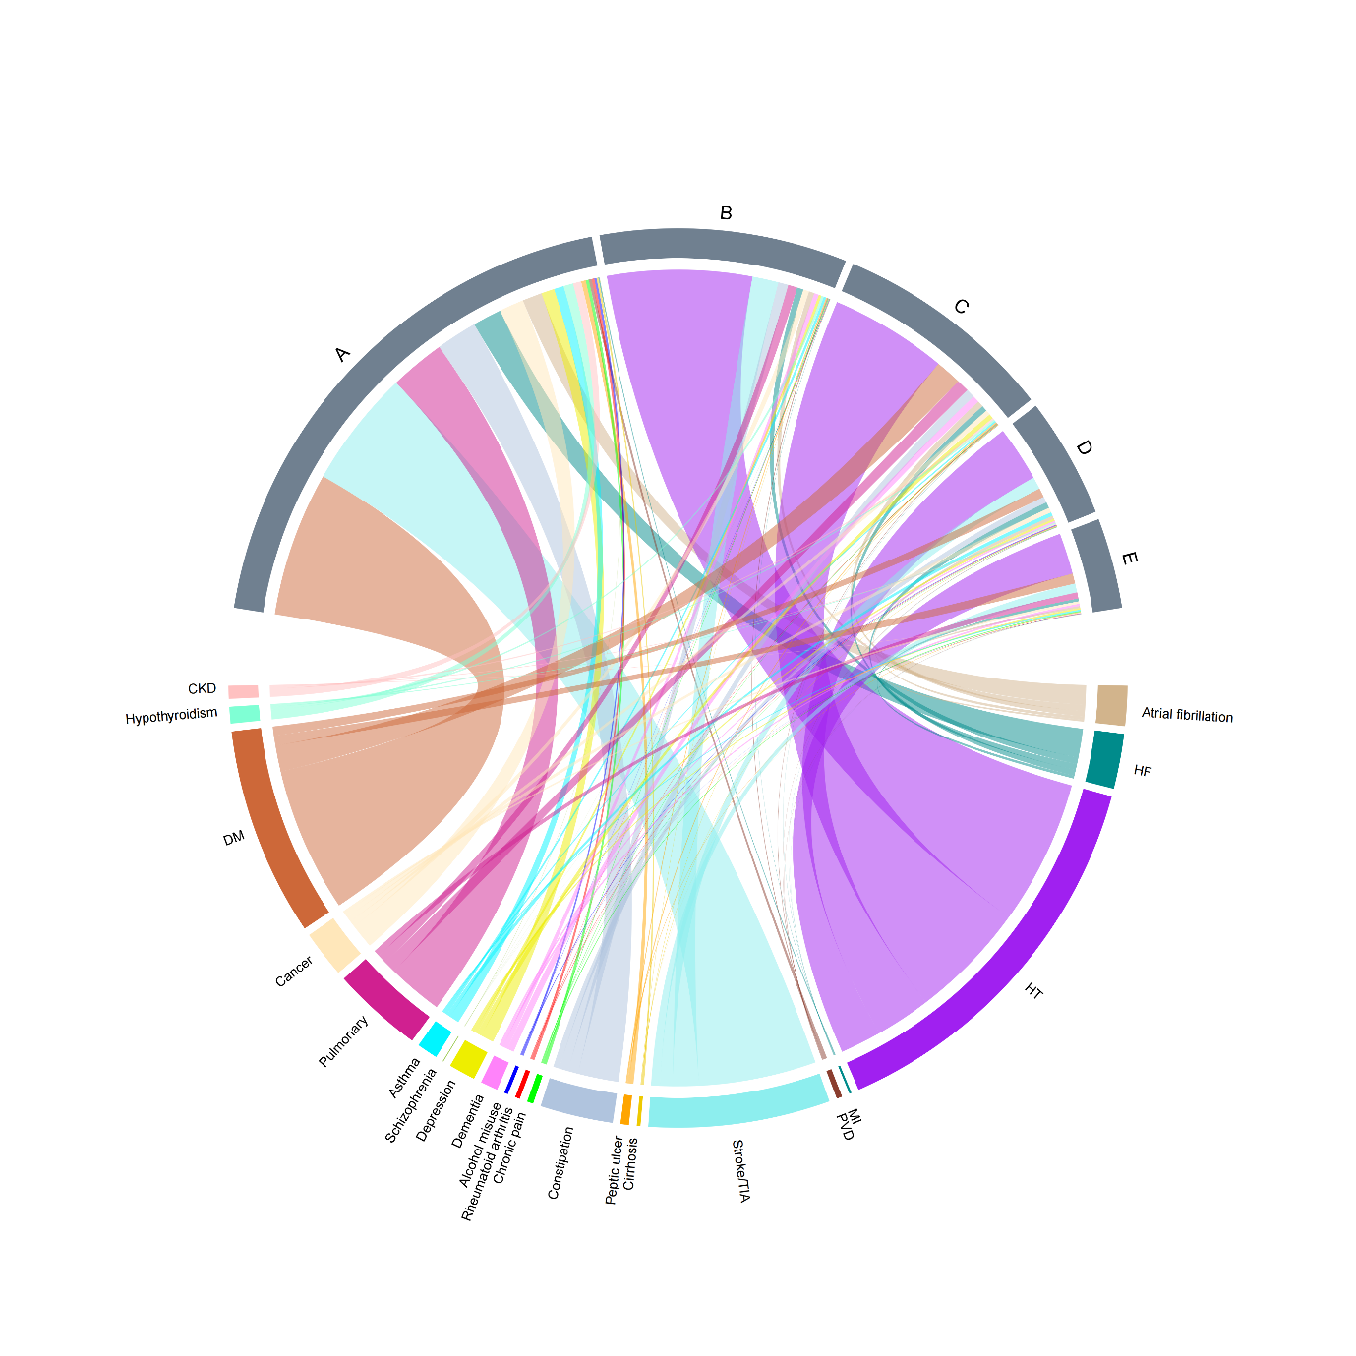
A: HT
B: DM
C: Stroke/TIA
D: Pulmonary
E: Constipation

HF: Chronic heart failure; HT: Hypertension; MI: Myocardial infarction; PVD: Peripheral vascular disease; Stroke/TIA: Stroke or transient ischemic attack; Constipation: Severe constipation; Pulmonary: Chronic pulmonary disease; DM: Diabetes; CKD: Chronic kidney disease.

