Tables

Additional Table 1: The recoding and recategorization of outcome and explanatory variables, along with their operational definitions.
Variable Name | Operational Definition | Value Label
Functional Difficulty | The dependent variable, women’s functional difficulty, represents whether a woman has a functional difficulty. If a woman responded "no difficulty" or "some difficulty," she was considered to have no functional difficulty. However, if she responded "at least one difficulty at a severe level" or "cannot see, hear, walk, remember, perform self-care, or communicate at all," she was considered to have a functional difficulty. | 0 = Has no functional difficulty
Functional Difficulty |  | 1 = Has functional difficulty
Women’s Age Group | Since the women in our study were aged 18 to 49 years, we divided them into four categories: "18-25," "26-33," "34-41," and "42-49," each with a 7-year interval. | 1 = 18-25
Women’s Age Group |  | 2 = 26-33
Women’s Age Group |  | 3 = 34-41
Women’s Age Group |  | 4 = 42-49
Educational Level | For women, we recoded the education completion data for each country as three categorical variables (none/pre-primary/primary, secondary & higher). Because vocational schooling is classified differently in each country's educational systems, a more disaggregated categorization was unable to be developed (such as none/pre-primary/primary, secondary, vocational, and higher). No education, less than primary and primary education were all labeled "none/pre-primary/primary". Lower secondary, higher secondary, and vocational education were all labeled as “secondary/vocational”. Since every national survey included a consistently labeled "higher" education category, we constructed a category that was classified as “higher”. | 1 = None/pre-primary/primary
Educational Level |  | 2 = Secondary/vocational
Educational Level |  | 3 = Higher
Marital Status | Current marital status of the woman | 0 = Never in union
Marital Status | Current marital status of the woman | 1 = Currently in union
Area of Residence | Whether a woman lives in an urban or rural area | 1 = Urban
Area of Residence | Whether a woman lives in an urban or rural area | 2 = Rural
Wealth Index | There are five quintiles in the wealth index for each nation in the dataset: the lowest (poorest) quintile, the second (poorer), the third (middle), the fourth (wealthier), and the fifth quintile (wealthiest). For ease of analysis, the lowest and second quintiles in this study were merged and labelled as "poor", the middle quintile as "middle", and the fourth and fifth quintiles as combined and labeled as "rich". | 1 = Poor
Wealth Index |  | 2 = Middle
Wealth Index |  | 3 = Rich
Media Exposure | Three criteria, television viewing, radio listening, and newspaper reading, were combined to evaluate media exposure. If a woman has had contact with at least one of the three media sources, she is considered to have had media exposure rather than if she has not. | 0 = No
Media Exposure |  | 1 = Yes
Intimate Partner Violence (IPV) | Regarding their experiences with IPV involving their husbands, women were questioned to measure women’s attitudes towards domestic violence using The UNICEF MICS standard woman’s questionnaire that can be found at https://mics.unicef.org/tools. Using the responses to the questions, a new dummy variable was constructed. Any positive response to one of these questions was considered evidence of physical IPV while a negative response indicating that the respondent had not been exposed to physical violence. | 0 = No
Intimate Partner Violence (IPV) |  | 1 = Yes
Number of Household Members | Categorized based on the number of household members | 1 =1-5
Number of Household Members | Categorized based on the number of household members | 2 = 6-10
Number of Household Members | Categorized based on the number of household members | 3 = 10-15
Number of Household Members | Categorized based on the number of household members | 4 = 15-50
Number of Children Women Have | Children ever born to a woman. | 0 = No child
Number of Children Women Have | Children ever born to a woman. | 1 = 1-2
Number of Children Women Have | Children ever born to a woman. | 2 = 3-6
Number of Children Women Have | Children ever born to a woman. | 3 = 7+
Age at Marriage | Age at which a woman was married | 1 = Less than 18
Age at Marriage | Age at which a woman was married | 2 = 18-24
Age at Marriage | Age at which a woman was married | 3 = 25+
One or More Live Births in the Last Two Years | Whether a woman had at least one live birth in the last two years | 0 = No
One or More Live Births in the Last Two Years |  | 1 = Yes
Sources of Drinking Water | According to the WHO/UNICEF criteria, drinking water sources were divided into improved and unimproved sources [44]. Piped water in a building, plot, or yard, standpipes or public taps, tube wells, protected drug wells, protected springs, carts with small tanks or drums, tanker trucks, bottled water, and rainfall collection are examples of improved water sources. Any of these sources that received a positive response were interpreted as using improved sources of water. If there were no affirmative responses, the response was classified as "unimproved sources." | 0 = Unimproved Sources
Sources of Drinking Water |  | 1 = Improved Sources
Water And Soap Available At the place of Handwashing | Availability of both water and soap at handwashing facilities | 0 = No
Water And Soap Available At the place of Handwashing |  | 1 = Yes
Sources of Sanitation Facility | Composting toilets, ventilated improved pit latrines, pit latrines with slabs, septic tanks, and flush or pour-flush to a piped sewer system are examples of improved sanitation facility sources. Any of these sources that received a positive response were interpreted as using an improved sanitation facility. If no affirmative response was given, the facility was classified as "unimproved sources." Additionally, a separate category for open defecation was retained. | 0 = Unimproved Sources
Sources of Sanitation Facility |  | 1 = Improved Sources
Sources of Sanitation Facility |  | 2 = Open Defecation
Life Satisfaction | Self-reported life satisfaction of the woman | 1 = Happy
Life Satisfaction | Self-reported life satisfaction of the woman | 2 = Neither Happy nor Unhappy
Life Satisfaction | Self-reported life satisfaction of the woman | 3 = Unhappy
Age of Household Head | The age of the household head ranged from 13 to 99 years, so we categorized this variable into five groups: "13-25," "26-33," "34-41," "42-49," and "50+". | 1 = 13-25
Age of Household Head |  | 2 = 26-33
Age of Household Head |  | 3 = 34-41
Age of Household Head |  | 4 = 42-49
Age of Household Head |  | 5 = 50+
Sex of Household Head | Gender of the household head | 1 = Male
Sex of Household Head | Gender of the household head | 2 = Female
Education Level of Household Head | For the education level of the household head, we categorized the data into two groups: 1) "none/pre-primary/primary" and 2) "secondary/vocational/higher." | 1 = None/pre-primary/primary
Education Level of Household Head |  | 2 = Secondary/vocational/higher
Own A Mobile Phone | Whether the woman owns a mobile phone | 0 = No
Own A Mobile Phone | Whether the woman owns a mobile phone | 1 = Yes
Internet Access at Home | Whether the woman has internet access at home | 0 = No
Internet Access at Home | Whether the woman has internet access at home | 1 = Yes
Country | Countries included in the study | 1 = Algeria
Country | Countries included in the study | 2 = Bangladesh
Country | Countries included in the study | 3 = Central African Republic
Country | Countries included in the study | 4 = Chad
Country | Countries included in the study | 5 = Comoros
Country | Countries included in the study | 6 = Fiji
Country | Countries included in the study | 7 = Ghana
Country | Countries included in the study | 8 = Guinea-Bissau
Country | Countries included in the study | 9 = Iraq
Country | Countries included in the study | 10 = Kiribati
Country | Countries included in the study | 11 = Lesotho
Country | Countries included in the study | 12 = Malawi
Country | Countries included in the study | 13 = Mongolia
Country | Countries included in the study | 14 = Nepal
Country | Countries included in the study | 15 = Pakistan Khyber
Country | Countries included in the study | 16 = Samoa
Country | Countries included in the study | 17 = Sao Tome and Principe
Country | Countries included in the study | 18 = Sierra Leone
Country | Countries included in the study | 19 = Suriname
Country | Countries included in the study | 20 = Togo
Country | Countries included in the study | 21 = Tonga
Country | Countries included in the study | 22 = Zimbabwe
Region of Country | The countries are categorized into three regions:  - Africa: Algeria, Central African Republic, Chad, Comoros, Ghana, Guinea-Bissau, Lesotho, Malawi, Sao Tome and Príncipe, Sierra Leone, Togo, Zimbabwe.  - Asia: Bangladesh, Iraq, Mongolia, Nepal, Pakistan Khyber.  - Oceania/South America: Fiji, Kiribati, Samoa, Tonga, Suriname. Since Suriname is the only country from South America, it is grouped with Oceania for clarity in analysis. | 1 = Africa
Region of Country |  | 2 = Asia
Region of Country |  | 3 = Oceania/South America

Additional Table 2: Variance Inflation Factor (VIF) for Selected Covariates in the Multivariable Model.
Factors | VIF
Women’s Age Group | 2.05
Education Level | 1.47
Marital Status | 1.27
Area of Residence | 1.22
Intimate Partner Violence (IPV) | 1.11
Number of Household Members | 1.33
Number of Children Women Have | 1.68
Age at Marriage | 1.19
One or More Live Births in the Last Two Years | 1.30
Sources of Sanitation Facility | 1.34
Life Satisfaction | 1.09
Age of Household Head | 1.42
Sex of Household Head | 1.25
Own a mobile phone | 1.31
Internet Access at Home | 1.31
Region of Country | 1.26

All factors included in the multivariable analysis had variance inflation factors (VIFs) less than 5, indicating that multicollinearity was not a concern.

Additional Table 3: Model comparison and model fitness
Parameter | Standard Logistic Regression Model | Null Model | Mixed-effect logistic regression model
LL | -38828.49 |  | -37390.52
AIC | 77754.99 |  | 74881.05
BIC | 78258.06 |  | 75394.38
Deviance  (-2LLR) | 77656.98 |  | 74781.04
ICC |  | 26% (95% CI: 25%, 27%)
MOR |  | 2.77 (2.69, 2.85)
LR-test | LR test vs. logistic model: chibar2(01) = 2875.94 Prob > = chibar2 = 0.000

Note: The null model’s intraclass correlation coefficient (ICC) was 26% (95% CI: 25–27%), indicating that between-cluster variability accounted for approximately one-fourth of the overall variation in functional difficulty. The median odds ratio (MOR) of 2.77 suggested that a woman from a high-risk cluster was 2.77 times more likely to have functional difficulty than one from a low-risk cluster. The multilevel mixed-effects logistic regression model outperformed the standard logistic model, with significantly better LR-test results and the lowest AIC, BIC, and deviance.

Abbreviations: ICC: Intraclass Correlation Coefficient, MOR: Median Odds Ratio, AIC: Akaike's Information Criterion, BIC: Bayesian Information Criterion (BIC), LR: Likelihood Ratio

Figures

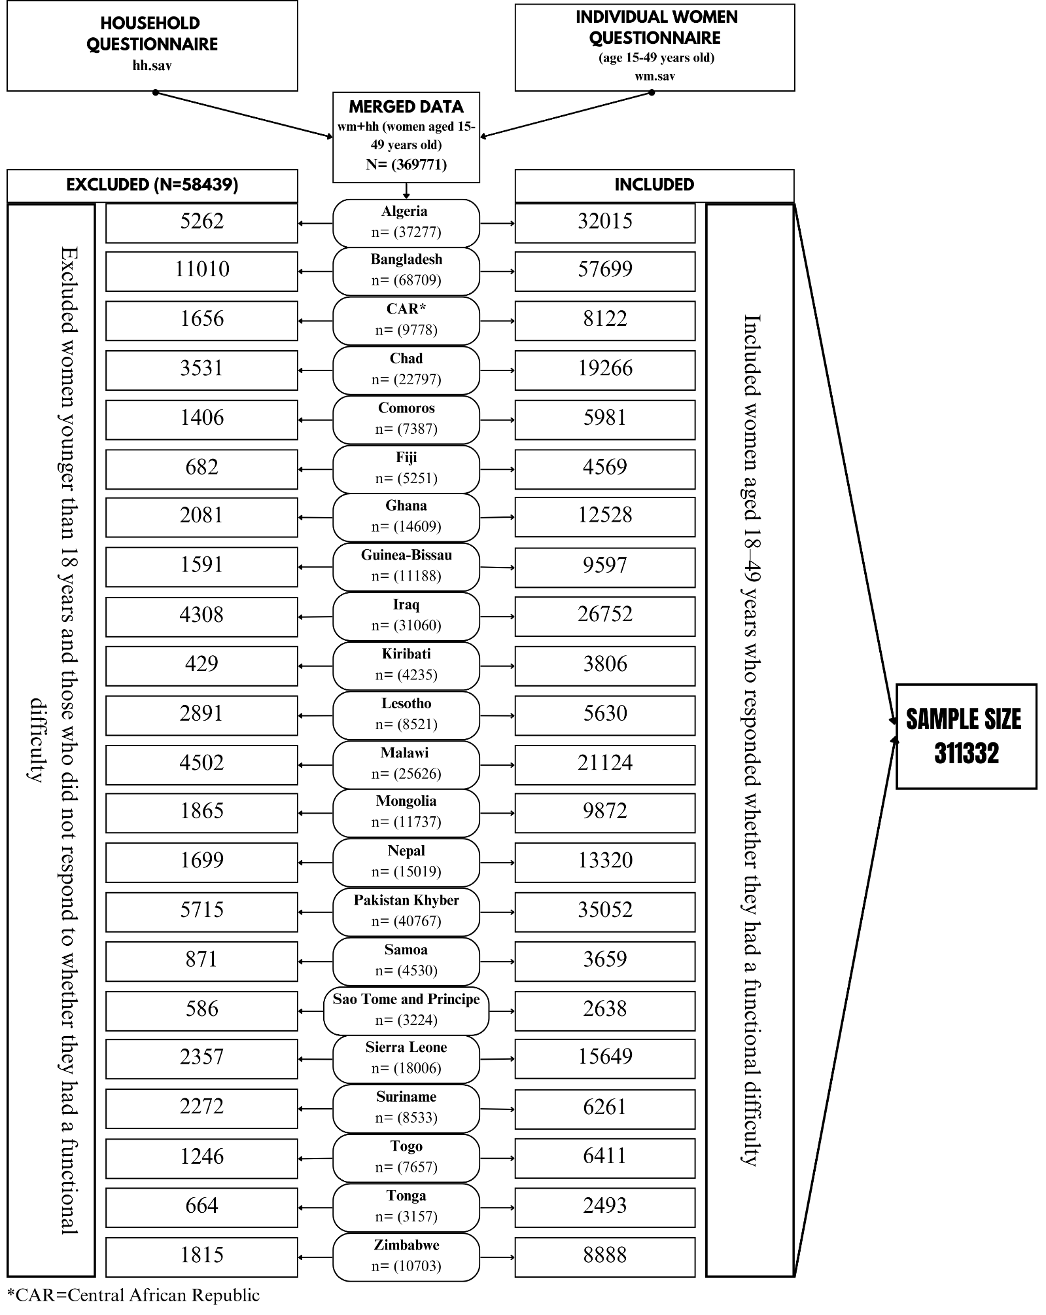
Additional Figure 1: Flow diagram illustrating the exclusions and final sample sizes for the study, derived from the 22 included MICS (2017-2022) datasets.
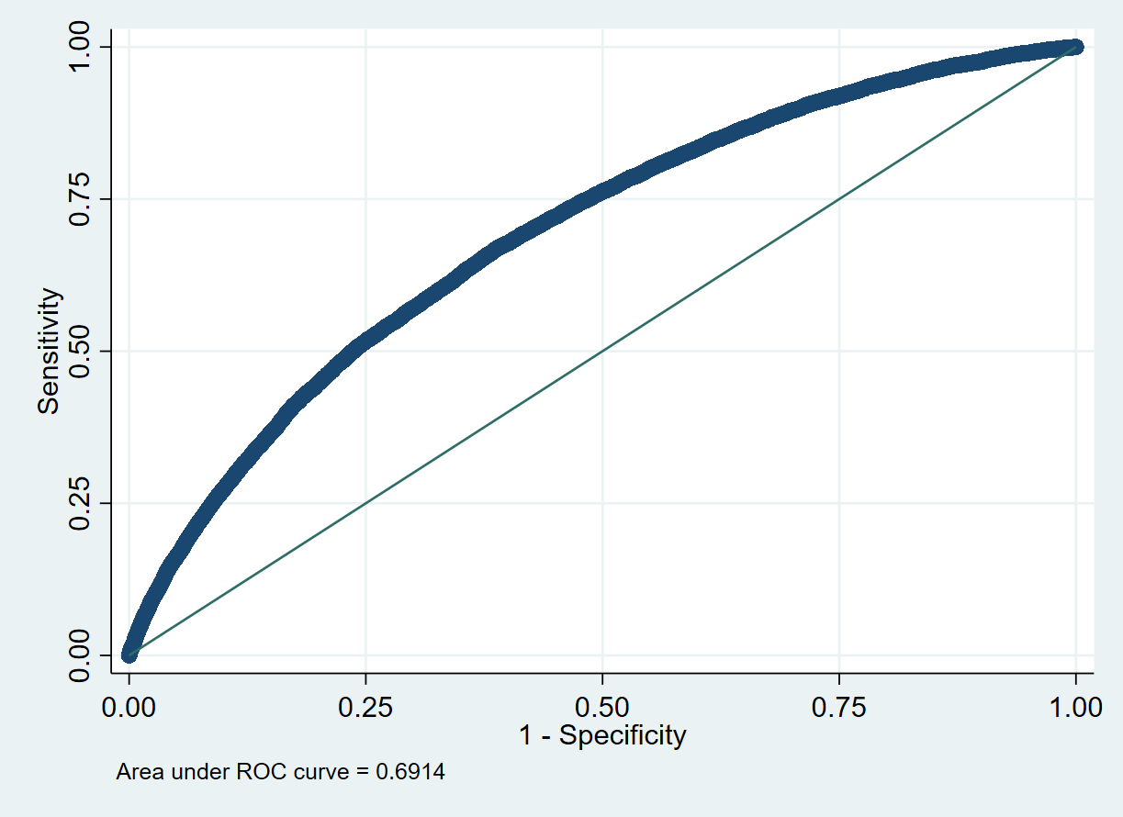
Additional Figure 2: Area Under the Receiver Operating Characteristic (ROC) Curve for the Multivariable Logistic Regression Model.

The discriminative ability of the multivariable logistic regression model was evaluated using the area under the receiver operating characteristic (ROC) curve, which was 0.6914, indicating acceptable model performance in distinguishing women with and without functional difficulty.
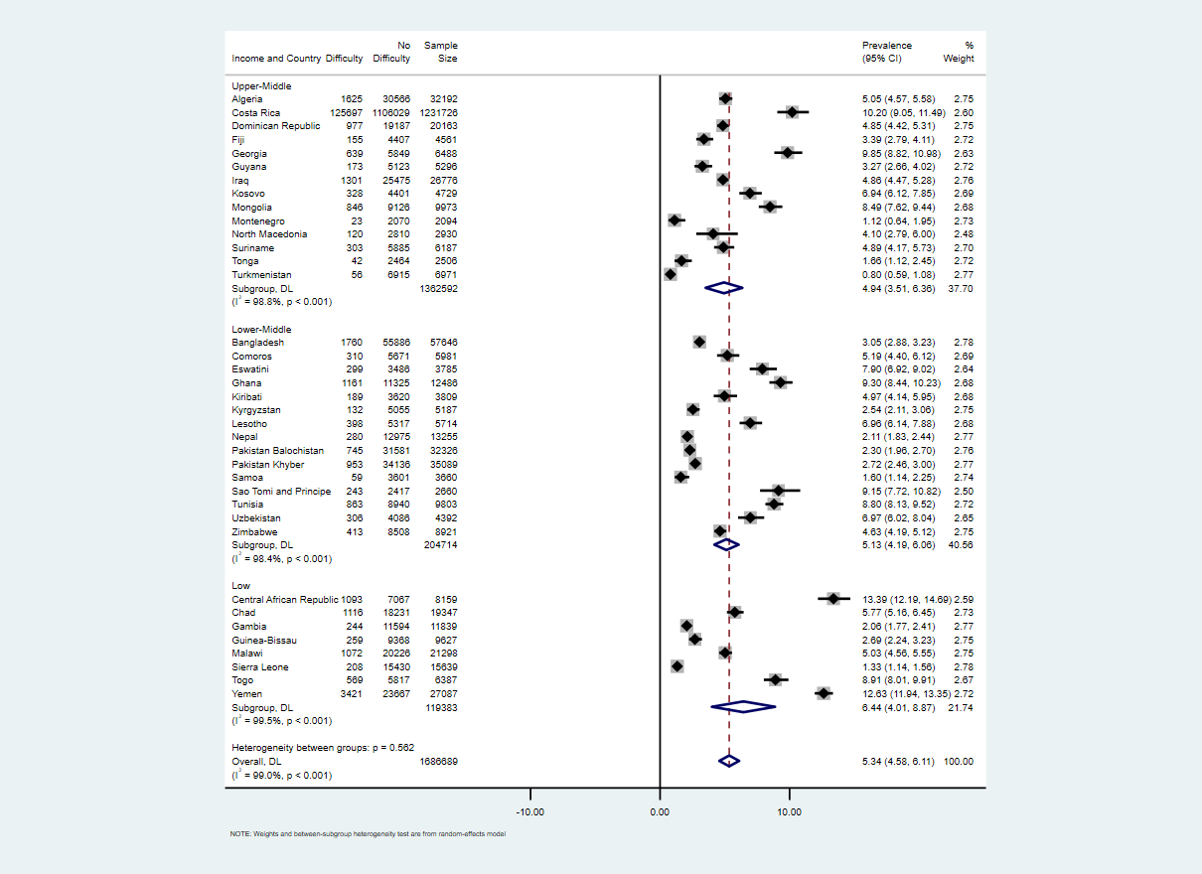

Additional Figure 3: Prevalence of functional difficulty among women aged 18–49 years by income classification in 37 LMICs (random-effects meta-analysis), 2017-2022 (MICS)

