Supplementary Material
S1 Diagnostic Assessment of Body Composition Indices and DML–GRF Model Parameter Specifications
S1.1 Estimand and analytic framework
For each body composition index X and each stratum, the target quantity is the average partial effect of X on the probability of prevalent hypertension Y conditional on the covariate vector Z, θ = E[∂E(Y | X, Z)/∂X]. Estimation followed the partially linear double/debiased machine learning design: the exposure is first orthogonalized with respect to Z by a flexible nuisance model estimated on independent sample splits, and the residualized exposure is then related to the outcome by a second-stage learner. Because the second-stage learner is a generalized random forest, the same fit simultaneously yields conditional average treatment effects (CATEs) at the individual level. The term "treatment effect" is used here in its statistical sense within the DML–GRF framework; given the cross-sectional design, all estimates are interpreted as associations.
S1.2 Analysis units and covariate sets
The seven indices were modelled separately because joint modeling indicated collinearity (VIF 2.86–17.38; Supplementary Table 1). Each exposure was analysed within 43 mutually exclusive strata—2 sex strata, 3 age strata (18–44, 45–59, ≥ 60 years), and 38 ethnic strata—yielding 7 × 43 = 301 analyses. The stratifying variable was excluded from the confounder set of its own analysis, and all remaining confounders were retained. Age entered in both continuous and three-category form; because both nuisance learners are tree ensembles, this redundancy affects neither the fit nor the orthogonalization. Categorical covariates were expanded into a complete set of indicator columns without an intercept, the appropriate encoding for tree-based learners. A stratum × exposure combination was analysed only if at least 100 records with complete data on the exposure, covariates and outcome were available; all 301 combinations met this threshold.
S1.3 First stage: cross-fitted XGBoost
Observations within a stratum were randomly assigned to K = 5 folds of approximately equal size under a fixed seed. For each fold k, an XGBoost regressor with squared-error objective was trained on the remaining K − 1 folds to predict the exposure from the covariate matrix, and generated predictions for fold k only. The residual for observation i in fold k was defined as Xᵢ − m̂⁽⁻ᵏ⁾(Zᵢ), so that no observation contributed to the model producing its own residual. Boosting was capped at 100 rounds with early stopping after 10 rounds without improvement on the held-out fold. Because the stopping iteration is therefore selected on the same fold used for evaluation, the cross-validated R² reported in Table 1 may be marginally optimistic; the shallow trees (maximum depth 4) and low learning rate (0.1) limit the magnitude of any such optimism. Fold-specific training and testing R², RMSE and MAE were retained, and the overfitting gap was defined as mean training R² minus mean testing R² across folds.
S1.4 Second stage: generalized random forest
The residualized exposure was supplied as the treatment variable to a causal forest (grf::causal_forest) with the binary hypertension indicator as the outcome and the same covariate matrix as predictors. Forests comprised 2,000 trees grown on 50% subsamples, with a minimum leaf size of 5 and honest splitting (half of each subsample used for split selection and half for leaf estimation), which decouples split selection from leaf estimation and supports valid pointwise confidence intervals. Confidence intervals were obtained by the bootstrap-of-little-bags procedure with groups of 4 trees. The grf implementation additionally re-centres the outcome and the treatment internally using out-of-bag regression-forest predictions; the exposure is therefore orthogonalized twice, once by the cross-fitted XGBoost step and once internally. This double residualization is conservative, preserves the Neyman orthogonality of the estimating score, and is reported here for completeness.
The AME for each stratum was obtained from the augmented inverse-probability-weighted (doubly robust) score evaluated over the full stratum. With a continuous treatment this quantity is the average partial effect, that is, the mean change in the predicted probability of hypertension per one-unit increase in the exposure; values in Table 2 are multiplied by 100 and expressed in percentage points. The individual CATEs used for the Q1–Q4 stratification were the out-of-bag predictions of the same forests.
S1.5 Inference, heterogeneity, and multiplicity
Standard errors were those returned by the doubly robust estimator. Two-sided P values were computed as 2Φ(−|AME/SE|) and 95% confidence intervals as AME ± 1.96 × SE. Heterogeneity across the levels of a stratifying variable was assessed by an inverse-variance Wald χ² test: given stratum estimates θ̂ⱼ with standard errors SEⱼ, weights wⱼ = SEⱼ⁻², and pooled estimate θ̄ = Σwⱼθ̂ⱼ / Σwⱼ, the statistic Q = Σwⱼ(θ̂ⱼ − θ̄)² was referred to a χ² distribution with k − 1 degrees of freedom; the resulting values are reported as P-diff in Table 2. Multiplicity across the 301 analyses was controlled by the Benjamini–Hochberg procedure at a false discovery rate of 5%, applied jointly to the full set of AME P values.
S1.6 Software and reproducibility
All DML–GRF analyses were conducted in R 4.4.3 using the xgboost and grf packages; cross-fitting was implemented directly rather than through a wrapper package. A single seed (123) governed both fold assignment and forest construction, so that all reported estimates are exactly reproducible from the analytic dataset. Baseline comparisons were performed in SPSS 18.0, and the standardized-weight heatmap in Figure 1 was produced in Python 3.13. Analysis code is available from the corresponding author on reasonable request.

Supplementary Table 1. Normality and VIF assessment of body composition indices
Variable | N | Skewness | Kurtosis | VIF | Normality Conclusion
BMI | 30035 | 0.126 | −0.807 | 6.542 | Approximately Normal
BRI | 30035 | 0.367 | −0.624 | 2.859 | Approximately Normal
BFP | 30035 | 0.112 | −1.018 | 17.384 | Approximately Normal
BWP | 30035 | 0.516 | −0.122 | 4.770 | Approximately Normal
VFL | 30035 | 0.340 | −0.752 | 2.998 | Approximately Normal
LBM | 30035 | 0.472 | −0.591 | 3.779 | Approximately Normal
MFR | 30035 | -0.143 | −1.619 | 8.824 | Approximately Normal
Supplementary Figure 1. Normal Q–Q plots for the seven body composition indices. Sample quantiles are plotted against theoretical normal quantiles, and the red line is the reference expected under normality; skewness and kurtosis are given above each panel. Vertical scales are in the native unit of each index.

Supplementary Table 2. Full specification of the DML–GRF workflow
Stage | Parameter (argument) | Value | Source | Description
First stage (XGBoost) | Objective (objective) | reg:squarederror | Package default | Squared-error loss for the continuous exposure
First stage (XGBoost) | Learning rate (eta) | 0.1 | User-specified | Step-size shrinkage per boosting round
First stage (XGBoost) | Maximum tree depth (max_depth) | 4 | User-specified | Complexity control
First stage (XGBoost) | Minimum child weight (min_child_weight) | 1 | Package default | Minimum summed instance weight per child node
First stage (XGBoost) | Row subsampling (subsample) | 0.8 | User-specified | Fraction of rows sampled per round
First stage (XGBoost) | Column subsampling (colsample_bytree) | 0.8 | User-specified | Fraction of covariates sampled per tree
First stage (XGBoost) | L2 regularization (lambda) | 1 | Package default | Ridge penalty on leaf weights
First stage (XGBoost) | L1 regularization (alpha) | 0 | Package default | Lasso penalty; not applied
First stage (XGBoost) | Maximum rounds (nrounds) | 100 | User-specified | Upper bound on boosting iterations
First stage (XGBoost) | Early stopping (early_stopping_rounds) | 10 | User-specified | Rounds without improvement on the held-out fold before termination
Cross-fitting | Number of folds (K) | 5 | User-specified | Random equal-sized partition; residuals taken from the held-out fold
Cross-fitting | Minimum stratum size | 100 | User-specified | Minimum complete records for a stratum × exposure analysis
Second stage (GRF) | Number of trees (num.trees) | 2000 | Package default | Forest size
Second stage (GRF) | Minimum node size (min.node.size) | 5 | Package default | Minimum leaf sample size
Second stage (GRF) | Subsample fraction (sample.fraction) | 0.5 | Package default | Fraction of data per tree
Second stage (GRF) | Honesty (honesty) | TRUE | Package default | Split selection separated from leaf estimation
Second stage (GRF) | Honest split fraction (honesty.fraction) | 0.5 | Package default | Share of each subsample used for splitting
Second stage (GRF) | Honest leaf pruning (honesty.prune.leaves) | TRUE | Package default | Pruning of empty honest leaves
Second stage (GRF) | CI group size (ci.group.size) | 4 | User-specified | Trees per bootstrap-of-little-bags group
Second stage (GRF) | Variables per split (mtry) | min(⌈√p⌉ + 20, p) | Package default | Candidate covariates evaluated per split
Second stage (GRF) | Split balance (alpha) | 0.05 | Package default | Minimum child-node share of parent observations
Second stage (GRF) | Imbalance penalty (imbalance.penalty) | 0 | Package default | Not applied
Second stage (GRF) | Parameter tuning (tune.parameters) | none | Package default | No internal tuning performed
Reproducibility | Random seed | 123 | User-specified | Applied to fold assignment and forest construction
Reproducibility | Threads (nthread) | 2 | User-specified | Fixed for bitwise reproducibility
Reproducibility | Software | R 4.4.3; xgboost; grf | — | Analysis environment
Note: Hyperparameters were fixed a priori at conventional regularized settings rather than tuned by nested cross-validation, in order to preserve the sample-splitting structure required for valid cross-fitting; all grf parameters other than ci.group.size were left at package defaults. Honest estimation splits each subsample into a tree-building set and a leaf-estimation set, which removes the adaptive bias of leaf averages and supports valid pointwise confidence intervals. Full workflow details are given in Supplementary Section S1.
S2 Sensitivity Analysis of Ethnic Association Pattern Classification
To evaluate the robustness of the quartile-based four-pattern classification, sensitivity analyses were performed using K-means clustering (K = 4, 50 random initializations) and agglomerative hierarchical clustering (Ward's method, K = 4) on the Z-standardized AME × 100 matrix (38 ethnic groups × 7 indices). Concordance was quantified using the adjusted Rand index (ARI). All analyses were conducted in R 4.4.3 with the cluster and mclust packages.
The two data-driven methods produced highly consistent partitions (ARI = 0.836; Supplementary Table 3). Agreement between each data-driven method and the original quartile-based classification was moderate (ARI = 0.353 for K-means; ARI = 0.308 for Ward; Supplementary Table 3), with concordance concentrated at the classification extremes (Supplementary Figure 2): 10 of 13 original high-sensitivity groups were assigned to the "Strong" data-driven cluster, and 8 of 12 relatively tolerant groups were assigned to the "Moderate-low" cluster by both algorithms. The Hani and Monba, which exhibited atypical profiles (negative BMI and positive BWP associations), were consistently separated into the "Weak" cluster. Partial discordance in the intermediate range arose because data-driven algorithms partition by overall magnitude, whereas the quartile-based method additionally distinguishes qualitative profile differences (fat-sensitive vs. muscle-protective) among groups with similar overall association strength (Supplementary Table 4).

Supplementary Table 3. Concordance between ethnic classification methods assessed by the ARI.
Comparison | Adjusted Rand Index
Original (quartile-based) vs. K-means (K = 4) | 0.353
Original (quartile-based) vs. Hierarchical clustering (Ward, K = 4) | 0.308
Original (quartile-based) vs. Hierarchical clustering (Complete, K = 4) | 0.144
K-means (K = 4) vs. Hierarchical clustering (Ward, K = 4) | 0.836
Note: ARI quantifies agreement between two partitions after correction for chance (ARI = 1, perfect; ARI = 0, random). All clustering was performed on Z-standardized AME × 100 values (38 ethnic groups × 7 indices). K-means used 50 random initializations with Euclidean distance. Hierarchical clustering used Euclidean distance with Ward's minimum-variance or complete linkage, cut at K = 4.

Supplementary Table 4. Cluster-level mean AME × 100 profiles and constituent ethnic groups across classification methods.
Method | Cluster | N | Members | BMI | BRI | BFP | BWP | VFL | LBM | MFR
Original (Quartile) | Fat-sensitive | 7 | Yao, Tu, Yugur, Han, Uyghur, Tibetan, Sherpa | 1.87 | 4.87 | 1.16 | −1.07 | 2.12 | 1.08 | −11.90
Original (Quartile) | High-sensitivity | 13 | Qiang, Salar, Miao, Nu, Lisu, Zhuang, Tujia, Bai, Mongol, Hui, Kazakh, Bouyei, Sarta | 2.91 | 8.43 | 1.44 | −1.62 | 3.00 | 1.56 | −19.23
Original (Quartile) | Muscle-protective | 6 | Maonan, Dong, Sui, Achang, Blang, Bonan | 2.04 | 7.34 | 1.17 | −1.22 | 2.18 | 1.26 | −17.98
Original (Quartile) | Relatively tolerant | 12 | Dai, Gin, Va, Hani, Derung, Mulao, Gelao, Jingpo, Lahu, Monba, Yi, Jino | 0.98 | 4.34 | 0.25 | −0.22 | 0.88 | 0.72 | −6.71
K-means | Moderate-high | 16 | Maonan, Tu, Dong, Sui, Achang, Zhuang, Mulao, Tujia, Bai, Yugur, Lahu, Han, Tibetan, Blang, Sherpa, Bonan | 2.18 | 6.53 | 1.06 | −1.04 | 2.16 | 1.29 | −13.75
K-means | Moderate-low | 10 | Dai, Gin, Yao, Va, Derung, Gelao, Jingpo, Uyghur, Yi, Jino | 1.07 | 3.89 | 0.49 | −0.50 | 1.24 | 0.45 | −7.62
K-means | Strong | 10 | Qiang, Salar, Miao, Nu, Lisu, Mongol, Hui, Kazakh, Bouyei, Sarta | 3.04 | 8.69 | 1.61 | −1.83 | 3.26 | 1.67 | −21.83
K-means | Weak | 2 | Hani, Monba | −0.50 | 4.70 | −0.53 | 0.67 | −1.01 | 1.12 | −3.59
Hierarchical (Ward) | Moderate-high | 14 | Maonan, Tu, Dong, Sui, Achang, Zhuang, Mulao, Tujia, Bai, Yugur, Lahu, Han, Tibetan, Blang | 2.16 | 6.78 | 0.95 | −0.91 | 2.16 | 1.25 | −13.53
Hierarchical (Ward) | Moderate-low | 10 | Dai, Gin, Yao, Va, Derung, Gelao, Jingpo, Uyghur, Yi, Jino | 1.07 | 3.89 | 0.49 | −0.50 | 1.24 | 0.45 | −7.62
Hierarchical (Ward) | Strong | 12 | Qiang, Salar, Miao, Nu, Lisu, Mongol, Hui, Kazakh, Bouyei, Sarta, Sherpa, Bonan | 2.92 | 8.05 | 1.65 | −1.84 | 3.08 | 1.65 | −20.74
Hierarchical (Ward) | Weak | 2 | Hani, Monba | −0.50 | 4.70 | −0.53 | 0.67 | −1.01 | 1.12 | −3.59
Note: Values are unweighted cluster-level means of AME × 100 for each body composition index. The Members column lists all ethnic groups assigned to each cluster. The original method classifies groups using composite scores derived from Z-standardized AMEs. K-means and hierarchical (Ward) methods are purely data-driven, with post hoc labels assigned by descending overall association strength.

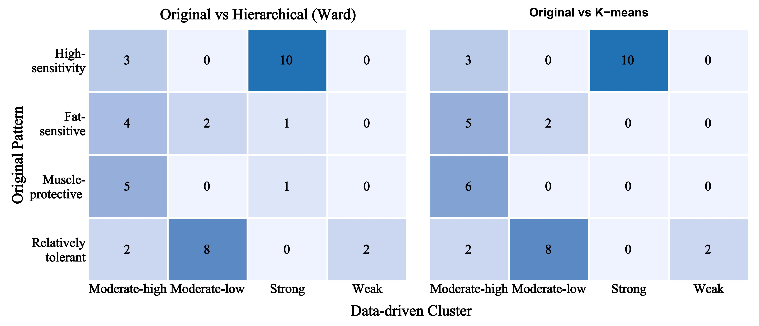
Supplementary Figure 2. Cross-tabulation of the original quartile-based classification (rows) with K-means clustering (right panel) and hierarchical clustering (Ward's method; left panel). Cell values indicate the number of ethnic groups assigned to each combination. Both data-driven methods were applied to Z-standardized AME × 100 values (38 ethnic groups × 7 body composition indices) with K = 4. Post hoc cluster labels (Strong, Moderate-high, Moderate-low, Weak) were assigned by ranking clusters in descending order of the sum of absolute mean AME values.
S3 Simulation-Based Assessment of Sample Size Adequacy
S3.1 Rationale
The DML–GRF estimator derives its standard error from an orthogonalized score whose precision depends on nuisance functions learned from the data. No closed-form power function exists, and the routines implemented in software such as G*Power presuppose a fully specified parametric model (t test, χ², linear or logistic regression); they are therefore not applicable here. Sample size adequacy was instead assessed by simulation. Because power computed from an observed estimate is circular, the design pairs two resampling procedures conditioned on the analytic data with a parametric Monte Carlo in which the true association is fixed a priori.
S3.2 Settings common to all procedures
All simulations used the estimation pipeline of Supplementary Methods S1 with identical hyperparameters, except that the causal forest was grown with 500 rather than 2,000 trees to keep computation feasible. The average marginal effect (AME) is obtained from the orthogonal score and does not depend on the causal forest, so full-sample estimates were identical under the two settings; doubling the internal nuisance regression forests from 500 to 1,000 trees changed the full-sample AME by 0.002% to 0.375% across the seven indices. Associations are expressed in percentage points (pp) of hypertension prevalence per one standard deviation (SD) of the exposure, which makes the seven indices comparable. The minimum detectable effect (MDE) at 80% power and two-sided α = 0.05 was defined as (z₀.₉₇₅ + z₀.₈₀) × SE = 2.8016 × SE and is interpreted throughout as the smallest association the design can detect. A single seed (123) governed all fold assignment and forest construction.
S3.3 Procedure A: subsampling power curves
The analytic dataset was treated as the sampling population. For each index and each of ten subsample sizes (n = 200, 400, 700, 1,200, 2,000, 3,500, 6,000, 12,000, 25,000 and 30,035), n records were drawn without replacement and the complete pipeline was re-run, with 200 replicates for n ≤ 2,000, 100 for n ≤ 6,000, 40 for n = 12,000 and 25,000, and 20 at n = 30,035. Power was the proportion of replicates yielding P < 0.05 with the same sign as the full-sample estimate.
Power rose from 0.310 to 0.700 at n = 200 to at least 0.955 at n = 1,200 and to 1.000 at n ≥ 3,500, crossing 80% between n = 287 (BRI) and n = 757 (LBM) (Supplementary Table 6; Supplementary Figure 3). Mean standard errors declined with a mean log–log slope of −0.482 on n against a theoretical value of −0.5. Subsample estimates were attenuated towards the null by 10.5% to 27.4% at n = 200 but by less than 3.3% at n ≥ 3,500. At the achieved sample size the MDE was 0.78 to 1.40 pp per SD.
Because subsampling was without replacement, the dispersion of estimates at the largest sizes is compressed by the finite-population correction: the mean estimated standard error divided by the empirical standard deviation of the estimates was 0.89 to 1.28 for n ≤ 12,000 but 1.81 to 2.42 at n = 25,000, and at n = 30,035 every replicate re-uses the entire dataset and differs only in fold assignment and forest seeds. Power at these two sizes is therefore not interpreted as a sampling-based quantity, and the assessment at the achieved sample size rests on the MDE and on Procedure C.
S3.4 Procedure B: minimum detectable association by ethnic stratum
Each of the 38 ethnic strata was analysed at its observed size. Comparing a stratum’s MDE with its own point estimate would be circular, because any estimate that fails to reach significance necessarily falls below the MDE; the MDE was therefore compared with the pooled association for the same index, which provides an external benchmark. In 67 of the 266 stratum-by-index combinations (25.2%) the MDE exceeded the pooled association, meaning that an association of population-average magnitude could not have been detected at 80% power in that stratum, and 54 of these occurred in the 12 strata with fewer than 500 participants. The median MDE fell from 12.2 pp per SD in strata with fewer than 300 participants to 6.7 in strata of 300 to 999 and 4.5 in strata with at least 1,000 (Supplementary Table 5; Supplementary Figure 4). All seven indices met this criterion in the Sherpa and the Derung, five of seven in the Monba and two of seven in the Gelao. The Qiang, at n = 232, nevertheless reached significance for all seven indices in the main analysis, confirming that stratum size constrains but does not determine detection.
S3.5 Procedure C: parametric Monte Carlo
Outcomes were regenerated so that the true association was known and specified in advance. A logistic model containing only the covariates (sex, ethnicity, and age modelled by a natural cubic spline with four degrees of freedom) was fitted to the analytic data to yield a baseline linear predictor η₀ᵢ, and simulated outcomes were drawn as Yᵢ ~ Bernoulli(expit(η₀ᵢ + β(Xᵢ − X̄))). Under this data-generating process the estimand targeted by the partially linear DML score is the average partial effect weighted by Var(X | Z), θ = β Σwᵢpᵢ(1 − pᵢ) / Σwᵢ, with wᵢ the squared full-sample first-stage residual; β was obtained by fixed-point iteration so that θ equalled the target exactly. The weighted and unweighted definitions of the estimand differ appreciably in these data, and the weighted definition was used because the discrepancy is sufficient to distort coverage at the full sample size. Targets were 0, 1, 2 and 4 pp per SD; BMI and MFR served as representative indices, evaluated at n = 200, 500, 1,500, 5,000 and 30,035 with 150, 150, 150, 100 and 40 replicates respectively.
Under the null the rejection rate ranged from 0.020 to 0.080 across all cells and was 0.050 at n = 30,035 for both indices. Coverage of the nominal 95% interval ranged from 0.887 to 0.990 overall and from 0.925 to 0.975 at n = 30,035, and the mean estimated standard error divided by the empirical standard deviation of the estimates ranged from 0.86 to 1.14. Absolute bias at n = 30,035 did not exceed 0.11 pp per SD. Power at n = 30,035 was 0.90 against a true association of 1 pp per SD and 1.00 against 2 and 4 pp per SD, whereas n = 5,000 gave 0.61 to 0.78 against 2 pp per SD (Supplementary Table 7; Supplementary Figure 5).
S3.6 Fidelity of the simulation pipeline and its limitations
Across the 35 sex- and age-stratified cells of Table 2, estimates from the simulation pipeline agreed closely with the published values (Pearson r = 0.998; median absolute relative difference 2.7%). Two deliberate simplifications should be noted. First, the simulations adjusted for sex, age and ethnicity only, whereas the main analysis additionally adjusted for educational attainment, physical activity, smoking status and alcohol consumption using multiply imputed covariates; simulated standard errors were consequently 0.97 to 1.39 times (median 1.06) the published values. Because the required sample size scales with the square of the standard error, the sizes reported here are lower bounds; rescaling each index by the largest ratio observed for it raises the 80%-power sample size to at most 946, still far below the achieved 30,035. Second, Procedure B is conditioned on the observed data and is presented as a descriptive comparison of attainable precision with the pooled association rather than as a post hoc power calculation; the a priori evaluation is provided by Procedure C.
S3.7 Software
Simulations were run in R 4.4.3 using the xgboost and grf packages under a single seed (123). The simulation script is available from the corresponding author on reasonable request.

Supplementary Table 5. Sample size, hypertension prevalence and minimum detectable effect for each of the 38 ethnic groups.
Ethnic group | n | Prevalence (%) | Median MDE (pp per SD) | Indices with MDE above the pooled association
Sherpa | 180 | 23.33 | 14.33 | 7/7
Nu | 185 | 40.00 | 12.53 | 6/7
Derung | 204 | 40.20 | 12.94 | 7/7
Qiang | 232 | 46.12 | 11.58 | 6/7
Monba | 235 | 30.21 | 11.01 | 5/7
Kazakh | 263 | 31.94 | 10.87 | 5/7
Tu | 312 | 44.55 | 8.83 | 4/7
Yugur | 362 | 35.91 | 11.06 | 5/7
Salar | 411 | 41.36 | 8.01 | 3/7
Bonan | 450 | 23.11 | 6.85 | 2/7
Maonan | 476 | 52.31 | 7.88 | 2/7
Gelao | 487 | 36.55 | 6.88 | 2/7
Mulao | 516 | 37.98 | 6.39 | 1/7
Dai | 526 | 58.56 | 7.43 | 2/7
Hani | 528 | 43.75 | 7.11 | 3/7
Uyghur | 560 | 24.11 | 6.36 | 0/7
Va | 565 | 45.84 | 7.81 | 2/7
Achang | 571 | 41.33 | 6.95 | 2/7
Lisu | 573 | 39.97 | 6.80 | 1/7
Jingpo | 609 | 34.48 | 6.54 | 1/7
Lahu | 676 | 33.28 | 6.56 | 0/7
Jino | 682 | 20.82 | 5.85 | 0/7
Bai | 764 | 36.78 | 6.24 | 0/7
Blang | 767 | 27.38 | 5.46 | 0/7
Sarta | 840 | 25.48 | 5.33 | 0/7
Miao | 863 | 40.21 | 6.21 | 0/7
Zhuang | 949 | 39.30 | 4.71 | 0/7
Tujia | 959 | 37.54 | 5.58 | 0/7
Han | 1010 | 33.27 | 5.40 | 0/7
Sui | 1014 | 41.62 | 4.70 | 0/7
Gin | 1066 | 50.09 | 6.78 | 1/7
Yao | 1195 | 46.69 | 4.94 | 0/7
Hui | 1232 | 33.12 | 4.18 | 0/7
Tibetan | 1332 | 28.83 | 4.49 | 0/7
Bouyei | 1382 | 30.90 | 4.15 | 0/7
Dong | 1422 | 44.37 | 5.00 | 0/7
Yi | 1703 | 27.77 | 3.62 | 0/7
Mongol | 3934 | 34.90 | 2.66 | 0/7
Note: The minimum detectable effect (MDE) is the smallest association detectable with 80% power at two-sided α = 0.05, computed as 2.8016 × SE at each stratum’s observed size and expressed in percentage points (pp) of hypertension prevalence per one SD of the exposure; the value shown is the median across the seven indices. The final column counts indices for which the stratum MDE exceeded the pooled association for the same index, that is, indices for which an association of population-average magnitude could not have been detected at 80% power in that stratum. Groups are ordered by sample size.

Supplementary Table 6. Subsampling power curve summary by body composition index
Index | Power at n = 200 | n80 | MDE at n = 30,035 (pp per SD) | Observed association (pp per SD) | log–log slope
BMI | 0.610 | 338 | 0.78 | 8.09 | −0.487
BRI | 0.700 | 287 | 0.82 | 9.39 | −0.484
BFP | 0.470 | 458 | 1.05 | 9.13 | −0.482
BWP | 0.385 | 655 | 0.91 | −6.46 | −0.483
VFL | 0.435 | 479 | 1.01 | 9.06 | −0.480
LBM | 0.310 | 757 | 1.40 | 10.27 | −0.478
MFR | 0.425 | 492 | 1.01 | −8.13 | −0.481
Note: Subsamples were drawn without replacement from the 30,035 analytic records and the complete pipeline was re-run on each. n80 is the subsample size at which power first reaches 0.80, obtained by linear interpolation on the sampling grid. The minimum detectable effect (MDE) and the observed association are in percentage points per one SD of the exposure, the latter being the full-sample estimate. The slope is from the regression of log(mean SE) on log(n); its theoretical value is −0.5.

Supplementary Table 7. Parametric Monte Carlo results for pre-specified true associations
Index | True association (pp per SD) | n | B | Rejection rate | Power | Bias (pp per SD) | Coverage | SE/SD
BMI | 0 | 200 | 150 | 0.027 | — | −0.008 | 0.973 | 0.99
BMI | 0 | 500 | 150 | 0.080 | — | −0.266 | 0.920 | 0.89
BMI | 0 | 1,500 | 150 | 0.067 | — | +0.055 | 0.933 | 1.03
BMI | 0 | 5,000 | 100 | 0.020 | — | −0.040 | 0.980 | 1.04
BMI | 0 | 30,035 | 40 | 0.050 | — | −0.076 | 0.950 | 1.05
BMI | 1 | 200 | 150 | 0.047 | 0.047 | −0.075 | 0.967 | 1.06
BMI | 1 | 500 | 150 | 0.100 | 0.087 | −0.135 | 0.913 | 0.89
BMI | 1 | 1,500 | 150 | 0.087 | 0.087 | +0.013 | 0.953 | 1.06
BMI | 1 | 5,000 | 100 | 0.230 | 0.230 | −0.102 | 0.990 | 1.06
BMI | 1 | 30,035 | 40 | 0.900 | 0.900 | −0.072 | 0.975 | 1.14
BMI | 2 | 200 | 150 | 0.087 | 0.080 | −0.500 | 0.967 | 1.03
BMI | 2 | 500 | 150 | 0.187 | 0.187 | −0.190 | 0.887 | 0.87
BMI | 2 | 1,500 | 150 | 0.360 | 0.360 | +0.016 | 0.953 | 1.02
BMI | 2 | 5,000 | 100 | 0.780 | 0.780 | −0.060 | 0.960 | 0.97
BMI | 2 | 30,035 | 40 | 1.000 | 1.000 | −0.108 | 0.975 | 1.07
BMI | 4 | 200 | 150 | 0.180 | 0.180 | −0.549 | 0.940 | 1.04
BMI | 4 | 500 | 150 | 0.420 | 0.420 | −0.279 | 0.887 | 0.86
BMI | 4 | 1,500 | 150 | 0.880 | 0.880 | −0.128 | 0.953 | 0.94
BMI | 4 | 5,000 | 100 | 1.000 | 1.000 | −0.070 | 0.920 | 0.95
BMI | 4 | 30,035 | 40 | 1.000 | 1.000 | −0.087 | 0.925 | 1.13
MFR | 0 | 200 | 150 | 0.080 | — | +0.008 | 0.920 | 0.94
MFR | 0 | 500 | 150 | 0.073 | — | +0.186 | 0.927 | 0.95
MFR | 0 | 1,500 | 150 | 0.060 | — | −0.230 | 0.940 | 1.00
MFR | 0 | 5,000 | 100 | 0.040 | — | +0.067 | 0.960 | 1.01
MFR | 0 | 30,035 | 40 | 0.050 | — | +0.021 | 0.950 | 1.05
MFR | 1 | 200 | 150 | 0.073 | 0.033 | −0.116 | 0.927 | 0.94
MFR | 1 | 500 | 150 | 0.073 | 0.067 | +0.073 | 0.907 | 0.96
MFR | 1 | 1,500 | 150 | 0.053 | 0.053 | −0.250 | 0.953 | 1.02
MFR | 1 | 5,000 | 100 | 0.210 | 0.200 | +0.033 | 0.970 | 1.07
MFR | 1 | 30,035 | 40 | 0.900 | 0.900 | +0.025 | 0.950 | 1.02
MFR | 2 | 200 | 150 | 0.120 | 0.107 | +0.069 | 0.893 | 0.91
MFR | 2 | 500 | 150 | 0.107 | 0.107 | +0.022 | 0.973 | 1.02
MFR | 2 | 1,500 | 150 | 0.140 | 0.140 | −0.340 | 0.940 | 1.04
MFR | 2 | 5,000 | 100 | 0.610 | 0.610 | −0.029 | 0.980 | 1.07
MFR | 2 | 30,035 | 40 | 1.000 | 1.000 | +0.025 | 0.925 | 1.02
MFR | 4 | 200 | 150 | 0.167 | 0.167 | −0.140 | 0.920 | 0.94
MFR | 4 | 500 | 150 | 0.287 | 0.287 | −0.280 | 0.960 | 1.03
MFR | 4 | 1,500 | 150 | 0.647 | 0.647 | −0.377 | 0.953 | 1.03
MFR | 4 | 5,000 | 100 | 0.990 | 0.990 | −0.065 | 0.960 | 1.09
MFR | 4 | 30,035 | 40 | 1.000 | 1.000 | −0.015 | 0.925 | 0.91
Note: Outcomes were regenerated from a covariate-only logistic model with the true average marginal effect fixed at 0, 1, 2 or 4 percentage points (pp) per SD of the exposure. The rejection rate at a target of 0 is the empirical type I error rate; power additionally requires the estimate to carry the correct sign and is undefined under the null. Bias is the mean estimate minus the true value. Coverage is the proportion of replicates whose 95% confidence interval contained the true value. SE/SD is the mean estimated standard error divided by the empirical standard deviation of the estimates. B is the number of completed replicates.

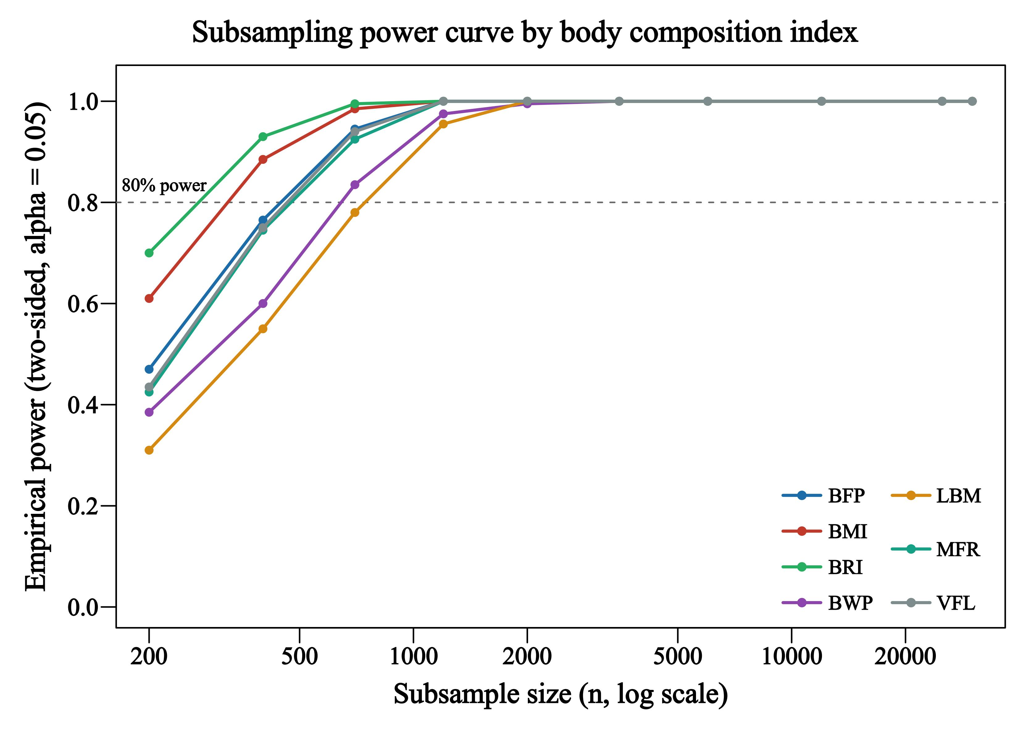
Supplementary Figure 3. Empirical power against subsample size for the seven body composition indices. Subsamples were drawn without replacement from the 30,035 analytic records and the complete DML–GRF pipeline was re-run on each. Power is the proportion of replicates with P < 0.05 and the same sign as the full-sample estimate; replicates numbered 200 for n ≤ 2,000, 100 for n ≤ 6,000, 40 for n = 12,000 and 25,000, and 20 at n = 30,035. The dashed line marks 80% power. Values at the two largest sizes are compressed by the finite-population correction and are not interpreted as sampling-based power (Supplementary Section S3.3).

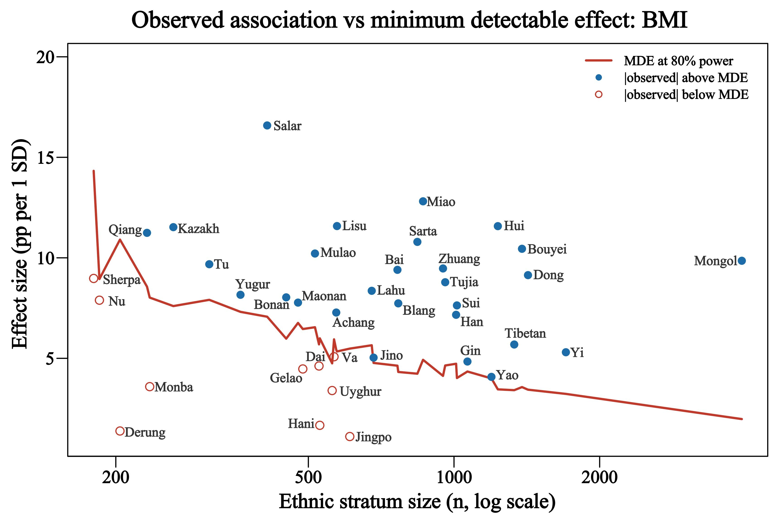
Supplementary Figure 4. Observed association and minimum detectable effect across the 38 ethnic strata, body mass index. The line is the minimum detectable effect at 80% power at each stratum’s observed size; points are absolute observed associations, both in percentage points per one SD of body mass index. Open symbols denote strata in which the observed association lies below the minimum detectable effect. Labels are shown for these strata and for strata with fewer than 300 participants. The remaining six indices showed the same pattern (Supplementary Table 5).

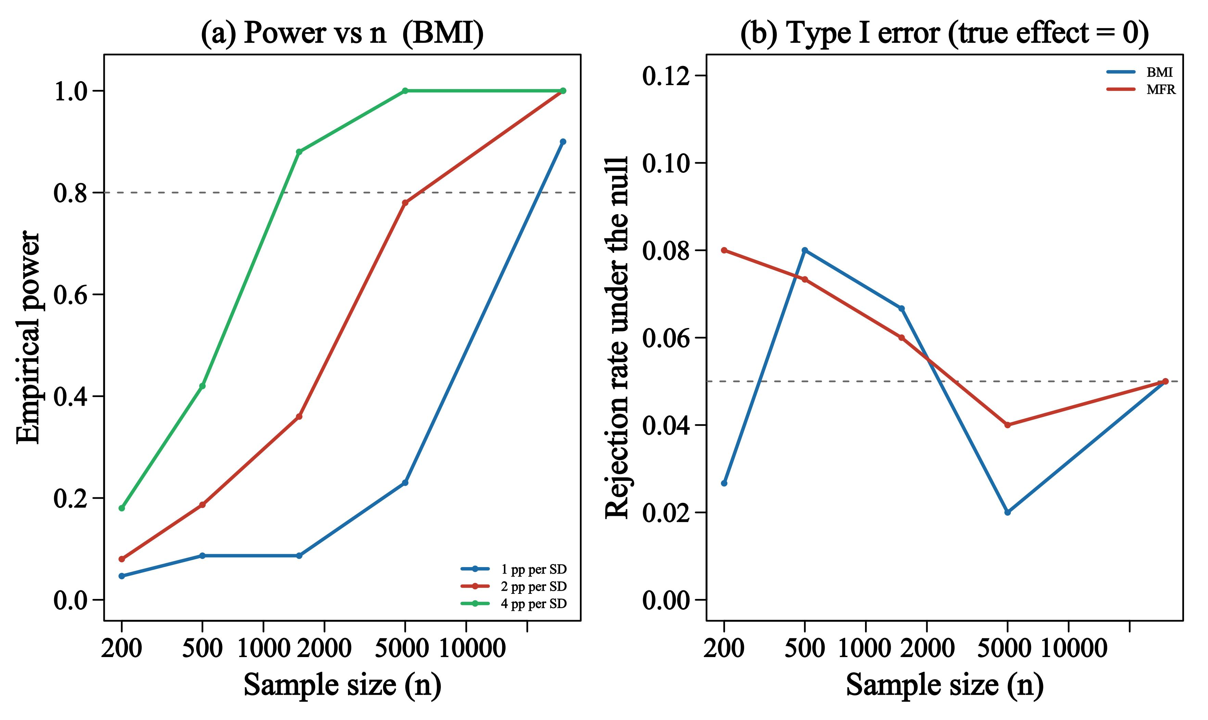
Supplementary Figure 5. Parametric Monte Carlo: power against pre-specified associations (a) and empirical type I error rate (b). (a) Power for body mass index against true associations of 1, 2 and 4 percentage points per SD. (b) Rejection rate when the true association is zero, for body mass index and muscle-to-fat ratio. Dashed lines mark 80% power and the nominal 5% level. Confidence interval coverage is given in Supplementary Table 7.

